ORIGINAL ARTICLE

Six weeks of high intensity interval training (HIIT) preserves aerobic capacity in sedentary older males and male masters athletes for four years: A reunion study

Peter Herbert¹, Lawrence D Hayes^{2*}, Alexander J Beaumont³, Fergal M Grace⁴, and Nicholas F Sculthorpe²

¹School of Sport, Health and Outdoor Education, Trinity Saint David, University of Wales, U.K.
²School of Health and Life Sciences, University of the West of Scotland, U.K.
³School of Science, Technology and Health, York St John University, U.K.
⁴Faculty of Health, Federation University, Victoria, Australia.

ORCID IDs
PH: 0000-0002-3439-3215
LDH: 0000-0002-6654-0072
AJB: 0000-0002-5773-6356
FMG: 0000-0002-3144-5999
NFS: 0000-0001-8235-8580

*L.D. Hayes
School of Health and Life Sciences,
University of the West of Scotland,
Glasgow, G72 0LH, UK
E-mail: Lawrence.Hayes@UWS.ac.uk

Word count: 4549

Abstract
Long-term implications of acutely increased cardiorespiratory fitness following short-term exercise interventions in older adults are unknown. In this study, we examined peak oxygen uptake (VO_{2peak}) after four years of 'free-living’ after a high intensity interval training (HIIT) intervention. Seventeen lifelong exercisers (LEX) and 17 previously sedentary (SED) males (55–74 years of age in 2012) were tested four years (phase D) after our previous experiment which included 6-weeks of aerobic moderate intensity exercise (phase B), followed by 6-weeks of HIIT (phase C). At all stages, a standard incremental exercise protocol on a cycle ergometer was completed to determine VO_{2peak}. SED (P=1.000, Cohen’s d=0.01) and LEX (P=1.000, Cohen’s d=0.11) VO_{2peak} at phase D was not different from phase A (enrolment). SED experienced a large decrease in VO_{2peak} from phase C to phase D (32 ± 6 ml·kg·min⁻¹ to 27 ± 6 ml·kg·min⁻¹ [P<0.001, Cohen’s d=0.81]). LEX experienced a small decrease in VO_{2peak} from phase C to phase D (42 ± 7 ml·kg·min⁻¹ to 39 ± 9 ml·kg·min⁻¹ [P<0.001, Cohen’s d=0.46]). At phase D, LEX had greater VO_{2peak} than SED (P<0.001, Cohen’s d=1.73). The proportion of subjects who reported discontinuing training, maintaining moderate training, and maintaining HIIT differed between groups (P=0.023), with LEX self-reporting more HIIT, and SED self-reporting more discontinuation from exercise. Those who continued exercising experienced a reduction in VO_{2peak} over the four years from 39 ± 7 ml·kg·min⁻¹ to 36 ± 9 ml·kg·min⁻¹ (N=25, P<0.001, Cohen’s d=0.37), and those who discontinued exercising also experienced a reduction in VO_{2peak} from 30 ± 7 ml·kg·min⁻¹ to 25 ± 9 ml·kg·min⁻¹ (N=9, P=0.003, Cohen’s d=0.62). Four years after completing a brief period of aerobic exercise and HIIT, older males demonstrated a preservation of VO_{2peak}, irrespective of training status (LEX or SED). However, LEX exhibited greater VO_{2peak} than SED after 4-years of unsupervised ‘free-living’. Finally, those who discontinued exercising experienced a greater reduction in VO_{2peak}. These findings infer that to maintain aerobic capacity, 6 weeks of HIIT every four year may be sufficient, but to attenuate the decline, exercise should be maintained.

Keywords

Ageing; Exercise; HIIT; Masters athletes; Oxygen uptake; Sedentary

- Introduction
Biological ageing is characterised by a progressive loss of physical function and increased risk of developing various common diseases, including cardiovascular disease (CVD), type II diabetes, and many cancers (Butler et al., 2008). Indeed, cardiovascular fitness is a powerful predictor of loss of independence (de Oliveira Brito et al., 2014), and risk of morbidity (Blair et al., 1989; Seccareccia and Menotti, 1992) and mortality (Imboden et al., 2018). Thus, the decline in physiological function that accompanies advancing age presents a major obstacle to achieving increased health span (Beard and Bloom, 2015), the phase of life without disability and free from serious chronic diseases (Seals and Melov, 2014). Lifestyle interventions capable of ameliorating the deleterious changes in physiological system (e.g. muscular, cardiovascular, endocrine, immune, to name but a few) associated with chronological ageing will prolong the heath span (Seals and Melov, 2014), whilst also reducing risk of age-related CVD (Chiao and Rabinovitch, 2015). One such strategy is physical activity, with recent meta-analytical work demonstrating running activities were associated with a 30% reduction in cardiovascular mortality (Pedisic et al., 2019). This corroborates the recently published narrative by the United Kingdom government, identifying a curvilinear dose-response relationship between physical activity and health outcomes (UK Chief Medical Officers' report). Furthermore, exercise has been proposed as a countermeasure to biological ageing in humans, whereby physically active humans are phenotypically younger than sedentary counterparts, or where individuals display a 'younger' phenotype as a result of exercise training (Beaumont et al., 2019; Campbell et al., 2019; Elliott et al., 2017; Hayes et al., 2015a, 2015b; Mcleod et al., 2019; Piasecki et al., 2019; Sellami et al., 2019, 2018, 2017; Stenbäck et al., 2019a, 2019b). Moreover, the ‘masters athlete’ – broadly defined as an individual older than 45 or 50 years of age involved with competitive exercise (D’Andrea et al., 2007; Wilson et al., 2010) – represents a non-pharmacological model to isolate the inexorable from the preventable declines in cardiovascular ageing (Beaumont et al., 2018).
One characteristic of advancing age is a reduced peak oxygen uptake (VO_{2peak}) (Astrand, 1960; Beaumont et al., 2020; Dill et al., 1967; Rogers et al., 1990). This decrease accelerates with age (Hawkins and Wiswell, 2003) such that there is a ~16% decrease across the fifth decade but a ~26% decrease during the seventh decade and above (Fleg et al., 2005). Indeed, lower levels of cardiorespiratory fitness are associated with an increased risk of cardiovascular and all-cause mortality (Imboden et al., 2018; Paffenbarger et al., 1993). Although decreased VO_{2peak} with increased age occurs irrespective of training status (Pimentel et al., 2003), the rate of decline may be "flattened" through exercise training, as masters athletes exhibit less VO_{2peak} loss over 8 years than sedentary counterparts (Rogers et al., 1990). This "flattened" decline with regular training becomes important given that small improvements in cardiorespiratory fitness have a disproportionately large impact on health and survival (Kaminsky et al., 2013b; Kodama et al., 2009). Although these studies report improved health and fitness with regular exercise training over the life course, sedentary individuals who take-up exercise later in life may also achieve considerable health benefits (Knowles et al., 2015).
Despite convincing evidence for improved cardiorespiratory fitness as a consequence of engaging in short term exercise (Esfandiari et al., 2014; Grace et al., 2018; Knowles et al., 2015), long-term implications of these benefits in older adults are unclear. Whilst a supervised exercise intervention is known to improve cardiorespiratory fitness, the longer-term effect of this during subsequent unsupervised years is unknown.
In 2012, we completed a study of adaptation to low-volume high intensity interval training (HIIT) in older lifelong exercising (LEX) masters athletes and age matched longstanding sedentary (SED) men (Grace et al., 2015; Knowles et al., 2015). On completion, participants were provided with a detailed summary of their cardiovascular and metabolic health and returned to the community. Apart from this debrief and an open offer of advice from the lead investigator, there was no formal support. The present study attempted to address the dearth of information regarding legacy effects of training interventions by presenting a follow-up of our previous work (Knowles et al., 2015). In medicine, a legacy effect, first discussed by Holman et al. (2008) describes the lasting benefit of a treatment long after cessation of said treatment (Coppo, 2013).
Therefore, the aim of the present investigation was to examine the legacy effect of 6-weeks of conditioning exercise followed by 6-weeks of supervised HIIT, on cardiorespiratory fitness after 4 years of ‘free-living’. We examined VO_{2peak} 4 years later, in a ‘reunion’ study to ascertain long-term implications. We hypothesised 1) both groups would experience a decline in VO_{2peak}, 2) LEX would experience less of a decline in VO_{2peak}, and 3) VO_{2peak} would be greater in LEX compared to SED at follow up.

2 Materials and Methods
2.1 Participants
In 2012, we recruited 39 participants aged 55–74 years from a random sample of the local community to participate in a HIIT study (participant descriptions in Table 1). To be eligible, participants were required to be healthy and have no medical conditions liable to contraindicate the training programme. Following approval to exercise by their general practitioner, participants provided informed written consent prior to the study which was approved by the University of the West of Scotland and the University of Wales ethics committees. The investigation adhered to the declaration of Helsinki. A SED and LEX group participated in the study as previously described (Grace et al., 2018; Hayes et al., 2020; Knowles et al., 2015). In 2016, participants were invited to participate in a reunion study to identify changes in cardiorespiratory fitness. These participants were not informed of a follow-up study during the original investigation in 2012 and thus, were only invited back a few weeks prior to the scheduled testing in 2016. The same inclusion criteria were used as for the 2012 assessments. SED participants had not participated in organised exercise programmes for >30 years prior to enrolment in the 2012 study. The LEX group were highly active exercisers and had been so for the previous >30 years. They consisted of current masters athletes in sports including water-polo, triathlon, track cycling, road cycling, and distance running. Participants arrived in the exercise physiology laboratory between the hours of 07.00–09.00 h, following an overnight fast and having abstained from strenuous exercise for a minimum of 48 h. Participants were reminded to maintain standardised conditions prior to each assessment point which included arriving in a hydrated state having abstained from caffeine and alcohol consumption for 36 h.

Table 1: Participant characteristics at baseline. SED = lifelong sedentary older males. LEX = lifelong exercising older males. VO_{2peak} = Peak oxygen uptake. *Different to SED at the P<0.05 level.
 | SED (n=22) | LEX (n=17)
Age (years) | 62 ± 2 (range 55-74) | 60 ± 5 (range 53-71)
Stature (cm) | 175 ± 6 | 173 ± 6
Mass (kg) | 91 ± 16 | 78 ± 12*
BMI (kg·m²) | 29.5 ± 4.9 | 26.0 ± 2.5*
Fat free mass (kg) | 67 ± 7 | 65 ± 6
Body fat percentage (%) | 24 ± 17 | 16 ± 6*
VO_{2peak} (ml∙kg∙min⁻¹) | 28 ± 6 | 39 ± 6*
Peak power output (W) | 699 ± 173 | 766 ± 163*
Peak power output (W∙kg⁻¹) | 7.7 ± 1.6 | 9.7 ± 1.8*

2.2 Peak oxygen uptake determination
Peak oxygen uptake was determined using a Cortex II Metalyser 3B-R2 (Cortex, Biophysik, Leipzig, Germany) utilising methods previously described (Knowles et al., 2015) and a modified Storer Test (Storer et al., 1990) on an air-braked cycle ergometer (Wattbike Ltd., Nottingham, UK). Coefficient of variation for VO_{2peak} determination in our laboratory is <3%, and the metabolic equipment was serviced and maintained according to manufacturer’s recommendations. The same equipment was used at all testing phases. Cycle ergometers were numbered, and each participant used the same ergometer for training and testing at all time points. Manufacturer reliability has been specified as ± 2% across the full power range.

2.3 Body composition determination
Stature was measured to the nearest 0.1 cm using a stadiometer (Seca, Birmingham, UK), and body mass and body composition was determined by a multi frequency bioelectrical impedance analyser (BIA [Tanita MC-180MA Body Composition Analyser, Tanita UK Ltd.]). GMON software (v1.7.0, Tanita UK Ltd.) was used to determine absolute and relative body fat. Fat free mass (FFM) was calculated by subtracting fat mass from total body mass.

2.4 Exercise training
To account for the contribution of aerobic conditioning exercise in SED, participants were initially tested at three phases in 2012 (A, B, and C; Figure 1), which were interspersed with two six week training blocks as previously described (Knowles et al., 2015). Briefly, training block 1 (between phase A and B) consisted of moderate aerobic training amounting to 150 min·wk⁻¹ for the SED group, in line with the physical activity guidelines (Garber et al., 2011). During this time, LEX maintained their current training, which allowed us to capture training volumes and intensities. SED completed a minimum of two sessions per week. Participants were given verbal instructions on the use of a Polar FT1 heart rate monitor (Polar, Kempele, Finland) and exercise intensities were self-monitored, enabling recording of exercise time, and average and peak heart rate (exercise was unsupervised, but heart rate was checked). The aim was to achieve an average heart rate reserve (HRR [(Karvonen and Vuorimaa, 1988)]) of approximately 55% for the first two weeks of the intervention. This was increased to 60% HRR for the subsequent weeks including 5-10 s of increased intensity (prescribed as 'vigorous' in line with the ACSM guidelines (Garber et al., 2011)) every 10 min. The final two weeks included brief periods of exercise which elicited a HRR of 60-65% every 5 min. The mode of training was optional, and included walking, jogging, and cycling. During the six-weeks of preconditioning, SED exercised for 160 ± 15 min·wk⁻¹. Heart rate was recorded, using %HRR as a determinant of exercise intensity. Exercise training logs, including heart rate data, were submitted to the research team on a weekly basis to ensure participants adhered to instructions. If required, interventions were amended, ensuring intensity and duration were achieved. No nonexercise component (e.g. dietary guidance) was provided and no adverse events occurred, according to self-reporting, when questioned at each training session by the lead researcher. Whilst SED underwent preconditioning, LEX maintained their habitual training (unsupervised) which totalled 281 ± 144 min·wk⁻¹ structured training. Exercise type, frequency, intensity (recorded by heart rate telemetry), and duration of training was recorded. 214 ± 131 min·wk⁻¹ and 67 ± 52 min·wk⁻¹ was spent at <65% HRR, and >65% HRR respectively.
Both groups underwent HIIT from phase B to C (training block 2). HIIT was performed on a cycle ergometer (Wattbike Ltd., Nottingham, UK) every five days, for six weeks (nine sessions in total). Rationale for this frequency comes from our previous work which identified five days of rest was required for recovery of peak power output (PPO) following HIIT in older males (Herbert et al., 2015a). Sessions consisted of 6 x 30 s sprints at 40% PPO, with a cadence between 75 rpm and 100 rpm, interspersed with 3 min active recovery. Rationale for this intensity comes from our previous work which demonstrated this protocol achieved >90%HRR in a similarly aged cohort, and achieved improvements in muscle power (Sculthorpe et al., 2017) which is imperative in ageing cohorts (Manini and Clark, 2012). Sessions were conducted in groups of 4-6, supervised by a member of the research team in an exercise physiology laboratory. HIIT was conducted according to participants' availability, but primarily during traditional working hours (i.e. 09.00-17.00 h). No adverse events were reported, and no nonexercised component (i.e. nutritional guidance) was provided. During this phase, HIIT was the sole exercise performed by both groups.
Phase D was completed 4 years later, using identical testing methods but without supervised training in the intervening 4 years (Figure 2). At follow-up (phase D), participants provided a current training diary. This included whether they were competing in masters events, the type of training (moderate aerobic conditioning, HIIT, and/or resistance training), and the training volume per week, in minutes.
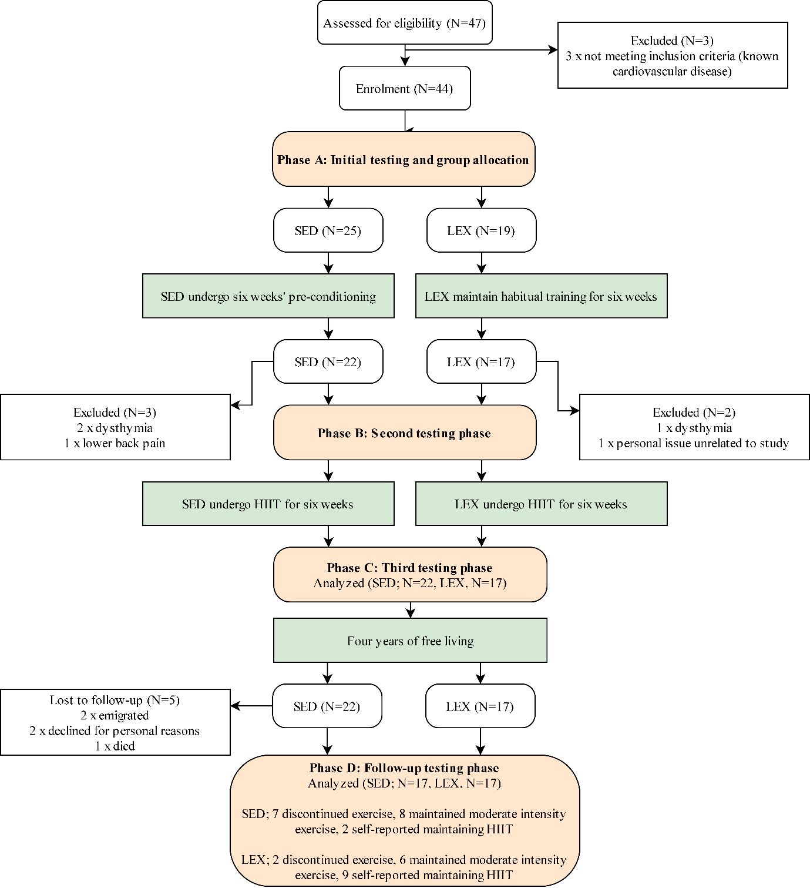
Figure 1: The CONSORT (Consolidated Standards of Reporting Trials) flow chart depicting transition of lifelong sedentary (SED) and lifelong exercising (LEX) participants though the study. HIIT = high intensity interval training.
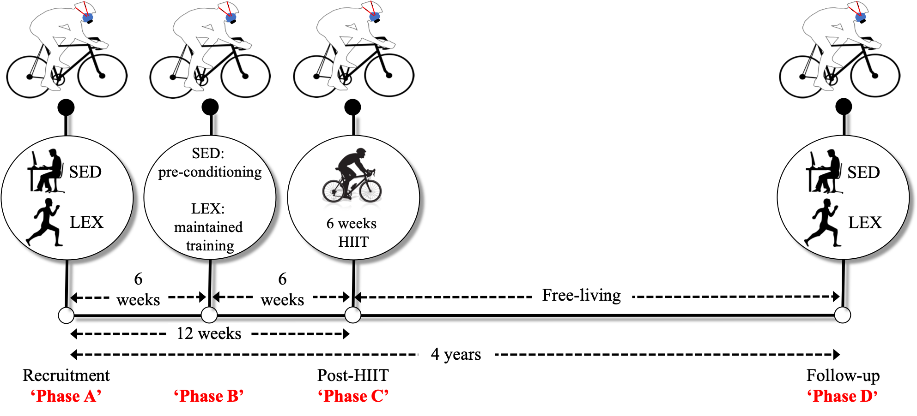

Figure 2: Peak oxygen uptake (VO_{2peak}) was determined at Phases A, B, C and D. Sedentary (SED) vs. lifelong exercisers (LEX) were compared at Phase D in their original groupings determined in Phase A. Phase A-B, 6 week intervention period whereby SED conducted pre-conditioning exercise and LEX maintained normal training; Phase B-C, 6 weeks high-intensity interval training (HIIT) in both LEX and SED; Phase C-D, period of free-living without intervention; Phase A- D, 4-year follow-up period.

2.5 Statistical Analysis
Data were analysed using Jamovi version 1.6.16. Following a Shapiro-Wilk test of normality and Levene’s test for homogeneity of variance, a two-way (group [SED, LEX] x phase [A, B, C, D]) mixed factorial analysis of variance (ANOVA) was conducted to test for differences between groups and time points. Subsequently, posterori T-tests with Bonferroni correction were conducted to determine differences between groups and between phases. A chi-square tested for differences in training habits between LEX and SED. To establish the effect of continuing or discontinuing exercise, a two-way (exercise habit ['continuer', 'discontinuer'] x phase [A, B, C, D]) mixed factorial ANOVA was conducted. Subsequently, posterori T-tests with Bonferroni correction were conducted to determine differences between groups (unpaired T-tests) and between phases (paired T-tests). Alpha level is reported as exact P values as suggested by Hurlbert et al. (2019) and effect size for paired comparisons is reported as Cohen's d whereby the difference in means between two samples was divided by the pooled standard deviation (SD). Thresholds of 0.15, 0.40, and 0.75 for Cohen’s d were interpreted as small, moderate, and large as these are appropriate in gerontology (Brydges, 2019). The analysis will primarily deal with comparisons between phase A (enrolment) and D (follow up), and phase C (post-HIIT) and D, consistent with other reunion studies (Johnson et al., 2019). Data are presented as mean ± standard deviation (SD) in text and figures are presented as grouped dot plots, as recommended by Drummond and Vowler ( 2012).

3 Results
3.1 Peak oxygen uptake
VO_{2peak} data have been previously reported for phases A, B, and C of the original study (Knowles et al., 2015). Briefly, both LEX and SED improved relative and absolute VO_{2peak} following HIIT, and LEX VO_{2peak} was greater than SED VO_{2peak} at all phases (all P<0.05).
There was a main effect of time (P<0.001), and group (P<0.001) on relative VO_{2peak}. However, there was no interaction between group and time (P=0.313). SED VO_{2peak} was 27 ± 6 ml·kg·min⁻¹ at enrolment (phase A), which increased post-HIIT (32 ± 6 ml·kg·min⁻¹ at phase C; P<0.001, Cohen’s d=0.81). Subsequently, SED VO_{2peak} decreased to 27 ± 6 ml·kg·min⁻¹ at phase D (P<0.001, Cohen’s d=0.81 compared to C). Importantly, SED VO_{2peak} at phase D was not different from phase A (P=1.000, Cohen’s d=0.01) or B (P=0.234, Cohen’s d=0.23). LEX VO_{2peak} was 38 ± 6 ml·kg·min⁻¹ at enrolment (phase A), which was increased post-HIIT (42 ± 7 ml·kg·min⁻¹ at phase C; P<0.001, Cohen’s d=0.67). Subsequently, LEX VO_{2peak} decreased to 39 ± 9 ml·kg·min⁻¹ at phase D (P<0.001, Cohen’s d=0.46 compared to C). LEX VO_{2peak} at phase D was not different from phase A (P=1.000, Cohen’s d=0.11) or B (P=1.000, Cohen’s d=0.15). VO_{2peak} was lower in SED compared to LEX at phase D (P<0.001, Cohen’s d=1.73).
In terms of absolute VO_{2peak}, results were concomitant with relative VO_{2peak} in that there was a main effect of time (P<0.001), and group (P<0.001). However, there was no interaction between group and time (P=0.641). SED VO_{2peak} was 2.38 ± 0.33 l·min⁻¹ at enrolment (phase A), which increased post-HIIT (2.80 ± 0.47 l·min⁻¹ at phase C; P<0.001, Cohen’s d=1.03). Subsequently, SED VO_{2peak} decreased to 2.39 ± 0.46 l·min⁻¹ at phase D (P<0.001, Cohen’s d=0.88 compared to C). Importantly, SED VO_{2peak} at phase D was not different from phase A (P=1.000, Cohen’s d=0.02) or B (P=1.000, Cohen’s d=0.28). LEX VO_{2peak} was 3.08 ± 0.50 l·min⁻¹ at enrolment (phase A), which was increased post-HIIT (3.43 ± 0.52 l·min⁻¹ at phase C; P<0.001, Cohen’s d=0.69). Subsequently, LEX VO_{2peak} decreased to 3.14 ± 0.55 l·min⁻¹ at phase D (P=0.003, Cohen’s d=0.54 compared to C). LEX VO_{2peak} at phase D was not different from phase A (P=1.000, Cohen’s d=0.17) or B (P=1.000, Cohen’s d=0.05). Absolute VO_{2peak} was lower in SED compared to LEX at phase D (P<0.001, Cohen’s d=1.48).

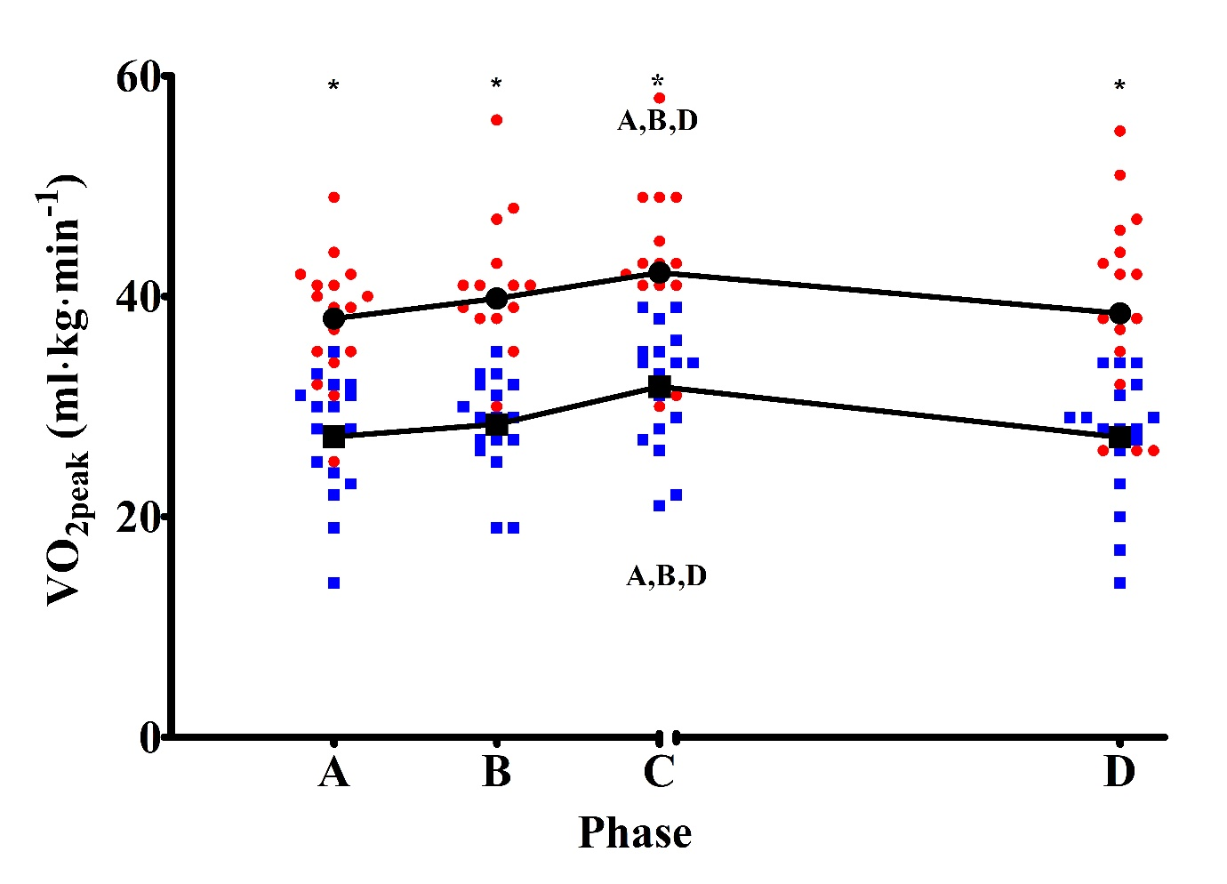 Figure 3: Peak oxygen uptake (VO_{2peak}), in a group of sedentary (SED; blue squares) and lifelong exercising (LEX; red circles) older males. Data are presented as means plus individual data points. *Denotes differences between groups at this experimental phase at the P<0.05 level. A = Different from phase A at the P<0.05 level. B = Different from phase B at the P<0.05 level. D = Different from phase D at the P<0.05 level.

The proportion of subjects who reported discontinuing training, maintaining moderate training, and maintaining HIIT differed between groups (P=0.023), with LEX self-reporting more HIIT, and SED self-reporting more discontinuation from exercise. As there were not enough SED participants who continued HIIT, and not enough LEX participants who discontinued exercise, we pooled these data into two groups; those who continued to exercise (N=25; 15 LEX), and those who discontinued exercise (N=9; 2 LEX) in the four years of free living. When comparing relative VO_{2peak} at phase C and D, there was an effect of time (P<0.001), and exercise continuation (continued exercising or discontinued exercising; P=0.002), but no interaction between exercise continuation and time [P=0.399]). In pairwise comparisons, those who continued exercising experienced a reduction in VO_{2peak} over the four years from 39 ± 7 ml·kg·min⁻¹ to 36 ± 9 ml·kg·min⁻¹ (N=25, P<0.001, Cohen’s d=0.37), and those who discontinued exercising also experienced a reduction in VO_{2peak} from 30 ± 7 ml·kg·min⁻¹ to 25 ± 9 ml·kg·min⁻¹ (N=9, P=0.003, Cohen’s d=0.62). When examining the SED cohort only, there was an effect of time (P<0.001), and exercise continuation (continued exercising, discontinued exercising; P=0.008), but no interaction between exercise continuation and time (P=0.755). In posteori Bonferroni corrected comparisons, those who continued exercise experienced a reduction in VO_{2peak} from 35 ± 3 ml·kg·min⁻¹ at phase C to 30 ± 3 ml·kg·min⁻¹ at phase D (N=10, P<0.001, Cohen’s d=1.05), and those who discontinued exercising experienced a reduction in VO_{2peak} from 28 ± 6 ml·kg·min⁻¹ at phase C to 23 ± 6 ml·kg·min⁻¹ at phase D (N=7, P<0.001, Cohen’s d=0.83). At phase A, SED 'continuers' VO_{2peak} was 29 ± 4 ml·kg·min⁻¹ and SED 'discontinuers' VO_{2peak} was 25 ± 7 ml·kg·min⁻¹ (two-tailed post hoc Bonferroni corrected T-test P=0.109, Cohen’s d=0.84). At phase B, SED 'continuers' VO_{2peak} was 30 ± 3 ml·kg·min⁻¹ and SED 'discontinuers' was 26 ± 5 ml·kg·min⁻¹ (P=1.000, Cohen’s d=1.16). At phase C, SED 'continuers' VO_{2peak} was 35 ± 3 ml·kg·min⁻¹ and SED 'discontinuers' was 28 ± 6 ml·kg·min⁻¹ (P=0.289, Cohen’s d=1.42). At phase D, SED 'continuers' VO_{2peak} was 30 ± 3 ml·kg·min⁻¹ and SED 'discontinuers' was 23 ± 6 ml·kg·min⁻¹ (P=0.185, Cohen’s d=1.47).
To further investigate the effect of the intervening four years on aerobic capacity, we examined self-reported exercise intensity (n=14 moderate intensity exercise only and n=11 self-reported maintaining HIIT) on VO_{2peak} from phase C to D. In this context, there was a main effect of time (P<0.001), and intensity group (HIIT or moderate intensity [P<0.001]) on relative VO_{2peak}. There was an interaction between intensity group and time (P=0.012). HIIT group VO_{2peak} was 39 ± 5 ml·kg·min⁻¹ at enrolment (phase A), which increased post-HIIT (44 ± 7 ml·kg·min⁻¹ at phase C; P<0.001, Cohen's d=0.82). Subsequently, HIIT group VO_{2peak} was unchanged from C to D (43 ± 7ml·kg·min⁻¹ at phase D; P=1.000, Cohen's d=0.14 compared to C). In terms of magnitude, the HIIT group VO_{2peak} at phase D was moderately increased from phase A (P=0.081, Cohen's d=0.66). The moderate intensity group VO_{2peak} was 31 ± 6 ml·kg·min⁻¹ at enrolment (phase A), which was greater post-HIIT (36 ± 5 ml·kg·min⁻¹ at phase C; P<0.001, Cohen's d=0.90). Subsequently, the moderate intensity group VO_{2peak} decreased to 30 ± 7 ml·kg·min⁻¹ at phase D (P<0.001, Cohen's d=1.20 compared to C). Moderate intensity group VO_{2peak} at phase D was not different from phase A (P=1.000, Cohen's d=0.18) or B (P=0.403, Cohen's d=0.54). VO_{2peak} was lower in the moderate intensity group compared to the HIIT at all phases (P≤0.038, Cohen's d≥1.30).

3.2 Body composition
Body composition in both groups at all phases is displayed in table 2. In brief, there was no main effect of time (P=0.071) or group (P=0.143) on total body mass at the P<0.05 level. However, there was an interaction between group and time (P=0.027). There was no main effect of time (P=0.440), group (P=0.163), or interaction (P=0.689) on lean body mass at the P<0.05 level. There was no main effect of time (P=0.156) on body fat percentage. However, the effect of group (P=0.005), and interaction between group and time (P=0.014) did reach the P<0.05 level.

Table 2: Body composition at phase A, B, C, and D in lifelong sedentary (SED) and lifelong exercising (LEX) older males.
 | LEX (N=17) | SED (N=17)
Total body mass
Phase A | 81.3 ± 12.4 kg | 90.6 ± 17.8 kg
Phase B | 81.0 ± 12.6 kg | 89.6 ± 17.2 kg
Phase C | 81.7 ± 12.6 kg | 89.8 ± 18.1 kg
Phase D | 83.5 ± 15.7 kg^{B} | 89.8 ± 18.6 kg
Lean body mass
Phase A | 62.9 ± 6.7 kg | 63.7 ± 7.0 kg
Phase B | 62.0 ± 6.8 kg | 63.4 ± 7.5 kg
Phase C | 62.2 ± 7.1 kg | 64.0 ± 8.3 kg
Phase D | 62.8 ± 7.9 kg | 62.8 ± 8.1 kg
Body fat percentage
Phase A | 18.9 ± 5.2% | 26.4 ± 7.1%
Phase B | 19.5 ± 6.1% | 25.5 ± 7.6%
Phase C | 19.9 ± 6.0% | 24.9 ± 7.6%
Phase D | 20.5 ± 7.2% | 25.8 ± 7.5%
^{B}=different from phase B at the P<0.05 level.

4 Discussion
In this reunion study, we evaluated changes in cardiorespiratory fitness 4 years after completing the original intervention, relative to assessments at enrolment. Accordingly, the present study represents the intervention-related changes plus those persisting over the intervening 4 years, aptly named the ‘legacy effect’. The main findings of this study are; (1) a short-term HIIT intervention which followed six weeks moderate intensity activity preserved VO_{2peak} over a four-year timespan, (2) lifelong exercise results in greater aerobic capacity than is achievable following a short-term HIIT intervention, (3) a short-term HIIT intervention resulted in half of the original SED group maintaining self-reported exercise adherence for four years, and (4) even in a group of highly motivated, life-long exercisers there is a attrition rate in terms of exercise engagement of 12% over 4 years. Taken together these findings indicate that short-term HIIT interventions can have substantial impacts on aerobic capacity, and by extension cardiovascular risk.
The finding that a short-term HIIT intervention can preserve VO_{2peak} over a four-year period is both novel and important. While the observation that LEX had greater cardiorespiratory fitness than LEX is not new, it is encouraging that irrespective of initial fitness levels, both groups exhibited a similar response pattern following short-term HIIT and then after 4-years of ‘free-living’. Few other studies have followed participants over such a long-time frame. Moreover, the lack of decline between Phase A and D is impressive given previous work. In the STRRIDE Reunion Study (Johnson et al., 2019), VO_{2peak} declined by ~10% from enrolment to 10 years follow-up, although the vigorous intensity training groups experienced only a ~5% decrease from pre-training to follow-up. This appeared primarily due to the 8 months of vigorous intensity training creating the greatest increase in VO_{2peak} (~10%, like the increase observed in our 12-week study). The obvious differences between the STRRIDE Reunion Study and this investigation was the difference in follow-up time (10 vs. 4 years, respectively), the difference in intervention duration (8 months vs 12 weeks, respectively), and the type of intervention (aerobic conditioning vs aerobic conditioning and HIIT). However, despite differences, both Johnson et al (2019), and we surmise that a short-term exercise intervention has significant legacy effects for cardiorespiratory fitness, which may be intensity dependent. The seminal work of Rogers et al. (1990) reported that in the absence of a training regime, sedentary individuals can expect to lose 10% of their aerobic capacity over an 8-year period. The same data would therefore predict a 5% decline in VO_{2peak} across the 4 years of our follow-up data which was not the case. One criticism of short-term interventions is the tendency to demonstrate large effect sizes over the short term during supervised, laboratory based interventions, which may not be sustained over the longer term, or may be reduced once moved out of a controlled laboratory setting, often termed the ‘voltage drop’ of interventions (Chambers et al., 2013; Kilbourne et al., 2007). The present data supports this view, since the intervention resulted in initial increases in aerobic capacity, which were lost over the 4-years.
Despite the ‘free living’ nature of the follow up period, most previously sedentary participants remained engaged with some form of regular exercise and prevented further declines relative to their original VO_{2peak}. Considering cardiorespiratory fitness is an independent predictor of all-cause mortality (Kodama, 2009), and that small increases correspond to large reductions in CVD risk (Kaminsky et al., 2013a) these observations have important implications for the role of exercise prescription in managing aerobic capacity and CVD risk in advancing age. Furthermore, although this investigation concerned VO_{2peak} exclusively, it would be expected that the maintenance of fitness would likely be associated with improved blood pressure, cholesterol, and other CVD risk factors. Future studies should explore whether the extent of this protection extends beyond 4 years. If we assume the rate of decline in the LEX group represents the best possible outcome, it is feasible that the SED group could maintain their level of fitness for a decade or more. In addition, future work should also investigate the influence of variations in HIIT protocols.
There are additional important findings from this study which also warrant further discussion. Aside from the intervention, our original study provided no additional access to supervised exercise or sport participation. However, the lead investigator did offer to provide ongoing advice to any participants who requested it. Considering this, the adherence rate of 59% is substantial given that it was not an aim in the original investigation. The reason for the relatively high adherence is unclear. The lead investigator (PH) is a member of the local community from which participants were recruited, and a local advocate for healthy ageing. It may be that being known in the community, combined with regular advice contributed to the higher adherence than anticipated, and future qualitative work will investigate this hypothesis. Conversely, it may be that the early introduction of HIIT, and the increase in aerobic capacity at Phase C resulted in participants feeling more able to take part moderate to high intensity exercise and removed their fear of participation. Previous work indicated that HIIT in this age group resulted in reductions in pain and increase in general health (Knowles et al., 2015). Others have also reported that sedentary participants find HIIT more enjoyable than moderate intensity exercise (Bartlett et al., 2011; Thum et al., 2017). It is plausible therefore that together, these factors may have contributed to the relatively high exercise adherence over the 4-years. Our hypothesis that greater aerobic capacity at phase C as a result of HIIT resulted in greater likelihood of exercise participation in the subsequent four years is supported by comparison between 'continuers' and 'discontinuers'. We observed that individuals classified as 'continuers' of exercise in the four years of free living had a greater VO_{2peak} at enrolment (phase A) and throughout the experiment. Although this was not at the P<0.05 level, the large effect size and difference of >1 MET (3.5 ml·kg·min⁻¹) at all phases suggest this was a clinically meaningful difference. Interestingly, continuers had a greater aerobic capacity than discontinuers, and they were more responsive to the HIIT stimulus (i.e. the difference in VO_{2peak} between phase A and phase C) was greater in continuers compared to discontinuers (5.3 ml·kg·min⁻¹ vs. 3.3 ml·kg·min⁻¹ respectively), suggesting that absolute fitness, but also adaptation to training, may underpin increased exercise participation.
A final unanticipated finding of the present study was that the attrition rate in the LEX group was higher than anticipated at 12% across the 4 years. Given that this group where originally included to act as a positive control, they represent a cohort of individuals who have a strong and persistent drive to exercise and maintain physical fitness and are likely therefore, to represent the greatest degree of adherence possible in this age group. While admittedly in a relatively small cohort, the present data suggests the best adherence realistically achievable in free-living studies. Thus, the 59% adherence of the SED group in this study, and adherence in general in other studies of the same age-range, should be viewed against this best feasible 88% (LEX group) outcome, rather than the best theoretical adherence of 100%.
There are some strengths and limitations of the current study that should be noted. A specific strength is the number of participants included in the follow up. Thirty-four (87%) of the original cohort agreed to be re-measured, which is comparable to the Johnson et al (2019) return success rate for STRRIDE (Studies of Targeted Risk Reduction Interventions through Defined Exercise) reunion study. Moreover, we have follow-up data regarding the reason for not being able to assess the remaining 10 participants, five of whom dropped out before phase B of the original study. However, an important limitation is the use of self-reported exercise at phase D rather than an objective assessment. However, given the duration of follow up, objective methods were unfeasible. Moreover, attempts to use objective measures at phase D would likely have suffered from a Hawthorn effect as others have noted (DÖSSEGGER et al., 2014). Likewise, self-reported activity of continuation or discontinuation of exercise were only recorded on one occasion which may not be reflective of the entire follow-up period. Although, repeated measurement could have violated a true ‘free-living’ period by altering said behaviours. Consequently, we accepted these as limitation as an unavoidable consequence of the duration and nature of follow-up. In addition, the assessed aerobic capacity of participants was broadly commensurate with their reported levels of physical activity. Secondly, non-exercise control groups from phase A to phase D would have strengthened the conclusions of this study. However, recruiting a SED and LEX group who did not undertake the HIIT intervention was not the aim of our initial work (Knowles et al., 2015). Although non-exercise control groups would have provided additional credence to the legacy effects we propose here in, and also to ascertain whether there was a true prevention in a reduction of VO_{2peak}, the work of Rogers et al. (1990) and Johnson et al. (2019) both detail expected decreases in aerobic capacity, so the lack of VO_{2peak} loss reported here is noteworthy. While the exercise training in Phases A and B were of an aerobic nature, exercise modalities performed during the free-living period may have varied within and between participants. Accordingly, we are unable to ascertain the isolated influence from a dichotomous classification of endurance or resistance exercise types. Although, our intention was to assess cardiorespiratory fitness mediated through self-directed exercise during the free-living phase. Nonetheless, the contributions from exercise modality warrants future consideration. Furthermore, while we assessed a single, indirect marker of cardiovascular risk through cardiorespiratory fitness, we were unable to report on other clinical markers related to cardiometabolic health. Future work should consider these considering that the longer term implications of cardiorespiratory fitness and cardiometabolic parameters may be intensity dependant Johnson et al. (2019). Thus, extension of our work pertaining to low frequency, short term HIIT would be beneficial.
In conclusion, the addition of six weeks of HIIT following six weeks of moderate intensity exercise training increasedVO_{2peak} to the extent that it was unchanged four years later in a cohort of LEX and SED older men. Thus, this combination of exercise appears a potent stimulus to increase (in the short-term) or maintain (in the long-term) VO_{2peak} in older males. The implication of these data is that exercise training concluding with 6 weeks HIIT can be utilised by practitioners and healthcare professionals to increase VO_{2peak} over a short period of time, which appears to be a catalyst for maintained cardiorespiratory fitness for years to come. There is an emergent body of evidence that endorses HIIT as an effective alternative to traditional endurance training that can yield enhancements in both cardiorespiratory fitness and a variety of health outcomes (Buchheit and Laursen, 2013; Gibala et al., 2012; Sylta et al., 2017, 2016; Yasar et al., 2019) and consequently, improvements in cardiorespiratory fitness have a significant impact on health and survival (Kaminsky et al., 2013b; Kodama et al., 2009).

Authors contributions statement
Peter Herbert: Conceptualization, methodology, validation, investigation, resources, project administration, writing – review & editing. Lawrence Hayes: Formal analysis, writing – original draft, review & editing, visualization. Alexander Beaumont: Formal analysis, writing – original draft, review & editing, visualization. Fergal Grace: Conceptualization, methodology, validation, investigation, project administration, supervision. Nicholas Sculthorpe: Conceptualization, methodology, validation, investigation, project administration, writing – review & editing, supervision.

Conflict of interest statement
The authors have no conflict of interest to declare.

Funding sources
This research did not receive any specific grant from funding agencies in the public, commercial, or not-for-profit sectors.
References
Astrand, I., 1960. Aerobic work capacity in men and women with special reference to age. Acta Physiol Scand Suppl 49, 1–92.
Bartlett, J.D., Close, G.L., MacLaren, D.P.M., Gregson, W., Drust, B., Morton, J.P., 2011. High-intensity interval running is perceived to be more enjoyable than moderate-intensity continuous exercise: implications for exercise adherence. J Sports Sci 29, 547–553. https://doi.org/10.1080/02640414.2010.545427
Beard, J.R., Bloom, D.E., 2015. Towards a comprehensive public health response to population ageing. Lancet 385, 658–661. https://doi.org/10.1016/S0140-6736(14)61461-6
Beaumont, A., Campbell, A., Grace, F., Sculthorpe, N., 2018. Cardiac Response to Exercise in Normal Ageing: What Can We Learn from Masters Athletes? Curr Cardiol Rev 14, 245–253. https://doi.org/10.2174/1573403X14666180810155513
Beaumont, A., Campbell, A., Unnithan, V., Grace, F., Knox, A., Sculthorpe, N., 2020. Long-term athletic training does not alter age-associated reductions of left-ventricular mid-diastolic lengthening or expansion at rest. Eur J Appl Physiol 120, 2059–2073. https://doi.org/10.1007/s00421-020-04418-1
Beaumont, A.J., Grace, F.M., Richards, J.C., Campbell, A.K., Sculthorpe, N.F., 2019. Aerobic Training Protects Cardiac Function During Advancing Age: A Meta-Analysis of Four Decades of Controlled Studies. Sports Med 49, 199–219. https://doi.org/10.1007/s40279-018-1004-3
Blair, S.N., Kohl, H.W., Paffenbarger, R.S., Clark, D.G., Cooper, K.H., Gibbons, L.W., 1989. Physical fitness and all-cause mortality. A prospective study of healthy men and women. JAMA 262, 2395–2401.
Brydges, C.R., 2019. Effect Size Guidelines, Sample Size Calculations, and Statistical Power in Gerontology. Innovation in Aging 3. https://doi.org/10.1093/geroni/igz036
Buchheit, M., Laursen, P.B., 2013. High-intensity interval training, solutions to the programming puzzle. Part II: anaerobic energy, neuromuscular load and practical applications. Sports Med 43, 927–954. https://doi.org/10.1007/s40279-013-0066-5
Butler, R.N., Miller, R.A., Perry, D., Carnes, B.A., Williams, T.F., Cassel, C., Brody, J., Bernard, M.A., Partridge, L., Kirkwood, T., Martin, G.M., Olshansky, S.J., 2008. New model of health promotion and disease prevention for the 21st century. BMJ 337, 149–150. https://doi.org/10.1136/bmj.a399
Campbell, A., Grace, F., Ritchie, L., Beaumont, A., Sculthorpe, N., 2019. Long-Term Aerobic Exercise Improves Vascular Function Into Old Age: A Systematic Review, Meta-Analysis and Meta Regression of Observational and Interventional Studies. Front. Physiol. 10. https://doi.org/10.3389/fphys.2019.00031
Chambers, D.A., Glasgow, R.E., Stange, K.C., 2013. The dynamic sustainability framework: addressing the paradox of sustainment amid ongoing change. Implement Sci 8, 117. https://doi.org/10.1186/1748-5908-8-117
Chiao, Y.A., Rabinovitch, P.S., 2015. The Aging Heart. Cold Spring Harb Perspect Med 5, a025148. https://doi.org/10.1101/cshperspect.a025148
Coppo, R., 2013. Is a legacy effect possible in IgA nephropathy? Nephrol Dial Transplant 28, 1657–1662. https://doi.org/10.1093/ndt/gft016
D’Andrea, A., Caso, P., Scarafile, R., Salerno, G., De Corato, G., Mita, C., Di Salvo, G., Allocca, F., Colonna, D., Caprile, M., Ascione, L., Cuomo, S., Calabro, R., 2007. Biventricular myocardial adaptation to different training protocols in competitive master athletes. International journal of cardiology 115, 342–9. https://doi.org/10.1016/j.ijcard.2006.03.041
de Oliveira Brito, L.V., Maranhao Neto, G.A., Moraes, H., Emerick, R.F. e S., Deslandes, A.C., 2014. Relationship between level of independence in activities of daily living and estimated cardiovascular capacity in elderly women. Arch Gerontol Geriatr 59, 367–371. https://doi.org/10.1016/j.archger.2014.05.010
Dill, D.B., Robinson, S., Ross, J.C., 1967. A longitudinal study of 16 champion runners. J Sports Med Phys Fitness 7, 4–27.
DÖSSEGGER, A., RUCH, N., JIMMY, G., BRAUN-FAHRLÄNDER, C., MÄDER, U., HÄNGGI, J., HOFMANN, H., PUDER, J.J., KRIEMLER, S., BRINGOLF-ISLER, B., 2014. Reactivity to Accelerometer Measurement of Children and Adolescents. Med Sci Sports Exerc 46, 1140–1146. https://doi.org/10.1249/MSS.0000000000000215
Drummond, G.B., Vowler, S.L., 2012. Do as you would be done by: write as you would wish to read. J. Physiol. (Lond.) 590, 6251–6254. https://doi.org/10.1113/jphysiol.2012.248278
Elliott, B.T., Herbert, P., Sculthorpe, N., Grace, F.M., Stratton, D., Hayes, L.D., 2017. Lifelong exercise, but not short-term high-intensity interval training, increases GDF11, a marker of successful aging: a preliminary investigation. Physiol Rep 5. https://doi.org/10.14814/phy2.13343
Esfandiari, S., Sasson, Z., Goodman, J.M., 2014. Short-term high-intensity interval and continuous moderate-intensity training improve maximal aerobic power and diastolic filling during exercise. Eur. J. Appl. Physiol. 114, 331–343. https://doi.org/10.1007/s00421-013-2773-x
Fleg, J.L., Morrell, C.H., Bos, A.G., Brant, L.J., Talbot, L.A., Wright, J.G., Lakatta, E.G., 2005. Accelerated longitudinal decline of aerobic capacity in healthy older adults. Circulation 112, 674–682. https://doi.org/10.1161/CIRCULATIONAHA.105.545459
Garber, C.E., Blissmer, B., Deschenes, M.R., Franklin, B.A., Lamonte, M.J., Lee, I.-M., Nieman, D.C., Swain, D.P., American College of Sports Medicine, 2011. American College of Sports Medicine position stand. Quantity and quality of exercise for developing and maintaining cardiorespiratory, musculoskeletal, and neuromotor fitness in apparently healthy adults: guidance for prescribing exercise. Med Sci Sports Exerc 43, 1334–1359. https://doi.org/10.1249/MSS.0b013e318213fefb
Gibala, M.J., Little, J.P., MacDonald, M.J., Hawley, J.A., 2012. Physiological adaptations to low-volume, high-intensity interval training in health and disease. J Physiol 590, 1077–1084. https://doi.org/10.1113/jphysiol.2011.224725
Grace, F., Herbert, P., Elliott, A.D., Richards, J., Beaumont, A., Sculthorpe, N.F., 2018. High intensity interval training (HIIT) improves resting blood pressure, metabolic (MET) capacity and heart rate reserve without compromising cardiac function in sedentary aging men. Exp. Gerontol. 109, 75–81. https://doi.org/10.1016/j.exger.2017.05.010
Grace, F.M., Herbert, P., Ratcliffe, J.W., New, K.J., Baker, J.S., Sculthorpe, N.F., 2015. Age related vascular endothelial function following lifelong sedentariness: positive impact of cardiovascular conditioning without further improvement following low frequency high intensity interval training. Physiol Rep 3. https://doi.org/10.14814/phy2.12234
Hawkins, S., Wiswell, R., 2003. Rate and mechanism of maximal oxygen consumption decline with aging: implications for exercise training. Sports Med 33, 877–888. https://doi.org/10.2165/00007256-200333120-00002
Hayes, L.D., Herbert, P., Sculthorpe, N., Grace, F., 2020. High intensity interval training (HIIT) produces small improvements in fasting glucose, insulin, and insulin resistance in sedentary older men but not masters athletes. Exp Gerontol 140, 111074. https://doi.org/10.1016/j.exger.2020.111074
Hayes, L.D., Sculthorpe, N., Herbert, P., Baker, J.S., Hullin, D.A., Kilduff, L.P., Grace, F.M., 2015a. Resting steroid hormone concentrations in lifetime exercisers and lifetime sedentary males. Aging Male 18, 22–26. https://doi.org/10.3109/13685538.2014.977246
Hayes, L.D., Sculthorpe, N., Herbert, P., Baker, J.S., Spagna, R., Grace, F.M., 2015b. Six weeks of conditioning exercise increases total, but not free testosterone in lifelong sedentary aging men. Aging Male 18, 195–200. https://doi.org/10.3109/13685538.2015.1046123
Holman, R.R., Paul, S.K., Bethel, M.A., Matthews, D.R., Neil, H.A.W., 2008. 10-year follow-up of intensive glucose control in type 2 diabetes. N. Engl. J. Med. 359, 1577–1589. https://doi.org/10.1056/NEJMoa0806470
Hurlbert, S.H., Levine, R.A., Utts, J., 2019. Coup de Grâce for a Tough Old Bull: “Statistically Significant” Expires. The American Statistician 73, 352–357. https://doi.org/10.1080/00031305.2018.1543616
Imboden, M.T., Harber, M.P., Whaley, M.H., Finch, W.H., Bishop, D.L., Kaminsky, L.A., 2018. Cardiorespiratory Fitness and Mortality in Healthy Men and Women. Journal of the American College of Cardiology 72, 2283–2292. https://doi.org/10.1016/j.jacc.2018.08.2166
Johnson, J.L., Slentz, C.A., Ross, L.M., Huffman, K.M., Kraus, W.E., 2019. Ten-Year Legacy Effects of Three Eight-Month Exercise Training Programs on Cardiometabolic Health Parameters. Frontiers in Physiology 10, 452. https://doi.org/10.3389/fphys.2019.00452
Kaminsky, L.A., Arena, R., Beckie, T.M., Brubaker, P.H., Church, T.S., Forman, D.E., Franklin, B.A., Gulati, M., Lavie, C.J., Myers, J., Patel, M.J., Piña, I.L., Weintraub, W.S., Williams, M.A., 2013a. The Importance of Cardiorespiratory Fitness in the United States: The Need for a National Registry: A Policy Statement From the American Heart Association. Circulation 127, 652–662. https://doi.org/10.1161/CIR.0b013e31827ee100
Kaminsky, L.A., Arena, R., Beckie, T.M., Brubaker, P.H., Church, T.S., Forman, D.E., Franklin, B.A., Gulati, M., Lavie, C.J., Myers, J., Patel, M.J., Piña, I.L., Weintraub, W.S., Williams, M.A., American Heart Association Advocacy Coordinating Committee, Council on Clinical Cardiology, and Council on Nutrition, Physical Activity and Metabolism, 2013b. The importance of cardiorespiratory fitness in the United States: the need for a national registry: a policy statement from the American Heart Association. Circulation 127, 652–662. https://doi.org/10.1161/CIR.0b013e31827ee100
Karvonen, J., Vuorimaa, T., 1988. Heart rate and exercise intensity during sports activities. Practical application. Sports Med 5, 303–311. https://doi.org/10.2165/00007256-198805050-00002
Kilbourne, A.M., Neumann, M.S., Pincus, H.A., Bauer, M.S., Stall, R., 2007. Implementing evidence-based interventions in health care: application of the replicating effective programs framework. Implement Sci 2, 42. https://doi.org/10.1186/1748-5908-2-42
Knowles, A.-M., Herbert, P., Easton, C., Sculthorpe, N., Grace, F.M., 2015. Impact of low-volume, high-intensity interval training on maximal aerobic capacity, health-related quality of life and motivation to exercise in ageing men. Age (Dordr) 37. https://doi.org/10.1007/s11357-015-9763-3
Kodama, S., 2009. Cardiorespiratory Fitness as a Quantitative Predictor of All-Cause Mortality and Cardiovascular Events in Healthy Men and Women: A Meta-analysis. JAMA 301, 2024. https://doi.org/10.1001/jama.2009.681
Kodama, S., Saito, K., Tanaka, S., Maki, M., Yachi, Y., Asumi, M., Sugawara, A., Totsuka, K., Shimano, H., Ohashi, Y., Yamada, N., Sone, H., 2009. Cardiorespiratory fitness as a quantitative predictor of all-cause mortality and cardiovascular events in healthy men and women: a meta-analysis. JAMA 301, 2024–2035. https://doi.org/10.1001/jama.2009.681
Manini, T.M., Clark, B.C., 2012. Dynapenia and Aging: An Update. J Gerontol A Biol Sci Med Sci 67A, 28–40. https://doi.org/10.1093/gerona/glr010
Mcleod, J.C., Stokes, T., Phillips, S.M., 2019. Resistance Exercise Training as a Primary Countermeasure to Age-Related Chronic Disease. Front. Physiol. 10. https://doi.org/10.3389/fphys.2019.00645
Paffenbarger, R.S., Hyde, R.T., Wing, A.L., Lee, I.M., Jung, D.L., Kampert, J.B., 1993. The association of changes in physical-activity level and other lifestyle characteristics with mortality among men. N. Engl. J. Med. 328, 538–545. https://doi.org/10.1056/NEJM199302253280804
Pedisic, Z., Shrestha, N., Kovalchik, S., Stamatakis, E., Liangruenrom, N., Grgic, J., Titze, S., Biddle, S.J., Bauman, A.E., Oja, P., 2019. Is running associated with a lower risk of all-cause, cardiovascular and cancer mortality, and is the more the better? A systematic review and meta-analysis. Br J Sports Med. https://doi.org/10.1136/bjsports-2018-100493
Physical activity guidelines: UK Chief Medical Officers’ report [WWW Document], n.d. . GOV.UK. URL https://www.gov.uk/government/publications/physical-activity-guidelines-uk-chief-medical-officers-report (accessed 4.1.20).
Piasecki, M., Ireland, A., Piasecki, J., Degens, H., Stashuk, D.W., Swiecicka, A., Rutter, M.K., Jones, D.A., McPhee, J.S., 2019. Long-Term Endurance and Power Training May Facilitate Motor Unit Size Expansion to Compensate for Declining Motor Unit Numbers in Older Age. Front. Physiol. 10. https://doi.org/10.3389/fphys.2019.00449
Pimentel, A.E., Gentile, C.L., Tanaka, H., Seals, D.R., Gates, P.E., 2003. Greater rate of decline in maximal aerobic capacity with age in endurance-trained than in sedentary men. Journal of Applied Physiology 94, 2406–2413. https://doi.org/10.1152/japplphysiol.00774.2002
Rogers, M.A., Hagberg, J.M., Martin, W.H., Ehsani, A.A., Holloszy, J.O., 1990. Decline in VO2max with aging in master athletes and sedentary men. J. Appl. Physiol. 68, 2195–2199. https://doi.org/10.1152/jappl.1990.68.5.2195
Sculthorpe, N.F., Herbert, P., Grace, F., 2017. One session of high-intensity interval training (HIIT) every 5 days, improves muscle power but not static balance in lifelong sedentary ageing men: A randomized controlled trial. Medicine (Baltimore) 96, e6040. https://doi.org/10.1097/MD.0000000000006040
Seals, D.R., Melov, S., 2014. Translational geroscience: emphasizing function to achieve optimal longevity. Aging (Albany NY) 6, 718–730. https://doi.org/10.18632/aging.100694
Seccareccia, F., Menotti, A., 1992. Physical activity, physical fitness and mortality in a sample of middle aged men followed-up 25 years. J Sports Med Phys Fitness 32, 206–213.
Sellami, M., Bragazzi, N.L., Slimani, M., Hayes, L., Jabbour, G., De Giorgio, A., Dugué, B., 2019. The Effect of Exercise on Glucoregulatory Hormones: A Countermeasure to Human Aging: Insights from a Comprehensive Review of the Literature. Int J Environ Res Public Health 16. https://doi.org/10.3390/ijerph16101709
Sellami, M., Dhahbi, W., Hayes, L.D., Padulo, J., Rhibi, F., Djemail, H., Chaouachi, A., 2017. Combined sprint and resistance training abrogates age differences in somatotropic hormones. PLOS ONE 12, e0183184. https://doi.org/10.1371/journal.pone.0183184
Sellami, M., Gasmi, M., Denham, J., Hayes, L.D., Stratton, D., Padulo, J., Bragazzi, N., 2018. Effects of Acute and Chronic Exercise on Immunological Parameters in the Elderly Aged: Can Physical Activity Counteract the Effects of Aging? Front Immunol 9, 2187. https://doi.org/10.3389/fimmu.2018.02187
Stenbäck, V., Mutt, S.J., Leppäluoto, J., Gagnon, D.D., Mäkelä, K.A., Jokelainen, J., Keinänen-Kiukaanniemi, S., Herzig, K.-H., 2019a. Association of Physical Activity With Telomere Length Among Elderly Adults - The Oulu Cohort 1945. Front. Physiol. 10. https://doi.org/10.3389/fphys.2019.00444
Stenbäck, V., Mutt, S.J., Leppäluoto, J., Gagnon, D.D., Mäkelä, K.A., Jokelainen, J., Keinänen-Kiukaanniemi, S., Herzig, K.-H., 2019b. Association of Physical Activity With Telomere Length Among Elderly Adults - The Oulu Cohort 1945. Front. Physiol. 10. https://doi.org/10.3389/fphys.2019.00444
Storer, T.W., Davis, J.A., Caiozzo, V.J., 1990. Accurate prediction of VO2max in cycle ergometry. Med Sci Sports Exerc 22, 704–712.
Sylta, Ø., Tønnessen, E., Hammarström, D., Danielsen, J., Skovereng, K., Ravn, T., Rønnestad, B.R., Sandbakk, Ø., Seiler, S., 2016. The Effect of Different High-Intensity Periodization Models on Endurance Adaptations. Med Sci Sports Exerc 48, 2165–2174. https://doi.org/10.1249/MSS.0000000000001007
Sylta, Ø., Tønnessen, E., Sandbakk, Ø., Hammarström, D., Danielsen, J., Skovereng, K., Rønnestad, B.R., Seiler, S., 2017. Effects of High-Intensity Training on Physiological and Hormonal Adaptions in Well-Trained Cyclists. Med Sci Sports Exerc 49, 1137–1146. https://doi.org/10.1249/MSS.0000000000001214
Thum, J.S., Parsons, G., Whittle, T., Astorino, T.A., 2017. High-Intensity Interval Training Elicits Higher Enjoyment than Moderate Intensity Continuous Exercise. PLOS ONE 12, e0166299. https://doi.org/10.1371/journal.pone.0166299
Wilson, M., O’Hanlon, R., Basavarajaiah, S., George, K., Green, D., Ainslie, P., Sharma, S., Prasad, S., Murrell, C., Thijssen, D., Nevill, A., Whyte, G., 2010. Cardiovascular function and the veteran athlete. Eur. J. Appl. Physiol. 110, 459–478. https://doi.org/10.1007/s00421-010-1534-3
Yasar, Z., Dewhurst, S., Hayes, L.D., 2019. Peak Power Output Is Similarly Recovered After Three- and Five-Days’ Rest Following Sprint Interval Training in Young and Older Adults. Sports (Basel) 7. https://doi.org/10.3390/sports7040094

