HISTORIOGRAPHY IN ACTION: TEACHING AND LEARNING HISTORIOGRAPHICAL APPROACHES THROUGH ACTIVE PRIMARY SOURCE ANALYSIS

Posted on December 16, 2019 by Historical Association

This semester, my students discussed their memories of the London 2012 Olympic Games. For the majority of them, this took place when they were around 11/12 years old, in the summer between primary and secondary school. They wrote a paragraph down in advance, which was anonymised and randomly distributed in the class.
Through comparative analysis, students were confronted with – in some cases – a very different memory to their own; others fully recognised what their classmates had recalled. Visits to London, trips to see the Olympic torch, watching events and games with their families on the weekends, feeling excited, feeling bored, feeling inspired, feeling apathetic – their responses drew attention to family dynamics, emotional ties, and experiences of culture and leisure.
When I asked ‘what facts about the London 2012 Olympic games can these primary sources tell us?’ the students’ answers were limited, as of course they were going to be: they did not mention things like how many medals were won, how many people watched certain events, which country topped the medals table. Instead, when I asked ‘what can these primary sources tell us about the memories of the London 2012 Olympic games?’ their responses demonstrated many reasons why the history of memory, as a historiographical approach, can be so beneficial and illuminating. Their responses articulated a range of social and cultural history of the time period. Leading into a discussion of the secondary research on the history of memory, students were enabled to articulate and utilise this approach to the past simply by doing.
Figure 1. A messy bookshelf. Source: Wikimedia Commons.
Teaching approaches to historiography is something that few lecturers seem to look forward to, and that students seem to enjoy and engage with even less.^{[1]} Having heard ‘through the grapevine’ about the challenging nature of the work involved in these types of modules, about the heavy theoretical content, and about the lack of ‘proper’ historical enquiry and content learning, the attitudes of students even before they begin these courses can often be disinterested and even resentful.^{[2]} As Caroline Hoefferle asserted of her own experiences of taking a historical methodology course in graduate school in the US, ‘I passed the examination, but had no idea what I had learned or why I had to take the class, and came away feeling that theory and historiography were best left to more advanced history scholars.’^{[3]} She confessed, further, to her reluctance at being asked to teach historiography in a US History department to undergraduates.
Michael Bentley suggested that as late as the 1980s, ‘professors, some of them major figures in their fields, advised that one could not teach the subject at all, either because it was too difficult and would ‘confuse’ students, or more radically, because the subject had no existence outside the particular historical problem one might be considering.’^{[4]} He went on to point out in a later volume that historiography used to be seen more as the ‘icing on the cake’, with few teachers up to fifty years ago raising the ‘awkwardness’ that historiography ‘ought to be seen as a crucial ingredient in the cake itself.’^{[5]}
Yet historiography or methodology modules which aim to explore the ways in which historians have approached the past, and how and why these approaches were devised, are common place within the history curriculum in UK HE (a quick search of Russell Group university websites suggests that 19 out of 22 institutions feature a module of this sort in their first and second years of study). Almost exclusively undertaken before a final-year dissertation in these surveyed universities, the ‘approaches’ aspect of teaching, either in its own module or as part of something broader relating to all study skills, is vital in helping students develop their own methodologies, appreciate the development of our discipline and crucially, how this allows them to find their place within it.
Scholars have noted that the study of approaches is part of the essential argument training of a student historian, allowing them to see historians as ‘engaged in an ongoing, communal and collaborative exercise’, in order to allow students to see themselves as active participants in such debates, rather than more passive observers (Walker, 2017, 126-128). By encouraging students to understand the age-old adage that there is ‘no wrong answer’ – or, in other words, through the practice-based study of historiographical methods – the solution to low engagement in and out of the seminar room may have been found.
In light of this, I have tried in my short experiences of teaching these methods courses to allow students to learn by doing. These exercises are drawn from my time at the University of Sheffield’s Historians and History course in 2017, and which I have adapted for other courses in my current institution, York St John University. Exploring the contents of a handbag for material culture – a lipstick, a bottle of perfume, a notebook, a pair of glasses – aimed at allowing students to put these twenty-first-century objects into their cultural context, bringing in ideas of gender, society and emotions. For classes on semantics and gender, students brought in primary sources from other courses whose analysis could be informed by approaches from other courses.
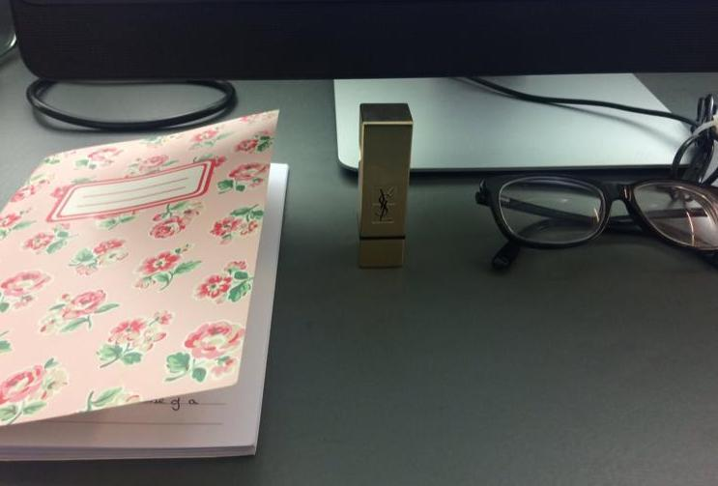Figure 1. An example of the objects used to teach material culture to undergraduates. Image provided by the author.
Given that students might feel that historiography modules ‘detract’ from the ‘real’ historical content in their other modules (where students study, for example, the Spanish Civil War, 1960s Britain, or the Wars of the Roses in great depth), it was important to both demonstrate how these historiographical approaches informed what they and other historians ‘did’ in these areas of historical inquiry, and enabled them to bring resources from other modules that they felt comfortable and familiar with into this class.
This enabling of a two-way process of engagement in and into historiography was key to their exercises, building confidence as experts in their chosen modules and providing them with the sources to put the theories into practice in the seminar itself. This technique enabled students to articulate their findings confidently, because the primary sources they were analysing were not only seen beforehand, but were things that individual students felt that they were more ‘expert’ in – sources from modules from across chronological periods and regions, where they knew the historical context and had perhaps already analysed them in a different context.
Doing so allowed them to present material to other members of the group – examples of texts from 1900s headlines to extracts of medieval hagiography to song lyrics, as well as photographs, film posters, newspaper articles and propaganda pieces relating to gender dynamics – that they felt comfortable and importantly, knowledgeable talking about. Addressing a James Bond film poster from the 1960s in gender week, for example, a student discussed the presentation not just of scantily-clad women and their position in the image as subservient, but the way that the poster presented a specific and potentially ‘traditional’ depiction of masculinity within Hollywood and wider culture. When they understood and could articulate the historical context of each primary source, they were enabled to analyse each piece through the approaches discussed that week.
There is much more research to be done to measure the long-term effectiveness of this practical approach to the historical methods course. In future, I want to take steps to qualitatively and even – if possible? – quantitively calculate the impact that such practical applications has on students, through questionnaires, future results, and their experiences of writing and preparing research projects like their dissertation. For the moment, however, I am happy to see students engaging in theories that so often feel separate from their historical studies in the classroom, in a way that engages them to utilise their skills as historians, as we aim to enable them to put these skills in practice.
Dr Elizabeth Goodwin is a lecturer in Late Medieval and Early Modern history at York St John University. She has previously taught at the Universities of Sheffield (where she did her PhD), Birmingham, Loughborough and York, as well as for the Workers Education Association in Sheffield, gaining her Senior Fellow of the HEA in 2018. Her research interests include the experiences of sixteenth- and seventeenth-century women religious, exile, visual and material culture, and religious history more widely. She was a University of Durham Holland library fellow in 2019, where she explored the communities in exile of Syon Abbey and the English Catholic Church in Portugal.

