Tick-box, weasel words, or a transformative experience? Insights into what educators consider the real impact of HEA Fellowships
Abby Cathcart*ª, Mark Dransfield^{b}, Sarah Floyd^{c}, Lauri-Anne Campbell^{d}, Rachael Carkett^{e}, Vicky Davies^{f}, Ros Duhs^{g}, and Fiona Smart ^{h}
* QUT Academy of Learning and Teaching, Queensland University of Technology, Brisbane, Australia
Contact: Professor Abby Cathcart; abby.cathcart@qut.edu.au; GPO Box 2434, 2 George St, Brisbane Qld 4001 Australia; Abby: http://orcid.org/0000-0001-7003-1273
Conflicts of Interest: Seven of the eight authors lead institutional schemes accredited by Advance HE, and six of the authors are Advance HE consultants or accreditors.

Tick-box, weasel words, or a transformative experience? Insights into what educators consider the real impact of HEA Fellowships
Global membership of the HEA fellowship scheme is increasing. Despite the focus by academic developers on supporting staff to achieve fellowship, there is limited research examining whether it improves teaching and the learning experience. Our detailed survey of educators’ perceptions in the UK and Australia indicate impact on individuals, practice, and community. Importantly for academic developers, the reflective act of developing a fellowship has potential to shape the student learning experience. However, some staff are frustrated and disillusioned by their experience. We call for institutions to design development and recognition that maximises impact and acknowledges the benefits valued by educators.
Keywords: HEA Fellow, Impact, Intangible benefits, Professional Standards Framework (PSF), Reflection, Self-efficacy.

Introduction
Higher Education (HE) is big business, with rapid global growth and competition amongst providers. Teaching quality is ever-more important, shaped by widening participation and demands to demonstrate impact and value. With market expansion comes increased focus on teaching metrics, demonstrated by the Times Higher Education Rankings, the UK Teaching Excellence Framework , and the Australian Quality Indicators of Learning and Teaching (Department of Education, 2019; Office for Students, 2019; Times Higher Education, 2019). Within this context, our research examined the impact of the standards-based Higher Education Academy (HEA) Fellowship scheme, a measure of quality adopted by many universities and academic developers worldwide. This paper reports on the impact of fellowship by analysing data from more than 300 respondents from six different institutions in the UK and Australia.

The Professional Standards Framework (PSF) and HEA Fellowship Scheme
The PSF was developed in 2006 by the HEA, Guild HE, and Universities UK on behalf of the sector (Higher Education Academy, 2011; 2016) to enhance students’ learning experiences by improving the quality of teaching and learning. The 2011 PSF underpins the HEA Fellowship scheme and enables institutions to align development programs to descriptors that articulate teaching and learning standards. In 2018 the HEA became part of a new not-for-profit entity Advance HE (AHE), with the objective of supporting continuous improvement through the development of individuals and organisations (Advance HE, 2019).
The PSF underpins four categories of Fellowship – Associate Fellow, Fellow, Senior Fellow, and Principal Fellow – encompassing roles from an early-career educator (Associate Fellow) through to strategic leaders in learning and teaching (Principal Fellow). Applicants seek recognition through a reflective account of practice (and referee statements) directly to AHE for assessment, or via an accredited institutional pathway. All applications must be written in English. Since 2014 applications have increased exponentially: there are now more than 135,000 HEA Fellows worldwide, and 334 member institutions including 66 outside the UK (see Figure 1). The majority of HEA Fellows are still UK-based and many UK institutions set strategic priorities for achievement of HEA fellowship. In some cases targets were linked to the ultimately unfounded expectation that the UK government’s Teaching Excellence Framework (TEF) would require reporting on this metric. Many institutions chose to include HEA Fellowship in their TEF submissions, and analysis indicated that references to HEA Fellowship were much higher amongst institutions awarded Gold or Silver ratings, compared to those awarded Bronze (Moore et al., 2017). Since 2016 more than two-thirds of Australian universities have joined AHE. The growing global membership is variously motivated, including a desire to raise teaching quality, benchmark academic development, provide recognition, and develop indicators to support recruitment, performance, and promotion (Beckmann & Cathcart, 2019; Smart et al., 2019).

[Insert Figure 1]

Interrogating the use and value of HEA Fellowship
Our systematic literature review identified 94 articles directly referencing HEA Fellowship since 2011. Researchers have focused on a range of recognition methods, including dialogues, peer observation, and reflective writing (Asghar & Pilkington, 2018; Daniels, 2017; Smart et al., 2019). Others have examined taught pathways, such as Graduate Certificates, new educator inductions, or continuing professional development (CPD) frameworks (Butcher & Stoncel, 2012; Fraser et al., 2019; Fung, 2014). More recently, researchers have focused on the inclusive nature of the PSF, examining its applicability to diverse cultures or as part of decolonising the curriculum (Buissink et al., 2017; Duhs et al., 2019). Others have examined the experience of particular groups, including professional staff, librarians, PhD students, and sessional/casual educators (George & Rowland, 2019; Greer et al., 2016). A recent study of academics in China and the Hong Kong Special Administrative Region for example, concluded that recognition compounded the impact of an academic development program and had the potential to accelerate sector-wide strategic change (Greer et al., 2020). A small number of studies have examined the relationship between HEA Fellowship, teaching qualifications, student satisfaction, and outcomes in the UK TEF (Barkas et al., 2019; Bell & Brooks, 2019).
Despite the proliferation of research, much of the focus has been on individual UK-based institutions, or on narrow categories of staff. Increasingly, scholars have called for research to focus on the international community to incorporate a broader conceptualisation of impact (Bamber & Stefani, 2016; Spowart et al., 2019; Turner et al., 2013).

Methodology
The collaborative study comprises partners from five UK (England, Scotland, and Northern Ireland) and one Australian university. Institutions represented a range of mission groups, all having well-established HEA accredited routes to fellowship, using certified and CPD pathways. All routes were, naturally shaped by their institutional context, but shared features including reflection on practice, engagement with the scholarly evidence base, and addressing the PSF dimensions of practice (see Table 1).
[Insert Table 1]

A survey was used to gather quantitative and qualitative responses from educators who had gained recognition through institutional routes in the three preceding years. The research explored participants’ perceptions of how fellowship had impacted on themselves, their peers, and their students. A broad conceptualisation of impact was used, building on constructs previously identified including self-efficacy, networks and community, and personal or institutional change (Kneale et al., 2015; PedRio, 2016). The research focused on staff perceptions of impact, but also encouraged reflection on students’ perceptions thereof. Open questions and free text responses elicited detailed answers which enabled a shift beyond narrow impact metrics (Spowart et al., 2019) to instead uncover intangible assets valued by HE educators which are not easily measurable or quantifiable (Robertson et al., 2019). The research had ethical approval and data collection was undertaken in 2017.

Survey design
The survey was developed iteratively, drawing on constructs in the HEA CPD evaluation resource (Kneale et al., 2015; PedRio, 2016) and incorporating questions on motivation, pathway, and the perceived impact of recognition. Respondents also provided demographic information, including gender, fellowship status, the route to fellowship, and educator experience. Quantitative questions used a five-point Likert scale from strongly agree to strongly disagree (5–1); open-text responses enabled respondents to define impact in ways of their choosing, including in relation to intangibles. The survey concluded by asking for any negative consequences from engaging with the fellowship process.

Sample
The survey was developed in Survey Monkey. Email invitations (with a reminder 2 weeks later) were distributed by institutional leads to all staff who had gained fellowship during the three preceding years. Response rates to web surveys are commonly lower than other survey modes with wide variation in response rates used in published studies (Fan & Yan, 2010; Nulty, 2008). Response representativeness is more important than response rate alone, and our sample is representative of the broader demographics of the fellowship population regarding gender, job type, and fellowship category. In total 331 surveys were returned (an overall response rate of 25%), which compares well to those of related studies (Spowart et al., 2017). Table 2 details the sample size and response rates.
[Insert Table 2]

Data analysis
Analysis of quantitative data yielded descriptive statistics to highlight broad trends which provided the focus for more nuanced qualitative analysis using open-text data.
Initial coding of qualitative data provided the a priori analytic categories consistent with the research questions: motivation and impact. Axial and selective coding techniques using NVivo 10 were applied to systematically analyse data, identify emergent themes, and generate a thick description of the dimensions of impact (Corbin & Strauss, 2008). To achieve theoretical saturation, data analysis was recursive: themes underwent constant comparison through wider research team discussion to confirm interrater reliability (Silverman & Marvasti, 2008).

Results
Here we report and discuss the results of our data analysis relating to educator perceptions of the impact of the PSF and fellowship scheme.

Demographics
Participants broadly reflected the demographics of the wider fellowship and HE community in that there were more women than men (66%), and the majority had worked in the sector for over 5 years (74%). A total of 21% had held fellowship for less than six months and 16% for more than two years. The sample represented all four fellowship categories and broadly mirrored wider fellowship populations. Data relating to ethnicity were not collected. Table 3 provides full demographic details.
[Insert Table 3]

Survey respondents self-designated their learning and teaching role, the majority (62%) selecting ‘traditional academic’ or ‘teaching-focused academic’. Of note are the percentages of ‘learning support’ (9%), ‘administrative’ (5%), and ‘technical’ (2%) respondents, highlighting a shift to the wider range of roles supporting HE learning.
Most respondents achieved fellowship through an experiential institutional scheme (69%), with fewer undertaking taught courses (24%). Over half had produced a written application (57%), and significant numbers had engaged in oral assessment (29%), reflecting sector-wide diversification through contextualised approaches to recognition (Smith, 2018).

Impact on self, practice, and peers
Our analysis of the data indicates multiple ways in which educators perceive fellowship impacts on their sense of self, practice and community. This includes 1) enhanced sense of self-efficacy and professional identity, 2) a reframing of work as scholarly, 3) career development, 4) use of innovative/effective methods, and 5) connection to a network of people who value teaching.

Self-efficacy and professional identity
Self-efficacy is defined as ‘people’s judgements of their capabilities to organise and execute courses of action required to attain designated types of performances’ (Bandura, 1986, p. 391). It has long been associated with examining the impact of professional development because of the relationship between belief in capabilities and persistence, effecting actual behavioural change and improvements to teaching quality (Greer et al., 2016). Seventy per cent of participants indicated that achieving recognition increased their confidence. For some, the use of a professional standard enhanced confidence:
… it is especially helpful for those moving into academia from industry; and, it is encouraging to feel that you are meeting the appropriate professional standards. (Male, Teaching-focused academic, FHEA, UNI-B)

For others, confidence came through a feeling of validation and fit within the university, and of being accepted by a community of peers. "Imposter” syndrome within HE is well-documented (Parkman, 2016), and several respondents cited fellowship as an affirmation of belonging:
Many of the things that I just 'do' I thought were standard things that everyone would 'do', but since obtaining fellowship, many colleagues have sought mentoring from me to develop their skills and capacities in the areas that I previously thought were pretty standard and normal. (Female, Traditional academic, FHEA, UNI-C)
In particular, the importance of being judged as ‘belonging’ was significant for staff in non-traditional academic roles:
Being a fellow, I believe helps 'normalise' our research degree students within the broader student community …my fellowship allows me to situate my role (as a researcher developer) in a broader teaching and learning environment. (Female, Educational/staff developer, SFHEA, UNI-B)

Engagement with the scholarly evidence base for learning and teaching
The second major impact of recognition was deeper engagement with the scholarship. This supports the notion of the scholarship of teaching and learning (SOTL) as ‘authentic practice’ for professional educators (Kreber, 2013). Engagement with SOTL can shape reflection on practice and empower educators to resolve challenges (Boyer, 1990). Most participants (78%) indicated that fellowship had led them to engage with the scholarly evidence base and, for some this was a new experience:
I was quite new to academic teaching … and had followed an instinctive approach rather than a pedagogical one. However, I found much of my thinking resonated with the literature, and that gave me confidence alongside peer review of my teaching practice. (Male, Teaching-focused academic, FHEA, UNI-B)

For others, fellowship was an opportunity to reconnect with literature:
It prompted me to revisit some literature that I hadn't looked at for a while, and this sharpened my focus when planning workshops and other learning events for staff. (Female, Learning support role, SFHEA, UNI-C)

Several commented poignantly on their sense of disconnect from the academic community and scholarly evidence, and the surprisingly positive impact that achieving fellowship had:
While I was not happy to have to do this after having taught for more than 20 years …it did help me remember what was important in my teaching, and made me aware of interesting new developments (e.g. concerning assessment). (Female, Traditional academic, FHEA, UNI-D)
Above all, participants talked about feeling empowered by using literature to find solutions to challenges encountered in practice. One noted, ‘I had no idea of pedagogy beforehand’ (Male, Traditional academic (blend of teaching/research and administration), FHEA, UNI-F), while another noted:
I now try to take a more evidence-based approach ... Previously, I would work on a mixture of experience and intuition. Now, I look to the literature first. (Male, Learning support role/Educational staff developer, FHEA, UNI-D)

Careers
Almost half the participants (47%) stated that fellowship had impacted positively on their career, reflecting the growing number of institutions aligning fellowship with promotion (Greer et al., 2021). Participants suggested fellowship helped in a range of ways, including promotion, probation, advancement (in non-academic roles), and award nominations:
It has been one of the most important selling points on my CV just after my PhD. (Male, Traditional academic, FHEA, UNI-F)

I have received [a] promotion, which I might have done anyway, but it helped. (Female, Traditional academic, SFHEA, UNI-A)
Some noted the emergent sector focus on fellowship as a hurdle to employment, reflecting a sense that recognition has become an important form of currency:
It has been a condition of job offers that I have [an] HEA fellowship. (Female, Traditional academic, SFHEA, UNI-B)

Not having [an] SFHEA was proving a barrier for some work with other institutions … (Male, Educational/staff developer, SFHEA, UNI-F)
For others, the impact on career was less tangible; however, in the Australian institution 61% of participants stated that it had helped their career. We surmise that this may reflect the relative newness of the PSF to the Australian sector and the fact that being a fellow in Australia is less common than in the UK:
It gave me visibility with senior staff (as SFHEA was rare at the time), wonderful supporting comments to use in a promotion application, and confidence that a weakness in my academic practice had been overcome. (Female, Traditional academic, SFHEA, UNI-C)

There were, however, criticisms and some expressed disappointment when recognition did not lead to promotion. Again, these were more prevalent in the UK-based institutions, with 16.2% disagreeing that fellowship had helped their career, compared to 10% from the Australian institution. Some questioned the authenticity of the process which they saw as a rhetorical exercise:
I worry it is a process very sensitive to people who are able to inflate their contributions with lots of weasel words. (Female, Research-focused academic, SFHEA, UNI-D)

This may reflect an emergent disillusionment particularly in institutions where fellowships form performance targets and staff are under pressure to achieve recognition:
Was told to get it in order to help my promotion case, at the end (after I got it) was told it didn't matter. (Female, Traditional academic, SFHEA, UNI-D)

…it has not given me any opportunities at all. It was not valued for promotion and not for leadership positions in the department. (Female, Traditional academic, SFHEA UNI-A)

Impact on practice and the student learning experience
Although fellowship often represents one strand within institutional approaches to enhancing students’ learning experiences, our results highlight a number of practical ways in which recognition impacted on practice. The impact on students remains an important but underexplored research area, despite being a primary concern of academic developers (Bell & Brooks, 2019). Our analysis indicates a number of ways in which fellowship impacts on practice with students.
The majority of respondents (82%) stated that the process of applying for fellowship had deepened their understanding of practice, including enhanced academic writing, improved reflection, and the use of new teaching methods. Many noted that changes to their practice were shaped by exposure to new pedagogy through taught components of the fellowship pathway.
…we were asked to formulate lesson plans/approaches for a variety of topics/experiences, deliver the session, gain feedback from students and peer observers... These methods still form the basis for my current teaching. (Female, Teaching-focused academic, FHEA, UNI-B)

For some, changes to practice came from the reflective act of recording and writing about their work, a process that forced them to stop and ask ‘why?’:
There can be no doubt that having to think hard and record one's teaching practices over many years helps to identify the essential factors in good practice and reinforces them. (Male, Part-time teacher (hourly paid role), FHEA, UNI-A)

Significantly, for some, the application process reminded them of the student perspective, prompting a more thoughtful and empathetic approach to practice:
It reinforced the iterative nature of the reading and writing process; the value of tutor feedback and of listening to the questions and difficulties experienced by others … as well as in carving out space and time to get writing done. (Female, Learning support role, FHEA, UNI-A)
Over three quarters of participants (78%) stated that the process had influenced their own approach to teaching, confirming that the pathway to developing an application for recognition has an important impact on practice. Participants described a new confidence in exploring innovative approaches to support learning; others drew on their emerging knowledge of pedagogy:
I wouldn't be able to mention any dramatic changes; it is more a matter of becoming more aware and consistent and thoughtful about things I already did sometimes – for example, in giving feedback that students can really 'hear'. (Female, Traditional academic, FHEA, UNI-F)
A number noted that the process led them to reconceptualise their students as partners in learning rather than passive recipients. This was shaped by exposure to the PSF, reminding them that student-centredness is at the heart of effective practice:
It has also encouraged me to simplify the language I use and to seek more feedback from students, not least that they have understood points made or instructions given. (Male, Teaching-focused academic, FHEA, UNI-A)
This shift was also evident in responses to questions about the impact on learners. Some talked about the affirming experience of reflection on practice, noting the challenges but, ultimately, emphasising its value in shaping their student-facing practice:
… I was encouraged to think about studentship, understanding the question, etc., but most importantly, [it] helped me to sympathise with student workloads and deadlines. Reflecting on teaching practice is crucial in understanding what works and what doesn't. (Female, Teaching-focused academic, SFHEA, UNI-E)
Significantly, the professional values within the PSF were clearly seen as shaping staff engagement with students, and, for some, this had a profound impact:
I found them [the dimensions of practice] intuitive and clarifying, on the whole. For example, those on inclusive teaching are important reminders to check habitual practices that might disadvantage some students. (Female, Traditional academic, FHEA, UNI-F)
Others saw fellowship as symbolically significant, giving students confidence in institutional teaching quality:
This allows the university to confidently state that their academic staff are focused on students. (Female, Teaching-focused academic, SFHEA, UNI-C)
Negative perceptions of HEA Fellowship
Not all participants were positive about the impact of fellowship on their practice, and 19% indicated negative consequences (14% in Australia). Some noted that it had actually taken them away from core work:
If anything, it impacted the learning experience of my students negatively – the time spent engaging with the fellowship process could have been time spent thinking about things that would have really made a difference to the students. (Male, Traditional academic, FHEA, UNI-A)

It was a huge drain on my time that necessarily impacted on my teaching… at one point, I had to cancel a class to undertake this activity. (Male, Traditional academic, FHEA, UNI-E)
Others commented on the curious disconnect between the fellowship application process and the student body, questioning whether students were aware of or cared about fellowship:
I have difficulty imagining why they would know or be interested in this. (Female, Research-focused academic/Part-time teacher, FHEA, UNI-B)

Impact on peers and a sense of belonging to a community of educators
Almost half (47.2%) of participants stated that the recognition process had led to engagement in new networks. This highlights the potential impact of the fellowship process in brokering new professional relationships and expanding the usual ‘significant networks’ drawn on in educational practice (Roxå & Mårtensson, 2009, p. 556):
As my tacit knowledge became more explicit… I grew in confidence in the classroom. I knew that a lot of the students liked what I did, but it was good to talk to colleagues about it. We don't do enough of that. (Male, Traditional academic, SFHEA, UNI-B)
Some asserted the positive impact of the fellowship process on practice was rooted in their sense of belonging to a supportive community of practice (Wenger, 2000):
A badge can't improve confidence. The support and encouragement of colleagues and support of the organisation for REAL career long[-term] development is the only way to do that. (Male, Learning support role/Technical, FHEA, UNI-A)
Several participants highlighted the enduring nature of the networks created through the process whose perceived benefits clearly continued after the award of fellowship.

Discussion and Conclusions
Our analysis shows that for university educators the process of applying for and gaining HEA Fellowship impacts on their sense of self, their practice, and their sense of belonging to a broader community of educators. Significantly for academic developers, much of the meaningful impact identified resulted from the process of developing a fellowship application through a combination of exposure to a scholarly evidence base, deep reflection on practice, and structured alignment with the PSF. The model below articulates this relationship between reflection and the transformation of self, practice, and peers, with the potential to shape the student learning experience.
[Insert Figure 2]
University educators are time-poor, and under pressure to deliver against competing demands. In this context, time spent on fellowship must add value for them and their students. The institutional context shapes how staff perceive and respond to fellowship, and, as noted elsewhere, ‘some staff feel pushed to achieve recognition’ (Spowart et al., 2019, p. 1299). Our analysis points to the complex relationship that many have with HEA Fellowship, and the frustration and disappointment experienced when recognition does not deliver the anticipated benefits.
It is clear from our analysis that connection with the community, peer engagement, and support are central to maximising the gains from the fellowship experience. This has important implications for institutions that may seek to separate academic development from recognition processes, and make fellowship an individual endeavour, rather than a collegial process. The developmental potential of engaging in this largely self-reflective exercise is augmented when the impact is understood as inextricably linked to relationships with others, and a platform for ongoing collegial networks and development.
Central to enhanced self-efficacy was the reflective process underpinning fellowship applications, and that this reflection on practice made the experience meaningful. This is an important finding, confirming for academic developers the key role of reflection on practice within professional learning. Confidence levels were not objectively substantiated; however, previous research clearly aligns self-reported confidence levels with enhanced persistence, performance, and innovation (Bandura, 1986; Greer et al., 2016). Above all, our findings point to a role for academic developers in supporting reflective practice that moves fellowships beyond a performative exercise. The power of the PSF lies not in the award (although clearly valued) but, in its enduring impact on practice:
The reflection that is undertaken [for fellowship] was at a depth and intensity that is unsustainable over a longer period. You had to make time to give it attention because it was being assessed. Once that imperative is removed then the impetus is reduced. However, the residual flavour is left behind, and the insights gained remain with you. (Female, Traditional academic, SFHEA, UNI-B)
A limitation of this paper is the absence of student perceptions of the impact of fellowship on their learning experience. Although the article extends the UK-centric focus of previous research by incorporating an Australian perspective, it nevertheless retains an Anglocentric viewpoint. Furthermore, while highlighting widespread self-reported impact, identification of sustained change requires a longitudinal study. In light of recent attention to decolonising the curriculum, and the growth in fellowships outside the UK, these are important areas for future research.
From the results, the PSF and HEA Fellowship scheme impact positively on higher education in a range of ways. Fellowships introduce staff to the scholarly evidence base, create a sense of community, promote teaching standards, and shape confidence and innovative practice. However, institutions may be failing our staff and students by reducing the rich, complex, reflective act of recognition to a metric-driven, tick-box exercise. The view of fellowship, as a formulaic exercise in weasel words and compliance, is misplaced. However, academic developers must highlight the multifaceted benefits of fellowship schemes encompassing stronger academic self-efficacy, deeper connections to peers and scholarship, and, above all, a rich reflective stance, which stimulates a focus on student learning.
Spowart et al. (2017, p. 369) acknowledge that ‘measuring impact is challenging’ and evaluation is ‘poorly conceptualised and understood across the sector’. Our study moves beyond post-event feedback sheets to a nuanced approach capturing reflections on the fellowship experience, subsequent changes to practice and potentially the students’ experience. Impact is shaped by an institutional context where engagement with the PSF is just one strand of a strategy pursuing educational excellence.
Given the widespread engagement with HEA Fellowship, the paucity of research on its efficacy is surprising, and it is hoped that this study will encourage further interrogation incorporating student perceptions, and insights from culturally and linguistically diverse members. Fellowships can be a powerful force for change within HE, but only if we look beyond metrics.

Abby Cathcart ª is a Professor of Higher Education Governance, and Director of the Queensland University of Technology Academy of Learning and Teaching, Australia. She is a Principal Fellow of the Higher Education Academy (HEA), and an Advance HE Strategic Advisor (Australasia).
Mark Dransfield ^{b} is a Senior Lecturer in Academic Practice at York St John University, UK. He is a Senior Fellow of the HEA and an institutional lead for Advance HE accredited provision.
Dr Sarah Floyd ^{c} is a Reader in Higher Education Practice in the Centre for Higher Education Research and Practice at Ulster University. She is a Principal Fellow of the HEA, an institutional lead for Advance HE accredited provision, and an Advance HE Accreditor.
Lauri-Anne Campbell ^{d} is a Research Assistant at Edinburgh Napier
Dr Rachael Carkett ^{e} is a Senior Academic Staff Developer at the University of Bath, UK. She is a National Teaching Fellow, HEA Principal Fellow, Senior Fellow SEDA, and Advance HE Accreditor.
Vicky Davies ^{f} is a Lecturer in Higher Education in the Centre for Higher Education Research and Practice at Ulster University. She is a Principal Fellow of the HEA, an institutional lead for Advance HE accredited provision, and an Advance HE Accreditor.
Dr Rosalind Duhs ^{g} is a Principal Teaching Fellow at the Arena Centre for Research-Based Education, University College London (UCL). She is a Principal Fellow of the Higher Education Academy and an Advance HE Accreditor.
Dr Fiona Smart ^{h} is an Associate Professor in Learning and Teaching and Head of the Department of Learning and Teaching Enhancement at Edinburgh Napier. She is a Principal Fellow of the HEA and an Advance HE Accreditor.

References
Advance HE. (2019). We are Advance HE. https://www.advance-he.ac.uk/about-us#More
Asghar, M., & Pilkington, R. (2018). The relational value of professional dialogue for academics pursuing HEA fellowship. International Journal for Academic Development, 23(2), 135-146. https://doi.org/10.1080/1360144X.2017.1386566
Bamber, V., & Stefani, L. (2016). Taking up the challenge of evidencing value in educational development: From theory to practice. International Journal for Academic Development, 21(3), 242-254. doi:10.1080/1360144X.2015.1100112
Bandura, A. (1986). Social foundations of thought and action: A social cognitive theory. Prentice-Hall.
Barkas, L. A., Scott, J. M., Poppitt, N. J., & Smith, P. J. (2019). Tinker, tailor, policy-maker: Can the UK government’s teaching excellence framework deliver its objectives? Journal of Further and Higher Education, 43(6), 801-813. https://doi.org/10.1080/0309877x.2017.1408789
Beckmann, E. A. & Cathcart, A. (2019). Institutional strategies for developing postgraduate research students’ teaching and communication capabilities. In F. F. Padró, R. Erwee, M. Harmes, & P.A. Danaher (Eds.), Postgraduate education in higher education. Springer. https://doi.org/10.1007/978-981-10-0468-1_1-1
Bell, A. R., & Brooks, C. (2019). Is there a ‘magic link’ between research activity, professional teaching qualifications and student satisfaction? Higher Education Policy, 32(2), 227-248. https://doi.org/10.2139/ssrn.2712412
Boyer, E. L. (1990). Scholarship reconsidered: Priorities of the professoriate. Carnegie Foundation for the Advancement of Teaching.
Buissink, N., Diamond, P., Hallas, J., Swann, J., & Sciascia, A. D. (2017). Challenging a measured university from an indigenous perspective: Placing 'manaaki' at the heart of our professional development programme. Higher Education Research & Development, 36(3), 569-582. https://doi.org/10.1080/07294360.2017.1288706
Butcher, J., & Stoncel, D. (2012). The impact of a postgraduate certificate in teaching in higher education on university lecturers appointed for their professional expertise at a teaching-led university: 'It's made me braver'. International Journal for Academic Development, 17(2), 149-162. https://doi.org/10.1080/1360144X.2011.620107
Cook, C., Heath, F., & Thompson, R. L. (2000). A meta-analysis of response rates in web- or internet-based surveys. Educational and Psychological Measurement, 60(6), 821-836. https://doi.org/10.1177/00131640021970934
Corbin, J., & Strauss, A. (2008). Basics of qualitative research (3rd ed.). Sage Publications.
Daniels, J. (2017). Professional learning in higher education: Making good practice relevant. International Journal for Academic Development, 22(2), 170-181. https://doi.org/10.1080/1360144X.2016.1261352
Department of Education. (2019). Quality indicators for learning and teaching. https://www.qilt.edu.au/
Duhs, R. M., Evans, J., Williams, P., & Chaudhury, P. (2019). The early impact of initiatives to close attainment gaps at UCL. Compass: Journal of Learning and Teaching, 12(1). https://doi.org/10.21100/compass.v12i1.1026
Fan, W., & Yan, Z. (2010). Factors affecting response rates of the web survey: A systematic review. Computers in Human Behavior, 26(2), 132–139. https://doi.org/10.1016/j.chb.2009.10.015
Fraser, K., Ryan, Y., Bolt, S., Copeman, P., Cottman, C., Fisher, M. B., Fleming, J., Luzeckyj, A. (2019). Contemporary induction to teaching in Australian universities. International Journal for Academic Development, 24(3), 286-300. https://doi.org/10.1080/1360144X.2019.161275
Fung, D. (2014). It's all about 'us': Lessons learned from running an accredited CPD framework. Educational Developments, 15(2), 8-10.
George, S., & Rowland, J. (2019). Demonstrating the impact of your teaching: Benefits of Higher Education Academy Fellowship for librarians. Health Information & Libraries Journal, 36(3), 288-293. https://doi.org/10.1111/hir.12272
Greer, D. A., Cathcart, A., & Neale, L. (2016). Helping doctoral students teach: Transitioning to early career academia through cognitive apprenticeship. Higher Education Research & Development, 35(4), 712-726. https://doi.org/10.1080/07294360.2015.1137873
Greer, D. A., Cathcart, A., & Swalwell, G. (2021). Compounding the impact of teaching development programs in China and Hong Kong SAR: Using the Professional Standards Framework to deepen learning and improve teaching self-efficacy. International Journal for Academic Development. https://doi.org/10.1080/1360144X.2021.1878032
Higher Education Academy. (2011). The UK Professional Standards Framework for teaching and supporting learning in higher education (UKPSF). https://www.heacademy.ac.uk/system/files/downloads/UKPSF_2011_English.pdf
Higher Education Academy. (2016). UKPSF Terms of Use Policy. https://www.heacademy.ac.uk/sites/default/files/downloads/ukpsf_terms_of_use_policy_april_2016_0.pdf
Kneale, P., Winter, J., Turner, R., Spowart, L., Hughes, J., McKenna, C., & Muneer, R. (2015). Evaluating teaching development activities in higher education: A toolkit. https://www.heacademy.ac.uk/knowledge-hub/evaluating-teaching-development-higher-education
Kreber, C. (2013). The transformative potential of the scholarship of teaching. Teaching and Learning Inquiry, 1(1), 5-18.
Moore, J., Higham, L., & Sanders, J. (2017). Evidencing teaching excellence: Analysis of the Teaching Excellence Framework (TEF2) provider submissions. Higher Education Academy. https://www.advance-he.ac.uk/knowledge-hub/evidencing-teaching-excellence
Nulty, D. D. (2008). The adequacy of response rates to online and paper surveys: What can be done? Assessment & Evaluation in Higher Education, 33(3), 301-314.
Office for Students. (2019). The Teaching Excellence and Students Outcomes Framework. https://www.officeforstudents.org.uk/media/0c6bd23e-57b8-4f22-a236-fb27346cde6e/tef_short_guide_-june_2019_final.pdf
Parkman, A. (2016). The imposter phenomenon in higher education: Incidence and impact. Journal of Higher Education Theory and Practice, 16(1), 51-60.
PedRio. (2016). HEA CPD Toolkit. https://www.plymouth.ac.uk/research/institutes/pedagogic/toolkit-2
Robertson, A., Cleaver, E., & Smart, F. (2019). Beyond the metrics: Identifying, evidencing and enhancing the less tangible assets of higher education. https://www.enhancementthemes.ac.uk/evidence-for-enhancement/defining-and-capturing-evidence/the-intangibles-beyond-the-metrics
Roxå, T., & Mårtensson, K. (2009). Significant conversations and significant networks – exploring the backstage of the teaching arena. Studies in Higher Education, 34(5), 547-559. https://doi.org/10.1080/03075070802597200
Silverman, D., & Marvasti, A. (2008). Doing qualitative research: A comprehensive guide. Sage Publications.
Smart, F., Asghar, M., Campbell, L.-A., & Huxham, M. (2019). Electing to speak: Professional dialogue in the context of Fellowship of the Higher Education Academy. International Journal for Academic Development, 24(3), 232-245. https://doi.org/10.1080/1360144X.2019.1585356
Smith, L. (2018). Annual review of Advance HE accredited CPD schemes 2017-18. https://www.heacademy.ac.uk/download/annual-review-advance-he-accredited-cpd-schemes
Spowart, L., Winter, J., Turner, R., Muneer, R., McKenna, C., & Kneale, P. (2017). Evidencing the impact of teaching-related CPD: Beyond the ‘Happy Sheets’. International Journal of Academic Development, 22(4), 360-372.
Spowart, L., Winter, J., Turner, R., Burden, P., Botham, K. A., Muneer, R., van der Sluis, H., & Huet, I. (2019). ‘Left with a title but nothing else’: The challenges of embedding professional recognition schemes for teachers within higher education institutions. Higher Education Research & Development, 38(6), 1299-1312. https://doi.org/10.1080/07294360.2019.1616675
Times Higher Education. (2019). The world university rankings 2020: Methodology. https://www.timeshighereducation.com/world-university-rankings/methodology-world-university-rankings-2020
Turner, N., Oliver, M., McKenna, C., Hughes, J., Smith, H., Deepwell, F., & Shrives, L. (2013). Measuring the impact of the UK Professional Standards Framework for Teaching and Supporting Learning (UKPSF). https://www.advance-he.ac.uk/knowledge-hub/measuring-impact-uk-professional-standards-framework-teaching-and-supporting-learning
Wenger, E. (2000). Communities of practice and social learning systems. Organization, 7(2), 225-246. https://doi.org/10.1177/135050840072002

Figure 1. Growth of fellowships globally. Source: Advance HE, August 2020 {used with permission}

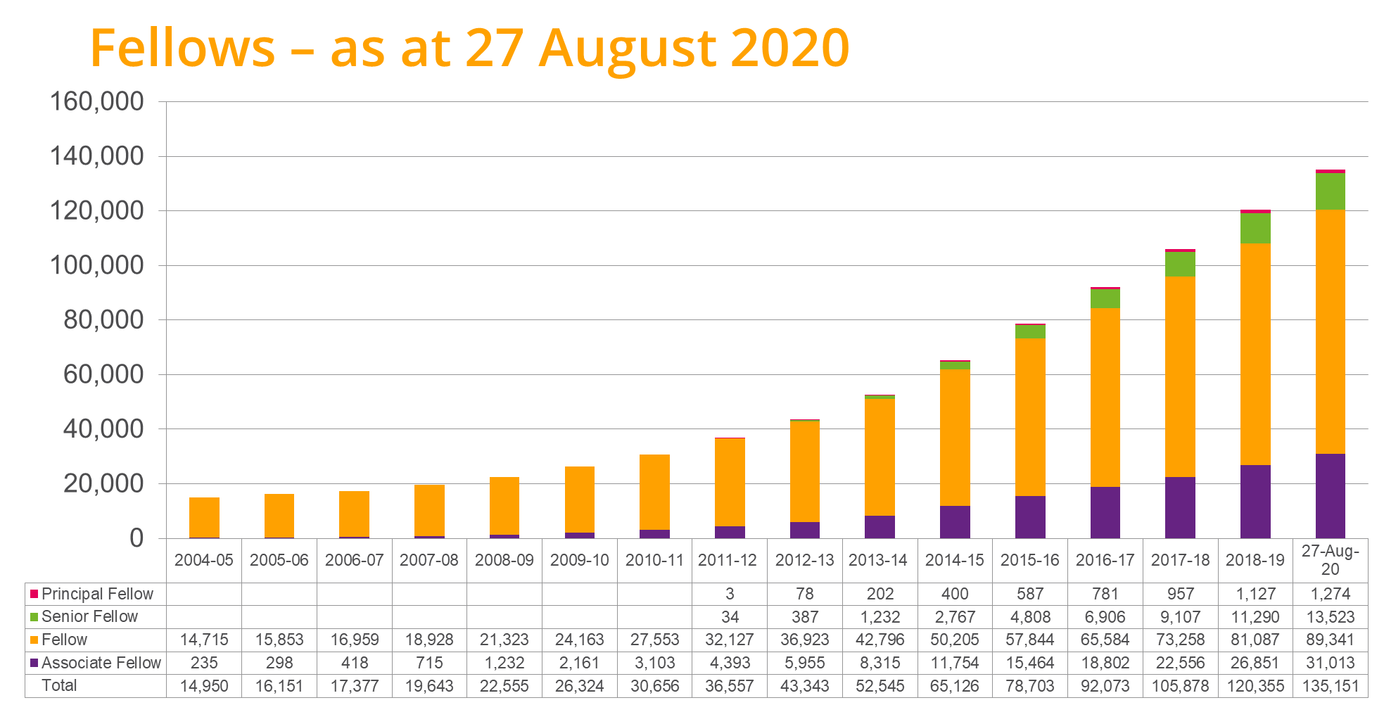

Figure 2. Perceptions of the impact of fellowship on the student experience.

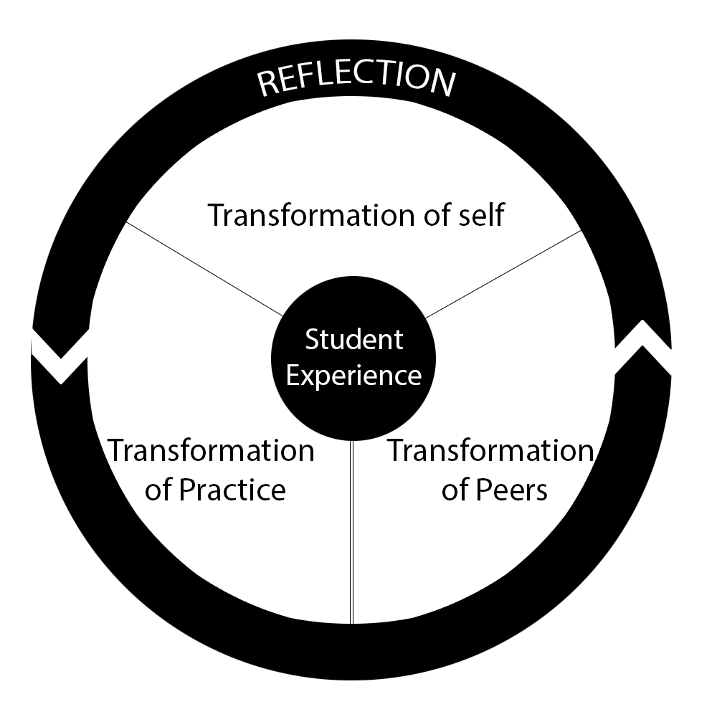

Table 1. Participating institutions.

Institution | Nature of institution | Number of academic staff | Accredited provision since | Accredited fellowship categories | Accredited taught pathway to fellowship
UNI-A | UK; medium-sized 1966 university with a reputation for excellence in teaching and research. | <1000 | 2013 | D1–D3 | D1–D2
UNI-B | UK; post-1992 public university with an international reputation for graduate employability. | < 1000 | 2013 | D1–D4 | D2
UNI-C | Australia; large public university with a strategic focus on real-world learning and research. | > 2000 | 2015 | D1–D4 | D1–D2
UNI-D | UK; large Russell Group university; highly ranked for research and committed to research-based education. | > 4000 | 2014 | D1–D4 | D1–D2
UNI-E | UK; large, distributed, pre-1992, university; mission is academic excellence and civic engagement. | < 1000 | 2013 | D1–D4 | D1–D2
UNI-F | UK; small post-1992 university, mission to inspire students. | 300 | 2012 | D1–D4 | D2

Table 2. Response rates.

Demographics |  | Percentage
Gender:
Female  Male |  | 66.0%  34.0%
Time teaching/supporting learning in HE:
Less than 3 years  3–5 years  More than 5 years |  | 9.7%  16.7%  74.2%
Fellowship category:
Associate Fellow  Fellow  Senior Fellow  Principal Fellow |  | 19.8%  42.9%  33.7%  3.6%
Length of time since recent fellowship:
Less than six months  Six months to 1 year  1–2 years  More than 2 years |  | 21.0%  27.4%  35.6%  16.1%
Route taken:
Taught  Experiential Institutional Scheme |  | 23.7%  68.7%  7.6%
Previous fellowship:
Associate Fellow  Fellow  Senior Fellow  None |  | 7%  16%  2%  75%

Table 3. Profile of survey participants.

Demographics |  | Percentage
Gender:
Female  Male |  | 66.0%  34.0%
Time teaching/supporting learning in HE:
Less than 3 years  3–5 years  More than 5 years |  | 9.7%  16.7%  74.2%
Fellowship category:
Associate Fellow  Fellow  Senior Fellow  Principal Fellow |  | 19.8%  42.9%  33.7%  3.6%
Length of time since recent fellowship:
Less than six months  Six months to 1 year  1–2 years  More than 2 years |  | 21.0%  27.4%  35.6%  16.1%
Route taken:
Taught  Experiential Institutional Scheme |  | 23.7%  68.7%  7.6%
Previous fellowship:
Associate Fellow  Fellow  Senior Fellow  None |  | 7%  16%  2%  75%

