Ephemeral and Eternal Images:
Deleuze, the Time-Image and Montage in the Films of Terrence Malick

James Lorenz
University of Oxford

In his seminal dual volume work on the cinema, the French philosopher Gilles Deleuze traces a shift in the cinematic image, where “the movement image of the so-called classical cinema gave way, in the post-war period, to a direct time-image.” A direct time-image, for Deleuze, is an image where time itself becomes the substance of the film image – rather than movement or action. This definition needs to be unpacked much further (which is the task of the very first section of this chapter), but by way of introduction it is helpful to understand Deleuze’s project in terms of the historical shift he perceives from ‘movement-image’ to ‘time-image’ – the respective subtitles of his two volumes on cinema. This shift, roughly demarcated by the end of the Second World War and anticipated by the films of Yasujirō Ozu, Fritz Lang, and others, represents the collapse of the sensory-motor schema inherent to the movement-image and action-image, such that time begins to appear for itself as the substance of the film image and not only in relation to movement. In other words, the conventional cinematic image, in which time is derived from the rational continuity between perception and movement, gives way to a direct time-image, where movement becomes subordinate to time.

Since Deleuze’s project, many filmmakers have continued creating in the mode of the time-image, and few have done so more fascinatingly than Terrence Malick. While many filmmakers have developed their work through enduring still life cinematography (in the style of Ozu), or through deliberately protracted long takes (in the style of Tarkovsky), the time-image is realised in Malick’s films not only through the long take and the static frame, but also through montage and ephemerality; through the transitory flow of his visuals and his soundscapes. If the genre of slow cinema, epitomised by the work of directors like Béla Tarr or Theo Angelopoulos, represents one extension of the time-image in contemporary film, then perhaps the ephemeral style so often adopted by Malick represents another. Where slow cinema seeks to protract and retard time, Malick so often works through compression and elision, layering time upon time in his anachronic montages.

Moreover, Malick’s style is engaged thematically with a philosophical focus on time, uncovering the ontological and existential structures of our temporality. In exploring these structures, Malick holds in tension the ephemerality of our existence with the permanent conditions of being and time itself. Whether through the interpersonal encounters and relationships of films like Badlands (1973) and Days of Heaven (1978), or through the dreamscapes and mnemonic fugues in The Tree of Life (2011) and The Thin Red Line (1998), Malick’s cinematic images seem to navigate a philosophical and theological tension between transience and permanence; between the ephemeral and the eternal.

This chapter will explore the temporality of Malick’s films in this way, first by outlining Deleuze’s concept of the time-image and then by exploring how the time-image manifests in Malick’s oeuvre. In doing so, I will examine Malick’s cinematographic techniques in close detail, focussing primarily on his particular use of montage, which is often accompanied by the anaphora of certain visual and musical leitmotifs, as well as by his own idiosyncratic use of voiceover. The latter of these, in particular, leads to a vital connection between time and memory, through which film appears as a technology of memory; that is, as τεχνη (technē), as mnemonic craft and art. I will suggest that Malick’s films often manifest the time-image through the use of anachronic montage, creating an impression of time itself as an eternal condition of being in the world through the ephemeral and elided passage of these sequences.

1. DELEUZE, BERGSON, AND THE TIME-IMAGE

What is a time-image? What does Deleuze mean when he writes esoterically about cinematic images which subordinate movement to time, and in which time appears for itself, as the primary substance of the image? Definitive answers to these questions are elusive throughout the pages of Cinema II: The Time-Image, but Deleuze comes very close to offering some kind of definition or explanation in the ‘Preface to the English Edition’ of the book:

In any case, what we call temporal structure, or direct time-image, clearly goes beyond the purely empirical succession of time – past-present-future. It is, for example, a coexistence of distinct durations, or of levels of duration; a single event can belong to several levels: the sheets of past coexist in a non-chronological order.

So, first and foremost, a direct time-image cannot be reduced to the empirical notion of linear time, which is a spatial metaphor that is conceptualised as succession (past moments are succeeded by present moments which in turn are already being succeeded by coming moments, as if along the linear space of a ‘timeline’). On the contrary, time is manifest to consciousness as an interpenetrating “coexistence of distinct durations.” The sheets of past coexist in a non-chronological order; or, as Deleuze articulates it later in the text, the sheets of past coexist in the peaks of present. This is actually far more intuitive than it sounds. After all, the everyday conscious acts of recollection, attention, and anticipation demonstrate that time does indeed manifest to consciousness as an interpenetrating multiplicity; in every present moment there can be attention to the time ‘now’, mindfulness of past times, and anticipation of coming times. To put it roundly, recollection, attention, and anticipation all ‘happen’ in the present moment. A direct time-image, then, manifests time in this way, as a coexisting multiplicity in which past, present, and future all interpenetrate.

This is the idea of time as duration – durée – and it is a word which reveals the key to understanding Deleuze’s concept of the time-image: the philosophy of Henri Bergson. Indeed, both Cinema I and Cinema II are united by their foundations in Bergson’s philosophy, and both volumes are constructed around four commentaries on Bergson’s thought, which are interspersed throughout the two books in chapters subtitled as the first, second, third, or fourth “commentary on Bergson.” While the initial two commentaries on Bergson play important roles in the first volume of Deleuze’s project, with regard to anatomising the signs and extensions of the movement-image, the final two commentaries open up the concept of the time-image through what is probably the most famous aspect of Bergson’s philosophy – his conceptualisation of time as durée. In order to understand Deleuze and the time-image, then, it is first necessary to understand Bergson’s philosophy of time.

A crucial starting point here is Bergson’s doctoral thesis, which he published in 1889 as Time and Free Will: An Essay on the Immediate Data of Consciousness. Bergson introduces the concept of durée from the outset of this text, before expounding it more fully in the second chapter, and at the heart of this concept is a key distinction between two multiplicities: first, time as we consider it empirically and scientifically (i.e. as the sum of units – seconds, minutes, hours, days, and so forth – that we can measure or count); and second, the actual manifestation of time to consciousness, which utterly resists the empirical expression of measured or counted time. We have, according to Bergson, a quantitative multiplicity on the one hand (that of measured or counted time, such as is expressed in the units of seconds, minutes, or hours), and on the other a qualitative multiplicity (that of our perception of time as a quality or state of consciousness). The confusion of these multiplicities has hindered our understanding of time as it appears directly to consciousness, Bergson argues, and only in distinguishing between them can an accurate understanding of time as duration become clear.

For Bergson, when we measure time empirically (through a clock or sundial, for example) we are not actually measuring duration; instead we are only measuring units of space. Consider, for example, the hands on a clock, which measure time through the spatial intervals across the circumference of its face. Even the concept of a twenty-four hour day is inextricably spatialised, for a day is the complete rotation of the planet on its axis. Likewise, we arrive at the concept of a year through its reality as a spatial quantity; as the distance the planet travels through space in one complete orbit of the sun. In Time and Free Will, Bergson adopts a number of examples to illustrate this confusion within our empirical measurements of time. The first is the example of a bell’s chimes, which Bergson suggests can only be counted through the intuition of space. This is because the intervals between the bell chimes are intuitively grasped through the appearance and disappearance of sound, and then through the ‘emptiness’ (a spatial concept) between the sounds. And so Bergson concludes: “If we count them, the intervals must remain though the sounds disappear: how could these intervals remain, if they were pure duration and not space? It is in space, therefore, that the operation [of counting] takes place.”

Bergson uses another example just a few pages later, which compares the spatial intuition of time with the consciousness of pure duration, and this example clearly illustrates his concept of durée and the reality of time as an interpenetrating multiplicity. The example he uses is that of a clockface, its hands, and the pendulum. It is worth quoting Bergson in full here:

When I follow with my eyes on the dial of a clock the movement of the hand which corresponds to the oscillations of the pendulum, I do not measure duration, as seems to be thought; I merely count simultaneities, which is very different. Outside of me, in space, there is never more than a single position of the hand and the pendulum, for nothing is left of the past positions. Within myself a process of organisation or interpenetration of conscious states is going on, which constitutes true duration. It is because I endure in this way that I picture to myself what I call the past oscillations of the pendulum at the same time as I perceive the present oscillation.

It is, then, the interpenetration of past moments with present moments that appears to consciousness as pure duration. This is how time manifests as a qualitative multiplicity. In any given moment our recollections interpenetrate with our present attention, which may also be projected as anticipation of future moments. Such is Bergson’s concept of durée, which stands in contrast to the quantitative multiplicity from which empirical measurements of time are drawn. Such scientific measurements, Bergson argues, “merely count simultaneities,” reducing time to the discrete sum of units and failing to recognise the reality of time as it appears to consciousness. As Bergson puts it, “pure consciousness does not perceive time as a sum of units of duration; left to itself it has no means and even no reason to measure time.” This seems to be true intuitively, for we do not perceive the world as a neat sum of hours and minutes and days, but rather as pure duration, where time might seem to fly by in a rush or to pass slowly in tedium.

In Cinema II, Deleuze takes up Bergson’s concept of durée in this way, emphasising the interpenetrating nature of time as a qualitative multiplicity. In his fourth and final commentary on Bergson, Deleuze turns to Augustine in order to clarify Bergson’s understanding of time, citing Confessions 11.20.26: “Adopting St Augustine’s fine formulation, there is a present of the future, a present of the present and a present of the past, all implicated in the event, rolled up in the event, and thus simultaneous and inexplicable.” While empirical units present time as a succession of discrete moments or events, which are ‘broken up’ into seconds, minutes, and so forth, as if the swing of the pendulum could somehow cut out ‘segments of time’, the reality of our conscious perception of time is such that every present instant is interpenetrated with the instants that preceded it, all “rolled up in the event,” as Deleuze articulates it in dialogue with Augustine. Durée, then, is not a quantitative sum of moments, but the quality of all moments enduring together in the present instant, without juxtaposition.

This is the vital philosophical context in which Deleuze forms his idea of the time-image in cinema. While film is itself a temporal phenomenon (it is experienced in and through time), it also has the potential to present its viewer with a direct time-image. The concept of the direct time-image is understood by Deleuze through the Bergsonian notion of time that interpenetrates each moment as a qualitative multiplicity. And so he describes the time-image in film as a “crystal-image,” in the sense that it is an image of crystallised time, with past and present refracting and solidifying all at once in the structure of the film image: “The image has to be present and past, still present and already past, at once and at the same time.” Deleuze returns to the metaphor of crystallisation throughout Cinema II, explaining its value in revealing the nature of time itself, in the Bergsonian mode of durée: “What the crystal reveals or makes visible is the hidden ground of time, that is, its differentiation into two flows, that of presents which pass and that of pasts which are preserved. Time simultaneously makes the present pass and preserves the past in itself.” The time-image is the crystal; an image of pure duration, which is not the sum of spatialised temporal intervals, but time itself as it appears directly to consciousness.

Naturally, the best way to illustrate Deleuze’s conceptualisation of the time-image in film is by considering his own cinematic analysis. In this regard, his comments on the famous vase scene of Ozu’s Late Spring (1949) are particularly helpful. This is the scene between Noriko and her father, where they say goodnight in the room they are sharing for the last time, as Noriko prepares to leave for her wedding the next day. As the two go to sleep, a close-up focuses on her smile while the diegetic soundtrack of her father’s snoring reinforces the banality of the moment. Then, Ozu cuts to a vase at the end of the room, holding the still life shot for a full eight seconds. When he cuts back to Noriko, her smile has faded and she is suddenly overcome with melancholy. Deleuze’s conceptualisation of the time-image is held in microcosm in his analysis of this scene. For Deleuze, the still life of the vase reveals the unique temporal fabric of cinema. In his own words:

The vase in Late Spring is interposed between the daughter’s half smile and the beginning of her tears. There is becoming, change, passage. But the form of what changes does not itself change, does not pass on. This is time, time itself, ‘a little time in its pure state’: a direct time-image, which gives what changes the unchanging form in which the change is produced.

These words smack of André Bazin’s reflections on the novel power of cinema: “The cinema is objectivity in time […] For the first time, the image of things is likewise the image of their duration and, as it were, mummified change.” It is precisely in this manner that the time-image appears; the film image ceases to be only the image of phenomena and their movements, and becomes also “the image of their duration.” There is still change and transformation, of course, just as with the movement-image, but as Deleuze enigmatically suggests, the form of this change is itself unchanging, because the structure of the time-image remains constant – to frame it in Bazin’s terms, the time-image embalms transformation, it mummifies change. For Deleuze, the vase scene of Late Spring is a prototypical example of this; it is “an image where time ceases to be subordinate to movement and appears for itself” – a direct time-image in which past and present crystallise in quality, appearing contemporaneously in the Bergsonian mode of pure duration.

What should we make of Deleuze’s philosophy of the cinematic image? His project continues to confound many film theorists and even other philosophers, with its esoteric and idiosyncratic terminology of ‘hyalosigns’, ‘onirosigns’, ‘noosigns’, ‘lectosigns’, and more. And yet, despite the inscrutability so often associated with Cinema I and Cinema II, Deleuze’s project remains a seminal work within the fields of film theory and philosophy. It is a work which explores film in the condition of philosophy, to borrow the terminology outlined by Steven DeLay in his introduction to this volume, such that it analyses the signs and extensions of the film image insofar as it constitutes a mode of perception. Bergson is the key to understanding this mode of perception, as this section has outlined, which makes time manifest in the form and structure of the film image, as a perceptible and enduring direct time-image. Perhaps one of Bergson’s own analogies indicates that film is well understood in these terms of interpenetrating duration. In The Creative Mind, Bergson uses the image of two spools with a tape running between them to illustrate durée: the spools wind and unwind the tape like the passing of time, while the tape itself is continuous, without any breaks or discrete segments – just as time appears irreducibly to consciousness as pure duration, without any discrete units or intervals. Could not the spool of tape in this image be replaced with a spool of celluloid? Perhaps, as Deleuze suggests, cinema ought to be understood through Bergson’s concept of durée, and perhaps the fabric of cinema is time itself, printed on a roll of film and unspooled through a projector to endure in its screening.

2. THE TIME-IMAGE IN MALICK: ANACHRONIC MONTAGE

The pages of Cinema II explore various manifestations of the time-image in modern cinema, moving discursively across an enormous range of filmmakers and international waves. There are passages devoted to anatomising the time-image in Orson Welles’ pictures, others which discuss the very different manifestation of the time-image in De Sica’s films, and still others that engage one of Deleuze’s most important contemporaries – Andrei Tarkovsky, who was grappling with similar issues about the temporal fabric of cinema, most notably in his remarkable hybrid of memoir, philosophy, and film theory, Sculpting in Time, published just one year after Cinema II. And yet nowhere in Cinema II does Deleuze mention Terrence Malick. Of course, Deleuze was writing his dual volume project on cinema during Malick’s twenty-year hiatus from filmmaking, in the early-to-mid eighties, so the only two of Malick’s films that Deleuze could have seen at the time were Badlands (1973) and Days of Heaven (1978). Yet it is alluring to wonder what Deleuze would have made of Malick’s resurgence in the 1990s and his work in the 21st Century. How would he have understood Malick’s dreamscapes and the vital power of memory in his films? What would the cosmic fugue of The Tree of Life have prompted Deleuze to say about its non-chronological form and its meditations on time and being? Deleuze’s own answers to these questions will forever remain a fantasy, but in this section I want to explore one particular element of Malick’s filmmaking in light of Deleuze’s concept of the time-image – montage.

At the beginning of this chapter, I suggested that the time-image is realised in Malick’s work through a tension between ephemerality and permanence. I mean this in a similar sense to Deleuze’s analysis of Late Spring, which was discussed above. Ozu’s shot of the vase manifests time as the unchanging form against which the transformation of the scene takes place, and so crystallises Noriko’s fleeting happiness, even as it has already passed and her first tears have begun to fall. Her happiness, its transformation, and the swelling melancholy of the scene all interpenetrate and endure together. There is a similar tension of change and temporal form in Malick’s use of montage, and particularly anachronic montage, in which the sequence of images cannot be reduced to a linear succession and instead manifest as a direct time-image of multiple durations. The individual shots of such sequences pass by fluently, even rapidly at times, yet they continue to endure even as they pass, as coexisting durations in the experience of the sequence as a whole.

Such montages are one of the most distinctive elements of Malick’s filmmaking. They are enigmatic sequences which sprawl across the lives of his characters, largely disconnected from the narratives of his films, creating instead an existential impression of these characters; their hopes, desires, anxieties, and above all their formation over the time in which they have lived. These sequences flow rhythmically, unfolding in a non-chronological montage of images and sounds, and they are almost always delivered in conjunction with Malick’s inimitable voiceovers. Such sequences seem to revolve like Deleuze’s crystals, refracting memories, dreams, and the passage of time itself, as they turn around formative experiences or decisive traumas in the lives of their characters. Technically, they are edited in an anachronic order, with past and present moments interposed so radically that it is hard to demarcate the historical location of each image within the film’s world. They also typically involve a moving camera rather than a static frame, so that the rhythm of the edited montage is already infused with a certain tempo from the shot itself. And this is enhanced further by Malick’s often unusual compositions, including point-of-view shots that seem to jar and displace the viewer by assuming unusual perspectives, as well as by the way he frequently breaks the line of action, disorienting the spectator’s sense of the mise-en-scène. These sequences are not long, either, and they are comprised of individual shots that rarely last more than a few seconds. They are sequences of ephemeral images, whose overall effect is to impart some sense and permanence of a lifetime, enduring in their fleeting passage on film just as our own transitory experiences endure in the passage of our lives.

One particular sequence from The Tree of Life will provide a concrete example of the power of these montages. This is the sequence that portrays Mr O’Brien’s fatherhood (Brad Pitt), which is triggered by the brief shot of him waking his three children and which is underscored throughout by Bach’s Toccata and Fugue in D Minor (the second shot of the montage shows the father O’Brien playing the piece on the organ in front of his son, Jack). This sequence is a montage that shows the very nature of Mr O’Brien as a father, and the impact of his fatherhood on Jack’s life. Various micro-narratives convey the kind of paternal figure that he is: a disciplinarian and authoritarian, as shown by the way he makes Jack practice closing the porch door quietly, “fifty times”; a playful father, illustrated by the dynamic shots of him and his sons playing with a garden hose, laughing and hugging; a paternal teacher, who shows his son exactly how to pull up weeds in the garden; an absentee, shown gambling away from his wife and children.

All of these fleeting episodes characterise his fatherhood. Each ephemeral image of the montage and accompanying fragment of dialogue is delivered non-chronologically, with some scenes and settings recurring unpredictably throughout, so that the sequence is tied together primarily by the Bach piece and the existential meditation on fatherhood. Even the dialogue is occasionally disconnected from the images it corresponds to, as if the words and the visuals of his father are only loosely connected in Jack’s memory. By its end, this sequence has taken just under three minutes to unfold, and in only three minutes Malick has composed an impression of years of Mr O’Brien’s fatherhood and the essence of his relationship with his son growing up. The sequence presents these moments non-chronologically and without any discrete demarcation, layering time upon time through its coexisting durations and so manifesting the Deleuzian time-image.

In this way, this montage appears like a fugue of recollection and dream, which is enhanced further by Malick’s cinematographic decisions. In typical style, nearly every shot of the sequence is framed with a moving camera, so that both the sequence’s edited rhythm and the internal tempo of each shot work in tandem throughout the montage. Angles and the focus of frames change every few seconds. Now and again a point-of-view shot is thrown in among other perspectives and compositions. Extreme close-ups are suddenly interposed with wider angles, for example with the intimate image of Mr O’Brien’s hands playing the organ, which is sandwiched between the admiring gaze of his son and then the image of him trying to imitate his father’s hand position while he plays. And then there is the insertion of one startling image just a few shots prior; that of a desert and the wind blowing through it. This fleeting image lasts just two seconds and it barely registers in the viewing of the entire sequence, lost among the micro-narratives and the overall depiction of Mr O’Brien. It follows the cryptic dialogue, “That was life, I lived it,” delivered as some mote of wisdom by Mr O’Brien to his son. And so the ephemeral, passing wind in the desert becomes a visual metaphor for the transiency of life and for time itself; the fleeting, ephemeral breath of wind held in tension with the eternal and transcendent form of the desert.

This is not, of course, the only example of anachronic montage in The Tree of Life, nor indeed in Malick’s oeuvre as a whole. Another important example is a sequence in The Thin Red Line, triggered by Private Bell’s memory or dream of his wife and accompanied by a voiceover which may ambiguously be addressed to her. This is the montage which includes the image of her on a swing, where Malick inverts the camera for one of the shots. Bell’s wife, or at least his imagined picture of her, is the centrepiece of this montage, but she is surrounded by other non-chronological shots which flow rhythmically and ephemerally between images of her; there is the shot of Witt on the island he escapes to at the start of the film, and later various shots of war and bombings, as well as sleeping soldiers veiled ethereally in the moonlight beneath their mosquito nets. Once again, this sequence is a fleeting montage of passing images that are held in tension with the ontological and existential structures of our temporality. It is largely detached from the film’s narrative and determined by its existential mood and the philosophical content of its accompanying voiceover. Overall, just like the sequence of fatherhood in The Tree of Life, this montage manifests the time-image by eliding years of experience into a couple of minutes, layering time upon time in the unfolding of its ephemeral images.

Famously, though, there is a very different kind of anachronic sequence in The Tree of Life – the depiction of creation and the cosmos towards the beginning of the film. This sequence is an absolute departure from the first twenty minutes of the picture, which portray the two generations of the O’Brien family at the heart of the film, introducing them non-chronologically at various stages of their lives. As David Cerbone puts it in his chapter for this volume, these first twenty minutes show “a branch or two of a family tree,” while the ‘creation’ sequence that follows, which sprawls across billions of years, depicts “the Tree of Life writ large.”

This sequence compresses and elides cosmic eons into a sixteen-minute montage, meditating on creation and manifesting some sense of cosmic and geologic ‘deep time’. Like many other sequences in The Tree of Life, it is narratively untethered, bound coherently to the film by its style while addressing the film’s eponymous theme of ‘life’ through its primordial and cosmic images. Creation is the subject of the sequence and time is its substance: celestial gasses swirl and settle, forming the galactic bodies of stars and planets through storms of fire and lightning; minutes later the sequence focuses on the sublunary, visiting one such planet after the conflagration has abided and primordial life has appeared. Soon the montage shifts in scale again, moving from the nebulous enormity of planets and stars to the microscopic detail of a biological cell. Prehistoric beasts are juxtaposed with something remarkably like a human foetus, while a scene of primal suffering is inserted into the montage as a dinosaur hunts another. In the end, Malick returns to the planetary perspective, depicting an extinction event before revisiting the motif of water and with it the latent presence of life beneath the face of the deep – that primordial and liquid chaos of the Book of Genesis’ first verses.

Time appears as the substance of this film image. In the first place, this is because of the visual content of the sequence, described in the paragraph above. Yet it also appears in the unfolding of the montage, as each sequential shot imposes a contemplative, attentive tempo; there is a glacial twenty-second shot of a slow sunrise over the rim of the earth, and it takes the first three minutes of the montage for the abstract, swirling, cosmic gasses to settle into something recognisable as a galaxy. Throughout the sequence, Malick imposes periods of dead time through a black screen, often breaking these moments of darkness with a sudden burst of light, as with the eruption of a volcano contrasted with the silhouette of an ash cloud in the foreground. And, although there is a general representation of the formation of the universe over time, the montage defies chronology; the formation and implosion of stars is perennial, happening now as well as billions of years ago, and the same is true of the division of cells in organisms. The sequence, then, is not some speculative ‘history of the universe’, but a meditation on time itself, as an eternal condition for all being.

This is augmented by Malick’s subtle focus on another perennial theme of life, which underlies this sequence as well as the entire film – suffering. The film opens with a quotation from the Book of Job (“Where were you when I laid the foundations of the Earth?”) and of course the death of a child is central to the family drama of the film. Additionally, the fatherhood sequence I examined above climaxes with a scene of the O’Briens in church, listening to a homily on the figure of Job and the suffering he endured. In the cosmos sequence, Malick attends to the theme of suffering in several ways; overtly with the dinosaur that hunts another and stamps down on its head, but subtly as well because the music which underscores the entire montage is the Lacrimosa from Preisner’s Requiem for my Friend. The use of a requiem in a sequence portraying the birth of the universe intimates a clear, inescapable connection between natality and mortality, while a ceaseless weeping (lacrimosa) accompanies the entire montage as if all of creation were crying out for God: “Pie Jesu Domine, dona eis requiem,” as the lyrics call out again and again.

Malick’s cinema manifests the Deleuzian time-image through montage sequences such as these. Formally and stylistically, the rhythmic flow of these sequences seems to elide and compress long passages of time, distilling lifetimes into an impression that Malick imparts on the viewer in only a few minutes. Entire romances and childhoods are often compressed in this way, rendered dreamlike by the anachronic order of each montage and the unusual – even disorienting – compositions Malick deploys in each individual shot, such as an incongruous point-of-view shot or an inverted camera angle. Interestingly, whereas Bazin rejected montage in favour of the single shot, on the grounds of ethical obligations he perceived within cinematic art, Deleuze explicitly includes both the shot and montage in his conceptualisation of the time-image:

The shot goes beyond the movement-image, and montage goes beyond indirect representation of time, to both share in a direct time-image, the one determining the form or rather force of time in the image, the other the relations of time or of forces in the succession of images (relations that are no more reducible to succession, than the image is to movement).

It is the shot and montage that work in tandem to manifest the time-image in Malick’s filmmaking. The internal tempo of each shot and the edited rhythm of the montage share in the time-image. And, as Deleuze observes, the sequence of images in montage is not reducible to succession; rather, time-image montage appears in the Bergsonian mode of durée, as an interpenetrating multiplicity of presents which pass and pasts which endure in their screening. Malick’s anachronic montages manifest the time-image in this way, layering time upon time as they pass ephemerally and yet leave something enduring in their wake.

3. FROM TIME-IMAGE TO REFLECTIONS ON TIME AND MEMORY

So far, this chapter has pursued a formal and stylistic analysis of Malick’s cinema, arguing that his filmmaking manifests the Deleuzian time-image, particularly through his use of montage. The time-image alone is a philosophically interesting and important mode of perception and expression, for it makes time the substance of the cinematic image, as a temporal distention of interpenetrating durations. Yet crucially the time-image in Malick’s cinema appears alongside deeper philosophical and existential concerns about the nature of time itself. And so Malick’s formal and stylistic decisions, which manifest the time-image on film, are deployed not in isolation, but in order to sharpen the philosophical contours of his cinema, uncovering the ontological and existential structures of our temporality.

At the heart of Malick’s preoccupation with time is a tension between the ephemeral nature of human being and the eternal conditions and structures of existence. His films return again and again to the idea that our fleeting, anxious lives are cast in relief against the permanence of time itself. The Tree of Life is the furthest extension of this idea in his oeuvre, where the transient, intersecting lives of the O’Briens are always held in tension with the concept of an eternal universe. The cosmos sequence incubates this tension, throwing the familial drama of the O’Briens’ household into stark relief against the incomprehensible scale of the universe, while the eschatological vision at the end of the film becomes a vision of eternity as Jack stands on the shores of time looking out, ‘beyond’. And all of this is framed by the film’s opening words from the Book of Job: “Where were you when I laid the foundations of the Earth?”

Yet the nature of time, and this tension between the ephemeral and the eternal, has been a focus of Malick’s throughout his career. Consider the enigmatic Q project, which Malick was commissioned to work on by Paramount, and which was alleged to be “about the origins of the universe.” Malick began work on this project as early as 1979, just after Days of Heaven, and although the film itself never materialised, significant elements of it supposedly appeared in the cosmos sequence of The Tree of Life, and then in Malick’s 2016 documentary Voyage of Time, which is a symphonic expression of time as being, in the Heideggerian mould. For almost forty years of his career as a filmmaker, then, time has been a chief philosophical concern of Malick’s, which seems unsurprising given his youth spent as student and teacher of Heidegger.

In Days of Heaven, one of the ways in which Malick explores time is through its cyclical rhythms, which are often as fundamental and ubiquitous as the passing of the seasons or the cycle of day and night. All four seasons pass during the film’s narrative, with each becoming a cipher for the various ‘seasons’ of life; in autumn the farmer is diagnosed with terminal cancer, winter sees gloom and even despair fall over the farm and the three protagonists, but in spring a vivacity returns with the arrival of the touring circus, and the summer nights that follow pass in laughter and elation. On a much smaller scale, Malick attends to the cyclical passing and coming of each day by setting a large number of scenes in the liminal, dynamic, twilight periods of dusk and dawn. Many of these compositions contribute to the much lauded aesthetic of the film, with remarkable skyscapes casting livestock and workers in silhouette against the rising or setting sun, while in other compositions the wheat fields glow golden in that very particular light. Even the climactic storm of locusts and the wheatfield fire take place from dusk until dawn, spanning the liminal twilight spaces of that single night and unfolding before the spectator in the half-light of the gloaming. Yet the focus on these times of day or evening go beyond the aesthetic; they become important motifs which go on to bear an existential significance within the film. The quality of dusk and twilight is the quality of something like hope or loss; their power comes from the last vestiges of light fading or the first promises of light falling. They are periods of passage and change, which are themselves a constant, unchanging feature of life. And so they hold in tension the transience and ephemerality of passing days with the existential constancy of time itself, its rhythms and its cycles.

Malick’s philosophical concerns with time are often expressed in this phenomenological and existential manner. In light of this, memory appears as a vital corollary of temporality, as a faculty through which we make sense of being and time. Notably, in several of the examples of anachronic montage discussed in the previous section, there is an implicit suggestion that the ontology of those sequences is mnemonic. The fatherhood sequence, for example, is constructed as if it were the stuff of Jack’s memory (with the notable exception of the two-second shot of wind blowing through the desert, which seems to be exclusively metaphorical and so more akin to dream). David Cerbone has written similarly about the mnemonic status of these childhood sequences in The Tree of Life, focussing especially on the various modes of recollection in these scenes (factual, deliberate, involuntary, or even imagined) in his chapter for this volume. As he observes, the key to the mnemonic status of these scenes is their filmic composition: “The childhood scenes are structured to reflect their memorial status: fleeting and fragmentary, without a precise temporal order, bits of remembered experiences interwoven with stretches of Jack’s life (infancy, the birth of his brother) that he could not possibly remember but has probably been told about so often that they blend almost seamlessly with his own recollections.” It is Malick’s use of anachronic montage which effects the fragmentary, ephemeral, and fugue-like structure within these sequences, and so their mnemonic status correlates directly with the manifestation of the time-image in his cinema.

In this way, Malick’s filmmaking appears as a kind of technology of memory. That is to say, as a mnemonic craft or art (from the Greek τεχνη) which simultaneously represents and performs the existential structures of memory. It represents these structures in the sense that sequences like those discussed above seem actually to ‘take place’ within the memory of certain characters; and it performs these structures in the sense that Malick’s cinematographic techniques and devices construct memory and recollections within the thought-world of the film itself. Malick’s use of anachronic montage, which seems to weave together reality and dream in its elided and compressed form, is key to this technology of memory, through the “fleeting and fragmentary” structure that David Cerbone has identified within it. Yet two other cinematic devices also stand out in this regard, enhancing and evolving these ephemeral montages: the anaphora of certain visual and musical leitmotifs, and Malick’s quintessential use of voiceover narration.

Many of Malick’s films utilise a musical theme which returns at various points as a leitmotif, often identified with a certain character, place, or movement within a film. Ennio Morricone’s wonderful locomotive theme recurs with almost every train journey in Days of Heaven, for example. However, Malick’s soundtracks also weave original music alongside famous classical pieces, even revising and inverting these compositions in new arrangements, such as Morricone did with The Aquarium from The Carnival of the Animals for Days of Heaven, and as Carl Orff did with his short piece Gassenhauer nach Hans Neusiedler, which is used as the main recurrent theme in Badlands. The anaphora of these musical leitmotifs works mnemonically on the viewer, throwing us back in time within a film like Proust’s madeleine and conjuring up durations of scenes past in the present moment.

The anaphora of certain visual motifs effects the viewer similarly. The Tree of Life is replete with visual anaphora, such as various iterations of the desert setting, the sight of wind in white fabric like a curtain or gown, and especially the various postures and movements of human hands, touching other hands and rearticulating every frame as they turn and gesture. In The New World (2005), trees and their roots are a predominant and recurring motif; they represent an abundant and connected natural world, and they return as a memory of some lost and irretrievable past in the film’s closing images. Various natural motifs recur across Malick’s entire oeuvre, of course, with still life cinematography of various animals a defining feature of his two early films, Badlands and Days of Heaven. In his later films, Malick began to use wide lenses with a broad depth of field for almost all of his close-ups, so that every subject in the foreground was connected with an in-focus background environment, rather than disconnected as with the conventional use of shallow depth of field for such compositions. The effect of this is to emphasise the environment and the subject together, as a unity of composition and not merely as a complementary composition. One of the best examples of this comes in Malick’s most recent film, A Hidden Life (2019), where various close ups of the principle characters are delivered with a wide lens and broad depth of field, so that even the distant peaks of the Bavarian mountains remain in focus in the background, despite being miles away. Compositions like these are not visual motifs themselves, but the frequency and the manner in which they are deployed has become a defining feature of Malick’s cinematographic style, and so they give his films a singular visual character, like some distinct cinematic idiolect; when they appear on screen the spectator feels Malick’s distinctive framing take possession of the cinematic gaze.

While the anaphora of various musical and visual motifs can trigger subconscious and unconscious connections in memory, arguably the most pointed connection between time and memory in Malick’s films is made through his use of voiceover. Voiceover is slippery, though, used in various ways by Malick, most of which are deliberately ambiguous or esoteric. In its simplest form, in Badlands, Malick uses a single voice (Sissy Spacek) whose narration is clearly her character’s own storytelling, and clearly a narrative recollection of the film’s events. Days of Heaven used voiceover similarly, through the exquisite performance of Linda Manz, whose raw and honest monologues underscore the entire picture, again in the form of narrative recollection sometime after the film’s ending. In later films though, after his twenty year hiatus, Malick started using multiple voices in certain situations, and within these voiceovers he began to blur the boundaries between memory, dream, and something else entirely.

The deepening complexity of Malick’s voiceovers is also tied to their content, which became more and more abstract over his career, becoming existentialist rather than narrative. Contrast, for example, the forthright voiceover of Linda Manz in Days of Heaven with the cryptic ruminations on suffering, God, and the cosmos in The Tree of Life. Thirteen years earlier, The Thin Red Line had explored existentialist themes in its voiceover, with fragmented, whispered questions inquiring into the very heart of our being in the world. “I want to stay changeless for you. I want to come back to you the man I was before. How do we get to those other shores? To those blue hills? Love. Where does it come from? Who lit this flame in us? No war can put it out, conquer it. I was a prisoner. You set me free.” Crucially, this voiceover explores the very same tension that permeates Malick’s entire oeuvre, between the inherent ephemerality of our existence and the enduring, eternal conditions of existence itself. The desire to stay changeless is itself a futile longing to transcend this tension, or perhaps a longing for some illusion of transcendence. Yet there is a great irony in this – even though such a concept of transcendence remains illusory in our finite existence, our lives seem continually to brush against the mystery of the transcendent, which is the mystery of love and whoever ‘lit its flame within us’.

Malick’s existential use of voiceover is part of a wider cinematic technology of memory; a mnemonic and oneiric art which both represents and performs the structures of human temporality. As a cinematic device, these distinctive voiceovers create connections across time and memory, representing the recollections of characters and simultaneously performing the cognitive and existential structures of memory itself. Along with the device of voiceover, the anaphora of visual or musical leitmotifs functions as a kind of trigger or prompt, perhaps encouraging the viewer to make certain connections actively or else throwing the viewer involuntarily back in memory, as past durations repeat and recur in a present film image. At the heart of it all is Malick’s use of anachronic montage, in which sequences flow rhythmically, unfolding non-chronologically and sprawling across the lives of his characters. Past and present moments are radically interposed in these montages, manifesting the interpenetrating durations of the Deleuzian time-image. All at once, the shot and montage share in this time-image, since the edited sequence of these images is already infused with the internal tempo of each individual shot. It is the combination of the time-image that manifests in Malick’s cinema and the existential concerns of his films which connects time and memory in this way. Durée, after all, becomes a phenomenological concept of time as it appears to consciousness, in which past and present durations interpenetrate and overlap, enduring through memory, attention, and anticipation. Formally and stylistically, then, Malick’s filmmaking embodies the time-image as Deleuze articulated it. What is more, the time-image which manifests in Malick’s films appears alongside an existential fascination with our temporality, as the condition and structure of our being in the world. The time-image enriches this thematic focus, sharpening the philosophical contours of Malick’s cinema and enhancing his films in their exploration of time and memory.

Figure 1.

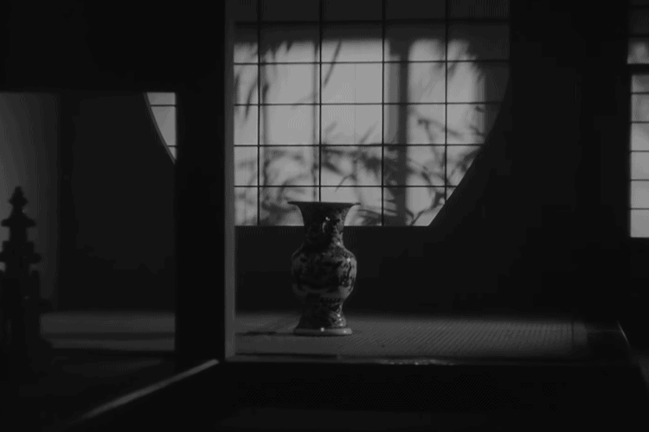

Figure 2.

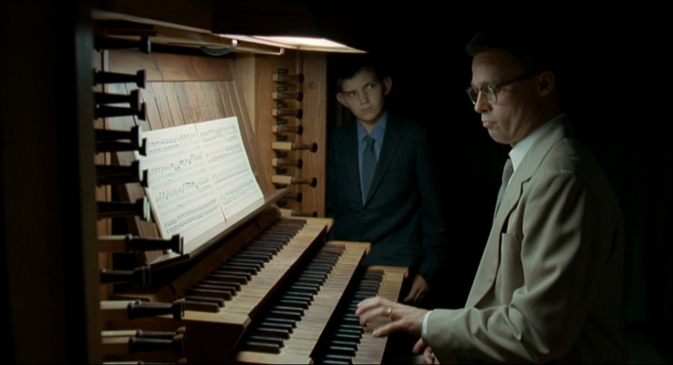

Figure 3.

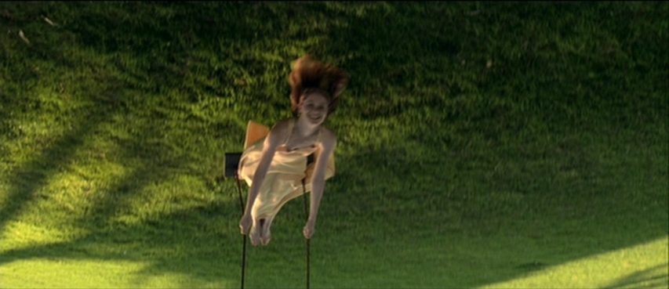

Figure 4.

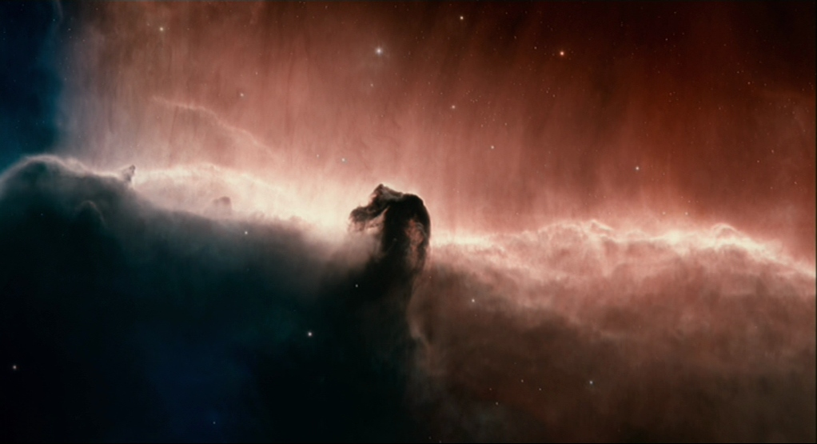

Figure 5.

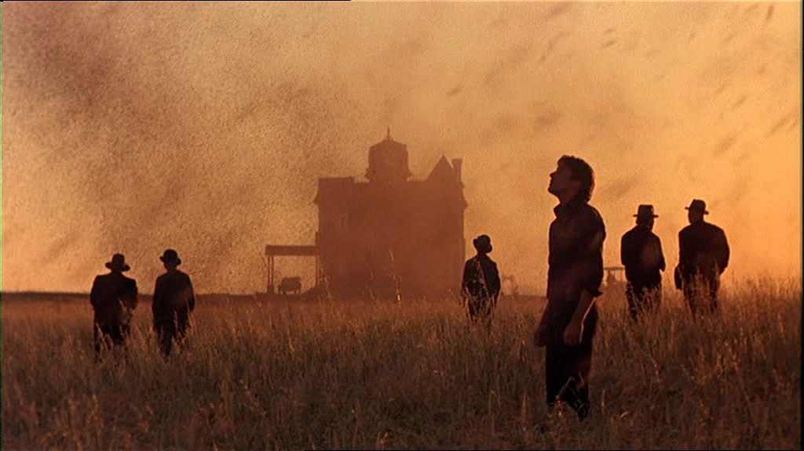

Figure 6.

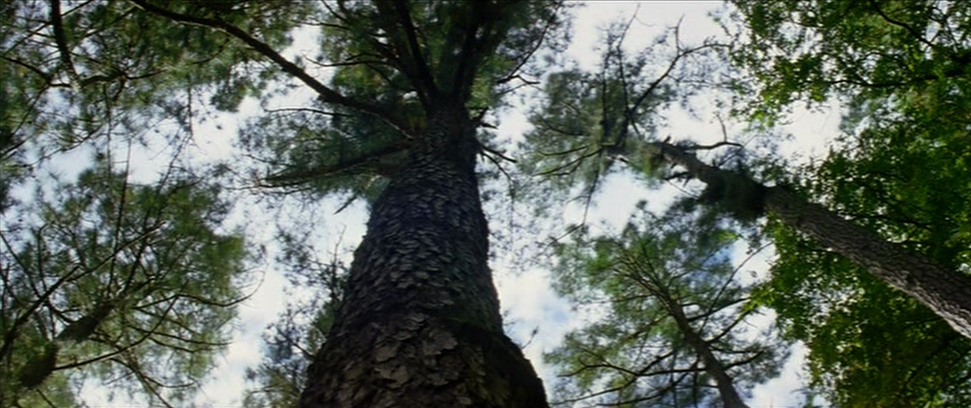

Figure 7.

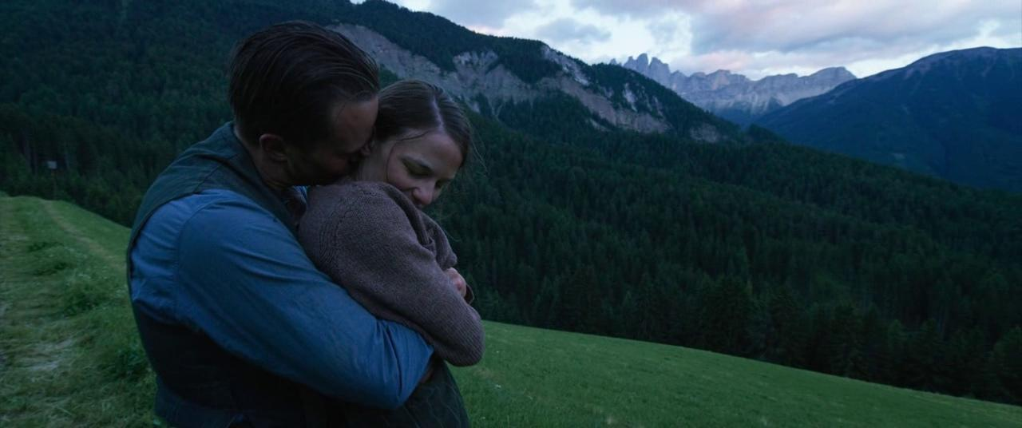

Cinema I: The Movement-Image (1983) and Cinema II: The Time-Image (1985).
Gilles Deleuze, Cinema II: The Time-Image (London: Bloomsbury, 2013) x.
Slow cinema (also occasionally called ‘contemplative cinema’) is characterised by its long single takes, static frames, non-narrative structure, and other minimalist devices. For an excellent introduction, see: Tiago de Luca and Nuno Barradas Jorge [eds.], Slow Cinema, (Edinburgh: Edinburgh University Press, 2016). Crucially, slow cinema is not merely a matter of films with a long running time; Béla Tarr’s The Turin Horse (2011) runs for 146 minutes, while the blockbuster The Lord of the Rings: The Return of the King runs for 201 minutes – and yet there is no doubt that the former is the slower film.
The Heideggerian influence here is inescapable. Steven DeLay has traced the Heideggerian contours of Malick’s life and work in his Introduction to this volume, rightly observing the extent of this influence as well as suggesting that reducing Malick’s films to a “Heideggerian cinema” is a reductive simplification.
Deleuze, Cinema II, xi.
Ibid., 103
For example, ‘From Recollection to Dreams: Third Commentary on Bergson’. Deleuze, Cinema II, 45.
Henri Bergson [trans. F. L. Pogson], Time and Free Will: An Essay on the Immediate Data of Consciousness (Mineola, NY: Dover Publications, 2001) 101-102.
Ibid., 102.
Ibid., 120.
Bergson’s distinction between virtuality and actuality is crucial here, and Deleuze draws it out particularly well in Cinema II. Our recollections, anticipations, and fantasies are virtual (that is to say, they are real in the present but not actually present); for Deleuze, a time-image is an image where the distance between these virtual images (recollections, anticipations, and fantasies) and the actual image (the present image of attention) is closed, such that it becomes impossible to distinguish between them.
Bergson, Time and Free Will, 197.
Deleuze, Cinema II, 105.
In the Glossary of Cinema II and throughout the preceding pages. Deleuze, Cinema II, 345.
Deleuze, Cinema II, 82. This is the uniting of the virtual and the actual in the time-image, mentioned above, in ft¹¹.
Ibid., 103.
Figure 1.
Deleuze, Cinema II, 17.
André Bazin, What Is Cinema? Vol 1 (Berkeley, CA: University of California Press, 2005) 14-15. “Le cinéma apparaît comme l’achévement dans le temps de l’objectivité photographique… Pour la première fois, l’image des choses est aussi celle de leur dureé et comme la momie du changement.”
Deleuze, Cinema II, 345.
Henri Bergson [trans. Mabelle L. Andison], The Creative Mind: An Introduction to Metaphysics (Mineola, NY: Dover Publications, Incorporated, 2007), 175-176.
Andrei Tarkovsky [trans. Kitty Hunter-Blair], Sculpting in Time: Reflections on the Cinema (London: Bodley Head, 1986).
Figure 2.
Figure 3.
For example: “Love. Where does it come from? Who lit this flame in us?” I will return to this voiceover in the next section.
Figure 4.
Deleuze, Cinema II, 42.
Distention is an apt word here, for it captures the sense in which interpenetrating durations (Deleuze’s sheets of past and peaks of present) coexist in the concept of durée, as if every present moment were ‘swollen’ with moments past and already passing. The word also bears connotations with Augustine’s philosophy of time, which Deleuze himself draws on (see section 1 of this chapter), and especially Augustine’s phrase distentio animi in Confessions 11.23.30.
C. Clinton Stivers, All Things Shining: A Narrative and Stylistic Analysis of Terrence Malick's Films (PhD dissertation: University of Tennessee, 2012), 181.
Figure 5.
Figure 6.
Figure 7.

