Working paper: Growing crystals in the classroom: Reflections on applying critical theory—a negative dialectic approach to enterprise and entrepreneurship education*

David M Atkinson

Abstract
This research paper reflects on a critical theory approach to practice—a heterodox application of enterprise and entrepreneurship education used in a 2nd year undergraduate module in 2022, in a UK business school. The module title—“Business , Creativity and Opportunism for the Workplace of Today”—learning objectives, and assessment methods were specified. However, the module design and delivery were based on a heterodox critical theory of artistic practice and the author’s significant practical experience of enterprise and entrepreneurship. While meeting the specified objectives, the content was grounded in a non-normative ontology of Socially Negotiated Alternativism and influenced by a methodology of Applied Negative Dialectics. Here, the concept being taught (entrepreneurship) is re-presented as an emergent non-concept, through a learning focus on its (enterprising) conditions of emergence (vision, creativity and enterprising skills). Data from anonymous feedback, responses to seminar questionnaires, module outcomes and the (assessed) personal reflections of students, suggests the approach merits further, critically exacting reflection on its potential to impact future enterprise and entrepreneurship education. With a focus on students who are not predisposed to study entrepreneurship, the conclusions hold profound implications for how difficult-to-define career concepts might be approached in future 21st century higher education contexts.

Keywords:
Enterprise education, entrepreneurship education, enterprise pedagogy, higher education, career indecision, critical theory
*A version of this working paper was presented at the 16th International Entrepreneurship Educators Conference (IEEC), Swansea, September 2022

Growing crystals in the classroom: Reflections on applying critical theory—a negative dialectic approach to enterprise and entrepreneurship education

Introduction
As the 16th International Entrepreneurship Educators Conference (IEEC) testifies, interest in enterprise and entrepreneurship (EE) education is significant and ongoing. However, in the UK at least, EE is not appealing to most teachers and managers in education. It is a marginalised ‘academic corner’, where a variety of EE courses and modules are taught, with little integration across subjects (Lackéus, 2018). In higher education (HE), EE finds its ‘academic corner’ in the many and varied business and management schools in which ‘EE educators’ principally reside. Here, as Simmons (2021) reflects, the UK’s Quality Assurance Agency (QAA, 2018) draws together guidance on learning about, learning for, and learning through EE (see also: Hannon, 2005). Moreover, in contrast to the more academic pursuit of learning about a subject, Simmons highlights that ‘Learning for and… through [EE] requires students to engage in more practical activities aimed at providing them with [EE] skills and awareness…’ (Simmons, 2021, p. 454). Here, I identify research question one as: can EE be made more (academically) appealing to teachers and managers in education?
As a critical management scholar, in the critical theory mould, I observe that learning ‘for’ and ‘though’ a subject, carries with it an assumption that the student is predisposed to learning with a goal of future participation in the matter of that subject. Therefore, in an EE context, do I assume the EE student is predisposed to an EE career? Furthermore, I suggest the notion of an EE career invokes the additional assumptions that entrepreneurship and enterprise are concepts with well-defined boundaries and contexts that can be effectively replicated in an educational context. Yet, persistently, this is not the case. The debate over the what and how of its teaching is still visible (for example: Lourenço and Jones, 2006; Neck and Corbett, 2018).
In a 2022 report on Entrepreneurship Education, the UK’s All Party Parliamentary Group (APPG) on Entrepreneurship, doggedly conflates both enterprise and entrepreneurship, making policy recommendations based on key findings such as:
“Responses to our Call for Evidence noted the importance of teaching methods in enterprise education, and specifically the need to adopt an active, hands-on approach, rather than more traditional abstract and purely knowledge-based methods. One popular and effective approach is to build educational programmes around the journey of starting a business” (Conway, 2022, p. 4).
But not all enterprise is entrepreneurship, and teaching enterprise through doing entrepreneurship—starting a business in school, for example—somewhat misses this distinction, setting up misconceptions of the totality of enterprising opportunity.
In Neck and Corbett’s (2018) study, a panel of 17 expert entrepreneurship educators revealed 16 different definitions of entrepreneurship, and no consensus (at least between the US and UK) over whether enterprise and entrepreneurship should be separated or combined. This followed Hytti and O’Gorman (2004), who considered enterprise education in a European context, suggesting there was some consensus that enterprise should take entrepreneurship as its starting point. Thus it seems little clarity has been gained in over a decade since Jones and Iredale (2010, p. 10) contested that “…Enterprise and entrepreneurship are often used interchangeably and this causes much confusion.” Or the two decades since Gibb (2002, p. 235) reasoned there was “…no common agreement as to what pursuit of entrepreneurship and the enterprise culture means.” Or the three decades since Gartner (1988) reviewed some of the (academic) attempts at the identification of the entrepreneur from among those others—non-entrepreneurs—also engaged in the enterprising work of operating organisations.
Is there any surprise, that without a common ground, there is little to appeal to teachers and managers in education, beyond the subject’s ‘academic corner’ in the many and varied business and management schools? The broad nature and potential of an enterprise education becomes lost in the chimera-like capitalist agenda of business creation, seemingly at all costs. Here, Frederiksen and Berglund (2020) noted a concern that such neoliberal drives to construct the (ideal student) entrepreneurial identity, risk obstructing the construction of alternative enterprising identities. Are we not, then, in danger of simply leading many young students, as square pegs yet to be whittled into shape, toward the ill-considered, educational equivalent of a plethora of round holes, all somewhat smaller than a single peg’s potential?
In the UK entrepreneurship camp of EE education, Burns (2016, p. 7) said that increasing the supply of future entrepreneurs is “probably one of the major challenges facing business schools in the 21st century” Thus, if as a society we desire more EE graduates, then why do we seek to recruit students into HE entrepreneurship programmes if they are not (at least) initially engaged? Isn’t it better to encourage engagement in a general enterprising sense first, and seek to educate them about EE’s full potential? Here is a paradox. Increasingly, career indecision (CI) is a factor in the lives of many young students. It is a core topic in the field of career development and counselling, with Xu and Bhang (2019, p. 3) defining CI as “a state of being undecided about one’s educational, occupational, or career-related path”.
Faced with increasingly uncertain and precarious futures in the workplace (for example: Hughes and Smith, 2020; Walsh and Gleeson, 2022), undergraduates on business school courses such as entrepreneurship, as opposed to enterprise, may lack the prerequisite of entrepreneurial intent (EI) that is not to be found in the minds of the undecided. Here, as Hughes and Smith report: “In a context where work itself is becoming so unpredictable, we must consider how young people can make good decisions about the opportunities and choices available to them” (2020, p. 7). While the literature suggests much can and has been done to foster EI, the rate of graduate entrepreneurship is low, with a variety of reasons offered to support this finding (Tomy and Pardede, 2020, p. 1426). The implication is that a focus on entrepreneurship education, and a need to enhance EI, does not address the wider issues of career indecision and finding a meaningful place in the (enterprising) work of society. Thus, I identify a second research question as: accepting students’ potential state of undecidedness, can EE provide students with better formative learning concerning a range of EE opportunities and choices, and help reduce CI?
In this paper I investigate both research questions by offering a reflection on critical theory in practice. I describe a heterodox approach to EE education (broadly defined), I applied within a UK HE Institution. I outline a knowledge framework, grounded in critical theory, presented to a class of 2nd-year undergraduate students, drawn from across a range of business school courses. The framework facilitates the development of enterprising ideas through a learning focus on their conditions of emergence. In this respect, I hold skills of enterprise in conjunction with those of creativity in innovation and value in vision. I proceed as follows. Firstly, I present the background to the module, together with its heterodox critical theoretical perspective: a theory of artistic work in the context of applied negative dialectics. I then comment on the module delivery and its assessment, and review the initial data returned. Finally, I offer a reflection on the outcomes and draw key insights, commenting on their wider implications for EE.

Background to the module
With the need to develop and deliver a 2nd-year undergraduate elective module in “Business, Creativity and Opportunism for the Workplace of Today”, I faced the prospect of engaging with a cohort of 65 business school students electing the module as an alternative to a work placement. While some authors suggest an elective is cause for assuming an intrinsic motivation to study the subject (for example: Hedges, Pacheco and Webber, 2014; Simmons, 2021), my experience was that several students believed it was a least-cost option, weighed against competing priorities in time and other resources. As a lower-ranked UK business school, with students drawn from a range of 13 different BA(Hons) and BSc(Hons) business and management-related programmes, including Sport Business Management, Fashion Marketing and Tourism and Destination Management, I made no assumptions concerning the abilities or motivations of the students towards EE.
The stated aim of the module is: “…to develop confident, enterprising and creative graduates who will be able to cope with the ever changing business environment, recognise opportunities and to take responsible and measured risks. This draws on the belief that EE will stimulate enterprise, encouraging individuals to consider self-employment or develop enterprising employees who can contribute to organisational success through intrapreneurship. Although the learning objectives and assessment method were modelled on a relatively typical approach to EE education, my module design and delivery drew on the heterodox, critical Conjunctive Theory of Artistic practice (CTA) (Atkinson, 2007) and my significant practical experience of EE.
While meeting the specified objectives, I grounded the content in a non-normative ontology of Socially Negotiated Alternativism (SNA), and a methodology of Applied Negative Dialectics (AND). Here, I re-present the concept being taught (entrepreneurship) as an emergent non-concept, through a learning focus on its (enterprising) conditions of emergence (vision, creativity and enterprising skills). The data I obtained from anonymous feedback, seminar questionnaires, student outcomes, and their (assessed) personal reflections, provide the means of immanent critique within the reflection section to follow. Before I set the critical theoretical basis of SNA’s non-normative ontology and its AND methodology in context, it is worth making a comment on my pedagogical approach.

EE scholarship: Academagogy—one size fits all?
Although I did not set out with a given educational approach, in the course of the research I determined that there was a strong alignment with Jones, Penaluna and Penaluna’s (2019) description of ‘Academagogy’: a mediating process by which the educator blends three other ‘gogies’. On this basis, the approach to scholarship I offer may be interpreted as a blend of:
- Pedagogy—in which the educator independently acts to support student learning toward the formal learning objectives. In the subject module, I set out a specific theoretical perspective on EE as a framework within which the other elements of Andragogy and Heutagogy are enabled. This is delivered through traditional lectures.
- Andragogy—in which students are given the opportunity for self-directedness and autonomy within the learning objectives. In the subject module, a series of seminars gives students the freedom (and encouragement) to think about and develop their own ideas about EE within the broadly defined framework.
- Heutagogy—in which students can choose to determine the focus of their learning and negotiate learning outcomes. Although the form of assessment (both written work and presentation) is pre-determined to meet establishment requirements, the structure and content required to verify agreed learning is negotiable between student and educator.
While some might question how well 2nd year undergraduates are able to negotiate learning outcomes, my response is that the majority of students are not expected to. The transition from pedagogy (traditionally the teaching of children) toward the adult-focussed teaching approaches of andragogy and heutagogy has been advocated in EE, particularly in the US with its focus on entrepreneurship (Neck and Corbett, 2018). However, not all HE students will be comfortable with the opportunity for self-direction, nor the notion of negotiating their own learning outcomes. Thus, underpinned by a sound pedagogy, my incorporation of andragogical and heutagogical elements simply allows those students who are more comfortable with self-direction to take full advantage of its freedoms. Those less comfortable are free to experiment in a supportive environment, playing to a requirement for inclusivity.
Hägg and Kurczewska (2019, 2020) characterise the typical undergraduate EE student as an ‘emerging adult’—in developmental psychology terms, one full of ambiguity, instability and experimentation. They may experience learning as a major developmental challenge. It is a characterisation that rests on an assumption that pedagogy does not fully capture the emerging ‘in-betweenness’ that is characteristic of HE students today. However, given the last decades’ changing socio-economic structures, I reason some students may prefer pedagogy while others, particularly those on UK degree apprenticeships or mature students, may not. Rather than guiding students along a phased continuum of ‘gogies’ (Hägg and Kurczewska, 2020), I see academagogy as simply facilitating an individualised negotiation of enterprising learning.

The module: a critical theory perspective
From the traditional pedagogical perspective, the module specification is grounded in the implicit conceptualisation of entrepreneurship embedded in the module’s learning objectives. Three of the five objectives specified are that students are able to:
- Demonstrate how the principles of creativity, innovation and entrepreneurship or intrapreneurship transfer into a practical context.
- Apply the concepts learned and the techniques and intellectual skills developed to suit different markets and situations and to the entrepreneurial process, to start up and manage a business venture
- Reflect on personal development needs and the development, skills and attributes of entrepreneurial and intrapreneurial behaviour
I argue that the module’s enterprising promise of a generalised ‘Business, Creativity and Opportunism’ learning for ‘the Workplace’, is not reflected in the implicit focus on the entrepreneurial process of starting and managing a business venture. This is problematic in relation to the two research questions. Firstly, despite (as an educator) having over 20 years’ experience in setting up and managing a range of business ventures in a range of sectors, I argue the subject holds little of ‘educational’ interest in a general sense that would appeal to those not predisposed to learn about it. Secondly—eschewing any push toward entrepreneurial identity—I believe that for many students with high levels of CI, the ideal ‘workplace’ may remain undecided. It may not be the cut and thrust, and risk and uncertainty of a start-up. Also, for many employers, I believe the ideal graduate applicant may not be one who is entrepreneurial. The idea of learning EE simply through setting up a business venture, sets the possibility of exclusion and failure for those students either not inclined to engage with such a narrow, conceptual focus, or not at least in possession of some level of EI.

AND: Entrepreneurship as a non-concept
To overcome the narrow, ill-defined conceptualisation of entrepreneurship as the subject of the module, I re-present entrepreneurship as an emergent non-concept. Here, the learning focus is not the concept ‘entrepreneurship’, but its (enterprising) conditions of emergence (through vision, creativity and enterprising skills). This shift of focus is an application of Critical Theorist Theodor W. Adorno’s Negative Dialectics (Atkinson, no date; Adorno, 2008). I argue this focuses study on the idea of the non-concept (or context) as the negative of the concept. It is like considering a photographic negative—by focussing on the reverse of the image itself. For example, in considering entrepreneurship, my focus is not on the dialectic specifics of entrepreneurship as might be defined by the authority of some traditional theorist, but on its context—that is the social and material conditions in which entrepreneurship emerges. In this case, I define the context along the dimensions of a general enterprising work, the application of creativity, and the potential of vision. Such an application of negative dialectics extends the range of enterprising possibilities determined by the variation in conjunctions, in this case between the dimensions of enterprising skills, creative capacity and visionary ability.

CTA: Defining conditions of emergence
The choice of the three dimensions of social and material conditions (or factors) is determined by CTA, a heterodox critical theory of artistic work (Atkinson, 2007). This provides an application of the artistic metaphor to the creative exercise of any given craft skill, in this case the craft of enterprising work. Here, entrepreneurship—as the ‘art of enterprise’—emerges as the conjunction of three core elements, the exercise of the identified craft skill (of enterprising work), with creative innovation, in experiencing a mimetic realisation of some aspect of the lived-in-world. I argue this approach is the negative dialectic of a notion that enterprise leans on a broad definition of entrepreneurship (Atherton, 2004; Liguori et al., 2019). Rather, it plays to the origins of entrepreneurship’s emergent evolution in the context of a broader concept of enterprise, for example: as an anti-management separation from the traditional organisation of enterprise (Kaplan, 1987); or as highlighted by the opportunities in advancing economies for both advancement in some enterprise or other and for entrepreneurship (Cole, 1954); or simply by the evolving perspectives on who ‘businessmen’ [sic] are (Cole, 1949); or the relationship of entrepreneurship to free-enterprise, a qualification of more bureaucratic, less-free forms of enterprise (Easterbrook, 1949); or the emergent function of the entrepreneur as an agent of production within the corporate form of an enterprise (Lewis, 1937).
In briefly introducing CTA, Figure 1 shows the circle with the shaded portion as representative of the world and what is both known and unknown within it. The shaded unknown space is that space within which artist and audience (entrepreneur and the social-economy) engage in the process of mediating a (new) sense of place, coming to a (new) ‘shared’ sense of being-in-this-world. This shaded area is dissected by the imaginary plane, delineating an area in which access to knowledge of the unknown is through the imagination. The un-shaded area represents what is currently known—that which exists predominantly on the real plane. The separation between real and imaginary planes is the antagonistic horizon.
In considering an example of enterprising work, I posit that the Craft object ‘C’ is a convention of enterprising work practice; a design ‘D’ is an adaptation or variation of such a convention. The idea ‘I’ within an innovative activity is that which is purely new, emerging solely from the activity of creative play. The experiment ‘E’ is the application of an idea to the process of mimesis, revealing an aspect of the unknown. The mimetic experience ‘M’ is that which exists in the unknown with the potential for a sensible affect that triggers an aesthetic response (anticipation) within the audience (in this case the social economy). The representation ‘R’ is what is capable of being reproduced by virtue of the conventions of enterprising work’s practice. The space represented by the union of C, M and I is analogous to the space in which the enterprising work is practiced. Here I identify the structures of that space, defining positions of reference for varied practitioners of a fluid enterprising work.
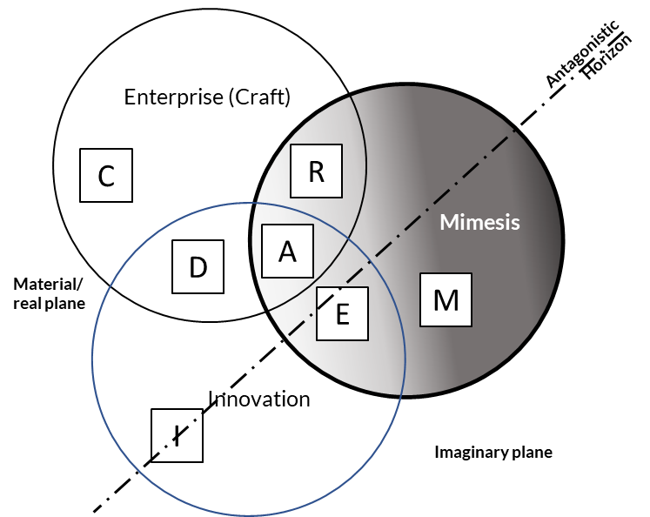
Figure 1 - Reframing entrepreneurship through CTA (adapted from Atkinson, 2007)
In adopting CTA as a framework for exploring the emergence of entrepreneurial practice within a broadly defined craft of enterprising work, I allow that some forms of the practice may tend to entrepreneuring, as the Art of enterprise ‘A’, while other forms of practice may co-emerge, without in any sense being othered, or otherwise marginalised. This allows me the possibility of de-othering the entrepreneur in the context of their work—a negative dialectic of the entrepreneur, in which the entrepreneur can only emerge from its non-concept of enterprising work. This allows a greater, more inclusive range of co-actors to emerge. So, as shown in Figure 2, alongside the artist—as the entrepreneur—we have the dreamer (or mimetic visionary), the reproducer, the craftsperson, the designer, the innovator, and the experimenter.

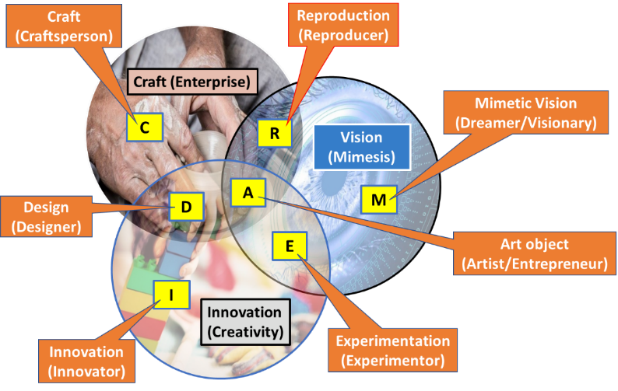
Figure 2 - Co-actors in the craft of enterprise (adapted from Atkinson, 2007)

SNA: Negotiation the emergent form
I underpin this reframing of entrepreneurship in the context of a critical theory of enterprising work with a non-normative ontology of SNA (Atkinson, 2007). This is more a philosophy; SNA is not founded on a single ontological position. Rather, the world is one world to be viewed from alternate perspectives. It is constantly subject to change; that is, I argue that the nature of the socio-economic world is transitory, as elements of it and other associated phenomena are added, negotiated, revised and subtracted or replaced as required. Therefore, SNA legitimises not only theories of representations in thought and representations in experience, but also theories of representations in ideas and fictions. As a basis for an ontology, it is not fallible—as is the case with critical realism—however individual (or groups of) elements and phenomena within it may be. The implication is that a philosophy of SNA does not deny the concurrent existence of multiple ontological subsets (for example positivism, social construction, critical realism and so on); each subset may also provide for a limited, context sensitive ontology.
In context, SNA implies an infinitely malleable ontology—a meta-theoretical framework. It allows a fluid ontological view of a negotiated reality to form a new socio-cultural narrative of EE. I argue it presents a view of the social-economic world of EE that is open to various legitimate interpretations—a negotiation of the meaning of EE between both educator and student. Here, my focus on dimensions of enterprising practice, rather than any specific conceptualisation of that practice, allows that practice to retain an emergent, non-determinative form, in which alternative views may be negotiated in respect of individualistic socio-economic contexts. While a detailed review of SNA is beyond this paper’s scope, its infinitely malleable ontology of enterprising work offers a fluid view of EE work that is open to various legitimate interpretations. This provides me an anti-foundationalist epistemology which accepts that ‘[all] concepts can be considered as legitimate candidates to a (negotiated) knowledge of the world’ (Atkinson, 2007, p. 155). This includes the educator’s and students’ own ideas about it.

The module: delivery
Pedagogically, I structured the module for a single semester delivery over a 12-week period. Each week comprised 1.5 hours of traditional lecture time. Each lecture comprised two parts, with a short (context-related) TED-type (video) talk used to break up the formal delivery. I made full transcripts and slides for the lecture content available using the institution’s Virtual Learning Environment (VLE) several hours before the start of each lecture. I also made seminar material available after the completion of all group seminar sessions.
With reference to Figure 3, in Week 1, as the educator, I presented the students with an introduction to the complete module, in which I simply outlined the course structure and learning expectations. In this first week, the second part provides for a lecture on failure in enterprise, and its interpretation. In Week 2, I introduce the students to a general theory of enterprise, with the point made that the module is not a theory-laden academic course, but that knowledge of some theory is necessary in the context of any practice.
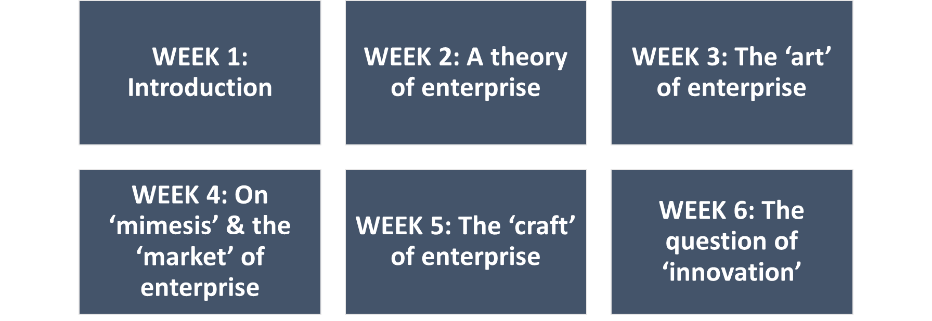
Figure 3 - Module Structure, Weeks 1 to 6
While Week 2 presents what I term the traditional view of EE, it is in Week 3 that I introduce the new theory (or framework) of a potentially artistic form of enterprising work. However, I did not position this as a critical theory. Over successive weeks, I explore the dimensions and key conjunctions of enterprising practice. In Weeks 4 to 6, I unpack and contextualise the core dimensions of ‘mimesis’, ‘craft’ and ‘creative innovation’. In Week 4, for example, I use the idea of mimesis to identify the market for enterprising ideas and discuss values and ethics. In Week 5, I turn to the ‘craft’ of enterprise and how it plays on ideas of personal and continuing professional development. Importantly, the content does not call for an in-depth knowledge of business and management functions. In Week 6, I unpack the notion of ‘creative innovation’, revealing the need for space to play creatively with ideas and the implications of power-relations in the sanctioning of that space.
It is during this first half of the module, in adjacent weekly seminars, that I encourage students to come up with and start to develop an idea they might have about their future place in an enterprising workplace. This could be anything from a career development idea, such as how to enter a desired industry, through the writing and publishing of a book or the development of a career as a social media influencer, to the more common EE idea for a new business start-up. The objective of the lectures is not to provide a knowledgebase to be internalised and examined, but to expose the students to different ways of thinking about the dimensions of a creative and opportunistic working practice. I encourage all students to submit a draft outline of their chosen idea at the end of Week 6. This is an ideal opportunity for educator and student to negotiate expectations on the assessment of their learning.
In the spirit of experiential learning about structured thinking, I encourage the students to ‘think’ critically (as in an exacting way) about their idea. In regard to Figure 4, I provide the students with a doing-thinking-week in Week 7.
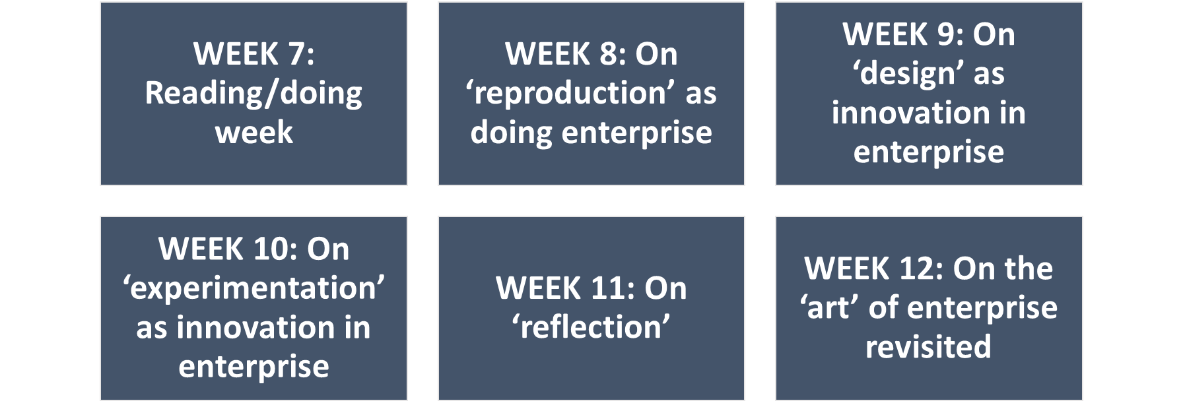
Figure 4 - Module Structure, Weeks 7 to 12
During Week 7, I have ample opportunity to evaluate the ideas presented in draft form and provide formative feedback. This can range from highlighting relevant pedagogic elements, to commenting on andragogical choices, or negotiating learning objectives, dependent on student capabilities and their desire or capacity for self-direction.
In Weeks 8, 9 and 10, I focus on the major conjunctions between the three key dimensions, highlighting how craft, mimesis and innovation can be combined to different effect in the workplace. The three primary conjunctions represent alternative strategic approaches to enterprise. Firstly, in Week 8, I explore reproduction as simply doing (or copying) existing enterprising work. Secondly, in Week 9, I unfold a focus on design as innovation in or through the craft of enterprise. Finally, in Week 10, I present the students with the notion of experimentation as mimetic innovation in the world. Over the course of Weeks 4 to 10, I expose the students to the essential work of the six enterprising personas: the dreamer (or mimetic visionary), the reproducer, the craftsperson, the designer, the innovator, and the experimenter. The remaining persona, the entrepreneur, is the one persona that adopts all three dimensions.
As the module nears its completion, I invite the students to comment on the type of persona they believe themselves to reflect at that time, and the type they aspire to in their initial post-graduation work environment. The student responses, and their responses to Week 1 and 11 questionnaires concerning their perceptions of their own levels of creativity, vision and enterprising skills, and their confidence in their post-university career direction, are the basis for a Week 11 lecture on (critical) reflection and reflective learning.
Finally, in Week 12, I revisit the art of enterprising work, with entrepreneurship as the conjunction of enterprising craft skills, creative innovation and mimetic vision. The students are assessed on both a 1750-word written idea development essay/plan and a 10-minute recorded presentation. The presentation has two distinct parts, one is an opportunity to pitch their idea for a general audience, the other is to offer a personal, (critical) reflection on their learning. Overall mark/grade weightings applied are 60% for the written work, and 20% each for the two parts of the presentation. Data from anonymous feedback, responses to seminar questionnaires, and the (assessed) personal reflections of students, leads me to suggest the module merits further critical reflection for its potential to address both the academic appeal of EE to teachers and managers in education, and the paradox of CI.

The module: outcomes
To offer a frame of analysis, I draw on Hannon’s (2005) principle differences between enterprise and entrepreneurship, providing four tenets for a theoretical perspective. Firstly, entrepreneurship is a focussed application of enterprise. Secondly, the desire and/or capability to be enterprising and/or entrepreneurial is contingent and may ebb and flow over time. Thirdly, individuals can learn to be more enterprising, developing and applying capabilities at varying levels in varying contexts. Fourthly, not all individuals will desire to practice enterprise in an entrepreneurial context (Hannon, 2005, p. 106). With these core tenets in mind, I now introduce some key findings on engagement, results and learning.

Student Engagement
Initially, I measured student engagement using the university’s attendance monitoring system. With 65 names assigned to the elective, individual in-person attendance covering both lectures and assigned seminar groups averaged 33.31% of the available teaching hours, with individual values ranging from 0 to 88%. Figure 5 shows the distribution of these attendance figures. As reported in the UK’s Times Higher Education on-line news source, 76% of 339, mainly UK-based respondents to a 2022 survey reported student in-class participation lower than pre-pandemic levels. In addition, around 55% of respondents experienced average class attendance figures between 21% and 60% (Williams, 2022). My experience was that the average lecture attendance was around 50% of the possible total, while seminars were typically at 33%. Such figures are indicative of a trend toward low face-to-face engagement, with significant factors being cited as students not wanting to come to campus, conflicts with paid work commitments, mental health issues and lack of sufficient prior preparation (Williams, 2022).
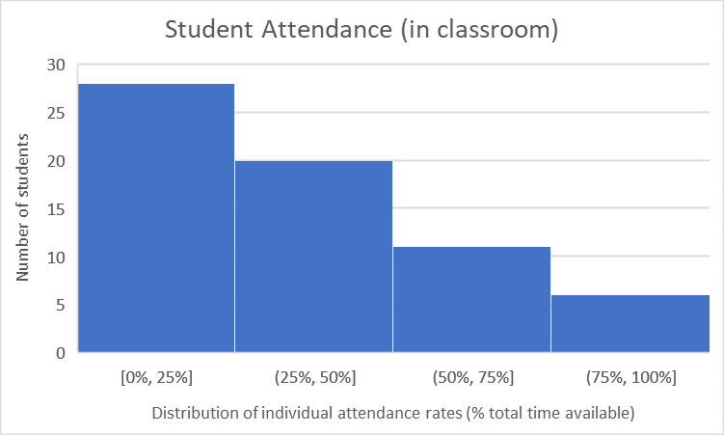
Figure 5 - Distribution of module in-class student attendance
While some lament the fall in face-to-face participation, Wolf-Wendel, Ward and Kinzie (2009) suggest engagement reflects both the time and effort students put into their studies and how HE institutions allocate resources and organize learning. Here, the growing conflict between many students’ paid-work commitments, the cost of tuition, and—more recently—the inflationary pressures of an increasingly uncertain economy, place greater responsibility on HE institutions to accommodate student needs (Tight, 2020). This responsibility is heightened inter alia by a growing need to accommodate the diverse learning styles of a range of students, such as those assessed as dyslexic (for example, see: Clouder et al., 2020). Accepting a need for a diverse engagement with educational material, I also assessed it by reference to VLE reports on students’ engagement with the module’s on-line materials.
I based engagement with the VLE on the number of times a student accessed the on-line content. I applied a simple weighting so that a single access to a single lecture or seminar part (32 parts in total) was equivalent to attending that part, whereas an access of two times, scored 1.1, three times scored 1.2 and so on, to a maximum of 2.0 (representing access to a single part on 11 or more occasions. I express a student’s VLE engagement as a percentage of a maximum of 32. Figure 6 shows a distribution of VLE access by the 65 students signed to the elective. Here, the average student access to the total available VLE material was marginally higher, at 37.59%, than the average in-class attendance, with individual values ranging from 0 to 100%.
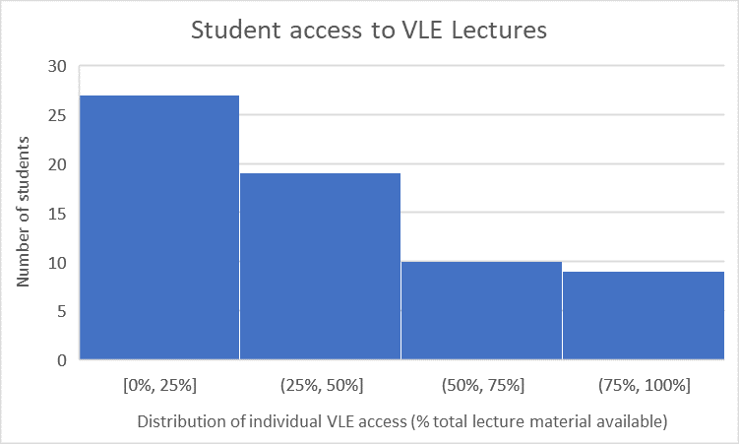
Figure 6 - Distribution of VLE module student access
Overall, the VLE provided a marginally preferable access route to the module’s pedagogic content; both in-class and VLE routes exhibit similar patterns of distribution. However, it is informative to take view on how module engagement is seen in the round. While no more than an indicative approximation of student engagement, Figure 7 provides a graphic distribution of the per-student summation of in-class attendance and VLE access percentages.
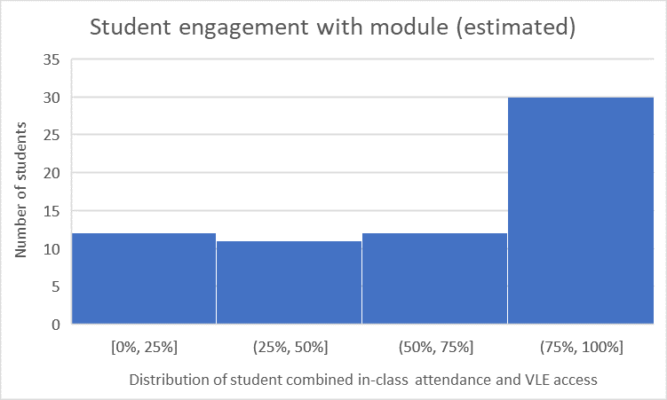
Figure 7 - Distribution of module student engagement
Here, an approximation of the average student engagement is 62.5% of the available material. Of the 12 students with 25% or less engagement, five attended no classes nor engaged with the VLE at all, and only four of these submitted assignments for assessment. Of nine students with 15% or less engagement, only one (10%) submitted assignments for assessment.

Student Results
Of the 65 students signed to the elective, five having no engagement with the module content also made no assignment submissions by the due date. In addition to these five, a further seven with engagement varying from 9% to 100% also made no submissions; although two students of the three in this group with over 50% engagement (100%, 52%) had been granted extensions to the submission date beyond the write up of this paper.
Of the submitted assignments, the average for Assignment 1 (written work) was 56%, with Assignment 2 (presentation) Part I being 59.94% and Part II being 51.19%. Combined with the weightings of 60% (Assignment 1), 20% (Assignment 2, Part I) and 20% (Assignment 2, Part II), the overall average mark achieved was 55.83%. Figure 8 maps individual student marks (including non-submissions) against their estimated engagement with the module.
Figure 8 - Student assignment marks
The close mapping of the overall trend with the trend for Assignment 1 is in large part explained by the greater weighting applied to Assignment 1. Whereas the separation between the trendlines for the different elements of the presentation assignment reflects a relative level of difficulty. Assignment 2 Part I—essentially an exercise in communication—trends with a relatively higher average than for the written work. Assignment 2 Part II—an exercise in (critical) reflective practice—trends with an average lower mark than for the written work.

Student Perceptions
The design and delivery of a module seeking to both engage its students and facilitate their achievement of learning objectives is only part of the impact equation. How the content is both internalised and influences their future thinking is another. Therefore, the educator must also ask: in what way or ways does the module meet its aim? That is, in what way or ways does it “…develop confident, enterprising and creative graduates who will be able to cope with the ever changing business environment, recognise opportunities and to take responsible and measured risks…”? Here, I included short seminar questionnaires focussed on both the students’ own perceptions of their capabilities and capacities in respect of CTA’s core dimensions, and their alignment of their ‘self’ with CTA’s enterprising personas. However, before I introduce the data, I will highlight a simplistic textual analysis of the lecture content.

Enterprising futures (entrepreneurship as a focussed application of enterprise)
By invoking negative dialectics, I position entrepreneurship as a phenomenon emergent from a focused application of enterprise. Using a freely available word-cloud tool, a simple visual analysis of key themes arising in all 22 lecture transcripts shows that in only one of the 22 lecture sessions do I introduce the word entrepreneur (and its derivatives) to any great extent. Figure 9 shows the word cloud for Week 2’s Part 2 lecture, covering the traditional view of a Theory of Enterprise. In acknowledging the limitations of such a visual representation of data, I use it here merely as an early-stage evaluation tool (Henderson and Segal, 2013).
From the raw data downloaded from MonkeyLearn, the search string <“preneur”> occurs 142 times in the transcript of 4722 words (circa 3%). By contrast, the only other notable lecture word-cloud featuring the same string, occurs in Week 3, Part 2; there, the terms “definition of entrepreneurship and “entrepreneurial journey” both feature only twice in 4191 words. While this is not meant to be a definitive textual analysis, it is relativistic of a module content that in no way privileges entrepreneurship as a focus for EE study. It is therefore somewhat insightful that, on responding to a questionnaire on enterprising personas (n=38), whereas no student positioned themselves as currently being an entrepreneur, 13 students expressed a desire to become an entrepreneur Ain the future.
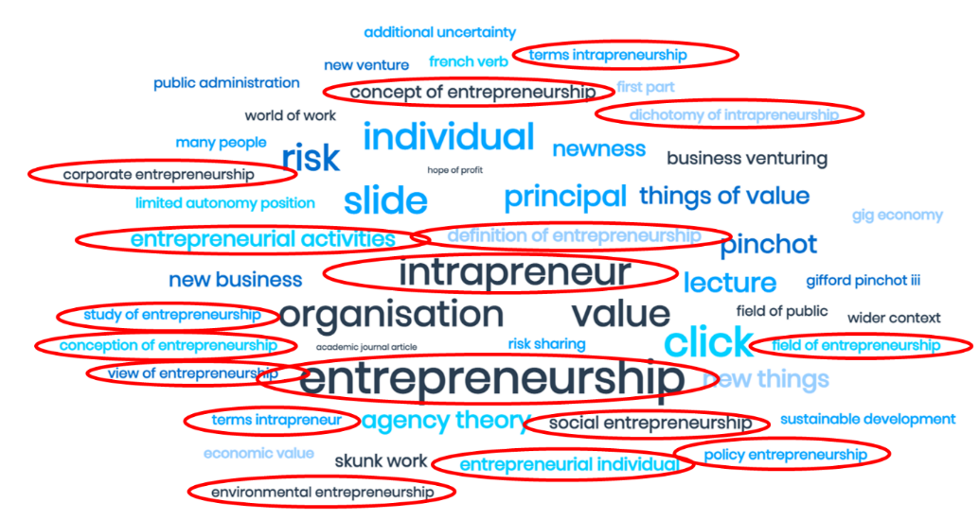
Figure 9 - Word cloud picture Lecture Week 2 Part II (adapted from source: author’s text and MonkeyLearn)
Thus, a focus on enterprise rather than entrepreneurship still has the ability to increase EI. This respects Hannon’s principle that “[if] all individuals have the potential to be enterprising, then some may choose to apply such characteristics, behaviours and attributes within a business context, and as such may be described as being entrepreneurial” (Hannon, 2005, p. 106).

Enterprising capabilities (contingency and ebb and flow)
From a theoretical perspective, a successful EE pedagogy that frames enterprising activity within the conjunction of enterprising craft skills, creative innovation and mimetic vision, should reflect a potential to influence a student’s desire and/or capability to be enterprising and/or entrepreneurial in a manner that Hannon (2005) suggested, ebbs and flows over time. Here, two questionnaires inviting students to reflect on their perceived capabilities are insightful. In Week 1 and Week 11, I invited students to record their perceived level of enterprising craft skills (Sk), creative innovation (Cr) and mimetic vision (Vs), alongside their perceived confidence in their future enterprising career/work direction. Responses were based on a simple Likert scale of 1 (low level) to 5 (high level). Figure 10 and Figure 11 plot the averages of the influencing factors as they ebb and flow over the duration of the module and as student’s (n=33) form and reform their views on their future enterprising selves.
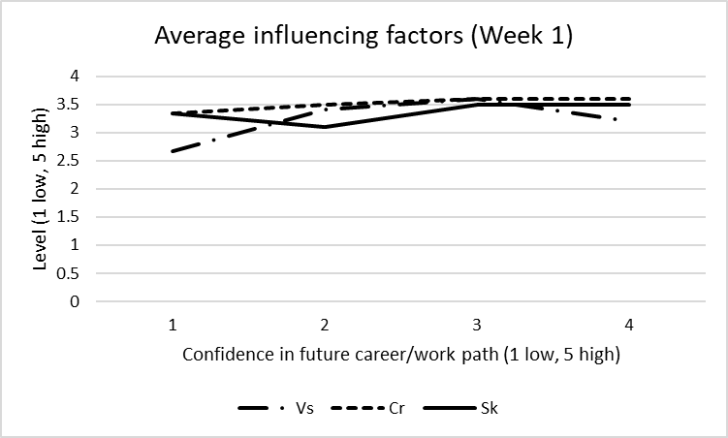
Figure 10 - Student influencing factors, Week 1
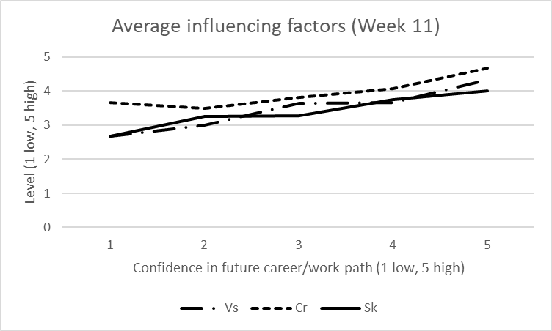
Figure 11 - Student influencing factors, Week 11

Enterprising learning (varying levels in varying contexts)
Across the sample of students completing both Week 1 and Week 11 questionnaires (n=33), the change in average perception of enterprising factor capabilities reflected a 21% increase in Vs, a 39% increase in Cr, and a 9% increase in Sk, with a 42% increase in the average student confidence concerning their future career direction. Figure 12 provides a graphic representation of the average change in enterprising factors across the sample. At a general level, this outcome is indicative of a measure of learning (about enterprise). However, it is further insightful to consider the variety of contexts that individual student learning is reflected within.
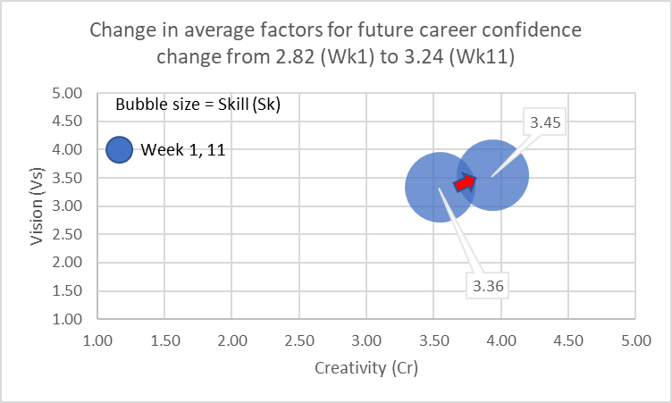
Figure 12 - Average change in student enterprising factors
Four exemplars will suffice. Figure 13 to Figure 16, are views of four individual students, each of whom initially positioned themselves as enterprising reproducers. These views also include a further questionnaire completed at Week 7, in which I invited the students to share their perceptions of enterprising factor capabilities in relation to the idea being developed in their assignments. Here, a limited response was received (n=15) from those also completing Week 1 and 11 questionnaires.
In Figure 13, we learn from student 1, a Fashion Marketing student with excellent engagement, that they experienced a 33% increase in confidence in their future career direction. Meanwhile, their perception of influencing factors has not changed, scoring relatively highly (4s) in both weeks 1 and 11. Here, the student comments in their reflective assignment:
‘…I tended to score 4s for most of the questions which is quite high, because I’d already had a confidence, and gained skills, and been able to experiment through the workplace, by having… four years [work] experience [in fashion retail management] …The area that did change was the confidence in post graduate career, and that did improve as this course, I felt like I learnt a lot of new skills and approaches which gave me the confidence to take the steps I need to achieve the goal, instead of procrastinating or over planning…’ (Student 1, Assignment 2 Part II).
This student’s future career thinking had moved from potential employment in a typical reproductive enterprising capacity, toward potential entrepreneurship. As the student reflects:
‘…Currently, I would say I am a reproducer—enterprising but with a vision. …Moving forward I think this will change into an entrepreneur… [and] hopefully, successfully combine elements of vision, innovation and craft skills by creating my own fashion line, for [my] Collection…’ (Student 1, Assignment 2 Part II).
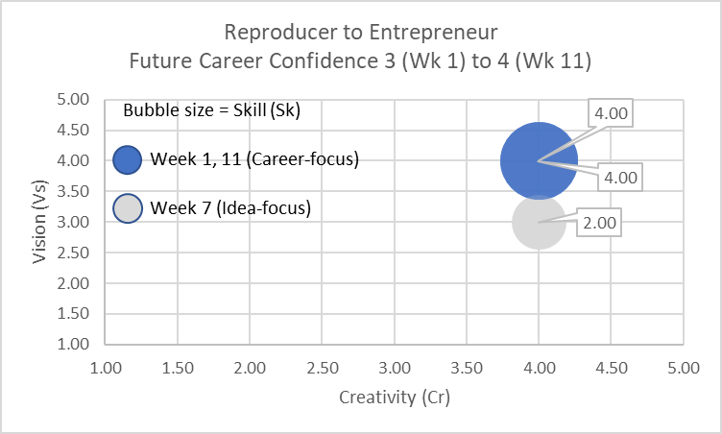
Figure 13 - Learning from reproducer 1
Certainly, an entrepreneurial role plays better to the student’s perceived strengths in all three factors. Here, we can reflect that the student’s perception of their idea—a curated e-commerce site specialising in non-exploitative independent artisan fashions brands—suggests 25% less vision and 50% fewer skills than they perceive are available to them. In their written assignment, the student’s idea development did not reflect a particularly visionary goal, yet their unprompted inclusion of an effective piece of market research showed clear creativity in applying some essentially basic enterprising skills. As feedback on their assignment reflected:
‘…The student… demonstrated a strong and sustained level of original and critical thought in the development of their idea… The strength of the analysis is… the inclusion of a consumer survey. While this survey is not effectively introduced… its impact on the development of the idea is key...’ (Educator feedback on Student 1, Assignment 1).
To consider a further example, in Figure 14 we learn from Student 2 enrolled on a Business Management degree. Here the student’s perceptions of their vision and creative capability increased (100% and 33% respectively), while their perception of enterprising skill levels is unchanged. Also, this student maintains, unchanged, a relatively high level of confidence in their future career direction, but with a shift in focus from replication to innovation.
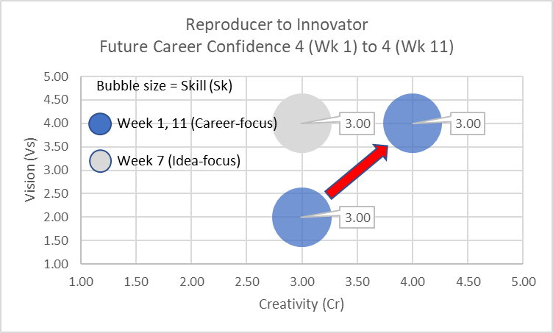
Figure 14 - Learning from reproducer 2
As the student reflects:
‘…When I first started the course, I believed I was and perhaps still am, a reproducer. My mindset was always quite narrow, restricting my creative thinking. This showed in my early concept ideas in which I tried developing both a social platform for gamers to meet, and 3-D printing housing. Both were either reproductions or had design flaws… Before this module, I’d never considered the possibility of creating and developing my own business. I was positive that I would become a manager or rise through the ranks of an established business, to maintain a secure job mitigating any risk. However, as I progressed through the course, I began transitioning to a dreamer, someone who wonders what the future might hold. The enterprising person I wish to be in the future is both an entrepreneur and an innovator…’ (Student 2, Assignment 2 Part II).
Here, we observe this student’s transition thinking in Week 7, when their idea focus reflects a 100% increase in the factor of vision, central to the position of the dreamer persona.
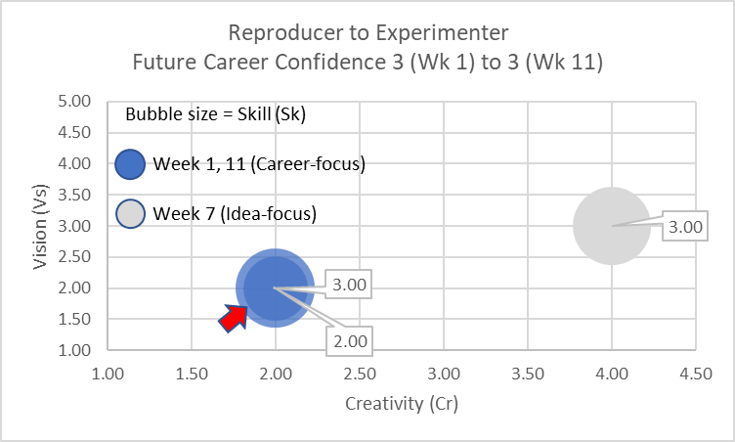
Figure 15 - Learning from reproducer 3
Figure 15 presents Student 3, an undergraduate in Economics and finance, who wrote about their development of an idea for a new gym start-up. Here we see no variation in relatively low levels of vision and creativity, and a 33% reduction in enterprising craft skills. Yet the idea-focus in Week 7 shows the student to be exercising a 50% increase in visionary capability and 100% increase in creative thinking. As the student reflects:
‘…Before the development plan and consideration of what I would require to attempt such a career development, I would say I had never considered the type of person in respect to—I am not forward looking and in fact live in the moment not the future. Furthermore, I would say I was entirely a reproducer, preferring to follow the trend and not think outside the box. However, upon the development plan I have found [myself] to be more of an experimenter and beginning to look through the eyes of a dreamer, to help allow my development in becoming a more creative person and having a more visionary approach to my future, rather than living in the moment.
…With myself being extremely analytical—and wanting things to be perfect through a keen eye of logical and detailed ideas—consequently I know this results in my very weakness of lacking spontaneity and the possible risk of being over-analytical and rejecting things that in my eyes do not fit. (Student 3, Assignment 2 Part II).
Anecdotally, one might well expect a finance and economics student to be less creative and visionary. Here, the module appears to have given the student a safe space to be creative in thinking about their career possibilities. Moreover, as the student suggests, they have found themself to be more experimenter than reproducer. Here, the reduction in enterprising craft skills could certainly be explained by their consciousness that their over-analytical mindset requires some further work to allow more creative and experimental thinking and action.
Finally, Figure 16 presents Student 4: an undergraduate in Business Management who developed an idea for a mobile pet-grooming service. Similar to Student 2 (another Business Management undergraduate), Case 4 also experienced perceived increases in their vision and creative capability of 100% and 33% respectively. For this student, there is a 25% increase in perceived enterprising skill level. Furthermore, for this student, although their confidence in their future career direction was initially very low, it increased over the course of the module, with a shift in focus from replication to design.
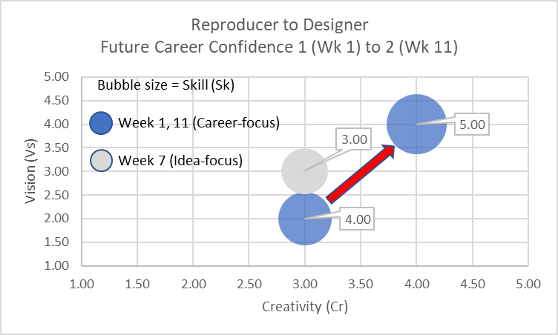
Figure 16 - Learning from reproducer 4
As the student reflects:
‘…The fourth question saw the biggest change, which was how visionary am I? As doing this proposed business plan has allowed me to become more visionary in the future, we can also see how this project has allowed me to see how truly creative I can actually be. It has also opened my eyes to the skills and knowledge that I would need, to be successful in an enterprising workplace…
…My current position is a reproducer as, so far, I have only developed mimetic [copy] visions. But in the future, I’d like to develop into a designer as this will allow me to have more freedom and be in control to pursue my own ideas. To do this, I need to advance my creative skills further… making more time for cohesive creative thinking and not being afraid of trying something new…’
Certainly, for Student 4, the Week 7 focus on the idea shows limited evidence of the creativity aspired to in Week 11, supporting the student’s assessment of their need to develop their creativity capacity.

Inclusivity and the non-entrepreneur (enterprise without entrepreneurship)
The data and reflections of each student tell individual, contextual stories about EE learning. They do not focus on entrepreneurship but cover a range of enterprising outcomes. This is enterprise without reifying entrepreneurship. As Figure 17 shows, of the 39 responses to the questionnaire concerning enterprising type—both at the end of the module and as post-graduation career aspiration—no student professed to currently being entrepreneurial. Yet, without specifically being taught entrepreneurship, 36% of the students learnt to become aspiring entrepreneurs.
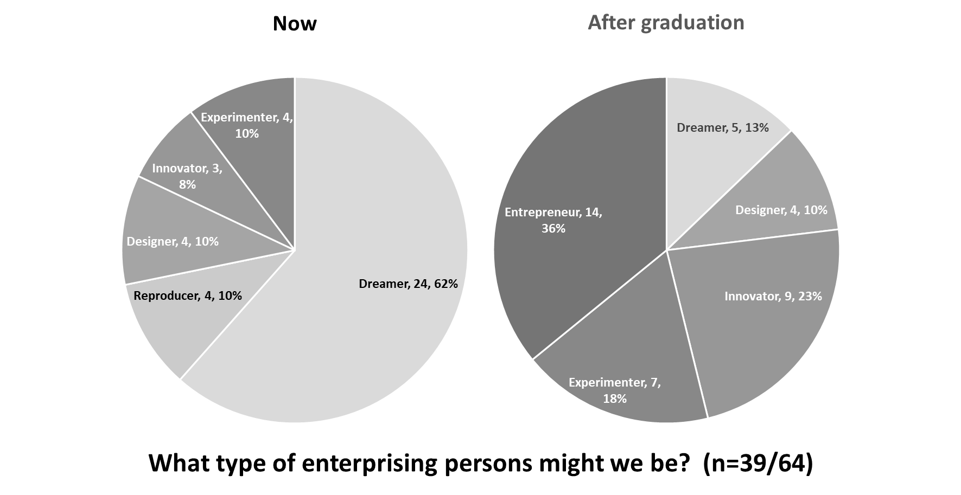
Figure 17 - Career aspirations for class of 2022
While the four cases introduced here represent the total of those who perceived their current position to be reproductively enterprising, it would appear that, following this module, not one student of the 39 responding would be happy to aspire to the routine of reproductive work. To these students, creativity and vision now matter in their thinking about future careers. Yet, with only 36% aspiring to be entrepreneurs, the learning outcomes are not simply an expression of the entrepreneur versus the non-entrepreneur. Among the class of 2022, we also have aspiring designers, innovators, and experimenters.
Figure 17 does not, however, show the variation in change of enterprising personas. For example, it does not reflect the net variations and the additional insight these bring. Rather, these variations can be seen in Figure 18, which maps the students’ perceptions of change in their enterprising career aspirations.
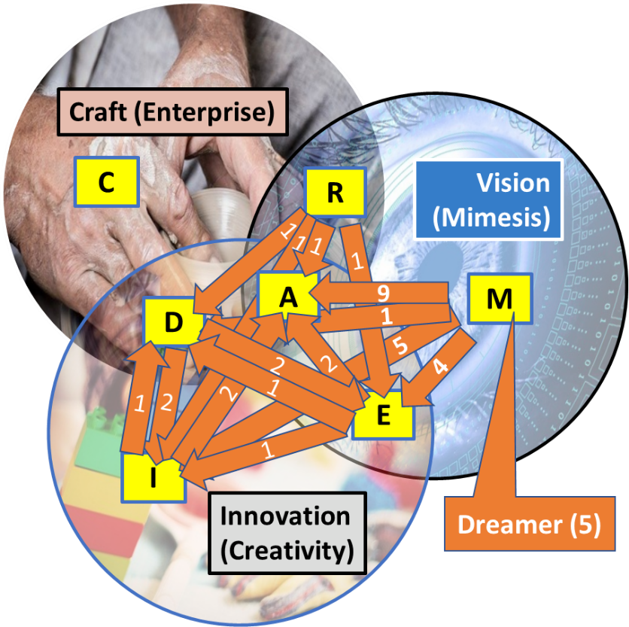
Figure 18 - Changes in aspirational enterprising personas, class of 2022
At the end of Week 11, no student considered themselves to be either a craftsperson (in a general enterprising sense) or an entrepreneur. As Figure 17 shows, at this point, the clear majority of students (62%) saw themselves as dreamers, presumably openly contemplating their future opportunities. Yet, while five aspired to remain dreamers, most of the 24 dreamer respondents had, through learning about enterprise in a general sense, determined their paths lay in becoming entrepreneurs (9), designers (1), innovators (5) or experimenters (4). For the students, gaining such knowledge at this stage of their studies certainty opens the door to a more effective and targeted 3rd year of study. It is certainly indicative of the underlying nature of the positive change in future confidence in career direction—working to decrease CI.
While the dreamers and the reproducers were clear losing personas, with entrepreneurs and innovators clear winning ones, there were other transitions of interest. For example, while two students aspired to move from being designers to becoming experimenters, one who perceived themselves to be an experimenter saw their future self as more designer. Such a transition is indicative of a move away from pure creative vision making, to take a more disciplined approach to idea development, such as might be practiced through design thinking. Whereas the move from design to experimentation is indicative of a desire for even greater creative freedom and vision making. Thus—moving from the privileging of the entrepreneur that risks the othering of the rest—the data suggests the module’s inclusive approach to learning about enterprise, allows a range of non-entrepreneurial co-actors to emerge, learning enterprise without learning entrepreneurship. Rather than experiencing any student resistance to some hidden neoliberal identity construction agenda (Frederiksen and Berglund, 2020), a range of enterprising student identities has been allowed to emerge.

Reflection
I consider that the module’s design approach is reflected in the analogy of growing salt crystals in the classroom. Here, a selected seed crystal (the student’s idea) is suspended in a concentrated salt solution (a pedagogy/knowledge of enterprising activity). It is free—within the boundary of what it is to become a certain crystal type—to take up its own shape as it grows. As I suggest, the notion of ‘academagogy’ (Jones, Penaluna and Penaluna, 2019) fits well with this approach. While a knowledge of enterprising activity forms the essential pedagogy, the students may exercise their potential for self-direction to the extent they are comfortable. Here, the notion of andragogy is respected to the extent that I give the students opportunity for self-directedness and autonomy—the idea is their own; it shapes their learning. There is no suggestion that any one enterprising persona is to be privileged over another. Within the scope of the learning objectives, the students are able to self-identify with one or another persona. Importantly, that identity remains fluid and open to adjustment through learning.
With an openness to heutagogy, there were clearly those students who appeared more able to determine the focus of their own learning. Where students took advantage of the opportunity to engage with me as the educator—either on a one-to-one basis through questions and answers concerning their ideas, or through the submission of a formative draft at the end of Week 6—they were, in effect, entering into a negotiation concerning their learning outcomes. The seed idea, and its shape as it grew, became the focus for the absorption of only relevant (knowledge) molecules from the ‘saturated solution’ presented. I made no suggestion that this or that item of lecture or seminar material had to appear, in rote fashion, in the student’s submitted work. Yet not all students were comfortable with the freedom this notion of learning offered. In an anonymous mid-semester review of the module, conducted at the end of Week 6, 20 students responded with feedback (30% of enrolled, 37% of engaged or partially engaged students). While a majority of comments were complimentary, here I reflect on the more critical aspects.
Of the 20 respondents: two (10%) thought the subject not interesting; three (15%) thought the subject not challenging; one (5%) thought the module not well organised; and three (15%) thought the assessment guidance not clear. These responses represented a total of five individuals (25%). In contrast, a further five individuals provided strongly positive views to these same concerns. Overall, only three students (15%) were not satisfied with the module, three (15%) were neutral, and the remaining 14 (70%) expressed satisfaction, with three of those (15%) strongly satisfied. Anecdotally, I observed that several students simply wanted to know what they had to do to pass the module assignment. This is a clear preference for a pedagogic-style of learning (Neck and Corbett, 2018, p. 15). In my opinion, such students were either not comfortable with the open nature of the topic and its learning (anticipating a traditional pedagogical approach), or they had enrolled simply because the module appeared the least bad option of their available electives.
Alongside the positive satisfaction levels of 70%, some 11 remarks/comments/suggestions for improvement were received. Of these, four were either a variation on a theme or indicated an exception that did not add value. The remaining remarks are picked up in the two following themes. Firstly, clearest of the remarks was a request for more engaging lectures. To an extent, this was anticipated. I am an openly autistic educator; stylistically, my lectures are scripted and relatively dense. However, this has the advantage that full transcripts of the knowledge content are available to the students.
In the second theme, one student commented that lectures could contain less content, as it’s hard to absorb so much information in a short amount of time. Another student commented that the theory wasn’t clear—that it was mixed in with scenarios that made it difficult knowing what models and theory to use in the assignment. This was similar in nature to a comment that lectures should explain about the assignment, or the link between the content and how to write the assignment, with other students requesting copies of past papers. Yet another student highlighted that lot of the content in the lectures was irrelevant to the seminars and assignments.
In considering this second critique, Neck and Corbett’s comparisons of andragogy and pedagogy—which draw on the adult-worker writing of Knowles, et al. (2015)—are insightful. Here, a student’s readiness to learn in a pedagogic style is reflected in their expectations of what to learn in order to get a passing grade; this is a readiness the pedagogic educator assumes (Neck and Corbett, 2018, p. 15). However, as previously highlighted, I did not set out the academagogical approach in advance of the module design. I addressed this pedagogic ‘readiness to learn’ assumption in a seminar in which I discussed the student’s responses to the review. It was here that I used the ‘growing crystals in the classroom’ metaphor to highlight to students that the content was saturated for a reason, and that they were not expected to learn it, but to draw from it as they saw fit to develop their own idea (and learning).
Where students are not ‘ready’ to pick out an appropriate path through the knowledge presented, it is the educator’s responsibility to set a minimum usable path in line with a student’s learning expectations. To an extent, I consider I had acknowledged this requirement with Seminar 1, in which I set out my basic expectations of the assessments. However, while the lectures provided the pedagogic framework, it was the seminars where I encouraged students and supported them to be more self-directed in their learning. As noted, attendance at seminars was lower than for lectures. Therefore, it is reasonable to assume the comments in this theme relate to those who chose only to engage with the lectures, and not the seminars. However, accepting some students will engage only with lectures, there is scope to introduce more detail in the introductory lecture.

The sorting hat: insight and implications
I return to the two research questions I sought to investigate. Firstly, “can EE be made more appealing to teachers and managers in education? And secondly, “can EE provide better guidance to students concerning the EE opportunities and choices available to them?
Firstly then, I do not address the idea of ‘appealing’ as, in some way, masking a minority agenda for EE, simply to gain greater acceptance of its marginalised nature—rooted in the ‘academic business school corner’. This mirrors the critique of others concerning, for example, the business plan’s colonisation of enterprise education. It is exemplified by an estimated 90% of a student population that might not engage with entrepreneurial learning activity (Clarke, Cornes and Ferry, 2020). While 10% of a student population might be pre-disposed to learning entrepreneurship through developing a business plan or starting a venture, such as a writing and publishing an e-book, or running a pop-up shop in a university space, what about the 90% who are not so predisposed? What about those young people and emerging adults who are still searching for their future enterprising identity? Where is the academic appeal in that?
What is required is an appeal to EE as a means of integration across academic subjects, aiding rather than denying inclusivity of thought about enterprise. Here, we may ask, as Thomassen (2017, p. 4) asks: ‘is learning achieved because the individual is interested in or predisposed to learning, or because the learning context is “rich” in offering support during the learning process and providing superior learning opportunities?’ In my interpretation of this question, a positive answer to a 10% predisposition to EE learning assumes entrepreneurship and enterprise are well defined concepts with boundaries and contexts that can be effectively replicated in an educational context. This is a prerequisite to teaching for and through EE. Here I reason that such a ‘learning for EE’ can only be (academically) appealing within the field to which the defined context applies—leading to a siloed approach to EE, while ‘learning through EE’ also requires a stable, unchanging context that does little to prepare a student for the uncertainty beyond.
I posit that a 90% negative predisposition to EE is likely to achieve little in student learning outcomes. In this sense, does a positive response to a rich and supported learning context fair better? Can EE be made more appealing to teachers and managers in education? The evidence from the preliminary data in this paper suggests it can be. From the educator perspective, aiming at the 90% seems a far more academically appealing challenge with greater potential for positive outcomes. However, Hase and Kenyon (introducers of the concept of heutagogy) suggest that learning—as a form of change in the student’s knowledge base—only effectively occurs in response to a very clear need. It usually involves ‘distress such as confusion, dissonance, and fear or a more positive motive such as intense desire. The satiated and the comfortable are less likely to [change behaviour] no matter what others [such as educators] may desire.’ (2007, p. 112). While desire may reflect in a predisposition to EE, an absence of desire (as a negative predisposition) is not the same as distress.
I reason that if EE is to be more generally and academically appealing, it must relate to the distress of its students. Only by appealing to the element of distress, can the educator seek to engage the greater range of students that might not be predisposed to a subject. The module that is my focus in this research invokes the element of distress by offering a means for students to question and investigate their future career direction in the context of a broad definition of enterprise. It is a traditional ‘teaching about’ EE (broadly defined). However, the incorporation of andragogical and heutagogical elements leaves the way open to students who are more predisposed to specific aspects of EE.
Secondly, I turn to address the question, “can EE provide better guidance to students concerning the EE opportunities and choices available to them? Here, if students are not sufficiently engaged by either distress (a need to determine or qualify for an EE occupation) or a desire (a pre-disposition for EE), it is unlikely that sufficient learning about EE will address their state of undecidedness. However, as Thomassen observed:
“…Most learning designs are tailored by educators to move the students towards the educators’ preconceptions, but if the gap between the preconceptions of the educator and his or her students is too large, it will be a very difficult task, and a challenging journey for the students to take (if they even are open to doing so) (Thomassen, 2017, p. 4).

Typically, the EE educator—in designing a programme, course or module in EE—is most likely to start with a preconception of what EE is about. Then, with the importance of context in EE education being well established, various contextual factors will be considered including, micro (classroom), meso (university and programme) and macro (local, regional, national and international). The design of such EE education can thus only be relatively narrowly conceptually and contextually defined. We see the potential risk in setting a concept and context that may appeal to some students, but which may not appeal to others. Furthermore, a narrowly defined concept of EE is also less likely to be seen as a solution to a general level of career ‘distress’. It is almost as if the famous Sorting Hat of J.K. Rowling’s world of witchcraft and wizardry education is required in EE education, to pre-select students for a range of enterprising educational options.
The clear implication is that we cannot avoid the learning ‘about’ EE, as a precursor to learning ‘for’ and ‘through’ it. As I discuss above, a narrowly defined and contextualised learning ‘for’ or ‘through’ a practice requires a student predisposition concerning that practice. Here, in the data of our subject class of 2022, this is not at all evident. As Hägg and Kurczewska (2020, p. 760) suggest, such students “…search for their identities and roles in life, start to take decisions and learn from experiences.” In the module I describe and in the data presented, 53 students developed their thinking around a range of 53 different ideas (Figure 19).
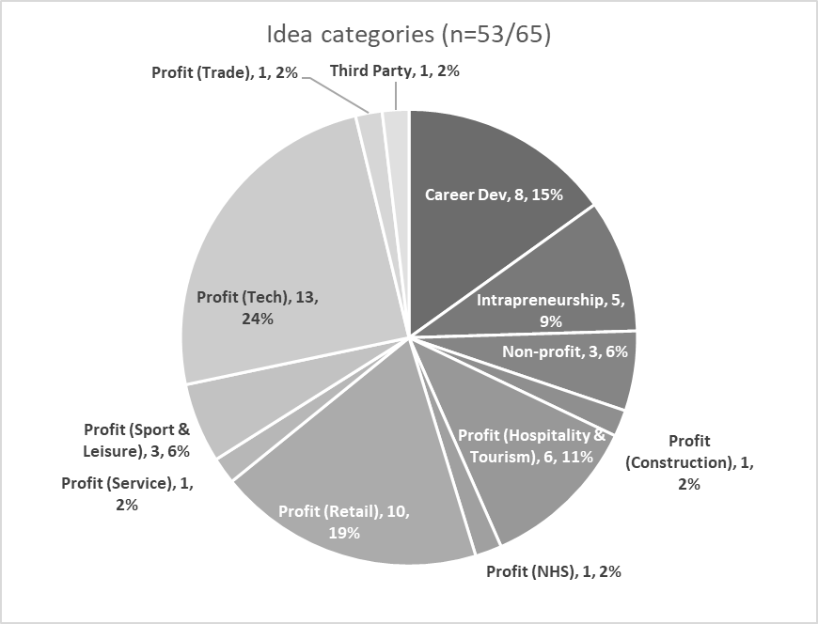
Figure 19 - A richness of idea types
While many were profit-related, others were not. Seventeen non-profit ideas amounted to 32% of the total (ideas for third parties, career development, intrapreneurship and third sector/non-profit). Moreover, while 36 ideas (68%) were related to profit-making enterprises, only 11 (30%) of these were born of aspiring entrepreneurs (Figure 20a). In the mix were the ideas of dreamers, designers, innovators and experimenters.
(a) (b)
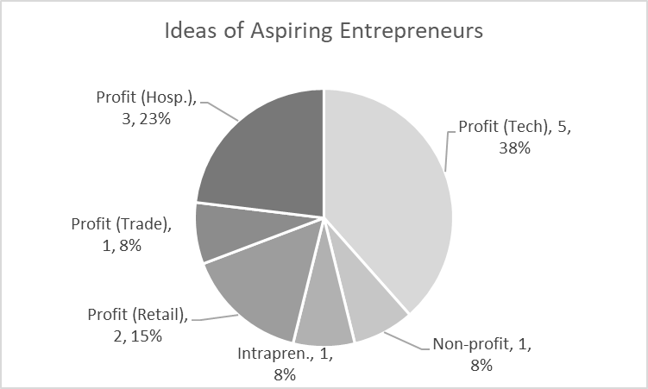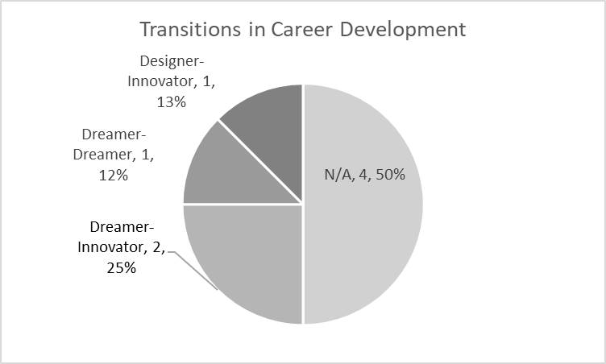
(c) (d)
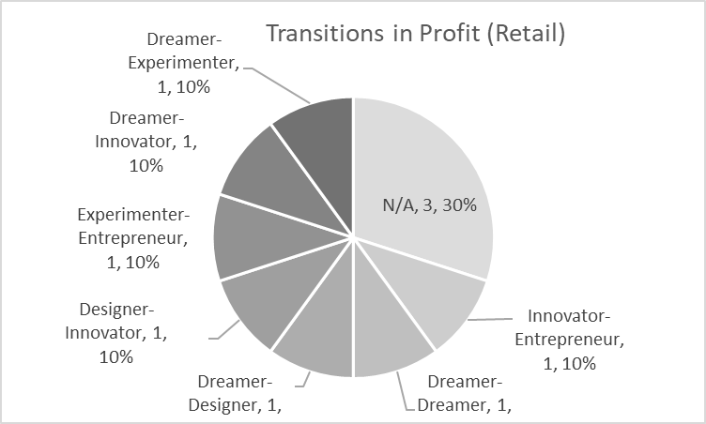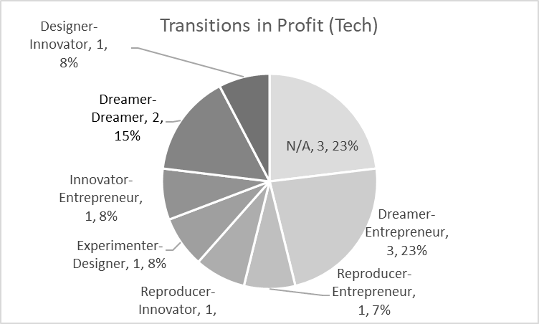
Figure 20 (a-d) - Ideas and transitions

Given the preliminary data and analysis from this module, I argue that—contrary to the specification of learning for and through marginal EE concepts and contexts—students with relatively low levels of confidence in their future career directions (a relatively high CI) should have their learning about enterprise set in the context of their own (transitionary) pre-dispositions and experiences in relation to the working world. Here, interesting transitions in enterprising learning can and have occurred. As Figure 20b to Figure 20d show in respect of some of the profit-related ideas, not every student wants to be an entrepreneur. Some see roles in innovation as employees in chosen industries; others aspire to experimenting or designing in retail contexts, and yet others can be happy dreaming about new tech-for profit applications.
Consider, rather than an elective, if this module was a core element of 21st century undergraduate EE education, in which students were encouraged to gain early clarity about their enterprising potential, without prematurely being guided toward reified and marginalised EE interests. What scope for encouraging a greater integration of EE with teachers and managers in education? If one considers setting an objective and key result (OKR) for this module—based on its aim: “…to develop confident, enterprising and creative graduates who will be able to cope with the ever-changing business environment, recognise opportunities and to take responsible and measured risks”, then might it be as well to set the first objective as the elimination (or at least reduction) of CI? I argue that a general approach to ‘learning about’ EE will better set the ground for a more focussed study about, for and through EE in the future.

Conclusions
In HE, EE learning is undertaken by an increasingly diverse range of students, from school leavers to adults (particularly regarding UK degree-apprenticeships). In this research paper I have reflected of a novel experiment in EE learning, grounded in critical theory. This concerns a 2nd-year undergraduate module in a UK HE business school. In the module design, I have dismissed an implied intent that students explore and assess a business opportunity to present a feasible business concept. Not all students (of business) want to be entrepreneurs, and in an elective where EI is far from evident, I used the module to create an environment where the students could develop an enterprising idea in the context of their own future in a workplace.
Reflecting on this approach to a broadly defined EE learning, my focus is on exploring the key dimensions of enterprising work. I eschew any notion of an idealised entrepreneurial identity. Furthermore, although the range of students drew from the business school environment, the nature of the lecture and seminar content did not call for in-depth prior knowledge of business and/or management functions.
In the paper I have introduced an essentially critical theory and method of artistic work. My reflection suggests that the outcomes from the module’s first cohort during Semester 2, 2022, have set sufficient groundwork for a more exacting, critical discussion of my approach. Here, in the context of HE’s great potential as a source of ideas and competences, and as a launch pad for enterprise, I have argued that it has been possible to encourage an appealingly diverse range of enterprising learning, rather than a narrow appeal to a minority of entrepreneurial students. In the module design, I have made it feasible for students to identify with the persona of the enterprise artist (the entrepreneur), or one of the six other personas: the dreamer, craftsperson, innovator (creative), experimenter, reproducer and designer. In this reflection on an application of critical theory, I have argued that these seven ‘personas of enterprise’ allow for a range of engagement from a variety of students who may be either uncertain of their future career direction or predisposed to adopt one persona over another. The knowledge/learning associated with the aspirational identification of one persona over another, may guide educators to better direct subsequent EE learning, in more narrowly defined and contextualised ways. I believe this approach through critical theory holds profound implications for how difficult-to-define career concepts might be approached in future 21st century higher education contexts.

Declaration of conflicting interests
The author declared no potential conflicts of interest with respect to the research, authorship, and/or publication of this article.

Funding
The author received no financial support for the research, authorship, and/or publication of this article.

Acknowledgements
The author wishes to acknowledge the insightful comments of Gustav Hägg and Marcel Lamoureux on an earlier draft of this paper.

References
Adorno, T. W. (2008) Lectures on Negative Dialectics. English. Edited by R. Tiedemann and R. Livingstone. Cambridge, UK: Polity Press (2003).
Atherton, A. (2004) ‘Unbundling Enterprise and Entrepreneurship’, The International Journal of Entrepreneurship and Innovation, 5(2), pp. 121–127. doi: 10.5367/000000004773863273.
Atkinson, D. M. (2007) Thinking the art of management: Stepping into ‘Heidegger’s shoes’. Palgrave Macmillan. doi: 10.1057/9780230589988.
Atkinson, D. M. (no date) Reimagining Capitalism: Applying Negative Dialectics for a Better Future. Vernon Press (forthcoming).
Bray, M. (2005) ‘Negative Dialectics’, in Protevi, J. (ed.) The Edinburgh Dictionary of Continental Philosophy. Edinburgh: Edinburgh University Press, p. 418.
Buchanan, I. (2018) ‘Critical Theory’, in Oxford Dictionary of Critical Theory. 2nd (onlin. Oxford University Press. doi: 10.1093/acref/9780198794790.001.0001.
Burns, P. (2016) Entrepreneurship and small business : start-up, growth and maturity. 4th ed. Palgrave Macmillan.
Clarke, A. P., Cornes, C. and Ferry, N. (2020) ‘The use of self-reflection for enhanced enterprise education: a case study’, Education and Training, 62(5), pp. 581–598. doi: 10.1108/ET-03-2019-0050.
Clouder, L. et al. (2020) ‘Neurodiversity in higher education: a narrative synthesis’, Higher Education, 80(4), pp. 757–778. doi: 10.1007/s10734-020-00513-6.
Cole, A. H. (1949) ‘The evolving perspective of businessmen’, Harvard Business Review, 27(1), pp. 123–128.
Cole, A. H. (1954) ‘Twentieth-Century Entrepreneurship in the United States and Economic Growth.’, American Economic Review, p. 35.
Conway, F. (2022) Entrepreneurship education, Entrepreneurship education. London, UK.
Easterbrook, W. T. (1949) ‘Possibilities for a Realistic Theory of Entrepreneurship. the Climate of Enterprise.’, American Economic Review, 39(3), pp. 322–335.
Frederiksen, S. H. and Berglund, K. (2020) ‘Identity work in entrepreneurship education: Activating, scripting and resisting the entrepreneurial self’, International Small Business Journal: Researching Entrepreneurship, 38(4), pp. 271–292. doi: 10.1177/0266242619889527.
Gartner, W. B. (1988) ‘“Who is an entrepreneur?” Is the wrong question’, American Journal of Small Business, 12(4), pp. 11–32.
Gibb, A. A. (2002) ‘In pursuit of a new “enterprise” and “entrepreneurship” paradigm for learning: creative destruction, new values, new ways of doing things and new combinations of knowledge’, International Journal of Management Reviews, 4(3), pp. 233–269.
Hägg, G. and Kurczewska, A. (2019) ‘Who Is the Student Entrepreneur? Understanding the Emergent Adult through the Pedagogy and Andragogy Interplay’, Journal of Small Business Management, 57(S1), pp. 130–147. doi: 10.1111/jsbm.12496.
Hägg, G. and Kurczewska, A. (2020) ‘Guiding the student entrepreneur – Considering the emergent adult within the pedagogy–andragogy continuum in entrepreneurship education’, Education and Training, 62(7–8), pp. 759–777. doi: 10.1108/ET-03-2020-0069.
Hannon, P. D. (2005) ‘Philosophies of Enterprise and Entrepreneurship Education and Challenges for Higher Education in the UK’, The International Journal of Entrepreneurship and Innovation, 6(2), pp. 105–114. doi: 10.5367/0000000053966876.
Hase, S. and Kenyon, C. (2007) ‘Heutagogy: A Child of Complexity Theory’, Complicity: An international journal of complexity in education., 4(1), pp. 111–118.
Hedges, M. R., Pacheco, G. A. and Webber, D. J. (2014) ‘What determines students’ choices of elective modules?’, International Review of Economics Education. Elsevier Ltd, 17, pp. 39–54. doi: 10.1016/j.iree.2014.05.003.
Henderson, S. and Segal, E. H. (2013) ‘Visualizing qualitative data in evaluation research’, in Azzam, T. and Evergreen, S. (eds) Data visualization, part 1. New Directions for Evaluation. Wiley Periodicals, pp. 53–71.
Hughes, D. and Smith, G. (2020) Youth Transitions: Creating Pathways to Success, Education Development Trust. Reading, UK.
Hytti, U. and O’Gorman, C. (2004) ‘What is “enterprise education”? An analysis of the objectives and methods of enterprise education programmes in four European countries’, Education + Training, 46(1), pp. 11–23. doi: 10.1108/00400910410518188.
Jones, B. and Iredale, N. (2010) ‘Enterprise education as pedagogy’, Education + Training, 52(1), pp. 7–19. doi: 10.1108/00400911011017654.
Jones, C., Penaluna, K. and Penaluna, A. (2019) ‘The promise of andragogy, heutagogy and academagogy to enterprise and entrepreneurship education pedagogy’, Education and Training, 61(9), pp. 1170–1186. doi: 10.1108/ET-10-2018-0211.
Kaplan, R. (1987) ‘Entrepreneurship reconsidered: the antimanagement bias’, Harvard Business Review, (May-June), pp. 84–89.
Knowles, M. S. et al. (2015) The Adult Learner: The Definitive Classic in Adult Education and Human Resource Development. 8th Ed. New York, NY: Routledge.
Lackéus, M. (2018) ‘Making enterprise education more relevant through mission creep’, Enterprising Education in UK Higher Education: Challenges for Theory and Practice, pp. 199–214. doi: 10.4324/9781315518138-12.
Lewis, B. W. (1937) ‘The Corporate Entrepreneur’, Quarterly Journal of Economics, 51(3), pp. 535–544.
Liguori, E. et al. (2019) ‘Under-researched domains in entrepreneurship and enterprise education: primary school, community colleges and vocational education and training programs’, Journal of Small Business and Enterprise Development, 26(2), pp. 182–189. doi: 10.1108/JSBED-04-2019-402.
Lourenço, F. and Jones, O. (2006) ‘Developing Entrepreneurship Education: Comparing Traditional and Alternative Teaching Approaches’, International Journal of Entrepreneurship Education, 4, pp. 111–140.
Mezirow, J. (1990) ‘How Critical Reflection Triggers Transformative Learning’, in Mezirow, J. (ed.) Fostering Critical Reflection in Adulthood: A Guide to Transformative and Emancipatory Learning. San Francisco: CA: Jossey-Bass, pp. 1–18.
Neck, H. M. and Corbett, A. C. (2018) ‘The Scholarship of Teaching and Learning Entrepreneurship’, Entrepreneurship Education and Pedagogy, 1(1), pp. 8–41. doi: 10.1177/2515127417737286.
QAA (2018) Enterprise and Entrepreneurship Education: Guidance for UK Higher Education Providers. Gloucester, UK: The Quality Assurance Agency for Higher Education.
Simmons, M. (2021) ‘Lessons learned by educator and students through experiential entrepreneurship’, Industry and Higher Education, 35(4), pp. 454–459. doi: 10.1177/09504222211023419.
Stevenson, A. and Waite, M. (eds) (no date) Concise Oxford English Dictionary. 12th edn. Oxford University Press.
Sull, D. and Sull, C. (2018) ‘With goals, FAST beats SMART’, MIT Sloan Management Review, 59(4), pp. 1–11.
Thomassen, M. L. (2017) ‘Gryffindor, Hufflepuff, Ravenclaw or Slytherin: Your Context influences Your Future. -How to address context in Entrepreneurship Education?’, in ECSB Entrepreneurship Education Conference - Cork, Ireland 10/05/17 - 12/05/17. Danish University Colleges.
Tight, M. (2020) ‘Student retention and engagement in higher education’, Journal of Further and Higher Education. Routledge, 44(5), pp. 689–704. doi: 10.1080/0309877X.2019.1576860.
Tomy, S. and Pardede, E. (2020) ‘An entrepreneurial intention model focussing on higher education’, International Journal of Entrepreneurial Behaviour and Research, 26(7), pp. 1423–1447. doi: 10.1108/IJEBR-06-2019-0370.
Walsh, L. and Gleeson, J. (2022) ‘Theorising and preparing students for precarity: how can leaders and educators better prepare students to enter an increasingly insecure workforce?’, Journal of Educational Administration and History, 54(1), pp. 7–19. doi: 10.1080/00220620.2020.1868981.
Williams, T. (2022) ‘Class attendance plummets post-Covid’, Times Higher Education (THE), 9 June.
Wolf-Wendel, L., Ward, K. and Kinzie, J. (2009) ‘A tangled web of terms: The overlap and unique contribution of involvement, engagement, and integration to understanding college student success’, Journal of College Student Development, 50(4), pp. 407–428. doi: 10.1353/csd.0.0077.
Xu, H. and Bhang, C. H. (2019) ‘The Structure and Measurement of Career Indecision: A Critical Review’, Career Development Quarterly, 67(1), pp. 2–20. doi: 10.1002/cdq.12159.

I apply the term critical theory as set out by Buchanan (2018) in which the critical theorist practices against the traditional conception of theory “which holds that it is a system of abstract (i.e. ahistorical, asubjective, and asocial) propositions which can be verified empirically”. In this sense, the theoretical approach set out in this paper acknowledges its subjectivity and its historic potential as a foundation for an emerging society.
A Guardian score of less than 60/100 for the subject of Business, Management & Marketing https://www.theguardian.com/education/ng-interactive/2021/sep/11/the-best-uk-universities-2022-rankings;
Internal document: Module Specification for Business, Creativity and Opportunism Skills for the Workplace of Today; a Level 5, 20 credit module.
As set out by Bray (2005), “Negative Dialectics [is] a term coined by Adorno for a process of thinking akin to Hegel’s ‘determinate negation’, in which the meaning of concepts is shown to be immanently and determinately related to that from which such concepts are distinguished—most fundamentally the material world itself. …[It] maps out the mutual implication and antagonisms within a series of conceptual ‘extremes’… [resisting] the temptation to ‘freeze’ these extremes as ontological firsts, or to order them as terms in a developing synthesis. Negative dialectics is thus ‘the logic of the wrong state of things’. …[It] opens the hesitant possibility for thinking otherwise, for thinking in the form of ‘constellations’ of concepts that cognise determinate objects by means of a field of conceptual antagonisms, without reducing them to that field. Negative dialectics thus embodies the sense of a debt to the ‘object’ that suffers under the domination of identity-thinking as well as the possibility of ‘reconciliation’ in which the thought no longer dominates nature.”
Notwithstanding the historic context, the Concise Oxford English Dictionary provides that the word ‘enterprise’ refers to 1) a project or undertaking or 2) a business or company (Stevenson and Waite, no date). Thus, broadly defined, an enterprise may be any meaningful undertaking of work, including the setting up and running of a business or company. In general terms, there is no suggestion (other than the qualification of a bold enterprise, that enterprise may exclusively refer to entrepreneurial organisations.
The antagonistic horizon is conceptually fluid over time (ahistorical), and therefore diachronic in nature.
I draw on Mezirow’s (1990, p. 1) distinction that “reflection enables us to correct distortions in our beliefs and errors in problem solving. [Whereas] critical reflection involves a critique of the presuppositions on which our beliefs have been built.” I denote (critical) reflection as a deepening progression from one to the other.
Capability is defined by Hase and Kenyon (2007, pp. 113–1114) as an holistic attribute concerning ‘the capacity to use one’s competence in novel situations…’. That is, capability is concerned with unknown contexts, while competencies are associated with known contexts.
https://monkeylearn.com/word-cloud/
For an introduction to OKRs see Sull and Sull (2018)

