Deep Learning Model Regression Based Object Detection for Adaptive Driving Beam Headlights

N.P Somasiri
Head of the Programme, Department of Computer Science, York St John University, London, United Kingdom
S.WICRAMASINGHE
Senior Director of Lighting, Rivian, Working, Surrey, United Kingdom.
S Ganesan
Lecturer, Department of Computer Science, York St John University, London, United Kingdom
As the world move toward automated driving (AD) continues, the future of adaptive driving beam headlights (ADB), is quickly coming into focus. Engineers, developers and designers are researching hard to identify the most effective combination of components to meet driver requitements for safety and visibility. ADB is a technology used in automotive headlight systems that automatically adjusts the beam pattern of the headlights to provide the best visibility for the driver while also reducing glare for oncoming drivers. The system uses cameras, sensors, and algorithms to detect the presence of other vehicles on the road and adjust the headlight beams accordingly. This allows the driver to have the highest level of visibility while minimizing the risk of dazzling other drivers. ADB is available on many vehicles including Europe, Asia & Middle East. Adaptive capabilities help reveal critical objects such as lane markings, pedestrians, and oncoming cars while avoiding using full high beams that might temporarily blind an oncoming vehicle driver. However, designing and developing a solution for the real road conditions is time-intensive, expensive, and complex. Hence, there is a requirement for adaptive driving beam headlights to detect the oncoming vehicles to reduce the glare for oncoming vehicle drivers. The detection solution needs to be fast, accurate and easy to integrate with automotive vehicular system. This paper reviews various detection techniques that can be used in implementing adaptive headlamps and application of the Machine Learning technique to predict fast and accurate object detection.
CCS CONCEPTS • Computing methodologies • Computer vision and pattern recognition • Object detection
Additional Keywords and Phrases: Adaptive driving beam, Adaptive front lighting system, Convolutional Neural Network, Region-based deep learning, Single Shot MultiBox Detector

- Introduction
An Adaptive Front Lighting System (AFS) is a feature found in some vehicles that adjusts the direction and intensity of the headlights based on the driving conditions. This can include steering angle, vehicle speed, and oncoming traffic. The goal of AFS is to improve visibility for the driver and increase safety by illuminating the road ahead more effectively. Some AFS systems also include automatic high-beam control, which can turn the high-beams on and off as needed to avoid blinding other drivers.

This paper analyses the detection techniques that can be used in the implementation of adaptive headlamps and presents the application of machine learning algorithm to predict fast and accurate object detection. In this case, the algorithm needs to quickly detect oncoming vehicles and adjust the beam pattern accordingly to avoid blinding other drivers. The study contributes to the state of the art in this field by highlighting the advantages of machine learning- based approaches and offering insights into their practical applications.

To define how the lighting system operates as an AFS. The system provides beams with differing characteristics to adapt automatically to varying conditions. AFS contains the following classes of low beam: Class C - Country/Neutral, Class V- City/Town and Class E-Motorway and AW - Adverse Weather. Country light (Class C) is defined as the standard low beam (low beam pattern) that is currently used on the vehicles. City light (Class V) is activated to allow greater visibility whilst driving in city traffic conditions and to more easily identify other road users such as pedestrians and cyclists, whilst reducing glare to oncoming vehicles.
Class E, Motorway light enables the driver to be more focused on far vision and reduce distractions caused by excessive light at the sides of the vehicle. These beam patters are displayed in Figure 1- 4. [10]

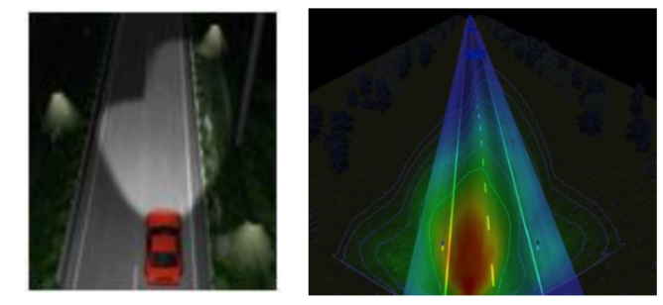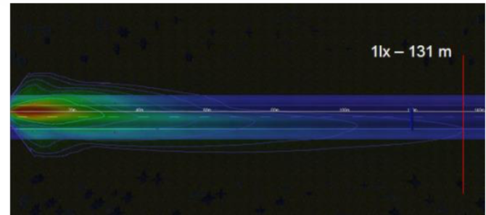
Figure 1: Country Light (Class C)
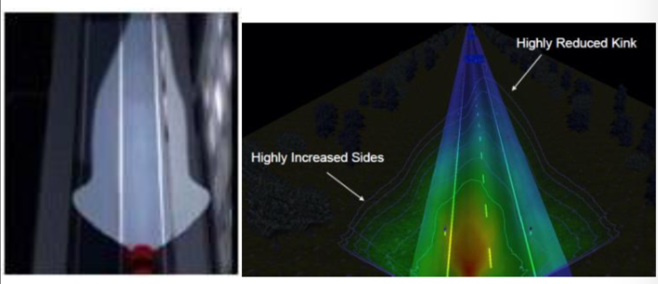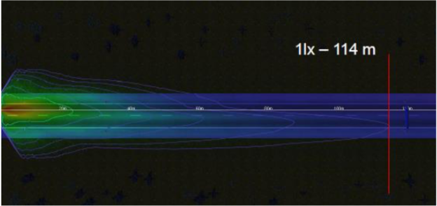
Figure 2: City/Town Light (Class V)

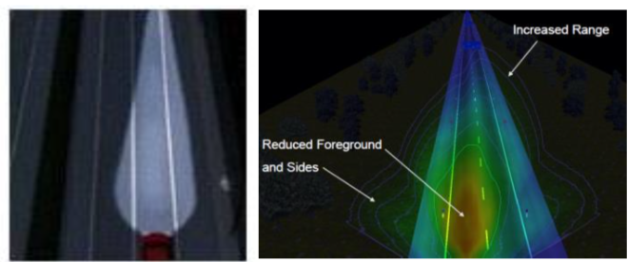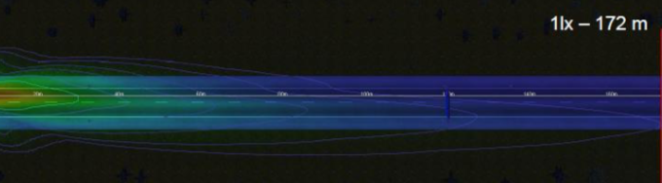
Figure 3: Motorway Light (Class E)

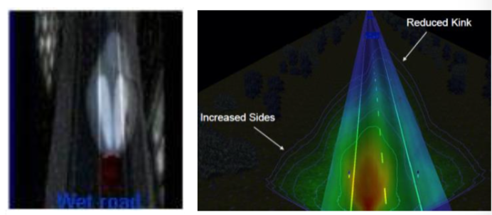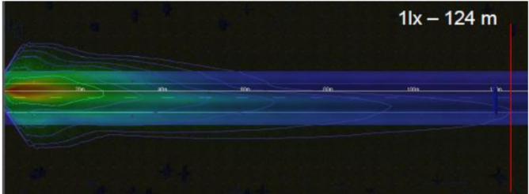
Figure 4: Adverse Weather Mode (Class AW)
- Current state of technology in adb research
In the realm of adaptive driving beam headlights, there has been a significant amount of research and development focused on the design and implementation of these systems. Currently, ADB technology is available in many vehicles in Europe, Asia and the Middle East. These systems have shown to improve driver visibility and reduce risk of dazzling other drivers. However the implementation of algorithms in the context of ADB poses several challenges including the requirement for large amounts of training data, the need for robust and reliable algorithms, and its ability to operate effectively in real world scenarios.

The research is focused on the development of fast, accurate and efficient algorithms for detecting and tracking other vehicles on the road, in real-time. Adaptive Driving Beam (ADB) Headlight detection algorithm is a crucial component of ADB technology. It uses input from cameras, sensors, and other information to determine the presence of other vehicles and adjust the beam pattern accordingly. The proposed algorithm operates in real-time, detects objects quickly with excellent accuracy, and adapts smoothly to changing road conditions. As a result of this, we will be able to determine the optimal beam pattern that provides clear visibility to the driver while minimizing glare for oncoming traffic.
- Adaptive driving beam (ADB) headlights
Adaptive driving beam (ADB) headlights are a type of advanced lighting system that can automatically adjust the beam pattern of a vehicle's headlights to improve visibility and safety while driving. Detection techniques used in ADB headlights include:
- Camera-based detection: A camera is mounted on the front of the vehicle and is used to detect the presence of other vehicles, pedestrians, and other obstacles in the road ahead. The camera feeds this information to the ADB system, which can then adjust the beam pattern of the headlights accordingly.
- Radar-based detection: A radar sensor is mounted on the front of the vehicle and is used to detect the presence of other vehicles, pedestrians, and other obstacles in the road ahead. The radar sensor feeds this information to the ADB system, which can then adjust the beam pattern of the headlights accordingly.
- Lidar-based detection: A lidar sensor is mounted on the front of the vehicle and is used to detect the presence of other vehicles, pedestrians, and other obstacles in the road ahead. The lidar sensor feeds this information to the ADB system, which can then adjust the beam pattern of the headlights accordingly.
- Ultrasonic-based detection: Ultrasonic sensors are mounted on the front of the vehicle and are used to detect the presence of other vehicles, pedestrians, and other obstacles in the road ahead. ADB can then adjust the beam patterns of the headlights based on the information supplied by the ultrasonic sensors.
Overall, the goal of these detection techniques is to automatically adjust the beam pattern of the headlights to provide the best possible visibility while minimizing glare for other road users. The system architecture of adaptive driving beam (ADB) headlights typically consists of several main components:
- Sensor module: This module includes one or more sensors such as cameras, radars, lidars, or ultrasonic sensors, which are mounted on the front of the vehicle. These sensors are used to detect the presence of other vehicles, pedestrians, and other obstacles in the road ahead.
- Processing module: This module receives the data from the sensor module and processes it to determine the location, speed and trajectory of the detected objects. The processed data is then passed to the control module.
- Body Control module: This module receives the processed data from the processing module and uses it to control the beam pattern of the headlights. It can adjust the beam pattern to avoid shining light on other road users and to provide the best possible visibility for the driver.
- Actuator module: This module receives the control signals from the control module and adjusts the position of the headlights accordingly.
- Communication module: This module facilitates communication between the different components of the ADB system, as well as with other systems in the vehicle such as the vehicle's onboard computer.
- Human Machine Interface (HMI): This module allows the driver to interact with the ADB system, such as turning it on or off or adjusting the settings.
- Object Detection Algorithm: This module is responsible to detect the object using the sensor data, it could be using YOLO [4], or any other algorithm to detect the objects on the road.
- Power Management module: This module is responsible to manage the power consumption of the ADB system and ensure that it doesn't drain the vehicle's battery.
Overall, the goal of the logical architecture of ADB headlights is to provide the driver with the best possible visibility while minimizing glare for other road users by using sensor data, processing it and adjusting the beam pattern accordingly.
  - ADB Operation Mode
ADB mode will become operative under these conditions.
Table 1: ADB Operation Mode Condition

Style Tag | City Light | Country Light | Motorway Light | Adverse Weather Mode
ADB Operative | x | √ | x | √
- vehicle detection techniques
To ensure optimal performance, adaptive headlamps must be able to detect and track targets. Detection involves identifying an object within the frame, while tracking involves using information from previous frames, such as size, shape, and direction, to predict the object’s position in subsequent frames. This method is preferred as it reduces the computational demands of repeatedly detecting the object in each frame. However, it is important to note that simultaneous detection and tracking can result in failure, as it is heavily reliant on the characteristics of the target. Nevertheless, a tracking algorithm can still predict the next position based on the previous frame’s information on speed and vehicle position. This section will examine various techniques used in object detection, as shown in Figure 5.

Figure 5: Vehicle Detection Techniques
An object or vehicle detection method entails outlining the area of interest, extracting characteristics, and categorization. There are different ways to detect vehicles in videos, such as models based on appearance or motion [2]. Appearance model detection relies on factors like color, size, or shape, while motion-based detection compares the movement of objects to the background. Appearance based models use prior knowledge to distinguish the foreground from the background. Various classifiers like SVM, deep-learning based models like R-CNN, Fast R-CNN, or regression techniques like YOLO, SSD can be used to detect vehicles.
There are several machine learning techniques that can be used for road object detection, including:
- Convolutional Neural Networks (CNNs): These are a type of deep learning algorithm that can be used to automatically extract features from image data. They are often used in object detection tasks, such as detecting cars, pedestrians, and traffic signs in road images.
- Region-based CNNs (R-CNNs): These are a type of CNN that are used to identify objects within a specific region of an image, rather than the entire image. R-CNNs have been used in road object detection to detect cars, pedestrians, and traffic signs.
- You Only Look Once (YOLO): This is a real-time object detection algorithm that can detect multiple objects within an image. YOLO has been used in road object detection to detect cars, bicycles, and pedestrians
- Single Shot MultiBox Detector (SSD): This is another real-time object detection algorithm that can detect multiple objects within an image. SSD has been used in road object detection to detect cars, bicycles, and pedestrians.
- Faster R-CNN: This is an object detection algorithm that is faster than R-CNN by using a technique called Region Proposal Network (RPN) to detect objects.
- RetinaNet : this is another object detection algorithm that is similar to Faster R-CNN and it uses a technique called Focal Loss to address the issue of class imbalance.
- Deep Learning based Object Detection using YOLOv3: This is an object detection algorithm that uses deep learning to detect objects within an image. YOLOv3 is known for its real-time object detection capability [4].
Region-based deep learning methods, such as RCNN, can be time-consuming and repetitive. While SPP-Net offers efficiency, it also requires multiple layers which can add to the time consumption. Faster RCNN attempts to address this issue, but it may not perform as well when detecting objects with changing shapes [5]. This can be concern for adaptive headlamp systems, where the speed and shape of the objects are constantly changing. In contrast, regression-based models like YOYO and its variants have demonstrated high performance and are well-suited for object detection in adaptive headlamps.
YOLO (You Only Look Once) is a real-time object detection algorithm created by Joseph Redmon and Ali Farhadi that uses convolutional neural networks (CNN) to detect objects in image and videos. It works by dividing an image into grid of cells and predicting the presence of objects within each cell. Each cell is responsible for predicting a set of bounding boxes around objects and the class of the object within those bounding boxes. This can detect multiple objects in an image and can classify them into different classes. One of the key advantages of YOLO algorithm is its speed. It can process images and video in real-time and is capable of detecting objects at a high frame rate. This makes it suitable for use in applications such as self-driving cars, security cameras, and other systems that require real-time object detection. Overall, YOLO is a powerful object detection algorithm that can be used in a variety of applications due to its speed, accuracy and ability to detect multiple objects and classifying them into different classes.
- Object Detection Experiment
YOLO 3 real-time object detection algorithm in Figure 6 that detects multiple objects within an image has been used in road object detection to detect cars, bicycles, and pedestrians in this study After obtaining the knowledge through the analysis of the training set, we test our network by going through a few night drives to ensure our model has good detection accuracy and performance during night conditions. We also carried out drive testing in adverse weather conditions to check the performance of the model. As shown in Figure 7, our system creates multiple vehicle candidates, predicts vehicle probabilities, and coordinates with good average accuracy with 0.86. Object detection probability score is shown in Figure 8.
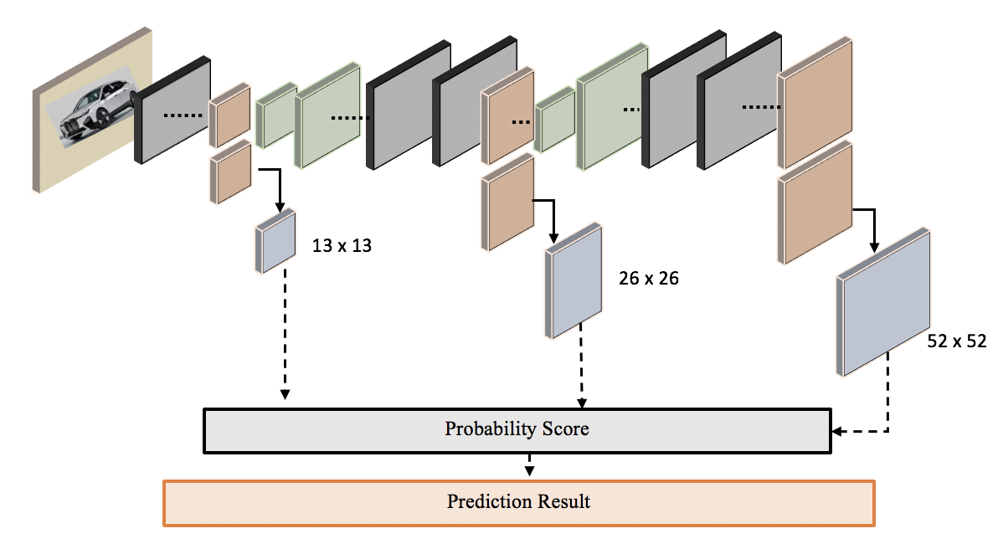
Figure 6: Deep Learning based Object Detection using YOLOv3 for Vehicle detection on UK Motorway for ADB operation.
Figure 7: Vehicle detection on UK Motorway (M40) during night drive for ADB operation.
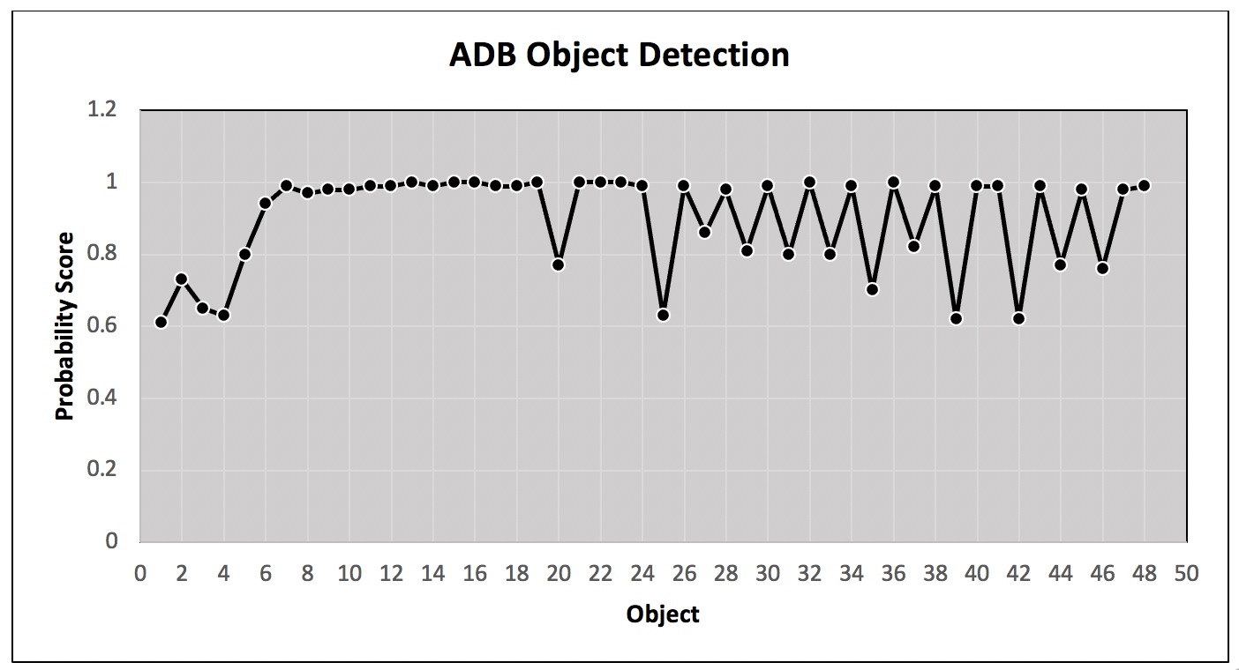
Figure 8: Object detection probability score during night drive for ADB operation.
- conclusion
There has been significant amount of research conducted in the field of object detection and various methodologies have been developed. However, there are few studies that have applied deep learning to investigate Adaptive Drive Beam (ADB) technology, which uses automated beamforming to control headlight direction. The limitations of existing models are discussed in section 4. The results presented show that a specific algorithm has been chosen to detect objects for ADB operation in vehicles. This algorithm performs well under all conditions, particularly low-light situations. Additionally, real time-data is used to simulate night driving scenarios using this algorithm. The result and accuracy plot in Figure 6 demonstrate that this algorithm is highly effective for ADB operation in all conditions.

REFERENCES
- Seelam Shanmukha Kalyan; Voruganti Pratyusha; Nandikonda Nishitha; T.K. Ramesh.2020.Vehicle Detection Using Image Processing. IEEE International Conference for Innovation in Technology (INOCON)
- R.Roopa Chandrika, N.S.Gowri Ganesh, A.Mummoorthy, K.M.Karthick Raghunath.Vehicle Detection and Classification using Image processing. 2019. International Conference on Emerging Trends in Science and Engineering (ICESE). https://doi.org/10.1109/ICESE46178.2019.9194678.
- Xiao-Feng Gu, Zi-Wei Chen, Ting-Song Ma, Fan Li, Long Yan. Real-Time vehicle detection and tracking using deep neural networks. 2016 13th International Computer Conference on Wavelet Active Media Technology and Information Processing (ICCWAMTIP). https://doi.org/10.1109/ICCWAMTIP.2016.8079830
- Joseph Redmon, Santosh Divvala, Ross Girshick, Ali Farhadi. You Only Look Once: Unified, Real-Time Object Detection. 2016. https://arxiv.org/pdf/1506.02640v5.pdf
- Glenson Toney, Cherry Bhargava. Adaptive Headlamps in Automobile: A Review on the Models, Detection Techniques, and Mathematical Models. 2021. IEEE Access, Volume 9, Journal Article, IEEE.
- B. Tian, B. T. Morris, M. Tang, Y. Liu, Y. Yao, C. Gou, D. Shen, and S. Tang, Hierarchical and networked vehicle surveillance in ITS: A survey. IEEE Trans. Intell. Transp. Syst., vol. 16, no. 2, pp. 557–580, Apr. 2015, https://doi.org/10.1109/TITS.2014.2340701.
- K. Mikolajczyk and C. Schmid. A performance evaluation of local descriptors. Proc. IEEE Comput. Soc. Conf. Comput. Vis. Pattern Recognit., Jun. 2003, p. II, https://doi: 10.1109/CVPR.2003.1211478.
- N. Najva and K. E. Bijoy, ‘‘SIFT and tensor based object detection and classification in videos using deep neural networks,’’ Procedia Comput. Sci., vol. 93, pp. 351–358, Jan. 2016, https://doi: 10.1016/j.procs.2016.07.220.
- C. Angulo, X. Parra, and A. Català. K-SVCR. A support vector machine for multi-class classification. Neurocomputing, vol. 55, nos. 1–2, pp. 57–77, 2003, http://doi: 10.1016/s0925-2312(03)00435-1.
- Ing.habil,Tran Quoc Khanh 2019. 13th The International Symposium on Automotive Lighting (ISAL2019). Darmstädter, Lichttechnik. Volume 18.

First Author | Position: Dr Nalinda Prasad Somasiri
 | Research Field: AI, Machine Learning & Blockchain
 | Homepage URL: https://www.yorksj.ac.uk
Second Author | Position: Mr Shammika Wickramasinghe
 | Research Field: Automotive Exterior Lighting
 | Homepage URL: https://rivian.com
Third Author | Position: Ms Swathi Ganesan
 | Research Field: AI, Machine Learning & Computer Vision
 | Homepage URL: https://www.yorksj.ac.uk

