Long term gain from short term doing
One of the key messages that came across from the speakers at i2c2 was that of trying small scale projects out and using those to develop your service. As Ros Bell said, in response to one of the parallel sessions, “Loving Karen Munro's tactical urbanism talk at #i2c2 "short term doing, experimenting, testing". This appeals to me. A lot.” (Bell 2014).
In Information Learning Services at York St John University, we are encouraged to investigate new ways of engaging with our community through various means. One of these is the small scale project, which can be instigated and evaluated quickly. Engaging with the community is core to our mission, with a key enhancement area in the 2012-15 operating plan being, “collaborating with other departments to ensure a holistic approach is taken to student support and develop better communication channels with students and staff” (Information Learning Services 2012). This chapter will outline three small scale projects which were established in response to this and, so far, look to be beneficial in contributing to the learning of those who interact with us and their satisfaction with the environment we provide:
- Book a librarian service
- Bite sized lectures and videos
- ILS feedback wall
Book a librarian
This is an example of using technology designed and implemented for one reason in a new way. The book a librarian service works via the YSJ internal tutorial booking system. This was set up to allow members of staff in the faculties to advertise the times they are available for appointments outside of the usual lecturing timetable (e.g. for ad hoc assignment help or to give personal tutees the opportunity to see them). The system was designed by the University’s development team in the ICT department to allow the tutor to offer appointments of any length and at the times of their choosing. They can be set up with regular slots over a period of weeks or months, or can be done on a day by day basis. The students can look up the member of staff, see when appointments are being offered and book in. The member of staff then gets an email to say that that student has booked in at that specific time.
Every member of staff has the opportunity to set up appointments and offer them to students (or indeed staff!), not just those on academic contracts. The Academic Liaison Librarians decided to see if this system could solve some issues that had arisen with encouraging students to approach the team for help.
Firstly, there was the issue of students taking the opportunity for tutorials with Academic Liaison Librarians. Although we had various cards, booklets and web pages offering the chance for tutorials, with our email addresses and phone numbers, it was felt that this may be too intimidating for some students. We wondered if an alternative method of booking, familiar to them as a result of its use with tutors, would encourage more to sign up.
There was also a problem with the length of time it took to arrange a time for an appointment, once a student had contacted us. Negotiating a time convenient to both parties could take up to 10 emails, over a period of days. A booking system should make this more streamlined.
Furthermore, we needed to manage expectations more. Some students would email and ask if they could see us within a matter of hours. With commitments elsewhere, such as university committees and teaching, it would often happen that these messages would not be picked up until after the time suggested by the student, leading to discontent.
It was therefore decided that each Academic Liaison Librarian, along with the Academic Technologies Trainer for Students, should populate the booking tool with offerings of tutorials of between 30 minutes and an hour, throughout the week and over the year (not just the academic year). The link to each individual’s booker was put in a variety of places, to be used by any member of the YSJ community. So, the links were put in each email signature and out of office reply, so that anyone receiving these could choose to use it if they wished. The links were distributed to faculty staff members, who placed them in modules in the Virtual Learning Environment, module handbooks, presentations and other programme information. They were also used extensively on the Information Learning Services web pages.
It was also important that the links were accompanied by contextual information where possible, as it is often the case that members of the community do not know the role of an Academic Liaison Librarian. The description that accompanies the booking link therefore focuses on how the tutorials can help, as well as who offers them or their role.
Initial analysis of ad hoc tutorial statistics indicate that this has been a contributing factor to an increase in take-up. For example, one Academic Liaison Librarian saw a total of 66 students in ad hoc tutorials in the 2011/12 academic year, before the introduction of the booking tool. This rose to 102 in 2012/13 and 142 in 2013/14. Many of these have been in groups of two or more, for 30 minute tutorials, so the time pressures are not as severe as they may seem, with an increase of just 11.5 hours per annum over the three years in question. This is in part because of linking the tutorial booker to specific modules and programmes, with associated assignments, such as the example of bite-sized information literacy in Primary Education, outlined in the next section.
Bite-sized information literacy
The bite sized information literacy project began in 2011, as a collaborative project between the library and Faculty of Education and Theology. The details of the early project are outlined in McCluskey (2013); to provide short (10 minute maximum) but regular information literacy lectures at the beginning of timetabled programme sessions, backed up with the opportunity for group or individual bookable tutorials, focussed upon a specific assignment.
The content of each session is designed to introduce some theoretical aspect of information literacy; certainly no demonstrating of interfaces! For example, one recent addition was on how to investigate what the resource you have found online is, in terms of its type (e.g. a policy document or a newspaper article). Students are using general web searches to find research information (and why shouldn’t they?) and what they are finding is, in the main, relevant to their need. This is increasing with more open access research reports being put online. They are evaluating the content and finding it appropriate. However, there is a tendency for the students to think that anything they find through such a search is a ‘website’ and to reference (or in some cases, entirely dismiss) it as such, despite the fact they are actually finding PDF versions of Governmental reports, pre-print journal articles or other research outputs. This is then affecting how they incorporate the information in to their own work, as they do not understand the context of what they have found. One of the bite-sized lectures aimed to address this.
It is therefore a key aim of a bite-sized lecture series to be appropriate to the programme and to concentrate on theoretical issues such as recognising that there are many different types of information and how to identify and evaluate them in relation to the task in hand. Given the introductory nature of these inputs, it is important to allocate time and resources to offering follow ups on a group or individual basis and also have appropriate learning objects, such as help guides and videos, to support on a more practical basis.
For this reason, the project has now grown to include short, 60 second, videos. These provide more practical, procedural help, to complement the theory based lectures and free up time for librarians, who can concentrate less on advising how to navigate to and through individual interfaces. It was decided to set a limit of 60 seconds for the content of the videos (there are introductory and extra information slides which add a little to it) to ensure they were to the point and avoid putting users off watching to the end. Some examples include refining search results to journal articles only in the discovery tool, accessing known journal titles and borrowing a book; the sort of thing that new members of the community may want to discover for themselves and that more the experienced may want refreshers on.
The videos are held in the YSJ media library, so are accessible to anyone doing a search in there. They can also be linked to from any other website and embedded in the VLE or ILS website as needed.
The idea of the bite-sized approach has been enthusiastically received by several academics, some of whom have then suggested further collaborative projects. For example, a senior lecturer in education approached his academic liaison librarian about using the ’10 days’ concept to market 10 bite-sized videos to introduce the key features of RefWorks to new students on a Foundation Degree, with associated lectures on the concept of intellectual property and avoiding plagiarism. This is now in development.
It is important, now these initiatives have been introduced, to ensure ILS encourages dialogue and gets feedback on the projects it has undertaken. One key tool in doing this is the ILS feedback wall.
Feedback wall
The ILS feedback wall was introduced as part of a wider project to increase dialogue between ILS and those who use its services. A re-design project gave the opportunity to rethink many of the established procedures. The library (as was) had regular questionnaires, feedback projects and user group meetings, but nothing to enable immediate dialogue.
We now have one small wall of the library building covered in ‘whiteboard’ paint, but at the beginning of the project, we simply applied temporary whiteboard sheets to the surface. This meant we weren’t incurring a lot of expense, should the project be abandoned quickly. Pens are provided and anyone can leave feedback, questions or comments. These are then responded to by ILS staff, depending upon who is best placed to do so. This has become a core part of our strategy to engage with the rest of the community and improve our offerings for them.

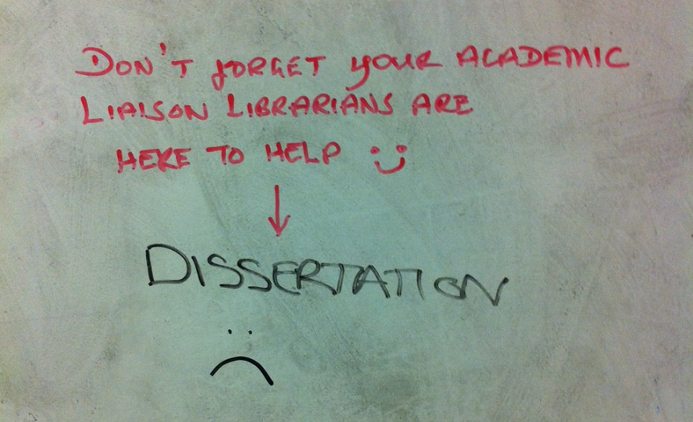

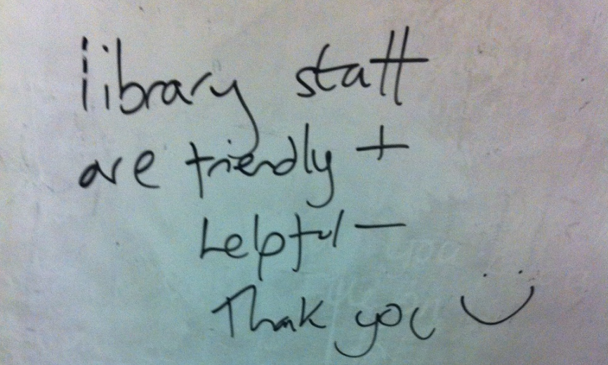
Of course, not everything written on the wall is positive. Common issues include a perceived lack of resources in a subject area, which may indicate an actual gap that needs filling or that students are unable to navigate our systems to find what we do have:

Question/Comment | Reply
More books on Buddhism in Thailand. Thailand religion & Sri Lanka. | Please ask your tutors to send orders through for these – we have money to buy them.
Could there be a Caribbean lit sub-section/post colonial lit sub-section. | Books in the library are shelved using the Dewey system, so that literature of the Caribbean, or other countries, or different topics, are shelved together. Always check the shelf number on Discover and watch out for interesting ebooks on the topic too! If you are having problems locating items, please ask at Question Point.
Please add more IT books! | Email (librarian’s email address) to tell which ones you need or let your tutor know and s/he can order some new things
More copies of the the ‘New Collins Japanese – English dictionary’. It’s the best one, but there’s only one copy. Also the second edition of ‘The Routledge comprehensive Japanese grammar’ would be nice | Yes, we will buy these texts ….thanks!

Another issue which occurs frequently is the old problem of misunderstanding what Athens is and how subscriptions work. We use Athens as one authentication method, but the convoluted nature of logging in with local details often causes problems and we try to use EZProxy where possible. The misconception that Athens is the magic answer to accessing anything with a paywall persists, however, and the feedback wall gave us further evidence that we need to explain subscriptions, open access and the whole issue of access to research much more:
Question/Comment | Reply
Could we have access to OpenAthens. Seems like they hog all the best articles. | Athens is used here. Please come to Question Point and ask to speak to an Academic Liaison Librarian who will be able to help you with this.
Why isn’t there access to ALL (mentions very large journal publisher) Journals online? | Please ask to talk to your Academic Liaison Librarian, who can explain more about journal subscriptions.
Primary Ed - more online journals;  More up to date sources | There are lots of journals for Primary Ed, with holdings through to 2014.  Ask (name of librarian) if you want advice on accessing them.

An unexpected bonus is that the students now communicate with and reply to each other on the wall, often beating us to it in the speed of reply! In terms of managing expectations, it is good for us to know that they are engaging with each other and letting others know that not everyone agrees with their point of view.
I don’t think there will be enough computers for all students in YSJ. But can you be considerate? If you are using your laptop instead of the computer in front of you, can you PLEASE move to empty tables instead?

Hard copies instead of electronic books. They are annoying to read! …Agree! …sometimes you can find copies, just change your search criteria! … Agreed, or try Google books …….This is the exact opposite of what I want ..… What if you can’t get to the library? E-books are easier to find your quote as well

Why are library fines so so expensive? Writing my dissertation so need 10/11 books out at one time and you’re charging in some cases 60p per day!?! (Even though no one else needs them) YSJ gets enough of my money!!! ….The fine is an incentive to get you to return the books, so others can use.

We keep a record of everything so that we can spot trends. Excellent work in noting all of the comments by our administrative staff in a single spreadsheet also means that we have a growing data bank to draw on. We plan to use the NVivo to analyse it as part of a large project on ensuring we understand the needs and concerns of the community.
Long term gain from short term doing
Each of the three initiatives outlined here were instigated as short term projects to answer immediate needs. They cost little, if anything, in terms of money or staff time to set up. However, each has shown its worth in helping Information Learning Services to develop better communication with, and understanding of, other members of the university community.
The book a librarian initiative arose from taking advantage of a service implemented for another part of the University community. Simply by adding librarian tutorial opportunities to the booking service, an alternative method of obtaining advice from our team was offered and allowed us to widen the opportunities for interaction.
The bite-sized information literacy project was a pragmatic response to a lack of opportunities to embed information skills in the busy Primary Education curriculum. After a couple of years, it became apparent that it was having a positive effect, as NSS scores for this programme increased and take-up of library tutorials rose. Feedback from the tutors on the course also indicates that the quality of resources used in the assignments has risen. It is now being extended in to different formats.
The feedback wall has become a focal point for dialogue in the library building. It encourages constructive comments and, in the main, it has been used for these. It took a little while to build up, but now it is full almost every week of the term. Not only do we get immediate responses to issues, we also have a large data bank to analyse, to help inform future projects.
Each has arisen from the concept of short term doing, as was evident in many of the talks at i2c2. They show the value of testing out ideas; they may well lead to some new, innovative practice at your place of work.
References
Bell R. (2014) ‘Loving Karen Munro's tactical urbanism talk at #i2c2 "short term doing, experimenting, testing". This appeals to me. A lot.’ [Twitter post]. Available from: https://twitter.com/ros_bell/status/441557237467975680 [Accessed 26 March 2014].
Information Learning Services (2012) Information learning services operating plan: 2012-15. York, York St John University.
McCluskey C. (2013) Mapping and evaluating the information landscape. In: Secker J. and Coonan E. eds. Rethinking Information Literacy: A Practical Framework for Supporting Learning. London, Facet, pp. 41-53.

