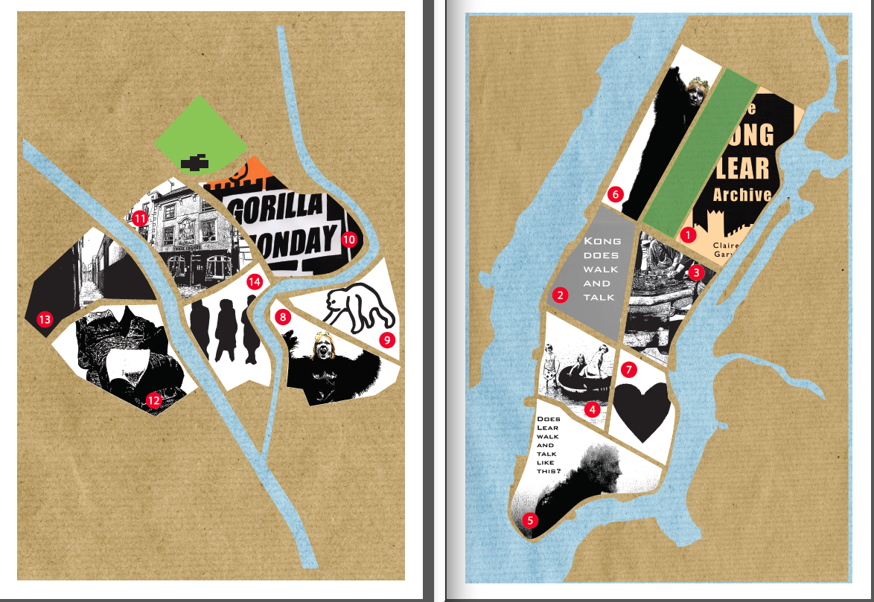

Claire Hind & Gary Winters sit down after the coffee break, START READING, AND REFER TO THE RED NUMBERED DOTS ON THE MAPS, BEGINNING ON THE UPPER EAST SIDE 1. Let’s make a world: A world to be alive in and a silent world to sleep in. A world of someone as King Lear, of some-thing on film, a world of sketches. People walking around a city, people running through another city. Old things in pieces, treasured things in bits, new things boxes. Let’s make a world - a world to be alive in, a world of someone as King Lear, of some-thing on film, a world of sketches and hybrids. Let’s start to live. Kong Lear has a heart. Has a funny bone, has a head, has dreams, has a skin, has a face. Kong Lear has footsteps, has a past, has fury, has an etiquette. 2. Its form: Our work together thus far has produced a 12minute Super 8mm film and a limited edition boxed archive of loose-leaf pages made up of mixed media images and performance texts, whose pages represent a range of what might be classed as ephemera stemming from the process of making the film, presenting it in a gallery exhibition and also its promotion and dissemination. It surfaces some of the crossroads and meeting points of the material we’ve become interested in, and includes quotations from ourselves, starting: We didn't want to make some half-narrative or remake of the film or play, instead a re-use of some of the texts and images from those figures. Some of those texts mutated from this basic impetus, with the introduction of Sigmund Freud into the mix - another heavyweight - to create the portrait of Kong Lear, which is, of course, silent. Some shots that we chose are just the nice shots. You can't get away from the nice quality of the Super 8mm film and y'know those happy accidents of the light that create certain moods. Sometimes you just have to work with what you have, when the light is alright for example, or when a section doesn’t immediately appear to fit in, and we've tried to keep with a very rudimentary and amateur, even home-movie, feel. And it's also very much about using this old technology, in comparison to recent technology, where it somehow has kind of limits, provides a limiting device - things that can’t be undone or redone very easily. For example, in the camera bits of crap get caught in the gate or on the film and when the film is transferred to digital there's all sorts of rubbish on the frames; hairs, bits and bobs, dust, so we used these sections of footage and named it blip crap. Little pauses and excursions into other worlds. PAUSE. And then there is a three-week process, to shoot, to get it developed and then transferred. So we quite liked the idea that we'd shoot something for a process that takes time to come back to you and then whatever arrives in the post is what you've got to work with. You can't just rush out, as you could do with digital and say “we'll re-do that shot”. I think that's quite nice, y'know, that there's a contingency within that, similar to say a stream of consciousness writing exercise, when you decide that what you get from a process is what you will take forward and work with. 3. Its head: Speaking through psychoanalytic interpretations is to suggest that the concept of this dark space, the inaccessible part of our psyche has a playful monster that we both fear and find attractive - the unhelmlich according to Freud is the uncanny and the monster that is mischievous, like Slavoj Žižek’s reference (in Fiennes 2006) to the Marx Brothers character of Harpo who he suggests is the id – silent, yet mischievous and very troublesome. Harpo is the character that does not speak. Lear demands his daughters to speak. Sallis (2000) suggests that in the text of King Lear nature is constantly at issue, as are also deformity of nature and excess of nature that is monstrosity. In the opening scene in which Lear demands from his daughters their professions of love, ‘his expressed intention of balancing bounty with nature serves to accentuate how thoroughly he is blinded to nature’ (Sallis, 2000). Yet, in the depths of his madness and speaking at nature, he confronts his id, the monster that is his shadow. In the window that was once an empty shop, Kong Lear stares deep into an image of herself, referencing King Kong catching his reflection in the water and recognising himself as beast, or as a nine year old girl. 4. Its dreams in its head: REMEMBER A CHILDHOOD DREAM, THEN REFER TO THE DOT IN THE FINANCIAL DISTRICT 5. Its crown: Susan Bennett’s 1995 essay, Production and Proliferation: Seventeen Lears, through whose mantra ‘Many new ways to play old texts and many more old ways to make new texts’ contextualises a study into productions of and reinterpretations of Lear over a 10 year period. She discusses 12 significant productions of King Lear and states that ‘it would seem that the paradigms in theatrical practice have not been so readily revolutionised’ and goes onto say that ‘it might be argued in the case of performance that Shakespeare’s texts have shifted very little in the last decade’ (Bennett, 1995). She argues for a ‘tenacious web of nostalgia and tradition that has Shakespeare as performance in its grip’. She further describes five other works however, that do reinvent Lear and all of these being what she calls ‘reinterpretations’, ‘reinventions’, and lists them including, and I draw here upon two: Welfare State’s filmed version of a site specific piece entitled King Real and the Hoodlums where ‘fifty or so Barrovians were employed, none professional actors, to create the ‘junk’ submarine that formed the centrepiece of the production’s procession through Barrow (where the size of the cast expanded considerably as others joined the hoodlums in their march) and was constructed by young apprentices from VSEL. (...). This was Barrow’s own youth worrying out loud and in public about the manufacture of weapons and behaviours that produce mass devastation’ (Bennett, 1995). Next, Bennett describes The Women’s Theatre Group’s production of Lear’s Daughters as ‘undoubtedly a herstory’ that it produces ‘gaps and absences of Shakespeare’s texts’ Bennett discusses the five characters in the play; ‘Three daughters, a nanny - a new character who takes over the girls upbringing after their mother’s death, the fool - an androgynous mistress/master of ceremonies who also represents the Queen/natural mother. No King Lear’ (Bennett, 1995). One year after its publication Bennett may have wanted to add another production to her list and to include Helena Kaut Howsen’s production with Lear played by the actress Kathryn Hunter as the monstrous male who at the opening of the play is seen dying in a hospital bed and looking back on his life. CLAIRE SAYS ‘I was a student and I was working the front of house at the Haymarket Theatre in Leicester and I was fortunate that my job, every night, allowed me to sit and watch the show. I witnessed Kathryn Hunter’s Lear - the first British actress to take on (in mainstream theatre) this role. An extraordinary actress taking on the role of the father. I watched it every single night for weeks, there was something that that moved me and I was affected by that repeating event.’ 6. Its skin: I think it's very easy to fall into the realm of a gimmick when you just have the costume. As you can see there is nothing too fancy about it, the gorilla costume was ordered online from Amazon and then we made the quick decision to have the plastic toy royal crown. We are influenced a bit from the Peter Brook film version of King Lear, with the actor Paul Schofield, where he wears a large black furry collar - accentuating the shoulders, shrinking the head - it was also quite gorilla-like. We stitched the head of our costume on the back so it's like a hood, or something more gruesome or perverse. In the process of the project, Claire and I walked, taking recces around the city, going to all four gates. I don't really know York very well, so Claire was showing me around some of the potential sites; some very touristy, also commercial and central sites and other residential areas that are within the city walls and the ring road that runs round it. But we didn’t want to develop a strange mascot, one that popped up and was just viewed. Instead we thought of the opportunity use an established mode of talking, an established mode of being and an image, and somehow that was an important part of the fabric of this place. And so we became a guide to sites in the city – and to the sites and images that were developing in our writing through the project of Kong Lear. The weekly Gorilla Mondays Kong Lear Walking Tour was not the usual sort of tour in York - it was free for a start! 7. Its favourite recital of a Baudrillard quote: Monstrosity has changed in meaning. 8. Its body part: The sequence of running and rolling in Deans Park Garden, York (available to view on Vimeo) has on one interpretation a frivolity and a freedom of behaviour in public space - often only afforded to children and animals, and maybe relaxed to those of a performer. The other is when viewed through our project sources of Kong and Lear, the actions of a rampage and an ensuing madness, respectively. I tried to recount ape-ish behaviour and I remembered as a child watching an Orangutan at Chester Zoo rolling in a hessian sack - it got inside it and rolled and rolled and rolled and sat up for a moment, and then repeated the rolling - and how beguiling it was. Funny, charming, poignant, skillful. The park presented a very still, faux natural environment, the recently fallen leaves in the park were so inviting - the ‘permission’ of a performer to engage in an unusual, no extra-ordinary way, for the tourists at the minster who are out of shot. The Orangutan had an awareness I think that it was performing; what else could it do. Years later I saw an Orangutan in Frankfurt Zoo doing the same trick with the sack. STAND UP AND SCREAM SILENTLY, THERE IS A DOT NEAR FOSS ISLANDS 9. Its past: 1933 - A small ape climbs a small tower, people scream but we cannot hear them. Later, an apparently huge ape climbs an enormous tower, people scream and run from the theatre. A woman is lost in a forest saying “Help! Where am I?” 1976 - A slightly more realistic ape arrives in the city, people gasp at the choice of towers it has to climb up. The Army is called in. Later a slightly more bearded Jeff Bridges climbs an enormous tower. People scream and are sexually aroused. Rewind, 1917 - the depiction of a large simian wearing a military helmet, wielding a wooden bat with ‘Kultur’ inscribed on it and clutching a listless woman is printed on thousands of posters with the caption ENLIST U.S. ARMY. A man dreams of a giant gorilla terrorising the city. 1977 - A young woman dreams of a giant gorilla knocking on her door and picking her up, she screams and nobody in the dream hears her. 2005 - Somewhere on the edge of the city a man breaks loose of his chains and runs and jumps and climbs and does other things. Later, people gather around a small screen to watch this. Later, later, people watch a huge ape break loose of his chains and run and jump and climb, they scream and run from the theatre, but the ape chases them and runs into the darkness of the city. 10. Its footsteps: We imagine the monstrous in the city. New York City is identified by Noel Carrol as the Jungle. Our jungle is old York as King Kong inside King Lear’s id roaming the streets of York, lost and looking for New York skyscraper to climb. Alternatively she discovers the water fountain; a basic place of animal needs where pumpkin soup from Prêt is bubbling like a popping geyser. Haraway asks in relation to the Gorilla: ‘what does it cost to be alone in nature?’ Carrol (1998) suggests that ‘King Kong is profoundly alone, and ultimately a fit object of pathos like the Frankenstein monster’. King Lear realises what it means to be alone in nature as does our character Kong Lear who spouts to a gathering of lunchtime smokers outside The Three Cranes pub: Roar against Monday lunchtimes, roar against the weather, roar the creatures that you are and roar against getting a quiet moment to yourself in this city. YOU HAVE DRUNK TOO MUCH COFFEE. 11. Its fury: Outside the pub The Three Cranes, York and hanging above the heads of the smokers who congregate is the beast no hide the cat no perfume - a painting of Goneril and Regan, those unnatural hags, and poor Cordelia - the three daughters disguised, transformed, redrawn, as cranes. Kong Lear rages up a fury against the price of bitter and moves on into the nearby snickelway where an exploding gas bomb is hurled, and with anthropomorphic characteristics she references the fury of nature and the representation of women as monsters. See thyself, devil! / Proper deformity shows not in the fiend so horrid as in woman” (King Lear, IV. ii). It is no surprise that monstrosity in King Lear is clearly linked to Nature and according to González; Shakespeare is constantly punning on the polysemic meanings of “Nature”, “natural” and “unnatural”. France conceives something monstrous as unnatural, but we should take into account that monsters are the product of Nature, that supposedly maternal and nurturing principle that is subject to ambiguity here (in a play where, by the way, the figure of the mother is coherently absent) (González, 1998). González goes on to observe that monstrosity is assigned to the females’ characters in King Lear noting that; Goneril is compared to negative animals like the wolf, the serpent or the boar, Regan is equally invested of animal characteristics, and together with her sister, they both share vampiric traits (1998). AROUND MICKLEGATE 12. Its recital of a couple of favourite Derrida quotes: Freud had to deal all of his life with ghosts, and Long live the ghosts. 13. Let’s make a world: A world to be alive in and a silent world to sleep in. A world with Kathryn Hunter as King Lear, King Kong on film, Kong Lear as a sketch. A world with gorillas in a dream, people walking around York, people running through New York. A world with an old camera in pieces, with Freud’s couch in bits, with dream sheets in a box. Kong Lear has a heart. Has a crown, has a head, has dreams, has a skin, has a face. Has a favourite Baudrillard quote. Kong Lear has footsteps, has a past, has a body, has fury, has an etiquette. STOP! I HAVE SOMETHING TO SAY. 14. Its funny bone: Noel Carroll has described King Kong as ‘a film abound with interpretations: Kong as dream, Kong as Myth, Kong according to Freud’. And we re-imagine them - Kong as John Candy blowing his wages. King Lear says: Does any here know me? Why, this is not Lear. Doth Lear walk thus? Speak thus? Where are his eyes? Either his notion weakens, or his discernings are lethargied. Ha, sleeping or waking? Sure, ’tis not so. Who is it that can tell me who I am? King Lear, 1: IV). Carroll has described the 1933 film of King Kong as ‘one of the miracles of cinema beguiling audiences of all ages and every intellectual pretension it is a film that abound with interpretations’. We see our hybrid through the lens of endless possibilities for the imaginal screen. Kong as currency. Kong as ghost. Kong as BBC correspondent. Kong as the managing director of Marks and Spencer as roadblock. Kong as Aled Jones as substitute maths teacher as best by date. Kong as curry chef as tour guide on drums. Kong giving verbal as John Candy blowing his wages. Kong as a nuisance in storage as the Dalai Lama. Kindergarten Kong. Kong as sound composer on eBay calculating the currency exchange rate on a herring baguette. Bisto family Kong. Kong on Heart FM vs. the Dulux dog as something for the weekend. Police camera Kong. Kong as this, Kong as that, Kong for 54 pages. Kong as Lear, Claire as Lear, Claire as Kong Lear. ‘Kong is not always alone in his madness’ (Caroll, 1998). CHANGE SLIDE. BLACK SCREEN. CLOSE LAPTOP. ROLL UP THE MAPS. CONSTRUCT ANTLERS FROM FALLEN BRANCHES IN CENTRAL PARK (available to view on Vimeo). References Bennett, S. 1995, Performing Nostalgia: Shifting Shakespeare and the Contemporary Past. (Routledge) Baudrillard. J. 1994, Simulacra and Simulation (The Body in Theory: Histories of Cultural Materialism). (The University of Michigan Press) Caroll, N. 1998, Interpreting the Moving Image. (Cambridge University Press) Fiennes, S. 2006, The Pervert's Guide To Cinema. (Mischief Films P Guide limited) González, A. B. 1998, The Ominous Fate of Monstrosity in King Lear. (Journal of the Spanish Society for English Renaissance Studies. Number 9) Hind, C & Winters, G. 2012 The Kong Lear Archive. www.garyandclaire.com Haraway, D. 1987, Donna Haraway Reads The National Geographic on Primates. (Paper Tiger Television. Tape number 126) McMullen, K. 2006, Ghost Dance. (Cornerstone Media) Sallis. J. 2000, Force of imagination: the sense of the elemental. (Indiana University Press).

