Assessment of policies and legislation that affect management of wetlands in Nigeria

Olalekan Adekola^{ab*} Shittu Whanda^{c} and Friday Ogwu^{bd}

ªSchool of Geography
University of Leeds
Leeds, LS2 9JT
UK.
^{b}School of Environmental Sciences
Federal University of Technology, Yola
P.M.B 2076, Yola
Adamawa State
Nigeria.

^{c}School of Geography
University of Nottingham
Nottingham, NG7 2RD
UK.

^{d}School of Architecture, Planning and Landscape

University of Newcastle upon Tyne
Newcastle, NE1 7RU
UK.

*Corresponding author:
Email: lekola1@yahoo.com; Tel: +44 113 343 3330; Fax: +44 113 343 3308
Assessment of policies and legislation that affect management of wetlands in Nigeria

Abstract
Wetlands in Nigeria provide diverse ecosystem services for human and societal benefits. However, these wetlands are subjected to considerable stress that has consequences for human wellbeing. Understanding the policies and legislation governing wetland use can enhance their management. However, there are few studies focusing on wetlands policies and legislation. Therefore, we review existing policies and legislation that affect management of wetlands in Nigeria. We draw upon the content of the Laws of the Federation of Nigeria and other policy documents acquired from government and non-governmental organizations. We assess the level of attention given to wetlands as ecosystems of ecological, economic and socio-cultural significance. We identified informal measures, 35 federal legislative acts, six international conventions, and voluntary measures relevant to wetlands management. Results indicated that none of the existing legislation and policy documents specifically addressed wetland management, implying that wetland management receives very little attention in decision making. This creates a situation whereby the value and relevance of wetlands are diminished However, much of the legislation applies indirectly to wetlands by protecting forests and wildlife that occur in wetlands. The sheer number of legislative actions led us to conclude that the reason for wetland degradation is not a lack of laws or policy documents, but weak enforcement of existing ones. Thus, there is a need to ensure the strict enforcement of existing laws while efforts are made at developing a comprehensive national wetland policy that will adopt a holistic approach to managing wetlands in Nigeria. This paper also highlights the need for integrating wetland management strategies, such as economic valuation into the decision making process.

Keywords: Enforcement, legislation, Nigeria, policy, wetland

Introduction
The importance of wetlands in sub-Saharan Africa as vital ecosystems providing food and water as well as sustaining and securing livelihoods is well recognised (Scoones 1991; Adams 1993; Barbier 2000; Schuyt 2005; Kangalawe and Liwenga 2005; Rebelo et al. 2009). Despite their importance, wetlands in the region are being degraded, modified or reclaimed for various economic motives (Schuyt 2005; Mfundisi 2008) that include agriculture, logging, mining, reclamation, dredging for transportation routes, construction of dams, and other physical infrastructures. These changes have significant consequences for the livelihoods of those that depend on these wetlands (Oyebande 2002; Schuyt 2005). Developing appropriate institutions and integrating principles of wise use of wetland into the decision making process will play an important role in protecting ecological integrity and help achieve broader development goals for wetlands (Tilton 1995; Goosen and Vellinga 2004; Ramsar Convention Secretariat 2007; Birol et al. 2008). However, this is not currently the case in Nigeria and other sub-Saharan African countries.

In Nigeria, wetlands are vanishing at an alarming rate (Uluocha and Okeke 2004). Increases in waterfront residences together with an increasing population and land shortages has induced unprecedented wetland reclamation projects in the southern areas of Lagos and the Niger Delta (Fig. 1A, B). In northnorthern Nigeria, water flow to the Hadejia-Nguru wetlands has been significantly reduced from the construction of the Tiga and Challawa dams, built upstream of the Hadejia and Yobe rivers (Thomas and Adams 1999; Schuyt 2002; Barbier 2003). In addition, the Lake Chad wetlands located in the north-eastern region of Nigeria (and shared with the Chad republic and Cameroon) was one of the largest in the world but has shrunk considerably due to agriculture (Coe and Foley 2001; Favreau 2008). The Niger Delta wetlands, which is the third largest wetland in the world (Uluocha and Okeke 2004; Umoh 2008) and the largest river delta and mangrove ecosystem in Africa (Awosika 1995), has been degraded due to oil and gas exploration, dredging, invasive plant (Nypa palm) infestation, logging and reclamation for residential, industrial, and other developments (Adekola and Mitchell 2011). These changes are a threat to human well being (Millennium Ecosystem Assessment 2005) because Nigerian wetlands provide diverse ecosystem services such as food provisioning and regulating greenhouse gases (Kimmage and Adams 1992; Eaton and Sarch 1997, Brooks et al. 2000).

Plate 1 and Plate 2 about here

Few studies address policies and legislation governing wetland management in Nigeria. This lack of knowledge limits our understanding of wetland management patterns in Nigeria. Therefore, we investigated what policies and legislation govern wetland management in Nigeria. Where they existed, we wanted to know why they have not been effective in addressing threats to wetland ecosystems. We analysed existing policy documents and legislative statutes in Nigeria and assessed their applicability in addressing and ensuring sustainable management of Nigerian wetlands. We relied on the Laws of the Federation of Nigeria, published in the online database of the International Centre for Nigerian Law (ICNL) (http://www.nigeria-law.org/) and the Food and Agriculture Organisation (FAOLEX) (http://faolex.fao.org/). The ICNL database has a comprehensive and growing library of materials about all aspects of Nigerian law, while FAOLEX contains treaties, laws, and regulations on food, agriculture and renewable natural resources from all over the world. These sources were complemented by policy documents acquired (directly and online) from government agencies (Ministry of Environment, Ministry of Agriculture and Ministry of Water Resources) and non-governmental organisations (Nigerian Conservation Foundation and Ramsar Convention Secretariat). Finally, relevant text books, conference and workshop papers and newspaper articles were consulted.

Wetlands of Nigeria
Definitions
The wetlands definition provided by the Ramsar Convention Secretariat (2007is the most widely used in Nigeria. According to the convention, wetlands are “areas of marsh, fen, peat-land or water, whether natural or artificial, permanent or temporary, with water that is static or flowing, fresh, brackish or salt, including areas of marine water, the depth of which at low tide does exceed six meters”. In addition, the convention suggests that wetlands may incorporate “riparian and coastal zones adjacent to the wetlands and island bodies of marine water deeper than six meters at low tide lying within the wetland” .
In Nigeria, wetlands are estimated to cover about 28,000 km² which is about 3% of the 923,768 km² land surface area of country (Garnier 1967; Uluocha and Okeke 2004) (Fig. 1).
Hughes and Hughes (1999) divide Nigerian wetlands into five categories. The most extensive are the coastal wetlands found in the southern region bordering the Atlantic Ocean. These include the Lagos and Lekki lagoons and affluents, the Niger Delta wetlands, and wetlands of the Cross Rivers. These coastal wetlands support large areas of mangrove essential in stabilizing the shorelines, provide unique habitat for biodiversity, and serve as carbon sinks. Further inland and scattered across the country are the riverine wetlands. These include the floodplains of the Niger/Benue, Ogun/Osun, Anambra/Imo, Soko/Rima, Komadugu Yobe, Ngadda, Yedseram, and ElBeid Rivers, which are extensively used for livestock grazing, farming, and fishing. In addition, riverine wetlands serve as important sites for cultural festivals (e.g., the Argungu fishing festival takes place on the Sokoto/Rima river system). The portions of Lake Chad located in northeastern Nigeria are another category of wetland. The importance of Lake Chad wetlands stems from their proximity to the edge of the Sahara Desert where they provide water for more than 20 million people living in Nigeria, Chad, Cameroon, and Niger (Gophen 2008). Lake Chad wetlands are also important fisheries (Bene et al. 2003). The third category from Hughes and Hughes (1999) was interior wetlands not associated with any major river system. Most of these wetlands not associated with river systems although seasonal, support a wide variety of livelihood activities including material collection, fishing and farming. These include the Clay-pan wetlands in northwest Nigeria (Kano State). The final category of wetlands in Nigeria are artificial impoundments, including Lake Kainji, which is important for electricity generation.
Ramsar Sites
In 2000, the Nigerian government indicated support of the statutes developed by the Ramsar Convention. The Nguru Marma Channel Complex in the Hadejia Nguru Wetlands was designated the first Ramsar site in Nigeria. Over the next eight years, 10 other sites were designated as Ramsar sites. Nigeria’s 11 Ramsar sites (Figure 1; Table 1) have a total surface area of about 10,700 km² comprising about 38% of total wetland area in the country. Other African countries such as Uganda and South Africa have only designated about 14% of their total wetlands area as Ramsar sites. However, it is important to note that designation on the Ramsar list does not necessarily translate to actual wise use of the wetlands. Some governments sign up to treaties only in return for bilateral or multilateral donor grants (Agrawal 2007). However, it would likely be beneficial to designate more Nigerian wetlands, especially in the Niger Delta, to the Ramsar list. This could serve as impetus for environmentalists to push for better wetland policies and laws.
Of the 10,700 km² of Ramsar designated wetlands in Nigeria, only about 5% (Apoi creek and Upper Orashi) are located in the Niger Delta, which is Nigeria’s largest wetland area and a fragile environment very sensitive to stress (Ogon 2006). Mangroves of the Niger Delta wetlands, which support high biological diversity and are currently threatened (Nigerian Conservation Foundation 2006), would clearly benefit by designation to the Ramsar list. Potential Ramsar sites here include Akassa coastal wetlands, Stubbs creek, and the wetlands in the Asamabiri and Kalama areas where several IUCN Red List species occur (Global Environmental Facility 2011). Other potential Ramsar sites in Nigeria include, Cross Rivers Estuary, Chingurim-Duguma wetlands, Pepe Ruwa, Wawa Deji, Ologie, Kalmalo Lake, Uturu Afikpo, Anam flat, and Yaboro.
Wetland values
Wetlands have played important roles in the development of Nigeria (Eaton and Sarch 1997; Acharya 2000; Olomukoro and Ezemonye 2007). Human settlements concentrate in wetland areas in Lagos, Warri, Port Harcourt, and Nguru. Wetlands are also the basis of popular Fadama projects, which are desgined to increase incomes of people using rural land and water resources on a sustainable basis (Nwachukwu et al. 2008; Ishaya and Ifatimehin 2009; Agwu and Abah 2009). These projects support agricultural production, fisheries, livestock grazing, and forestry. Some Nigerian wetlands are culturally significant, containing sacred sites and places of historical importance (Anderson 2003; Anwana et al. 2010). Wetlands regulate and support services such as carbon sequestration, climate regulation, nutrient cycling, oxygen production, and soil formation (Acharya and Barbier 2000; Uluocha and Okeke 2004). The Hadejia-Nguru wetland constitutes an important feeding ground for various migratory bird species, and almost 1.5 million farmers, herders, and fishermen depend on the wetlands for their livelihoods (Birdlife International 2008). The Niger Delta is home to several endemic or near-endemic mammals (e.g., Kinixys homeana) (Luiselli et al. 2006; Obot 2007), and a large human population here engages in fishing, farming, and collection of various food materials such as Bush Mango (Irvingia gabonensis), snails (Archachatina marginata), and periwinkles (Tympanotonus fuscatus) (World Bank 1995). Orimoogunje et al. (2009) reported that wetlands in Ilesa, southwestern Nigeria, are important for commercial and subsistence cropping.
Threats to Wetlands
Threats to Nigerian wetlands, as identified by Uluocha and Okeke (2004), are both anthropocentric and natural. The human factors threatening Nigerian wetlands include increasing population pressure, rapid rate of urbanisation, mining, oil and industrial waste pollution, uncontrolled tilling for crop production, overgrazing, logging, land reclamation, and construction of dams, roads, and other infrastructure. Other threats include climate change, marine and coastal erosion, subsidence, ocean water intrusion, invasion by non-native biota, and desertification and droughts.

Past Government policies have also encouraged wetland drainage for agriculture and infrastructural development (Fig. 1B), directly impacting wetlands. Agricultural policies such as Operation Feed the Nation or Back to Land have led to massive reclamation of wetlands for agriculture without recognizing how agricultural production goals may impact wetlands and the communities that rely on them. The government also supports reclamation of wetlands for residential, industrial, and urban development – the Lagos state government actively supported reclamation of wetlands for wealthy residential areas of Lekki and Aja. When a former president of Nigeria was asked how to create space in the Niger Delta, he said “drain the swampy areas” (Oyatomi and Umoru 2009). Thus, one can understand why massive areas of wetland were reclaimed for residential purposes during his administration. At a community level, many people still view wetlands as wastelands, and convert them to dumpsites (Fig. 1C,D). It is therefore important that appropriate policies and laws are instituted to address these threats, and preserve the ecological health of wetlands so their ability to perform ecosystem functions that provide essential goods and services important to humans is maintained (De Groot et al. 2002).

Wetland policies and legislation in Nigeria
Nigeria is a federation consisting of 36 states and 774 local government areas. Federal, state, and local governments all have powers to make laws. Federal laws apply throughout the country, but state or local laws are limited only to their territorial jurisdictions. Where there is conflict between any of these levels, the law of higher territorial jurisdiction takes precedent. Wetland management falls under the complex interaction of this multi-tiered legal structure and also functions in conjunction with other institutions.

We discuss wetland legislation and policy for four periods: pre-colonial (before 1830), colonial pre-independence (1830 to 1960), early period of post-independence (1960 to 1980), and recent history (1981 until present). We focus on formal policies and legal frameworks that relate most directly to managing the ecology and biodiversity of wetlands. There are also informal and private initiatives that address challenges facing wetlands of Nigeria. Special emphasis is placed on the Niger Delta wetlands as they are large, fragile, and most important to the people of Nigeria. Apart from supporting over 30 million inhabitants, about 22% of Nigeria’s population (Adekola and Mitchell 2011), oil exploration in the Niger Delta region accounts for about 90% of Nigeria’s foreign earnings (Odulari 2008).

Pre-colonial wetland policy and legalisation (before 1830)
Many local communities in Nigeria managed their wetlands long before the advent of colonialism (Alagoa 1971; Berkes et al. 2000; Sarch 2001; Etkin 2002). Management regimes were mostly driven by traditional and religious motives and conducted through the designation of traditional reserves and harvesting periods, among others. For instance, the traditional institution in Oporoma in Bayelsa state (the Niger Delta) has long been regulating human activity on Boukpere Lake. ). The lake is normally closed to fishing, logging, farming, or any other human activity until the time the leaders (the king and Inkiye, traditional spiritual leader) give permission. Breaking these informal laws is considered taboo. Similar institutions still exist throughout Nigeria, and local communities respect them. During a recent informal discussion in the Niger Delta, most locals suggest that when faced with either traditional institutions or formal laws, they would honor the traditional informal institutions since potential repercussion were viewed as being more severe. This can benefit wetland management, although some aspects of traditional practices may be detrimental to wetland integrity. Most communities still perceive wetlands as wastelands and tend to treat them as such (Fig. 1C,D).

Colonial pre-independence wetland policy and legislation (1830 to 1960)
The first formal law governing wetland management in Nigeria can be traced back to the creation in 1897 of a Department of Woods and Forests for the Colony and Protectorate of Lagos. Wetlands and forests are often interlinked and interact to produce healthy and productive ecosystems, although functional differences exist. As such, forestry laws will not always address challenges faced by wetlands.
In 1901, the first forest ordinance to regulate the sale of timber concessions and minimise exploitable girth limits were enacted (Okali and Eyog-Matik 2004). These laws were targeted at controlling the exploitation of some timber products such as African mahoganies (Khaya anthotheca) which are abundant in the wetland areas of Benin, Degema and Lagos. Forestry fees and exact duties were also imposed on exported logs and concessionaires were required to replant 20 tree seedlings at each stump site. It was not until 1916 (after the 1914 amalgamation of the northern and southern protectorate forming the Nigerian state) that the foundation for nature conservation laws in Nigeria was established with the Forestry Ordinance of 1916. The principal activities of the forestry service at that time was the selection and demarcation of suitable sites as forest reserves, and the preparation of working plans (Okali and Eyog-Matik 2004). Under the ordinance, forest reserves were established by the central government and subsequently handed over to local authorities for management. In the same year, the Wild Animals Preservation Act of 1916 also came into force to ensure the preservation of indigenous wildlife (Anadu 1987). Other relevant legislation during this period were the Forestry (Southern Provinces Native Authorities) Rules of 1943, the Forestry (Northern Provinces Native Authorities) Rules of 1951, the Forestry (Northern Region Native Authorities) Rules of 1955, the Eastern Region Forest Law of 1955, the Forestry Regulations Eastern Region of 1956, the Forestry Ordinance with Amendments, and the Northern Regionof 1960 (Ebeku 2004). Although these colonial acts did not specifically target wetlands, they covered various aspects of wetland ecosystem services including trees and wild animals. Their effectiveness was diminished because the policies were not really intended for the sustainable management of natural resources, but to secure a constant supply of timber for colonial infrastructure and export (Hogendon 1975). For instance, the exploitation of timber was intensified in Nigeria during and after the Second World War to meet wood shortages in Europe (Bee 1990; Okali and Eyog-Matik 2004).

Early period of post-independence legislations (1960 to 1980)
When Nigeria gained independence in 1960, most of the nature conservation laws followed prior colonial practices of focusing on forestry and wildlife conservation. As a result, legislation relied largely, as far as its substantive content was concerned, on the structure and provisions of the Forestry Ordinance. Some of the legislation during the early period of independence included the Northern Nigeria Wild Animals Law of 1963, the Eastern Nigerian Wild Animals Law of 1965, the Forestry (amendment) Edict; Western State of 1969, the Forestry Amendment Edict of 1969 (Western State) and the Forestry (amendment) Edict; Western State of 1973 (Ebeku 2004).

During this period, there were a number of oil industry regulations with sections addressing issues of the pollution of land, water, and air. These regulations, if properly implemented, could serve the purpose of protecting wetlands, especially those of the Niger Delta. Some of these legislations dated back to colonial times, but were amended in the early years of independence.

The Mineral Oil (Safety) Regulation of 1963 (implements the Petroleum Act of 1969) prescribed rules for safe drilling, storage and handling of mineral oils by holders of land leases or licenses. It stipulates that tanks should be constructed in such a way that leakage is contained. It also regulates the discharge of noxious and inflammable gases vented from tanks by stipulating that they should be carried to a safe distance from regular operating areas and be properly disposed of. Similarly, the Petroleum Regulation of 1967 prohibits the discharge or release of petroleum products into water bodies within harbour areas and directs that precautions be taken to ensure the safe conveyance of petroleum products. The regulation also covers rules on safe pipeline operations.

The Oil Pipelines Act of 1965 aims to prevent the pollution of land and water across which pipelines traverse. It regulates that construction of pipelines. It prohibits the construct works in, under or over water ways. It prohibits deposit of materials that will alter the flow, flood, diminish, or restrict the quantity of water required for domestic, industrial or irrigational use and restricts access to (for construction of oil pipeline) any land containing graves, grotto, area, trees or anything held to be sacred or the object of veneration.

The Oil in Navigable Waters Regulations 1968 (implements the Oil in Navigable Waters Act 1968) is a provision for preventing pollution in navigable waters of Nigeria. It prohibits the discharge of crude oil or any substance with oil content into territorial or navigable waters. Its mandate states that every ship operating in Nigeria install equipment to prevent oil pollution. The act was enacted to implement the terms of the International Convention for the Prevention of Pollution of the Sea by Oil.

The Petroleum Refining Regulations 1974 specifically deals with requirements for the construction of oil storage tanks, and is meant to minimise any damage resulting from product leakage or discharge into the environment.

The Petroleum Production and Distribution (Anti-Sabotage Act) 1975 makes wilful acts to disrupt or interfere with the distribution of petroleum products an act of sabotage. Apart from industrial crude oil spills into the environment, acts of sabotage through illegal bunkering are believed to be a major source of oil spills in the Niger Delta. The act states that guilty offenders can be subjected to 21 years in prison, or even the death sentence. It also affirms non-payment of compensation to communities for damages caused by pipeline vandalism.

The Associated Gas Reinjection Act 1979 outlaws gas flare in Nigeria, a major threats to Niger Delta wetlands. Section 3 of the Act set 1984 as the deadline after which companies could only flare gas if they have field(s)-specific, lawfully-issued, ministerial certificates. All oil corporations operating in Nigeria were required to produce detailed plans for gas utilisation as well as guarantee zero flares by 1984. However, this deadline was not respected. The government has resorted to shifting the deadline according to oil corporation excuses on their inability to acquire and install the necessary technologies. Shifts have been made through executive orders embedded in speeches and remarks without any backing by law. Most recently, a 2015 deadline has been proposed.
Like previous legislation, early post-independence legislation did not target wetland specifically, but included legislation on wildlife conservation, hunting-control, and national park management. Also important legislation such as the Associated Gas Reinjection Act 1979 which outlaws gas flare in Nigeria was promulgated. However, while these legislations look good on paper, the actual behaviour of the government does not enable their enforcement because it will affect the oil industry and the elites. Therefore, just like the period before it, legislations were conditioned at satisfying the colonialist represented by the oil multinationals and the elites with whom the leadership of the country maintain a strong alliance.

The rising influence of the oil industry also resulted in institutional processes aimed at continued exploitation of natural resources, including some legislation that was counterproductive to sustainable development. An example is the Land Use Act of 1978, where all land was nationalized and its management vested to state governments. The law allowed occupancy to be revoked if the land was required for mining or oil sector activities (Constitutional Rights Projects 1999). This law made it easier to continue exploitation of wetlands; wetland areas previously under control of local communities have been acquired and used for commercial purposes.

Later period of post- independence (1981 until present)
In 1981, a bill came before the then Federal House of Representatives for the establishment of the Federal Environmental Protection Agency. Nothing came forth from the bill. The discovery of five ship loads of toxic waste of Italian origin in 1988 at the small port town of Koko in the Niger Delta became the catalyst that spurred the government into action and the populace to greater environmental awareness. The government’s response was swift and decisive with the immediate promulgation of the Harmful (toxic) wastes criminal provisions of decree 42 of 1988. Furthermore, the defunct Federal Environmental Protection Agency (FEPA) was created by decree 58 in 1988. Since then, there has been a series of laws and policy documents aimed at conserving and protecting the environment in Nigeria. In the next section, recent legislation that are relevant to werlands, especially the Niger delta wetlands considered as being of immense economic, social and ecological importance to Nigeria and the world, is highlighted.

The Navigable Waterways Declaration Act of 1985 declares rivers, creeks, lakes, lagoons and intra-coastal waterways located in the county as federal navigable waterways. It gives the Federal Inland Waterways Department the right to use all lands within the right of way of any such declared waterway for the purpose of navigation and prohibits the taking of such natural resources as sand, gravel or stone from such waterways. It also bans the erection of permanent structures within the right of way or the diversion of water from such waterway without the consent of the Inland Waterways Department.

The River Basins Development Authorities (RBDA) Act, 1986 (repealed the River Basins Development Authorities Act 1979) allowed the establishment of eleven RBDAs, most of whose jurisdiction include areas within wetlands. These agencies ensures that surface and underground water resources are used for multipurpose uses with particular emphasis on providing irrigation infrastructure, controlling floods and erosion and water-shed management. They are also to develop and keep an up-to-date and comprehensive water resources master plan, identifying all water resources and requirements in the authority's operation area through adequate collection and collation of water resources, water-use, socio-economic and environmental data in the river basin. The agency will ensure that the use of natural resources for agriculture, irrigation, forestry and fisheries is carried out with utmost environmental care.

The Petroleum (Drilling and Production) Regulations of 1988 protects against the pollution of inland waters, river watercourses, territorial waters or high seas from oil, mud or other fluids and substances that might contaminate water, banks and shorelines or might cause harm or destruction to fresh water or marine life. It requires operators (license holders) to implement acceptable precautionary measures, while relevant authorities must provide equipment for preventing the pollution of inland, territorial waters or high seas from oil or related fluids.

The Harmful Waste (Special Criminal Provisions etc) Act 1988 prohibits carrying, depositing and dumping harmful waste on any land and in the territorial waters of Nigeria. In the Act, "harmful waste" means any injurious, poisonous, toxic or noxious substance and, in particular, includes nuclear waste emitting any radioactive substance if the waste is in such quantity, whether with any other consignment of the same or of different substance, as to subject any person to the risk of death, fatal injury or incurable impairment of physical and mental health. The fact that the harmful waste is placed in a container should not by itself be taken to exclude any risk that might be expected to arise from the harmful waste. According to this definition, the wetland areas such as the Niger Delta are protected from harmful waste including waste from oil exploration that may affect human health. However, waste gas is been dumped in the Niger Delta through flaring.

The Federal Environmental Protection Agency Act 1988 (Amended as 59 of 1992; 14 of 1999) signaled the beginning of environmental enforcement in Nigeria. It established the Federal Environmental Protection Agency (now defunct), providing its composition, function and power. The agency was expected to promote natural resource conservation in the country through stringent environmental policy guidelines on effluent limitations, water quality for industrial water use at point of in-take, industrial emission limitations, noise exposure limitations, management of solid and hazardous wastes and pollution abatement in industries as well as prevention of any form of pollution of the air, land or water of Nigeria. The agency was also responsible for developing policies, co-coordinating environmentally related activities at all levels and enforcing the EIA Decree No. 86 of 1992. This is one of the policy documents that approach environmental management through the establishment of an organization. It was not immune of the bureaucracy, such as frequent changes of administrative heads before they could settle down to any meaningful task, non-release of budgetary allocation at the right time and instead of been an enforcement agency turned to another administrative entity.

The Endangered Species (Control of International Trade and Traffic) Act 1990 provides for the conservation and management of Nigeria's wildlife and the protection of some of the endangered species from extinction as a result of over-exploitation, as required under certain international treaties (especially the Convention on International Trade in Endangered Species of Wild Fauna and Flora), on which Nigeria is a signatory. On the list of species listed in the schedule is the important biodiversity of wetland areas. For example, the Niger Delta Pigmy Chimpanzee is protected by this legislation. While enforcement is almost non-existent as there are few field staff, there is a need to keep updating the list to take note of new threatened species.

The Environmental Impact Assessment (EIA) Decree No. 86 of 1992 is probably the most widely recognised environmental law in Nigeria. It is one of the few documents that specifically mention wetlands. The law mandates that an EIA must be conducted for projects or any activity that is likely to affect the environment or have environmental effects. In schedule 3, it makes an EIA mandatory for any activity relating to the drainage of a wetland, wild-life habitat or of virgin forest covering an area of 100 hectares or more. Most activities (such as damming, land reclamation, dredging, construction of oil platforms and refineries among others) that are major threats to wetland require an EIA. However, there have been numerous cases of neglecting the provisions of this law, especially when it involves activities backed by the government. By replacing the Federal Environmental Protection Agency (an enforcement agency) with the Federal Ministry of Environment (an Administrative agency), the enforcement of environmental laws has suffered a great deal. However, the recently established enforcement agency, National Environmental Standards and Regulations Enforcement Agency, is expected to resolve this issue.

The Inland Fisheries Decree 1992 (No. 108 of 1992) is a piece of legislation that regulates inland fishing through restricting the use of fishing gear, prohibiting certain fishing methods (such as use of explosive substances, noxious or poisonous matter and electricity for fishing), prohibiting exportation or importation of live fish, and controlling closed areas, restricted seasonal fishing and construction of dams in inland waters. This law can be applied to the protection of wetland areas by preventing over-fishing and the use of destructive fishing methods as well as protecting wetlands from the introduction of invasive fish species. However, this legislation seems outdated and in need of updating if it is to achieve its aim. For example, penalty for fishing with prohibited fishing gear stipulate a fine of N500 (about $3) which is a lot in 1992, but too meager to serve as deterrent today.

The Water Resources Decree 1993 vests the rights and controls of water resources within the Federal Government. The policy states that the government will ensure the application of appropriate standards and techniques for the control, protection and management of water resources for the watering of animals, irrigation, agricultural purposes, domestic, and non-domestic uses such as the generation of hydro-electric energy, navigation, fisheries and recreation. The government will also ensure safe disposal of sewage, effluent and water-borne wastes, control and prevent damage to watershed areas, protect inland and estuarine fisheries as well as flora and fauna and ensure that the possible consequences of particular water development proposals on the environment are properly investigated and considered before approval.

The National Inland Waterways Act 1997 has established the National Inland Waterways Authority with the responsibility, among others, to prescribe offences relating to the obstruction and pollution of waterways (such as river, creeks, lakes, tidelands and lagoons) in addition to prescribing the penalties for such offences. The agency is also responsible for ensuring that an EIA is conducted for any navigation and dredging activities within inland water and its right-of-ways.

The National Park Service Decree 1999 (repealed National Park Service Decree, 1991) has enabled the establishment of national parks for enhancing ecological processes and life support systems in Nigeria. There are already seven national parks established to provide for the permanent preservation of its natural condition to the greatest possible extent, protect and preserve its cultural and natural resources and values, and to ensure that its use shall be naturally based and ecologically sustainable. Some of these parks include wetlands areas. However, no part of the core Niger Delta wetland is designated a national park.

The Niger-Delta Development Commission (NDDC) Act 2000 is a piece of legislation specifically targeted at the development of the Niger Delta region. This established the NDDC with the aim, amongst other things, of tackling ecological and environmental problems that arise from the exploration of oil mineral in the Niger Delta region. The commission also advises the Federal Government and member States on the prevention and control of oil spills, gas flaring and environmental pollution. It is also responsible for the use of money allocated from the Federation Account for tackling ecological problems arising from oil exploration and the implementation of the Niger Delta master plan. Although with a huge budget to manage environmental challenges in the Niger Delta, the organization is ridden with bureaucracy and awarding contracts rather than remain focused on the enormous environmental challenges in the area. The huge budgetary allocation exposes commission to corrupt practices. Three of the five past chairmen of the commission have been removed for corrupt practices. These frequent changes in leadership also limit the policy direction and prove inimical to achieving its goal of sustainable development of the Niger Delta wetlands.

The Coastal and Inland Shipping (Cabotage) Act (No. 5 of 2003) controls the nature and type of vessel engaged in fishing on Nigerian coastal and inland waters. Section 22 of the Act requires specified types of vessels, including fishing trawlers, to register in the Special Register for Vessels and Ship Owning Companies. By this, heavy ships that are capable of disturbing the benthic fauna can be regulated out of wetland zones especially around coastal wetlands.

The National Environmental Standards and Regulations Enforcement Agency (NESREA) Act 2004 established NESREA to regulate and enforce environmental standards. This includes protecting and developing strategies for quality environment, biodiversity conservation and sustainable development of Nigeria’s natural resources. It is vested with the responsibility of initiating strategies for coordinating or liaising with relevant stakeholders within and outside Nigeria on matters regarding the enforcement of environmental standards, regulations, rules, laws, policies and guidelines. The agency has power on freshwater quality standards in addition to effluent limitations for the protection of human, animal, marine and plant life. The agency can, from time to time, evolve new or review existing guidelines, regulations and standards regulating the environment, except if they involve the oil and gas sectors, thereby shielding the all powerful oil and gas sector from environmental legislation again.

The National Oil Spill Detection and Response Agency (NOSDRA) Act 2006 is one of many policy documents that established organisation to protect the Niger Delta. NOSDRA is expected to restore and preserve Nigeria’s environment by ensuring the best oil field, storage and transmission practices in exploration, production and use of oil in the quest to achieve sustainable development in Nigeria. Whilst this act focuses on ameliorating the impact of oil spills (a major threat to Niger Delta wetlands), it is not an enforcement agency and can therefore only work within the dictates of the oil companies.

The Nigerian Minerals and Mining Act 2007 (repealed the Minerals and Mining Act, No. 34 of 1999) provides rules for the exploration and exploitation of resources and for the protection of the environment. It also concerns the possession of mining material, small-scale mining and the protection of interests of host communities. The act set up the Mines Inspectorate Department which is, amongst other things, meant to monitor and ensure that mine operators comply with Nigerian environmental requirements. These requirements prohibit water pollution or water courses during mining operations and ensure the reclamation and rehabilitation of mines sites. Since wetland areas are rich in natural resources, this act goes a long way to protect these ecosystems from contamination. However, according to the act, “minerals” mean “any substance whether in solid, liquid, or gaseous form occurring in or on the earth, formed by or subjected to geological processes including occurrences or deposits of rocks, coal, coal bed gasses, bituminous shale, tar sand, any substances that may be extracted from coal, shale, or tar sands, mineral water, and mineral components in tailings and waste piles, but with the exclusion of petroleum and waters without mineral content”. This detailed description conspicuously leaves out mining for petroleum products, the biggest threat to the Niger Delta wetlands. However, mining activities for kaolin, gravel, silica sand, bauxite, river sand and clay are covered.

International conventions: During this later period of post-independence, Nigeria signed and domesticated five international laws, treaties and agreements that are central to the regulation and management of wetlands (Table 2). The Convention on Wetlands of International Importance especially as Waterfowl Habitat (Ramsar convention) is the one directly addressing wetlands, aiming at conservation and sustainable utilization. However, adoption of these conventions has not necessarily translated into actual wise use of wetlands. By signing, domesticating and designating a Ramsar site, Nigeria received substantial international support (financial) from donor agencies such as the Birdlife international, Royal Society for the Protection of Birds, the Ramsar Convention Secretariat and Wetlands International. With this support and basking from the euphoria of designating a Ramsar site a National Wetlands Unit was established in the Federal Ministry of Environment. The unit existed for about seven years but was subsequently scraped/merged with other units. This might have affected the process of developing a national wetland policy. The National Wetland Policy of Nigeria which would have been the most direct wetland policy is still in draft form since about 2001.

Table 2 about here

Others international conventions include, the Convention on International Trade in Endangered Species of Wild Fauna and Flora (CITES), aimed at ensuring that international trade of wild animal and plant specimens does not threaten their survival. There are a number of endangered species found in wetlands across Nigeria, especially in the Niger Delta. There is also the Convention on the Conservation of Migratory Species of Wild Animals (CMS) aimed at conserving terrestrial, marine and avian migratory species throughout their range. The Hadejia-Nguru wetland is prominent because it is a nesting ground for migratory birds. The signing of these conventions was mostly a result of international pressure on the federal government, such as the conditions for financial aid, in which the country is required to adopt the principles of the convention in exchange for bilateral and multilateral donor grants (Sand 1999; Agrawal 2007). Therefore, the government often signs but without actually appreciating the real aim of the conventions, affecting the manner of enforcement when domesticated. This may explain why despite being a signatory on conventions including the Ramsar, there is yet no specific document or legislation addressing wetlands management in Nigeria.

Private (cooperate) initiatives: There is a trend in Nigeria for private establishments to adopt environmental regulations as part of their cooperative social/environmental responsibilities. Statements made especially by operators in the oil industry are of most interest, considering the fact that their activities produce great stress on Niger delta wetlands. For example, Shell’s sustainability Report 2006 asserted that they would end “routine gas flaring everywhere in the world by 2008” (Royal Dutch Shell plc 2006); however this is yet to come to fruition in Nigeria. There is also the voluntary adoption of the ISO 14000 (Environmental Management System) by other local and multinational oil companies. These initiativesare usually defined in the company’s mission and environmental policy statements and is an independent voluntary contribution to improve the environment. To appreciate their (companies) commitment to preventing oil spill, in November 1981, eleven major oil companies collectively established the Clean Nigeria Associates (CNA), an outfit with the primary aim of combating oil spills in member’s or third party areas of operation (Nwilo and Badejo, 2006). The outfit is equipped with necessary response equipment required for fast and effective spill response, in addition to the technical expertise and equipments in its repository readily available to complement individual member’s requirements when combating oil spills (Nnubia, 2008). Despite this, routine oil spill by the same organizations continue unabated in the delta. The voluntary measures appear to be mere publicity statement/documents because the actual actions are at disparity with the statements.

State and Local Government Laws: During this period especially after 1999 (return to democratic rule), few of the thirty six states and seven hundred and seventy four local governments have enacted relevant laws on conservation of natural resources. Most of these generally follow the federal laws, for example, according to the FEPA Act; each state in the country is expected to set up its own environmental protection body for the protection and improvement of the environment. Likewise, state laws take their root from federal laws, which are also direct outcomes of the colonial forest legislations. For instance, in Cross Rivers, one of the Niger Delta states, the government has set up a task force on deforestation and enacted a law on forest management through timber bans. None of the identified state government legislations and policy documents specifically addresses wetlands as a unique ecosystem but instead lumps it with forestry laws. Besides, these states laws can only operate under the federal laws.

Although, attention given to wetlands remain very minimal during this later period of post-independence, for the first time a legislation - the Environmental Impact Assessment (EIA) Decree No. 86 of 1992 did mention wetlands as ecosystems to protect. No other policy document or legislation specifically mentions wetlands, indicative of the relevance given to wetlands in environmental decision making in Nigeria. The RBDA act, FEPA act, Endangered Species act and NESREA act also bear some semblance of direct wetland policy. There was a focus on establishment of organizations to enforce environmental laws (six of fifteen legislation during this period focused on establishing an organization), but, some of these are caught up in bureaucracy, corruption and interference which is to protect the vested interests in the oil industry. The emergence of policies and legislation recognizing distinct natural resources and ecosystems, rather than the initial focus on forestry is noteworthy.

Overall, we identified about 35 legislations (Figure 2) relevant to management of wetlands in Nigeria. We also found that there is more legislation during the post colonial era than during the colonial era. There is an average of one legislation every eight years during the pre-colonial period compared to one every two years during the post-colonial period.

Figure 2 about here

Discussion
Generally, in Nigeria, the management of the environment and its biodiversity is carried out through local (formal and informal) laws and bye-laws, national legislation and decrees, and international agreements and conventions. Since 1988, there has been interest in environmental management and protection in Nigeria; however, most have not achieved significant or desired results owing to a number of factors including weak enforcement. While there are a number of policy documents governing the management of the environment and its biodiversity in Nigeria, none specifically and comprehensively deal with wetlands by addressing wetlands in their own right. Rather, wetland management is merely covered in general forestry laws and more recently, nature conservation laws. This lack of a specific wetland policy document in Nigeria is an indication that wetlands have not yet been given adequate attention it demands in Nigeria. On the other hand, the sheer number of legislations with aspects that can address wetland ecosystems suggests that the reason for wetland degradation is not lack of laws or policy documents, but weak enforcement of existing ones.

A close look through the policies, especially in the post-independence era, revealed that much of the policy direction is aimed at establishing organisations. This is evident in legislation establishing government agencies such as the River Basin Development Authorities, National Environmental Standards and Regulations Enforcement Agency and National Oil Spill Detection and Response Agency. This was probably done with the hope that relevant institutions would be generated and enforced. Instead, what happened was a setting up of various organisations with often conflicting duties, which may have led to no action or even frictions among the organisations. The high number of organisations did not in any way translate to enforcement of laws and policies. Apart from the defunct FEPA, the organisations are ineffectual at best and are either headed by non professionals (politicians) or by individuals whose interests are closely linked to those of the same people whose activities stress the wetlands. This is why they are often described as the “five fingers of a leprous hand”, attesting to the fact that these institutions have only achieved vested interest goals.
The fragmentation of organisations also introduces another sort of problem inimical to wetland conservation. Since these organisations are basically bureaucratic, most are constantly engaged in leadership tussles and competitions for awarding contracts. It is therefore not surprising that allegations of bribery are common in these organisations (Omotola 2007; Adeh 2010). There is a need to streamline activities and do away with the negative effects of many organisations, making them more professionally oriented. In addition, the independence of these organisations needs to be guaranteed to avoid interference by the political class. An organisation to enforce laws (of which even the government is found complacent) will need all independence to carry out its duties. It is probably the time to review the sole power of the head of state to “hire and fire” heads of enforcement organisations.

Another reason for weak enforcement is the lack of sincerity on the part of the government and business operators, especially in the oil and gas sector. Some legislation has been prevented from been effective. For instance, the NESREA and Mining act excludes the oil and gas industries. The Act stipulates that the agency has the powers to evolve and review existing guidelines, regulations and standards on environment except in the oil and gas sector. Likewise, the Mining Act gave a definition of a mineral that completely excludes petroleum. These legislations have made the oil and gas industry a ‘no go’ area and have sent the wrong signal to operators in the sector. Such lack of sincerity on the part of the government is not helping environmental management. Business operators in the wetland area, especially multinational oil companies operating in the Niger Delta, should obey laws and respect their own documents. While, parent companies flaunt international commitments and standards (such as Shell group biodiversity standard), reality where they operate on the ground in Nigeria is different from their international posturing.

Apart from the fact that the majority of existing legislations are poorly enforced, some are outdated and will therefore need to be reviewed to take into account present day knowledge. For instance, penalty for fishing with prohibited fishing gear as recommended in the Inland Fisheries Decree 1992 is N500 (about $3), which is obviously not an adequate deterrent. Likewise, the lists in schedule 1 and 2 (animals in relation to which trade is absolutely prohibited or regulated) of the Endangered Species Act need to be reviewed as there are now a number of species that need to be included into the list. Some aspects of available legislations will also need to be looked into again. A typical example is the EIA law that allows the draining of wetlands less than 100 hectares. This is inimical to the environment and development, as many studies have shown that small wetlands are very important to national development (Taylor et al. 1995; Adekola et al. 2008, Macfarlane and Teixeria-Leite 2009).

Considering the lack of a specific wetland policy document, it is therefore essential to have a national wetland policy to specifically and comprehensively address use and management of Nigeria’s wetlands. This document should be holistic by involving multiple sectors and avoid the lack of coordination that characterises existing policies, since wetland policy in Nigeria involves a number of sectors. The absence of such a policy naturally leads to the non-existence of an agency entrusted with the responsibility of protecting and developing wetlands. To avoid establishing another organisation, the existing wetlands unit of the Federal Ministry of Environment should be the principal government institution responsible for managing wetlands in accordance with the tenets of the Ramsar convention as domesticated in Nigeria. This unit needs to be strengthened with adequate staff and funds. When completed, the mechanisms for enforcement should be the priority.

The national wetland policy should ensure that decision making is aided by various instruments, such as an ecosystem valuation framework (Barbier et al. 1997; De Groot 2006). This framework can assist decision-making especially when it comes to the conflicting interests of various sectors (e.g., the oil sector and community use in the Niger Delta). The effective use of such a resource valuation framework will ensure that complete knowledge of values and use options for wetlands and their associated risks are factored into decision making. The policy should make provisions for the use of various media to bring wetlands into general public discourse and should also be encouraged to stem poor level of awareness among the populace and decision makers. The policy also ought to de-emphasise formal institutions, by encouraging adoption of effective aspects of traditional (informal) institutions that will be effective.

With a comprehensive wetland policy in place, there will be a need for effective enforcement. This will require making laws, providing funds and capacity building as well as building the judicial and “the political will” to see that regulations are enforced. The judiciary should be kept abreast of relevant wetland provisions, which should involve raising environmental awareness among court officials, both in a general sense and the existing legislative framework. This will serve to help strengthen the application of environmental legislation among the judiciary.

References
Acharya G (2000) The value of Biodiversity in the Hadejia-Nguru Wetlands of Northern Nigeria. In: Perrings C (ed) The economics of biodiversity conservation in sub-Saharan Africa: Mending the ark. Edward Elgar Publishing Ltd, Cheltenham, pp 49-78.
Acharya G, Barbier, EB (2000) Valuing groundwater recharge through agricultural production in the Hadejia-Nguru wetlands in northern Nigeria. Agricultural Economics. 22: 247-259.

Adams WM (1993) Indigenous use of wetlands and sustainable development in West Africa. The Geographical Journal 159: 209-218.

Adeh I (2010) Corruption and environmental law: The case of the Niger Delta. Transaction Publishers, Berlin.

Adekola O, Morardet S, De-Groot RS, Grelot F (2008) Economic value of provisioning services and livelihood dependence on the Ga-Mampa wetland, South Africa In: 13th IWRA World Water Congress, 1 - 4 September, 2008, Montpellier, France.

Adekola O, Mitchell G (2011) The Niger Delta wetlands: threats to ecosystem services, their importance to dependent communities and possible management measures. International Journal of Biodiversity Science, Ecosystem Services & Management 7: 50-68.

Agrawal A (2007) Forests, governance, and sustainability: common property theory and its contributions. International Journal of the Commons 1: 111-136.

Agwu AE, Abah HO (2009) Attitude of farmers towards cost-sharing in the second national fadama development project (NFDP-II): the case of Kogi State of Nigeria. Journal of Agricultural Extension 13: 92-106.

Alagoa EJ (1971) The development of institutions in the States of the Eastern Niger Delta. The Journal of African History 12: 269-278.

Anadu P (1987) Wildlife conservation in Nigeria: problems and strategies. The Environmentalist 7: 211-220.

Anderson M (2003) Ikiyan Aru: Ijo vessels of sacrifice. African Arts 36: 24-39+91-92

Anwana ED, Martin AM, Cheke A, Obireke L, Ase M, Otufu P, Otobotekere D (2010) The crocodile is our brother: conservation management of the sacred lakes of the Niger Delta, Nigeria. In: Verschuuren B, Wild R, McNeely J, Oviedo G (ed) Sacred natural sites conserving nature and culture. Earthscan Publications Ltd, London, pp 129-138.

Awosika L (1995) Impacts of global climate change and sea level rise on coastal resources and energy development in Nigeria. In: Umolu JC (ed) Global climate change: impact on energy development., DAMTECH Nigeria Limited, Nigeria.

Barbier EB (2000) The economic linkages between rural poverty and land degradation: some evidence from Africa. Agriculture, Ecosystems & Environment 82: 355-370.

Barbier E.B (2003) Upstream dams and downstream water allocation: the case of the Hadejia-Jama'are floodplain, Northern Nigeria. Water Resources Research 39: 1311.

Barbier EB, Acreman M, Knowler D (1997) Economic valuation of wetlands: A guide for policy makers and planners. Ramsar Convention Bureau, Gland, Switzerland.

Bee OJ (1990) The tropical rain forest: patterns of exploitation and trade. Singapore Journal of Tropical Geography 11: 117-142.

Bene C. Neiland A, Jolley T, Ovie S, Sule Q, Ladu B, Mindjimba K, Belal E, Tiotsop F, Baba M, Dara L, Zakara A, Quensiere J (2003) Inland fisheries, poverty, and rural livelihoods in the Lake Chad Basin. Journal of Asian and African Studies 38: 17-51.

Berkes F, Colding J, Folke C (2000) Rediscovery of traditional ecological knowledge as adaptive management. Ecological Applications 10: 1251-1262.

Birdlife International (2008) Community led wetland restoration in Nigeria. In: BirdLife state of the world's birds website. http://www.birdlife.org/datazone/sowb/casestudy/36. Accessed 4 Apr 2011.

Birol E, Koundouri P, Kountouris Y (2008) Integrating wetland management into sustainable water resources allocation: the case of Akrotiri wetland in Cyprus. Journal of Environmental Planning and Management 51: 37 - 53.

Brooks JM, Bryant WR, Bernard BB, Cameron NR (2000) The nature of gas hydrates on the Nigerian continental slope. Annals of the New York Academy of Sciences (Gas Hydrates: Challenges for the Future) 912: 76-93.

Coe MT, Foley JA, (2001) Human and natural impacts on the water resources of the Lake Chad basin. Journal of Geophysical Research 106: 3349–3356.

Constitutional Rights Projects (1999) Land, oil and human rights in the Niger Delta region. Constitutional Rights Project (CRP), Lagos.

De Groot RS (2006) Function-analysis and valuation as a tool to assess land use conflicts in planning for sustainable, multi-functional landscapes. Landscape and Urban Planning 75: 175-186.

De Groot RS, Wilson MA, Boumans RMJ (2002) A typology for the classification, description and valuation of ecosystem functions, goods and services. Ecological Economics 41: 393-408.

Dugan PJ (1990) Wetland conservation: A review of current issues and required action International Union for Conservation of Nature and Natural Resources, Gland, Switzerland.

Eaton D, Sarch MT (1997) The economic importance of wild resources in the Hadejia-Nguru Wetlands, Nigeria. International Institute for Environment and Development (IIED), London.

Ebeku KSA (2004) Biodiversity conservation in Nigeria: an appraisal of the legal regime in relation to the Niger Delta area of the country. Journal of Environmental Law 16: 361-375.

Etkin N (2002) Local knowledge of biotic diversity and its conservation in rural hausaland, Northern Nigeria. Economic Botany 56: 73-88.

Favreau G (2008) Impact of land clearing and irrigation on groundwater recharge in the Lake Chad Basin, Africa. In: Joint meeting of the Geological Society of America, Soil Science Society of America, American Society of Agronomy, Crop Science Society of America, Gulf Coast Association of Geological Societies with the Gulf Coast Section of SEPM. Houston, Texas.

Garnier BJ (1967) Weather conditions in Nigeria. climatological research series No. 2. McGill University, Montreal.

Global Environment Facility (2011) Nigeria: SPWA-BD Niger Delta biodiversity project. http://www.thegef.org/gef/sites/thegef.org/files/documents/document/Council%20document_15.pdf. Accessed 27 Sep 2011.

Goosen H, Vellinga P (2004) Experiences with restoration of inland freshwater wetlands in the Netherlands: lessons for science and policy-making. Regional Environmental Change 4: 79-85.

Gophen M (2008) Lake management perspectives in arid, semi-arid, sub-tropical and tropical dry climates. In: Sengupta M, Dalwani R, (ed). 12th World Lake Conference, International Lake Environment Committee, Jaipur, India, pp1338-1348.

Hogendon JS (1975). Economic initiative and African cash farming. In: Peter D, Lewis HG (ed), Colonialism in Africa: The economics of colonialism Vol. 4. Cambridge University Press, New York, pp 1870-1960.

Hughes RH, Hughes JS (1992) A directory of African wetlands. World Conservation Union, United Nations Environment Programme and World Conservation Monitoring Centre. Gland, Switzerland.

Ishaya S, Ifatimehin OO (2009) Application of remote sensing and GIS techniques in mapping fadama farming areas in a part of Abuja, Nigeria. American-Eurasian Journal of Sustainable Agriculture 37- 44.

Kangalawe RYM, Liwenga ET (2005) Livelihoods in the wetlands of Kilombero Valley in Tanzania: opportunities and challenges to integrated water resource management. Physics and Chemistry of the Earth, Parts A/B/C 30: 968-975.

Kimmage K, Adams WM (1992) Wetland agricultural production and River Basin development in the Hadejia-Jama'are valley, Nigeria. The Geographical Journal 158: 1-12.

Luiselli L, Politano E, Lea J (2006) Assessment of the vulnerable status of Kinixys homeana (Testudines : Testudinidae) for the IUCN Red List. Chelonian Conservation and Biology 5: 130-138.

Macfarlane DM, Teixeria-Leite A (2009) Qualitative assessment of the wetland functions and benefits in the Orange/Senqu basin. NeWater technical report.

Mfundisi KB (2008) Soil fertility in wetland versus reclaimed land using plant parameters in relation to nitrogen content: The case of Yala swamp, Western Kenya. Scientific Research and Essay 3: 287-293.

Millennium Ecosystem Assessment (2005) Ecosystem and human well-being: synthesis. Island Press, Washington DC.

Nigerian Conservation Foundation (2006) Niger Delta named most polluted ecosystem http://www.ncfnigeria.org/web/inthenews/news_feeds.php?article=21. Accessed 25 Sep 2011

Nnubia C (2008) Clean Nigeria Associates Limited: Development, Challenges And Future Of An African Oil Spill Co-Operative. In: International Oil Spill Conference, Georgia, USA. pp 1123-1129

Nwachukwu IN, Agwu N, Ezeh CI, Mbanasor JA, Onyenweaku CO, Kamalu CE (2008) Evaluation of second national fadama development project in Nigeria: a rapid policy appraisal. Munich Personal RePEc Archive, Munich.

Nwilo PC, Badejo OT (2006) Impacts and management of oil spill pollution along the Nigerian coastal areas. In: Administering Marine Spaces: International Issues. International Federation of Surveyors, Fredriksberg, Denmark.

Obot E (2007) Ensuring ecosystem integrity. In: National stakeholders forum on the new mechanism for environmental protection and sustainable development in Nigeria. Abuja, Nigeria.

Odulari OG (2008). Crude oil and the Nigerian economic performance. Oil Gas Bus J http://www.ogbus.ru/eng/authors/Odularo/Odularo_1.pdf. Accessed 20 Mar 2011.
Ogon P (2006) Land and forest resource use in the Niger Delta: issues in regulation and sustainable management. Berkeley (CA): Green Governance Project, Institute of International Studies, UC
Okali D, Eyog-Matig O (2004) Rain forest management for wood production in West and Central Africa. A report prepared for the project Lessons Learnt on Sustainable Forest Management in Africa for The African Forest Research Network (AFORNET), Nairobi, Kenya, The Royal Swedish Academy of Agriculture and Forestry (KSLA), Stockholm, The Food and Agriculture Organisation of United Nations (FAO). Rome, Italy.

Olomukoro JO, Ezemonye LIN (2007) Assessment of the macro-invertebrate fauna of rivers in southern Nigeria. African Zoology 42: 1-11.

Omotola JS (2007). From the OMPADEC to the NDDC: an assessment of state responses to environmental insecurity in the Niger Delta, Nigeria. Africa Today 54: 73-89.

Orimoogunje OOI, Oyinloye RO, Soumah M (2009) Geospatial mapping of wetlands potential in Ilesa, South-Western Nigeria FIG Working Week 2009: Surveyors Key Role in Accelerated Development Eilat, Israel.

Oyatomi K, Umoru H. (2009, Monday 19th January). Dont blame Yar’Adua if he is slow - IBB Nigerian Guardian

Oyebande L (2002) Sustaining wetland ecosystems in the West and Central African Sahel. Presented at the Fourth International FRIEND Conference. Cape Town. South Africa.

Ramsar Convention Secretariat (2007) Wise use of wetlands: a conceptual framework for the wise use of wetlands Ramsar handbooks for the wise use of wetlands. 3rd edn. Ramsar Convention Secretariat Gland, Switzerland.
Rebelo LM, Mccartney M, Finlayson C (2009) Wetlands of Sub-Saharan Africa: distribution and contribution of agriculture to livelihoods. Wetlands Ecology and Management 18: 557-572.
Royal Dutch Shell PLc (2006) Meeting the energy challenge: The Shell Sustainability Report 2006. UK, Royal Dutch Shell plc.

Sand PH (1999) Carrots without Sticks? New Financial Mechanisms for Global Environmental Agreements,” Max Planck Yearbook of United Nations Law, Vol. 3, http://www.mpil.de/shared/data/pdf/pdfmpunyb/sand_3.pdf Accessed 4 Apr 2011.

Sarch MT (2001) Fishing and farming at Lake Chad: institutions for access to natural resources. Journal of Environmental Management 62: 185-199.

Schuyt KD (2002) Land and water use of wetlands in Africa: Economic values of African wetlands. Interim Report IR-02-063. Laxenburg: International Institute for Applied Systems Analysis.

Schuyt KD (2005) Economic consequences of wetland degradation for local populations in Africa. Ecological Economics 53: 177-190.

Scoones I (1991) Wetlands in drylands: key resources for agricultural and pastoral production in Africa. Ambio 20: 366-371.

Taylor ARD, Howard,GW, Begg GW (1995) Developing wetland inventories in southern Africa: A review. Plant Ecology 118: 57-79.

Thomas DHL, Adams WM (1999) Adapting to dams: agrarian change downstream of the Tiga Dam, Northern Nigeria. World Development 27: 919-935.

Tilton DL (1995) Integrating wetlands into planned landscapes. Landscape and Urban Planning 32: 205-209.

Uluocha N, Okeke I (2004) Implications of wetlands degradation for water resources management: Lessons from Nigeria. GeoJournal 61: 151-154.

Umoh SG (2008) The promise of wetland farming; evidence from Nigeria. Agricultural Journal 3: 107 - 112.

World Bank (1995) Defining an environmental strategy for the Niger Delta. Nigeria, World Bank Industry and Enegry Operations Division, West Central Africa Department.

Plates

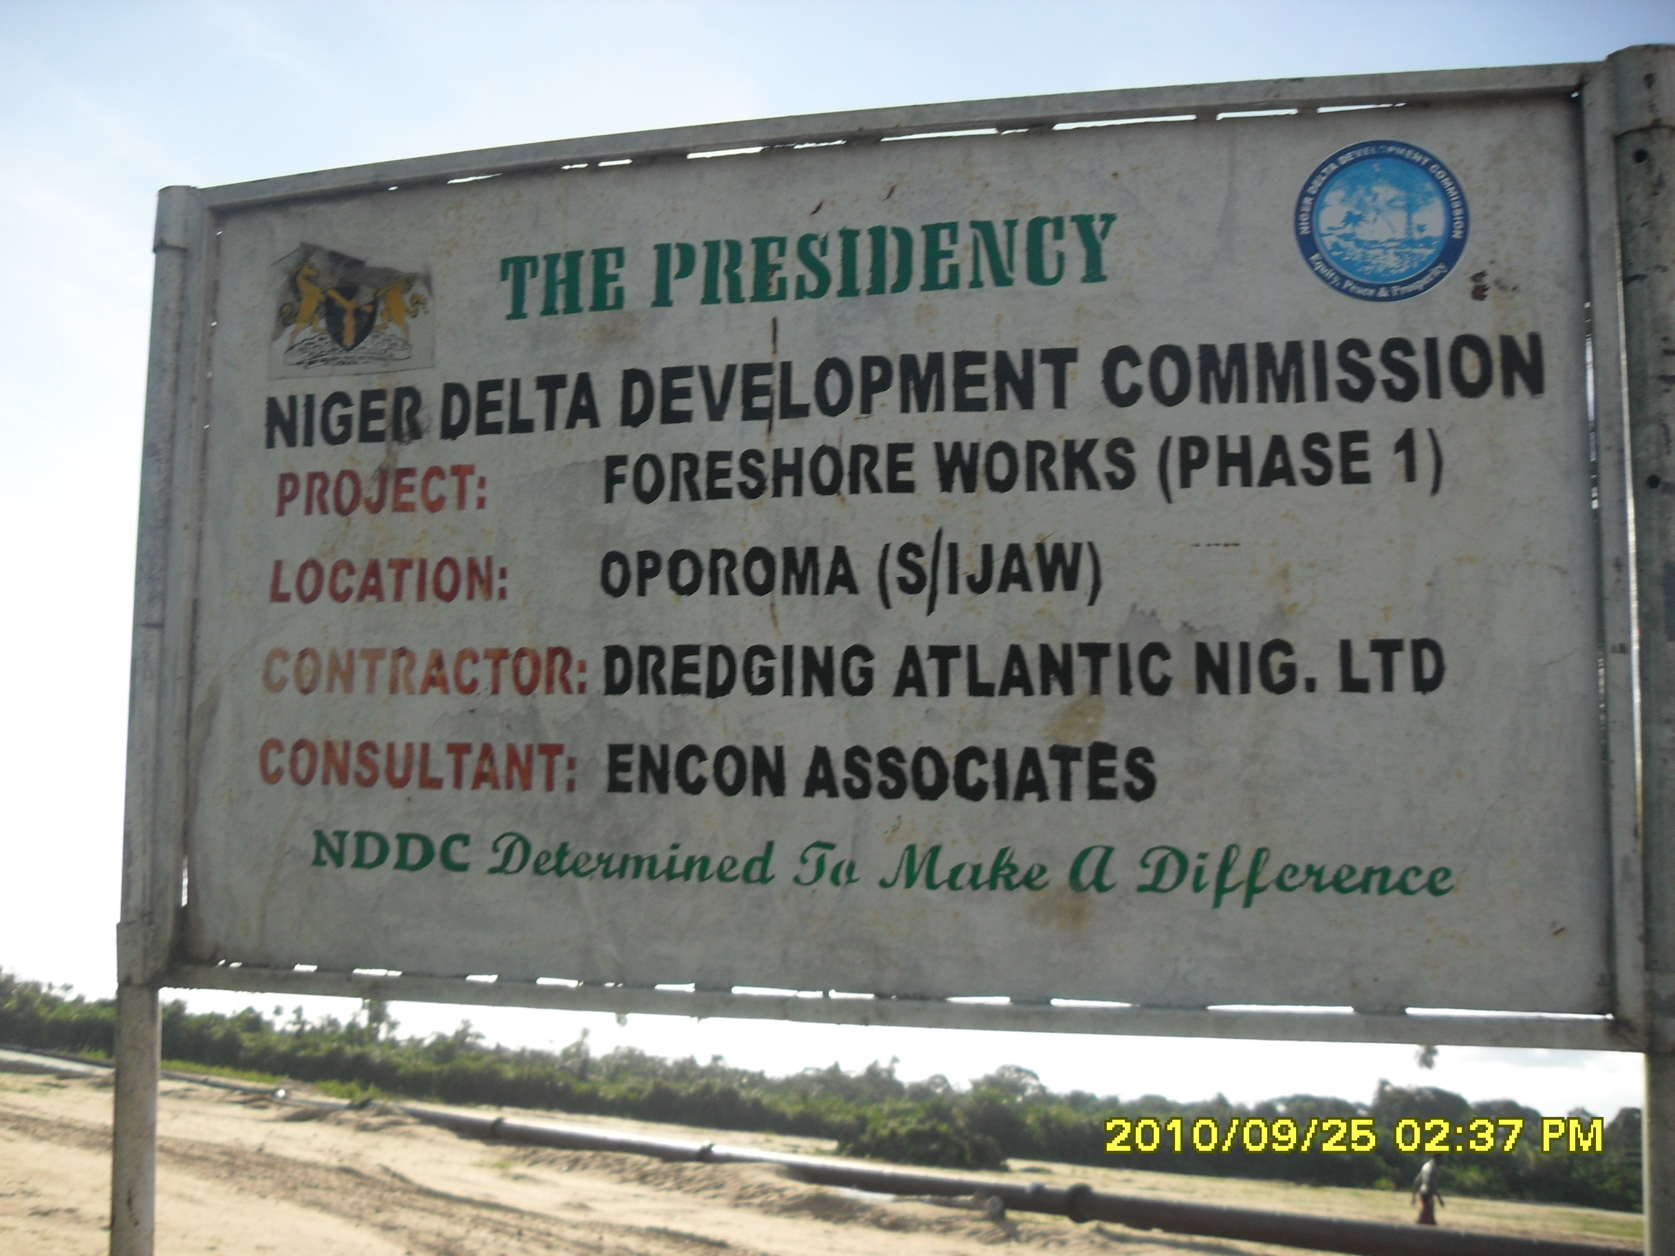
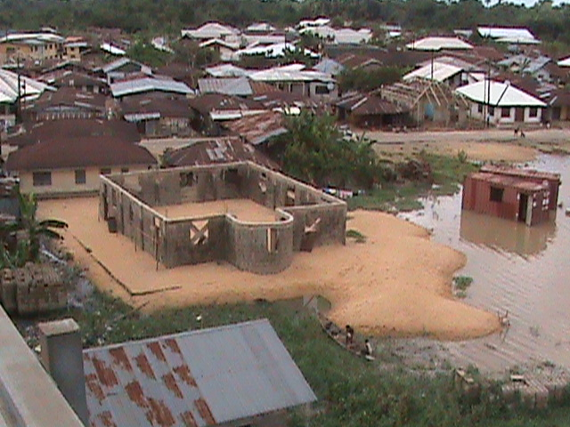
Plate 2: A sign post indicating government sponsored wetland reclamation and dredging project
Plate 1: Wetland area reclaimed for residential purpose

.

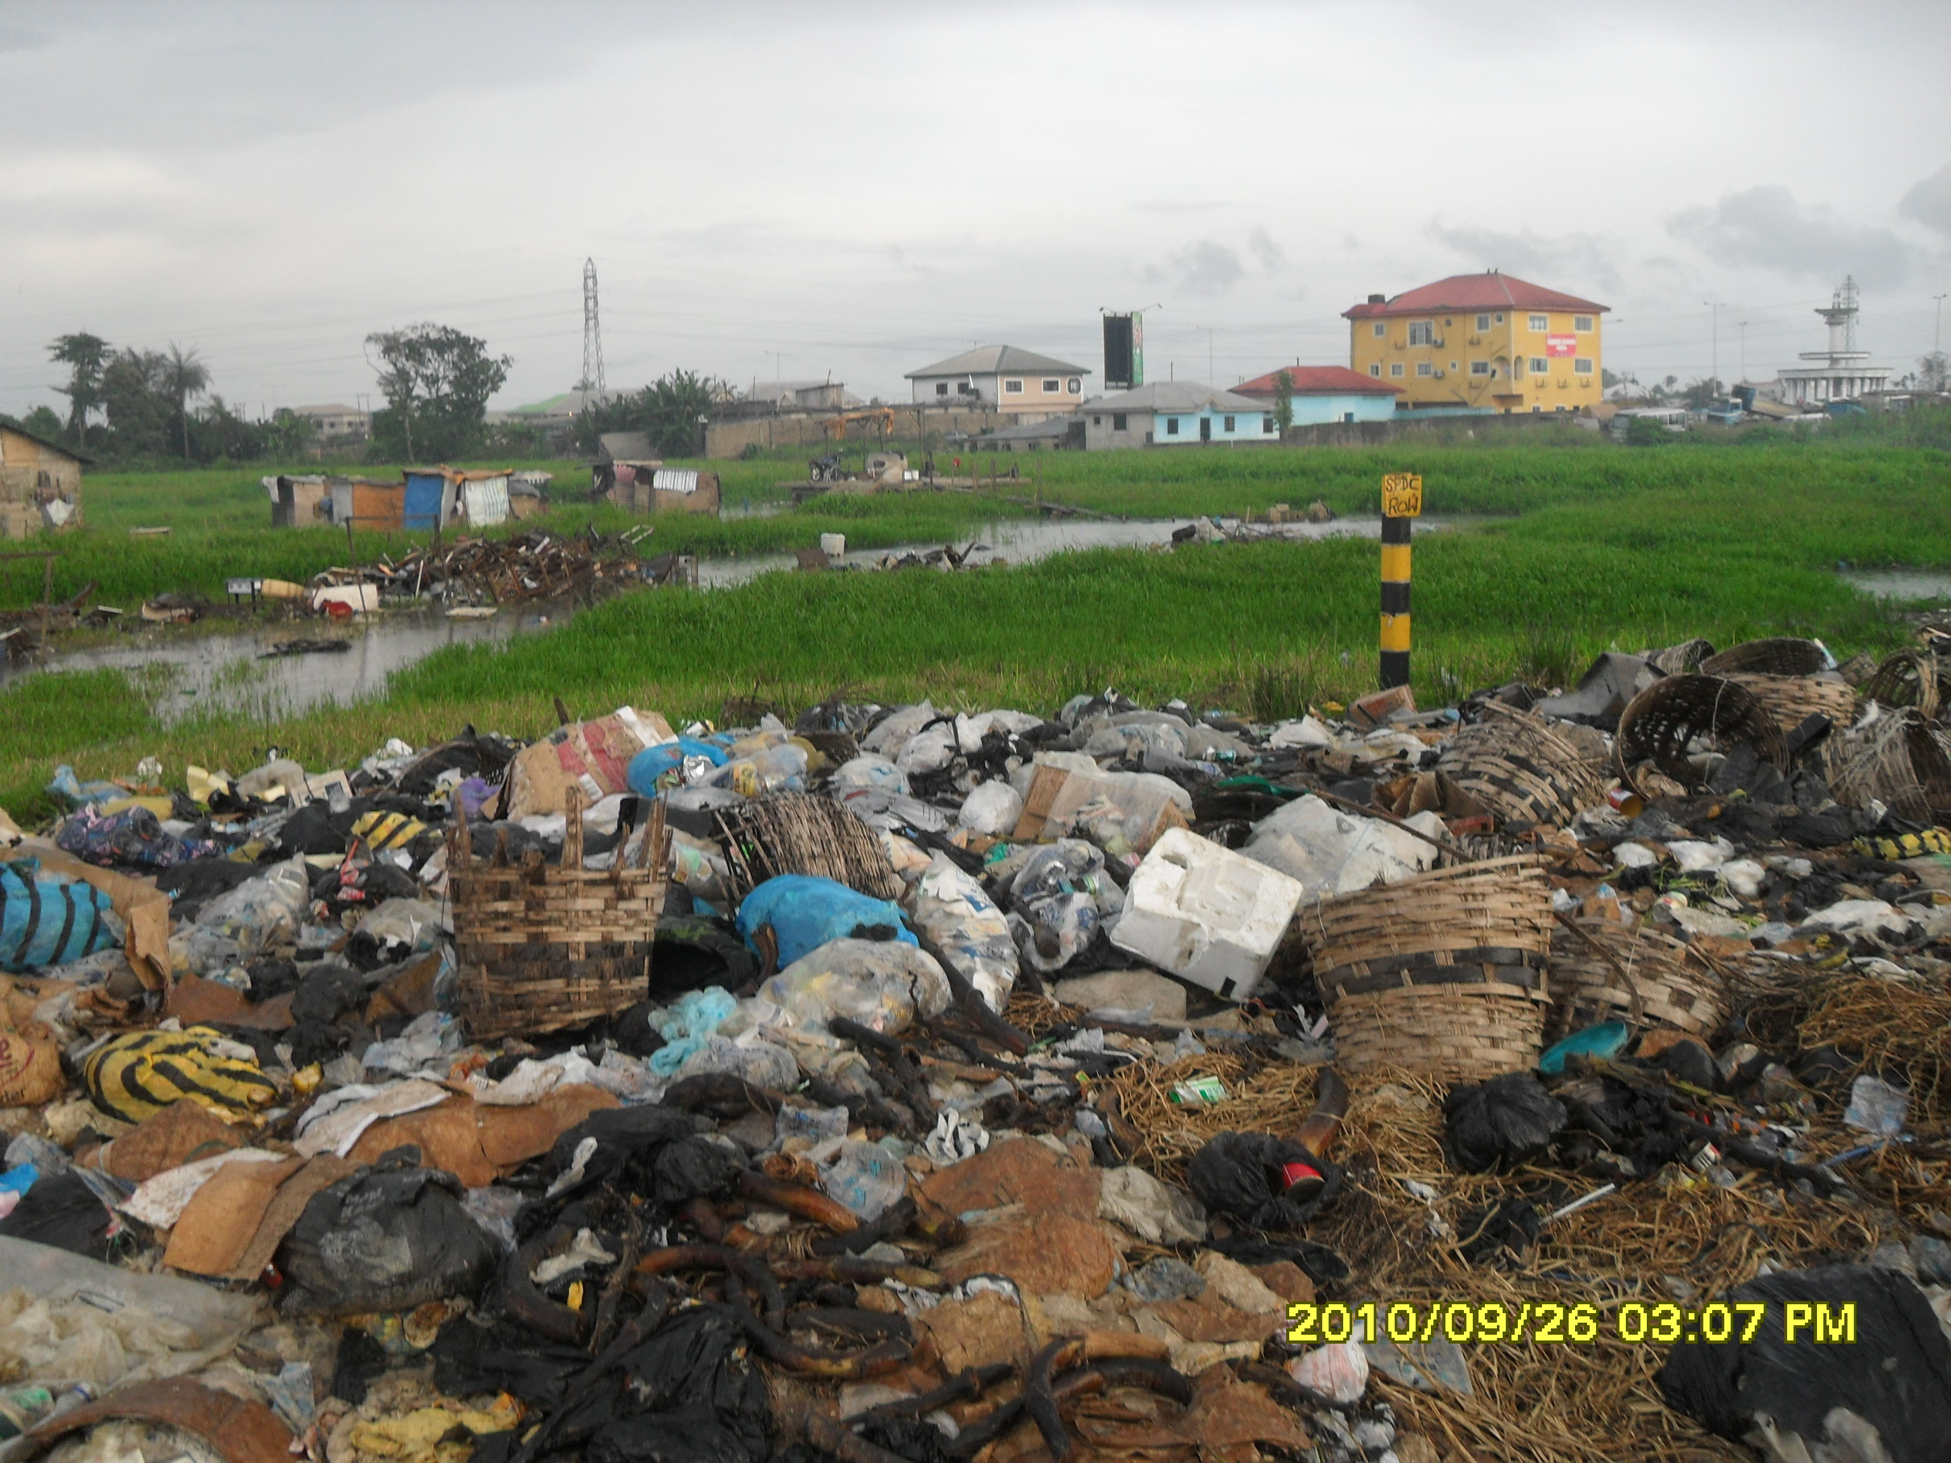
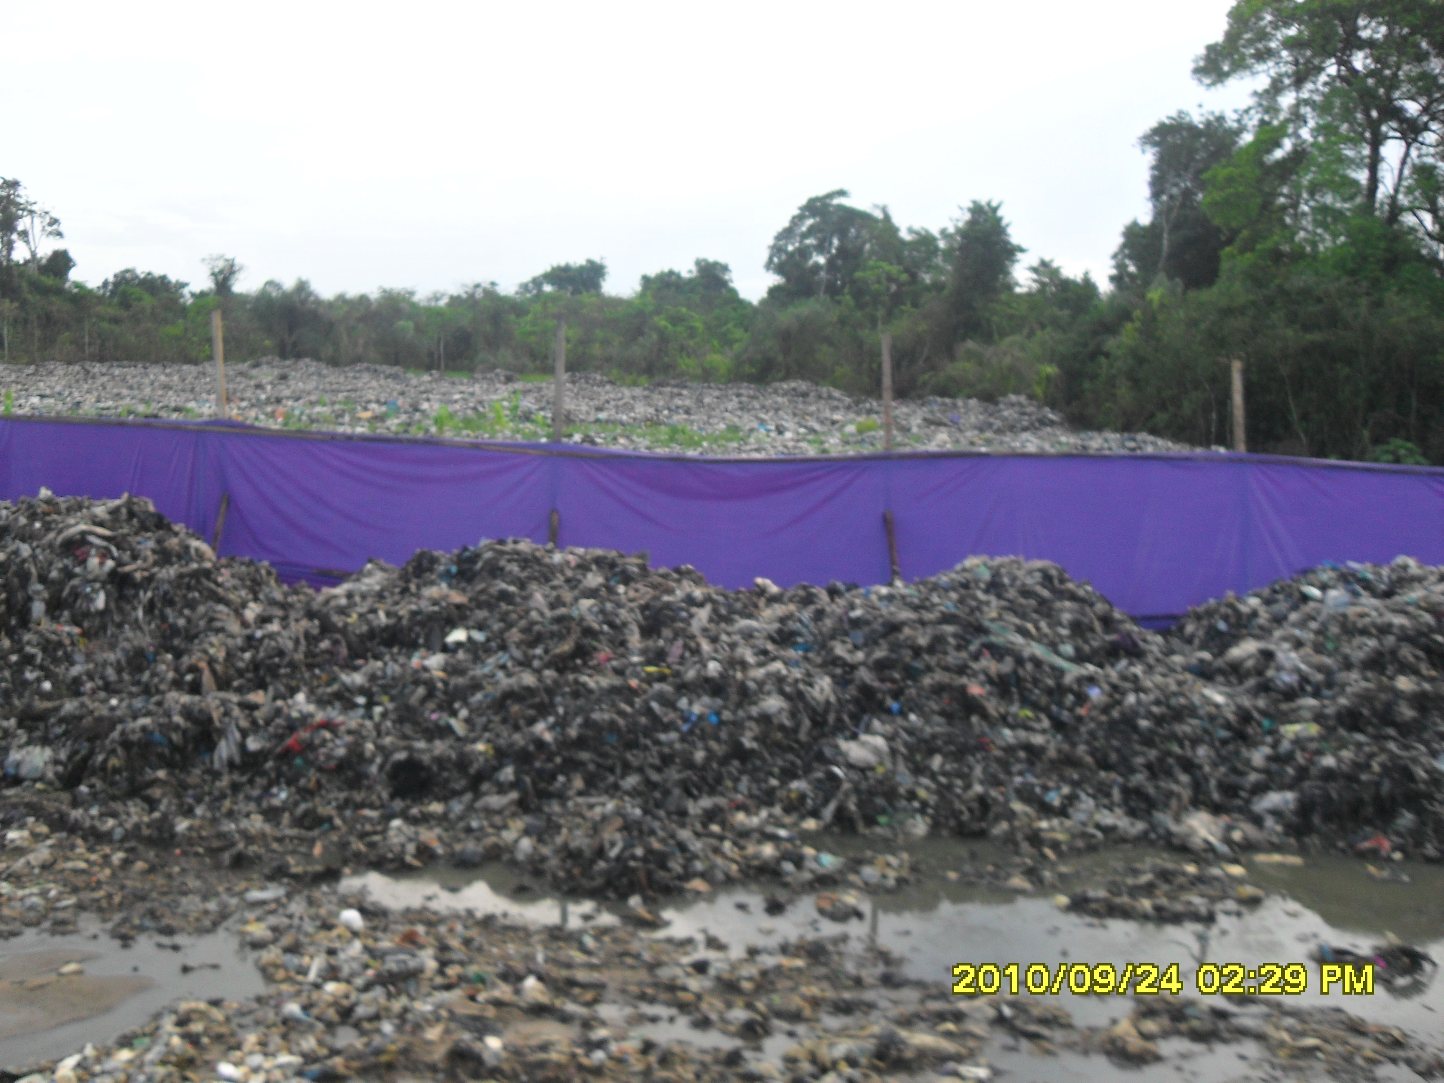
Plate 4: A part of wetland converted to dump site by traders and nearby residents
Plate 3: A government approved dumpsite in the wetland

Figures

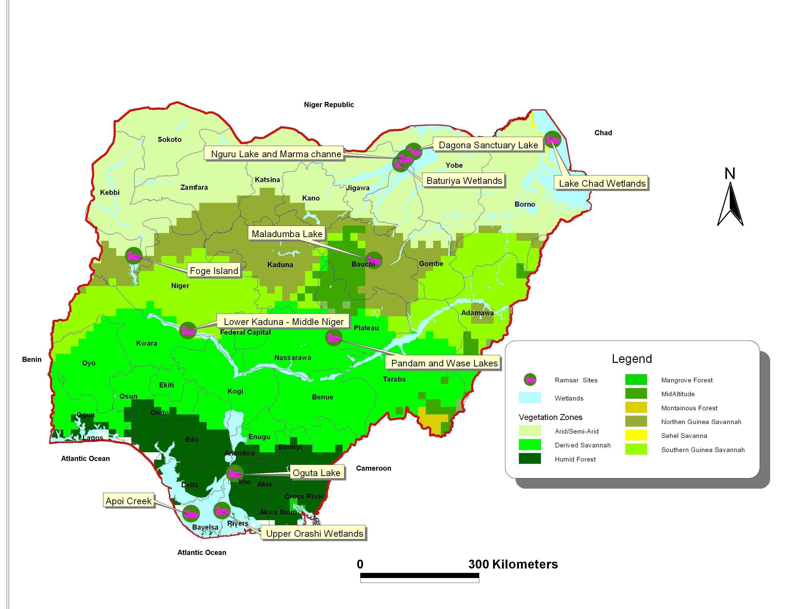

Figure 1: Map of Nigeria showing the Ramsar sites.

Figure 2: Evolution of legislation relevant to wetlands management in Nigeria

Tables

Table 1: Sites already designated as Ramsar in Nigeria.
Site | Date of designation | State | Area (ha) | Coordinates
Apoi Creek Forests | 30/04/2008 | Bayelsa | 29,213 | 05°47’N 004°42’E
Baturiya Wetland | 30/04/2008 | Kano | 101,095 | 12°31’N 010°29’E
Dagona Sanctuary Lake | 30/04/2008 | Yobe | 344 | 12°48’N 010°44’E
Foge Islands | 30/04/2008 | Kebbi, Niger | 4,229 | 10°30’N 004°33’E
Lake Chad Wetlands in Nigeria | 30/04/2008 | Borno | 607,354 | 13°04’N 013°48’E
Lower Kaduna-Middle Niger Floodplain | 30/04/2008 | Kwara, Niger | 229,054 | 08°51’N 005°45’E
Maladumba Lake | 30/04/2008 | Bauchi | 1,860 | 10°24’N 009°51’E
Nguru Lake (and Marma Channel) complex | 02/10/2000 | Jigawa, Yobe | 58,100 | 10º22’N 012º46’E
Oguta Lake | 30/04/2008 | Imo | 572 | 05°42’N 006°47’E
Pandam and Wase Lakes | 30/04/2008 | Nasarawa | 19,742 | 08°42’N 008°58’E
Upper Orashi Forests | 30/04/2008 | Rivers | 25,165 | 04°53’N 006°30’E

Table 2: International conventions relevant to wetland management.
Conventions | Adopted | Signed by Nigeria | Domesticated in Nigeria under | Aim /Remark
Convention on Wetlands of International Importance Especially As Waterfowl Habitat | 1971 | 2001 |  | An international treaty for the conservation and sustainable utilisation of wetlands. Also known as the Ramsar convention
CITES (the Convention on International Trade in Endangered Species of Wild Fauna and Flora) | 1973 | 1974 | Endangered Species (Control of International Trade and Traffic) Act 1985 | Aims to ensure that the international trade of wild animal and plant specimens does not threaten their survival.
Convention on the Conservation of Migratory Species of Wild Animals (CMS) | 1979 | 1987 |  | Aims to conserve terrestrial, marine and avian migratory species throughout their range. Also known as CMS or the Bonn Convention.
Convention for Co-operation in the Protection and Development of the Marine and Coastal Environment of the West and Central African Region | 1981 | 1981 |  | The convention (also known as the Abidjan Convention) provides an important framework through which national policy-makers and resource managers implement national control measures in the protection and development of the marine and coastal environment of the WACAF Region (West and Central African Region).
Convention on Biodiversity | 1992 | 1994 | National Biodiversity Strategy and Action Plan 2003 | Aims to conserve biological diversity, sustainable use of the components of biological diversity, and the fair and equitable sharing of the benefits arising out of the utilisation of genetic resources.
Cartagena Protocol on Bio-safety | 2000 | 2000 |  | Aims to ensure the safe handling, transport and use of living modified organisms (LMOs) resulting from modern biotechnology that may have adverse effects on biological diversity, taking into account risks to human health.

Enacted as decrees during military rule, however with democratic rule (May 1999), the decrees still exist as laws of the Federation of Nigeria, however, laws promulgated from May 1999 are referred to as Acts.
Fadama” is Hausa name for irrigable lands or flood plains and low-lying areas underlined by shallow aquifers.
Ability of the wetland to continually provide ecosystem services
See Harmful Waste (Special Criminal Provisions, etc.) Act 1988 (Decree No. 42) (CAP 116, LFN 2000)
Section 64 Nigerian Minerals and Mining Act, 2007

