bECG-Based Timings Cause Systematic Errors In Vascular Strain Measures: A Method for Error Correction and Estimation of Pulse Transit Time

Prof. Nick Sculthorpe, PhDª *, Ms. Amy Campbell, MScª, Dr. Alexander Beaumont, PhD^{b}

ª Institute of Clinical Exercise and Health Science, University of the West of Scotland, Lanarkshire, Scotland, G72 0LH, UK

^{b} School of Sport, York St John University, Haxby Road, York, YO31 8TA, UK.

* Corresponding author:
Professor Nicholas Sculthorpe
University of the West of Scotland, Stephenson Place, Hamilton International Technology Park Blantyre, Glasgow, United Kingdom
Tel: (0)1698 283100
Email: nicholas.sculthorpe@uws.ac.uk

Speckle-tracking ultrasonography (STE) has been applied to the assessment of circumferential strain (ɛ) and strain rate (SR) of the common carotid artery (CCA).^{1–5} Originally developed for echocardiography,⁶ the analysis of ɛ is tethered to key points of the electrocardiogram (ECG). Thus, to prevent measurement drift STE software assumes no deformation (i.e 0% ɛ) at the start of the cardiac cycle defined by the QRS wave. However, the pressure wave will take some time to travel from the aortic valve to the insonated section of vasculature, meaning vascular expansion and recoil occur shortly after ventricular systole. Unless this delay is accounted for, drift compensation will ‘zero’ vascular strain before recoil is complete and underestimate ɛ, with time-to-peak (TTP) ɛ overestimated if measured from the QRS wave. We have developed a simple method of correcting for the onset of vessel expansion using custom software to extract raw ɛ indices from commercially available speckle-tracking software.

Ninety-seven cross-sectional cine-loops of the CCA (imaged approximately 1cm inferior to the carotid bulb) from 33 apparently healthy, post-menopausal females without known cardiovascular disease (age=58±4 years, SBP=132±21 mmHg, DBP=71±12 mmHg, BMI=26.8±4.2 kg.m⁻²) enrolled in a previous study were retrospectively analysed. All images were acquired by the same sonographer using a Vivid IQ ultrasound machine with a 6-13 MHz linear transducer (GE Healthcare, Cambs, UK), at 106.9 fps. Images were analysed as previously detailed^{1,3,5} using EchoPac software (GE Healthcare, Cambs, UK). The resulting data files were further analysed by applying a 1000-point cubic spline to either the ɛ or SR data, which was used to identify raw and corrected peak ɛ (outlined below), and TTP. Data processing was automated using custom software (Vascular Strain Toolkit, V0.5beta; VST).
To calculate corrected ɛ, VST identified the time and ɛ at the of onset of expansion (OE; defined as the point where vessel mechanics changed from recoil to expansion). Corrected peak strain was calculated using: Corrected ɛ = Peak positive ɛ - ɛ at OE (Figure 1A). For ɛ and SR, raw TTP was defined as the time period between the onset of the cardiac cycle and the time of peak ɛ or SR from the splined data. Corrected TTP was identified using the following equation: Corrected TTP = Raw TTP – time at OE (Figure 1A). Also, we assessed pulse wave transit time (PTT) as the time between the onset of the cardiac cycle derived from the ECG and the time of OE. The VST identified the time between OE and end of expansion as ‘expansion’ and considered any times outside these two points as ‘recoil’ enabling estimation of total expansion and recoil time from a single ECG cardiac cycle (Figure 1B). We assessed the adequacy of this estimation using the area under the curve of expansion and recoil phases which should have a 1:1 ratio. Corrected and uncorrected methods were compared with Student’s t-test and statistical significance was set at p<0.05.

87 (89.7%) participants displayed negative ɛ after drift compensation (mean = 0.475 ± 0.36%, range 0-1.7% ɛ). As a percentage of uncorrected peak ɛ this produced a mean underestimation of 10.6 ± 7.9% of raw ɛ (range, 0-31.8%). Uncorrected ɛ was significantly lower than corrected ɛ (Figure 2A). Corrected TTP ɛ was significantly shorter compared to uncorrected TTP calculated directly from ECG timings (Figure 2B). TTP SR was shorter when corrected for the OE (p=0.0000; 0.18±0.04s vs 0.09±0.03s for uncorrected and corrected, respectively). Systolic time was shorter than expansion time, even accounting for the later start time of vessel expansion (p<0.0001; 0.23±0.06 s vs 0.27±0.04s for systolic time vs. expansion time, respectively). Correspondingly, total recoil time (0.74±0.01s) was shorter than diastolic time (0.78±0.137s; (p<0.0001). There was substantial variation in the difference between expansion-systole times with reciprocal variation in recoil-diastole times (47±50ms and -47 ± 50ms respectively). The AUC ratios of the expansion SR duration, and the total recoil SR duration were not significantly different to 1 (p>0.05, mean AUC ratio =1.01±0.06), nor were AUC of systolic and diastolic periods different to 1 (mean AUC ratio =0.98±0.09). PTT was calculated as 51 ± 15ms.

Drift compensation using ECG timings results in a significant underestimation of peak strain during vessel expansion while ECG timings overestimate TTP when assessing circumferential ɛ of the CCA. Our novel method applies new boundary conditions to correct for peak ɛ, and by identifying the time-point where vessel ɛ changes from recoil to expansion, it is possible to identify vessel expansion time, a more physiologically relevant measure of vascular mechanics than systolic or diastolic time. This approach has the added advantage of rapid and non-invasive identification of PTT. Collectively, these findings reinforce the importance of accurate methodological procedures, and given relatively wide inter-individual variation this approach provides a more accurate assessment of vessel mechanics. Replication in a larger, clinical cohort is warranted.
REFERENCES

1. Bjallmark A, Lind B, Peolsson M, Shahgaldi K, Brodin L-A, Nowak J. Ultrasonographic strain imaging is superior to conventional non-invasive measures of vascular stiffness in the detection of age-dependent differences in the mechanical properties of the common carotid artery. European Journal of Echocardiography. 2010 Aug 1;11(7):630–6.
2. Yuda S, Kaneko R, Muranaka A, Hashimoto A, Tsuchihashi K, Miura T, et al. Quantitative Measurement of Circumferential Carotid Arterial Strain by Two-Dimensional Speckle Tracking Imaging in Healthy Subjects: 2D Tracking in Carotid Artery. Echocardiography. 2011 Sep;28(8):899–906.
3. Black JM, Stöhr EJ, Stone K, Pugh CJA, Stembridge M, Shave R, et al. The effect of an acute bout of resistance exercise on carotid artery strain and strain rate. Physiological Reports. 2016 Sep;4(17):e12959.
4. Iino H, Okano T, Daimon M, Sasaki K, Chigira M, Nakao T, et al. Usefulness of Carotid Arterial Strain Values for Evaluating the Arteriosclerosis. Journal of Atherosclerosis and Thrombosis. 2018 26(5): 476-487
5. Pugh CJA, Stone KJ, Stöhr EJ, McDonnell BJ, Thompson JES, Talbot JS, et al. Carotid artery wall mechanics in young males with high cardiorespiratory fitness. Experimental Physiology. 2018 Sep;103(9):1277–86.
6. Leitman M, Lysyansky P, Sidenko S, Shir V, Peleg E, Binenbaum M, et al. Two-dimensional strain-a novel software for real-time quantitative echocardiographic assessment of myocardial function. J Am Soc Echocardiogr. 2004 Oct;17(10):1021–9.
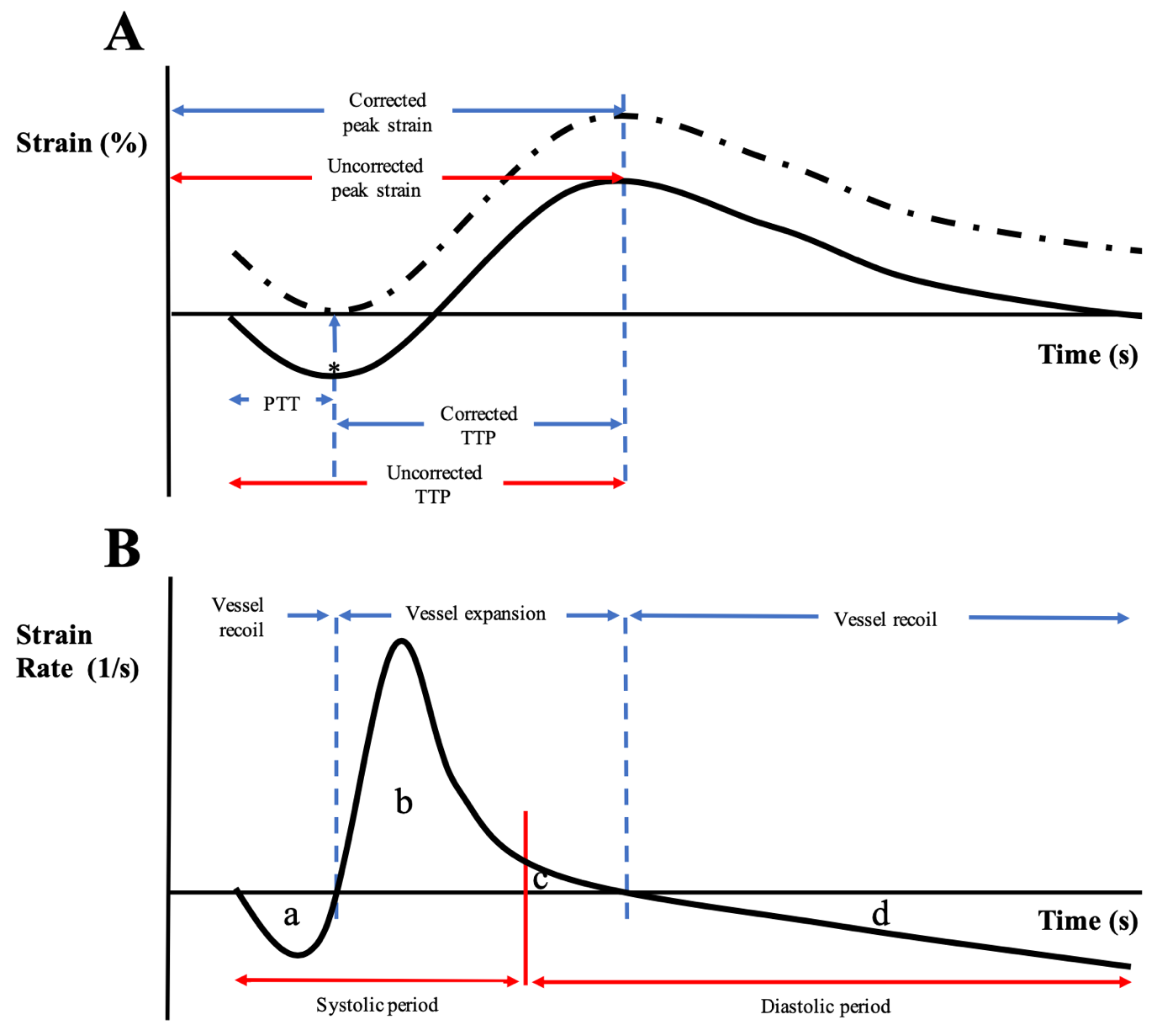
1
Figure 1. (A) Schematic demonstrating how application of boundary conditions ensures ɛ is zero at the onset of the cardiac cycle (point 1). The corresponding peak ɛ may be underestimated when assessed directly from strain data. Correction is achieved by zeroing the onset of expansion (marked *). Analysis of time-to-peak ɛ (TTP) using raw data may also be overestimated. Correction is achieved by selecting the onset of expansion as the start time rather than the ECG determined onset of the cardiac cycle. The calculated difference between corrected and uncorrected TTP represents an estimation of the pulse wave transit time (PTT). (B) Using systolic and diastolic time periods may not provide physiologically meaningful delineation of vascular mechanics phases. In this case, systolic phases mixes vessel recoil and vessel expansion (sections a + b), as does the diastolic phase (c + d). Conversely delineating vascular mechanics using end of expansion defines the recoil period as a + d, while the expansion period is b + c. Collectively, expansion is defined as strain rate-time curves above the x-axis and recoil as below.
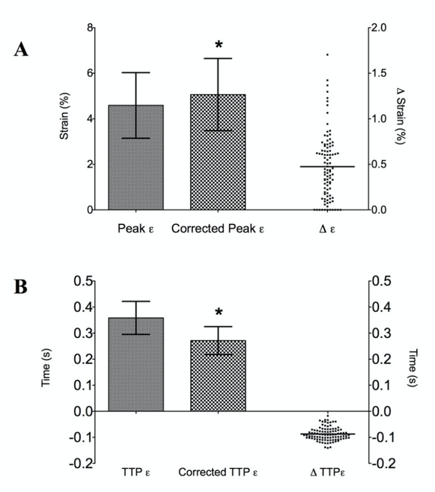

Figure 2. (A) Difference between raw, uncorrected peak strain (ɛ) and peak ɛ corrected for ɛonset. Δ ɛ denotes individual changes from uncorrected to corrected ɛ. (B) Difference between time-to-peak (TTP) ɛ measured from the ECG (TTP) versus measured from the onset of vessel expansion (Corrected TTP ɛ). ΔTTP ɛ denotes individual changes in TTP using the two methods. Data are presented as mean ± SD. * p < 0.01 between uncorrected and corrected methods.

