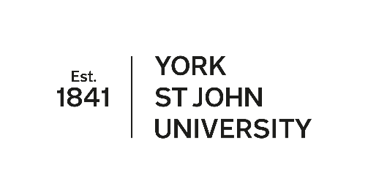

The Real Reason Neoliberalism Became Extinct

●

A Curious Educational History of 2020

**Julian Stern**

**York St John University**



**Professor Julian Stern, York St John University, York YO31 7EX**

**tel 01904 876520, email j.stern@yorksj.ac.uk, web www.yorksj.ac.uk**

**The Real Reason Neoliberalism Became Extinct: A Curious Educational History of 2020**

**Abstract**

There’s a Gary Larson *Far Side* cartoon entitled *The Real Reason Dinosaurs Became Extinct*. It shows three dinosaurs surreptitiously smoking cigarettes. Why would such a peripheral habit like burning some leaves cause an extinction?

Like dinosaurs, neoliberalism has had a bad press. There have been plenty of critiques of neoliberalism, and plenty of models of post-neoliberal societies. I propose that 2020 will be the year that – surprisingly – marks the extinction of neoliberalism. The future is for us all to make, but from the perspective of the future, looking back, it may seem obvious that 2020 marked not only the deaths of hundreds of thousands, perhaps millions, of people as a result of a new virus, but also – oddly, accidentally – the death of the whole system of neoliberalism.

This article therefore presents a very brief history of educational changes from a long-distant future, a history pivoting around the year 2020. It describes how curiosity killed the SAT, how we miraculously rediscovered that people care, and how schools prioritised care and curiosity in community. We can all dream.

**Introduction**

*Each epoch dreams the one to follow*

Walter Benjamin[1]

There’s a Gary Larson *Far Side* cartoon entitled *The Real Reason Dinosaurs Became Extinct[2]*. It shows three dinosaurs surreptitiously smoking cigarettes. The history (’65 million years in the making’) of the extinction of dinosaurs is rewritten every few years, so perhaps scientists will end up concurring with Larson, and will blame tobacco. But in the meantime, it’s a joke: why would such a ridiculously mundane, quotidian, thing like burning some leaves, rather than a catastrophic meteor strike, cause an extinction? Like all the best jokes, though, this joke contains wisdom. Larson shows how big events may have trivial, as much as dramatic, causes. History is the result of a number of tiny, odd, often (with respect to the historic events) mundane causes, even if we prefer to look for the large-scale dramatic and suitably ‘historic’ causes. The decisions of great leaders, heroic revolutions, wars won or lost as a result of strategic decisions, laws enacted after decades of lobbying: these are the kinds of causes we find attractive when writing elegant histories. What often happens, though, is historic changes occur as the result of mundane events – or events that seem entirely peripheral to the changes. Heroic narratives become pathetic. Napoleon may have lost the Battle of Waterloo because his haemorrhoids prevented him from attending his usual meeting to review strategy (Mason 2010).

A recurring source of pathos in history is disease, whether the individual indisposition of Napoleon, the haemophilia of the Romanov Russian Tsars, the possible syphilis of Henry VIII or Ivan the Terrible, or the widespread influence of disease across populations. Plagues have changed economies, helping destroy Feudalism in Europe and helping establish colonialism in the Caribbean. Cartwright and Biddiss (2014) provide an impressive overview of the odd relationships between disease and history. What I want to suggest in this article is that the current pandemic may, inadvertently, have a profound effect on education, and may – with respect to education – lead to the death of neoliberalism. Covid-19 is far from mundane: it is a major new disease causing a pandemic that has already killed hundreds of thousands of people. And yet it has no obvious relationship to neoliberalism. (Global travel may have spread the disease quickly, but plagues have swept the world – a little slower – for centuries.) So I am arguing that when, in a few decades, the history of education is being written, 2020 will be the year that neoliberalism became extinct. And it will not be primarily the result of protests against neoliberalism, or the work of those (like me) who have campaigned for a more caring and curiosity-driven education, but, instead, the Larson-like absurd reason that we caught a virus.

Writing history before it has happened is risky. Sinclair Lewis wrote *It Can’t Happen Here* in 1935 (Lewis 1963). He was worried that the anti-intellectual-elite populist demagogue Huey Long might beat FDR for the Democratic nomination in the 1936 presidential election, and so wrote a wonderful ‘history’ of USA from 1936 to 1939. History rarely works as we expect it. Huey Long was assassinated a month before Lewis’s novel was published, and FDR won the nomination and the election. However, the novel shot to the top of the bestseller lists in 2016, when another anti-intellectual-elite populist with demagogic tendencies took power. So if I am proven wrong about the extinction of neoliberalism in 2020, perhaps I will be shown to be prescient later in the century.

**Neoliberalism and Beyond**

Like dinosaurs, neoliberalism has had a bad press. It is a particular form – perhaps a style – of free-market capitalism that has been characterised (in education, health, and much of the public sector) by centralised regulatory frameworks in which local units are expected to compete in a system of ever-moving targets. This ‘performativity’ is ‘one that makes public services answerable to the pressure of competition and the incentive of relative advantage of the marketplace’ (Fielding and Moss 2011, p 21, quoting Ransom). ‘Individual responsibility’ and ‘choice’ nominally take the place of communal or wider collective political responsibility and decision-making, but without any room for genuine individuality or real choice – as externally-set and tested standards are all-powerful and are seen as neutral and inevitable and as merely measures of ‘what works’ (Dean et al 2012, Thomas 2009). The ‘responsibilising of the self’ is a form of neoliberal governance, one that is both economic and moral (Peters 2001, p 61).

There have been plenty of critiques of neoliberalism. Critiques not only of the ways in which it misdirects people, taking the intrinsic value out of activities (such as education or welfare) and replacing that value with externally-determined economically-driven targets, or the ways in which it undermines communal and larger-scale political action by insisting on its supposed neutrality and efficiency. Some are critical of the way in which neoliberalism seems to erase history, so that, for example, ‘[f]ew people know very much about why schools exist as they do today; the intellectual traditions that have shaped education seem to be invisible to most observers’ (Thomas 2013, p xi). Others are critical about how neoliberalism erases possible futures, by creating a ‘dictatorship of no alternatives’ (Fielding and Moss 2011, p 1) or ‘false necessity’ (Unger 2004). Time is almost eliminated, and simply serves to demonstrate a recent past (that we must be better than) and a near future (of even better performance). And however much neoliberalism depersonalises human beings, it is worse for the rest of the world. Non-human animals and the environment as a whole has no value beyond that which is immediately exploitable for economic ends. For example, the most powerful neoliberal argument for maintaining biodiversity is the ready supply of new drugs to cure human ailments (Fenical 1996, Brahic 2007), with one writer noting that ‘[f]ar from being mutually exclusive, biodiversity and genomics should be the driving force of drug discovery in the 21st century’ (Tan et al 2006, p 265). (A much more balanced view is given by Neergheen-Bhujun et al 2017, noting the contribution of biodiversity to a wide range of the UN’s sustainable development goals.) Of course, if biodiversity can only be protected because of its value to drug companies, that is better than biodiversity being unprotected. And the new drugs produced may indeed save many lives. But neoliberal principles make us think that non-human nature can only be valued in such economic terms.

As well as critiques, there have also been plenty of models of post-neoliberal societies. Gandin and Apple (2002) describe how the ‘Citizen School’ project developed under the ‘Popular Administration’ system in Porto Alegre. This was a specific attempt to ‘disarticulate’ aspects of neo-liberalism and neo-conservatism, and within it ‘[t]he category of ‘citizenship’ serves as a discursive weapon against the rival notions of ‘client’ or ‘customer’ that have played such an important part in the language of neo-liberalism’ (Gandin and Apple 2002, p 103). Jones, similarly, offers a democratic route out of neoliberalism:

One immediate solution to some of the problems would be an assertion by those who work in schools of their collective power to shape the circumstances in which they work – an assertion which would entail reviving a tradition of workplace democracy … for a workforce whose current quietude is doing little to improve its well-being. (Jones 2012, p 212.)

Couldry notes economic ways out of neoliberalism, and promotes the ‘radical critique[s]’ of Amartya Sen and Charles Taylor (Couldry 2010, p 21), before describing a ‘Post-Neoliberal’ politics (Couldry 2010, p 135). Educational researchers Fielding and Moss base their post-neoliberal approach in part on Unger’s overthrowing of ‘the dictatorship of no alternatives’ (Fielding and Moss 2011, p 1). They propose ‘real’ utopian ideals that ‘are grounded in the real potentials of humanity, utopian destinations that have accessible waystations, utopian designs of institutions that can inform our practical tasks of navigating a world of imperfect conditions for social change’ (Fielding and Moss 2011, p 2, quoting Wright).

Along with the educational utopianism of Fielding and Moss, it is the post-neoliberal approach of MacLeavy that most informs my own prospective history of neoliberal extinction. MacLeavy recognises that neoliberalism ‘has been in turmoil’, but suggests there is ‘an unstable interregnum’ in which ‘the old is dying and the new cannot be born’ (MacLeavy 2019, p 637, quoting Gramsci on the old and new). Current political systems and, increasingly, authoritarian systems survive in part because ‘there is not yet a project that is anti-neoliberal, let alone anti-capitalist’ (MacLeavy 2019, p 637). In the light of such openness, I propose that 2020 will be the year that – surprisingly – marked the extinction of neoliberalism. The future is for us all to make, but from the perspective of the future, looking back, it may seem obvious that 2020 marked not only the deaths of hundreds of thousands, perhaps millions, of people as a result of a new virus, but also – oddly, accidentally – the death of the whole system of neoliberalism. So this is my attempt to look back at the pandemic as an educationalist, bearing in mind that, when we are in a position to look back at the pandemic, its history will have been ‘smoothed’ and made to seem straightforward and certain, rather than complex and uncertain.

**A Look Back at the Pandemic**

How does education look, now that the pandemic has faded into history? Education systems are often at the centre of social and policy changes following a major national or international crisis. In the UK as in many countries, major education policies were enacted after each of the World Wars. The 1918 Education (for England and Wales) introduced a ‘[p]rogressive and comprehensive organisation of education’ up to the age of 14 (*Education Act 1918*, p 1). This was the first statutory reference to ‘progressive’ and ‘comprehensive’ education, although ‘progressive’ was not a reference to the politically progressive but to progression through and beyond the schooling system, and ‘comprehensive’ referred to the schooling system as a whole (and education ‘otherwise’), and not to individual schools. There was – following a war in which the physical limitations of conscripted fighters was notable – also an emphasis on ‘social and physical training’ (*Education Act 1918*, p 12) and on the development of education beyond schools, and continuing research and education to make for a better education system. Towards the end of World War II, the 1944 Education Act (for England and Wales) raised the school leaving age further, to 15, and provided a more holistic view of education that would ‘contribute towards the spiritual, moral, mental, and physical development of the community by securing that efficient education throughout those stages shall be available to meet the needs of the population of their area’ (*Education Act 1944*, p 4). That broad educational purpose (a *communal* purpose, not just an individual purpose) was maintained, in law, throughout the neoliberal policy years from the late 1980s to the 2010s, and was ‘noticed’ during the pandemic (McInerney 2020).

Following the pandemic, education once again took a progressive (in the sense of being concerned with progress through life), comprehensive, holistic and communal turn, a turn away from neoliberal concerns with possessive individualism (Macpherson 1962), immediate ‘performance’, competition and testing. Progress through life was no longer considered simply in terms of earnings and competitive success. The pandemic (re-)taught us that we are mortal, and that few people on their deathbeds talk about their earnings and who they competed against. There was an increasing sense of death as arbitrary. We recognised the importance of being able to be with people when we/they were dying, the need for coming together to celebrate the life of someone who had died, and the continuing bonds with people who had died (Klass et al 1996). Education in mortality became recognised as necessary in schools and in families alike. Related to this development, education in life – education in life in all its variety, well beyond the human – became far more central to education. People remembered seeing how nature recovered within weeks of the lockdown, birds sang louder and wild animals returned to cities in huge numbers. We smelt fresh air as pollution levels reduced, and we rediscovered walking and cycling. Nature was recognised as independent of us (i.e. not entirely dependent on us)v, and not simply for our exploitation. This was not forgotten in the re-written curriculum after the pandemic: it was not just human beings that mattered, but people as part of wider, interdependent, environments.

Not only were life and death recognised and celebrated in the new schooling, as the purpose of education was realigned to communal priorities. Those who survived the pandemic recognised the importance of community as a general term: the need and the wish for people who were *present* for us, and for whom we were present, as ends in themselves, not as means to other ends. Living in community was suddenly noticed, and schools were newly understood as communities in their own right, as ways of helping young people learn to live in community. As Macmurray said, long before the pandemic, ‘the school is a community; and we learn to live in community only by living in a community’ (Macmurray 2012, p 671). In the curriculum review following the pandemic, subjects were no longer viewed merely as junior versions of academic disciplines with an emphasis on established ‘powerful’ knowledge. Subjects survived the review, and still – of course – carried huge quantities of knowledge and friendly relationships to academic disciplines. But at their heart was the sense of children and young people learning as a way of becoming ‘better people’. Noddings had – before the pandemic – written of ‘the need for a unitary (or unifying) educational purpose: to produce better adults’ (Noddings 2015, p 2), and this was taken up by the new curriculum.

Noddings also informed a new sense of the role of care in education. During the pandemic, the people seen as most important were not the politicians or the people with the highest-paid or highest-status jobs. Care was – during and, thankfully, after the pandemic – seen as the central ethical value in society (Noddings 2005), and one which ‘r[an] counter to the ideals of competition, consumption and self-interest which are seen to be at the heart of neo-liberal ideology’ (Fine 2007, p 8). Care ethics were translated into schooling (Noddings 2005, 2012). And, just as in the pandemic, care was understood as necessarily mutual: an ethically caring relationship means I care for you and you care for me. There may be an inequality in the caring relationship – nurses or teachers are doing more caring, we hope, than patients and students – but if we fail to care for nurses and teachers, if the care is not mutual but one-directional, it is a merely functional not an ethical form of care, it is ‘care-giving’ not ‘caring’ (Noddings, in Stern 2016, p 31). This was seen during the pandemic, when people clapped and cheered those who ‘cared’, and left notes on dustbins thanking refuse collectors, and left messages in windows and on social media for cleaners and delivery drivers. Within the new post-pandemic curriculum, care was embedded in humanities subjects, where understanding people and listening to their voices became more powerful than simply accumulating facts. History was, once again, an attempt to understand how and why people lived in their own way, and students learned from this about how they too might live. And the increased awareness of life other than human life meant that care’s intellectual cousin, curiosity, became the driver for all learning. Best of all, ‘curiosity killed the SAT’ (Stern 2018a). Curiosity – ‘care for the object of study’ (Stern 2018b, p 86) – became the companion of (interpersonal, mutual) care, in the community of the school. And the larger-scale lesson of the pandemic was learned too. Notwithstanding the newly emphasised communalism, founded on a principle of subsidiarity (i.e. power devolved to the lowest possible level), the global interdependence illustrated by the pandemic itself and by the various, often botched, national and international responses to the pandemic, led to an appreciation that ‘the lowest possible level’ is, on some issues, the earth as a whole. The curriculum of schools was able to connect young people with far-flung places and peoples, and with the long-distant past and with future generations.

Schools were renewed, following the pandemic. Education happened beyond schools, though, and the experience of ‘lockdown’ included a greater understanding in homes and families of the ways in which children and young people learned, and possible relationships between homes and schools. There was a surge in home-based education, as more families ‘noticed’ that education in a home was possible. And there was a surge in collaboration between homes and schools – with parents no longer seen as cheap unqualified substitutes for teachers: teachers were seen, instead, as reasonably expensive, professional, substitutes for parents (Stern 2003). Teachers were recognised as ‘society’s professional adults’ (Lawrence-Lightfoot 2003, p 30, quoting Waller) rather than as mere disseminators of knowledge, whilst parenting and various other forms of caring in households were recognised as appallingly underpaid if somewhat better understood not-as-yet-professional care workers. Other education-related organisations changed, too. Inspection was no longer seen as divorced from support. There was a return to school inspectors also having long-term responsibility for supporting schools, rather than merely reporting results into a centralised system. Online learning developed further and, rather than replacing schooling or home learning, made the knowledge-dissemination aspects of schooling less necessary, and the personal, communal, creative and deep learning that schools could offer all the more welcome.

As the economy moved from its focus on growth-at-all-costs to sufficiency (Princen 2005), so education moved from its focus on improving-test-results-at-all-costs to curiosity-driven learning for its own sake and for the sake of making better people, communities, and world. It was the change from growth to sufficiency, and from the impersonal to the personal, that best characterised the post-pandemic education system. Neoliberalism, based on constant competition and impersonal measurement, finally became extinct. Already in crisis following the crash of 2008, it finally disappeared because viable alternatives, such as prioritising care, curiosity and community, were made visible during the pandemic. Those alternatives were already well-known amongst educationalists – at least those educationalists who were not seduced by the false necessity of ‘what works’. It was the pandemic that made them visible to most of the population, during the extraordinary period of lockdown.

**Conclusion: Dreaming the Future**

Neoliberalism became extinct in large part because we had the imagination to create an alternative way of organising society. It is the current pandemic that has the power to stimulate such an imaginative leap. This article started with a quotation from Benjamin, that ‘[e]ach epoch dreams the one to follow’ (Benjamin 1999, p 4, quoting Michelet). We must keep doing that, and it is an imaginative exercise that is also a kind of ‘real’ utopianism (as recommended by Fielding and Moss 2011). Some may think such dreaming unnecessary or a distraction, an absurd fantasy. Yet it is familiar to us, every day. Buber describes how we enter into dialogue with each other, treating the other as a real person (an ‘end in itself’, as Kant might say) wholly separate from us and yet, in dialogue, connected. He says that all dialogue requires an act of imagination, an imaginative leap into the reality of the other person, whilst remaining on our own side. This, he describes as *Realphantasie*, or ‘imagining the real’ (Buber 1998, p 71). I have attempted to dream the next educational epoch, to imagine the reality of the post-pandemic world. It is an educational world of care and curiosity in community, after neoliberalism became extinct.

Of course, some elements of neoliberalism may continue a while. Even as the dinosaurs became extinct, a few survived as they were evolving into the bird species that are still with us. I would not be so foolish as to think that all aspects of the old system will die out. Indeed, I am a someone who is comfortable with competition, with exams, with knowledge, with inspection, with ‘standards’, and with a great deal of what is called bureaucracy. I just think that each of those, on its own or in combination, is insufficient to justify an education system. Care, curiosity and community are sufficient. And sufficiency, too, is what we all need. We will not survive: we are mortal. But we can live well, live curiously, caring, in community. Education can demonstrate this and can facilitate it. Who will dream this next epoch if not us?

**Bibliography**

Benjamin, W (1999 [1927-1939]) *The Arcades Project*; Cambridge, Massachusetts: Belknap Press.

Brahic, C (2007) ‘Biodiversity May Yield New ‘Blockbuster’ Drugs’, *New Scientist, 20 March 2007*, online at https://www.newscientist.com/article/dn11420-biodiversity-may-yield-new-blockbuster-drugs/.

Buber, M (1998 [1965]) *The Knowledge of Man: Selected Essays*; New York: Humanity Books.

Cartwright, F F and Biddiss, M (2014) *Disease and History: Third Edition*; London: Thistle Publishing.

Couldry, N (2010) *Why Voice Matters: Culture and Politics after Neoliberalism*; London: SAGE.

Dean, C B, Hubbell, E R, Pitler, H, and Stone, B (2012) *Classroom Instruction that Works: Research-Based Strategies for Increasing Student Achievement: 2nd Edition*; Alexandria, Virginia: ASCD and McREL.

*Education Act 1918*, available at: http://www.legislation.gov.uk/ukpga/Geo5/8-9/39/enacted/data.pdf.

*Education Act 1944*, available at: http://www.legislation.gov.uk/ukpga/Geo6/7-8/31/contents/enacted.

Fenical, W (1996) ‘Marine Biodiversity and the Medicine Cabinet The Status of New Drugs from Marine Organisms’, *Oceanography, 9:1*, pp 23-27. Also available online at https://www.jstor.org/stable/43925536?seq=1#metadata_info_tab_contents.

Fielding, M and Moss, P (2011) *Radical Education and the Common School: A Democratic Approach*; London: Routledge.

Fine, M D (2007) *A Caring Society?: Care and the Dilemmas of Human Service in the 21st Century*; Basingstoke, Hampshire: Palgrave Macmillan.

Gandin, L A and Apple, M W (2002) ‘Thin Versus Thick Democracy in Education: Porto Alegre and the Creation of Alternatives to Neo-Liberalism’, *International Studies in Sociology of Education, 12:2*, pp 99-116.

Jones, K (2012) ‘Power, Democracy – and Democracy in Education’, *Forum: For Promoting 3-19 Comprehensive Education, 54:2*, pp 205-214.

Klass, D, Silverman, P R, and Nickman, S L (eds) (1996) *Continuing Bonds: New Understandings of Grief*; Philadelphia: Taylor and Francis.

Lawrence-Lightfoot, S (2003) *The Essential Conversation: What Parents and Teachers Can Learn From Each Other*; New York: Ballantine.

Lewis, S (1963 [1935]) *It Can’t Happen Here*; New York: Penguin Random House.

McInerney, L (2020) ‘Education Was Never Schools’ Sole Focus. The Coronavirus Pandemic Has Proved It’, The Guardian, 14th April 2020, online at https://www.theguardian.com/education/2020/apr/14/education-was-never-the-sole-focus-of-schools-the-coronavirus-pandemic-has-proved-it.

MacLeavy, J (2019) ‘Neoliberalism and the New Political Crisis in the West’, *Ephemera: Theory & Politics in Organization, 19:3*, pp 627-640.

Macmurray, J (2012 [1958]) ‘Learning to be Human’, *Oxford Review of Education, 38:6*, pp 661-674.

Macpherson, C B (1962) *The Political Theory of Possessive Individualism: Hobbes to Locke*; Oxford: Clarendon Press.

Mason, P (2010) *Napoleon's Hemorrhoids: And Other Small Events That Changed the World*; New York: Skyhorse.

Neergheen-Bhujun, V, Awan, A T, Baran, Y, Bunnefeld, N, Chan, K, dela Cruz, T E, Egamberdieva, D, Elsässer, S, Johnson, M-V V, Komai, S, Konevega, A L, Malone, J H, Mason, P, Nguon, R, Piper, R, Shrestha, U B, Pešić, M and Kagansky, A (2017) ‘Biodiversity, Drug Discovery, and the Future of Global Health: Introducing the Biodiversity to Biomedicine Consortium, a Call to Action’, *Journal of Global Health, 7:2*, available online at https://www.ncbi.nlm.nih.gov/pmc/articles/PMC5735771/c.

Noddings, N (2005) *The Challenge to Care in Schools: An Alternative Approach to Education: Second Edition*; New York: Teachers College Press.

Noddings, N (2012) ‘The Caring Relation in Teaching’, *Oxford Review of Education, 38:6*, pp 771-781.

Noddings, N (2015) *A Richer, Brighter Vision for American High Schools*; New York: Cambridge University Press.

Peters, M (2001) ‘Education, Enterprise Culture and the Entrepreneurial Self: A Foucauldian Perspective’, *Journal of Educational Enquiry, 2:2*, pp 58-71.

Princen, T (2005) *The Logic of Sufficiency*; Cambridge, Massachusetts: MIT Press.

Stern, L J (2003) *Involving Parents*; London: Continuum.

Stern, L J (2016) *Virtuous Educational Research: Conversations on Ethical Practice*; Oxford: Peter Lang.

Stern, L J (2018a) ‘Curiosity Killed the SAT: The Role of Research in Redirecting Performativity in Initial Teacher Education’, *Research in Education, 100:1*, p 50-64.

Stern, L J (2018b) *A Philosophy of Schooling: Care and Curiosity in Community*; London: Palgrave.

Tan, G, Gyllenhaal, C and Soejarto, DD (2006) ‘Biodiversity as a Source of Anticancer Drugs’, *Current Drug Targets, 7:3*, pp 265-277.

Thomas, G (2009) ‘‘What Works’ as a Sublinguistic Grunt, Lessons from Catachresis, Asymptote, Football and Pharma’, *ResearchIntelligence, 106*, pp 20-22.

Thomas, G (2013) *Education: A Very Short Introduction*; Oxford: Oxford University Press.

Unger, R M (2004) *False Necessity: Anti-Necessitarian Social Theory in the Service of Radical Democracy*; London: Verso.

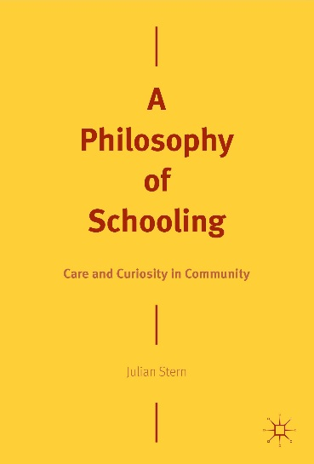

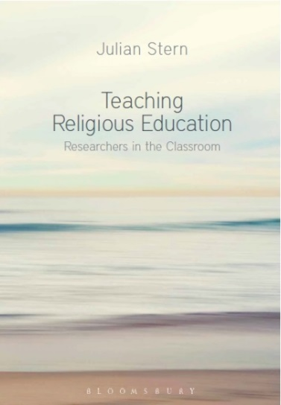

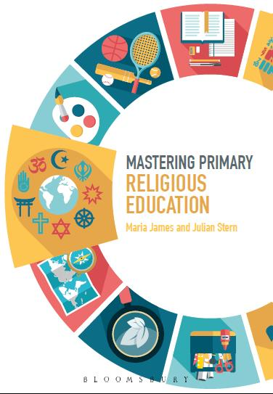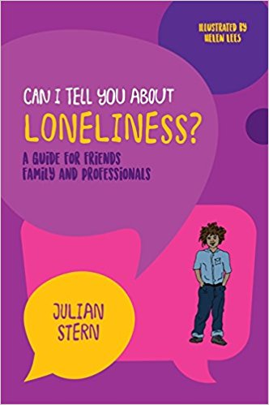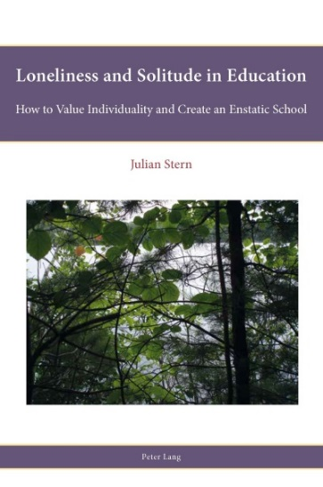

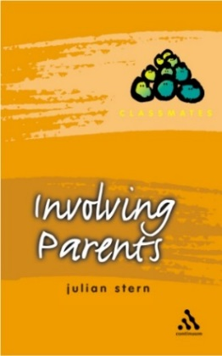

**About the Author**

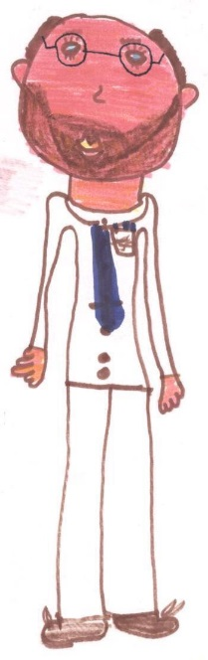Julian Stern is Professor of Education and Religion at York St John University, General Secretary of ISREV: the [International Seminar on Religious Education and Values](http://www.yorksj.ac.uk/isrev) ([@ISREV1978](https://twitter.com/ISREV1978) #ISREV), and Editor of the [British Journal of Religious Education](https://www.tandfonline.com/loi/cbre20). He was a school teacher for fourteen years, and has worked in universities for twenty-eight years. Julian is widely published, with sixteen books (plus five second or subsequent editions), contributions to twenty-one other books, and over thirty peer-reviewed articles. Books include *Mastering Primary Religious Education* (with Maria James, 2019), *A Philosophy of Schooling: Care and Curiosity in Community* (2018, [@2018Care](https://twitter.com/2018Care)), *Teaching Religious Education: Researchers in the Classroom: Second Edition* (2018), *Can I Tell You About Loneliness* (2017), *Virtuous Educational Research: Conversations on Ethical Practice* (2016), *Loneliness and Solitude in Schools: How to Value Individuality and Create an Enstatic School* (2014), *The Spirit of the School* (2009), *Schools and Religions: Imagining the Real* (2007), and *Involving Parents* (2003).

He can be contacted by telephone on 01904 876520, by email on j.stern@yorksj.ac.uk, and at Amazon on <http://amzn.to/1g9cADN>

1. Benjamin 1999, p 4, quoting Michelet.
2. https://www.thefarside.com/