The moderating impact of maturation on acute neuromuscular and psycho-physiological responses to simulated soccer activity in academy soccer players

Jamie Salter^{1,2}, Mark B.A. De Ste Croix² and Jonathan D. Hughes²

¹School of Sport, York St John University, York, UK
²School of Sport and Exercise, University of Gloucestershire, Gloucester, UK

Submission Type: Original Investigation
Running Head: Moderating impact of maturation on acute responses
Corresponding Author:
Jamie Salter
School of Sport
York St John University
Lord Mayors Walk
York, YO31 7EX,
United Kingdom
j.salter@yorksj.ac.uk
@jay_salter
ORCiD: 0000-0002-7375-147

Abstract Word Count: 248

Main Text Word Count: 3997

Tables: 3

Figures: 1

The moderating impact of maturation on acute neuromuscular and psycho-physiological responses to simulated soccer activity in academy soccer players

Abstract
Resource constraints complicate load monitoring practices in some academies, which is problematic based on load-injury associations surrounding periods of rapid non-linear growth. Limited research has explored relationships between maturation and perceived psycho-physiological response to activity and associated neuromuscular performance changes. This study aimed to quantify neuromuscular and psycho-physiological responses to standardised activity and analyse whether dose-responses were moderated by maturation. Fifty-seven male soccer players (age: 14.1 ± 0.9 years; stature: 165 ± 10 cm; body mass, 57 ± 9 kg; percentage of predicted adult height 92.7 ± 5%) from two Elite Player Performance Plan (EPPP) academies completed the youth soccer-specific aerobic fitness test (Y-SAFT⁶⁰). Countermovement jump (CMJ), reactive strength index (RSI), absolute (ABS) and relative leg stiffness (REL) were measured pre-post the Y-SAFT⁶⁰ with playerload (PL), heart rate (HR), total distance (TD^{ist}) and differential ratings of perceived exertion (dRPE) used as markers of load and intensity. A moderation model was employed to analyse interactions of maturation as a continuous variable. Analysis indicated no significant interaction (p <0.05) between maturation and neuromuscular performance but RPE-Technical demonstrated significant interactions (p = 0.01). Slope analysis indicated four variables (PL, RSI, ABS and REL) that demonstrated significance at various stages of maturation, most notably aligning with peak height velocity (~87-96% PAH). Tentatively, we propose that maturational developments in the neuromuscular system offer some mechanistic explanation to the varied dose-responses observed. It is therefore important that maturation is habitually considered within prescription of training programmes and that further empirical studies are completed to determine maturity specific dose-responses.

Key words: Adolescence, injury & prevention, neuromuscular, team sports, training load

Introduction
Technological advances have proliferated research around dose-response relationships between load, fatigue and training prescription to incorporate various internal and external training load metrics (i.e. total distance covered, high-speed running and player load). As a result, quantifying physical demands has become commonplace in elite adult populations, with dose-response markers used to influence athletic outcomes (Hader et al., 2019). Recently soccer academies indicated that resource and logistical constraints sometimes prevented implementation of best-practice monitoring strategies (Salter et al., 2020). This is problematic for practitioners working with adolescent populations as the temporal, dynamic and non-linear changes in biological development (e.g. hormonal, neural, bone and muscle) likely complicate dose-responses (Bergeron et al., 2015). Barriers to accurate quantification of individual loads make effective manipulation of the training prescription complex and likely inappropriate, particularly for early or late maturing players (approx. 16-40% of academy populations) (Hill et al., 2020; A. Johnson et al., 2017).

Injuries are multifactorial, but evidence suggests that inappropriate loading may compound already relatively high incidences during adolescent soccer (D. Johnson et al., 2020; Rommers et al., 2020). Associations between load and injury are noteworthy since the introduction of the Elite Player Performance Plan (EPPP) presented a substantial linear, chronological-age correlated increase in coaching hours from approximately 3,760 to 8,500 (accrued annually between the ages of 8-21) (Premier League, 2011). Subsequent trends suggests increased growth and overuse related injuries particularly in U13-U14 age groups, with Osgood-Schlatter’s and Severs Disease widespread (Read et al., 2018). Additionally, audit methods likely underestimate incidences of overuse injuries as they typically adopt a ‘time-loss’ definition, when often players do not miss training but need modification (Whalan et al., 2020). Between 46-72% of EPPP injuries are non-contact and 30-43% are moderate in nature with approximately 50% injuries occurring during training sessions (Read et al., 2018). It is largely considered that non-contact injuries are preventable whereas traumatic contact injuries are unavoidable (Read et al., 2016). Therefore, better appreciation of dose-responses within these age groups may better mitigate risk and individualise training based on the physical capabilities of individuals.

Rating of Perceived Exertion (RPE) has been extensively applied within soccer and suggested to have acceptable re-call bias and interchangeability between validated scales (CR10 and CR100) (Fanchini et al., 2017; Wright et al., 2020). This versatility and intuitive application proposed by Foster (1998) (RPE multiplied by session duration) make this a robust and accessible method to document training volume and intensity and subsequently inform training prescription. However, despite being common within academy settings, only one empirical study has explored maturity specific responses to subjective psycho-physiological perceptions of intensity (De Ste Croix et al., 2019) and only three studies have observed the age related training response using RPE derived methods in adolescent team sports (Brink et al., 2010; Wright et al., 2020; Wrigley et al., 2012). Instead, most maturity related research has focussed on performance markers such as speed, endurance or match performance (Beyer et al., 2020; Buchheit & Mendez-Villanueva, 2014). These studies offer mechanistic explanations regarding changes in performance during the major growth period but offer limited insight as to how individuals perceive dose-controlled activity during this period.

Academy squads are comprised of players within chronological parameters but often present significant variations in physical characteristics including body mass (~50%), stature (~29cm), percentages of predicted adult height (10-15%) and fat free mass (3-8.6kg) (Figueiredo et al., 2010; Hannon et al., 2020; van der Sluis et al., 2015). These maturation specific components likely influence performance (Buchheit & Mendez-Villanueva, 2014), but limited studies using standardised activity profiles have directly observed this influence (Lehnert et al., 2018). Relationships between maturation related dose-responses have also been performed observing neuromuscular performance around competitive fixtures and/or training (De Ste Croix et al., 2019; Oliver et al., 2015; Read et al., 2016). Radnor et al. (2018) suggests that stretch-shortening cycle (SSC) performance increases with age across various neuromuscular tasks such as sprinting, hopping and jumping, therefore it is intuitive to assume maturation influences acute responses in neuromuscular performance. Ambiguously however, findings indicate both significant and non-significant relationships with neuromuscular performance, such as countermovement jump (CMJ), reactive strength index (RSI) and leg stiffness (De Ste Croix et al., 2015, 2019; Lehnert et al., 2017). Most recently De Ste Croix and colleagues (2019) concluded that maturation did not influence responses to match-play in youth soccer despite large changes in RSI, a finding reinforced by Lehnert et al. (2017). Interestingly, despite sharing many of the same SSC characteristics as RSI, leg stiffness response is less predictable, whereby some individuals experienced acute reductions in leg stiffness with others a state of potentiation with improved stiffness scores post-exercise (De Ste Croix et al., 2019; Oliver et al., 2015). Yet mechanistic theories suggest an inhibited stretch-reflex and reduced rate-of-force development and golgi-tendon organ (GTO) involvement surrounding peak height velocity (PHV), which likely heightens injury threat and reduces mechanical efficiency (Lehnert et al., 2017).

The relative ambiguity and apparent paucity of evidence observing the influence of maturation on neuromuscular performance and psycho-physiological response provides a rationale for further work in this area. These player monitoring methods (i.e. RPE, CMJ and RSI) are commonly used within academy settings to routinely assess development and can therefore provide meaningful data to practitioners regarding maturity related dose-responses. By better understanding this relationship throughout maturation, we can develop approaches to training prescription and recovery. This may, in turn reduce the possible detrimental impact of loading that is associated with non-contact injury within this population (Oliver et al., 2015). Therefore, the aim of this study was to quantify the neuromuscular performance and psycho-physiological responses to a simulated soccer-specific activity profile and analyse whether this dose-response was moderated by maturation in EPPP academy players.

Materials and Methods
Participants
Fifty-seven male soccer players (age: 14.1 ± 0.9 years; stature: 165 ± 10 cm; body mass, 57 ± 9 kg; predicted adult height 92.7 ± 5%) from Youth Development Phase (YDP) age groups at two EPPP academies took part in this study. Participants were included if they were part of the YDP (U13-U16 age groups), free from injury and available for all scheduled training sessions and matches for the two-weeks prior to data collection. Participants usually complete three training sessions per week and compete in matches at weekends for approximately forty weeks a year. Participants completed written informed consent and parental assent in line with the declaration of Helsinki following ethical approval from the University ethics committee.

Procedures
Maturity status was expressed as a percentage of predicted adult height (PAH%) determined by measurement of somatic markers (standing stature, body mass) alongside self-reported parent stature corrected for overestimation (Epstein et al., 1995; Khamis & Roche, 1994). This common approach to estimating maturity status in EPPP academies appears to more accurately predict timing of peak height velocity (PHV) than maturity offset methods (Parr et al., 2020). It is common within maturity research to dichotomise the variable into pre- or post-PHV, or even trichotimise into pre-, circa- and post-PHV for analysis (Radnor et al., 2020; van der Sluis et al., 2015). Although it is possible to do this using the PAH% approach (PHV occurs at approximately between 88-93% PAH) (Cumming et al., 2017), categorisation of continuous variables limits sensitivity (by consuming variability) of data dramatically reducing statistical power, particularly in smaller sample studies (Altman & Royston, 2006). For example, two individuals at a similar percentage of adult height that fall either side of the cut-off threshold for pre-post PHV will be reported as very different opposed to very similar. Therefore, maturity status (PAH%) was regressed as a continuous variable to protect true variations in the outcomes and maintain statistical power (Altman & Royston, 2006).

To simulate soccer match-play an adapted soccer-specific aerobic field test (SAFT⁹⁰) was used, termed Youth-SAFT (Barrett et al., 2013). This 15-minute fixed-intensity activity profile is based on global-positioning satellite (GPS) locomotion data from male academy competition and includes acceleration, deceleration, lateral shuffling, jogging, back-pedalling and sprinting to replicate demands of match-play. The intensity and locomotor activity is controlled by audio cueing which adopts the multidirectional model of the original SAFT⁹⁰ (Small et al. 2009). In groups of four to minimise variation in neuromuscular sampling time, the 15-minute activity profile was repeated a total of four times (Y-SAFT⁶⁰), interspersed with a 10-minute half-time interval to approximately replicate adolescent competition duration between U13 and U16 (Premier League, 2011). All Y-SAFT⁶⁰ simulations were completed on 3G pitch whilst participants wore their normal training attire in order to reduce the variance associated with different surfaces and maintain ecological validity.

To quantify external load (total distance [T^{Dist}] and playerload [PL]) each player wore a microtechnology Global Positioning Satellite (GPS) unit sampling at 10Hz (Catapult, Optimeye S5, firmware version 7.27, Melbourne, Australia) including a tri-axial accelerometer, gyroscope and magnetometer and sampled at a rate of 100Hz. Devices were located in commercially available vests and sized appropriately for the individual to prevent movement artifact. The mean number of satellites (13.1) and horizontal dilution of precision (HDOP; 0.57) was assessed across all testing sessions to validate data fidelity. Internal load was measured using a T31 Heart Rate (HR) belt (Polar, Finland) and sessional rating of perceived exertion (sRPE) using the centiMax scale (CR100®) obtained within 15-minutes post Y-SAFT⁶⁰. However, this single gestalt sRPE score may oversimplify the psycho-physiological dose-response which is comprised of various physiological and psychological components (i.e. cardiovascular, neuromuscular, cognitive) (McLaren et al., 2017). Therefore, ratings for breathlessness (RPE-B), leg muscle exertion (RPE-L) and cognitive/technical (RPE-T) demands were added, utilising the same reliable scale (ICC = 0.99; TEM = 4%) (McLaren et al., 2017; Wright et al., 2020) and obtained post Y_SAFT⁶⁰ as outlined above. Players were habituated during training sessions and used a numerically blinded, touch-screen tablet (Acer Iconia One 8 B1-850, Taipei, Taiwan; Acer Inc) to record perceptions of intensity using a customised application to provide confidential responses free from conformation bias (Wright et al., 2020).

Neuromuscular performance was measured with countermovement jump (CMJ), absolute and relative leg stiffness and reactive strength index (RSI) before, at half-time and after the Y-SAFT⁶⁰. Participants had opportunity to familiarise themselves with the protocol after a standardised 5-minute dynamic warm-up consisting of bodyweight activities (e.g. skipping, lunges, squats, hopping) designed to mobilise and activate appropriate muscles. After sufficient rest (3-5 mins) participants completed two attempts of each protocol using the Optojump photocell system (Microgate, Bolzano, Italy) with the best result taken for analysis. CMJ and RSI were calculated from five consecutive, maximal bilateral jumps. Participants started in an upright, standing position with hands on hips and then squatted to a self-selected depth and without pausing jumped maximally five times. Participants were encouraged to perform the eccentric phase as quickly as possible to maximise jump height and minimise ground contact time. Jump height (cm) was calculated from the first jump using flight time from the following equation (equation 1) (Oliver et al., 2015). Jump height and ground contact time were averaged across the five rebound maximal bilateral jumps to calculate RSI using the following equation (equation 2).

Equation 1
Jump height = (Flight time² * gravity) / 8
Equation 2
RSI = jump height (m) / ground contact time (s)

Absolute and relative leg stiffness was measured from contact times and flight times during 20 consecutive bilateral sub-maximal hops at a frequency of 2.5 Hz. This tempo has the highest reliability of leg stiffness measured in adolescent populations (CV 7.2%) (De Ste Croix et al., 2015). Participants were asked to place hands on their hips to minimise upper body interference; rebound for height and land within the photocell gates; landing with legs fully extended and looking forwards. Absolute leg stiffness (K_{leg}) was calculated using equation 3 where K_{leg} refers to leg stiffness, M is total body mass, Tc refers to ground contact time and Tf is equal to flight time. To account for the influence of mass on leg stiffness and leg length on mechanical properties of locomotion between participants, absolute values of leg stiffness were divided by body mass and leg length to provide a dimensionless value of relative leg stiffness (De Ste Croix et al., 2017).

Equation 3: Absolute Leg Stiffness
K_{leg} = [M*π (T_{f}+T_{c})] / T_{c2} [T_{f}+T_{c}/π) - (T_{c}/4)]

Data Analysis
To investigate whether PAH% influenced responses in neuromuscular performance, a within-participant repeated measures moderation model was employed. Relationships between the focal predictor (Y₁) and the outcome (Y₂) were examined by testing interactions between these and the stable moderating variable (W₁) utilising a simple moderation model (Montoya, 2019):
Y_{i2} – Y_{i1} = b₀₁ + (b₁₂ - b₁₁) W_{i} + (ε_{i2} - ε_{i1})
Y_{Di} = b₀ + b₁W_{i} + ε_{i}

Ordinary least squares (OLS) regression equations for pre-post changes in neuromuscular performance were conducted using the SPSS macro MEMORE v2.1 (Montoya, 2019). The moderator (PAH%) and focal predictor (e.g. baseline CMJ) were mean centred to eliminate the effects of multicollinearity between variables and to allow the intercept to equal the overall treatment effect (Wu & Zumbo, 2008).

Analysis to explore whether PAH% moderated interactions between mean centred predictor variable (i.e. total distance) and outcome variable (e.g. player load) was conducted using a simple moderator model in the SPSS macro PROCESS v3.4 (Hayes & Rockwood, 2017). Due to the continuous nature of all variables, interactions for both analysis methods were further analysed using the Johnson-Neyman procedure to identify points of transition (i.e. boundaries of significance) across the whole data range, rather than across arbitrarily selected points (Montoya, 2019). If the 95% confidence intervals (CI) did not contain zero, the test was considered significant at the p <.05 level.

Results
The descriptive changes in neuromuscular performance are shown in table 1 and the pooled descriptive internal and external load metrics derived from the Y-SAFT⁶⁰ are shown in table 2.
Table 1. | Pooled changes (Mean ± SD) in CMJ, RSI and Stiffness (Absolute and Relative) throughout the Y-SAFT⁶⁰
 | Pre | HT | % Change | Pre | FT | % Change | HT | FT | % Change
CMJ | 25.10 ± 5.0 | 24.90 ± 6 | -0.8% | 25.10 ± 5 | 23.90 ± 6 | -4.7% | 24.90 ± 5.5 | 23.90 ± 6.0 | -4.1%
RSI | 0.55 ± 0.20 | 0.60 ± 0.2 | 9.1% | 0.55 ± 0.2 | 0.57 ± 0.2 | 3.6% | 0.60 ± 0.22 | 0.57 ± 0.2 | 5.0%
Absolute Stiffness | 36.60 ± 11.0 | 37.60 ± 10 | 2.7% | 36.60 ± 11 | 35.20 ± 11 | -3.8% | 37.60 ± 10 | 35.20 ± 12.0 | -6.3%
Relative Stiffness | 57.30 ± 17.0 | 62.20 ± 16 | 8.5% | 57.30 ± 17 | 58.90 ± 17 | 2.7% | 62.20 ± 16 | 58.90 ± 17.0 | -5.3%
CMJ, countermovement jump; RSI, reactive strength index; Pre, before SAFT⁶⁰; HT, half-time; FT, full-time

Table 2. Pooled internal and external load metrics (mean ± SD) for the Y-SAFT⁶⁰
Internal Load | Mean ± SD
sRPE (AU) | 65 ± 14
RPE-B (AU) | 55 ± 19
RPE-L (AU) | 67 ± 17
RPE-T (AU) | 43 ± 24
Heart Rate (bpm) | 166 ± 10
External Load
Total Distance (m) | 5139 ± 226
Metres per minute (m.min⁻¹) | 85 ± 4
Player Load (Au) | 651 ± 69
sRPE; sessional rating of perceived exertion; RPE-B, breathlessness; RPE-L, leg muscle exertion; RPE-T, technical exertion
Within-participant moderation analysis indicated that there were no significant interactions between percentage of PAH% and neuromuscular response post Y-SAFT⁶⁰. However, both absolute and relative stiffness indicated that PAH% explained approximately 27-28% of the variance from the model respectively (Table 3). Although there was a clear decline in countermovement jump (-4.7%) and a slight improvement in overall RSI performance (3.6%) these were not considered significant. A similar outcome emerged when analysing the interactions between PAH% and load metrics, whereby only RPE-T produced a significant interaction, indicating that approximately 10% (R² = 0.10) of the variation explained by PAH% (Table 3).

Table 3. Regression model characteristics of training load metrics moderated by percentage of predicted adult height
Estimate |  | R² |  | Coefficient | SE |  | t value | p-value | 95% CI
sRPE ~ T^{Dist} |  | 0.06 |  | 0.01 | 0.01 |  | 1.19 | 0.23 | -0.01 to 0.02
sRPE ~ PAH |  |  |  | -0.51 | 0.39 |  | -1.31 | 0.19 | -1.29 to 0.27
sRPE ~ T^{Dist} x PAH |  | 0.01 |  | -0.01 | 0.01 |  | -0.72 | 0.46 | -0.01 to 0.01
RPE-B ~ T^{Dist} |  | 0.05 |  | -0.00 | 0.01 |  | -0.07 | 0.94 | -0.02 to 0.12
RPE-B ~ PAH |  |  |  | -0.78 | 0.53 |  | -1.48 | 0.14 | -1.84 to 0.27
RPE-B ~ T^{Dist} x PAH |  | 0.01 |  | -0.01 | 0.01 |  | -0.96 | 0.33 | -0.01 to 0.01
RPE-L ~ T^{Dist} |  | 0.07 |  | 0.01 | 0.01 |  | 1.65 | 0.10 | -0.01 to 0.03
RPE-L ~ PAH |  |  |  | -0.46 | 0.46 |  | -1.00 | 0.32 | -1.39 to 0.46
RPE-L ~ T^{Dist} x PAH |  | 0.01 |  | -0.01 | 0.01 |  | -0.41 | 0.68 | -0.01 to 0.01
RPE-T ~ T^{Dist} |  | 0.13 |  | -0.01 | 0.01 |  | 0.37 | 0.70 | -0.02 to 0.03
RPE-T ~ PAH |  |  |  | -1.73 | 0.62 |  | -2.77 | 0.00* | -2.99 to -0.47
RPE-T ~ T^{Dist} x PAH |  | 0.10 |  | -0.01 | 0.01 |  | -2.50 | 0.01* | -0.01 to -0.01
HR ~ T^{Dist} |  | 0.02 |  | 0.01 | 0.01 |  | 1.18 | 0.23 | -0.01 to 0.02
HR ~ PAH |  |  |  | -0.05 | 0.29 |  | -0.20 | 0.84 | -0.64 to 0.2
HR ~ T^{Dist} x PAH |  | 0.01 |  | - 0.01 | 0.01 |  | -0.08 | 0.93 | -0.01 to 0.01
PL ~ T^{Dist} |  | 0.23 |  | 0.11 | 0.04 |  | 2.93 | 0.04* | 0.03 to 0.19
PL ~ PAH |  |  |  | -4.58 | 1.7 |  | -2.69 | 0.00* | -8.00 to -1.17
PL ~ T^{Dist} x PAH |  | 0.01 |  | -0.00 | 0.00 |  | -2.59 | 0.12 | -0.01 to -0.00
CMJ |  | 0.01 |  | -0.02 | 0.36 |  | -0.79 | 0.42 | -0.10 to 0.43
RSI |  | 0.01 |  | 0.01 | 0.01 |  | 0.23 | 0.81 | -0.04 to .01
Absolute Stiffness |  | 0.27 |  | -0.11 | 0.09 |  | -1.22 | 0.22 | -0.30 to 0.07
Relative Stiffness |  | 0.28 |  | -0.20 | 0.16 |  | -1.25 | 0.27 | -0.52 to 0.12
sRPE, sessional rating of perceived exertion; RPE-B, breathlessness; RPE-L, leg muscle exertion; RPE-T, cognitive/technical demand; HR, heart rate; PL, player load; T^{Dist}, total distance; PAH, predicted adult height; CMJ, countermovement jump; RSI, reactive strength index
SE, standard error; CI, confidence interval

Johnson-Neyman slope analysis of data identified that specific ranges of four variables (PL, RSI, absolute and relative stiffness) showed some evidence of moderation by PAH% (Figure 1). RSI demonstrated a significant slope from 86.3% of PAH% with less mature individuals experiencing smaller changes in RSI over the course of the Y-SAFT⁶⁰. Similarly, smaller changes in absolute leg stiffness were evident in less mature individuals, with slope significance observed from 89.3% PAH% (Figure 1). In contrast, this trend reversed for relative stiffness, where there was evidence of slope significance across the PAH% spectrum to ~100%. Additionally, it appears that there is evidence of slope significance between 87.9-96.1 PAH% for PL, but not for other load variables (Figure 1).

Discussion
This study aimed to quantify neuromuscular performance and psycho-physiological responses to a soccer-specific activity profile and the influence of maturation in EPPP academy players. Firstly, T^{Dist}, HR and sRPE during the Y-SAFT⁶⁰ were comparable with data previously reported from U12 to U16 age-competition, however the intensity of 85 m.min⁻¹ was below data previously reported (98-118 m.min⁻¹) (Harley et al., 2010; Wrigley et al., 2012). Despite this slight reduced intensity, the Y-SAFT⁶⁰ provided a locomotive stimulus comparable to previously reported activity (Table 2). Primary findings from these data illustrate an interaction between perceived psycho-physiological load (RPE-T) and maturation, with absolute stiffness, relative stiffness and PL showing slope significance across various stages of maturation. These interactions suggest that psycho-physiological dose responses are influenced by maturation and should be considered for training prescription purposes.
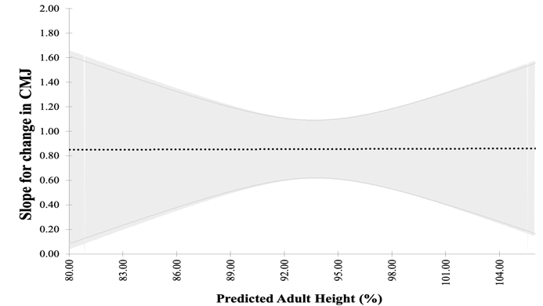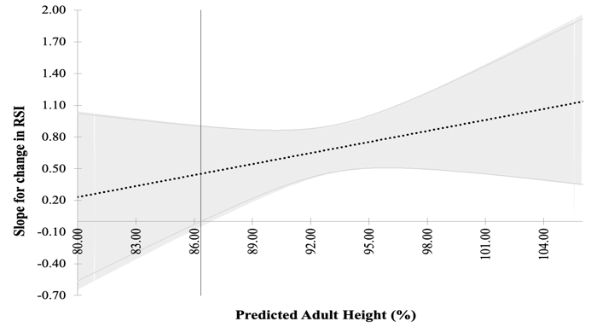
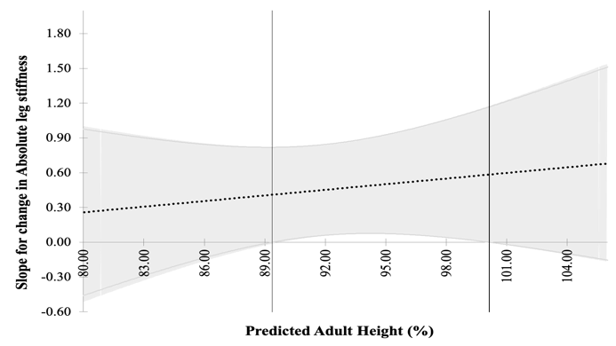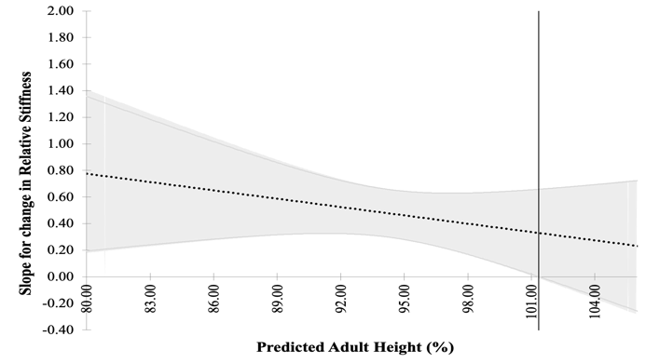
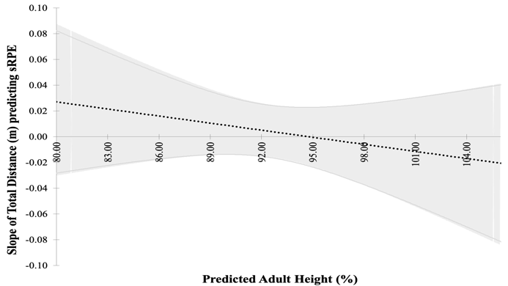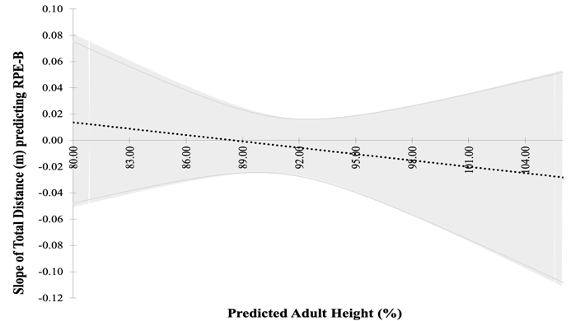
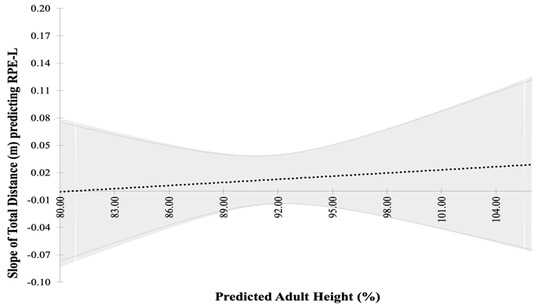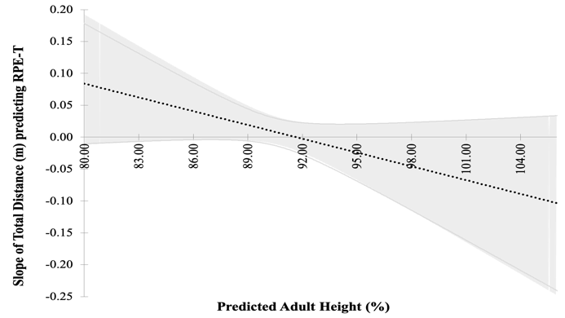
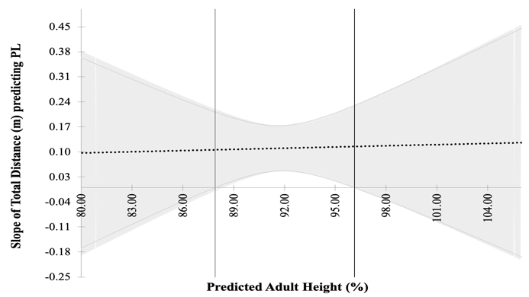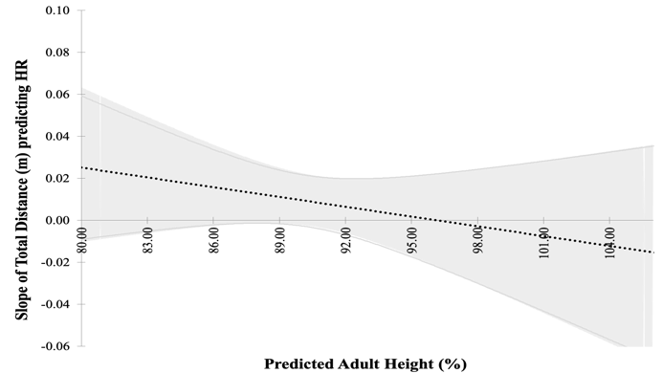
Figure 1. Johnson-Neyman slope analysis illustrating responses of neuromuscular performance and training load variables with predicted adult height (%) as the moderator, with thin vertical lines illustrating regions of significance.
Mean pooled data (Table 1) illustrates RSI performance improved by >3% during the activity, which is likely a potentiation effect and one that opposes previous findings (De Ste Croix et al., 2019; Lehnert et al., 2018). These studies utilised actual game-play (De Ste Croix et al., 2019) and the SAFT⁹⁰ (Lehnert et al., 2018) which provided greater stimulus duration, possibly explaining the differences. However, slope analysis indicated a linear trend whereby more mature individuals experienced greater potentiation. Radnor et al. (2018) explained that SSC function develops during maturation through increased elastic energy utilisation, neural potentiation and more efficient stretch-reflex combined with a higher force production propensity. The improved tendon stiffness, motor unit-recruitment and electro-mechanical delay may result in more mature individuals coping better with activity demands and therefore demonstrating more positive responses to the same stimulus. Less mature individuals may experience greater inhibition of SSC function, in turn elevating stress on contractile components and resisting limb deformation during the spring-mass model. This places a greater emphasis on strength characteristics of muscle (compliance) leading to longer propulsive contact times (De Ste Croix et al., 2019; Lehnert et al., 2017). Therefore, with tendon cross-sectional area (CSA) having large influences on its function and CSA increasing with growth, it is unsurprising that more mature individuals demonstrate efficient SSC function (Radnor et al., 2018) and, therefore, more favourable RSI responses from the standardised activity.

This inhibition of SSC function in less mature individuals can partly explain the responses to CMJ, absolute and relative leg stiffness. Pooled means indicate reduced CMJ of 4.1% and leg stiffness of 5.3-6.3% respectively with evidence of a significant slope from ~89% PAH for absolute stiffness and across maturation for relative stiffness (Figure 1). Mechanically this translates to increased yielding in the less mature individuals, with greater ground contact times, centre of mass (CoM) displacement and reduced movement efficiency (Radnor et al., 2018). Yielding is caused by the tendon being stiffer than the contractile element of the musculotendinous unit reducing the ability to utilise the elastic storage potential of the tendon. Therefore, less mature individuals fail to generate sufficient muscle stiffness through adequate recruitment of motor units and correct activation strategies (Radnor et al., 2018). This scenario may increase injury risk in the less mature individuals, via increased relative biomechanical load due to increased absorption of shear stress and greater reliance on the knee compared to more mature counterparts (Lloyd et al., 2012). This notion is similar to that reported in other sports, namely ballet where characteristically training loads associate closely with chronological age and where later maturing individuals experience crucial training periods in conjunction with PHV, often resulting in negative injury outcomes (Bradshaw et al., 2014; Mitchell et al., 2020). Findings relating to stiffness are similar to those proposed by De Ste Croix et al. (2017) in adolescent female soccer, whereby the negative impact of soccer activity on leg stiffness reduced as the maturation increased, with prepubescent individuals having the most substantial performance decrements and heightened risk of knee injury. In general, the lack of model significance supports assertions by Oliver et al. (2014) and De Ste Croix et al. (2019) in that leg stiffness responses are highly individualised and improvements in one neuromuscular component are not necessarily mirrored in others, despite sharing many SSC characteristics (Lloyd et al., 2012).

Variations in locomotive movement patterns may be linked to interactions observed between PL and PAH% highlighted in Figure 1. Although PL appeared consistent through the PAH% range, slope analysis suggests there is greater dose-response variation at the tails of maturation (considered pre- or post-PHV) with a significant slope identified almost exactly aligned with PHV (87.9-96.1% PAH; Figure 1). Tentatively, this may suggest that load-response patterns are influenced around PHV from a single exercise bout. Admittedly, the likely larger variation in anthropometric and physical properties at the tails of maturation could have also influenced the variation observed either side of the significant slope (Figueiredo et al., 2010). PL is a measure of the instantaneous rate of change in acceleration in each of the three vectors and can infer biomechanical load, though its accuracy for assessing load-response pathways at a structural level is yet to be determined (Verheul et al., 2020). However, a similar response that aligned with PHV (88-93% PAH) was observed in both absolute and relative stiffness. Therefore, in light of a fairly small sample size, interpretations should be cautious and treated as an informed possibility that whole-body load-response pathways are influenced by PAH% with further empirical investigation required. More frequent use of accelerometery within academy soccer will permit this work on which has the potential to provide valuable insights for injury prevention within youth soccer and more widely youth sport.

In general, internal load metrics were not moderated by PAH%, but analysis indicated an interaction with RPE-T and Figure 1 illustrates a progressive reduction in perceived RPE-T as PAH% increases. In line with other research (McLaren et al., 2017) RPE-T was perceived to be lower than other RPE metrics, likely because the Y-SAFT⁶⁰ is a repetitive audio-controlled activity profile requiring minimal cognitive strain in comparison to training and match activities. Why less mature individuals perceive the Y-SAFT⁶⁰ more technically demanding remains unclear, although one theory is linked to the relative physical shortcomings explained previously. Lloyd et al. (2012) suggested that changes in SSC during growth are associated with improvements in anaerobic performance such as sprinting and change of direction, which may have indirectly influenced perceptions of technical effort. For example, Y-SAFT⁶⁰ audio cues such as ‘stride’ or ‘sprint’ require maximal effort. A highly intense period during the Y-SAFT⁶⁰ could be perceived more cognitively demanding for less mature individuals endeavouring to maintain pace with the audio. An alternative theory is that less mature individuals experienced greater training monotony during the repetitive activity profile or non-linear differences in physical and cognitive maturation could have influenced perceptions (Brink et al., 2010; Wright et al., 2020). Despite no interaction, other dimensions of intensity (sRPE, RPE-B and HR) followed a similar trend whereby more mature individuals found the activity less intense (Figure 1). This would confirm the intuitive hypotheses, but lack of statistical significance prevents this conclusion; again, suggesting the need for more work in this area. It would also appear that perceptions of exertion during adolescence are influenced by the specific protocol and training mode which may have contributed to these findings (McLaren et al., 2017).

Limitations
Whilst the standardised Y-SAFT⁶⁰ facilitated a dose-response comparison, it is conceded that it disregards many reactive soccer-specific actions (e.g. responding to opponents, jumping and kicking). Consequently, although comparative from a locomotive perspective, the Y-SAFT⁶⁰ may underrepresent true anatomical, physiological and biomechanical stresses placed on adolescent players during actual training and/or competition. This may explain why some individuals experienced a level of potentiation in neuromuscular performance as the demands were insufficient to elicit detrimental performance changes. However, the large positional and individual variability of external loads from competitive matches and training activities make more ecologically valid dose-response protocols highly complex for research. In addition, it is appreciated that baseline markers of physical fitness (e.g. aerobic fitness, strength, speed) may influence individual responses to the standardised activity profile and therefore should not be discounted when considering the moderating impact of PAH%.

This acute study suggests that a single soccer specific activity bout can elicit maturation specific dose-responses (RSI, RPE-T, Stiffness), which are likely magnified when combined with repeated activities each week. Therefore, practitioners are urged to consider the maturational load-response variation in an attempt to reduce injury incidence from inappropriate levels of physical and cognitive stress (Brink et al., 2010). Based on tentative findings, it would be irresponsible to make robust recommendations regarding how to change training practices, but the authors would encourage practitioners to be mindful of dose-response variations across maturation in the following ways. Firstly, activities high in biomechanical load characterised by short, intense intervals with frequent accelerations, decelerations and changes of direction, often over small to moderate pitch-dimensions may accentuate variations in response. Therefore, it may be prudent to restrict the frequency and volume of exposure to such load across the training week, particularly in those approaching peak-height velocity. Secondly, practitioners are encouraged to adapt their prescription processes and routinely consider maturation specific load management strategies whenever possible, for example utilising existing maturity-categorised strategies such as bio-banded training or competitions (Cumming et al., 2018). Although this does not automatically reduce the load on those deemed vulnerable, it provides opportunity for the coach to better manage the frequency and volume of exposure to stressful activities on a group level and therefore reduce large variations in inter-individual response attributed to maturity. Finally, this would facilitate the inclusion of activities that required less unpredictable, reactive strength (typified by deceleration or COD) actions in favour of more structured ‘technical’ practices that built on key movement competencies such as acceleration, deceleration, change of direction and strength development as suggested by the Youth Physical Development (YPD) model (Lloyd & Oliver, 2012). It is not recommended that practitioners reduce training exposure per se or remove any particular activities completely, but more that the emphasis of training shifts to allow smart prescription of loads that are directed at the individual appropriately.

Conclusion
Collectively, these findings provide evidence of the moderating effect of maturation to perceptions and responses to standardised activity. Therefore, the findings suggest that failure to consider maturity-related responses may elevate the predisposition to injury of some athletes. Both psycho- and physiological responses are altered during maturation which must be considered by practitioners within their training prescription to avoid negative consequences on their players. Strategies already exist within research and practice to facilitate maturity specific training interventions which may help coaches manage the individual dose-response smartly and practically within a group environment. More work is needed to corroborate these findings and provide exact mechanisms of the causes; however, tentative inferences suggest that repeated high-velocity biomechanical loads may contribute to the observed differences in neuromuscular response across maturation and should be managed considerately.

Acknowledgements
The author team would like to thank the clubs involved with the study for facilitating the data collection.

Declarations of interest
The authors report no conflicts of interest.

References
Altman, D. G., & Royston, P. (2006). The cost of dichotomising continuous variables. British Medical Journal, 6(332), 1080. https://doi.org/10.1136/bmj.332.7549.1080
Barrett, S., Guard, A., & Lovell, R. (2013). SAFT90 simulates the internal and external loads of competitive soccer match-play (pp. 95–100).
Bergeron, M. F., Mountjoy, M., Armstrong, N., Chia, M., Côté, J., Emery, C. A., Faigenbaum, A., Hall, G., Kriemler, S., Léglise, M., Malina, R. M., Pensgaard, A. M., Sanchez, A., Soligard, T., Sundgot-Borgen, J., van Mechelen, W., Weissensteiner, J. R., & Engebretsen, L. (2015). International Olympic Committee consensus statement on youth athletic development. British Journal of Sports Medicine, 49(13), 843–851. https://doi.org/10.1136/bjsports-2015-094962
Beyer, K. S., Stout, J. R., Redd, M. J., Baker, K. M., Church, D. D., Bergstrom, H. C., Hoffman, J. R., & Fukuda, D. H. (2020). Effect of somatic maturity on the aerobic and anaerobic adaptations to sprint interval training. Physiological Reports, 8(9). https://doi.org/10.14814/phy2.14426
Bradshaw, E., Karin, J., Bowermann, E., & Hume, P. (2014). Growth and injury patterns of aspiring classical ballet dancers.
Brink, M. S., Visscher, C., Arends, S., Zwerver, J., Post, W. J., & Lemmink, K. A. (2010). Monitoring stress and recovery: New insights for the prevention of injuries and illnesses in elite youth soccer players. British Journal of Sports Medicine, 44(11), 809–815. https://doi.org/10.1136/bjsm.2009.069476
Buchheit, M., & Mendez-Villanueva, A. (2014). Effects of age, maturity and body dimensions on match running performance in highly trained under-15 soccer players. Journal of Sports Sciences, 32(13), 1271–1278. https://doi.org/10.1080/02640414.2014.884721
Cumming, S. P., Brown, D. J., Mitchell, S., Bunce, J., Hunt, D., Hedges, C., Crane, G., Gross, A., Scott, S., Franklin, E., Breakspear, D., Dennison, L., White, P., Cain, A., Eisenmann, J. C., & Malina, R. M. (2018). Premier League academy soccer players’ experiences of competing in a tournament bio-banded for biological maturation. Journal of Sports Sciences, 36(7), 757–765. https://doi.org/10.1080/02640414.2017.1340656
Cumming, S. P., Lloyd, R. S., Oliver, J. L., Eisenmann, J. C., & Malina, R. M. (2017). Bio-banding in Sport: Applications to Competition, Talent Identification, and Strength and Conditioning of Youth Athletes. Strength and Conditioning Journal, 39(2), 34–47. https://doi.org/10.1519/SSC.0000000000000281
De Ste Croix, M., Hughes, J. D., Lloyd, R. S., Oliver, J. L., & Read, P. J. (2017). Leg Stiffness in Female Soccer Players: Intersession Reliability and the Fatiguing Effects of Soccer-Specific Exercise. Journal of Strength and Conditioning Research, 31(11), 3052–3058. https://doi.org/10.1519/JSC.0000000000001715
De Ste Croix, M., Lehnert, M., Maixnerova, E., Zaatar, A., Svoboda, Z., Botek, M., Varekova, R., & Stastny, P. (2019). Does maturation influence neuromuscular performance and muscle damage after competitive match-play in youth male soccer players? European Journal of Sport Science, 19(8), 1130–1139. https://doi.org/10.1080/17461391.2019.1575913
De Ste Croix, M., Priestley, A. M., Lloyd, R. S., & Oliver, J. L. (2015). ACL injury risk in elite female youth soccer: Changes in neuromuscular control of the knee following soccer-specific fatigue: Female youth soccer and fatigue. Scandinavian Journal of Medicine & Science in Sports, 25(5), e531–e538. https://doi.org/10.1111/sms.12355
Epstein, L. H., Valoski, A. M., Kalarchian, M. A., & McCurley, J. (1995). Do Children Lose and Maintain Weight Easier Than Adults: A Comparison of Child and Parent Weight Changes From Six Months to Ten Years. Obesity Research, 3(5), 411–417. https://doi.org/10.1002/j.1550-8528.1995.tb00170.x
Fanchini, M., Ferraresi, I., Petruolo, A., Azzalin, A., Ghielmetti, R., Schena, F., & Impellizzeri, F. M. (2017). Is a retrospective RPE appropriate in soccer? Response shift and recall bias. Science and Medicine in Football, 1(1), 53–59. https://doi.org/10.1080/02640414.2016.1231411
Figueiredo, A. J., Silva, M. J. C. e, Cumming, S. P., & Malina, R. M. (2010). Size and Maturity Mismatch in Youth Soccer Players 11- to 14-Years-Old. Pediatric Exercise Science, 22(4), 596–612. https://doi.org/10.1123/pes.22.4.596
Foster, C. (1998). Monitoring training in athletes with reference to overtraining syndrome: Medicine & Science in Sports & Exercise, 30(7), 1164–1168. https://doi.org/10.1097/00005768-199807000-00023
Hader, K., Rumpf, M. C., Hertzog, M., Kilduff, L. P., Girard, O., & Silva, J. R. (2019). Monitoring the Athlete Match Response: Can External Load Variables Predict Post-match Acute and Residual Fatigue in Soccer? A Systematic Review with Meta-analysis. Sports Medicine - Open, 5(1), 48. https://doi.org/10.1186/s40798-019-0219-7
Hannon, M. P., Carney, D. J., Floyd, S., Parker, L. J. F., McKeown, J., Drust, B., Unnithan, V. B., Close, G. L., & Morton, J. P. (2020). Cross-sectional comparison of body composition and resting metabolic rate in Premier League academy soccer players: Implications for growth and maturation. Journal of Sports Sciences, 1–9. https://doi.org/10.1080/02640414.2020.1717286
Harley, J. A., Barnes, C. A., Portas, M., Lovell, R., Barrett, S., Paul, D., & Weston, M. (2010). Motion analysis of match-play in elite U12 to U16 age-group soccer players. Journal of Sports Sciences, 28(13), 1391–1397. https://doi.org/10.1080/02640414.2010.510142
Hayes, A. F., & Rockwood, N. J. (2017). Regression-based statistical mediation and moderation analysis in clinical research: Observations, recommendations, and implementation. Behaviour Research and Therapy, 98, 39–57. https://doi.org/10.1016/j.brat.2016.11.001
Hill, M., Scott, S., Malina, R. M., McGee, D., & Cumming, S. P. (2020). Relative age and maturation selection biases in academy football. Journal of Sports Sciences, 38(11–12), 1359–1367. https://doi.org/10.1080/02640414.2019.1649524
Johnson, A., Farooq, A., & Whiteley, R. (2017). Skeletal maturation status is more strongly associated with academy selection than birth quarter. Science and Medicine in Football, 1(2), 157–163. https://doi.org/10.1080/24733938.2017.1283434
Johnson, D., Williams, S., Bradley, B., Sayer, S., Fisher, J. M., & Cumming, S. (2020). Growing pains: Maturity associated variation in injury risk in academy football. European Journal of Sport Science, 20(4), 544–552. https://doi.org/10.1080/17461391.2019.1633416
Khamis, H. J., & Roche, A. F. (1994). Predicting Adult Stature Without Using Skeletal Age: The Khamis-Roche Method. Pediatrics, 94(4), 504–507.
Lehnert, M., Croix, M. D. S., Xaverova, Z., Botek, M., Varekova, R., Zaatar, A., Lastovicka, O., & Stastny, P. (2018). Changes in Injury Risk Mechanisms After Soccer-Specific Fatigue in Male Youth Soccer Players. Journal of Human Kinetics, 62(1), 33–42. https://doi.org/10.1515/hukin-2017-0157
Lehnert, M., De Ste Croix, M., Zaatar, A., Hughes, J., Varekova, R., & Lastovicka, O. (2017). Muscular and neuromuscular control following soccer-specific exercise in male youth: Changes in injury risk mechanisms. Scandinavian Journal of Medicine & Science in Sports, 27(9), 975–982. https://doi.org/10.1111/sms.12705
Lloyd, R. S., & Oliver, J. L. (2012). The Youth Physical Development Model: A New Approach to Long-Term Athletic Development. Strength & Conditioning Journal, 34(3), 61–72. https://doi.org/10.1519/SSC.0b013e31825760ea
Lloyd, R. S., Oliver, J. L., Hughes, M. G., & Williams, C. A. (2012). Age-related differences in the neural regulation of stretch–shortening cycle activities in male youths during maximal and sub-maximal hopping. Journal of Electromyography and Kinesiology, 22(1), 37–43. https://doi.org/10.1016/j.jelekin.2011.09.008
Lovell, R. (n.d.). Physiological responses to SAFT90: A new soccer-speciﬁc match simulation. 1.
McLaren, S. J., Smith, A., Spears, I. R., & Weston, M. (2017). A detailed quantification of differential ratings of perceived exertion during team-sport training. Journal of Science and Medicine in Sport, 20(3), 290–295. https://doi.org/10.1016/j.jsams.2016.06.011
Mitchell, S. B., Haase, A. M., & Cumming, S. P. (2020). Experiences of delayed maturation in female vocational ballet students: An interpretative phenomenological analysis. Journal of Adolescence, 80, 233–241. https://doi.org/10.1016/j.adolescence.2020.03.005
Montoya, A. K. (2019). Moderation analysis in two-instance repeated measures designs: Probing methods and multiple moderator models. Behavior Research Methods, 51(1), 61–82. https://doi.org/10.3758/s13428-018-1088-6
Oliver, J. L., De Ste Croix, M. B. A., Lloyd, R. S., & Williams, C. A. (2014). Altered neuromuscular control of leg stiffness following soccer-specific exercise. European Journal of Applied Physiology, 114(11), 2241–2249. https://doi.org/10.1007/s00421-014-2949-z
Oliver, J. L., Lloyd, R. S., & Whitney, A. (2015). Monitoring of in-season neuromuscular and perceptual fatigue in youth rugby players. European Journal of Sport Science, 15(6), 514–522. https://doi.org/10.1080/17461391.2015.1063700
Parr, J., Winwood, K., Hodson-Tole, E., Deconinck, F. J. A., Parry, L., Hill, J. P., Malina, R. M., & Cumming, S. P. (2020). Predicting the timing of the peak of the pubertal growth spurt in elite youth soccer players: Evaluation of methods. Annals of Human Biology, 0(ja), 1–23. https://doi.org/10.1080/03014460.2020.1782989
Premier League. (2011). The Elite Player Performance Plan. English Premier League.
Radnor, J. M., Oliver, J. L., Waugh, C. M., Myer, G. D., & Lloyd, R. S. (2020). The Influence of Maturity Status on Muscle Architecture in School-Aged Boys. Pediatric Exercise Science, 32(2), 89–96. https://doi.org/10.1123/pes.2019-0201
Radnor, J. M., Oliver, J. L., Waugh, C. M., Myer, G. D., Moore, I. S., & Lloyd, R. S. (2018). The Influence of Growth and Maturation on Stretch-Shortening Cycle Function in Youth. Sports Medicine, 48(1), 57–71. https://doi.org/10.1007/s40279-017-0785-0
Read, P. J., Oliver, J. L., De Ste Croix, M. B. A., Myer, G. D., & Lloyd, R. S. (2016). Neuromuscular Risk Factors for Knee and Ankle Ligament Injuries in Male Youth Soccer Players. Sports Medicine, 46(8), 1059–1066. https://doi.org/10.1007/s40279-016-0479-z
Read, P. J., Oliver, J. L., De Ste Croix, M. B. A., Myer, G. D., & Lloyd, R. S. (2018). An audit of injuries in six english professional soccer academies. Journal of Sports Sciences, 36(13), 1542–1548. https://doi.org/10.1080/02640414.2017.1402535
Rommers, N., Rössler, R., Goossens, L., Vaeyens, R., Lenoir, M., Witvrouw, E., & D’Hondt, E. (2020). Risk of acute and overuse injuries in youth elite soccer players: Body size and growth matter. Journal of Science and Medicine in Sport, 23(3), 246–251. https://doi.org/10.1016/j.jsams.2019.10.001
Salter, J., De Ste Croix, M., Hughes, J., Weston, M., & Towlson, C. (2020). Monitoring practices of training load and biological maturity in UK soccer academies. International Journal of Sports Physiology and Performance, 28.
Small, K., McNaughton, L. R., Greig, M., Lohkamp, M., & Lovell, R. (2009). Soccer Fatigue, Sprinting and Hamstring Injury Risk. International Journal of Sports Medicine, 30(08), 573–578. https://doi.org/10.1055/s-0029-1202822
van der Sluis, A., Elferink-Gemser, M., Brink, M., & Visscher, C. (2015). Importance of Peak Height Velocity Timing in Terms of Injuries in Talented Soccer Players. International Journal of Sports Medicine, 36(04), 327–332. https://doi.org/10.1055/s-0034-1385879
Verheul, J., Nedergaard, N. J., Vanrenterghem, J., & Robinson, M. A. (2020). Measuring biomechanical loads in team sports – from lab to field. Science and Medicine in Football, 1–7. https://doi.org/10.1080/24733938.2019.1709654
Whalan, M., Lovell, R., & Sampson, J. A. (2020). Do Niggles Matter? - Increased injury risk following physical complaints in football (soccer). Science and Medicine in Football, 4(3), 216–224. https://doi.org/10.1080/24733938.2019.1705996
Wright, M. D., Songane, F., Emmonds, S., Chesterton, P., Weston, M., & McLaren, S. J. (2020). Differential ratings of perceived match and training exertion in youth female soccer: Differential RPE in girls soccer.
Wrigley, R., Drust, B., Stratton, G., Scott, M., & Gregson, W. (2012). Quantification of the typical weekly in-season training load in elite junior soccer players. Journal of Sports Sciences, 30(15), 1573–1580. https://doi.org/10.1080/02640414.2012.709265
Wu, A. D., & Zumbo, B. D. (2008). Understanding and Using Mediators and Moderators. Social Indicators Research, 87(3), 367–392. https://doi.org/10.1007/s11205-007-9143-1

where _{I} = individual participant; ₁ or ₂ denotes instance; b₀ intercept; b₁ = regression weight; ε = normally distributed residuals with Intercept variance

