How can Augmented Reality help bridge the gap between classroom and outside science learning for primary schools?

Warren Fearn
York St John University
2019

W

Thanks to:

Professor Sara Kassis, Engineering Science, Sonoma State University
Tim Bradbury, STEM Learning Centre
Steve Parkinson, Education Manager, Autodesk UK
Lisa Niven, All Saints School, York (Subject Leader for Chemistry)
Caspar Thykier – CEO, Zappar
Pete Casson – CTO, TWINKL
Dr Anne Hodgson, York University
Dr Robert Edgar, York St John University
Dr Jon Hook, York University
Dr Lynda Dunlop, York University
Paul Hamilton, AR Teacher, Apple Educator
Professor Judith Bennet, York University
Professor Andy Parsons, York University

Table of Contents
Page(s)

Executive Summary 5 - 6

Introduction 7 - 11

_____________________________________________________

- Science Education Page(s)

  - What are the key challenges in teaching
primary science education? 12

    - Resources 12 - 13
    - Practical 13 - 14
    - Teacher Expertise 14 - 16
    - CPD for Teachers 16 - 17
    - Technical Support 17
    - Policy Makers 17 - 18
    - Health & Safety 19
    - Curriculum Delivery 19 - 21
    - Content Consumption 21 - 22
    - Science Capital 22 - 25

_____________________________________________________

- Technology Page(s)

  - EdTech 26 - 27

  - Virtual Environments and Simulations 27 - 30

  - What is Augmented Reality? 30 - 32

2.4. Characteristics of Augmented Reality 32 - 33
2.4.1. Wearable AR 33 - 36
2.4.2. Handheld AR 36 - 37
2.4.3. Marker Based AR 37
2.4.4. Marker Less AR 38
2.4.5 Haptics 38 - 39

_____________________________________________________

- AR in Education Page(s)

  - What are the educational benefits using AR? 40 - 41

  - Pedagogical Alignment 41 - 43
  - Location Based 43 - 44
  - Storytelling 44 - 46
  - Augmented Creativity 46 - 47
  - Tangible 48 - 50
  - Game Based 51
  - Project-Based 51 - 52
  - 21st Century Skills 53

___________________________________________________

- AR Challenges Page(s)

  - What are the challenges facing AR in Education? 54

    - Cost & Investment 55 - 56
    - Technical Implications 56 - 57
    - Adoption & Accessibility 57 - 58

  - Ethical Implications 59
    - Privacy 59 - 60
    - Liability 60 – 63

____________________________________________________

- Conclusion Page(s) 64 – 67

  - Beyond the Classroom 67
    - Non-Formal Learning 67 – 68
    - Home Learning 69
    - Subscription 69 – 72

  - Online Education 71 - 72
    - Flipped & Blended Learning 72 – 73
    - MOOC (Massive Open Online Course) 73 – 74

Design Requirements

Bibliography

Executive Summary

This paper aims to explore the development and innovative uses of Augmented Reality (AR) in science primary education. One of the main advantages of using AR applications and platforms is the ability to display relevant digital information to support students’ learning in real time and through specific contexts. Augmented reality offers exciting opportunities to digitally interact in ways traditional methods cannot necessarily deliver. The literature review provides an overarching view of how augmented reality applications can offer new ways of learning sciences for young children.
SCIENCE EDUCATION: Chapter one outlines the challenges facing science curriculum in schools. This section identifies key factors regarding what obstacles schools are having to confront in terms of delivering a robust science curriculum.
TECHNOLOGY: Chapter two focuses on the use of technology. Whereabouts are all of these ‘realities’ heading in the future and how are smartphones and wearables impacting on our interaction? The emergence of augmented reality offers the opportunity to think creatively of how its enriched content can promote innovative ways of delivering digital learning experiences.
AR IN EDUCATION: Chapter three explores pedagogical approaches to how AR can be implemented as a learning tool. How can AR change the way we learn? This section provides examples of how AR is being used through a variety of learning applications, from interactive text books, storytelling through to tangible interaction using 21st century skills. Where can these technologies serve to impact the learning delivery?
AR CHALLENGES: Chapter four draws attention towards the obstacles encountered when using AR through mobile and wearable devices. What are the ethical implications involved? Are teachers willing to adopt such technologies for learning? It’s important to address these issues in order to understand the appropriateness of using AR technology in any given environment, especially in the case of young children.
CONCLUSION: Chapter five considers the significant points raised across all chapters and how they interweave between one another. How can AR technology support sciences and in what capacity? Supported evidence shows that UK primary schools are facing a problem when teaching sciences during regular school hours. How can we engage young people in these subject areas and where do interventions need to take place? This section offers suggestions to how AR can offer new learning experiences by aligning to a more flexible curriculum delivery.

__________________

Introduction
There are great economic benefits of chemistry for the UK economy; it is the bed rock of manufacturing. The EPSRC (Engineering and Physical Sciences Research Council) and RSC (Royal Society of Chemistry) commissioned an independent study and identified the chemistry-reliant industries contributed £258 billion towards the UK economy in 2007, equivalent to 21% of UK GDP whilst supporting 6 million jobs. The success of all the UK’s established growth sectors (aerospace, agritech, automotive and life sciences) will be dependent on chemistry in the future. The Strategy for Delivering Chemistry-Fuelled Growth of the UK Economy envisages by 2030 , chemistry led industries will contribute £300 billion towards the economy.
The Sector Skills Council (Cogent), has estimated that chemistry-using industries in the UK will need 33,000 apprentices and 37,000 graduates by 2020, yet the projected supply figures are 12,000 and 19,000 respectively. An international analysis from the Department for Business, Innovation and Skills evidenced the UK demonstrates a weakness in (Science, Technology, Engineering and Mathematics) STEM skills talent base, in comparison to other countries who are taking significant steps to train, attract and retain talent. In 2017, an estimated 26,945 students applied to university to study chemistry, according to UCAS figures. This is down 8.5 per cent on 2016 and further down 13.4 per cent on 2015, although recent figures indicate A-level subject (chemistry) had a 3.4% slight increase change from 2017 to 2018 in candidate numbers.

A growing concern surrounding the UK’s key economic problems is a broad shortage of STEM skills in the workforce. The November 2017 policy paper, Industrial Strategy: Building a Britain fit for the future, included ‘people’ as one of its five themes, and stated that “…we need to tackle particular shortages of STEM skills. These skills are important for a range of industries from manufacturing to the arts”. The Confederation of British Industry (CBI) reported that “STEM skills shortages are widespread” with over 40% of employers currently experiencing difficulty recruiting staff with STEM qualifications. The Council for Industry and Higher Education (CIHE) warned that ‘the workforce of the future will increasingly require people with the capabilities that a STEM qualification provides’.

Despite the benefits towards the economy, the Royal Society of Chemistry have identified too many young people are not taking the opportunity to fulfil these employment roles due to a lack of science and chemistry skills. The underlining facts point towards schools in England are under immense pressure to perform well in written examinations; consequently, teachers are reporting that science is now perceived a far less important part of the curriculum (CBI, 2015) and rarely prioritised in curriculum development (Wellcome Trust, 2014). Amanda Speilman, Her Majesty’s chief inspector for education, outlined in an Ofsted study that science lessons were in danger of being discarded due to the pressure on schools being result driven. The issue lies around key stage 2 SATs results, taken by students aged 11 years old, where it’s becoming more favourable for schools to prioritise English and maths above science subjects in order to climb up the league school tables. According to the Royal Society of Chemistry, there appears to be a commonality amongst senior leadership teams where more emphasis is being placed on rating approvals; in some cases, the Standards and Testing Agency (2016) do suggest students may not have received chemistry teaching in Year 6 or even experienced the chemistry curriculum in its full entirety. The Wellcome Trust evidences that primary teachers are now only managing to devote on average 1 hour and 24 minutes per week in teaching science.

As the future economy continues to grow, there will be a greater demand for a workforce that possess high levels of scientific and technological skills, so young people starting at primary level need to be enthused in order for them to continue studying a science subject beyond the curriculum and linked to employability. Due to the lack of recognition as a core subject area, there is a significant impact on less curriculum time and investment, causing repercussions in reduced budgets for resources, reduction in technical support and CPD for science teachers. Therefore, schools are having to overcome certain obstacles, where primary schools lack sufficient and appropriate resources to teach practical science effectively. The Department for Education revealed there remains a shortage of chemistry teachers and specialist subject leaders in England. Many schools face challenges relating to the recruitment and retention of teachers, with some subjects and schools facing particular difficulties. The Royal Society of Chemistry (RSC) acknowledged that more needs to be achieved in attracting new teaching talent to the profession with the relevant expertise and qualifications starting from the beginning at primary science education level to secure UK competitiveness.

The ASPIRES project conducted by Kings College London, references previous research (Lindahl., B. 2007) and shows the period between 10 – 14 years old is a critical time for the development of a young person’s attitude towards science. By the time students reach the age of 14, their attitudes towards science are fairly fixed on whether they wish to pursue science as a career choice. The study highlights the concerns around not enough young people are choosing to study a science career in STEM related subjects. Furthermore, it highlights the importance of ‘science capital’ to young people’s aspirations, background knowledge, and social interaction in knowing ‘how it all works’. Parents appear to be unaware of the underlining values and career opportunities of learning sciences in comparison to English and maths subject areas. By building ‘science capital’ it encourages families to understand the relevance of science through their everyday lives (Archer et al 2015).

Susan Hockfield, the first lady president of the Massachusetts Institute of Technology (2004-2012), believes that STEM education should be introduced as early as primary schools to enhance children's enthusiasm, interest and exposure. She believes that waiting to motivate children to take up STEM later on in education will not help boost their confidence. Consequently, this is a reasoning she believes why there is such a disinterest and low uptake for STEM subject areas within further education.

Whether it’s exploring forces, investigating materials or analysing atomic structures, the use of augmented reality offers the unique affordances of combining the physical and virtual worlds to discover how we can interact with our own environments and make sense of the world around us. Therefore, AR presents unique affordances to engage learners using text, videos, sounds, animations etc. to conduct investigations (Dede, 2009). It has the potential to ‘enable students to see the world around them in new ways and engage with realistic issues in a context with which students are already connected’ (Klopfer & Sheldon, 2010). The New Media Consortium Horizon Report (2016) found early pilot findings using AR provided a positive impact on the classroom, including enhanced group and peer-to-peer learning. (Billinghurst 2002; Klopfer & Squire 2008, Wang. M et al 2017) believe that AR has vast potential implications and numerous benefits for the augmentation of teaching and learning environments through integrating digital learning resource to enable learners to experience scientific phenomena that are not possible in the real world. AR offers a range of exciting opportunities to enhance the learning experience through contextual, collaborative, personalised, instructional etc processes to help engage students in activities. Furthermore, the use of assistive technologies can enhance the experience of students with disabilities or special educational needs.

Technologies such as Augmented Reality and Virtual Reality are already changing the face of education in the creation of new learning experiences. The government’s Industrial Strategy establishes to invest in digital and technical education to support the shortage of STEM skills; they recognise that immersive technologies (augmented, virtual and mixed reality) are changing how we experience the world around us and are willing to invest in these technologies for the future – from entertainment through to classroom activities.

Overall, the use of augmented reality presents opportunities for teachers to rethink their traditional approach to teaching and encourage them to explore innovative methods of using technologies as part of their learning process. The Salters approach advocates involving different stakeholders to shape the curriculum delivery (funders, policy-makers, science educators, teachers, students, designers etc) can all play an important role in creating a robust and inspiring AR learning experience. It is essential for stakeholders to not only focus on secondary schools, but to address such issues at an earlier stage of a child’s education. Earlier interventions need to begin at primary education in an effort to aspire students around STEM related activities.

Science teaching at primary level is a pivotal moment in how children perceive whether they wish to pursue a science subject towards the end of primary school; therefore, having a significant impact on their long-term achievements and goals for the future. We must engage young people far earlier and build upwards. It’s about switching them on and not switching them off to science.

__________________

- Science Education

  - What are the challenges in teaching primary science education?
Primary science education faces some key challenges since the national curriculum reforms. In 2013, the government made changes to the primary national curriculum which resulted in some leaders and curriculum managers finding it difficult to manage; as not all teachers perceive themselves as being science specialists. As a consequence, science is being taught with less rigour in comparison to other subject areas. Ofsted warned that science “has clearly been downgraded in some primary schools” since the key stage 2 science test was scrapped in 2009 and have identified primary science as a key priority for their new framework to be launched in September 2019. Primary school managers should be planning towards the new Ofsted framework by educating students to use skills to find out about the world they live in. The following key factors highlight how they are impacting on the curriculum delivery for primary science education.

    - Resources
SCORE (Science Community Representing Education), revealed concerns about the provision of resources for practical work in schools. The situation is worse in primary schools, with teachers having access to less than half of their materials required to teach practical science. They commissioned a report on, ‘Resourcing for Practical Science in Primary schools’ and created a set of benchmarks that reflected an acceptable level of resourcing, between one end of the spectrum being ‘bare minimum’ to the other at ‘gold standard’. Their criteria were benchmarked against three main areas:

- Equipment and consumables and an estimation of quantity required
- Classroom facilities
- Access to outside space
The research gathered 401 responses from 397 unique primary schools and revealed:

- Many primary schools lack sufficient appropriate resources to teach practical science effectively
- Facilities in many primary schools are not adequate for practical science
- There is large variation in funding for practical science in primary schools
- Low levels of resourcing are accepted as the norm

Many primary schools lacked sufficient and appropriate resources to teach practical science effectively, with over (70%) of schools having less than (60%) of the items needed. On average, most of the primary schools maintained (46%) of their equipment and consumables to teach science, and (20%) of respondents having a lack of storage space. Staff reported (40%) being dissatisfied with the amount of funding available for resources and decreasing budgets dependent on their Local Authority. Primary teachers expressed the following concerns and obstacles when teaching leading science:

- Lack of budget and resources (35%)
- Lack of time and curricular importance (22%)
- Lack of subject knowledge (11%)
- Issues relating to setting up space or access to resources (10%)

1.1.2. Practical
Practical work in any branch of science is seen by the majority of science teachers as a vital part of a learner’s teaching and learning experience. It prepares students for technical education routes, as well as for general academic study and helps motivate students to continue with STEM whether they are heading for university, a technical qualification or a STEM apprenticeship. Taking part in practical work is an integral and essential part of learning the sciences. It provides experiences through which students can develop their understanding, enabling them to make the link between subject content and the physical world.
The Gatsby report (Holman, J. 2017) reveals that practical science can help motivate students and teach practical skills. The National Curriculum must be more explicit about the laboratory skills that science education seeks to develop. For example, an elementary school in Quebec teach students to become familiar with the use of observational instruments (magnifying glass, binoculars) and simple measuring instruments (ruler, eyedropper, graduated cylinder, balance, thermometer, chronometer).

    - Teacher Expertise
Currently, there is a total of 8.67 million students in all schools in England. This is an increase of just under 110,000 students (1.3%) in 2016. The total number of students have grown every year since 2009 and there are now 577,000 more students in schools. The decline in the number of schools, coupled with increases in student numbers, means schools are on average larger. Schools are struggling to recruit the science specialists they need. A report by the Education Policy Institute (EPI) reveals teacher training applications are down by 5% and training targets have been persistently missed in science. Most science subjects struggle to attract highly-qualified teachers due to the decline in teacher pay.
The main factors outlining where science education is being impacted on are:

1) only one-third of secondary-school chemistry teachers do not have a chemistry degree
2) only (6%) of primary schools were found to have a science subject leader with a science degree and
3) (8.3%) of primary school teachers overall (as opposed to just science subject leaders) in England have a science degree.
National statistics of the school workforce in England (2016), published by the Department for Education (DfE) in June 2017, showed that of teachers in state-funded secondary schools, (25.1%) of chemistry teachers did not have a relevant post A-Level qualification. The data reveals many teachers in England do not hold prior specialist knowledge of their subject area and there remains a shortage of chemistry teachers and specialist subject leaders in England.

As a direct response, the Royal Society of Chemistry (RSC) recommended that career pathways into chemistry has to begin at primary science education level to secure UK competitiveness.

Government must ensure by 2020:

- Every primary school has a specialist science subject leader.
- Every post-14 chemistry student, (including those studying the subject as part of a combined science qualification) is taught by a chemistry-specialist teacher.

To achieve this, the Government should work with a variety of stakeholders to:

- Ensure chemistry teachers and primary science leaders have the right subject expertise
- Ensure chemistry teachers and primary science leaders have access to continuing professional development
- Learn from best practice overseas and build a better understanding of the situation in England.
- The Government should urgently address the severe shortage of science graduates becoming primary teachers and consider rolling out some of the more successful secondary science teacher recruitment incentive programmes to primary.

Professor Sir John Holman reveals - the ‘biggest challenge for England’ is that too many science teachers are teaching outside their specialism and those teachers with specialist qualifications are more confident and more prepared to do experiments than if they were not specialised’. The Gatsby report advises schools should have subject specialist training (both initial and continuing) in the science subject areas (biology, chemistry, physics etc.) and age range they teach, so they can conduct practical science with confidence and with suitable background knowledge . It is recommended that:

- At pre-16 level, teachers who do not hold an A-level science qualification related to their subject area, will require training to help their confidence and skill base.
- Each year, science departments should review their teacher expertise and recognise where support and development are needed for individuals. This should include professional reflection and specific training in practical science.

    - CPD for Teachers
Given the realities of teacher shortages in England, additional training may often be the only available route to scarce subject expertise. Whilst (91%) of UK schools had a science lead and (60%) had science-specific areas in their school development plan, only (37%) of schools had an allocated budget for CPD in science and (30%) of teachers reported they ‘had not received any support for science teaching in the last year’ from their school. The National Education Union (NEA) report in 2017, analysed 8,173 teachers views on their workload, revealing that (40%) of respondents said their opportunities for CPD had reduced in the last 5 years and (61%) were predominately undertaken to meet school requirements. There are many opportunities for teachers to engage in science, emphasising the importance of not only recruiting expert teachers but helping to develop their expertise. Teachers need to have their subject knowledge updated and to find new ideas for practical activities, including for example the use of digital technology to support practical science.

The UK government in partnership with the Chartered College of Teaching have recently launched online training for teachers and leaders in education. Their aim is to improve the use of technology in education and acknowledge that best leaders place a strong focus on how technology can improve processes and teaching. The first training courses can be found at FutureLearn with free access to online content for all educators. Other initiatives such as external STEM Clubs operated through the National STEM Learning Centres and ENTHUSE bursaries help to support teachers’ professional development.

    - Technical Support
Technicians are crucial to preparing practical lessons for teachers, ensuring secure storage of chemicals and equipment in order to oversee the safety of a laboratory environment. The Association for Science Education (ASE) published a survey in 2017 based on schools struggling to cope with a dwindling number of science technicians. They reviewed information based on almost 400 schools, including academies, state schools and independent ones; the stark reality is over the past year, the number of technicians fell in about 50% of state schools, 40% of academies and 10% of independent schools. It is quite obvious that state schools and academies are losing their technical support and as a result workload are being exacerbated, whilst not having sufficient time to prepare a practical can have severe consequences with regards to teachers and pupil’s safety. Schools are finding it increasingly difficult to recruit and retain technicians due to low pay, reduced hours and only term-time contracts through budget cuts. Reducing their time leads to poorer laboratory maintenance and safety checks. Only a third of state schools have a specialist technician, compared to two-thirds of academies and four-fifths of independent schools. Furthermore, SCORE reported that technical support was an issue with over a quarter of respondents needing at least one additional technician and finding technical support was being lost due to poor working conditions.

    - Policy Makers
The driving influencers of resourcing practical science in primary schools happened to be the removal of the National Curriculum test resulting in less emphasis on science-based subjects; decreasing budget measures and attitudes of head teachers to prioritise and devote funding to practical science. The Welcome Trust conducted an online survey across the UK and revealed that:

- (83%) of teachers surveyed rated English as “very important”
- (84%) math’s is ‘very important’
- (30%) science is ‘very important’
- (57%) of Headteachers / Acting Headteachers or Deputy Headteachers found science is ‘very important’.
- (25%) in all other roles found science ‘very important’

A concern frequently expressed by science educators are that primary schools driven by math and reading test, often pushes science aside. The National Education Union (2017) reported the main workload pressure for teachers (74%) is to increase pupil test scores and exam grades in order to remain competitive in the school league tables.
The Gatsby report advises schools to create their own written policy on practical science, encouraging teachers and technicians to think collectively about why and how they approach practical science. This presents an opportunity to address styles of teaching and learning and encourage teachers to be innovate in their approach. It recommends the policy should:

- Explain how practical work in science is assessed.
- Accommodate both special educational needs and disabilities
- Explain the differences in practical science between different age groups
- Identify opportunities for practical science outside the school, in universities, employers, science centre’s etc.

It is essential for policy makers to not only focus on secondary schools, but to address such issues at an earlier stage of a child’s education. The ASPIRES findings show that STEM participation issues need to be addressed by policy-makers and funders to focus on ‘building science capital’. Earlier interventions need to begin at primary school level in an effort to aspire students around STEM related activities. Policy-makers can play a key strategic role in setting the context for intervention – highlighting links between science and popular aspirations helping young people appreciate its relevance.
    - Health & Safety
There is no doubt safety is paramount when conducting varied science experiments – the ultimate responsibility lies with the employer to carry out their own risk assessments. Teachers need to assess the risks and benefits for every practical activity, sometimes leading to an adverse effect of being ‘risk averse’ and removing the most engaging elements of learning science. (SCORE 2008) highlight a key finding that “although there are currently no serious threats to practical science from health and safety requirements, there is a negative impact resulting from perceptions as to the restriction imposed by health and safety concerns, particularly regarding field trips. This latter situation needs to be addressed and kept under review as new legislation, pupils’ behaviour and a lack of technical support can result in significant reductions in practical science”. The number of experiments carried out in schools and universities is usually limited due to safety reasons, lack of adequate infrastructure, equipment, due to limitations of time and space, and also due to poor precision in the implementation of experimental exercises (Sokoutis 2003).

    - Curriculum Delivery
Primary science is concerned with three broad areas: energy and forces; materials; and living things, which lay the foundations for physics, chemistry and biology respectively. Whilst these are the broad areas of study, primary science is not just concerned with knowledge, but more particularly with the scientific method and the effect of the use of this method on the individual child. Wellcome Trust commissioned a report on ‘State of the Nation –UK primary science education (2017)’ to evaluate the impact of the UK-wide Primary Science Campaign. The report centres on the geographical outreach of UK schools and their quality and quantity of science teaching in primary schools. The vision being – all primary school children should experience an exciting, inspiring and relevant science education for them to be well-prepared to progress further. When science is taught well, children start to develop a love for science in the primary school, which can only happen if primary-aged children experience inspiring science that ‘builds their understanding of the value and place of science in their lives’ (Wellcome Trust, 2013).

It is worth noting, science teaching can vary throughout the UK. In England, the National Curriculum is prescriptive in its nature for Key stages 1 and 2 in sciences, although academies can be excluded and have more flexibility. In order to capture the data, 902 science or senior leaders were interviewed by computer assisted telephones, 1,010 teachers responded to an online survey about how they teach science classes, reaching across the UK (England – 819, Scotland – 77, Wales – 41 and Northern Ireland – 71). In addition, an online survey of 1,906 students (aged 7 -11) across 49 schools explored their perceptions of science.

The report argues science subjects are not being given enough precedence during the week. Primary school teachers are only managing to devote on average 1 hour and 24 minutes per week in teaching science, presenting real concerns over the lack of significance and engagement to children. In terms of weekly science teaching:

- (75%) of schools in the UK deliver science on a weekly basis to all year groups, through either standalone lesson, cross curricular work or a mix of both
- (13%) provide weekly science lessons to some year groups within their school (but not all)
- (12%) deliver no weekly science to any year groups
- (40%) deliver standalone lessons and a further (44%) deliver a mix of standalone and cross -curricular to years 3-6).
- (59%) weekly science lessons are delivered to younger students (especially reception).
Other methods of teaching are delivered through ‘dedicated science weeks’, where for each science week most schools typically teach science for between 7 – 8 hours across the week. According to the figures:
- (52%) of schools have dedicated science weeks for all year groups
- (75) deliver them to some year groups (but not all).
The Primary Science Teaching Trust issued an ‘Impact Statement’ (2017) in partnership with academic collaborators and strategic partners to address issues in primary science across the UK. The issues identified, revelations around no requirements for Ofsted or other inspectorates to focus on science in primary school inspections; science does not feature in primary school ‘floor standards’ and remains outside the dominant markers for accountability; last of all, there is no requirement placed on schools for a specific number of hours of primary science a week (hence the inadequate time for learning sciences).

    - Content Consumption
The Wellcome Trust report (Atkinson et al., 2014) revealed seven in ten young people (68%) engaged with science related content through print media, TV and online channels. Most commonly used content was via visual media including TV and online content (57%) and printed media such as books, newspapers or online written content (43%). However, it is important to note, engagement in science via media declines by age with Year 10 students most active (73%), falling to 64% among those in Year 13.

The 2014 Public Attitudes to Science survey (Castell et al., 2014) shows UK young adults (16-24 years old) are more likely to use online newspapers or news websites, as well as social networking websites to search for sources of information about science. One in ten 16 -24-year olds specifically refer to Facebook (12%) and Twitter (6%), using social media to access information. On reflection, these statistics do evidence a shift amongst young people accessing alternative sources for science learning. The 2012 Wellcome Monitor (Clemence et al., 2013) revealed that nearly half of 14-19-year olds (46%) had never read factual books science outside of school and (57%) of young people had not read about science in the last 12 months through books, magazines or online services. Single science students frequently watched more videos of practical science (44% at least once a fortnight, compared with 37% of triple science students).
There are other emerging learning products on the market accessible to young people and offer greater alternative learning opportunities. Professional bodies are now offering more online resources to help enrich informal learning. In 2013, the RSC reported over 2,000 teacher members reached out onto the Talk Chemistry online community and an estimated 3,700 teachers found high-quality teaching and learning resources from their Learn Chemistry website.

Most recently, the Wellcome Trust partnered with a number of companies such as the BBC and the Institute of Engineering and Technology, to provide a range of online resources through an initiative named ‘Explorify’. These resources help to provide primary school teachers with accessible content to enable students to learn creative problem-solving skills and without almost no preparation for lessons.

    - Science Capital
Science capital is a concept that can help people understand patterns in science participation and why some people engage with science whilst others do not. The concept is becoming an increasingly familiar term in STEM education research, policy, and practice (House of Commons, 2017).

The idea of science capital was developed by Professor Louise Archer and colleagues as a conceptual device to capture an individual’s science-related resources and dispositions, or lack thereof (Archer et al., 2015). The analogy of ‘science capital’ is described by an individual carrying around a ‘holdall’ of resources and experiences that may be regularly topped up by experiences at home or school. On one hand, the ‘holdall’ may appear to dwindle due to a lack of recognised resources, whilst those with a full bag to hand can use their resourcefulness in science lessons or other contexts, as opposed to those who do not possess the same level of ‘high status’ and thus have no invested interests throughout science learning. The contents of the bag (capital) can be grouped into different types, or ‘compartments’ – what you know, how you think, what you do, who you know – that correspond to science-related forms of cultural, social and symbolic capital (Archer et al, 2015; King et al., 2015).

By building ‘science capital’ it encourages families to understand the relevance of science through their everyday lives. There is an engagement problem in science and for many students they feel that science is ‘important, but not for me’. They know science is powerful, but they do not see its relevance to their lives and they don’t believe that ‘people like them’ go on to study science – it’s ‘only for clever people’. This is an issue that starts young and worsens through compulsory schooling, with attitudes declining from the age of five onwards;

(Godec, S., King, H. & Archer, L. 2017) A student’s science capital can be grouped into eight dimensions: The points below offer teachers to consider how they may incorporate them into their science teaching.

- Scientific literacy: Supporting students’ understanding of science and how it works.

- Science-related attitudes, values and dispositions: Discussing the value of scientific developments and the role science plays in culture, society and the local community; talking about the use and misuse of scientific evidence in everyday life; broadening the idea that a diverse range of people use science skills and applications.

- Knowledge about the transferability of science: Highlighting science skills involved in the varied jobs to which students may aspire.

- Science media consumption: Encouraging students to watch science documentaries on TV or online or read science-related news. These could be discussed and drawn upon during science lessons.

- Participation in out-of-school science learning contexts: Pointing students to local science learning opportunities; arranging a school visit; asking students about out of school activities.

- Family science skills, knowledge and qualifications: Supporting students to find and recognise any science skills and knowledge that their family members might use in their jobs or daily lives.

- Knowing people in science-related roles: Introducing students to people who work in science-related professions; arranging for STEM Ambassadors to visit schools; arranging for A -level science students to talk with younger students and share their experiences of studying science post-16.

- Talking about science in everyday life: Setting homework tasks that encourage talking with family or peers about science. The aim being to normalise science talk outside the science classroom.

The ASPIRES project led by Kings College, London, investigated young people’s attitudes towards science, responding to growing government and organisation concerns that not enough young people are choosing to study STEM related subjects after the age of 16. The study sought to understanding how young people’s aspirations develop over 10 – 14 age periods, and what influences these changes. The research team (Archer, L., & Osborne, J., et al) surveyed and interviewed students at three critical points:

- End of primary school - Year 6, (Age 10/11),
- Second year of secondary school - Year 8, (Age 12/13) and
- Third year of secondary school - Year 9, (Age 13/14).

Most young people reported liking school science from Year 6 (at primary level) through to Year 9 (the end of Key Stage 3 in secondary school). Year 9 students (42%) expressed an interest in studying more science in the future. Students reported positive views of scientists and parents felt it is important for them to learn science. However, 10 – 14-year olds do not aspire to become scientists. Key findings showed students between the ages of 10 and 14 evidenced that ‘liking science is not enough’. Young people begin to develop their own perceptions around science in and out of school. By the age of 10 to 11 years of age a significant proportion of students make the decision the idea of a career after the age of 16 in STEM ‘is not for me’. Generally, students are fairly positive from Year 6 to Year 9 and value school science - although it is evident their enthusiasm begins to diminish over a period of time and students due to an increase in test preparation and writing, in contrast with undertaking less practical experimental work.

Families can heavily influence how their children may take a certain career pathway, and it is common for parents and young people to not be aware of opportunities science qualifications can offer. Supporting families to feel comfortable and knowledgeable about science and its relevance to their everyday lives and futures might help more students. Evidence shows young people with strong family science connections were more likely to be interested in a science-related career (59%) and to have done relevant work experience in this area (22%) than young people with weak family science connections (33% and 8% respectively). Students from medium or high science capital are more likely to aspire to science and STEM related careers. This is a particular challenge for schools to engage young people who do not have the advantage of strong science networks outside of school. Longitudinal tracking showed that a student with low science capital who do not express STEM related aspirations at age 10 are unlikely to develop further aspirations by the age of 14. Students aspirations and career choices by the age of 14 provide a good indication as to whether they will continue learning a STEM based subject area.

_____________
- Technology

  - EdTech
Education technology (EDTech) refers to the practice of using technology to support both teaching and learning. This includes how we can use digital resources, software and services that help aid teaching and students to learn. Technology has become embedded into our own society and transformed how we engage and consume content.
Research findings show (46%) of young people from 5-15 years old have their own smartphone, and (49%) own a tablet. Generation Alpha (children born from 2010 to 2025), are considered to be the most technological to date and are already familiar with smartphones and tablets.

UK EdTech sector is projected to be worth £3.4bn by 2021, helping to place cutting-edge technologies in the hands of teachers and students for the future. A 2018 report by the British Educational Suppliers Association (BESA) has found that school spending on ICT is set to rise in 2018/19, after recognising the positive impact of educational technology and the transformation it can bring to the classroom. The government’s Industrial Strategy has set out ambitious plans to place the UK at the forefront of the technology sector. One area to help transform the economy is to invest an additional £406 million in maths, digital and technical education, helping to address the shortage of science, technology, engineering and maths (STEM) skills and to boost the UK digital infrastructure with over £1bn of public investment to roll out 5G connectivity of full -fibre networks. The government recognises immersive technologies such as virtual, augmented and mixed reality are changing how we experience the world around us – from entertainment, art and classroom activities. Consequently, they wish to invest in these technologies through a £33 million government Industrial Strategy Challenge Fund for the future.

In terms of using digital technology for education, the Education Endowment Foundation asks fundamental questions regarding what schools need to consider before implementing a strategy into a learning environment.

  - Effective use of digital technology is driven by learning and teaching goals rather than a specific technology: the technology is not an end in itself. You should be clear about how any new technology will improve teaching and learning interactions.

  - New technology does not automatically lead to increased attainment.

  - How will any new technology support students to work harder, for longer, or more efficiently, to improve their learning?

  - Students’ motivation to use technology does not always translate into more effective learning, particularly if the use of the technology and the desired learning outcomes are not closely aligned.

  - Teachers need support and time to learn to use new technology effectively. This involves more than just learning how to use the hardware or software; training should also support teachers to understand how it can be used for learning.

  - Virtual Environments and Simulations
Technology is accepted to be an integral part of science education with the use of ICT, videos, simulation, broadcast media and data systems. Information and communication technology (ICT) offer a new educational world of creativity for students and teachers, playing an important role in planning and managing lessons
ICT should supplement not replace ‘hands on experience’ according to a study an approach to experimental design applications may not be ‘real and messy’. The Gatsby report acknowledges virtual environments and simulated experiments have a positive role to play in science education but should not be used to replace a good quality hands-on practical. However, the report recognises digital technologies are rapidly evolving, and teachers should have access to evidence about what works, and training in their use before implementing them into lesson plans. Simulation processes were considered to have a role in developing understanding, through using clear and attractive presentations and providing immediate computerised data. A computer simulation of an experiment allows students to go through a particular activity, so they are familiar with the process when they repeat it in a classroom setting and allows a student to concentrate on learning. The economic differences between a real and virtual lab must be considered.

(Dalgarno.B et. al. 2003) reinforces this in reference to virtual environments allow students to explore an environment, collect and assemble apparatus before undertaking their first laboratory session. They identify specific benefits in:

- Students feeling more relaxed and comfortable in the laboratory
- Less time wasted trying to find and set up apparatus
- Greater familiarity with laboratory procedures to improve safety
- Students had more time to devote their attention to chemistry concepts having become more familiar with the procedural aspects of the task.

(Hawkins & Phelps 2013) identify that a virtual lab simulation can be just as good as the normal hands-on general chemistry laboratory at teaching concepts in electrochemistry. The difficulty is knowing when it’s appropriate to use for a particular situation. (Herga. N., Cagran. B & Dinevski D 2016) raise their own points over the advantages a virtual laboratory can bring:

- Dangerous experiments can be performed without concerns over health and safety issues being implicated
- Simulations are affordable, given once they have been created they can be delivered without any further additional costs.
- A virtual laboratory allows for independent or collaborative work
- The use of virtual laboratories in chemistry classes help to present teaching matter at the microscopic, symbolic and sub-microscopic levels.
Current VR examples such as Labster, HoloLAB Champion and MEL Science are all available to remotely access. Labster’s justification for using virtual reality laboratories as a resource for learning is a) lack of time – being not enough contact hours for science students to facilitate a more authentic research-style laboratory approach b) lack of second chances – the limitation of research-based activities, c) lack of accessibility to lab facilities – the cost of keeping well-equipped and laboratories up to date in relation to new techniques and methods. HoloLAB Champion is an immersive virtual reality lab practice game show that allows students to interact and compete safely in a lab environment, perform actual measurements complete challenges to earn trophies.
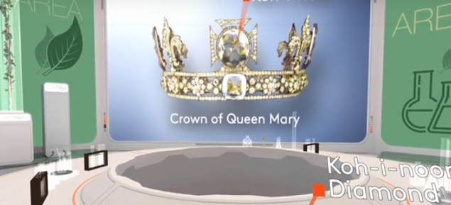
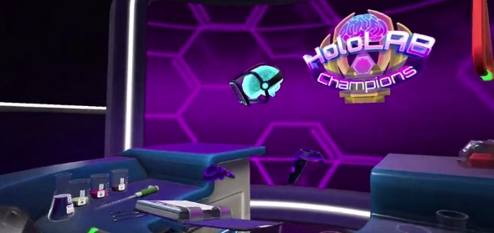

HoloLAB VR Champions / MEL Science

Setting up and analysing molecular simulations can be a lengthily process that requires considerable patience and expertise. Whereas, interactive simulations provide a much lower latency approach for manipulating and exploring molecular structures (Tek et al, 2012). Such methods provide a virtual or augmented reality framework that immerses a user within a simulation to intuitively interact with molecular structures. The use of constructing physical models within chemistry has always been through a traditional method; however, with the advent of computing the use of haptic interaction and utilisation of tangible physical models that may be augmented have shown promise in enhancing student learning (Host GE et al 2013).

In 2015, the USA department of education, released a report - A vision for STEM based learning 2026. They outlined the need for flexible and inclusive learning spaces that offer teachers and students the structure, equipment, and access to materials, including spaces that are located in the classroom, in the natural world, makerspaces, and those that are augmented by virtual and technology-based platforms to enhance learners’ STEM experiences. Virtual laboratory technology is becoming more manipulative, interactive and ‘real’ as time goes on, and the future of these types of technologies will only develop quicker. (Brinson. J 2015).

  - What is Augmented Reality?
Virtual and Augmented Reality are not necessarily new inventions; in fact, during the 1950s and 60s Morton Heileg known as the ‘Father of Virtual reality’ describes in his essay, The Cinema of the Future (1955), about how our senses can be used to create a defining experience. He later invented the Sensorama Stimulator – an experience theatre – to stimulate a person by using visual image, breeze and vibrations.

In 1968, Sutherland along with his student Bob Sproull invented the ‘The Sword of Damocles’, the first head-mounted display system containing transparent parts, designed to help helicopter pilots land at night by automatically moving low-light cameras in synchronisation with their head movement. A device suspended from a ceiling incorporating the first sign of augmentation, was able to see through to reality whilst having the ability to track the user’s eyes and head position contained through transparent parts. These were the first embryonic signs of augmentation. A quarter-century onwards and scientists working for aircraft manufacturer Boeing, eventually coined the term “augmented reality” to articulate the technology developed for see-through head mounted displays pioneered using HUD set technology (Caudwell, T, et al 1993). These terms helped to shape and define the differences in technologies between augmented and virtual reality. By the early 2000s, Hirokazu Kato of Nara Institute of Science and Technology had created the ARToolkit, an open source computer tracking library for the creation of augmented reality applications. The technology was first seen running on an iPhone 3G in 2008 and finally on an Android mobile phone by 2010.

Further research was undertaken into the area of Tangible Augmented Reality (TAR) and Tangible User Interface (TUI) to analyse how intuitively the use of physical input devices combine with the over layering of virtual images. (Kato, H., Billinghurst, M., Poupyrev, K., Imamoto, K., Tachibana, K, 2000). To contextualise the spectrum between the realm of virtual and real environments, an early diagram ‘Virtuality Continuum’ (Milgram, P., Kishino, F., 1994) describes any combination of virtual and physical objects (mixed reality) between the extremes of reality and virtual reality.
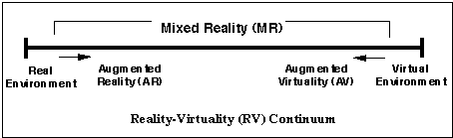

Virtuality Continuum (Milgram and Kishino 1994)

At one end of the spectrum, a virtual environment exists solely through virtual objects (e.g. a computer graphic simulation); whilst by contrast at the other end is an entirely physical environment (e.g. video display of a real-world scene). The polar differences illustrate a closer scale of immersion for AR to be closer to reality, whereas VR is a fully immersive experience in a simulated environment; in-between mixed reality exists at any point on the continuum and encapsulates both augmented and virtual reality. Augmented reality is quite similar to virtual reality in that they are both interactive, immersive, and include information sensitivity. However, a VR users’ experience is completely tied to a virtual world, whereas in AR user’s experience is still connected and centred around the real world, but with virtual objects superimposed so that both real and virtual objects coexist in the same space (Azuma, 1997). The most important advantage of Augmented Reality over Virtual Reality is the overcoming of the risk of social isolation and the lack of social skills and communication amongst users. (Kiryakova. G., et al 2018). Some users may feel psychologically unsafe when their view is isolated from the real world, whereas AR allows a user to ‘keep control’, to see the real world around them (Kaufmann. H., 2003).

Nowadays, there are so many acronyms associated to realities, it becomes confusing on how to differentiate the processes between AR (Augmented Reality), VR (Virtual Reality), MR (Mixed Reality) and XR (Extended realities). Where do they overlap and how do they distinguish themselves from one another? The diagram below illustrates the differences in the technologies at the present time.

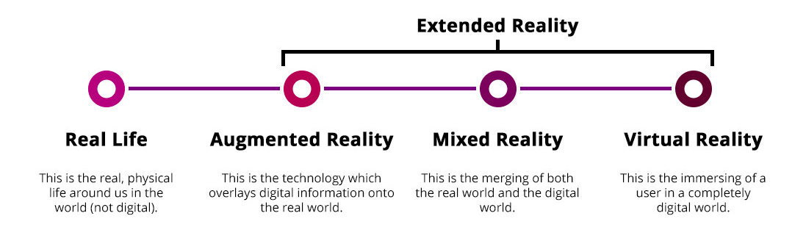
Extended Reality is the latest of all acronyms. This terminology is being used to encompass all of the emerging technologies under one umbrella. It focuses more upon how new platforms, software and hardware ‘cross reality’ in an interdisciplinary manner. There is a strong possibility, the use of AR, VR, and MR will become defined as one medium - being ‘XR’ - and solely refer to immersive computing.

Clay Bavor, Vice President for Virtual Reality at Google, raised a point at Google’s recent 2018 I/O conference, stating ‘these technologies will eventually evolve, and their distinctions will be far less important. In the future, it is inevitable these technologies will integrate to provide both a fully immersive experience and one that interacts with the real world. Imagine using wearable technologies, one moment interacting with augmented information in a real environment using an AR mode, to then simply switch to a VR mode where you can shut out your surroundings and be immersed within a different world’.

  - Characteristics of Augmented Reality
Azuma (1997) and other researchers (Kaufmann, 2003; Zhou, Duh, & Billinghurst, 2008) examined the different uses of augmented reality and described it as a variation of VR. Whilst VR entirely immerses a user in a computer simulated environment, AR allows a user to view the real world with virtual entities layered onto a real-world environment. Three characteristics of AR were identified as a system that:

1) combines the real and the virtual,
2) is interactive in real time, and
3) incorporates three-dimensional graphics.

Ionitescu and Radu (2015) defined AR as “adding computer-generated content upon the real, physical objects in the world around us, by displaying overlays of information and digital content connected to physical objects and locations”. Augmented Reality (AR) is a live, direct or indirect view of a physical, real world environment whose elements are augmented by computer generated 3D graphics, sound, videos or GPS data.

There are a variety of devices that uses AR technologies. These can be divided into three categories 1) wearable, 2) handheld, and 3) fixed. Wearable AR technologies generally include head-mounted displays, smart glasses, and gesture-recognition devices. Handheld AR devices are characteristically operated using mobile tablets or smartphones, whilst fixed AR projects content onto a surface or is a screen-based application.

    - Wearable AR
Wearable technology is related to portable devices with processing power that can record an activity conducted by the user. Head-mounted displays (HMD) are technologically complex devices worn on the head, which allow the learner to see an augmented view of reality through a digitally-enhanced viewfinder (Novak et al. 2012). Visual information can be superimposed over a user’s field of view, whilst having the benefits of being handsfree (Wang et al 2017). At present, such AR wearable devices do not provide a full 360-degree field of view. However, as technology advances it is inevitable companies will strive to create an all-round visual experience with less bulky headsets and lighter, slicker and well-designed frames. Even now in development are AR contact lens ‘eMacula’ to use with display eyewear to augment information onto reality, whilst Samsung and SONY have filed for AR lens patents for a new kind of augmented reality technology.
There are far more emerging wearable AR products available on the market, including the Microsoft Hololens, Magic Leap, Epson Moverio BT-300FPV Drone Edition, Google Glass Enterprise Edition, Vuzix Blade AR, ODG r_7 Smartglass System, Nreal etc. So how do wearable devices work? In most cases, AR head mounted displays (HMD) use two transparent combiner lenses that project images onto the visor’s lower half. These dual lenses use optical waveguides to colour blue, green and red across three diffractive layers. (see figure 1). A ‘light engine’ above each combiner lens projects light into the lens, which hits a diffractive element and is reflected repeatedly until it is outputted into each eye. Further advancements in AR technology are now trending towards adopting ‘virtual retinal projection’ in which pixels are directly projected onto the retina of the eye. This process uses advanced optics and millions of mirrors to project photons (light) directly into an eye to mimic natural sight. The Maxwellian principal (figure 2) illustrates thin parallel beans emitted from a spatial light modulator (SLM), such as liquid crystal display (LCD) and organic light emitting diode (OLED) all converge at the centre of the pupil and projects onto the retina. Each pixel of the SLM that forms a clear image at any position behind the SLM stimulates a certain unique point on the retina. Therefore, an image pattern modulated from the SLM is recognised and the Maxwellian view doesn’t require ocular assistance due to the beams passing through the crystalline lens (Lin. J et al., 2017). This method allows for an image pattern to support a long-distance focal depth.

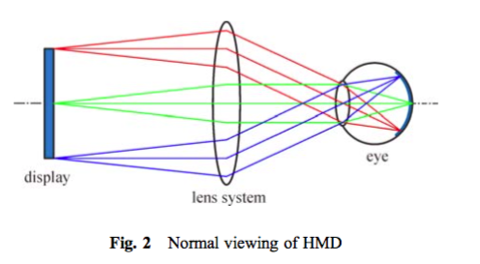
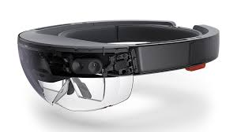

Figure 1 – Normal viewing HMD / Microsoft Hololens 1
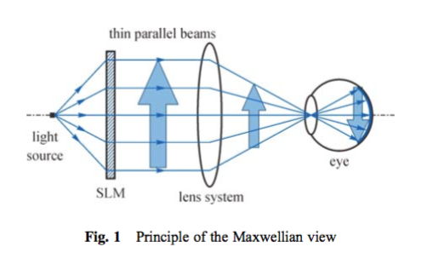
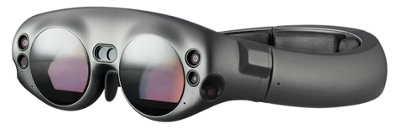

Figure 2 – Principle of the Maxwellian view / Magic Leap

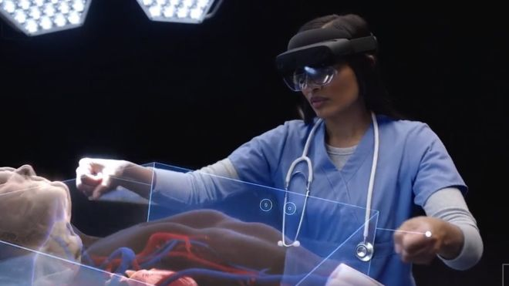
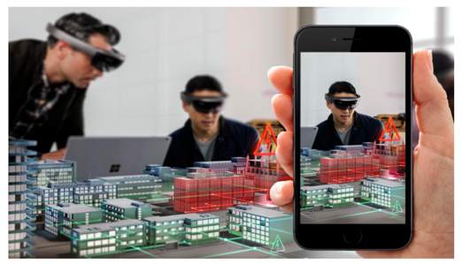
The recent announcement of Hololens 2 demonstrates how this particular wearable device has advanced over the last few years with upgrades and new features through a wider field of view, a more intuitive approach to manipulating objects and the integration of eye-tracking capabilities to understand where a user is looking and responds to voice commands for interaction with a specific object. In terms of sharing experiences, each user wearing a device is able to view and share the same experience. The Spectator view allows other participants who are not wearing a Hololens to use their mobile devices and share experiences with other students.

Microsoft HoloLens 2 & Spectator View

Educational immersive technology called ‘Lifeliqe’ are looking to turn schools and their students into VR development centres in partnership with K-12 education, giving students the ability to create their own content . Their vision is to turn school libraries into centres with vast amounts of 3D models for viewing and storing new types of knowledge. Alternatively, wearable products using mobile phone technology targeted at a younger audience can be found at ZAPPAR, where the ZAPBox provides a more affordable solution for experiencing augmented reality using marker-based AR.

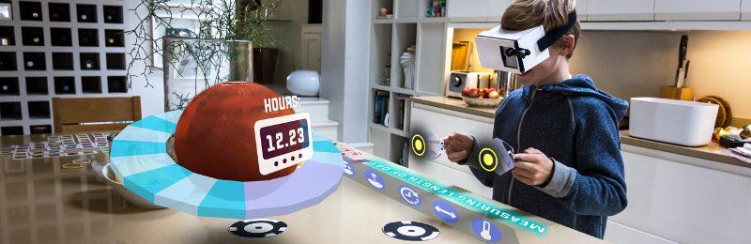
ZAPPAR - ZapBOX

    - Handheld AR
The use of smart-phones and tablet devices used for augmented reality are quite cost effective due to the availability of good quality touch screen displays and an array of in-built sensors (Onime & Abiona 2016). Novak et al (2012) describe how such portable devices now ‘have the necessary battery power, processing power, internet connectivity, multimedia capabilities and location-based services to make augmented reality practical for education’. Many mobile AR technologies (MAR) are inherent in nature and can be considered as a bridge of information in a classroom environment as today’s children are born into a world of ‘digital immersion’.

Handheld AR can be classified into various categories such as
1) Marker based,
2) Marker-less,
3) Projection Mapping and
4) Superimposition.
The launch of Apple’s ARKit, AR Quick Look and Google’s ARCore adoption of augmented reality has significantly opened up new opportunities for building creative AR apps for smart devices. There are, of course, many other tools designed to help educators create Augmented Reality content and experiences. More popular AR authoring tools that don’t require programming are software applications such as Zappar, Blippar, HP Reveal, Augment, Metaverse, Vuforia, Wikitude, EasyA, Twinkl etc.

    - Marker Based AR
Marker-Based AR is also referred to Image Recognition or Recognition based AR. The technology uses the camera in an AR device to detect the location of a QR (Quick Response) / 2D code to produce a reaction when the marker is sensed by a reader. Advancements in smart-phone and tablet technologies have offered more scope for designing creative AR markers. Markers can trigger a variety of media from 3D graphics, video, sound and animations. It works by directly pointing a camera at a target for the device to recognise a distinctive picture or pattern. Upon being recognised, it will trigger an event. In the case of a 3D model, wherever it is positioned the virtual content will be locked onto the real surface and orientate around in correlation to it.

APPreal AR Plane

    - Marker-less AR
Marker-less Augmented Reality allows the use of specific or all parts of the physical environment to become a target base for the placement of overlayered virtual objects. Furthermore, marker-less systems have the capacity to extract and store information about the characteristics of an environment that can be retrieved later on.

Smartphones and other digital devices make use of in-built Global Positioning System (GPS) to locate and interact with an augmented reality application being used. This type of marker less Augmented Reality is referred to as location-based AR. Simultaneous Localisation and Mapping Technology (SLAM) made a breakthrough in 2017; this type of technology allows a device to understand whereabouts it is situated in space and overlay 3D content on its location. By using both a camera and senses, it enables a device to map out a structure of any given environment and detect its location. By using complex algorithms, SLAM can help anyone predetermine their surroundings and identify a location at the same time.

    - Haptics
A haptic interface (HI) device can essentially capture a sensation on contact and manipulation of an object that is set within a virtual environment or remote setting. Therefore, a user may experience similar characteristics of holding a real object, temperature, texture, weight and shape etc. In the future, it is envisaged haptic communication will eventually be integrated into virtual experiences. Alex Kipman, Technical Fellow for new device categories for Microsoft’s Windows and Device describes how ‘One day you might be able to throw a hologram and it pushes you back as you catch it, or a hologram has temperature to it – cold, warm, lukewarm – it all changes the level of immersion and experience.’

(Berger. C., Ofek. E., Franco. M., Hinckley., 2018) found that increasing the realism of haptic sensation doesn’t necessarily increase the quality of the AR experience. Contrary to expectations of kinaesthetic haptics (force feedback) to perform better, they discovered that cutaneous haptics (skin sensation), fared far better through a combination of light touches and vibrations by fooling the brain into an illusion. If the fidelity of the haptic sensation increases but is not rendered in concordance with other sensory feedback (such as visual and auditory cues), this often has a negative impact due to the uncanny valley of realism in simulations.

Today, we can experience haptic technology through tactile feedback in our game consoles, tablets and smartphones. Apple has integrated the Taptic Engine that introduces vibrations and levels of interactivity when tapping a device. Advances in technology by Ultrahaptics have led to haptic technology using ultrasound that creates three dimensional shapes and textures that can be felt, but not visible. This enables haptics to be applied to virtual objects, interfaces and gesture control. Haptic technology offers a new dimension for augmentation and how we interact with our environments and 3D models. The eventuality is where our tactile experiences with virtual objects becomes indistinguishable between the unreal and real.
________
- AR in Education

3.1. What are the educational benefits for using AR?
The use of mobile devices such as smartphones and tablets, all have built-in cameras, available to create dynamic context aware and interactive digital content. In comparison to VR, augmented reality doesn’t no longer require expensive hardware or restrictions on portability. This presents new opportunities to move away from lecture-style teaching and use AR in educational environments to create practical and highly interactive visual forms of learning (Huang et el., 2016). It offers new alternatives for learning materials by making them interactive and providing an incentive for children to directly interact with their environment in creative ways. By over layering virtual objects onto the real world it can transform rudimentary tasks into creative playgrounds to explore. Mobile augmented reality provides learning designers and educators with a new opportunity to creatively think more deeply about the mobile learner’s context and situation. One of AR’s key advantages is the ability to create contextual learning experiences (Dede et al., 2009).

The New Media Consortium Horizon Report (2016) found early pilot findings using AR provided a positive impact on the classroom, including enhanced group and peer-to-peer learning. (Billinghurst 2002; Klopfer & Squire 2008, Wang. M et al 2017) believe that AR has vast potential implications and numerous benefits for the augmentation of teaching and learning environments through integrating digital learning resource to enable learners to experience scientific phenomena that are not possible in the real world. The development of new augmented reality systems is disrupting education and the way we approach it; AR is capable of providing technology-enhanced learning experiences that are changing the boundaries of education. It can be applied in different educational settings – from young children using magic books, through to schools testing wearable AR applications, academic research and industry led training.
The introduction and use of AR in education helps to stimulate student’s excitement and stirs up their motivation to the learning process. A review of ‘Using Augmented Reality in Education from 2011 to 2016’ (Chen., P et al 2017), concludes that from the 55 studies published, most of the studies reported that AR in educational settings lead to better learning performance and promote learning motivation, which was because AR supplies the authenticity graphical content and interaction. In addition, deeper student engagement improved perceived enjoyment and positive attitudes of AR are reported as the effectiveness of using AR. The innovative technology attracts and inspires learners, stimulating their creativity and curiosity. AR provides opportunities for interaction with abstract concepts, experiments and exploration of objects, phenomena and processes that is not always possible or safe (Akçayır, M., & Akçayır, G. 2017).

3.2. Pedagogical Alignment
Pedagogy plays an important role in the employments of augmented reality technology. (Dunleavy, M., & Dede, C, 2014) refer to theoretical foundations that are based around ‘situated’ and ‘constructivist’ learning. AR offers an innovative learning space by merging digital learning materials with tools or objects, directly into a physical space and therefore creating ‘situated learning’. Furthermore, AR aligns with constructivist notions of education where learners can take control of their own learning, through the interactions with real and virtual environments. (Bower et al. 2014) reinforce these types of practices, referring to AR being compatible with a number of pedagogical approaches like the following ones:

- Constructivist learning. Augmented Reality facilitates that students immerse themselves in their tasks and make more profound and lasting connections in their knowledge framework by using diverse kinds of information.

- Situated learning. Augmented Reality places the student in an actual learning context by incorporating daily life into the classroom.

- Game-based learning. These Augmented Reality games submerge the student in a virtual narrative in which he must play a given role that prepares him to deal with daily life.

- Enquiry-based learning. Augmented Reality makes it possible to experiment with virtual models that are immersed in real world scenes

(Muñoz. J, 2014) states that augmented reality fits perfectly with those pedagogies that are different to traditional ones. From practices that teach oral presentations to passive students in a classroom, teachers may wish to implement AR through processes of ‘learning by doing’ as they must construct their own learning whilst the teacher orientates and motivates them. A common feature of these models is that a student can play a central role in their own ‘active learning’. Augmented reality fits with these pedagogies where students from all ages can learn by doing, investigating and developing their own creativity.

When using ICT as part of a learning process, designers need to collaborate closely with their target audiences of both children and teachers, at least in the formative evaluation phase. It would be even more beneficial to involve teachers at earlier stages, say in the specification and design phases of courseware production. The pedagogical element of much software designed for use in primary science is frequently lacking. Problems can be addressed through more consultation with pedagogical experts and target groups at incremental stages. Key questions to be highlighted for curriculum development are:

- Is the pedagogical approach the most appropriate to enhance learning of the material?
- Has the navigation been fully piloted and evaluated by the target group?
- Has the material been checked for bias towards any particular group of users?
- Have developers made provision for students with special needs?
- Are there measurable learning outcomes?
- Are learners sufficiently motivated by the experience?
- Are interactions frequent and meaningful?
- Are the graphics aesthetically pleasing?
- Are there any directions and are they clear?
- Is the lesson length satisfactory?
- Does a pupil fully determine the pace of learning?

If AR is to be used as an effective learning tool within future primary classrooms in the UK, the challenge for designers, and for teachers, is to scaffold children’s explorations and manipulations of the AR elements within carefully designed parameters to ensure that specific learning aims can be achieved within a relatively short period of time. Teacher’s questions need to be less about what the children can see and more about describing the effects of what they have done and what they have learnt from their actions. (Kerawalla, L. et al, 2006). There is common evidence from previous studies (Akcayir 2017; Wang 2017; Radu 2014 & Yuen 2011) that educators and learning designers need to collaborate in terms of creating sound pedagogy to develop AR applications that maximise on learning outcomes.

3.3. Location-Based
It is worth noting that shared experiences can fall under defined categories. When a shared experience takes place in the same location this is referred to as co-located; remote location refers to users in separate physical spaces and both means there are a mix of co-located and remote users. Location based learning emphasises the learner’s interactions with the physical environment, so AR can exploit these advantages through geo-location to track learners (De Lucia et al. 2012). Using mobile devices and geological positioning systems, learners can access certain information dependent on their current location. Therefore, a location of learning may take place in a school environment or actual neighbourhood (Wu. H., et al 2012). This offers students the possibilities to investigate and collect data in a physical environment and yet still be grounded to reality (Rosenbaum et al, 2007). There are different examples of location-based AR experiences, such as the Magical Park app, developed for public parks in New Zealand as a tool to get children more involved in being outdoors. In contrast, a mobile app named Mossland is a gamified platform that is a completely new ecosystem to sell and buy AR properties allowing gamers to navigate through cities and different locations.
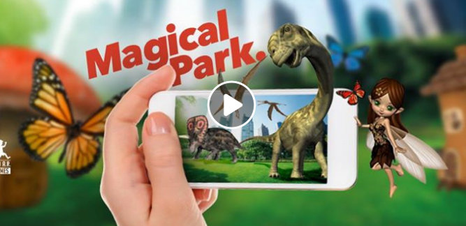

Magical Park & Mossland

Teachers can organise treasure hunts or create ‘learning journeys’ by setting up key points to engage in and around the school; maybe even students can roam around their own cities and towns to investigate where science exists. BeED learning experiences supports South-East Asian schools by connecting learners to adventures and travel with education platforms. Teachers can create their own assignments for a location or alternatively purchase learning packages available online. The structure works through knowledge phase, action phase, and reflection (uploading notes, photos, audio and videos). This offers great opportunities to integrate AR experiences within this type of learning delivery method. What about a child’s home environment? Homework for a student could involve exploring their home or surrounding area to understand how science is relevant to their everyday lives.

  - Storytelling
The use of AR in education brings about enriched ways of telling educational stories. Through augment reality, educational storytelling has become powerful through visual models. These models are unique and help student to visualize educational concepts.
Lessons can now include innovative experiences and interactions through immersive technology never envisaged before. AR technology is capable of augmenting virtual objects over reality, so consequently it allows stories to be placed in a space whether it’s on a desk in your classroom, in an outside environment or on your floor at home. ‘Wonderscope’ uses mobile AR to superimpose characters, scenes and stories onto a user’s living room carpet or outside in the garden. The characters can communicate to the user through voice-recognition technology, and the AR based stories encourage children to engage and move around their environment. Part of the challenge is to understand the balance of not overwhelming a user with digital content and have a cognitive overload. Chris Milk, CEO of Wonderscope, recognises that one of the problems of AR is how developers can create stories around different contexts and environments. “You have to build a story that can work in someone’s kitchen, in someone’s backyard, next to someone’s pool.”

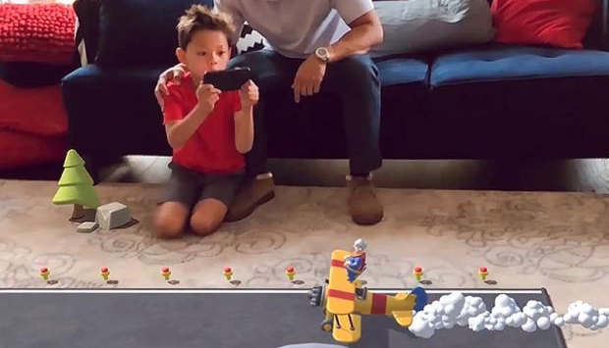
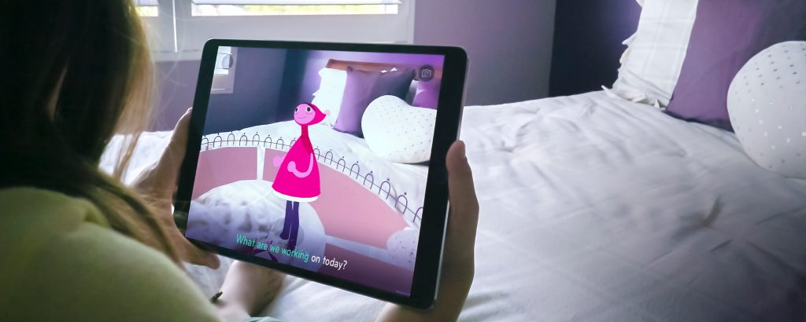

AR Wonderscope

Another way of storytelling is through the use of books, where AR can bring animations and 3D objects to life from print. (Billinghurst & Kato 2001) designed the ‘Magic Book’ using AR to superimpose 3D rendered models onto books. AR can transform the traditional textbook into an interactive one and where abstract concepts are difficult to comprehend, this technology can help facilitate a learners’ understanding delivered in a multilingual mode. AR books will change the way stories are experienced; commanding increased awareness from the storyteller on an array of concerns, such as the book’s structure, value, and immersive and “The potential of AR books to appeal to many types of learners, through many paths, is undeniable and exciting for educators” (Yuen et al. 2011). Due to the growing number of smartphones and tablets with inbuilt cameras and AR capabilities, interactive books are becoming a more attractive proposition in using them to learn. Today, there are many AR learning applications that cover a broad spectrum of subjects, from science, engineering, history through to interactive colouring books.

  - Augmented Creativity
Augmented reality can make environments interactive and engaging to a learner in a variety of ways that has never been possible before. The rich content of media lends itself to creating an individual’s unique pathway for discovery through the use of 3D environments and models (Kangdon. L., 2012). Because AR can be used to superimpose virtual objects and information onto physical environments it enables users to visualise intangible concepts and therefore supports learners in helping them to understand abstract concepts or unobservable phenomena (Wu et al., 2013).
Augmented creativity is referred to as ‘mobile devices that bridge between real world activities and digital experiences, allowing users to engage their imagination and boost their creativity in colouring, music, storytelling, exploration, and other areas of active discovery. By enabling such experiences, Augmented Creativity fosters a renewed sense of curiosity and exploration in today’s youth’.
Augmented Creativity aims to combine educational and entertainment values together by integrating them into an AR experience that explores new ways of interacting with the application. It’s a response to how humans and machines can work together in synergy between human intelligence (HI) and artificial intelligence (AI). How can machines support and augment our creativity through a more active role? Research conducted by ETH Zurich, Disney Research and Rutgers University, presents six prototype applications that explore Augmented Creativity in different ways.
The colouring book uses a tablet or smartphone to detect a character. Whatever colour the 2D character is coloured inside the book – the system will convert the UV texture map and place it onto the 3D virtual character. This type of process encourages children to use their imagination, motivates them to colour and explore 3D. Furthermore, there is the ability to author a story in a non-linear fashion, so users become integral to their actions and consequences altering the outcomes of a storyline. This method has far more complexity in terms of interaction, so a good balance might
be to provide a simple narrative structure that includes isolated interactive segments.
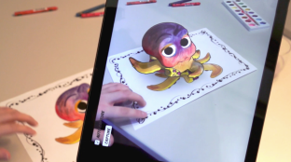
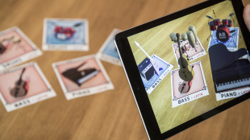

Disney Colouring Book / Music Arrangement

AR markers have been used to compose music and experiment with various styles of melodies, rhythms, scales, chords etc. The application is split into a choice of style and instrument and the user can choose them independently. By using AR physical markers and moving them closer to a device’s camera, affecting the type of sound composition and arrangement of song. In terms of learning, it offers educational goals through teaching concepts of arrangements, styles and encourages collaboration and understanding of an orchestra.
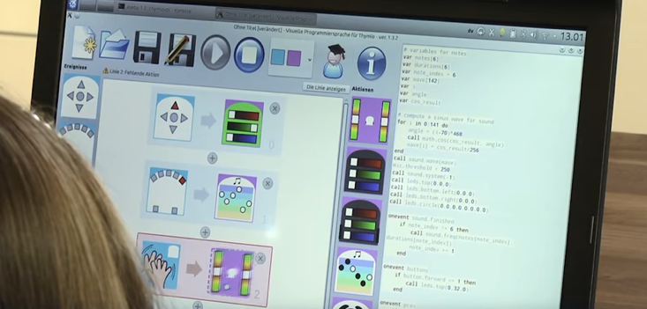
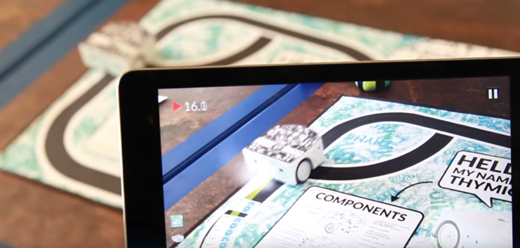
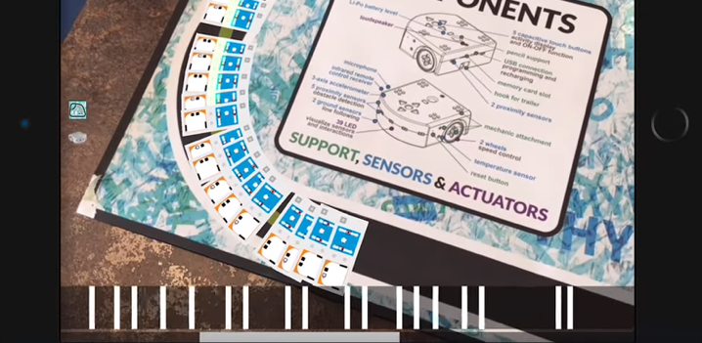
Physical objects – in this case a robot named Thymio – can be programmed by children to learn coding skills. Children use visual programming languages to move the robot but tracking the programme execution can be difficult to visualise. To help children understand the program, the use of AR via a mobile device can show where and when the program is being executed through visual interaction.

Thymio Robot - AR Project
  - Tangible
Tangible interaction refers to the concept of interacting with the digital world using physical objects, gestures and behaviours in an intuitive manner. It allows students to go far beyond the screen and physically interact with objects to support their own learning. This is a framework for developing pedagogical systems with the aid of products that open up new possibilities for students to learn through discovery, whilst engaging with lesson material on a more personal and motivated level. Tangible interaction has the ability to excite students in ways that are not achievable using traditional teaching tools. Billinghurst (2002) found that the relationship between virtual and tangible items is very personal in AR and these tangible items can be embellished in ways that are impossible in traditional settings. The advantage is that students with little to no technology experience will still enjoy a fulfilling interactive experience.
An early example of tangible user interface is called Augmented Chemistry (AC). It is an interactive workbench that shows students how and what an atom or a molecule consists of using AR. (Fjeld & Voegtli., 2002) created a booklet with free elements of 3D molecular models, a gripper and a cube for students to undertake certain tasks using both hands. Working from a table and a rear projection screen, a user can move the gripper next to the cube and trigger a composition of a molecular model.
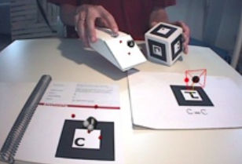
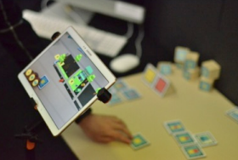
The AC system in use: The booklet. gripper, cube and platform / AR BLOCK
More recently, (Zhu. Y., & Wang., S. 2017) have focused on the use of interaction through a tangible augmented reality toy kit (AR BLOCK) to help 4-7 years old children understand abstract concepts, such as a colour mix, mathematics and 2D-3D geometrical shapes. It allows users to interact with both onscreen (intangible) and physical objects (tangible) at the same time. AR BLOCK focuses more on the interaction of physical objects with the screen and provides feedback depending on which markers it recognises on the block. Parents widely believed that AR BLOCK creates a fun and interactive learning environment with embedded pedagogical factors. In the context of chemical sciences, DAQRI, an augmented reality company, have designed block faces that can trigger chemical reactions in 4D. The cubes can be made out of paper or laser cut so it can be created within a classroom. Students can work in pairs or small groups using an iPad to bring the element block together and test predictions.
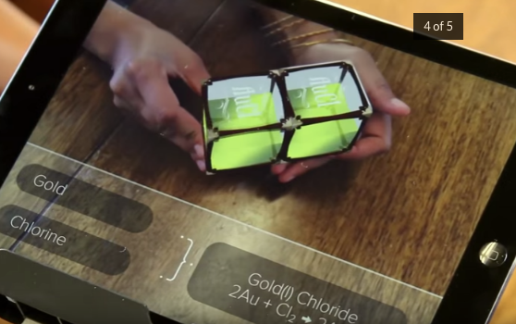
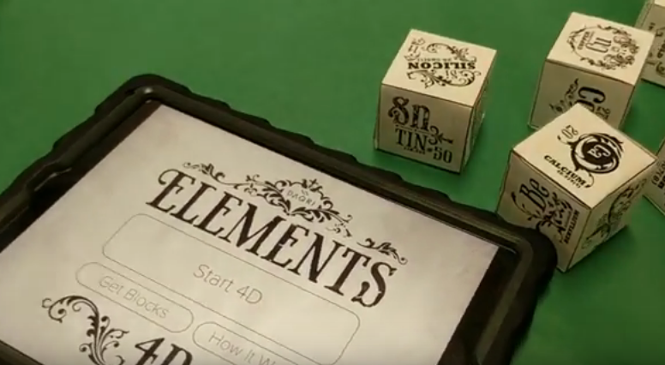

DAQRI, 4D Elements

Recent studies have shown exploration of intelligent virtual characters using AR. Developers (Cimen., G et al 2018) have demonstrated how animation models (in this case a character’s skeleton as an input), can navigate around real-world environments and react to objects in real-time. Using motion clips a virtual character is able to collide with both real and virtual objects by walking over different real-world slopes and changing its behaviour according to the arrangements of predefined physical objects. Real and virtual objects can push the character and move it, whilst virtual objects such as a virtual fan can create virtual forces that impact on the characters movement.
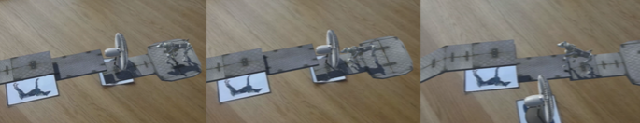

Virtual fan stopping character from moving / Virtual character reacting to physical book

When looking towards the commercial sector, the Creative Play Lab -LEGO AR-Studio have used Apple’s ARKit to explore interaction by mixing the virtual and physical LEGO play together. It brings LEGO to life with animations and visual effects when they are placed together. For example, a dragon breathing fire, trains sounding a horn, fire truck using a fire-hose, that are all activated whilst playing with the bricks. The app allows children to control their virtually enhanced animations in real-world environments, so they can create their own stories and adventures. Even virtual golden bricks are hidden around the AR environment for children to search and collect!! LEGO do promote STEM LEGO challenges and sell their chemistry sets – so could AR be an inroad to teaching children about sciences?
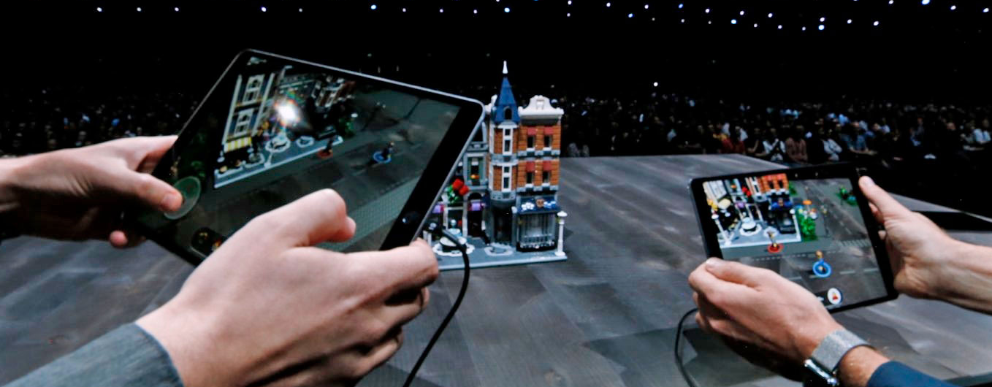
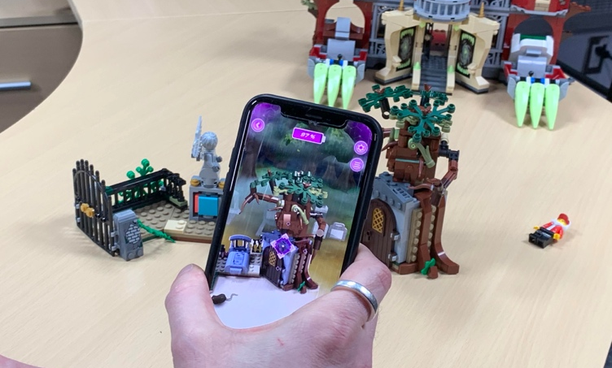

LEGO AR
  - Game Based

The emergence of location-based AR offers great opportunities to interact with public areas as a ‘creative playground’. Playfulness can be added to open spaces; it can be augmented over them. Gaming AR holds the potential to provide a novel kind of interaction with buildings, parks, classrooms etc to create innovative experiences. These may involve engaging students in quests, with an expectation that users will need to solve AR puzzles in order to progress and eventually be rewarded. It also encourages learning to take place outside of the classroom and let students find new perspectives in their familiar environments. (Laine. T, 2018) evidences that contemporary educational mobile AR games (EMARGs) are probably best represented by treasure hunts with characteristics of puzzle and adventure genre. Who hasn’t ever played Pokemon Go? Puzzle-based EMARGs are also common, but it is questionable whether they are too simplistic and engaging for learning. For example, Metaverse is an AR platform that empowers teachers to author their own interactive experiences, so they can introduce them to their students. It has the functionality for creating all types of games including: role playing games, choosing your adventure, puzzles, time challenges etc. (Dunleavy. M, 2014) outlines one of his design principles of the affordances of AR, is to drive the player interaction and learning through gamified stories or narratives. The story or narrative helps to provide the structure and rationale for the AR experience. By combining gamification elements, such as a scoring system or fail states, an AR designer can reinforce the learning objectives.

  - Project Based
Project-Based Learning (PBL) is a teaching method in which students gain knowledge and skills by working for an extended period of time to investigate and respond to a question, problem, or challenge. It can demonstrate the importance of 21st century skills such as collaboration, creativity, critical thinking, communication and problem solving. Well-designed authentic projects usually feature real-world context, tasks and tools that a student can relate to through their own personal interests and learning needs. A driving question enables teachers and students to explore, feasible, contextualised and meaningful to the ‘real-world’.

‘Seppo’ based in Finland, are using mobile technology for students to play games and learn outside of the classroom. A user can choose a game to be played in the school premises, city centre or on a field trip location. Their framework centres around playful learning, creativity and active participation (see illustrated diagram). Participants can problem solve through teamwork, collaboration and critical thinking in a way that establishes context to an environment. Teachers can create their own content and monitor how the students are progressing during a game.
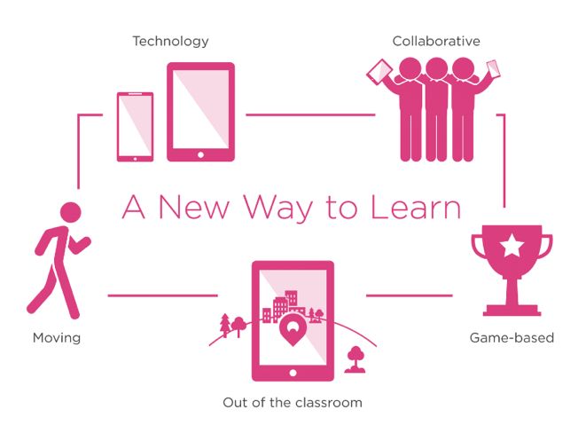
Framework: SEPPO – Playful Learning, Creativity & Active Participation

There are opportunities for science to be delivered in conjunction with other subject areas as part of a project. The primary curriculum taught as a blend of science skills and content acts as a sound and realistic foundation to secondary science. It offers teachers a broader range of activities that intersect learning through making and the use of technology.

  - 21st Century Skills
The exposure of technology throughout our daily lives certainly highlights the need for students to be aware and engaged with current practices. The term ‘twenty-first century skills’ offers a framework for digital media skills that are applicable for schools to undertake. These particular skills are condensed into the 4 c’s that include: collaboration, creativity, critical thinking, communication and problem solving (Jenkins et al. 2009). Augmented reality can be used to support both teachers and students in all of these areas as 21st century thinkers and problem solvers. Whether it is sharing technology devices in a classroom to achieve goals, communicating through interaction with 3D models, being challenged by an AR experience or using mobile devices to be creative and innovative. Furthermore, using AR embraces skills aligned to information, media and technology literacy; from understanding visual data, through to teaching students about how technology works. According to Dede (2008), AR educational activities can play an important role in helping students to be up to date for 21st century education, preparing them for challenges and activities in a rapidly changing technology enhanced world.

__________________

- AR Challenges

4.1. What are the barriers facing Augmented Reality in Education?
Augmented reality can act as a catalyst for major change in education, but as with any technology there are inherent risks we should acknowledge, anticipate, and confront when designing for it. There are some real benefits to using AR, but considerations need to be made in terms of individual’s privacy, security and who is liable when using the technology. Because AR blurs the divide between digital and real-worlds, it can present threats to a person’s physical safety and identity.

The main facilitators for the adoption of AR technology within the education sector are teachers themselves. New technologies associated with AR could encounter resistance amongst teachers, as the learning approach may be quite different from their traditional methods. When working with hardware and software, most users will need adequate technical support and training to help facilitate a robust learning experience.
The government recognises in order for education to make good use of technology certain barriers need to be addressed such as:

1) creating a modernised infrastructure to address slow internet connectivity.
2) providing greater digital capabilities and skills – (to build confidence in using technology effectively, to instigate and empower teachers to be confident user of Edtech and to be aware of available and expertise digital tools).
3) helping to make the right choices in selecting and buying technology products.
4) concern about privacy, safety and data security and how education providers and students can both be protected.

4.2. Cost & Investment
Dede (2008) suggests that due to the decrease in the cost of digital devices, AR will become more affordable for schools to purchase in the future causing a rise in the use of AR. Schools are beginning to take advantage of being able to use more affordable and accessible wearable technologies to deliver curriculum content. The hardware used to implement AR at a classroom level is technologically complex but has become increasingly affordable and common in modern learning environments (Singh & Singh, 2013). Although AR technologies have been available for several years, it is the increase and demand of mobile devices that has made affordable AR systems available to the general public (Wu et al., 2013).
In terms of hardware, one main factor is the size of a mobile device and its screen size; this obviously has implications on cost. It would be presumed smaller screen sizes will be adequate for personal tasks, whereas, larger screen sizes would help to promote collaborative working (Major. L., et al 2017). There is a further consideration in brand loyalty, usability, operating systems and the appropriateness of how much control a school wishes to empower over content. (Chen., C & Tsai., Y 2012) highlight the moderate costs for designing and renewing educational courses, especially in light of remote laboratories and using virtual objects. Costs can be lowered through reducing the number of printed textbooks and replacing them with apps. There is the fine balance between the cost of updating software content in comparison to reprinting textbooks periodically (Andujar., J et al 2011).
In the case of wearable technologies, such as Microsoft Hololens and MagicLeap, the main obstacle lies with the developer kit costing around £3,500, so a full consumer version is still a few years away until it becomes mainstream and affordable to schools. Such innovations in the future will require more powerful processing engines and hardware that implies further investment will be needed. There are alternative, and cheaper options on the market such as ZapBox, Google Cardboard, TWINKL etc, that are helping to democratise learning and provide a learning experience for a younger audience.
Given the government’s Industrial Strategy and the department for education report ‘Realising the potential of technology in education’ there may possibly be more external support towards purchasing both software and hardware in order to utilising AR technology in schools, providing it can demonstrate a significant impact on a learning process. Key policy makers and head teachers will be the driving influencers for allocating such funds towards using AR for learning. Alternatively, software providers may seek to offer their resources for free and integrate advertising campaigns as art of their revenue stream. Goldman Sachs estimates roughly $700 million dollars will be invested in AR / VR applications in education by 2025. This significant figure provides the opportunity for education marketers to influence purchase decisions via their devices.

4.3. Technical Implications
In terms of AR, we need to consider the technical aspects of using devices to deliver a robust and fairly seamless activity. Before becoming a mainstream educational platform, AR faces a number of challenges that include a lack of technical standards, due to inexistent collaboration among companies developing the technologies (Pena-Rios et al. 2017). Therefore, it is not recommended that facilitators spend their time providing both technical and cognitive support that will render a learning activity ineffective. If this does occur, it generally detracts from the activity’s ability to help learners reach curricular goals (Mitchell, 2011).

Different technical problems may be caused by a device camera malfunction, lack of internet connection and software issues (Kiryakova. G., et al 2018), whilst the greater number of devices can lead to the higher risk of device failure and maintenance (Wu. H., et al 2013). The integration of both hardware and software can contribute towards the instability of devices; although technical assistance could be integrated into AR-related activities to enhance such systems and the usage of graphic recognition (image-based AR) may provide an alternative solution for GPS errors (Dunleavy et al 2009). Other issues may involve using the latest mobile devices, where users can potentially be on an unequal footing or the need to recharge devices and synchronise content. It is important to understand that using mobile devices to construct AR experiences does require some form of infrastructure. AR generally relies on the use of mobile devices, (whether handheld or wearable), to require a connection to a wireless internet provider in order to drawn down data sources. Information can be stored directly onto a device for retrieval, but internet connectivity allows for users to access real-time information.

Fortunately, the issues of device integration and stability could be solved by the recent rapid advancement in portal and wireless technologies. In the future, it can be expected that the portable devices in AR systems will be far more integrated and reliable when running simulations, games, videos, and GPS applications (Wu. H., et al 2013). It is worth noting, the government’s Industrial Strategy (2017) has set out to boost the UK digital infrastructure with over £1bn of public investment to roll out 5G connectivity of full-fibre networks.

  - Adoption and Accessibility
Many leading teachers have difficulties in understanding how to implement technology into their own teaching; they may be experts in education but not necessarily in digital technology. The BESA (British Educational Suppliers Association) EdTech and ICT survey (2018) revealed that school state teacher’s willingness as the most common barrier to using more EdTech (29%) with primary schools more likely to state teacher willingness as a barrier (32%) in comparison to secondary schools (25%). Training on their ICT resources is the largest challenge faced by both primary (54%) and secondary (66%) schools.

The issues lie within the processes for teachers to develop efficient deployable content or gaining access to it. Teachers who are not so experienced in using mobile technologies may find trying to integrate AR within their lessons more challenging. In some cases, the development of appropriate AR educational applications can be a difficult and time-consuming process, that requires teachers to think innovatively around the presentation of content and approaches to accessing and interacting with it (Kiryakova. G., 2018).

(Fernandez. M. 2017) suggests the first action is to educate teachers around the capabilities of the technology and knowing how to use it with a view to a teaching itinerary as a learning tool. Schools shouldn’t assume that teaching staff are ready to effectively use mobile devices from the outset (Melhuish & Falloon 2010); they should look to support adequate opportunities for teachers own professional development and training. There are recommendations towards a need for learners to be able to assist one another in navigating around an AR experience and for facilitators to be already familiar with the AR hardware and software before it is implemented for educational purposes (Mitchel, 2011 & Chen. Y., 2006). Another important action is to consider how the learning content aligns to the curriculum, rather than only offering experiences that interest students. This can be adapted to existing parts of the curriculum or alternatively any experiences could be developed in accordance to the subject accredited with regulators. (Fernandez. M. 2017).

(Silva., M. et al 2018) outline there needs to be more user-friendly AR authoring tools, preferably based on teachers’ previous knowledge. It would enable them to independently create their own content delivery and decide how to evaluate students’ knowledge and their learning. For teachers to incorporate it more often into lessons they need a way to customize the contents and types of activities proposed. (Radu 2014) emphasized the need for guidelines for designing effective educational AR experiences, i.e. tools supporting teachers in promoting student learning. The development of AR authoring tools that require a limited amount of preparation time could potentially allow teachers with limited technical skills to create content capable of facilitating and enhancing the learning process.

In an interview with Paul Hamilton, a school teacher, author and a keynote speaker for sharing ideas on VR and AR in the classroom, he says ‘It’s really important to make sure there is a connection between using augmented reality and the curriculum delivery in order to contextualise your ideas. Teachers are reluctant to use these types of technologies if they don’t recognise the benefits.’

As technology ever changes, educators need to keep abreast of embracing and developing new methods of teaching, taking advantages of the affordances of AR devices for learning. Apple, Microsoft and Google are all now competing to muscle their way into UK classrooms. Although AR has great potential, it will need a shift in culture of educational institutions who already withstand heavy workloads to value and reward teaching innovation for teachers.

  - Ethical Implications
There are undoubtedly concerns around ethical implications of using augmented reality. (Southgate, E. et al 2017) argue there is a strong and moral case for commercial developers, educators and scientists alike to be accountable for the development and integration around ethical issues when designing, VR and AR products for young consumers or engaging with children. AR is recognised as being a persuasive application as it can create convincing experiences that can change our thoughts, perceptions, behaviour on how we see and interact with the world around us (Rutledge. P. 2012).

A 2013 YouGov survey showed that between 2000 and 2013 mobile phone ownership had increased from 50% to nearly 100% - at the same time public concern about mobile phones decreased from 27% to 9%. AR platforms, such as smartphones and tablets are better persuaders because they are ubiquitous and have the ability to utilise timing, user data and GPS offering persuasive opportunities always at the right time and place. (Pase. S., 2009) argues that persuasive technology can be considered unethical due to intruding into people’s lives and having the ability to manipulate them. This type of technology hasn’t the ability to read human cues so consequently if an end user isn’t comfortable with certain techniques AR hasn’t the ability to modify its intentions. However, as the technology involves in the future through areas such as eye tracking, facial recognition and haptics, this may help to signal an emotional response and modify an experience according to a user’s behaviour.

    - Privacy
Mobile technology privacy remains a key concern for consumers. Personal and private data collection of an end user remains a significant point of ethical concerns in AR applications. The use of AR in public spaces presents challenges in respecting other people’s privacy and ensuring a device does not record an environment without consent. Wearable AR technologies in a classroom will need to be regulated against, age, maturity of the students and consider who is responsible for an individual’s welfare. The risk of AR smart glasses or headsets in an open education environment, may pose a threat to privacy legalities. If young children are using these technologies responsibility needs to be accounted (Hein.D et al 2017) and I.T. support may carry the burden of implementing strict controlling measures.

Catapult Digital recommend that AR companies need to consider geolocation warnings and privacy settings according to personal preferences. Furthermore, given the EU General Data Protection Regulation (GDPR), personal data has the potential to be gathered during a VR or AR experience through eye tracking, height, movement styles and behavioural patterns. Will an AR application track users’ every movement through its GPS data? Does it track how long they stay or how many times they frequent a location? What control does an AR user have over both disseminating and retrieving information (S.Pase., 2009)? Developers’ objectives are to obtain as much data as possible in order to effectively engage and persuade their users. These tactics need to be transparent to any end user if data is being collected or recorded in order to protect user safety. The capacity of wearable technologies to instantaneously broadcast information about ourselves and receive information about other people raises a number of privacy, ethical and social issues.

    - Liability
In terms of user navigation, there is limited capacity to focus on multiple activities so more focus is emphasised on the screen of their mobile device. This can present issues around spatial awareness and the environment around them, taking a user into a ‘flow state’ where they become too engrossed in an activity losing awareness of time and their surroundings (Neal. M et al 2012). Distracting users with AR content to such a degree has the potential to cause incidents or even accidents. Who will take responsibility for any of these cases? Liability is a serious concern where potential harm can occur, through both physical and emotional circumstances. On one hand, AR developers want to create engaging content, but on the other, considerations need to be taken to avoid injury and negligence. (S. Pase 2009) suggests that simple measures can be taken by applying ‘time out’ features to pause a session and provide a user with an opportunity to be aware of their environment. Additionally, an upfront warning disclosure could be triggered at the beginning of an event to inform the user of the potential harm from immersion and injury. (Wassom, B., 2014) comments on marketing defects can lead to a manufacturer’s failure to warn users against hidden dangers. Often liability can be avoided in design by clearly communicating the risks to any users. Whilst this is not full proof, it does offer a limitation to exposure of liability and at least provides limitations for an ethical dilemma.

As AR applications become more mainstream, it will raise more questions from both a personal and individual perspective. All stakeholders will need to determine their own ethical standards, how they will be applied, adapted or abandoned based on user needs. Catapult Digital recommend ensuring all developers consider some of the following key factors in relation to safety standards:

- Assess the potential health and safety risks posed by the AR product or service
- Identify relevant legislation and any specific requirements
- Consider and incorporate any safety features within the product or service
- Provide appropriate warnings and user guide details of risks and safety
- Plan and audit a review for ongoing safety measures
- Provide contact details in response to dealing with any incidents

AR technologies do raise questions around whether young people can adequately multi-task safely and effectively. By limiting the amount of information displayed may help to reduce the potential for distraction (S. Pase., 2009). Can this lead to cognitive overload when using them? (Southgate, E et al 2017) highlight the intensity of presence through immersive environments and for researchers to consider the cognitive dimensions of how children distinguish from what is real and unreal. If we revert to the functionality of an HMD (Yao. C., & Wang. Y., 2016) in its capacity to project light onto a retina, it does raise concerns over AR-related devices that rely on laser projection to either recognise physical objects or to relay digital information onto the eye (B., Wassom, 2014).

Coincidentally, the Microsoft HoloLens manual identifies potential motion sickness, dizziness, disorientation, eye strain etc. Furthermore, they recommend specific user requirements for health and safety procedures; advising that most adults and children aged 13 and older are only suitable to use the device. The inter-pupillary distance (IPD), the eye measurement of distance between two students (see image below), has an adult range between 50 mm and 75mm (with a mean of 63mm). A minimum IPD for children is around 40mm, hence the unsuitability for wearing this type of AR device as it can result in poor eye-lens alignment, image distortion, strain on the eyes and trigger headaches.

Illustrative of Inter-pupillary distance

(Southgate, E et al 2017) provide a ‘practical framework for asking ethical research questions involving immersive technologies with children’ (see framework). These include four areas in expertise, orientation, design and developmental perspectives. Expertise refers to collaborating with specialists in child development and /or socio-cultural aspects of children and youth culture. These people will be able to provide technical advice, ask provocative questions and reflect on processes. Orientation challenges the notion of whether the research is about, with or by children? Recommendations are made for researchers undertaking this line of enquiry to include ways in which children can be empowered to seek, receive, communicate, interpret and reflect on information and processes; all user feedback will help to inform and influence the area of design. Design is key to creating sound and ethical studies that enable researchers to publish research protocols and risk assessments. This information can be shared and transparent, highlighting different ethical practices associated with research conducted in experimental versus natural settings. Finally, the developmental area should recognise perspectives in physical, cognitive, linguistic, social, emotional and moral to identify potential risks and benefits.

Expertise  Does the study team compromise the right expertise and include research experience with children?  Has the ethics application for institutional approval been peer reviewed by an expert in research with children? | Orientation  Is the research on, with or by children?  What strategies will ensure that the research has broad benefit, and is fair and respectful?  How will researchers monitor assent and how will dissent be recognised and responded to?  Where relevant, have cultural or specialist protocols been followed?
Design  Have ethical implications of the study setting been considered?  How will ethics-in-practice be reflected on, documented and published?  How will the research protocols and risk assessment be publicly shared? | Developmental  Have developmental aspects been considered in the study design and ethical protocols?  How might the affordances, content and social interaction modes of the technology benefit or adversely affect children?

A practical framework for asking ethical questions in VR, AR and MR research with children

__________________

- Conclusion

There is clear supporting evidence (Wellcome Trust, 2017) that primary school science is certainly perceived a far less important part of the curriculum. Senior leadership teams tend to support and acknowledge both maths and English take precedence over science led subject areas taught in primary schools. It is most apparent that insufficient time is being dedicated to science led subjects. Teachers have reported being dissatisfied with the amount of funding available for resources and decreasing budgets by their Local Authority. As teacher training applications dwindle, science subjects struggle to attract highly-qualified teachers due to a decline in teacher pay,; science education is being impacted on with a lack of qualified teachers. Earlier interventions need to begin at primary education in an effort to aspire students around STEM related activities. The Council for Industry and Higher Education (CIHE) have highlighted that ‘the workforce of the future will increasingly require people with the capabilities that a STEM qualification provides’.

Science teaching at primary level is a pivotal moment in how children perceive whether they wish to pursue a science subject towards the end of primary school; therefore, having a significant impact on their long-term achievements and goals for the future.
The ASPIRES project highlights the period between 10 – 14 years old is a critical time for the development of a young person’s attitude towards science; by the age of 14, their attitudes towards science are fairly fixed on whether they wish to pursue science as a career choice. Furthermore, is the importance of ‘science capital’ for young people’s aspirations, background knowledge and social interaction. How does ‘science work in their everyday lives’? Parents appear to be unaware of the career opportunities available; through building ‘science capital’ it encourages families to understand the relevance of science through their everyday lives (Archer et al 2015).

Augmented reality is already making an impact on education by providing new learning experiences. The medium has not set out to replace science teaching and nor does it have the capabilities to do that. ICT should supplement not replace ‘hands on experience’, whilst playing a positive role in science education. AR has the ability to overlay virtual content in almost any location. It opens up new domains for location-based AR and how we interact with our environment. This is where the technology can contextualise everyday objects and make science relevant to our lives. There are already exisiting AR applications where characters are brought to life in your own living room or garden through storytelling, interactive text books provide ways of visualising abstract information, games can be played in collaboration and AR can playfully interact with real objects. All these variants have great potential to explore new ways of teaching sciences to young children. Furthermore, this technology can offer the opportunity to target a larger audience through multilingual modes.

Digital technologies are rapidly evolving so teachers need to be open minded to innovative ways of working. The government’s Industrial Strategy are investing in digital immersive technologies for the future – one being classroom activities. Therefore, it requires policymakers and stakeholders to be at the forefront of making those pivotal decisions if they wish to invest and adopt technologies as part of their school curriculum strategy for the future. Teachers maybe resistant to use AR, but the issues lie within the processes for teachers to develop efficient deployable content or gain access to it (Kiryakova. G., 2018). Educators and designers need to collaborate in terms of creating a robust AR application that maximises on learning (Akcayir 2017). Additionally, developers should look to support adequate opportunities for teachers own professional development and training (Melhuish & Falloon 2010).

There are of course with any technology obstacles to address. Location based AR relies on good connectivity. The governments initiative is looking to roll out 5G connectivity fairly soon in the future, so these problems will slowly become insignificant. Ethical issues need to be considered in terms of privacy and liability. It is clear that wearable AR devices (Magic Leap, Hololens etc) are not suitable for children below 13 years old as they are still developing and could affect their eyesight. However, products such as Google Cardboard, Samsung Gear VR and ZAPBox AR that use smartphones to view are acceptable for a younger audience. These factors set the parameters and determine what technologies can be used depending on a certain age range. Maybe in the future this might change, and all AR wearable devices will be accessible to any age groups.
The Wellcome Trust report reveals evidence is pointing towards young adults (16-24 years old) are more actively searching for information about science online through news and social networking websites – a small proportion even use facebook or twitter. In addition, the 2012 Wellcome Monitor revealed that half (46%) of 14 -19-year olds had never read factual science books outside of school. Given, generation Alpha (children born from 2010 to 2025), are considered to be the most technological to date and already familiar with smartphones and tablets - does this represent a bigger shift in online education in the future? The progress of smart device processors and quality of screens has increased exponentially with a conceptual view that AR through online channels will happen as part of educational programs and real experiences. Online education will get the best of both worlds: convenience from learning from home, alongside face-to-face teaching (Fernandez M., 2017). If we reflect on some of the challenges for science education in primary schools’ different factors contribute towards a system that is facing hurdles such as:

- Lack of technical support
- Inadequate resources
- Non-specialist science teachers
- Minimal weekly primary school science teaching / or no teaching.
- Teachers requiring CPD
- Policy makers / head teachers prioritising maths and English subjects above science
- Mounting pressure on teachers to produce good SAT results

Where can AR technology help? Formal learning remains the standardised and most common system for educating the young generation in the sciences. However, schools are no longer the only place where science education is taking place (Coll et al., 2013). If we consider, the limited time for science teaching during the week in primary schools and lack of specialist tutors – ‘How can AR potentially play a supporting role both in and beyond the classroom’? AR mobile technology has the capability to eradicate educational boundaries and create new learning opportunities away from traditional teaching. Here are different ways in which the classroom delivery is changing and how learning can be reshaped in order to alleviate some of the responsibilities of teachers and more around young children developing to be independent and active learners. Furthermore, parents can take a role in helping to support their child’s learning in the hope of building science capital.

5.1. Beyond the classroom
Out-of-classroom contexts can add to and improve the learning of science and help promote the understanding and integration of science concepts. (Falk and Dierking) have reviewed studies that show that science museum visits can lead to improved understanding of such classic school science concepts as force and motion, an improvement measured by tests of knowledge before and after visits. produce a record that can be followed up later in the classroom. The evidence demonstrates a positive relationship between consumption of science related content via informal learning and the importance of using other media channels to engage young people. It is evidenced that engaging with science informally beyond the classroom can have a positive impact on student science performance and aspirations (Archer et al., 2015). It’s not only about what we learn, but how and where we learn.

Augmented reality has the functionality to free education from constrained conventional models by augmenting digital content over the real world. It offers students of any age the opportunity to learn through interactive experiences and because it is using mobile technology it can be used almost anywhere.

    - Non-Formal Learning
Non-formal educational programs aim to raise students’ motivation and interest towards science, to orient them towards science-related careers, to provide a broader and more authentic view on science, or to overcome shortages in school science teaching caused by limited budgets, time constraints, or lack in infrastructure (RSC, 2015). It offers the possibilities to develop new pedagogies and materials for practical work for later implementation in school classrooms) as well as providing a platform for innovative curriculum and related pedagogy (Garner et al, 2014).

Non-formal education programmes are bolstered by family, community and parental involvement; helping to develop interpersonal skills amongst young people as they learn to interact with peers outside the class and with adults in the community. OFTSED in partnership with NIACE (2014), identified parents usually participate in family learning due to interest in their school’s performance and open programmes, so will therefore be motivated to encourage a more informal approach to learning within the family.

One of the initiatives is to strengthen and better connect the informal science education sector to formal education in schools (Garner et al 2015). Eshach (2007) suggested several conditions which need to be fulfilled in order to make optimal use of non-formal learning environments:

- The subject matter content needs to be covered in school before and after visiting the out-of-school learning environment. Otherwise there is a danger that students will not link the out-of-school experiences with formal learning.

- National syllabi should be met in order to bridge inner and outer school learning

- Flexible and individually adaptable programs simplify the integration of out-of-school learning activities with formal learning

- The learning environment should be student-centred, inquiry-based, and interactive. Cooperative learning forms should be instituted.

- The working materials need to be adjustable to the current student’s performance and knowledge level.

5.1.2. Home Learning
Learning at home can occur through a different range of activities such as play, leisure, fun events, sports, trips, cultural or volunteering experiences. It can also happen through curriculum related activities, homework, reading and sharing books. Activities for learning at home can be specifically designed to enable parents to engage in their child’s learning and further develop their foundational learning at school. Furthermore, it provides intergenerational learning opportunities for a child, family and community. Some families may even benefit from using a family learning approach to help support them with learning at home. An important enabler to supporting academic success is the relationship between home and school (Dodd & Konzai, 2002). Schools which are engaging effectively with parents often operate within the widest definitions of parental involvement, parental engagement and family learning (Goodall and Vorhaus, 2011). Around 80 per cent of the difference in how well children do at school depends on what happens beyond the school classroom and so learning at home is crucial for children to learn and develop (Rasbash et al, 2010; Save the Children, 2013).

Across the UK 48,000 children were being home-educated in 2016-17, up from 34,000 in 2014-15. Issues appertaining to mental health and avoiding exclusion were two of the main reasons for removing children from classrooms. Dr Carrie Herbert, founder of the charity Red Balloon, commented “I’m not too sure it’s very useful anymore to put 30 children in one classroom with an adult all doing the same thing in the same way at the same time. We should be thinking more about the 21st century and outside the box about this and teaching online in real time can help do this.”

Using augmented reality for home-based learning offers opportunities to create, for example, interactive worksheets, quizzes, explanation videos, 3D interactive objects, audio presentations, game etc. through a student’s phone or table. In addition, interactive textbooks can enable students to learn as part of the process.
5.1.3. Subscription
A subscription box is referred to as a ‘recurring, physical delivery of products packaged as an experience and designed to offer additional value on top of the actual retail products contained in a box’. According to figures, the box market is set to grow by 72%, from $538 million in 2017 to £1 billion by 2022. Over a quarter (27%) of UK consumers have already signed up to a subscription box service, with boxes being most popular with 25 – 34 years old (52%) having signed up to at least one service, compared to (12%) of 55 - 64-year olds and (8%) of over 65-year olds. A further (40%) of consumers are have expressed interest in joining more schemes in the future.

Educational subscription boxes for kids contain a curated educational activity once a month (or more often). This type of delivery can:

- help to encourage and support a child’s interest,
- create excitement around a parcel being delivered as a gift,
- keep track on current trends
- save money in comparison to retail value
- provide products that are specific to a niche market or category
- be one of convenience (a subscription automatically updates and is recurring)

Today, there are numerous products available on the market to entice both parents and children into purchasing them. Themes from STEAM, art, children’s books, through to general education boxes; products such as Kiwi and Tinker Crates, MEL Science, Reading Bug Box, Spangler Science Club and many more that offer young children to undertake a realm of activities, at their own pace and with a family connection. What if young people could experience AR? The education market is already showing early signs of combining augmented technology with real physical objects for interactive learning. An example is the Hololab, which is a subscription product for children from the age of 9 upwards. This offers great potential in terms of connecting both classroom with outside activities, whilst focusing on a child’s environment and its relevance to science.

The interaction between Augmented reality and hands-on craft making are being developed by a company - Get Qurious. They are exploring how children from the ages of 6-9 years old can play through thinking, motor skills, imagination and visual storytelling. The subscription boxes focus on a new adventure each month and encourage age-appropriate STEM learning, whilst practical ‘hand-on’ activities provide young children to learn ‘by doing’. Given the exciting opportunities for AR – is this something that can be further developed into location-based learning or with objects that can effectively be made into tangible AR? What if this was a tangible AR experiment set for young people to engage them at an earlier age? No mess, no fuss and completely safe to make your own experiments!

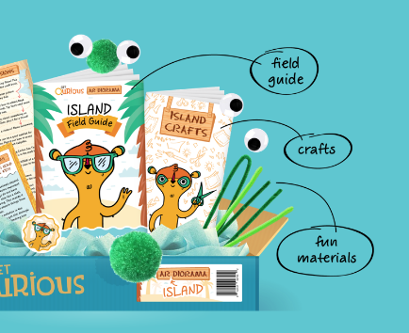
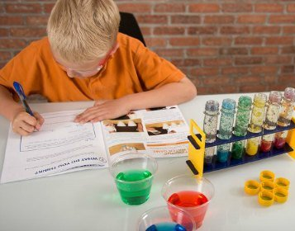

Spangler Science Club / Hololab / Get Qurious

  - Online Education
There are other emerging learning products on the market accessible to young people and offer greater alternative learning opportunities. Professional bodies are now offering more online resources to help enrich informal learning. In 2013, the RSC reported over 2,000 teacher members reached out onto the Talk Chemistry online community and an estimated 3,700 teachers found high-quality teaching and learning resources from their Learn Chemistry website. Most recently, the Wellcome Trust partnered with a number of companies (BBC and the Institute of Engineering and Technology), to provide a range of online resources through an initiative named ‘Explorify’. These resources help to provide primary school teachers with accessible content to enable students to learn creative problem-solving skills and without almost no preparation for lessons.

    - Flipped & Blended Learning
Flipped learning is a pedagogical approach in which students are introduced to learning material prior to lessons, usually through online resources. In the 1990s, Harvard Professor Eric Mazur developed a model of ‘peer instruction’ in which students were tasked to prepare and reflect on material before class. The model was later expanded to include technological elements and delivered as ‘The Classroom Flip’ (Baker 2000). The use of technology allows students to watch video explanations, complete problems and undertake activities that assess prior learning. There is a clear divide between technology and face-to-face elements of the learning experience; knowledge gained from using the technology can then be applied to the classroom. A good example of where it has been successful is the MathsFlip programme where students from Years 5 and 6 accessed the internet before-school and after-school to complete their activities. The evaluation found that students taking the approach made an equivalent of one additional month in mathematics compared to those students who didn’t undertake the learning. Flipped classrooms don’t have to be on a large scale. They can be initially integrated on a smaller capacity, depending on how many times a teacher wishes to use the approach.

Blended learning involves online and face-to-face instruction. Both are used alongside each other in order to provide a comprehensive learning experience. The great benefit is it offers supplemental resources and most instruction is delivered online providing the flexibility to learn. Students can work at their own pace through online learning, encouraging a self-pace and information retention. It encourages a more personalised approach and enables students to be able to track their own progression. Given the element of ‘self-blend’ it helps to alleviate the pressures from a more traditional way of working and provide a greater way to interact. Under the correct supervision of a teacher, blended learning can bring another dimension to a classroom by adding new layers to explore and fact find. By setting clear objectives, students have the freedom to focus on the most relevant and interesting aspects of a project.

Given the increasing popularity and accessibility of AR, using any of one these learning strategies offers the opportunity to use video, text, animations, 3D virtual models to enhance a learning experience. If schools are struggling to deliver or prioritise other subject areas, these learning methods may help to alleviate teaching workloads for science led classes.

    - MOOC (Massive Open Online Course)
MOOCs are distance learning courses run online where they can provide the option of studying a subject without the constraints of a traditional teaching method. They can be anywhere in the world as a resource and open to anyone regardless of what they are studying. The standard MOOC pedagogy is to provide a mix of presentations (videos, digital resources), automated assessment, peer-assessed assignments and peer discussions (Conole 2013). This makes learning flexible, so a student can access them whenever and wherever they want to. CPD requirements make it possible to run MOOCs on a very large scale, as they require only the fixed teaching costs of preparation, and none of the variable teaching costs of student support while the course is running. Furthermore, all MOOCs are generally available to access free of charge – opening education for everyone. Today, there are a whole variety of MOOCs on offer. One example being Future Learn is a digital education platform established by the Open University, that has now partnered with 143 UK and international educational institutions, including non-university partners. Professor Andy Parsons for Organic Chemistry at York University explores ‘everyday chemistry’ as part of an online course.

There are various challenges that MOOCs are coming across with few of them having accreditation or certification for students, increased dropout rate and assessment of learning, so they only act to expand an individual’s knowledge. The department for education does recognise that MOOC-type courses as a supplementary resource could support teachers with their out-of-classroom teaching preparation and highlights that the greatest benefit from MOOCs is the opportunity to teach more young people to teach themselves, to generate independent learners. However, 11- 14 years of age children will certainty need both parental and teacher’s support to direct and guide instructions. Mickey Revenaugh, Director for New Schools Models, Pearson Education comments, “High-quality baseline curriculum content is becoming easier to source – there is a good base layer of high-value digital textbook material. We now spend more development resources on what goes on top of it, on material that supports lesson structures – video or interactive media and support material for the educator—and assessments.”

Augmented reality has the potential to transform MOOCs education beyond the traditional method of video and audio formats. There are examples MOOCs using an augmented panoramic 360 view, as a new medium was used to teach students about the construction related education (Masoud., G, et al 2015) or using AR gamification for adaptive learning, providing better visualisation and engaging a learner during the process (Chauhan. J., et al 2015). Is this an opportunity for existing educational content to be repurposed using AR? Could it be aligned to the curriculum? Can parents or schools download material which will come alive as part of the learning process? MOOCs present some interesting and alternative ideas to for students to learn outside of the classroom in their own time and at their own pace.

Design Requirements

These points are presented to highlight the common key factors around how augmented reality can be adapted for science teaching and influence future research:

- AR experiences need to provide learning experiences that are rich and meaningful, building on the affordances of the technology. Pedagogical approaches need to be considered for effectiveness.

- All stakeholders (teachers, students, policy makers, designer etc.) need to be consulted as part of the process to create a robust curriculum delivery.

- AR learning experience should have relevance to the ‘real-world’ in science and connect to the curriculum school delivery.

- AR systems need to take a ‘user-centred’ design approach in order to be flexible and adaptable for individual teachers and students. All authoring tools need to be kept simple for the end user.

- AR should contextualise a child’s ‘active learning’ beyond the classroom; helping to connect the classroom to the outside world.

- AR experiences should encourage families to interact and get involved towards building ‘science capital’.

- Technical AR support and guidance must be provided to teachers and learners on how to operate a system; parents can play an active role as part of the process.

- An AR experience may benefit from helping to track and support a students’ individual learning progression.

- AR requires adequate wireless connectivity to enable an application to operate seamlessly.

Bibliography

Akçayır, M, Akçayır, G (2017) Advantages and challenges associated with augmented for education: a systematic review of the literature. Educ Res Rev 20:1–11
Andujar., J, Mejias., A, Marquez., M (2011) Augmented Reality for the Improvement of Remote Laboratories: An Augmented Remote Laboratory. IEEE Transactions on Education (Volume: 54, Issue: 3, Aug. 2011)
Archer, L, Dawson, E, DeWitt, J, Seakins, A & Wong, B 2015, '"Science capital": A conceptual, methodological, and empirical argument for extending Bourdieusian notions of capital beyond the arts', Journal of Research in Science Teaching, vol. 52, no. 7
Azuma, R.T. (1997) A Survey of Augmented Reality, Presence. Teleoperators and Virtual Environments, 6, 355-385.
Barber, M. and Mourshed, M. (2007) ‘How the World’s Best-Performing School Systems Came Out on Top’. New York: McKinsey and Company.

Bennett, J., Lubben, F. and Hogarth, S. (2006) ‘Bringing science to life: a synthesis of the research evidence on the effects of context-based and STS approaches to science teaching. Science Education, 91 (3), 347-370.
Berger., C. Gonzalez-Franco., M, Ofek,, E, Hinckley., K (2018) The uncanny valley of haptics, Science Robotics, 3 (17). Art. No. eaar7010. ISSN 2470-9476.
Billinghurst, M., Kato, H., & Poupyrev, I. (2001). e Magic Book — Moving seamlessly between reality and virtuality. IEEE Computers, Graphics and Applications, 21(3), 2-4.
Billinghurst M (2002) Augmented reality in education. New Horizons Learn. http://www.newhorizons.org/strategies/technology/billinghurst.htm.
Bower, Matt/Howe, Cathie/McCredie, Nerida/Robinson, Austin/Grover, David (2014): “Augmented Reality in education – cases, places and potentials.” In: Educational Media International 51(1), 1–15.
Brinson, J. R. (2015). Learning outcome achievement in non-traditional (virtual and remote) versus traditional (hands-on) laboratories. A review of the empirical research. Computers & Education, 87, 218-237.
Bromberg, S; Chiu, W; Ferrin, TE. (2010) Workshop on Molecular Animation. Structure 18, 1261-1265.

Burkett, V. C., & Smith, C. (2016). Simulated vs. Hands-on Laboratory Position Paper. Electronic Journal of Science Education, 20(9).
Carr, J. M. (2012). Does Math Achievement h’APP’en when iPads and Game-Based Learning are Incorporated into Fifth-Grade Mathematics Instruction? Journal of Information Technology Education, 11(1).
Campbell, B., Lazonby, J., Millar, R., Nicolson, P., Ramsden, J., & Waddington, D. (1994). Science: The Salters approach—a case study of the process of large-scale curriculum development. Science Education, 78(5), 415–447.

Caudell., T & Mizell., D, (1992) “Augmented reality: an application of heads-up display technology to manual manufacturing processes,” in Proceedings of the Twenty-Fifth Hawaii International Conference on System Sciences

Chauhan. J., Goel., A, Shilpi., T (2015) Enhancing MOOC with Augmented Reality, Adaptive Learning and Gamification. DOI: 10.1109/MITE.2015.7375343
Conference: Third IEEE Conference on MOOCs, Innovation and Technology in Education (MITE 2015), At Amritsar, India
Chen Y-C (2006) A study of comparing the use of augmented reality and physical models in chemistry education. In: International conference on virtual reality continuum and its applications, Hong Kong, China, pp 369–372
Chen, C.-M., Tsai, Y.-N. (2012): Interactive Augmented Reality System for Enhancing
Library Instruction in Elementary Schools. Computer and Education 59, 638–652

Chen., P, Liu., X, Cheng., W, Huang., R (2016) A review of using Augmented Reality in Education from 2011 to 2016

Cimen., G. Yuan., Y, Sumner., R. Coros., S, Guay., M. (2018) Interacting with Intelligent Characters in AR. International SERIES on Information Systems and Management in Creative eMedia (CreMedia)

Coll S. D. and Treagust D., (2015), Using informal learning experiences to enhance student learning outcomes in chemistry, in Eilks I. and Hofstein A. (ed.), Relevant chemistry education: from theory to practice, Rotterdam: Sense, pp. 355–368.
Conole, G. (2013) MOOCs as disruptive technologies: strategies for enhancing the learner experience and quality of MOOCs, Revista de Educacion a Distancia, vol. 39
Dalgarno, B., Bishop, A.G. and Bedgood, D.R. (2003). The potential of virtual laboratories for distance education science teaching: reflections from the development and evaluation of a virtual chemistry laboratory. In Improving Learning Outcomes Through Flexible Science Teaching. Proceedings of the 2003 UniServe Science Conference, Sydney, Australia.
Dede, C. (2009). Immersive interfaces for engagement and learning. Science, 323(5910), 66-69.
De Lucia., A, Francese., R, Passero., I. (2012) A Collaborative Augmented Campus Based on Location-Aware Mobile Technology. International Journal of Distance Education Technologies (IJDET) 10(1)
Dunleavy, M., Dede, C., & Mitchell, R. (2009). Affordances and limitations of immersive participatory augmented reality simulations for teaching and learning. Journal of Science Education and Technology, 18(1), 7–22.

Dunleavy. M., (2014) Design Principles for Augmented Reality Learning. DOI
https://doi.org/10.1007/s11528-013-0717-2

Eshach., H. (2007) Bridging In-school and Out-of-school Learning: Formal, Non-Formal, and Informal Education. Journal of Science Education and Technology
April 2007, Volume 16, Issue 2, pp 171–190

Falk., J. Dierking., L (2000) Learning from Museums: Visitor Experiences and the Making of Meaning. AltaMira Press. 0759117195

Field.J & Tuckett. (2016) A: Government Office for Science – Informal Learning in the family and community (Future of Skills & Lifelong Learning)

Fjeld & Voegtli., (2002) Augmented Chemistry: an interactive educational workbench. DOI: 10.1109/ISMAR.2002.1115100

Fernandez, M., (2017) Augmented Virtual Reality: How to Improve Education Systems, Universidad Europea de Madrid, Madrid, Spain
DOI:10.18870/hlrc.v7i1.373

Godec, S., King, H. & Archer, L. (2017) The Science Capital Teaching Approach: engaging students with science, promoting social justice.
London: University College London.
Goodall. J., and Vorhaus.J , (2011) Department for Education: Review of best practice in parental engagement
Habler., B, Major. L., Hennessy., S. (2017) Tablet use in schools: a critical review of the evidence for learning outcomes. Faculty of Education, University of Cambridge, Cambridge, UK. Journal of Computer Assisted Learning.

Hamlyn, R., Matthews, P. and Shanahan, M. (2017) ‘Young people’s views on science education: Science Education Tracker’. London: Wellcome Trust.
Hawkins., I., & Phelps., A. (2013) Virtual laboratory vs. traditional laboratory: Which is more effective for teaching electrochemistry?
Hein.D., Jodoin., J, Rauschnabel., P, Ivens., B. (2017) Are Wearables Good or Bad for Society? An Exploration of Societal Benefits, Risks, and Consequences of Augmented Reality Smart Glasses. Source Title: Mobile Technologies and Augmented Reality in Open Education. DOI: 10.4018/978-1-5225-2110-5.ch001
Herga N.R., Cagran B., Dinevski D., 2016, Virtual laboratory in the role of dynamic visualisation for better understanding of chemistry in primary school, Eurasia Journal of Mathematics Science & Technology Education, 12(3), 593-608, DOI: 10.12973/eurasia.2016.1224a
Höst GE, Larsson C, Olson A, Tibell LA. Student learning about biomolecular self-assembly using two different external representations. CBE Life Sci Educ. 12, 471-82 (2013).

Hostetter, A. B., and Alibali, M. W. (2008). Visible embodiment: gestures as simulated action. Psychon. Bull. Rev. 15, 495–514. doi: 10.3758/PBR.15.3.495

Huang., T, Chia., C. Wen., Yu (2016).Animating eco-education: To see, feel, and discover in an augmented reality-based experiential learning environment

Jenkins, E. & Nelson, N. (2005) ‘Important but not for me: students’ attitudes towards secondary school science in England’. Research in Science and Technological Education, 23 (1), 41-57.

Ionitescu, S., & Radu., C. (2015) Perspectives on implementing interactive e-learning tools using augmented reality in education. The International Scientific Conference eLearning and Software for Education; Bucharest Vol. 1: 104-111

Jenkins., H, (2009) Confronting the Challenges of Participatory Culture: Media Education for the 21st Century. Massachusetts Institute of Technology

Johnson, L., Adams Becker, S., Cummins, M., Estrada, V., Freeman, A., and Hall, C. (2016). NMC Horizon Report: 2016 Higher Education Edition. Austin, Texas: The New Media Consortium.

Kangdon., L. (2012) Augmented Reality in Education and Training. 56: 13. https://doi.org/10.1007/s11528-012-0559-3

Kato., H; Billinghurst., M; Poupyrev. I.; Imamoto. K; Tachibana.,K (2000) Virtual object manipulation on a table-top AR environment, Conference: Augmented Reality, 2000. (ISAR 2000). Proceedings. IEEE and ACM International Symposium on

Kaufmann., H. (2003) "Collaborative Augmented Reality in Education"; in: "Imagina Conference 2003", issued by: Imagina; Monaco Mediax, Monaco.

Kerawalla, L., Luckin, R., Seljeflot, S., and Woolard, A. (2006) Making it real: exploring the potential of Augmented Reality for teaching primary school science. Virtual Reality
King, Donna T (2007) Teacher beliefs and constraints in implementing a context- based approach in chemistry. Teaching Science: The Journal of the Australian Science Teachers Association 53(1): pp. 14-18. Copyright 2007 Australian Science Teachers Association
Kiryakova., G. Yordanova., L. Nadezhda., A (2018) The potential of augmented reality to transform education into Smart education
Klopfer. E., & Sheldon. J. (2010) Augmenting your own reality: student authoring of science-based augmented reality games.
Kytö, M., Ens, B., Piumsomboon, T., Lee, G. A., & Billinghurst, M. (2018). Pinpointing: Precise Head-and Eye-Based Target Selection for Augmented Reality. In Proceedings of the 2018 CHI Conference on Human Factors in Computing Systems (p. 81). ACM.

Leach, J., & Scott, P. (1995). The demands of learning science concepts: Issues of theory and practice. School Science Review, 76 (277), 47-52.
Leonardi, S., Lamb, H., Howe., P & Choudhoury., A. (2017) ‘State of the nation’ report of UK primary science education: Wellcome Trust
Lin., J., Cheng, D., Yao., C & Wang., Y (2017) Retinal projection head-mounted display
Front. Optoelectron. 10: 1. https://doi.org/10.1007/s12200-016-0662-8
Lindahl, B. (2007). A Longitudinal Study of Student's' Attitudes Towards Science and Choice of Career. Paper presented at the 80th NARST International Conference New Orleans, Louisiana.

Lindgren, R., Tscholl, M., Wang, S., and Johnson, E. (2016). Enhancing learning and engagement through embodied interaction within a mixed reality simulation. Comput. Educ. 95, 174–183. doi: 10.1016/j.compedu.2016.01.001

Lunetta, V. N., Hofstein, A., & Clough, M. P. (2007) Learning and teaching in the school science laboratory: an analysis of research, theory, and practice. In S. K. Abell & N. G. Lederman (Eds), Handbook of Research on Science Education (pp. 393-441). Mahwah, NJ.: Lawrence Erlbaum.

Masoud., G. (2016) Integrating BIM and Panorama to Create a Semi-Augmented-Reality Experience of a Construction Site. International Journal of Construction Education and Research · October 2016. DOI: 10.1080/15578771.2016.1240117

Melhuish, K. & Falloon, G. (2010). Looking to the future: M-learning with the iPad. Computers in New Zealand Schools: Learning, Leading, Technology, 22(3), 1– 16.

Milgram, P., Kishino, F(1994) A Taxonomy of Mixed Reality visual displays. IEICE Transactions on Information Systems, Vol E77-D, No.12

Mitchell., R, (2011) Alien Contact! Exploring teacher implementation of an augmented reality curricular unit. Volume 30, Number 3, July 2011 ISSN 0731-9258 Publisher: Association for the Advancement of Computing in Education (AACE), Waynesville, NC USA

Muñoz, Juan Miguel (2014): “Augmented Reality, an opportunity for the new education.” Journal of Communication and Pedagogy 277–278, 6–11.

Muprhy, C., (2003) FutureLab Series – Report 5: Literature Review in Primary Science and ICT, Graduate School of Education, Queens University, Belfast

Neal, M (2012) "Creating and Maintaining Psychological Flow State in Augmented Reality Applications," presented at the 2012 EEE International Conference on e-Learning, eBusiness, Enterprise Information Systems, and e-Government, Las Vegas, NV

Nomikou, E., Archer, L. and King, H. (2017) ‘Building ‘science capital’ in the classroom’. School Science Review, 98 (365), 118-124.
Onime., C, Abiona., O (2016) 3D Mobile Augmented Reality Interface for Laboratory Experiments. Int. J. Communications, Network and System Sciences, 2016, 9, 67-76 Published Online April 2016 in SciRes. http://www.scirp.org/journal/ijcns http://dx.doi.org/10.4236/ijcns.2016.94006
Pase. S., (2009) Ethical Considerations in Augmented Reality Applications. Department of Psychology, Fielding Graduate University, Santa Barbara, CA, USA
Pell, T. and Jarvis, T. (2001). ‘Developing attitude to science scales for use with children of ages from five to eleven years.’ International Journal of Science Education, 23 (8), 847–862.

Radu, L., (2014). Augmented reality in education: a meta-review and cross-media analysis. Personal & Ubiquitous Computing. Aug2014, Vol. 18 Issue 6, p1533-1543
Rosenbaum, E., Klopfer, E., & Perry, J. (2007). On location learning: authentic applied science with networked augmented realities. Journal of Science Education and Technology, 16(1), 31–45.

Rasbash., J, Leckie., G, Pillinger., R, Jenkins., J (2010) Children's educational progress: Partitioning family, school and area effects. Journal of the Royal Statistical Society Series A (Statistics in Society) 173(3):657-682 · DOI: 10.2307/40666280

Rudd, P., Berenice, A., Aguilera, V., Elliott, L., and Chambers, B. (2017) ‘MathsFlip: Flipped Learning: Evaluation report and executive summary’, Education Endowment Foundation. https:// educationendowmentfoundation.org.uk/public/ les/ Projects/Evaluation Reports/Flipped_Learning.pdf

Singh., M, Singh., M. (2013) Augmented Reality Interfaces. IEEE Internet Computing (Volume: 17, Issue: 6 , Nov.-Dec. 2013 )
Stone JE, Kohlmeyer A, Vandivort KL, Schulten K. Immersive molecular visualization and interactive modeling with commodity hardware. Lecture Notes in Computer Science 6454, 382-393, (2010).

Southgate, E Smith., S, Scevak., J. (2017) Asking ethical questions in research using immersive virtual and augmented reality technologies with children and youth. DOI: 10.1109/VR.2017.7892226

Tai, R. H., Qi Liu, C., Maltese, A. V. and Fan, X. (2006) ‘Planning early for careers in science’. Science, 312 (5777), 1143-5.

Van den Akker, J. (1998). The science curriculum: Between ideals and outcomes. In B. Fraser & K. Tobin (Eds.), International handbook of science education (pp. 421–447). Dordrecht, The Netherlands: Kluwer.

Wang, M., Callaghan, V., Bernhardt, J., White, W., and Pena-Rios., A (2017) Augmented reality in education and training: pedagogical approaches and illustrative case studies, Journal of Ambient Intelligence and Humanized Computing, pp. 1-12

Wassom, B., (2014) Augmented Reality: Law, Privacy, and Ethics: Syngress print. ISBN: 978-0-12-800208-7

Woodfield, B. F., Andrus, M. B., Andersen, T., Miller, J., Simmons, B., Stanger, R., et al. (2005). The Virtual ChemLab Project: A Realistic and Sophisticated Simulation of Organic Synthesis and Organic Qualitative Analysis. Journal of Chemical Education, 82(11), 1728-1735.
Wu., H, Lee., S, Chang., H, Liang., J. (2013) Current status, opportunities and challenges of augmented reality in education. Computers & Education

Yuen, Steve Chi-Yin; Yaoyuneyong, Gallayanee; and Johnson, Erik (2011) "Augmented Reality: An Overview and Five Directions for
AR in Education," Journal of Educational Technology Development and Exchange (JETDE): Vol. 4 : Iss. 1 , Article 11. DOI: 10.18785/jetde.0401.10

Yoon, S. A., Elinich, K., Wang, J., Steinmeier, C., and Tucker, S. (2012). Using augmented reality and knowledge-building scaffolds to improve learning in a science museum. Comput Support. Collab. Learn. 7, 519–541. doi: 10.1007/s11412-012-9156-x

Zhu., Y, Yang., X, Wang., S. (2017) Augmented Reality Meets Tangibility: A New Approach for Early Childhood Education. EAI Endorsed Transactions on Creative Technologies DOI: 10.4108/eai.5-9-2017.153059

_________________

BLANK PAGE

Oxford Economics, The UK Chemicals Outlook to 2030, December (2012).
Joint Council for Qualifications - Campaign for Science and Engineering
HM Government, Industrial Strategy: Building a Britain fit for the future, November (2017).
CBI, Building for Growth: Business Priorities for Education and Skills—Education and Skills Survey, May (2011)
CIHE, The demand for STEM graduates and postgraduates, January (2009).
https://www.gov.uk/government/publications/ofsted-annual-report-201718-education-childrens-services-and-skills/the-annual-report-of-her-majestys-chief-inspector-of-education-childrens-services-and-skills-201718
Wellcome Trust – ‘State of the nation’ report of UK primary science education (2017).
Wellcome Trust: Primary Science: Is It Missing Out? Recommendations for reviving primary science (2014)
SCORE (Science Community Representing Education) – Resourcing Practical Science in Primary Schools (2013)
HM Government – Industrial Strategy: Building a Britain fit for the future (2017)
SCORE (Science Community Representing Education) – Resourcing Practical Science in Primary Schools (2013)
Gatsby Foundation Report: Good Practical Science (2017)
Gatsby Foundation Report: The National Curriculum Review (2011)
DFE – Schools, pupils and their characteristics (2017)
Education Policy Institute: The teacher labour market in England: shortages, subject expertise and incentives (2018)
School Workforce Census 2013: https://www.gov.uk/government/publications/school-workforce-in-england-november- 2013. Data covers-maintained schools, free schools and academies
The deployment of science and maths leaders in primary schools. A study for the Wellcome Trust (2013)
RSC – Inspiring, encouraging and expert: the formula for world-class science and chemistry education
Royal Society of Chemistry – Parliamentary briefing: Specialist chemistry and primary science teaching in England
Gatsby Foundation Report: Good Practical Science (2017)
Wellcome Trust – Developing Great Subject Teaching (2018)
Gatsby Foundation Report: Good Practical Science (2017)
DfE: Realising the potential of technology in education (2019)
www.futurelearn.com/courses/technology- teaching-learning.
STEM Clubs are clubs that give students opportunities to do science, technology, engineering and mathematics activities outside the formal curriculum. Advice and support on setting up STEM Clubs is available from the National STEM Learning Centre www.stem.org.uk/stem-clubs (accessed April 2017).
ENTHUSE bursaries contribute towards the costs of CPD at the National STEM Learning Centre for all UK state-funded schools and colleges www.stem.org.uk/bursaries (accessed June 2017).
SCORE (Science Community Representing Education) – Resourcing Practical Science in Secondary Schools (2013)
Wellcome Trust: ‘State of the Nation’ report of UK primary science education (2017)
SCORE – Practical work in Science – A report and proposal on a strategic framework (P 2)
The Primary Science Teaching Trust Academic Collaborators and Strategic Partners – Impact Statement (2017)
Young people’s views on science education, science education tracker, research report (2017)
MORI – Public Attitudes to Science (2014)
Young Peoples’ Views – Science Education Tracker 2017
Royal Society of Chemistry – Inspiring, engaging and expert: the formula for world-class science and chemistry education (2014)
The Science Capital Teaching Approach – Engaging students with science, promoting social justice
Economic and Social Research Council. ‘What influences participation in science and mathematics?’ A briefing paper from the Targeted Initiative on Science and Mathematics Education (TISME). London: ESRC/TISME; 2013.
Young Peoples’ Views – Science Education Tracker Report 2017
Young Peoples’ Views – Science Education Tracker Report 2017
Lindahl, B. (2007). A Longitudinal study of students’ attitudes towards science and choice of career. Paper presented at the Annual Meeting of the National Association for Research in Science Teaching. New Orleans, Louisiana.
Ofcom: Children and parents: Media use and attitudes report (2017)
Mark Mcrindle: The ABC of XYZ: Understanding the Global Generation (2018)
DfE: Realising the potential of technology in education (2019) - https://edtechnology.co.uk/Article/the-uk-ranks-1-in-edtech-venture-capital-funding-in- europe/
HM Government – Industrial Strategy: Building a Britain fit for the future (2017)
Education Endowment Foundation – Teaching and Learning Toolkit 2019
SCORE – A framework for practical science in schools (2009)
Gatsby Foundation Report: Good Practical Science (2017)
Labster – The complete guide to VR virtual labs in science education – white paper - https://get.labster.com/white-paper-vr-virtual-labs
https://www.tvrlp.com/ultimate-extended-reality-glossary/
https://www.emacula.io/
https://www.microsoft.com/en-us/hololens
https://www.magicleap.com/
https://www.nreal.ai/
https://www.lifeliqe.com/
https://www.zappar.com/zapbox/#experiences
https://www.ultrahaptics.com/
Futurelab (2003) – Literature Review in Primary Science and ICT
https://www.beedtheworld.com/
http://www.augmentedcreativity.ch/
https://www.youtube.com/watch?v=R5uuwAe6BX0
https://studio.gometa.io/landing
https://seppo.io/about/
DfE: Realising the potential of technology in education (2019)
CATAPULT Digital – Growing VR/AR companies in the UK: A business and legal handbook 2017, Page 91
CATAPULT Digital – Growing VR/AR companies in the UK: A business and legal handbook 2017,
CATAPULT Digital – Growing VR/AR companies in the UK: A business and legal handbook 2017, Page 89
https://www.microsoft.com/en-us/hololens/legal/health-and-safety-information
https://uxdesign.cc/human-eyes-understanding-of-space-for-augmented-reality-d5ce4d9fa37b
https://uxdesign.cc/human-eyes-understanding-of-space-for-augmented-reality-d5ce4d9fa37b
Education Policy Institute: The teacher labour market in England: shortages, subject expertise and incentives (2018)
CIHE, The demand for STEM graduates and postgraduates, January (2009).
SCORE – A framework for practical science in schools (2009)
Gatsby Foundation Report: Good Practical Science (2017)
HM Government – Industrial Strategy: Building a Britain fit for the future (2017)
Young people’s views on science education, science education tracker, research report (2017)
Mark Mcrindle: The ABC of XYZ: Understanding the Global Generation (2018)
Braund, M and Reiss, M J (Eds) (2004) Learning Science Outside the Classroom, Routledge Falmer, London.
Falk, J H and Dierking, L D (2000) Learning from museums, AltaMira Press, Walnut Creek USA
https://www.royalmailgroup.com/en/insights-innovation/insight/boom-boxes-uk-subscription-box-market-to-be-worth-1-billion-by-2022/
https://www.lightup.io/
https://www.getqurious.co/
Royal Society of Chemistry – Inspiring, engaging and expert: the formula for world-class science and chemistry education (2014)
Rudd, P., Berenice, A., Aguilera, V., Elliott, L., and Chambers, B. (2017) ‘MathsFlip: Flipped Learning: Evaluation report and executive summary’, Education Endowment Foundation.
https://www.futurelearn.com/courses/everyday-chemistry
DfE (2014): MOOCs: Opportunities for their use in compulsory-age education

