The effect of long-term soccer training on changes in cardiac function during exercise in elite youth soccer players

Viswanath Balagopalan Unnithan¹, Thomas Rowland¹, Keith George², Andisheh Bakhshi³, Alexander Beaumont⁴, Nicholas Sculthorpe¹, Rachel Nia Lord⁵ and David Lee Oxborough²
¹ Institute of Clinical Exercise and Health Science, Division of Sport and Exercise, School of Health and Life Sciences, University of the West of Scotland, Hamilton, Scotland, UK, ²Research Institute for Sport and Exercise Sciences, Liverpool John Moores University, Liverpool, UK, ³Phastar, Glasgow, Scotland, UK,⁴School of Sport, York St. John University, York, UK and ⁵Cardiff Centre for Exercise and Health, Cardiff Metropolitan University, Cardiff, UK,

Address for correspondence:
Professor V.B. Unnithan, Ph.D., FACSM
Division of Sport and Exercise
Institute of Clinical Exercise and Health Science
School of Health and Life Sciences
University of the West of Scotland
Hamilton
Scotland, UK
Tel: 01698 894413
E-mail: vish.unnithan@uws.ac.uk

Section 1: Physiology and Biochemistry

Abstract
It is unclear what the effect of long-term, high-volume soccer training has on left ventricular (LV) function during exercise in youth soccer players. This study evaluated changes in LV function during submaximal exercise in a group of highly-trained male soccer players (SP) as they transitioned over a three-year period from pre-adolescent to adolescent athletes. Data were compared to age-and sex-matched recreationally active controls (CON) over the same time period. Twenty-two SP from two professional English Premier League youth soccer academies (age: 12.0 ± 0.3 years at start of the study) and 15 CON (age: 11.7 ± 0.3 years) were recruited. Two-dimensional echocardiography was used to quantify LV function during exercise at the same submaximal metabolic load (approx. 45%VO₂peak) across the 3 years. After controlling for growth and maturation, there were training-induced changes and superiority (p<0.001) in cardiac index (QIndex) from year 1 in the SP compared to CON. SP (year 1: 6.13 ± 0.76; year 2: 6.94 ± 1.31 and year 3: 7.20 ± 1.81 L/min/m²) compared to CON (year 1: 5.15 ± 1.12; year 2: 4.67 ± 1.04 and year 3: 5.49 ± 1.06 L/min/m²). Similar training-induced increases were noted for mitral inflow velocity (E): SP (year 1: 129 ± 12; year 2: 143 ± 16 and year 3: 135 ± 18 cm/s) compared to CON (year 1: 113 ± 10; year 2: 111 ± 12 and year 3: 121 ± 9 cm/s).This study indicated that there was evidence of yearly, training-induced increases in left ventricular function during submaximal exercise independent from the influence of growth and maturation in elite youth SP.

Keywords: Youth Soccer Training, Submaximal Exercise, Left Ventricular Function

Introduction
Evidence from the extant literature is clear from both an intensity- and time-domain perspective, that elite youth soccer players (SP) spend a significant amount of match-play at submaximal intensities, interspersed with periods of high-intensity activity¹. Furthermore, it is unequivocal that elite youth SP are exposed to high annual training volumes². Indeed, training volumes have been reported to be 400 to 500 minutes per week in 12 -14 years elite youth SP from English Premier League academies^{3,4}.
It is unclear, however, what the influence of the high-intensity intermittent training and the large training volumes have over time on left ventricular (LV) function during exercise in these elite youth SP. The LV functional capacity of youth athletes, particularly SP has been elucidated at rest⁵, but greater insight into the LV mechanisms that drive their superior physical performance compared to their recreationally active peers can be derived from in-exercise evaluations. Limited, cross-sectional evidence exists for the “in-exercise” submaximal cardiovascular function of pre-adolescent and adolescent athletes and particularly SP using exercise echocardiographic studies^{6,}’^{7, 8}. The few in-exercise, cross-sectional studies in pre-adolescent athletes have demonstrated greater global markers (cardiac output index [QIndex] and stroke volume index [SVIndex]) of LV function at the same absolute⁶ and relative (%VO₂max) submaximal⁷ intensities in endurance trained and SP, respectively, when compared to recreationally active control (CON) participants. This pattern of superior SVIndex was also noted at absolute submaximal intensities in adolescent (14.6 years) SP⁸ when compared to their recreationally active peers.
Moreover, interrogation of cardiac function using tissue-doppler echocardiography (TDI) demonstrated no differences in systolic function in pre-and post-adolescent SP compared to their respective recreationally active peers when compared at relative ⁷ and absolute⁸ exercise intensities, respectively. Evidence does exist, however, for superior diastolic function (E) in the SP exercising at the same relative submaximal work load than their recreationally active CON group⁷. This difference did not manifest itself in the adolescent SP exercising at the same absolute submaximal workload as their recreationally active peers⁸, thus highlighting the importance of assessment at relative intensities.
Advancements in two-dimensional speckle tracking echocardiography (2D STE) have enabled cardiac strain (ε) to be evaluated during exercise. In particular, longitudinal ε is the most commonly assessed marker of LV systolic function and also provides greater insight to LV pump function than conventionally derived ejection fraction⁹. The scant quantity of literature has demonstrated no significant difference in peak global longitudinal ε at the same relative exercise intensity when comparing pre-adolescent SP and recreationally active CON participants⁷. Increasing peak, global longitudinal ε during incremental submaximal exercise to a point of plateau was also noted within a group of recreationally active (13.2 years of age) and elite adolescent (15.4 years of age) SP^{10,11}.
The limited number of in-exercise echocardiographic studies, while providing some valuable information on the influence of training status on submaximal cardiac function in elite youth SP, have been constrained by their cross-sectional nature and the lack of CON participants in some instances. Data does exist on the influence of growth and maturation on resting LV function in children and adolescents.¹² However, no current evidence exists that delineates the long-term impact of high-intensity and volume elite soccer training from the influence of growth and maturation on submaximal cardiac function and sparse information exists for the normative in-exercise response in elite adolescent athletes¹¹.
Consequently, the aim of the study was to evaluate the impact of 3 years of soccer training on changes in LV systolic and diastolic function during submaximal exercise using two-dimensional transthoracic and speckle tracking echocardiography in a group of highly trained elite youth SP.

Materials and Methods
Participants
Twenty-two elite male youth SP from two Category 1 (highest Level) English Premier League Academy U-12 teams were evaluated during an incremental cycle ergometer exercise test to volitional exhaustion, once a year for 3 consecutive soccer seasons as the players progressed from the U-12 to U-14 teams. At the same time, a group of fifteen recreationally active, but not systematically trained control participants (CON) were evaluated using the same protocol over the same 3-year time period. Stature, sitting height and body mass were measured. In order to obtain a marker of growth and maturation, maturity status was subsequently quantified using the maturity offset method¹³. There were no significant inter-group differences in maturity (Figure 1), determined through the lack of difference in maturity offset at the start of year 1. SP (year 1: -2.09 ± 0.58; year 2:-1.10 ± 0.56 and year 3: -0.52 ± 0.69 years) and CON (year 1: -2.36 ± 0.45; year 2: -2.51 ± 0.48 and year 3: -0.50 ± 0.72 years.
The mean of two measurements of subscapular, triceps, and calf skinfolds using skinfold calipers (Holtain Ltd., Crymych, UK) was determined in all participants. The Slaughter equation¹⁴ based on the triceps and subscapular skinfolds were used to estimate percent body fat and subsequently lean body mass (LBM) for each participant. The Slaughter equation has been reported to be a valid method for estimating percent body fat in children and adolescents¹⁵. Both groups were of similar chronological age at the start of the observation period (SP: 12.0±0.3 years and CON: 11.7±0.3 years) Written assent was provided by all participants and written informed consent was provided by all parents/legal guardians. All procedures performed in the study were in accordance with the ethical standards of the Declaration of Helsinki and the study was approved by Staffordshire University Research Ethics Committee.
Study Design and Pre-Participant Requirements
The study employed a 3-year observational, cohort assessment of LV function in highly trained pre-adolescent SP and CON. Within testing sessions, repeated measures of physiological variables were completed at rest and during progressive cycle ergometer exercise to volitional exhaustion. Data presented in this study is delimited to the submaximal exercise intensities. All testing took place at the training grounds of the two soccer clubs and at a local school for the CON participants. Participants were instructed to avoid exercise on the day preceding the test. Furthermore, all participants were also informed to refrain from consuming any drinks containing sugar or caffeine as well as the consumption of any food in the two hours preceding the testing session.

Training and Physical Activity Profiles of the Participants Across the 3 years of the Longitudinal Study
At the Under-12 (U12) age group, all players in both Category 1 Youth Soccer Academies were exposed to 7.3 hours of high-intensity soccer activity per week including matches. One of the clubs also included 45 minutes of gym-based strength work for this age group, as part of the overall 7.3 hours. In addition to this, players from both clubs took part in physical education classes at school and sports club activities such as rugby union, cycling and cross-country running amounting to: 3.22 ± 1.68 (mean ± SD) hours per week. Consequently, the total training and physical activity load of the players in the U12 age group was approximately 10.5 hours per week. When these same players progressed to the next age category (U13) in their respective clubs, the training load increased to 10.5 hours of intermittent, high-intensity soccer training including matches and 1 hour of gym work per week. This was supplemented by 2.59 ± 1.20 hours per week of physical education classes in school and other sports activities. This resulted in a training and activity load of the U13 players of approximately 13.1 hrs per week. In the final year of the observational study, similar training loads (10.5 hours) were maintained at the U14 level in both clubs and in concert with physical activity and other sports participated in away from the clubs (2.94 ± 1.51 hours per week), this resulted in 13.4 hrs per week. All player training load data was taken from the database from the respective clubs and the physical activity participation times came from a validated self-report questionnaire⁸.
In contrast, the recreationally active, but not systematically trained CON group took part in physical education in school and other sports activities away from school such as football, track and field, cycling and martial arts resulting in physical activity durations of: 3.30 ± 1.44, 3.89 ± 1.95 and 3.38 ± 1.43 hours per week at 12, 13 and 14 years of age respectively. The evidence suggests a 3-4 times higher volume of training and activity in the SP per year compared to the CON across the 3 years of the study.
Data collection
Physical activity and training questionnaires⁸ were completed prior to the testing each year. Participants then completed a cycle ergometer test to volitional exhaustion, with echocardiographic and open circuit, breath-by-breath metabolic measurements obtained throughout. The participants pedalled at 60 rpm with an initial workload of 20 W, with 20 W increments until a workload of 60 W was attained. Each stage was 3 minutes in duration. Following this, the workload duration was shortened to 2-minute stages and workload increments were individualised until each participant reached volitional exhaustion. The data in this paper are delimited to only the initial 3 submaximal workload intensities (20 W to 60 W) to allow the simultaneous collection of TDI and strain data that would not be hampered by exercise artefact and would be similar to the low intensity bouts of exercise that the SP were exposed to during competitive matches.
Echocardiographic measurements were taken 90 seconds into each stage for the first three stages (20, 40 and 60 W). Submaximal exercise inter-group comparisons were made at the same relative exercise intensity (%$\dot{V}O_{2peak}$) within and between each year (Table 1), to ensure that inter-group submaximal cardiovascular evaluations were made at the same approximate metabolic load.
Echocardiographic Measurements: Indices of LV function during incremental exercise
All echocardiographic assessments (VividQ Ultrasound System, GE Ltd, Horton, Norway) were completed by DLO and subsequent analysis were also performed by DLO. Imaging of the LV was performed 90 seconds into each of the first three, 3 minute stages, from the focused, apical four-chamber view and the suprasternal notch with the participant in an upright, but forward-leaning position on the cycle ergometer (Lode, Corival, Groningen, Netherlands)⁷. Offline analysis (EchoPac, Version 6.0, GE Ltd, Horton, Norway) included, peak early diastolic filling velocity (E); where clearly discernible, the E wave was measured. During faster heart rates, however, fusion of the E and atrial (A) waves meant that a single peak diastolic filling velocity was measured, but still termed E for ease of comparison. Pulsed wave tissue-Doppler imaging determined peak longitudinal mitral, lateral, annular velocities in systole (S’) and early diastole (E’). Both E’ and S’ were adjusted for heart size by LV Length¹⁶. Similar to conventional blood flow assessment, the peak diastolic myocardial velocity was utilized, when fusion of E and A’ occurred. E/E’ was calculated as an estimate of LV filling pressure and thus preload¹⁷. A sub-sample of 5 SP in the 3rd year of observation were asked to return 7 days after the third-year cardiac evaluation to establish the test-retest reliability of systolic and diastolic TDI variables. Coefficients of variation during submaximal exercise ranged from 4.7 to 8.8% for S’ and 3.6 to 5.1% for E.
Stroke volume (SV) was calculated using continuous–wave Doppler from the suprasternal notch to detect ascending aortic flow (PAV). The velocity-time integral (VTI) during submaximal exercise was calculated and multiplied by the pre-exercise, upright, LV outflow tract cross-sectional area (measured from a parasternal long axis view) to determine SV. Subsequently, submaximal exercise cardiac output (Q) was determined by multiplying SV by the heart rate (HR) (as determined from the R-R interval from the same cardiac cycle on the ECG inherent to the echocardiographic machine [VividQ Ultrasound System, GE Ltd, Horton, Norway]). Both Q and SV were adjusted for body surface area (QIndex and SVIndex). Arterial venous oxygen difference (AVO₂) was computed as VO₂/Q. A sub-sample of 5 SP in the 3rd year of observation were asked to return 7 days after the third-year cardiac evaluation to establish the test-retest reliability of the cardiovascular variables (SV and Q). Mean coefficients of variation during submaximal exercise (20W to 60W) ranged from 4.7 to 8.8% for SV and 10.1 to 16.4% for Q.
STE Methodology
A focused apical 4-chamber cardiac ultrasound of the LV was acquired and optimized to improve endocardial delineation using frequency and gain with a single focal zone placed mid LV cavity to reduce the impact of beam divergence. Frame rates were maintained as high as possible within the working range of 60-90fps. The apical measurements were taken at rest and in the final minute of 3 minute exercise stages at 20W, 40W and 60W in both the SP and CON each year, for the 3-year period⁷.
Subsequent offline analysis using dedicated speckle tracking software (EchoPac, Version 6.0, GE Ltd, Horton, Norway)) provided peak longitudinal ε, systolic strain rate (SSR), and early diastolic strain rate (DSR) (as defined as the peak value in diastole allowing for early and late diastolic fusion). Global values were calculated as an average of six myocardial segments from the basal, mid and apical septum, and lateral walls. All images were digitally stored and analysed offline. The average of three to five consecutive cardiac cycles was calculated and recorded.
Inter-group comparisons were made at comparable relative exercise intensities (%$\dot{V}O_{2peak}$) within and between each year (Table 1).
Gas exchange measurements during exercise
Gas exchange data over the three years were obtained using an online gas analysis system (Cortex MetaMax 3B, Cortex Biophysik GmbH, Leipzig, Germany). The online gas analyser was calibrated prior to each visit according to the manufacturer’s instructions, using a known gas concentration and a 3 litre syringe for manual volume calibration of the flow turbines. Peak volume of oxygen uptake (VO₂) was defined as the highest 15 seconds mean value during the final stage of exercise. This value was expressed relative to body mass (mL.kg.min⁻¹). The criteria used to determine a true maximal effort were: 1) Participants demonstrated subjective evidence of exhaustion (hyperpnea, sweating and fatigue), 2) a maximal RER value greater than 1.0 or 3) a HR in excess of 180bpm⁸. HR was assessed by ECG and a Polar Heart rate monitor (Polar Electro, Kempele, Finland). All participants achieved the criteria for a maximal effort.
Statistical Methods
All maturity and submaximal data were tested for normality using the Shapiro-Wilk test and homogeneity of variance was evaluated using Levene’s test. All data were normally distributed, consequently, a parametric statistical approach was used throughout. Descriptive statistics were calculated in the form of mean, standard deviation and 95% confidence intervals (CI) of the mean. A linear mixed effect model was developed to simultaneously control for the fixed effects of Group (SP, CON), Year (1, 2, 3) and with maturity offset adjusted as a covariate on all the dependent variables at the same relative exercise intensity between each year. The mixed effect model estimates the coefficients of the fixed effects. Coefficients for the categorical factors Group and Year indicate the average differences between the selected category and the reference category in the outcomes measurements. For the Group factor, the reference were the CON and for the Year factor, the reference was Year 1.
The unique personal ID code for each participant was considered as a random effect. This approach takes into account the variation in the number of individuals during the three-year longitudinal analyses. This is particularly relevant in the present study, as due to SP deselection and individual CON school participants relocating, the participant numbers were not constant throughout the three years. Twenty two SP started in year 1. Five players were deselected from year 1 to year 2 and three players were deselected from year 2 to year 3. Four players joined the clubs at the end of year 1. Consequently, in year 3, eighteen players were evaluated. Of the eighteen, fourteen were evaluated from years 1 to 3 and four players were monitored from year 2 to the end of year 3. Fifteen CON started in year 1. One CON dropped out from year 1 to year 2 and another two dropped out between years 2 and 3. Therefore, in year 3, twelve CON were evaluated and had been in the study from years 1 to 3.
Due to the alteration in participant numbers each year, each individual player ID was considered as a random effect. Consequently, player ID was not a fixed effect and the model was run at each time point with the assumption that the ID will be varying. Using this assumption, the lme4 in R enabled the model to estimate the coefficient taking into account the changes in participant number at each time point (i.e. a participant leaves or enters the study). This model estimation is defined as a partial random effect, for those participants that do not change across the 3-years, it is fixed and for those that change, it takes this variation into account for calculating the coefficients. This mixed effect model estimated the 95% CI for the estimated coefficients, instead of p-values, to indicate the significance as well as the variation of the differences in all variables.
In the mixed effect model, if a significant interaction (p<0.05) was identified between Group (SP, CON) and Year (1, 2, 3), a post-hoc linear regression analysis was conducted to identify the effect of training at each year separately; in these instances, the significance is presented by p-values. The presence of an interaction between Group and Year indicates that the effect of training follows different patterns over the 3 years.
Strain Data Analyses
Descriptive statistics (mean and SD) were calculated for the SP and CON during exercise. A linear mixed effect model was developed to simultaneously control for the fixed effects of Group (SP, CON), Year (1, 2, 3) and with maturity offset adjusted as a covariate for the 3 dependent variables (peak longitudinal ε, SSR and DSR) at approximately the same relative exercise intensity between each year. The significant alpha level was set at 0.05 and all statistical analyses were programmed in R.
Results
In-Exercise Responses
Table 2 highlights the mean and standard deviation and Figures 2 and 3 highlight the median and quartiles of all LV variables for SP and CON across the 3 years of the study. Table 3 outlines the estimated coefficients for Group, Year and Group and Year interactions after controlling for maturity offset. Significant interactions were noted for: HR, QIndex, AVO₂ difference (Figure 2), PAV, S’ adj, E and E’ adj (Figure 3), for which the effect of Group were looked at separately for each year. For QIndex, PAV and E, there were training-induced increases in each year, with the SP presenting with greater values than CON. Training-induced increases in S’ adj, E’ adj and HR were noted in Year 2, with the SP significantly greater than CON for all three variables. These interactions are also visualised by the box plots in Figures 2 and 3, when following the median (line inside the box) pattern. There were no significant group by year interactions for SVIndex and E/E. A group effect was apparent for SVIndex (Figure 2) and E/E ’(Figure 3), with SP being greater than CON from Year 1 and the magnitude of difference staying constant across all 3 years.

In-Exercise Strain Evaluation
Table 4 describes the changes in strain-related variables for the SP and CON, when exercising at the same relative exercise intensity between groups and years. When creating a model for the influence of training, year and maturity on peak Longitudinal ε, SSR and DSR, the following outcomes were derived. Neither Group (p= 0.509), Year (p= 0.231) or Maturity (p=0.275) played any significant roles in the variations of peak longitudinal ε when compared at the same relative exercise intensities within and between each year. Similarly, there were no significant influence of group (p= 0.875), year (p= 0.817) or maturity (p= 0.242) on changes in SSR when compared at the same relative exercise intensities within and between. The effect of group (p= 0.703) and year (p= 0.872) were insignificant on DSR variations. Maturity, however, was shown to be influential (p= 0.016) on changes in DSR. The result demonstrated that for every unit increase in maturity offset, there was an estimated decrease in DSR by average of 0.338 1/s .
Higher LBM were noted in the SP compared to CON in year 2 (SP: 38.7 ± 5.2 kg vs CON: 34.5 ± 5.3 kg, p=0.03) and this was maintained in Year 3 (SP: 44.5 ± 6.6 kg vs CON: 42.6 ± 7.6 kg, p=0.48).

Discussion
This 3-year longitudinal observational study is the first to assess the influence of elite high-volume soccer training on cardiac performance during submaximal exercise in youth players and age-matched controls. This study demonstrated that soccer training improved LV function during submaximal exercise over time and this was independent of the effects of growth and maturation. During submaximal exercise, QIndex, E and E’adj were all enhanced by soccer training over time. The progression of soccer training over 3 years did not mediate strain-related variables during submaximal exercise.
QIndex increased from year 1 to year 2, and sustained into year 3, in the SP but not CON, after controlling for any growth-related effects (Fig 2). The timing of this increase was synonymous with a significant increase in training volume in year 2. These observations suggest a training-mediated increase in QIndex in the SP during submaximal exercise. Interrogation of the LBM data in Years 2 and 3 in the SP provides a potential mechanism for the greater QIndex increases seen in the SP. Training-induced increases in LBM were noted in the SP compared to CON in year 2 and this was maintained in Year 3. The superior QIndex is a unique finding in a longitudinal study, this SP-CON difference, however, has been observed in a previous cross-sectional analyses ⁷ that demonstrated that QIndex in SP was greater than CON when exercising at two similar relative metabolic loads. The higher QIndex during exercise at the same relative metabolic load was also identified in highly trained pre-adolescent (11.2 years) endurance cyclists when compared to recreationally active age-matched peers⁶.
The training-mediated increases in Qindex seen in the SP over the 3 years were primarily driven by increases in SVIndex, with a minor contribution from increased HR. SVIndex was superior in the SP compared to CON in all three years. The initial superiority of SVIndex noted in the SP in year 1 could be a product of the players being exposed to 4.5 years of soccer training prior to the onset of the study. Evidence to support these assertions were provided by cross-sectional studies in the same cohort of elite players when they were at the pre-adolescent phase⁷ and endurance trained pre-adolescent cyclists⁶ that had been training for 2 years In both instances, the pre-adolescent athletes presented with higher SVIndex values (58-60 mL/m²) than their comparable, recreationally active peers when exercising at the same submaximal metabolic load.
There is no evidence in the extant literature of longitudinal data as presented in the present study that spans the pre- to adolescent time period in youth soccer players. Evidence from Rowland et al.⁸ cross-sectional study in elite male adolescent soccer players (14.6 years) demonstrated greater SVIndex values than their recreationally active peers at absolute workloads. The magnitude of submaximal SVIndex values was lower in these adolescent soccer players (55-59 mL/m²) compared to that seen in the adolescent soccer players in the present study (64 mL/m²). This could be a product of comparing absolute vs relative workloads between the studies and/or the training volume (5.4 ± 1.9 hours per week) that the soccer players were exposed to in 2009 was significantly less than that seen in the current study and pre-dates the significant increase in training volume initiated by the English Premier League¹⁸.
This greater SVIndex in SP during submaximal exercise could be a product of increased pre-load, decreased afterload or increased myocardial contractility⁶. The unique aspect of the present study was that the mechanistic underpinning of the superior SVIndex in the SP across 3 years could be determined from the TDI and strain variables. Increased pre-load is a product of enhanced diastolic filling and evidence of a higher mitral inflow (E) was noted in the SP in year 1. Furthermore, there was a disproportionate increase in year 2 (not seen in the CON) that was temporally aligned with the increase in training volume and independent of any maturity-related effects. Cross-sectional analyses of a similar cohort of pre-adolescent elite youth soccer players demonstrated greater E in SP compared to CON at two relative exercise intensities⁷ .The evidence of superior E during submaximal exercise in the adolescent SP (year 3) in the present study compared to CON was supported by cross sectional studies in male and female elite adolescent (14.6 years) soccer players^{8,19} .The magnitude of E in the two cross-sectional studies were lower (110 cm/s) than seen in year 3 of the present study (135 cm/s), where the players had transitioned into the adolescent maturity status. The bases of this higher mitral inflow velocity could be related to the higher training volume experienced by the SP in the present study. There was some evidence of a unique, training-induced increase in “downstream” ventricular relaxation properties (E’adj) in year 2 in the SP. This was temporally associated with the significant increase in training volume.
No changes in atrial pressures were noted (E/E’) during submaximal exercise in the SP (after controlling for growth and maturation) over the 3 years in the present study. These findings were supported by cross-sectional studies in pre-adolescent male soccer players⁷ and male and female adolescent soccer players^{8,} ¹⁹ that demonstrated no differences in E/E’ between soccer players and recreationally active control participants at submaximal exercise intensities. Alterations in LV structure can also enhance preload and evidence from cross-sectional data in the literature supports the contention for the presence of exercise-induced cardiac remodelling in the pre-and adolescent athlete ^{5,20}. Training-induced blood volume expansion could also have enhanced preload in the SP. Evidence does exist from the extant literature in highly-trained child athletes that a threshold of 4 hours per week exists beyond which any further increase in training volume results in increases in haemoglobin mass and subsequently blood volume²¹. No mean arterial pressures were obtained during submaximal exercise in the present study, so it is not possible to determine whether a training-mediated decrease in afterload contributed to the increased SVIndex in the SP.
Overall, the lack of training-induced changes in peak longitudinal strain suggests that during submaximal exercise, there may be different mechanisms for the myocardial contractile response during exercise. Indeed, evidence from adolescent soccer players during submaximal cycle ergometer exercise suggested a preferentially greater contribution from circumferential rather than longitudinal strain to myocardial contractility during submaximal exercise¹¹. This mechanism may support the lack of training-related changes in peak longitudinal strain seen in the present study and this requires further investigation. Indeed, we have previously reported in the present cohort that resting differences were apparent in circumferential strain and twist mechanics yet not longitudinal strain²². In summary, there was evidence that significant increases in HR, QIndex, E and E’adj during submaximal exercise were temporally aligned with the largest increase in training volume (year 2) in the SP during the three year longitudinal study.
There are some limitations associated with the current study. There was a drop-out of eight SP from the two English Premier League Youth Soccer Academies due to talent deselection by the coaching staff and four players joined the clubs at the start of year 2 from other English Premier League Clubs. The players that joined at the start of year 2 were exposed, however, to similar training volumes in the year prior to joining the study. This is in line with the Elite Player Performance Plan curriculum¹⁸ which is common to all English Premier League clubs. Similarly, this study was impacted by three participants in the CON group relocating and therefore, no longer participating in the study and these factors impacted on participant numbers. There were some echocardiographic image quality issues in all three years during data capture in exercise that prevented all variables being derived for all participants. The data capture accuracy was 94% across all three years.
Only one common relative exercise intensity (approximately 45%VO₂peak) overlapped for the SP and CON within and between years and this limited our ability to make comparisons at higher common metabolic loads that could have highlighted further functional differences between the SP and CON. The observational study evaluated the SP from 11 to 14 years of age, but they had been training for 4.5 years prior to the start of the study. It is possible that several training-induced LV adaptations could have occurred prior to the onset of the study. Evidence does exist to support the presence of the athlete’s heart in the trained paediatric population⁵. Irrespective of this, the window of trainability observed in this study did coincide with a significant increase in training volume and after controlling for growth and maturation, training-induced gains in LV function were noted during submaximal exercise. The paucity of previous cross-sectional or longitudinal literature in the area of in-exercise, submaximal cardiac responses in the pre-adolescent athlete makes it difficult to contextualize our findings. It does, however, highlight the unique nature of the data generated in this study.

Conclusion
This study is the first to evaluate the impact of 3 years of high-volume soccer training on changes in LV function during submaximal exercise in elite youth soccer players, while simultaneously controlling for the influence of growth and maturation. This study indicates that there are training-induced increases in LV function during submaximal exercise independent from the influence of growth and maturation in elite youth soccer players. These changes were most marked in year 2, which was concomitant with a significant increase in training volume induced increases in SVIndex in the SP and were most likely mediated by factors that influence pre-load.

Perspective
An array of cross-sectional studies exist that infer the influence of training status on LV morphology and function at rest in elite youth athletes⁵. This is complemented by a limited number of cross-sectional studies that have attempted to elucidate LV function during exercise in elite youth athletes^{6,7}. The present study is the first to interrogate LV function during exercise in a group of elite youth soccer players exposed to yearly increases in training volume and intensity over a three-year period. In order to delineate the influence of growth and maturation from training, a group of age-matched participants were tracked over the same time period. This study design allowed us to demonstrate that there were training-induced increases in LV function that were independent from the influences of growth and maturation. Furthermore, there was no evidence to suggest that a high volume training stimulus over 3 years was synonymous with any pre-clinical markers of cardiac pathology during exercise in these young players.

Acknowledgments
The authors would like to thank Mr. Marc Campbell (Wolverhampton Wanders FC) and Dr. Russ Wrigley (Blackburn Rovers FC) in the organisation of the SP data collection sessions. Ms. Katie Davis and Ms. Leanne Brittle for their help with the organisation of the testing session of CON (Staffordshire University Academy).
Funding
This research did not receive any specific grant from any funding agency in the public, commercial, or not-for-profit sectors.
Declaration of conflicting interests
The Authors declare that there is no conflict of interest.
Author contributions statement
V.B.U. conceived and designed the research study. V.B.U., T.R., and D.O. conducted the experiments and collected the data. D.O analysed data. V.B.U., A.B., D.O., N.S., K.G. T.R. interpreted the data. V.B.U. prepared figures and wrote the manuscript. D.O., K.G., T.R., N.S., R.L., A.B. and A.Ba edited and revised the manuscript. A. Ba. ran the statistical analyses. All authors read and approved the final version of the manuscript.

References

1. Goto H, Morris JG, Nevill ME. Motion analysis of U11 to U16 elite English Premier League Academy players. J Sports Sci 2015; 33: 1248–1258.
2. Hannon MP, Coleman NM, Parker LJF, et al. Seasonal training and match load and micro-cycle periodization in male Premier League academy soccer players. J Sports Sci 2021; 1–12.
3. Wrigley R, Drust B, Stratton G, et al. Quantification of the typical weekly in-season training load in elite junior soccer players. J Sports Sci 2012; 30: 1573–1580.
4. Brownlee TE, O’Boyle A, Morgans R, et al. Training duration may not be a predisposing factor in potential maladaptations in talent development programmes that promote early specialisation in elite youth soccer. Int J Sports Sci Coach 2018; 13: 674–678.
5. McClean G, Riding NR, Ardern CL, et al. Electrical and structural adaptations of the paediatric athlete’s heart: a systematic review with meta-analysis. Br J Sports Med 2018; 52: 230–230.
6. Nottin S, Vinet A, Stecken F, et al. Central and peripheral cardiovascular adaptations to exercise in endurance-trained children: Cardiac responses to exercise in trained children. Acta Physiol Scand 2002; 175: 85–92.
7. Unnithan VB, Rowland TW, George K, et al. Left ventricular function during exercise in trained pre-adolescent soccer players. Scand J Med Sci Sports 2018; 28: 2330–2338.
8. Rowland TW, Garrard M, Marwood S, et al. Myocardial Performance during Progressive Exercise in Athletic Adolescent Males. Med Sci Sports Exerc 2009; 41: 1721–1728.
9. Blessberger H, Binder T. Two dimensional speckle tracking echocardiography: basic principles. Heart 2010; 96: 716–722.
10. Pieles GE, Gowing L, Forsey J, et al. The relationship between biventricular myocardial performance and metabolic parameters during incremental exercise and recovery in healthy adolescents. Am J Physiol Heart Circ Physiol 2015; 309: H2067-2076.
11. Pieles GE, Gowing L, Ryding D, et al. Characterisation of LV myocardial exercise function by 2-D strain deformation imaging in elite adolescent footballers. Eur J Appl Physiol 2021; 121: 239–250.
12. Schmitz L, Koch H, Bein G, et al. Left ventricular diastolic function in infants, children, and adolescents. Reference values and analysis of morphologic and physiologic determinants of echocardiographic Doppler flow signals during growth and maturation. J Am Coll Cardiol 1998; 32: 1441–1448.
13. Sherar LB, Mirwald RL, Baxter-Jones ADG, et al. Prediction of adult height using maturity-based cumulative height velocity curves. J Pediatr 2005; 147: 508–514.
14. Slaughter MH, Lohman TG, Boileau RA, et al. Skinfold equations for estimation of body fatness in children and youth. Hum Biol 1988; 60: 709–723.
15. Truesdale KP, Roberts A, Cai J, et al. Comparison of Eight Equations That Predict Percent Body Fat Using Skinfolds in American Youth. Child Obes 2016; 12: 314–323.
16. Batterham A, Shave R, Oxborough D, et al. Longitudinal plane colour tissue-Doppler myocardial velocities and their association with left ventricular length, volume, and mass in humans. Eur J Echocardiogr 2008; 9: 542–546.
17. Nagueh SF, Smiseth OA, Appleton CP, et al. Recommendations for the Evaluation of Left Ventricular Diastolic Function by Echocardiography: An Update from the American Society of Echocardiography and the European Association of Cardiovascular Imaging. J Am Soc Echocardiogr 2016; 29: 277–314.
18. Premier League Elite Player Performance Plan - EPPP, https://www.premierleague.com/youth/EPPP (accessed 17 July 2020).
19. Rowland T, Unnithan V, Roche D, et al. Myocardial function and aerobic fitness in adolescent females. Eur J Appl Physiol 2011; 111: 1991–1997.
20. Pieles GE, Stuart AG. The adolescent athlete’s heart; A miniature adult or grown‐up child? Clin Cardiol 2020; 43: 852–862.
21. Prommer N, Wachsmuth N, Thieme I, et al. Influence of Endurance Training During Childhood on Total Hemoglobin Mass. Front Physiol 2018; 9: 251.
22. Beaumont A, Oxborough D, George K, et al. Superior cardiac mechanics without structural adaptations in pre-adolescent soccer players. Eur J Prev Cardiol 2020; 27: 1494-1501.

Figure Legends
Figure 1: Changes in maturity offset across the 3-year observational study. All values are median and inter-quartile range.
Figure 2: Changes in heart rate (HR), cardiac index (QIndex), stroke volume index (SVIndex) and arterial-venous oxygen difference (AVO₂ difference) at approximately 45%$\dot{V}O_{2peak}$ in the control participants and soccer players over the course of the 3-year observational study. All values are median and inter-quartile range.
Figure 3: Changes in TDI derived markers of systolic (peak aortic velocity and S’adj) and diastolic function (E, E’adj and E/E’) during submaximal exercise at approximately 45%$\dot{V}O_{2peak}$ in the control participants and soccer players over the course of the 3-year observational study. All values are median and inter-quartile range.

Figures
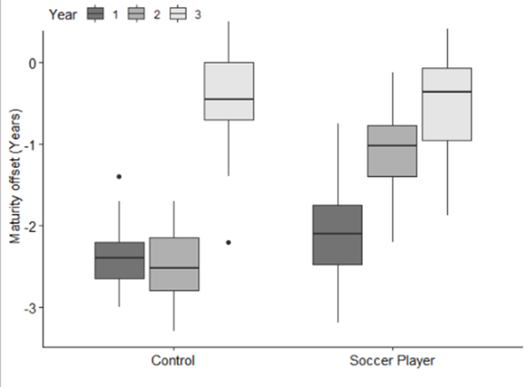

Figure 1: Changes in maturity offset across the 3-year observational study. All values are median and inter-quartile range.

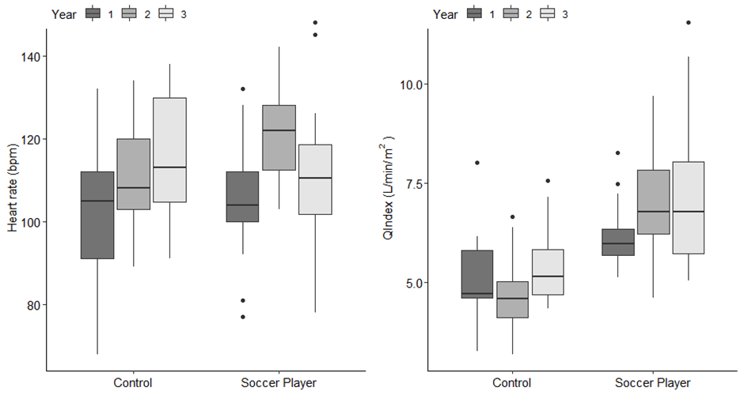
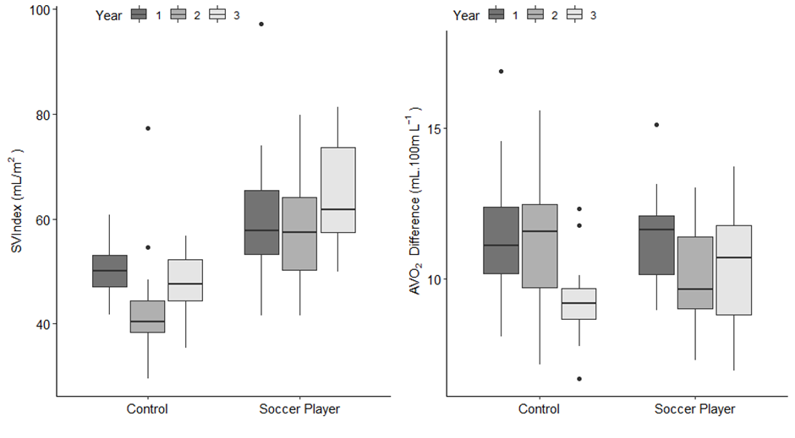
Figure 2: Changes in heart rate (HR), cardiac index (QIndex), stroke volume index (SVIndex) and arterial-venous oxygen difference (AVO₂ difference) at approximately 45%$\dot{V}O_{2peak}$ in the control participants and soccer players over the course of the 3-year observational study. All values are median and inter-quartile range.

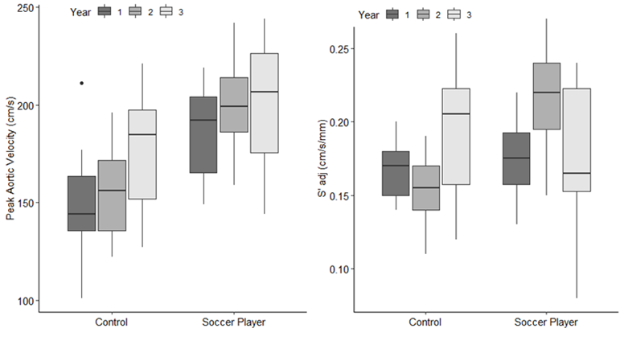
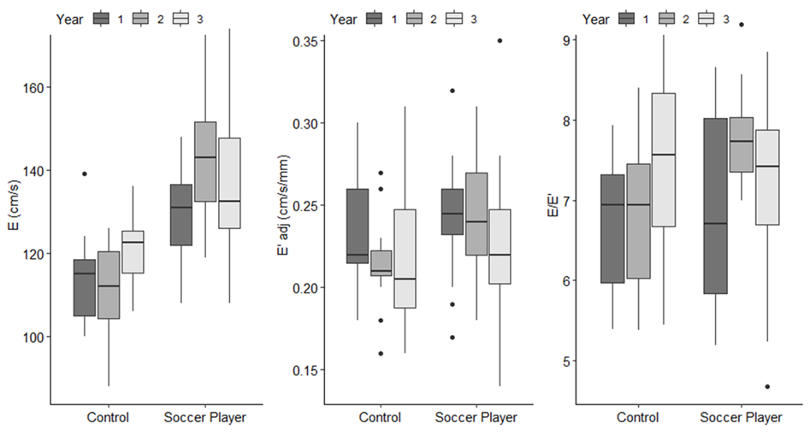
Figure 3: Changes in TDI derived markers of systolic (peak aortic velocity and S’adj) and diastolic function (E, E’adj and E/E’) during submaximal exercise at approximately 45%$\dot{V}O_{2peak}$ in the control participants and soccer players over the course of the 3-year observational study. All values are median and inter-quartile range.

Tables
Table 1: Relative Exercise Intensities for Soccer Players (SP) vs Controls (CON) across all 3 years. All values are mean ± SD.
 | YEAR 1 | YEAR 2 | YEAR 3
Relative Exercise Intensity (%$\dot{V}O_{2peak}$) | SP:46.8 ± 5.6% vs CON: 46.5 ± 7.9% | SP:43.9 ± 9.9% vs CON: 47.3 ± 7.4% | SP: 46.3 ± 8.0% vs CON: 42.3 ± 12.3%.

Table 2: Cardiovascular and Tissue-Doppler Measurements at the same relative exercise intensity within and between years across the 3 years of the study. All values are mean ± SD.
 | Soccer Players | Soccer Players | Soccer Players | Control | Control | Control
 | Year 1 | Year 2 | Year 3 | Year 1 | Year 2 | Year 3
n | 22 | 19 | 18 | 15 | 12 | 12
Heart rate (bpm) | 106 ± 14 | 122 ± 11 | 111 ± 17 | 103 ± 16 | 110 ± 13 | 115 ± 15
n | 22 | 19 | 18 | 15 | 12 | 12
QIndex (L/min/m²) | 6.13 ± 0.76 | 6.94 ± 1.31 | 7.20 ± 1.81 | 5.15 ± 1.12 | 4.67 ± 1.04 | 5.49 ± 1.06
n | 22 | 19 | 18 | 15 | 12 | 12
SVIndex (mL/m²) | 60 ± 12 | 58 ± 11 | 64 ± 10 | 50 ± 5. | 44 ± 12 | 47 ± 7
n | 22 | 19 | 16 | 15 | 12 | 12
A VO₂ Difference (mL.100mL⁻¹) | 11.3 ± 1.5 | 10.0 ±1. 7 | 10.5 ± 2.0 | 11.5 ± 2.4 | 11.7 ± 3.1 | 9.3 ± 1.5
n | 22 | 19 | 18 | 15 | 12 | 12
Peak Aortic Velocity (cm/s) | 186.7 ± 24.5 | 200.2 ± 21.2 | 200.1 ± 32.6 | 149.5 ± 25.9 | 155.7 ± 23.9 | 177.1 ± 28.8
n | 12 | 19 | 18 | 15 | 12 | 12
S’ adj (cm/s/mm) | 0.18 ± 0.03 | 0.22 ± 0.03 | 0.17 ± 0.05 | 0.17 ± 0.03 | 0.15 ± 0.02 | 0.19 ± 0.05
n | 22 | 19 | 18 | 15 | 12 | 12
E (cm/s) | 129 ± 12 | 143 ± 16 | 135 ± 18 | 113 ± 10 | 111 ± 12 | 121 ± 9
n | 22 | 19 | 18 | 15 | 12 | 12
E’ adj (cm/s/mm) | 0.25 ± 0.04 | 0.25 ± 0.04 | 0.23 ± 0.05 | 0.23 ± 0.04 | 0.22 ± 0.03 | 0.22 ± 0.05
n | 22 | 19 | 18 | 15 | 12 | 12
E/E’ | 6.9 ± 1.1 | 7.8 ± 0.6 | 7.3 ± 1.1 | 6.7 ± 0.9 | 6.8 ± 1.0 | 7.4 ± 1.2

(QIndex) Cardiac output adjusted for body surface area , (SVIndex) Stroke volume adjusted for body surface area, (AVO₂) Arterial venous oxygen difference, (E) Peak early diastolic filling velocity, Peak longitudinal mitral annular velocities in systole (S’) and early diastole (E’). Both E’ and S’ were adjusted (adj) for heart size by LV length. E/E was calculated as an estimate of LV filling pressure and thus preload.

Table 3: Influence of training at each year for the Outcome Variables. All values are Coefficient (p-value). The model is adjusted for individual maturity offset values in each year.
 | Year 1  Group (Soccer Player) | Year 2  Group (Soccer Player) | Year 3  Group (Soccer Player) | Interaction
Heart rate (bpm) | 3.0 (p=0.590) | 25 (p<0.001)* | -4.0 (p=0.460) | p<0.001*
QIndex (L/min/m²) | 0.95 (p=0.010)* | 2.67 (p<0.001)* | 1.72 (p<0.001)* | p=0.012*
SVIndex (mL/m²) | 11 (4, 17)^{Σ} |  |  | p=0.378
A-VO₂ Difference (mL.100mL⁻¹) | 0.0 (p=0.990) | -1.4 (p=0.350) | 1.1 (p=0.120) | p=0.043*
Peak Aortic Velocity (cm/s) | 34.5 (p=0.010)* | 47.4 (p<0.001)* | 24.0 (p=0.040)* | p=0.046*
S’ adj (cm/s/mm) | 0.00 (p=0.770) | 0.10 (p<0.001)* | -0.02 (p=0.270) | p<0.001*
E (cm/s) | 17 (p<0.001)* | 43 (p<0.001)* | 15 (p=0.010)* | p<0.001*
E’ adj (cm/s/mm) | 0.01 (p=0.310) | 0.08 (p<0.001)* | 0.01 (p=0.660) | p=0.008*
E/E’ | 0.1 (-0.5, 0.8) |  |  | p=0.205

(QIndex) Cardiac output adjusted for body surface area , (SVIndex) Stroke volume adjusted for body surface area, (AVO₂) Arterial venous oxygen difference, (E) Peak early diastolic filling velocity, (S’) Peak longitudinal mitral annular velocities in systole and (E’) early diastole. Both E’ and S’ were adjusted (adj) for heart size by LV length. E/E was calculated as an estimate of LV filling pressure and thus preload.
*For those with a Group (SP. CON) x Year (1, 2, 3) interaction the effect of training was estimated at each year separately. But in the absence of a significant Group x Year interaction, but a significant effect of Group (Σ) the influence of training followed the same pattern over the three years for SVIndex and the average coefficient was estimated. No Group x Year or Group effect was identified for E/E’.

Table 4 illustrates the observed mean ± SD for SP and CON from years 1-3 at approximately the same relative exercise intensity within and between each year for all strain data.
 | SP Year 1 | SP Year 2 | SP Year 3 | CON Year 1 | CON Year 2 | CON Year 3
Peak ε (%) | -19.93 ± 3.33 | -18.91 ± 3.67 | -18.05 ± 2.41 | -20.46 ± 2.50 | -18.32 ± 2.70 | -18.92 ± 3.55
SSR (1/s) | -1.44 ± 0.18 | -1.56 ± 0.45 | -1.37 ± 0.24 | -1.33 ± 0.22 | -1.35 ± 0.20 | -1.59 ± 0.06
DSR (1/s) | 2.20 ± 0.49 | 2.57 ± 0.63 | 2.01 ± 0.45 | 2.15 ± 0.40 | 2.18 ± 0.50 | 2.32 ± 0.76

(ε) Peak longitudinal strain, (SSR) strain rate during systole and (DSR) strain rate during diastole

