To cite: Hagyard, J., Brimmell, J., Edwards, E. J., & Vaughan, R. S. (2020). Inhibitory control across athletic expertise and its relationship with sport performance. Journal of Sport and Exercise Psychology. Advance Online Publication. https://doi.org/10.1123/jsep.2020-0043. Accepted 16-07-20.

Inhibitory control across athletic expertise and its relationship with sport performance
Jack D. Hagyard¹, Jack Brimmell¹, Elizabeth J. Edwards², & Robert S. Vaughan¹
York St John University, UK¹
The University of Queensland, Australia²

— 7, 451 words —

Author Note
Correspondence concerning this article should be addressed to Jack Brimmell, School of Education, Language, and Psychology, York St John University, Lord Mayors Walk, York, UK, YO31 7EX, E-mail: j.brimmell@yorksj.ac.uk
Abstract
Inhibitory control may be vital in elite sport (Vestberg et al., 2017). We examined the link between athletic expertise, inhibitory control and sport performance in a two-part study quasi-experiment. Inhibitory control was indexed using the Stop Signal Task, athlete expertise was categorised on literary recommendations, and sport performance was assessed using athlete and coach ratings. Study 1 examined cross-sectional and longitudinal patterns of inhibitory control across athletic expertise. Study 2 investigated whether the inhibitory control-sport performance relationship was moderated by expertise. Study 1 showed that expertise was linked to greater inhibitory control cross-sectionally and longitudinally. Study 2 revealed that expertise related to superior performance on the Stop Signal Task and athlete and coach performance ratings, and this relationship was moderated by athletic expertise. Inhibitory control relates to sport performance, increases with greater athlete expertise, and develops longitudinally. Long-term participation in sport may bring about changes in inhibitory control, that may lead to improved sport performance.
Key Words: Stop Signal Task; Expertise; Athlete Performance

1. Introduction
Interest in cognitive processes, referred to as executive functions, have increased recently due to their fundamental role in human performance (e.g., sport; Sakamoto, Takeuchi, Ihara, Ligao, & Suzukawa, 2018.; education, Duncan et al., 2007; & work, Bailey, 2007). Inhibitory control, a key executive function, refers to the cognitive control mechanism that regulates attention and behaviour during internal and external interference (Diamond, 2013). Inhibitory control involves a cognitive and/or motor suppression of situationally inappropriate actions and subsequent maintenance of flexible goal-directed attention within changing environments (Verbruggen & Logan, 2008). Increased inhibitory control has been associated with potential success in sport as it may facilitate adaptation to new or changing situations that often occur within complex sporting scenarios (e.g., soccer; Verburgh, Scherder, van Lange, & Oosterlaan, 2014). Research into the association between inhibitory control and athlete expertise has gained particular traction (e.g., Alves et al., 2013; Verburgh et al., 2014). However, studies have often failed to include intricate delineations of expertise (see Swann, Moran, & Piggott, 2015, for a review), nor examined how robust the effect of expertise is longitudinally. In addition, the impact of inhibitory control on sport performance remains unclear. The current two-part study aimed to address these issues.
1.1 Inhibitory control
Executive function can be defined as a multicomponent construct comprising distinct, yet interrelated, cognitive processes that regulate goal-directed behaviour (Zelazo & Carlson, 2012). Research suggests that executive function is a key component of performance (Bailey, 2007; Duncan et al., 2007; Sakamoto et al., 2018). Diamond (2013) proposes a lower-order model of executive function (inhibitory control, cognitive flexibility, & working-memory). Given the sometimes complex nature of executive functions, measuring specific components (i.e., a single low-order process) may be more suitable than measuring global constructs (i.e., complex higher order processes) as it allows for more precise change detection (Tomporowski, Davis, Miller, & Naglieri, 2008). Inhibitory control is a key lower-order executive function and is defined as the ability to withhold behaviour, thoughts, and/or emotion during distraction (Ishihara, Sugasawa, Matsuda, & Mizuno, 2018).
While inhibitory control is similar to other self-regulating processes, such as self-control, important distinctions have been noted between these concepts (Wennerhold & Friese, 2020). For example, measures of self-control capture general tendencies of multiple areas of behaviour dependent upon an individual’s available resources, whereas tasks of inhibitory control tend to assess maximum performance within specific contexts (Wennerhold & Friese, 2020). Moreover, outside of sport, Scherbaum, Frisch, Holfert, O’Hora, and Dshemuchadse (2018) support the conceptual uniqueness between self-control and processes such as inhibitory control noting significant differences at the process level. In the sport context, Pfeffer and Strobach (2017) reported no relationship between self-report self-control and inhibitory control measured by Stop Signal Task performance. Interest surrounds inhibitory control in sport because of the hypothesised role in suppressing motor action within rapidly changing environments (e.g., soccer; Verburgh et al., 2014).
Paradigms such as the Stroop colour-naming task (Stroop, 1935), the Go/No-Go task, and the Stop Signal Task (SST; Logan, Cowan, & Davis, 1984) have been used to index inhibitory control. Studies employing a Stroop task found that competitive tennis players displayed greater inhibitory control compared to non-athletes (Pacesova, Smela, Kracek, Kukurova, & Plevkova, 2018). Differences only occurred between the groups in the incongruent Stroop condition (i.e., stimulus and response differ: the word ‘red’ displayed in ‘blue’ coloured ink) where inhibitory control is predominately required. However, the Stroop task may not be a process-pure measure of inhibitory control as it also taps selective attention (MacLeod, 1991). This creates problems with generalising findings as it is unclear whether differences in performance were down to inhibitory control or another executive function (e.g., cognitive flexibility; Diamond, 2013).
The Go/No-Go task and the SST both involve a ‘go’ and a ‘stop’ process and have been inappropriately said to measure similar response inhibitory control (Verbruggen & Logan, 2008). Theories of automaticity state that these two paradigms create a different stimulus-response relationship via divergent mapping styles (i.e., consistent & varied mapping; Schneider & Shiffrin, 1977) and that each task requires different responses. In a Go/No-Go task, certain stimuli are regularly associated with a ‘go’ response and other stimuli are consistently associated with a ‘no-go’ response. Whereas in the SST, all stimuli are associated with a ‘go’ response nullifying any pre-planned/automatic processes (Verbruggen & Logan, 2008). The SST presents a ‘stop’ signal after target stimulus presentation, typically once physical movement has begun, potentially increasing applicability to sport situations (e.g., interactive, & reactive sports) that require inhibitory control based on often unpredictable opponent actions. Soccer players will often identify a pass, and then have to quickly suppress this motor action (e.g., when a teammate is closed down by an opposing player; Chen et al., 2019).
1.2 Inhibitory control and athlete expertise
Studies have typically reported greater inhibitory control in expert groups relative to amateur groups (see Jacobson & Matthaeus, 2014, for an exception). Research using the SST has found greater inhibitory control in volleyball players compared to non-athletes (Alves et al., 2013), in elite youth soccer players compared to amateur soccer players (Verburgh et al., 2014), and in expert volleyball players compared to lower-level badminton players (Meng, Yao, Chang, & Chen, 2019). Research examining inhibitory control differences in elite athletes (from fencing & taekwondo) and non-athletes found that elite athletes displayed both greater proactive (i.e., early, strategic restraint, in preparation for stopping), and reactive inhibitory control (i.e., late, correcting process resulting in an actual stop) in a modified SST (Brevers et al., 2018). Finally, Nakamoto and Mori (2012) revealed that, when faced with unexpected ball deceleration, elite baseball players made fewer incorrect responses on a baseball specific inhibitory control task.
Categorisation of athletes into precise expertise groups has advanced following the emergence of a recent theoretical framework proposed by Swann et al. (2015). Often, expert status is ascertained when an individual has achieved 10 years of sustained deliberate practice (Ericsson, Krampe, & Tesch-Romer, 1993). However, in a review of 91 athletic expertise studies Swann et al. (2015) found eight different groups were referred to as “experts”, ranging from Olympic to University athletes, based on this criteria. Swann and colleagues (2015) suggest that, despite the widespread acceptance, significant theoretical problems regarding the generalisability of conclusions drawn about “experts” may arise. Swann et al. (2015) provided a framework that allows for more intricate and precise classifications of expertise based on a single continuum, moving away from simple dichotomous groupings that are applicable across different types of athletes.
The framework draws upon previous research to allow for a more precise creation of expertise groups. Swann et al. (2015) consider the athletes highest standard of performance, success at the respective highest level, experience at the respective highest level (in years), the competitiveness of the sport in the athlete’s country, and the global competitiveness of the sport. Scores are obtained for each of these characteristics and are then utilised to create a composite score for analyses with athlete expertise being stated as either: non-athlete, amateur, novice, elite or super-elite (e.g., Vaughan & Edwards, 2020). It is possible that improved inhibitory control may facilitate high-performance, however, we argue that a robust test of the more intricate differences between levels of expertise is warranted as previous conclusions may have unintentionally drawn from inaccurate classifications. Applying the recent framework from Swann and colleagues (2015), designed to differentiate between levels of expertise, we sought to gain further understanding into how inhibitory control varies across the expertise continuum.
1.3 Physical activity and inhibitory control
Research has shown that when undertaking physical activity, mean cerebral blood flow increases within the brain (particularly the pre-frontal cortex), which may facilitate executive function performance (e.g., improved neural efficiency; Chen et al., 2019). Some studies have demonstrated that inhibitory control is susceptible to differences in physical activity level (e.g., Chan, Wong, Liu, Yu, & Yan, 2011; Huijgen et al., 2015). For example, Chan and colleagues (2011) compared inhibitory control in athletes and non-athletes and revealed that level of moderate to vigorous physical activity (MVPA) was a significant covariate in the athlete expertise and inhibitory control relationship. Huijgen et al. (2015) examined the role of MVPA on inhibitory control in elite and sub-elite youth soccer players. After controlling for MVPA, results revealed that elite soccer players demonstrated better inhibitory control than their sub-elite counterparts. Together, these works suggest that MVPA should be treated as a covariate when examining inhibitory control and sport performance due to differences across expertise groups. Often the inclusion of MVPA as a covariate is omitted from studies (e.g., Brevers et al., 2018; Meng et al., 2019) and may explain inconsistencies in inhibitory control differences.
1.4 The Present Study
Research has reported that athletes with greater expertise demonstrate greater ability to inhibit prepotent responses (i.e., better performance on tasks of inhibitory control) compared to athletes with lower expertise (i.e., elite athletes outperform non-athletes; see Voss, Kramer, Basak, Prakash, & Roberts, 2010, for a review). However, research is yet to delineate more subtle differences between expertise levels (i.e., non-athlete, amateur, novice, elite or super-elite) or examine the longitudinal robustness of this effect. That is, when examined over an extended period, are the effects of expertise comparable (i.e., maintained), or different (i.e., heightened or reduced). The aim of Study 1 was to examine whether inhibitory control differed across athletic expertise at its more subtle variants and whether this effect was consistent or varied over a longitudinal period. The role of expertise in the relationship between inhibitory control and sport performance also remains uncertain, with little empirical evidence available. Study 2 aimed to examine the role of expertise in the relationship between inhibitory control and sport performance, that is, does expertise moderate the relationship between inhibitory control and sport performance over time. Both studies controlled for MVPA.
2. Study 1
We investigated whether inhibitory control (assessed via the SST) differed across athletic expertise (i.e., non-athletes, novice, amateur, elite, and super-elite) based on the recommendations of Swann et al. (2015; i.e., highest performance level, success and experience at performance level, and the competitiveness of the sport within their country and globally) using a cross-sectional design. Previous research has suggested that long-term participation in sport increases executive function performance (Ishihara & Mizuno, 2018). However, this has yet to be replicated. The present study also addressed the long-term robustness and generalisability of inhibitory control in athletes, examining SST performance longitudinally over a 16-week period. The 16-week period was selected based on previous findings that showed cognitive improvement following an exercise-based intervention of the same length (Ardoy et al., 2014). Results from Ardoy et al. (2014) suggest that consistent engagement in sport over this period improved cognitive performance. We hypothesised that after controlling for MVPA, athletes with higher athletic expertise would demonstrate greater inhibitory control (i.e., shorter Stop Signal Reaction Times, more Successful Stops, & fewer Errors), and that SST performance would improve across all participants from Time 1 to Time 2. Specifically, we predicted minor performance improvements across all participants due to potential practice effects. We expected larger improvements at each incremental stage of expertise due to engagement in more cognitively demanding situations (e.g., training with/against opponents with greater ability).
2.1 Method
2.1.1 Participants
At Time 1, 106 participants were recruited (M_{age} = 21.32 ± SD_{age} = 5.77; 53% female) with a range of athletic expertise; non- (n = 37), novice (n = 14), amateur (n = 15), elite (n = 30), and super-elite (n = 10) athletes (Swann et al., 2015¹). Participants were from externally-paced (i.e., those engaging in sports that require adaptability and rapid processing for example, soccer; n = 26) and self-paced (i.e., those engaging in sports that afford time to prepare for action before initiating a response for example, golf; n = 43) sports (see Singer, 2000). At time 2, 64 participants volunteered (M_{age} = 21.19 ± SD_{age} = 5.12; 44% female) and comprised a variety of expertise levels (i.e., non-athlete: n = 14, novice: n = 11, amateur: n = 9, elite: n = 23, & super-elite: n = 7). Again, participants comprised both externally-paced (n = 20) and self-paced (n = 30) sports (Singer, 2000). Attrition from Time 1 to Time 2 was 39.62%. Participants were recruited via sport coaches’ and tutors in the University’s psychology and sport departments. The study was approved by a university ethics committee and informed consent was received prior to participation. A G*Power sample size calculation suggested a sample size of 105 (.15, 1 – β = .80, α = .05; Faul, Erdfelder, Lang, & Buchner, 2007) for ANCOVA modelling.
2.1.2 Materials
Demographic Questionnaire. Participants provided age, sex, and sport participation activity (e.g. time spent playing sport, sport played, highest competition level, & highest achievement level), for descriptive and grouping purposes.
International Physical Activity Questionnaire (IPAQ; Booth, 2000). The 7-item short form of the IPAQ was used to measure physical activity (i.e., MVPA) over the last seven days. Items focus on different intensities of physical activity (e.g., vigorous, moderate, & walking), and indicators of sedentary behaviour (e.g., sitting). Items are orientated around frequency (e.g., During the last 7 days, on how many days did you do vigorous physical activities like heavy lifting, digging, aerobics, or fast bicycling?), and duration (e.g., How much time (in hours) did you usually spend doing the vigorous physical activity on one of those days). The IPAQ short form has demonstrated equivalent reliability and validity to the longer format questionnaire (Booth, 2000; Craig et al., 2003).
Stop Signal Task (SST; Logan et al., 1984). The SST from the Cambridge Automated Neuropsychological Test Battery (CANTAB; Cambridge Cognition Ltd.) was used to index inhibitory control following recommendations from Verbruggen et al. (2019). The SST measures reactive response inhibition in which participants must withhold an action based on the presentation of a ‘stop’ signal. Participants use a two-button press pad to record responses to an on-screen arrow stimulus pointing either left or right. If an auditory tone was presented following the visual stimulus (25% of trials), the participant had to inhibit their response. The task comprised 16 introductory trials and five blocks of 64 trials that followed similar protocol, but included an auditory tone on certain trials. The task followed a staircase design which adapted to participant performance and aimed for a 50% success rate. Outcome measures included Stop Signal Reaction Time (i.e., SSRT; time the participant takes to successfully inhibit their response based on the integration method² recommended by Verbruggen, Chambers, & Logan, 2013), Successful Stops (i.e., the percentage of trials in which the participant successfully inhibited their response), and Errors (i.e., the percentage of trials in which the participant responded incorrectly to the ‘go’ or ‘stop’ stimuli).
2.1.3 Procedure
Participants were tested individually in sound-attenuated laboratories in the university’s psychology or sport departments. Testing sessions lasted approximately 30 minutes. Participants completed the demographic questionnaire and IPAQ followed by an initial motion-screening task to ensure there were no visual acuity difficulties with using the CANTAB (results showed no acuity issues). Next, participants completed the SST. Testing was completed on a GIGABYTE 7260HMW BN touchscreen computer running a Pro Windows 8 operating system with a high resolution 12-inch display. Finally, on completion of testing, participants were debriefed, and thanked for participating. At time 2, participants who returned for the 16-week follow-up session completed the same procedure.
2.1.4 Design and analyses
A quasi-experimental design with a 16-week longitudinal follow-up was used (Ardoy et al., 2014). Preliminary analyses were conducted to screen for outliers and missing data. A one-way between subjects MANOVA was used to assess differences in MVPA across athlete expertise. Scores for vigorous, moderate, and walking activity were entered as dependent variables and athletic expertise as the independent variable. The cross-sectional differences in inhibitory control across athlete expertise were assessed through separate ANCOVA models. Stop Signal Reaction Time, Successful Stops, and Errors were used as dependent variables, athlete expertise (super-elite, elite, amateur, novice, & non-athlete; Swann et al., 2015) was entered as the independent variable, and MVPA as a covariate.
Following recommendations of Ishihara and Mizuno (2018), we tested the longitudinal effects with regression-based modelling. As data were collected at two time points, we assessed inter-class correlations as a measure of test-retest reliability (Tabachnick & Fidell, 2007). All variables indicated acceptable to good levels of reliability (e.g. α = .78-.89). Linear mixed models allow for observations on the dependent variable to have non-zero covariance and examination of residual changes over time. Three linear mixed models (controlling for MVPA) examining changes in efficiency (indexed via SSRT) and effectiveness (indexed via Successful Stops & Errors) across athletic expertise were constructed (cf. West, 2009). There were two sources of variation within the study: over time, and between athletes. Thus, an unconditional model with no fixed effects provided an estimate of variance at both levels. Subsequent fixed models with changes in inhibitory control between Time 1 and Time 2 were added as predictor variables. The restricted maximum likelihood estimation method was used to provide unbiased estimates of the variance (West, 2009).
2.2 Results
2.2.1 Descriptive statistics and preliminary analyses
Measures of central tendency were tabulated for SSRT, Successful Stops, and Errors across athlete expertise at both time points (see Table 1). Data were screened for multivariate outliers via Mahalanobis distance which revealed no outliers larger than the critical value (χ²(10) = 5.97, p < .01; Tabachnick & Fidell, 2007). Box’s M was non-significant (p > .05) therefore subsequent analyses were collapsed across gender. Age was not significantly correlated with the inhibitory control outcome measures therefore it was not added as a covariate in subsequent analyses (p > .05). MANOVA modelling indicated a significant multivariate difference between athlete expertise levels on MVPA (Wilks’ λ = .63, F (12, 256.93) = 4.15, p = .001; ηρ² = .15). There was a significant group difference on the measure of vigorous (F (4, 99) = 4.90, p = .001, ηρ² = .17); moderate (F (4,99) = 4.59, p = .001, ηρ² = .16); and walking activity (F (4, 99) = 3.37, p = .005, ηρ² = .12). Results indicated that higher levels of athletic expertise scored significantly higher on all measures of MVPA, supporting the treatment of MVPA as a covariate in subsequent analyses.
Table 1 here
2.2.2 ANCOVA
Differences in inhibitory control were analysed across athlete expertise entering MVPA as a covariate. Results indicated a significant variation in SSRT (F (4,98) = 3.11, p = .006, ηρ² = .13), Successful Stops (F (4,98) = 3.84, p = .003, ηρ² = .14), and Errors (F (4,98) = 4.97, p = .002, ηρ² = .15) by athlete expertise (see Table 2). Post-hoc analyses indicated those of higher expertise outperformed their lower expertise counterparts. That is, at each incremental increase in expertise, those with more expertise demonstrated enhanced inhibitory control via lower SSRT, a greater percentage of trials in which they successfully inhibited the dominant response, and committed less Errors across trials, compared to those with less expertise (i.e., performance on the SST improved with each subsequent increase in athletic expertise).
Table 2 here
2.2.3 Linear Mixed Models
We constructed regression models at Time 1 and Time 2 to examine linearity between athletic expertise and inhibitory control. At Time 1 athletic expertise predicted 7% of the SSRT variance (R² = .068; F(1, 104) = 2.57, p = .028), 11% of the Successful Stops variance (R² = .096; F(1, 104) = 3.64, p = .019), and 9% of the Errors variance (R2 = .085; F(1, 104) = 3.14, p = .023). At Time 2 athletic expertise predicted 10% of the SSRT variance (R² = .098; F(1, 62) = 5.29, p = .014), 15% of the Successful Stops variance (R2 = .146; F(1, 62) = 7.76, p = .006), and 12% of the Errors variance (R² = .124; F(1, 62) = 6.43, p = .011). As athletic expertise predicts inhibitory control we proceeded to our main analyses.
An initial unconstrained model over Time 1 and Time 2 revealed significant individual variance in slopes and intercepts of inhibitory control (p < .01), indicating that participants varied in their performance at Time 1. Next, three main effect models assessing changes in inhibitory control over the 16-week period across athletic expertise and controlling for MVPA were tested. Residual changes in the variance were significant for SSRT (β = 2.02, SE = .03 [95% CI 1.16 – 3.02]), with a mean change of -54.66 from Time 1 to Time 2, Successful Stops (β = .10, SE = .01 [95% CI .07 - .15]), with a mean change of .06 from Time 1 to Time 2, and Errors (β = 1.08, SE = .02 [95% CI .66 - 1.82]) with a mean change of -5.47 from Time 1 to Time 2 (see Table 3). In general, growth trajectories were significantly different across expertise (p < .01), and typically larger in individuals with higher expertise (e.g. elite & super-elite). Participants competing at a higher level observed greater increases in their inhibitory control from Time 1 to Time 2, independent of MVPA levels.
Table 3 here
2.3 Study 1 - Discussion
As predicted, athletes with higher expertise outscored athletes with lower expertise on measures inhibitory control (i.e., SSRT, Successful Stops, & Errors). This finding is comparable with previous research (e.g., Liao, Meng, & Chen, 2017; Verburgh et al., 2014), suggesting the ability to control prepotent responses may be essential for sporting success. Interpretations, however, remain cautious as studies have reported no association between athletic expertise and inhibitory control (e.g. Jacobson & Matthaeus, 2014). Inconsistencies may be due to differences in categorisation of expert groups (e.g. super-elite, elite, amateur, etc.) and variations within analyses (i.e., we controlled for a key confounding variable in MVPA). Moreover, athletic expertise predicted SSRT, Successful Stops, and Errors on the SST indicating that better inhibitory control may be associated with higher athletic expertise and the two may interact to predict performance.
It is interesting to note that as SSRT (a key measure of inhibitory control efficiency; Verbruggen et al., 2013) decreased, effectiveness (evidenced by more Successful Stops and less Errors) increased significantly across expertise. Athletes with greater expertise demonstrate greater covert latency of the stop process without impeding effectiveness. This flexible behaviour is particularly relevant for sport performance. The SSRT estimates an independent race model between the ‘go’ and ‘stop’ process triggered by ‘stop’ signal presentation. Thus, withholding the dominant response (i.e., successful inhibitory control) is dependent on the ‘stop’ process finishing before the go process which is transferable to the behavioural flexibility required for elite level sport (Jacobson & Matthaeus, 2014; Krenn, Finkenzeller, Würth, & Amesberger, 2018). As anticipated, all levels of expertise improved in efficiency and effectiveness longitudinally. The present results concur with studies that found longitudinal improvements in executive function in sport (e.g. Ishihara & Mizuno, 2018; Vestberg, Gustafson, Maurex, Ingvar, & Petrovic, 2012). While there is limited work tracking the development of inhibitory control in athlete populations, the present findings concur with studies investigating the impact of sports participation on inhibitory control in clinical and community samples (e.g., Ji et al., 2017).
2.3.1 Inhibitory control and sport performance
The present results add to the large proportion of literature concluding that expert athletes outperform amateur or non-athletes on measures of inhibitory control (Brevers et al., 2018; Nakamoto & Mori, 2012; Verburgh et al., 2014). However, such research typically excludes measures of sport performance (see Vestberg, Reinebo, Maurex, Ingvar, & Petrovic, 2017, for an exception). Additionally, while research attests to cognitive skills transfer of athletic training on human beings (Krenn et al., 2018), the downstream applications of neurocognitive testing in elite athletes lacks empirical investigation (Jacobson & Matthaeus, 2014). Given that athletic expertise is a predictor of sport performance, and of inhibitory control, it is difficult to determine whether the influence of inhibitory control on sport performance, is in fact driven by athletic expertise. In order to provide a robust test of the relationship between athlete expertise and inhibitory control, we propose that inclusion of an appropriate index of sport performance is warranted.
3. Study 2
To assess the stability of our findings we replicated the cross-sectional component from Study 1 and extended our methodology by including a measure of sport performance. In line with Study 1, after controlling for MVPA, we predicted that higher inhibitory control would correspond to higher sport performance ratings. That is, SST scores at the start of the season would be positively related to athlete self-report and coaches’ ratings at the end of the season. Additionally, we retained athlete expertise as a moderator predicting that larger effects would be found for those with more expertise. As Study 2 focuses on sport performance there were no non-athlete controls.
3.1 Method
3.1.1 Participants
Ninety-one athletes (M_{age} = 20.10 ± SD_{age} = 1.08; 32% female) with a mean playing experience of 10.35 years, participated. In accord with Study 1, classification of athletes followed Swann et al.’s (2015) recommendations (i.e., novice: n = 29, amateur: n = 28, elite: n = 19 and super-elite: n = 15). All athletes participated in externally-paced sports such as soccer, rugby and basketball (Singer, 2000). The study was approved by the university’s research ethics committee and volunteers provided written informed consent prior to participation. In order to determine moderation effects with bias-corrected bootstrapping, Fritz and MacKinnon (2007) recommend a minimum sample of 89 for medium indirect effects.
3.1.2 Materials
Demographic Questionnaire. As per Study 1.
International Physical Activity Questionnaire. As per Study 1.
Stop Signal Task. As per Study 1.
Sport Performance. The self-report performance rating scale (Verner-Filion & Vallerand, 2016), was used as a measure of sport performance. Athletes’ responded using a 7-point Likert scale ranging from 1 (do not agree at all) to 7 (completely agree) on 5 items (e.g., I meet the demands of performance expected out of me, as an athlete). The scale has shown excellent psychometrics (e.g. internal consistency α = .83; Bouizegarene et al., 2018), supported in the present data (α = .79). We also used a coaches’ rating scale to measure sport performance (Vallerand et al., 2008). Coaches rated players in the context of the playing season on a scale ranging from 0 (very poor performance) to 100 (outstanding performance), with a score of ≥ 60 deemed indicative of “passable” performance. With this scale in mind, coaches were told to rate each players’ performance, since the beginning of the season. The scale is considered a valid estimator of sport performance congruent with other performance related variables (e.g. deliberate practice; Verner-Filion, Vallerand, Amiot, & Mocanu, 2017). The correlation between the athlete and coach rating of sport performance was significant (p < .01; see Table 4), supporting the scales convergent validity.
3.1.3 Procedure
Similar procedures to Study 1 were used. Following Vestberg et al. (2012; 2017), the SST was completed at the start of the playing season. Athlete- and coach-ratings of sports performance were completed at the end of the playing season, representing a 6-month follow up.
3.1.4 Data analyses
A quasi-experimental design with a 6-month performance follow-up was used. Data were screened for outliers, missing data, and checked for normality to ensure all variables met the assumptions of parametric statistical analysis (e.g. skewness & kurtosis). Descriptive statistics were extracted for all variables. Within-subjects ANCOVA models were constructed to replicate Study 1, such that SSRT, Successful Stops, and Errors were the dependent variables, athlete expertise was the independent variable, and MVPA was a covariate.
Moderated regression models were constructed to examine the unique and combined relationship between inhibitory control, athletic expertise, and sport performance, with MVPA treated as a covariate. To test for moderation, hierarchical regression analyses of the total and higher order unconditional interaction with 5000 bootstrap resamples were examined using the PROCESS macro for SPSS (Hayes, 2012). If the bias-corrected bootstrap 95% confidence intervals (CI) does not contain zero, the test can be considered significant at the p < .05 level (Preacher & Hayes, 2008). Simple slope analyses were used to present the interaction between inhibitory control and athletic expertise on sport performance. The unique variability accounted for by the independent and mediator variables in the dependent variable produces an unstandardized regression coefficient with associated p value. As significant interactions are typically small, we focused on the direction and practical relevance of significant moderation as opposed to the size of effect, in line with previous recommendations (Dawson, 2014).
3.2 Results
3.2.1 Descriptive statistics and preliminary analyses
A small number of cases (<1%) contained missing data which were replaced with the item mean (ipsatised item replacement; Tabachnick & Fidell, 2007). Univariate skewness and kurtosis fell within normal ranges meeting the assumptions of parametric analysis (+/-2; Tabachnick & Fidell, 2007). Additionally, no Mahalanobis distance values were greater than the critical value of χ² (10) = 12.33, p < .001, therefore all cases were retained (Tabachnick & Fidell, 2007). Box’s M was non-significant (p > .05) thus subsequent analyses were collapsed across gender (Tabachnick & Fidell, 2007). Descriptive statistics and bivariate correlations indicated a positive relationship between Successful Stops and sport performance and a negative relationship between SSRT with sport performance (see Table 4). ANCOVA indicated significant differences on SSRT, Successful Stops, and Errors with a range of small to medium effects across athletic expertise. Like Study 1, post-hoc analyses indicated those of higher expertise (i.e. elite & super-elite) outperformed those with less expertise independent of MVPA (see Table 2).
Table 4 here
3.2.2 Moderation
We constructed regression models to examine the relationship between the moderator (i.e., athletic expertise) and predictor (i.e., inhibitory control) before interactions were assessed. Athletic expertise predicted 12% of the SSRT variance (R² = .122; F(1, 89) = 6.08, p = .009), 16% of the Successful Stops variance (R² = .163; F(1, 89) = 8.92, p = .004), and 15% of the Errors variance (R² = .148; F(1, 89) = 7.25, p = .006). Moderation models were constructed separately to test the moderating role of expertise on the inhibitory control (SSRT, Successful Stops, & Errors) and sport performance (self-report & coaches’ ratings) relationship. Results indicated that the interaction in all analyses predicted additional variance in both self-report and coaches’ ratings of sport performance with MVPA non-significant as a covariate (see Table 5).
Table 5 here

The SSRT x athletic expertise interaction indicated that those with lower SSRT and higher expertise scored highest on Athlete Self Report Performance (b = .14, t = 2.58, p = .021; See Figure 1).
Figure 1 Here
The Successful Stops x athletic expertise interaction indicated that those with more Successful Stops and athletic expertise scored highest on Athlete Self Report Performance (b = .20, t = 5.08, p = .003; See Figure 2).
Figure 2 Here
The Errors x athletic expertise interaction indicated that those with less errors and more athletic expertise scored highest on Athlete Self Report Performance (b = .17, t = 3.59, p = .009; See Figure 3).
Figure 3 Here
The SSRT x athletic expertise interaction indicated that those with lower SSRT and higher expertise scored highest on Coach Rated Athlete Performance (b = .15, t = 2.81, p = .016; See Figure 4).
Figure 4 Here
The Successful Stops x athletic expertise interaction indicated that those with more Successful Stops and athletic expertise scored highest on Coach Rated Athlete Performance (b = .23, t = 4.87, p = .006; See Figure 5).
Figure 5 Here
The Errors x athletic expertise interaction indicated that those with less errors and more athletic expertise scored highest on Coach Rated Athlete Performance (b = .19, t = 3.92, p = .007; See Figure 6).
Figure 6 Here
Consistent with Dawson’s (2014) recommendations, the independent-mediator variable interactions accounted for small amounts of unique variance (2.44-6.87%). Despite these small effect sizes, findings suggest that the combination of inhibitory control and athletic expertise added to the positive prediction of self-report and coaches’ ratings of sport performance in externally-paced athletes.
3.3 Study 2 - Discussion
Study 2 replicated and extended Study 1. For example, athletic expertise predicted inhibitory control performance. The findings of Study 2 showed that athletes from externally-paced sports with higher expertise demonstrated greater inhibitory control, independent of MVPA. The results of Study 2 align with previous research that the ability to control prepotent responses may be associated with sporting success (Study 1; Liao et al., 2017; Verburgh et al., 2014). Furthermore, the similar pattern of results between Study 1 and Study 2 provides evidence of methodological rigor. Although the relationship between inhibitory control and sport performance had previously been proposed, it had not been empirically tested, nor in the context of athletic expertise across a 6-month playing season (Ishihara et al., 2018).
Study 2 took a novel approach and demonstrated that inhibitory control was positively associated with self-report and coaches’ ratings of sport performance in externally-paced athletes. This suggests that inhibitory control may be important for successful performance in athletes who engage in cognitively complex sporting situations (e.g., soccer). This relationship was moderated by athlete expertise, independent of MVPA. Specifically, not only was there a positive association between sports performance and inhibitory control but that this effect is more prominent in athletes with more expertise. Our data showed that externally-paced athletes with greater sports performance (on both athlete’s self-report and coaches’ ratings), and higher levels of expertise performed with greater efficiency and effectiveness on the SST (i.e., shorter SSRTs, more Successful Stops, and fewer Errors) than those with less expertise.
One possible explanation for these findings might relate to individual differences relevant to participation in elite level sport. For example, anxiety has been noted to disrupt executive functions such as inhibitory control (Eysenck, Derakshan, Santos, & Calvo, 2007). Attentional Control Theory suggests that highly anxious individuals’ function less efficiently and therefore deplete available attentional resources. It is possible that competitive sports participation might not only enhance the development of athletic expertise but may eventually reduce the debilitating effect of anxiety (e.g., using compensatory strategies to maintain performance despite reduced attentional resources). Although beyond the scope of the current work, future research could explore the precise strategies and/or additional resources that could characterise this relationship, and furthermore, whether such strategies could be specifically learned or trained in conjunction with sport-specific skills.
4. General Discussion
Whether athletes with greater expertise perform better on measures of inhibitory control in comparison to athletes with less expertise is of interest to researchers and sports practitioners alike. However, the characteristics underpinning this link has received little attention. Study 1 examined the cross-sectional differences in inhibitory control across athletic expertise levels (see Swann et al., 2015), after controlling for MVPA. Using ANCOVA modelling we found inhibitory control (indexed by SST performance) improved incrementally with expertise. Study 1 also assessed the longitudinal robustness of this relationship, via the incorporation of a 16-week follow-up, and showed that SST performance improved in all participants, with larger growth trajectories in those with more athletic expertise. Study 2 aimed to consolidate and expand upon Study 1, examining whether inhibitory control influenced sport performance in externally-paced athletes and found greater inhibitory control was associated with higher self-report and coach ratings of performance. Specifically, Study 2 investigated the moderating role of athlete expertise in the inhibitory control and sport performance relationship. Athlete expertise was found to moderate the relationship between inhibitory control and sport performance, such that greater inhibitory control (greater efficiency and effectiveness on the SST) and greater athlete expertise predicted greater sports performance.
Consistent across Study 1 and 2, and in line with other studies (e.g., Alves et al., 2013; Brevers et al., 2018; Verburgh et al., 2014), athletes outperformed their non-athlete counterparts on the SST. More specifically, the present work consistently found that performance on a measure of inhibitory control improved incrementally with level of expertise. For example, super-elite athletes outperformed all other performance levels (i.e., elite, amateur, novice, & non-athletes), while elite athletes outperformed the amateur, novice, and non-athletes. These findings suggest that, while an athlete-non-athlete dichotomy allows examination of inhibitory control differences, these differences are more elaborate and sensitive to performance levels than previous research has noted.
Inhibitory control efficiency (SSRT) and effectiveness (more Successful Stops and less Errors) improved incrementally with each subsequent increase in athletic expertise illustrating the cognitive superiority of elite athletes and the impact of athletic training on inhibitory control. That is, the method for categorising expert groups used in the present work may provide further understanding of the role of expertise on inhibitory control. The relationship between athlete expertise and MVPA was also consistent across Study 1 and 2, supporting the premise to include MVPA as a covariate (Chan et al., 2011; Huijgen et al., 2015). By controlling for MVPA it is possible to say with more certainty that differences in inhibitory control are a result of expertise, as opposed to increased physical activity time.
As expected in Study 1, all participants showed improved SST performance from Time 1 to Time 2. It could be argued that improvements were due to practice effects, as practice effects have been found to occur between first and second performance on cognitive batteries (Falleti, Maruff, Collie, & Darby, 2006). However, given that growth trajectories increased in size based on expertise at each incremental stage (i.e., super-elite athletes exhibited greater improvement than other expertise groups), it is unlikely that improvements were driven by practice effects alone. Previous work noted greater improvements in working-memory among those in a high-dose training intervention group compared to a low-dose training intervention group (Ishihara & Mizuno, 2018). While this suggests increased participation in sport may facilitate working-memory, the same results were not found for inhibitory control (i.e., increased dosage of exercise did not facilitate inhibitory control). Albeit hypothetical, we propose that inhibitory control does not necessarily improve vastly due to increased exercise time (Ishihara & Mizuno, 2018), but via engagement in regular practice and competition with individuals greater in expertise, evidenced by larger growth trajectories in athletes with more expertise.
4.1 Future research and implications
Our moderation analyses in Study 2 found that inhibitory control was positively associated with athlete self-report and coaches’ rating of sport performance (within externally-paced athletes) and that this effect was enhanced by expertise. These results agree with the limited studies suggesting an association between inhibitory control and sport performance (e.g., Ishihara et al., 2018; Vestberg et al., 2017) and shed new light on the moderating role of athletic expertise in this relationship. However, it is possible that these effects are characterised by some other variable(s). For example, Park and colleagues (2020) suggest that inhibitory control is related to a propensity for reinvestment (i.e., ability to consciously process movement). Park et al. (2020) revealed that individuals with high propensity for reinvestment demonstrated faster RTs on a Go/No-Go task (i.e., inhibitory control), yet there were no differences in accuracy. Other research has shown that working-memory capacity (e.g., Krenn et al., 2018) and mental toughness (Gucciardi, Hanton, Gordon, Mallett, & Temby, 2015) are related to both sport performance and inhibitory control. Possible lines of research might focus on these variables as potential moderators, in addition to exploring these effects with internally-paced athletes.
These findings may support the utility of inhibitory control training and the possible benefits for athletes in the long-term. Indeed, evidence posits that inhibitory control training may improve an individual’s ability to combat impulsive reactions to better regulate behaviour (Ducrocq, Wilson, Vine, & Derakshan, 2016). This may be particularly useful for athletes in-situ game performance and related behaviours (e.g., training). However, research to-date has been limited to the effects of short-term inhibitory control training (Ducrocq et al., 2016). The current findings suggest that investigation into the long-term effects of inhibitory control training is warranted.
4.2 Limitations
While novel, the present study is not without limitations. First, self-report measures of sport performance may be susceptible to desirability bias. While coach ratings strengthened this measure, the scale may still contain room for variability in performance ratings. Future research could capture an objective metric of sport performance (e.g., goals and assists; Vestberg et al., 2012). Similarly, whilst the IPAQ is the most robust and widely used measure of MVPA (Nigg et al., 2020), an objective measure of MVPA (e.g., fitness tracker) may increase robustness of effects. Second, only the SST was used to assess inhibitory control. Given that research has shown different measures of inhibitory control may require different response behaviours (i.e., the Go/No-Go paradigm may differ from the Stop Signal paradigm) it may be useful to examine multiple measures of inhibitory control and examine task-specific relations (Verbruggen & Logan, 2008). Future research should use multiple measures of inhibitory control and examine consistency across these tasks.
Third, the longitudinal design cannot determine directional causality or rule out training effects. That is, whether athlete expertise influences inhibitory control and sport performance or vice versa. Also, while our design was longitudinal, inhibitory control captured at snapshot intervals allows for the possibility that differences may have occurred due to practice effects. The use of a different measure of inhibitory control at Time 2 compared to Time 1 would alleviate the potential problem. Alternatively, including waves of data collection (i.e., numerous measures of inhibitory control, captured using multiple inhibition tasks, across a playing season) would enable researchers to observe continual changes in inhibitory control and model this effect on sport performance with greater control. We believe that the current findings provide foundation for future work to replicate and extend considering these limitations. Finally, whilst overall attrition was acceptable (Gustavson, von Soest, Karevold & Røysamb, 2012), lower numbers of non-athletes returned compared to athletes (novice – super-elite). No research to date has examined the predictors of attrition in longitudinal designs with athletes, thus future work could examine selective attrition in participants with varying athletic expertise.
4.3. Conclusion
Together, the present research is the first to delineate the significant variance of inhibitory control across athlete expertise levels (i.e., at each incremental increase in expertise, inhibitory control also increases). Our longitudinal findings suggest that the impact of expertise on inhibitory control is robust over time. Finally, our moderation analyses provide preliminary support suggesting inhibitory control influences sport performance in externally-paced athletes, and this influence gets stronger as expertise level increases. It is possible that the superior inhibitory control observed in athletes with more expertise is a result of their long-term training and cognitively demanding competition.

Note
¹Athletic expertise is computed across five equally weighted elements within the equation: [(A+B+C/2)/3] x [(D+E)/2]. All elements are scored between 1-4. Where A is the athlete’s highest standard of performance ranging from “university level” (1) – “international level” (4), B is success at the athlete’s highest level ranging from “success in university level competition” (1) – “sustained success at international level” (4), C is experience at the athlete’s highest level ranging from “1 – 2 years’ experience” (1) – “8 plus years’ experience” (4), D is competitiveness of sport in athlete’s country ranging from “sport ranks outside top 10 played for that country” (1) – “national sport of a large sporting country” (4), and E is global competitiveness of sport ranging from “not Olympic or world event and limited to a few countries” (1) – “regular Olympic or World event recognised globally” (4). Samples are coded as novice (score of 1-4), amateur (score of 5-8), elite (score of 9-12) or super-elite (score of 13-16). Those who failed to score on Swann et al.’s (2015) criteria were non-athletes (a score of 0) in line with previous work (Vaughan & Edwards, 2020).

²In the integration method, the point at which the ‘stop’ process finishes is estimated by integrating the reaction time distribution and finding the point at which the integral equals the probability of responding for a specific delay. More simply, the number of successful responses to ‘go’ trials (trials with no ‘stop’-signal presentation), multiplied by the probability of responding to the ‘go’ stimulus (represented by a value between 0-1). The integration method is then used to estimate SSRT by subtracting Stop Signal Delay (i.e., the variable interval between the presentation of the ‘go’ stimuli and the auditory ‘stop’ signal) from this newly obtained value.

Acknowledgments
No conflict of interests are present for any aspect of the current work.
References
Alves, H., Voss, M., Boot, W. R., Deslandes, A., Cossich, V., Inacio Salles, J., & Kramer, A. F. (2013). Perceptual-cognitive expertise in elite volleyball players. Frontiers in Psychology, 4, 36.
Ardoy, D. N., Fernandez-Rodriguez, J. M., Jimenez-Pavon, D., Castillo, R., Ruiz, J. R., & Ortega, F. B. (2014). A physical education trial improves adolescents’ cognitive performance and academic achievement: The EDUFIT study. Scandinavian Journal of Medicine & Science in Sports, 24(1), 52-61.
Bailey, C. E. (2007). Cognitive accuracy and intelligent executive function in the brain and in business. Annals of the New York Academy of Sciences, 1118(1), 122-141.
Booth, M. (2000). Assessment of physical activity: an international perspective. Research Quarterly for Exercise and Sport, 71, 114-120.
Bouizegarene, N., Bourdeau, S., Leduc, C., Gousse-Lessard, A. S., Houlfort, N., & Vallerand, R. J. (2018). We are our passions: The role of identity processes in harmonious and obsessive passion and links to optimal functioning in society. Self and Identity, 17, 56–74.
Brevers, D., Dubuisson, E., Dejonghe, F., Dutrieux, J., Petieau, M., Cheron, G., ... & Foucart, J. (2018). Proactive and Reactive Motor Inhibition in Top Athletes Versus Nonathletes. Perceptual and Motor Skills, 125(2), 289-312.
Chan, J. S. Y., Wong, A. C. N., Liu, Y., Yu, J., & Yan, J. H. (2011). Fencing expertise and physical fitness enhance action inhibition. Psychology of Sport and Exercise, 12(5), 509-514.
Chen, J., Li, Y., Zhang, G., Jin, X., Lu, Y., & Zhou, C. (2019). Enhanced inhibitory control during re-engagement processing in badminton athletes: An event-related potential study. Journal of Sport and Health Science, 8(6), 585-594.
Craig, C. L., Marshall, A. L., Sjostrom, M., Bauman, A. E., Booth, M. L., Ainsworth, B. E., … & Oja, P. (2003). International physical activity questionnaire: 12-country reliability and validity. Medicine and Science in Sports & Exercise, 35(8), 1381–1395.
Dawson, J. F. (2014). Moderation in management research: What, why, when, and how. Journal of Business and Psychology, 29, 1-19.
Diamond, A. (2013). Executive functions. Annual Review of Psychology, 64, 135-168.
Ducrocq, E., Wilson, M., Vine, S., & Derakshan, N. (2016). Training attentional control improves cognitive and motor task performance. Journal of Sport and Exercise Psychology, 38(5), 521-533.
Duncan, G. J., Dowsett, C. J., Claessens, A., Magnuson, K., Huston, A. C., Klebanov, P., ... & Sexton, H. (2007). School readiness and later achievement. Developmental Psychology, 43(6), 1428.
Ericsson, K. A., Krampe, R. T., & Tesch-Romer, C. (1993). The role of deliberate practice in the acquisition of expert performance. Psychological Review, 100(3), 363.
Eysenck, M. W., Derakshan, N., Santos, R., & Calvo, M. G. (2007). Anxiety and cognitive performance: attentional control theory. Emotion, 7(2), 336.
Falleti, M. G., Maruff, P., Collie, A., & Darby, D. G. (2006). Practice effects associated with the repeated assessment of cognitive function using the CogState battery at 10-minute, one week and one month test-retest intervals. Journal of Clinical and Experimental Neuropsychology, 28(7), 1095-1112.
Faul, F., Erdfelder, E., Lang, A. G., & Buchner, A. (2007). G*Power 3: A flexible statistical power analysis program for the social, behavioral, and biomedical sciences. Behavior Research Methods, 39, 175-191.
Fritz, M. S., & MacKinnon, D. P. (2007). Required sample size to detect the mediated effect. Psychological Science, 18(3), 233-239.
Gucciardi, D. F., Hanton, S., Gordon, S., Mallett, C. J., & Temby, P. (2015). The concept of mental toughness: tests of dimensionality, nomological network, and traitness. Journal of Personality, 83(1), 26-44.
Gustavson, K., von Soest, T., Karevold, E., & Røysamb, E. (2012). Attrition and generalizability in longitudinal studies: findings from a 15-year population-based study and a Monte Carlo simulation study. BMC Public Health, 12(1), 918.
Hayes, A. F. (2012). Introduction to mediation, moderation, and conditional process analysis: A regression-based approach. London: Guilford.
Huijgen, B. C., Leemhuis, S., Kok, N. M., Verburgh, L., Oosterlaan, J., Elferink-Gemser, M. T., & Visscher, C. (2015). Cognitive functions in elite and sub-elite youth soccer players aged 13 to 17 years. PLoS ONE, 10(12). doi:10.1371/journal.pone.0144580
Ishihara, T., & Mizuno, M. (2018). Effects of tennis play on executive function in 6-11-year-old children: a 12-month longitudinal study. European Journal of Sport Science, 18, 741-752.
Ishihara, T., Sugasawa, S., Matsuda, Y., & Mizuno, M. (2018). Relationship between sports experience and executive function in 6–12‐year‐old children: independence from physical fitness and moderation by gender. Developmental Science, 21(3), e12555.
Jacobson, J., & Matthaeus, L. (2014). Athletics and executive functioning: How athletic participation and sport type correlate with cognitive performance. Psychology of Sport and Exercise, 15(5), 521-527. doi:10.1016/j.psychsport.2014.05.005
Ji, Z. Li, A., Feng, T., Liu, X., You, Y., Meng, F., … & Zhang, C. (2017). The benefits of Tai Chi and brisk walking for cognitive function and fitness in older adults. PeerJ, 5, e3943. doi:10.7717/peerj.3943
Krenn, B., Finkenzeller, T., Würth, S., & Amesberger, G. (2018). Sport type determines differences in executive functions in elite athletes. Psychology of Sport and Exercise, 38, 72-79.
Liao, K-F., Meng, F-W., & Chen, Y-L. (2017). The relationship between action inhibition and athletic performance in elite badminton players and non-athletes. Journal of Human Sport and Exercise, 12(3), 574-581. doi:10.14198/jhse.2017.123.02
Logan, G. D., Cowan, W. B., & Davis, K. A. (1984). On the ability to inhibit simple and choice reaction time responses: a model and a method. Journal of Experimental Psychology: Human Perception and Performance, 10(2), 276.
MacLeod, C. M. (1991). Half a century of research on the Stroop effect: an integrative review. Psychological Bulletin, 109(2), 163.
Meng, F. W., Yao, Z. F., Chang, E. C., & Chen, Y. L. (2019). Team sport expertise shows superior stimulus-driven visual attention and motor inhibition. PloS One, 14(5).
Nakamoto, H., & Mori, S. (2012). Experts in fast-ball sports reduce anticipation timing cost by developing inhibitory control. Brain and Cognition, 80(1), 23-32.
Nigg, C. R., Fuchs, R., Gerber, M., Jekauc, D., Koch, T., Krell-Roesch, J., ... & Sattler, M. C. (2020). Assessing physical activity through questionnaires–A consensus of best practices and future directions. Psychology of Sport and Exercise, 101715.
Pacesova, P., Smela, P., Kracek, S., Kukurova, K., & Plevkova, L. (2018). Cognitive function of young male tennis players and non-athletes. Acta Gymnica, 48(2), 56-61.
Park, S. H., Lam, W. K., Hoskens, M. C. J., Uiga, L., Cooke, A., & Masters, R. S. W. (2020). Inhibitory control, conscious processing of movement and anxiety. Psychology of Sport and Exercise, 46.
Pfeffer, I., & Strobach, T. (2017). Executive functions, trait self-control, and the intention–behavior gap in physical activity behavior. Journal of Sport and Exercise Psychology, 39(4), 277-292.
Preacher, K. J., & Hayes, A. F. (2008). Asymptotic and resampling strategies for assessing and comparing indirect effects in multiple mediator models. Behavior Research Methods, 40(3), 879-891.
Sakamoto, S., Takeuchi, H., Ihara, N., Ligao, B., & Suzukawa, K. (2018). Possible requirement of executive functions for high performance in soccer. PloS One, 13(8), e0201871.
Scherbaum, S., Frisch, S., Holfert, A. M., O'Hora, D., & Dshemuchadse, M. (2018). No evidence for common processes of cognitive control and self-control. Acta Psychologica, 182, 194-199.
Schneider, W., & Shiffrin, R. M. (1977). Controlled and automatic human information processing: I. Detection, search, and attention. Psychological Review, 84(1), 1.
Singer, R. N. (2000). Performance and human factors: Considerations about cognition and attention for self-paced and externally-paced events. Ergonomics, 43(10), 1661-1680.
Stroop, J. R. (1935). Studies of interference in serial verbal reactions. Journal of Experimental Psychology, 18(6), 643.
Swann, C., Moran, A., & Piggott, D. (2015). Defining elite athletes: Issues in the study of expert performance in sport psychology. Psychology of Sport and Exercise, 16, 3-14.
Tabachnick, B.G., & Fidell, L.S. (2007). Using multivariate statistics. Boston: Allyn and Bacon.
Tomporowski, P. D., Davis, C. L., Miller, P. H., & Naglieri, J. A. (2008). Exercise and children’s intelligence, cognition, and academic achievement. Educational Psychology Review, 20(2), 111.
Vaughan, R. S., & Edwards, E. J. (2020). Executive function and personality: The moderating role of athletic expertise. Personality and Individual Differences, 161. Advanced Online Publication.
Vallerand, R. J., Mageau, G. A., Elliot, A. J., Dumais, A., Demers, M., & Rousseau, F. (2008). Passion and performance attainment in sport. Psychology of Sport and Exercise, 9(3), 373-392.
Verbruggen, F., Aron, A. R., Band, G. P., Beste, C., Bissett, P. G., Brockett, A. T., … & Colzato, L. S. (2019). A consensus guide to capturing the ability to inhibit actions and impulsive behaviors in the stop-signal task. Elife, 8, e46323.
Verbruggen, F., Chambers, C. D., & Logan, G. D. (2013). Fictitious inhibitory differences: how skewness and slowing distort the estimation of stopping latencies. Psychological Science, 24(3), 352-362.
Verbruggen, F., & Logan, G. D. (2008). Automatic and controlled response inhibition: associative learning in the go/no-go and stop-signal paradigms. Journal of Experimental Psychology: General, 137(4), 649.
Verburgh, L., Scherder, E. J., van Lange, P. A., & Oosterlaan, J. (2014). Executive functioning in highly talented soccer players. PloS One, 9(3), e91254.
Verner-Filion, J., & Vallerand, R. J. (2016). On the differential relationships involving perfectionism and academic adjustment: The mediating role of passion and affect. Learning and Individual Differences, 50, 103–113.
Verner-Filion, J., Vallerand, R. J., Amiot, C. E., & Mocanu, I. (2017). The two roads from passion to sport performance and psychological well-being: The mediating role of need satisfaction, deliberate practice, and achievement goals. Psychology of Sport and Exercise, 30, 19-29.
Vestberg, T., Gustafson, R., Maurex, L., Ingvar, M., & Petrovic, P. (2012). Executive functions predict the success of top-soccer players. PLoS ONE, 7(4), e34731. doi:10.1371/journal.pone.0034731
Vestberg, T., Reinebo, G., Maurex, L., Ingvar, M., & Petrovic, P. (2017). Core executive functions are associated with success in young elite soccer players. PLoS One, 12(2), e0170845.
Voss, M. W., Kramer, A. F., Basak, C., Prakash, R. S., & Roberts, B. (2010). Are expert athletes ‘expert’ in the cognitive laboratory? A meta‐analytic review of cognition and sport expertise. Applied Cognitive Psychology, 24(6), 812-826.
Wennerhold, L., & Friese, M. (2020). Why self-report measures of self-control and inhibition tasks do not substantially correlate. Collabra: Psychology, 6(1), 9.
West, B. T. (2009). Analyzing longitudinal data with the linear mixed models procedure in SPSS. Evaluation & the Health Professions, 32(3), 207-228.
Zelazo, P. D., & Carlson, S. M. (2012). Hot and cool executive function in childhood and adolescence: Development and plasticity. Child Development Perspectives, 6(4), 354-360.
Table 1.
Means and Standard Deviations for Inhibitory Control Performance at Time 1 and Time 2 across Expertise Groups.
M (SD)
Time 1 | Variable | Total (N = 106) | Non-Athletes (n = 37) | Novice (n = 14) | Amateur (n = 15) | Elite (n = 30) | Super Elite (n = 10)
 | SSRT | 239.35 (57.92) | 253.87 (54.75) | 244.16 (56.87) | 237.12 (54.67) | 214.68 (58.92) | 196.38 (55.26)
 | Successful Stops | .62 (.15) | .60 (.14) | .54 (.08) | .58 (.19) | .69 (.13) | .59 (.11)
 | Errors | 39.45 (5.65) | 46.28 (5.82) | 43.17 (5.37) | 40.12 (5.33) | 37.54 (5.64) | 33.92 (5.51)
Time 2 | Variable | Total (N = 64) | Non-Athletes (n = 14) | Novice (n = 11) | Amateur (n = 9) | Elite (n = 23) | Super Elite (n = 7)
 | SSRT | 224.35 (51.62) | 248.32 (54.87) | 237.28 (56.34) | 222.01 (53.28) | 203.93 (51.77) | 181.63 (52.67)
 | Successful Stops | .65 (.13) | .54 (.13) | .60 (.08) | .69 (.16) | .73 (.08) | .68 (.07)
 | Errors | 37.35 (5.57) | 45.51 (6.02) | 41.25 (6.32) | 39.66 (5.81) | 35.28 (5.74) | 31.44 (5.86)
Note. SSRT = Stop Signal Reaction Time.

Table 2.
Between-subjects Analysis of Covariance for Athletic Expertise on Inhibitory Control.
Study | DV | F ^{(4,98)} | ηρ² | Post Hoc
Study 1 | SSRT | 3.11** | .13 | NA N ≠ A E S
 | Successful Stops | 3.84** | .14 | NA N A ≠ E S
 | Errors | 4.97** | .15 | NA N A ≠ E S
Study 2 |  | F ^{(3,59)}
 | SSRT | 5.07** | .16 | NA N A ≠ E S
 | Successful Stops | 4.01** | .15 | NA N A ≠ E S
 | Errors | 5.47** | .18 | NA N A ≠ E S
Note. SSRT = Stop Signal Reaction Time. Covariate Physical Activity insignificant across all models (p > .05). Independent Variable = Expertise. NA = Non-Athlete, N = Novice, A = Amateur, E = Elite, S = Super-Elite. Time 1 n = 106, Time 2 n = 64. **p < 0.01. *p < 0.05.
Table 3.
Linear Mixed Models Assessing Change in Inhibitory Control over Time 1 and Time 2 controlling for Moderate-Vigorous Physical Activity across Athlete Expertise.
Descriptives of Model Summary |  |  |  | Test of Fixed Effect | Covariance
Variable | Mean Change | Time 1 | Time 2 | F ^{(4,59)} | β (LLCI-ULCI) | Wald Z
SSRT | -54.66 | 243.21 | 188.55 | 3.84* | 2.02 (1.16-3.01) | 5.42**
Successful Stops | .06 | .62 | .68 | 9.02** | .10 (.07-.15) | 5.43**
Errors | -5.47 | 39.71 | 34.24 | 6.78** | 1.08 (.66-1.82) | 5.44**
Note. SSRT = Stop Signal Reaction Time. LLCI = 95% lower limit confidence interval; ULCI = 95% upper limit confidence interval. Time 1 n = 106, Time 2 n = 64. **p < 0.01. *p < 0.05.
Table 4.
Descriptive Statistics and Bivariate Correlations for Inhibitory Control and Athlete Performance.
Variable | M (SD) |  |  |  |  | Bivariate Correlations
 | Total (N = 91) | Novice (n = 29) | Amateur (n = 28) | Elite (n = 19) | Super-Elite (n = 15) | 1 | 2 | 3 | 4 | 5
1. SSRT | 228.66 (55.93) | 247.69 (58.74) | 234.87 (56.27) | 209.35 (51.67) | 187.29 (52.36) |  | -.45** | .33** | -.19** | -.27**
2. Successful Stops | .66 (.12) | .62 (.13) | .67 (.14) | .70 (.11) | .72 (.06) |  |  | -.41** | .33** | .37**
3. Errors | 36.21 (5.12) | 43.17 (5.63) | 39.41 (5.39) | 35.84 (5.03) | 32.52 (5.17) |  |  |  | -.21 | -.24
4. Athlete Performance | 3.89 (1.89) | 3.12 (2.87) | 3.78 (2.02) | 4.09 (1.71) | 4.23 (1.76) |  |  |  |  | .56**
5. Coaches’ Rating Performance | 69.95 (12.45) | 63.88 (10.62) | 68.06 (9.97) | 76.74 (9.58) | 82.68 (9.81)
Note. SSRT = Stop Signal Reaction Time. **p < 0.01. *p < 0.05.

Table 5.
Moderated Regression Assessing Interaction between Inhibitory Control and Athletic Expertise Predicting Self-Report and Coaches’ Ratings of Athlete Performance.
Outcome | Predictor | F | R² | ΔR² | Δƒ² | B | t | LLCI | ULCI
Athletes Self-Report Ratings of Performance |  | 18.25** | .1345** | .0297** | .0527**
 | SSRT |  |  |  |  | -.33** | -4.78 | -.15 | -.48
 | Athletic Expertise |  |  |  |  | .21** | 4.34 | .05 | .39
 | Interaction |  |  |  |  | .14* | 2.58 | .04 | .23
Athletes Self-Report Ratings of Performance |  | 22.39** | .1702** | .0541** | .0582**
 | Successful Stops |  |  |  |  | .37** | 6.12 | .29 | .64
 | Athletic Expertise |  |  |  |  | .27** | 4.57 | .10 | .43
 | Interaction |  |  |  |  | .20** | 5.08 | .07 | .34
Athletes Self-Report Ratings of Performance |  | 11.58* | .1047** | .0244* | .0442**
 | Errors |  |  |  |  | -.39** | 5.84 | -.24 | -.66
 | Athletic Expertise |  |  |  |  | .24** | 4.17 | .08 | .38
 | Interaction |  |  |  |  | .17** | 3.59 | .06 | .29
Coaches’ Ratings of Performance |  | 21.37** | .1548** | .0341** | .0616**
 | SSRT |  |  |  |  | -.35** | -4.93 | -.12 | -.54
 | Athletic Expertise |  |  |  |  | .24** | 4.78 | .09 | .37
 | Interaction |  |  |  |  | .15* | 2.81 | .06 | .28
Coaches’ Ratings of Performance |  | 28.33** | .1954** | .0687** | .0706**
 | Successful Stops |  |  |  |  | .51** | 8.24 | .68 | .35
 | Athletic Expertise |  |  |  |  | .29** | 5.35 | .13 | .46
 | Interaction |  |  |  |  | .23** | 4.87 | .09 | .38
Coaches’ Ratings of Performance |  | 12.74* | .1098** | .0265* | .0498**
 | Errors |  |  |  |  | -.41** | 6.22 | -.27 | -.69
 | Athletic Expertise |  |  |  |  | .27** | 4.73 | .12 | .41
 | Interaction |  |  |  |  | .19** | 3.92 | .09 | .32
Note. SSRT = Stop Signal Reaction Time. Moderator = athletic expertise. LLCI = 95% lower limit confidence interval; ULCI = 95% upper limit confidence interval. MVPA non-significant covariate across all models (p > .05). N = 91. **p < 0.01. *p < 0.05.
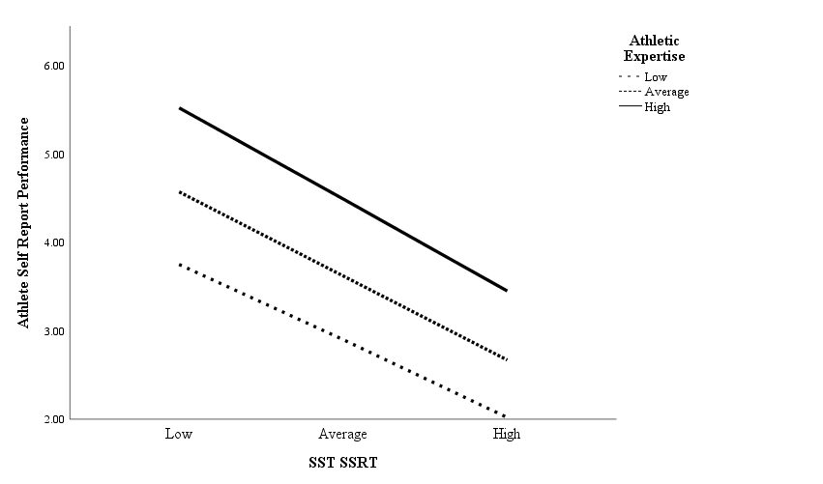
Figure 1. The association between SSRT on the Stop Signal Task and Athlete Self Report Performance for high (+1 SD), medium (0 SD) and low (-1 SD) levels of Athletic Expertise.
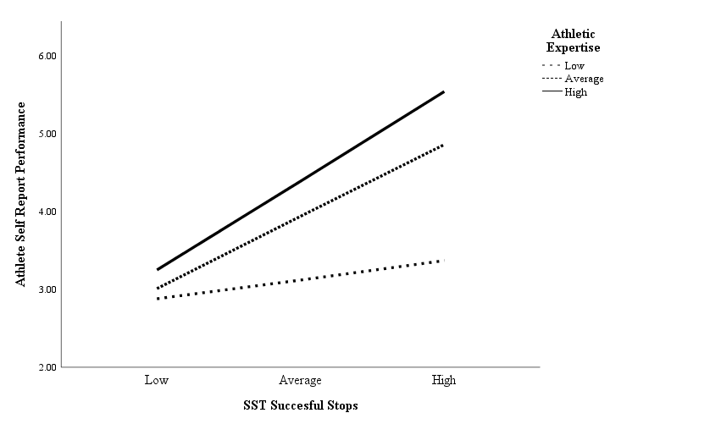
Figure 2. The association between Successful Stops on the Stop Signal Task and Athlete Self Report Performance for high (+1 SD), medium (0 SD) and low (-1 SD) levels of Athletic Expertise.

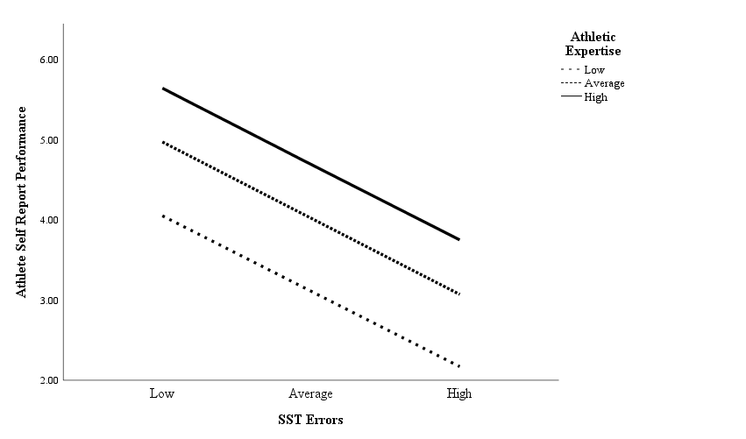
Figure 3. The association between Errors on the Stop Signal Task and Athlete Self Report Performance for high (+1 SD), medium (0 SD) and low (-1 SD) levels of Athletic Expertise.
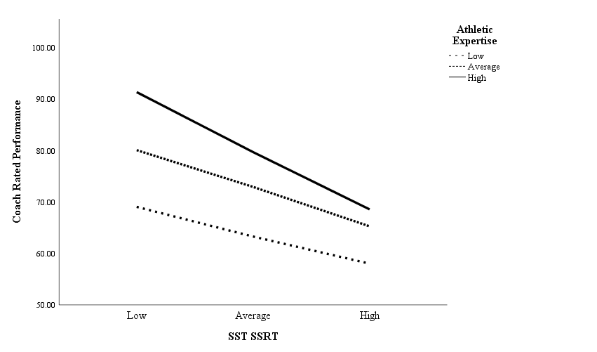
Figure 4. The association between SSRT on the Stop Signal Task and Coach Rated Athlete Performance for high (+1 SD), medium (0 SD) and low (-1 SD) levels of Athletic Expertise.
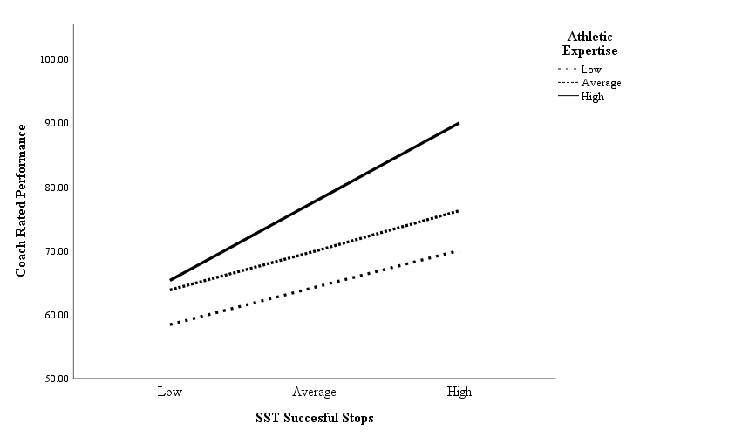
Figure 5. The association between Successful Stops on the Stop Signal Task and Coach Rated Athlete Performance for high (+1 SD), medium (0 SD) and low (-1 SD) levels of Athletic Expertise.
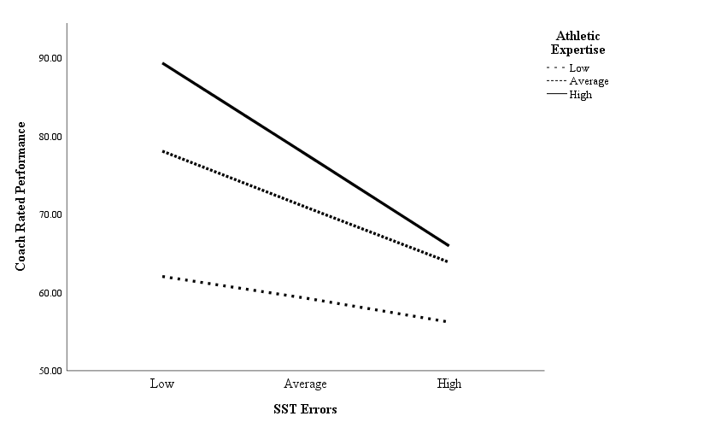
Figure 6. The association between Errors on the Stop Signal Task and Coach Rated Athlete Performance for high (+1 SD), medium (0 SD) and low (-1 SD) levels of Athletic Expertise.

