“The Navel Between Cities”: Copula Hall and the representation of Borders and Liminal Space in China Mieville’s The City & The City.

Article

The work of China Miéville - both non-fiction and fiction – contain strong political themes, yet they evoke these themes in contrasting ways, itself an important distinction. This is seen very effectively if you compare the presentation of borders and interstitial spaces within his essay “Exit Strategy” (published 2013 in the journal Guernica) and his novel The City & The City (2009). “Exit Strategy” is a journalistic article recounting Miéville’s thoughts of inhabiting the interstitial space of the border checkpoint between Bethlehem and Jerusalem. The article is tinged with commentary regarding the highly politicised border conflict in the West Bank, moving from a reflection of this atrocity, to Miéville’s own personal musings regarding passing through the checkpoint. In The City & The City the same concept of politicised borders is mirrored through the fantastical construction and interweaving of the twin cities of Besźel and Ul Qoma. Miéville’s aim with both texts is to consider and scrutinise the situation in the West Bank, and other similar politicised borders. He achieves this through two different methodologies: stylistic reportage in “Exit Strategy” and fantastical extrapolation in The City & The City. This is a common feature of Miéville’s work: there are thematic overlaps within his two strands of writing, but it is important to recognise the overtly political, authorial intent present in his non-fiction from the extrapolation and imaginative representation of political themes within his fictional output.
In 2013 Miéville visited the West Bank at the invitation of the Palestine Festival of Literature. “Exit Strategy” describes his trip through the border point between Jerusalem and Bethlehem. Miéville starts “Exit Strategy” with a reference to the Mohammed Al-Durra incident in 2000, when a 12-year old boy was caught in the crossfire between Israeli soldiers and Palestinian security forces. Caught on camera, the boy was killed as he and his father cowered behind a metal barrel. After a public funeral in which the boy became a martyr, conspiracy theories were suggested about the boy’s death being faked as a means of condemning Israeli forces. Suggestions that the boy died at the hands of friendly fire were put forward in opposition. What Miéville highlights with this initial reference is the real brutality of border control and the methods used to ensure that it remains “unseen”. An official report on the incident was published by the Israeli government in 2013, claiming that there was ‘no evidence that the child was injured or killed by Israeli fire’. This report was immediately disputed by Jamal al-Dura and the original French 2 television reporter Charles Enderlin. Jamal al-Dura further added in response that ‘he was willing for his son’s body to be exhumed to prove the circumstances of his death’ (Sherwood, 2013) in order to, as Mieville wrote: ‘prove that this thing we saw happen happened, that the boy we saw die died’ (Miéville, 2013b). The father’s actions here are a crucial counterpoint to enforced “unseeing”; a concept which Mieville analyses through a fantastical lens in The City & The City. The suggestion of the boy’s faked death by Israeli forces is a means of declaring to the controlled population that ‘what you saw is not real’. This is a similar effect to the role of indoctrinated “unseeing” between the populations of Besźel and Ul Qoma in The City & the City.
What makes The City & the City so intriguing is the nature of the novel’s setting. Inspector Tyador Borlú of the Extreme Crime Squad in the city-state of Besźel is assigned the case of a homicide involving a disfigured girl found on the outskirts of the city. Besźel shares the same geographical space with the city of Ul Qoma but through the volition of their citizens they are perceived as two different states. From childhood, residents of each city are taught to recognise elements of the other and then immediately “block out” their existence, to “unsee” the other city and its citizens. To not comply is known as breaching and is punishable. The result is an indoctrinated method of unseeing both architecture and people from the other city which is policed by a secret force known as Breach. As the murder investigation develops, Borlú finds himself on both sides of the border as the clues lead him into the shadowy corners of both cities and force him to evaluate the true motives behind Breach. Unseeing plays a significant role within the narrative: The concept of policed borders engages the reader with political issues and subtexts due to contemporary and historical conflicts involving land disputes and imperialistic motives.
The epigraph in The City & the City reads: ‘Deep inside the town there open up, so to speak, double streets, doppelganger streets, mendacious and delusive streets.’ This sentence is from a specific translation of the story “The Cinnamon Shops” (1934) by the Polish writer, Bruno Schulz. This is an interesting quotation for Miéville to use. Considering this quotation was adopted – in both cases – by overtly political writers, it is impossible to ignore the allusions to the act of dissembling the streets. The reality of our streets is lost behind a cover of social and political falsehoods. Given that Schulz himself was murdered for appearing in the wrong quarter of Drohobych, the concept of borders and the brutality of their control is being expressed here through Miéville’s choice of epigraph.
Miéville shows a keen interest in this concept of politicised zones and spaces, exploring how specific locations affect our personal emotional perception and create interstitial gaps and overlapping, or “cross-hatched” spaces. As Roger Luckhurst states in his essay “In the Zone: Topologies of Genre Weirdness”:
These interstitial zones, opening at random, shifting and disappearing from the purview of organized space, recur across Miéville's work... The interpenetration of zones becomes the motor of the plot in The City & the City, featuring apparently separate cities that occupy the same space and are cross-hatched over each other in complex ways... Miéville’s zones are ‘impossible’ non-Euclidean spaces in which, as Laura Salisbury argues, ‘generic transgression is figured in terms of topological complexity’. (Luckhurst, 2011: 29-30)

The City & The City communicates its central political message through an exploration of physical spaces, with contrasting urban zones creating social, political, and emotional behaviours on their inhabitants. The interpretation of physical areas and the interstitial spaces that exist between them becomes central to Miéville’s work. Topological boundaries become blurred and break down. We begin to question what defines a border and, more importantly, what social and political function it serves. Who controls the space?
In fact, the French Marxist philosopher Guy Debord took this concept of behavioural zones and interstitial space a stage further, producing a map of Paris centred on this idea. “The Naked City” presents the capital as a collective of nineteen sections seemingly dispersed at random. The arrows on Debord’s map suggest possible routes for the users to follow according to the emotional context they experience within a certain zone.

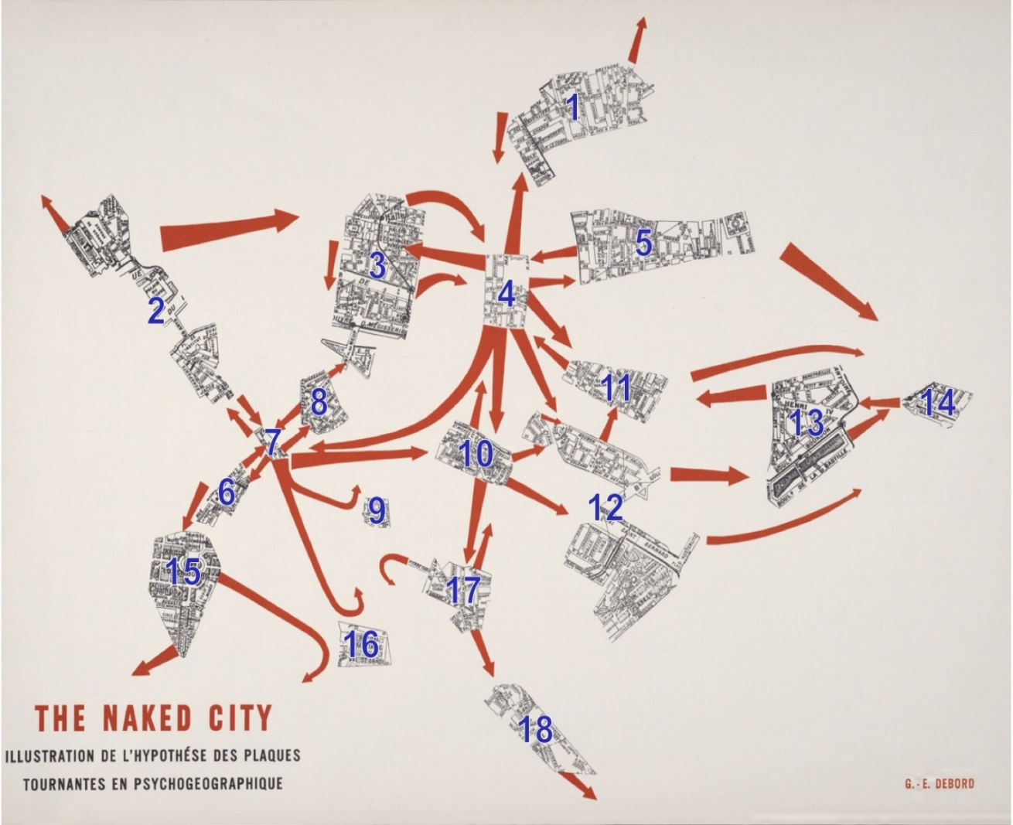© Guy Debord, The Naked City, found at: https://isinenglish.com/2016/01/09/debords-the-naked-city-mapped-onto-google-maps/

If we view this map in the context of Miéville's The City & the City we could imagine this to be a cartographic representation of either Besźel or Ul Qoma with the other city removed, what Mieville refers to as “total” zones. By creating this unique urban landscape, Miéville experiments in a similar manner to Debord’s “The Naked City”. He is examining how particular zones of emotional ambience and social influence can interact together and be aesthetically represented. To this formula he also adds the political examination of borders and physical space.
The most dominating presence in “Exit Strategy” is Miéville’s description of the border checkpoint itself as a ‘rising, concrete animal’ (Miéville, 2013b). Not only are borders a political idea, they can be a physical manifestation, literally preventing the populace from moving between geographical spaces. Mieville’s own photographs of the border checkpoint do depict a vast barrier of grey, crowned with twisted barbed wire and full of cages and walls. They are physically intimidating and a highly militarised space, devoid of human emotion. Miéville keenly highlights the irony of Israel tourism posters in a location where personal perception of time and space are shifted: ‘that these are exactly the posters a Palestinian is supposed to see at this point, that this is information she needs, now move on, keep going on this time out of time, time off, this vacation you have been given on the sand. You are beached. Get out’ (Miéville, 2013b). Miéville’s astute observational style is ideal for examining the interstitial spaces of border controls. He encapsulates the sense of forced displacement that occurs in such spaces, the way in which a person is physically in a geographical space but politically is not. This absurdity is further highlighted in Miéville’s key observation within the essay. On both sides of the border is the same sign, declaring “entrance”. Miéville describes the border checkpoint as ‘a non-place. No exit is marked. The arrows both point in’. The checkpoint becomes a space of trapped people, ‘two near-unending lines of broken living and the authorized dead, ordered forward and pushing and pushed and becoming nothing. What is lawfully inscribed here is not “No Exit”: it is “Entrance—Entrance”’ (Miéville, 2013b). This image from the Jerusalem/Bethlehem checkpoint is reminiscent of Breach’s actions upon the unfortunate perpetrators of unlicensed border crossing in The City & the City, those individuals vanishing mysteriously into the space between Besźel and Ul Qoma; between being and not being, registered and unregistered, alive and dead. Breachers become lost, just as those people who temporarily cease to exist in between political borders.
The harsh physicality of the Jerusalem/Bethlehem border is also reflected through Copula Hall in The City & the City. Copula Hall is the official border checkpoint for passage between Besźel and Ul Qoma. The description of its size and its Gothic architecture magnify the building into a monstrous entity. A thoroughfare for traffic and pedestrians between the two cities, Copula Hall is a militarised checkpoint such as those seen in destabilised nations around the world, ‘the waist of an hourglass, the point of ingress and egress, the navel between the cities. The whole edifice a funnel, letting visitors from one city into the other, and the other into the one’ (Miéville, 2009b: 85). The people within its thoroughfare are in a state of limbo, awaiting clearance and ‘stamped permissions-to-cross’ in order to exist again as tourists and visitors to the other city. In this initial description of Copula Hall Miéville reveals the inherent problems when indoctrinated unseeing is combined with strict border control:
If someone needed to go to a house physically next door to their own but in the neighbouring city, it was in a different road in an unfriendly power... But pass through Copula Hall and she or he might leave Besźel and at the end of the hall come back to exactly (corporeally) where they had just been... a street they had never visited before, to the architecture they had always unseen, to the Ul Qoman house sitting next to and a whole city away from their own building, unvisible there now they had come through, all the way across Breach, back home. (Miéville, 2009b: 85-86)

Miéville refers to this movement as ‘grosstopical’. To visit an Ul Qoman neighbour, a Besź citizen would have to pass through Copula Hall and then return to the exact same spot as a tourist, unseeing their own city and their own home in order to avoid the wrath of Breach. Although an extreme exaggeration, Miéville cleverly highlights the absurdity that such militarised border control inevitably creates.
Borders are contested areas of geographical space created by political powers and circumstances, fundamentally changing the psychological behaviour of the citizens who exist within those spaces. Populations become controlled by the policing of borders, not only in their physical movements around those spaces but through indoctrinated behaviour enforced through the use or threat of brutality. Miéville encapsulates this in The City & the City, using the concepts of unseeing, breaching and Breach to comment on the political control of borders that we witness across the contemporary world. However, he is keen to highlight that analogies can be dangerous, that The City & the City does not represent an analogy of contemporary political border control but is rather an extreme fictionalised account of it: ‘It is based on the absurd idea of Borders - that infinitely thin line that can kill you. On one side of it, your actions are punishable by law, while a few centimetres over you are fine. It is wholly absurd... The novel is an uncanny exaggeration of real-life politics; it is intended as an uncanny extrapolation of the political logic of borders.’ (Schmeink, 2013)
Miéville does highlight that in a real-world context a “Two States in One Space” idea is ‘completely demented’: ‘I don’t think that it would work at all, and I don’t think Israel has the slightest intention of trying it… analogies occur but sometimes they will obscure as much as they illuminate’ (Manaugh, 2011). After all, Ul Qoma and Besźel are fictional cities, and to apply their municipal structure in real life is absurd.
The brutality of borders is emphasised in The City & the City by the circumstances of the three principal acts of violence within the novel. Mahalia Geary’s body is discovered in the Besź suburb of Lestov, far out from the crosshatched areas of the inner city. It soon becomes clear in the investigation that Mahalia was killed across the border in Ul Qoma and then transported with ease – thanks to the correct political papers – through Copula Hall to Besźel. The assistance of Breach cannot be invoked because no breach has officially occurred. Effectively, the body has been legally smuggled across. The killer can use the regulations of the border control to try to conceal the brutal crime of Mahalia’s murder.
The second act of violence is the shooting of Yolanda. This takes place in Copula Hall itself, just as Borlú, Dhatt and Yolanda are walking across No-Man’s Land. The fatal shot comes from Besźel, crossing the checkpoint to kill Yolanda on the Ul Qoma side. It is significant that this occurs in Copula Hall, in the one place of border neutrality, the one place where a person can view both cities without breaching. The crime happens in Besźel and Ul Qoma simultaneously and the killer realises this potential to avoid the wrath of Breach. This is a murder committed with ‘a surplus of care for the cities’ boundaries, the membrane between Ul Qoma and Besźel. There was no breach, Breach had no power here, and only Besź police were in the same city as the killer now.’ (Miéville, 2009b: 282). If we interpret borders as a space where individuals shift between existence and nonexistence then this action represents the killing of a person who is already metaphorically dead. The precise location of the shooting means that the brutal act is, on a philosophical level, unseen. Under this interpretation, it could be argued that the event does not take place; hence the reluctance of Breach to intervene. The comparison to the Al-Durra killing can clearly be seen and drawn.
This event leads onto the final act of violence to consider here. Borlú chases Yolanda’s killer through the streets of Ul Qoma, observing him through crosshatched areas as he chases him down. Eventually though the killer heads towards a ‘total’ area in Besźel, taking one last look at Borlú as they both realise that the pursuit cannot continue. At that moment Borlú considers his options, raises his gun, and shoots at the killer across the border, invoking the wrath of Breach. Once again, violence is associated with the concept of borders.
The concept in The City & The City seems extremely pertinent, a whole decade after its publication. Indeed, it could be described as prophetic. Given recent global political upheavals, the importance of Borders and, more importantly, the political significance of how they are militarised and controlled, has become shockingly relevant. Whether it is the building of a wall along the U.S./Mexican border, or Brexit redefining the borders of a continent, or the mass migration of people across borders due to the displacement of military action; the consideration of borders, what they represent and how they affect people’s psychological state, remains significant. It is clear to see that the Mohammed Al-Durra incident was an influence for Mieville when constructing the concept for The City & The City. The military action seen that day - in a highly contested border zone - plus the actions of political agents to deny that it happened – to make it “unseen” – are clearly on display within Mieville’s text through the motifs of Copula Hall, unseeing and Breach. Mieville is using the extrapolation of speculative fiction - the fantastical - to highlight “real-life” social concerns. This is the success of Mieville’s project. Through the application of the fantastical, Mieville gives us a glimpse at the dark borders of real-world political structures. Within the “navel between two cities”, he shows us how violent borders can be.

Works Cited
Manaugh, Geoff (2011) Unsolving the City: An Interview with China Miéville, BLDGBLG [online] found at: http://bldgblog.blogspot.co.uk/2011/03/unsolving-city-interview-with-china.html, accessed November 2014.
Miéville, China (2013) “Exit Strategy”, Guernica Magazine [online] found at: http://www.guernicamag.com/features/exit-strategy/ accessed: December 2014.
Miéville, China (2011) The City and the City, London, UK, Pan Macmillan (published 2009).
Schmeink, Lars (2013) “Extreme Visions - An Interview with China Miéville” - Smart Magazine, Issue 1: Space, [online] found at: http://smart-magazine.com/post/extreme-visions/ accessed October 2014.
Schulz, Bruno (2008) The Street of Crocodiles and Other Stories, London, UK, Penguin (translated by John Curran Davis).
Sherwood, Harriet (2013) “Israeli inquiry says film of Muhammad al-Dura's death in Gaza was staged”, The Guardian [online] found at: https://www.theguardian.com/world/2013/may/20/israeli-inquiry-film-aldura-death-gaza, accessed April 2019.
Wasson, Sara; Alder, Emily (eds.) (2011) Gothic Science Fiction 1980 - 2010, Liverpool, UK, Liverpool University Press.

Abstract (207 words):
The duality between the non-fiction and fiction of British author China Miéville – in terms of their qualities of propaganda – is most effectively evoked if you compare his essay “Exit Strategy” (2013) with his novel The City & The City (2009). Both texts explore the concepts of politicised borders. “Exit Strategy” is a journalistic article recounting Miéville’s thoughts of inhabiting the interstitial space which is the border checkpoint between Bethlehem and Jerusalem. In The City & The City we witness this mirrored in the fantastical construction of the twin cities of Besźel and Ul Qoma and the border crossing of Copula Hall. Even though “Exit Strategy” was published after The City & The City, their intrinsic connection clearly demonstrates that Miéville’s method in both texts is to extrapolate to the extreme the situation in the West Bank, and other similar politicised borders.
Out of all of Miéville’s novels The City and the City most successfully demonstrates the political fluidity of urban landscapes and the novel’s central premise – ‘Unseeing’ – becomes an imaginative interpretation of political and psychological indoctrination. By analysing The City and the City closely, this paper demonstrates how Miéville is using fantastical fiction to explore the real-life politics and psychological effects associated with borders and liminal spaces.

***END***

