The relationship between the Dark Triad and attitudes towards feminism

Melanie D. Douglass¹, Michael Stirrat¹, Monica A, Koehn², & Robert S. Vaughan¹
York St John University, UK¹
Western Sydney University, Austailia²

Word Count: 5109 (including references & tables)

Contact Details: Melanie Douglass, Room HG209, School of Education, Language and Psychology, York St John University, Lord Mayors Walk, York, UK, YO31 7EX, E-mail: m.douglass@yorksj.ac.uk
Abstract
The Dark Triad traits are considered a male-centric framework of personality with women generally scoring lower on narcissism, Machiavellianism, and psychopathy. Research has examined the drivers behind this relationship attributing effects mostly to biological or evolutionary reasons with less work understanding environmental factors. To date, no research has examined the relationship between the Dark Triad and attitudes towards feminism. Three hundred and forty-three participants completed self-report measures of the Dark Triad and feminist attitudes. Results reported no differences between men and women on feminist attitudes, but men scored higher on the Dark Triad. Multiple linear regression indicated a negative association between the Dark Triad and feminist attitudes with all three traits significantly negatively contributing to the model. In all cases, this effect was stronger in men. These findings suggest that whilst men and women hold similar feminist attitudes, Dark Triad traits may facilitate a disregard for feminism.

Key Words: Dark Triad; Narcissism; Machiavellianism; Psychopathy; Feminism.

The relationship between the Dark Triad and attitudes towards feminism
1.1. The Dark Triad
The Dark Triad of psychopathy, narcissism, and Machiavellianism are three separate yet related traits (Paulhus & Williams, 2002). Narcissism describes grandiosity, entitlement, and superiority, Machiavellianism is characterised by manipulation, self-service, and deceit, and psychopathy describes an impulsive, unempathetic, and anxious individual (Paulhus & Williams). In combination, these traits provide social and biological advantages through behaviours that typify them; for example, ‘fast’ mating strategies (Jonason & Buss, 2012; Jonason, Li, Webster, & Schmitt, 2009). Consistent with a life-history model, the traits hold a fitness benefit for men via behavioural manifestations, including assertiveness, reproductive opportunities, and interpersonal relations (Jonason & Davis, 2018; Koehn, Okan, & Jonason, 2019). It should be noted that there is debate regarding the appropriateness of applying genetic explanations, such as those proposed in life history theory, as rationale for processes that tailor an individual to its environment (i.e., trait covariation; see Zietsch & Sidari, 2020, and Meanie et al., 2021, for contrasting reviews). Nonetheless, research proposes that the Dark Triad reinforces stereotypical gender roles by advantaging men who possess them via social adaptions of masculinity and femininity (Jonason & Davis, 2018), gender specific approaches to life (Jonason et al., 2011; Jonason et al., 2013), and differences in how society views male and female traits (e.g., social dominance; Semenyna & Honey, 2015).
Individuals high in Dark Triad traits also share inappropriate reactions in interpersonal situations (Wai & Tiliopoulos, 2012). This includes a tendency towards cold-heartedness, reduced motivation for justice, and less condemnation of immoral behaviour (Decety & Yoder, 2016). These behaviours have the potential to decrease the probability of engaging in prosociality (White, 2014), tend to result in an unwillingness to intervene on behalf of victims in moral dilemmas (Takamatsu & Takai, 2019), and predict race-based prejudice (Koehn, Jonason & Davis, 2019). When combined with the influence that the traits have on one’s sexual script (Willis et al., 2017), this results in attitudes and beliefs that contribute to sexual assault by shifting the blame from the perpetrator to the victim in the form of victim-blaming (Brewer et al., 2019), the acceptance of rape myths (Jonason et al., 2017), and rape-accepting/enabling attitudes (Jonason et al., 2017).
Finally, those high in Machiavellianism and psychopathy are more intrasexually competitive (e.g., women spreading rumours about other women; Lyons et al., 2019) and narcissism may be particularly relevant in predicting female-on-female competition (i.e., intasexual competition; Carter et al., 2015) which likely impact ones attitudes towards feminism (e.g., solidarity with women). Specifically in the context of women, high scores in the Dark Triad may provide social advantages via extra resources, higher social rank, and less suspicion in malevolent behaviours used during intrasexual competition (Semenyna & Honey, 2015). This intrasexual competition is not necessarily hierarchical, like male intrasexual aggression, rather, women compete via subtle, more relational strategies compared to men (Campbell, 1999), and are invested in their comparative social status (Eder, 1985). This suggests that, despite women scoring lower on the Dark Triad (e.g., Gluck, et al., 2020; Vaughan et al., 2019), the traits may still be adaptive.
If selective pressure for the Dark Triad is beneficial to men, it should also follow that there is selective pressure for these traits in women (Koehn et al., 2019). However, the behavioural expression may differ between the sexes. Research attests that men and women may benefit in similar domains but through different mechanisms. For example, Jonason et al. (2013) found that whilst the Dark Triad was linked to lower empathy in both men and women, the traits differentiated across sex with low empathy related to narcissism in women but psychopathy in men. Moreover, given their lack of prosociality and disregard for victims of gender-based violence, it suggests that there may be a link between the Dark Triad and anti-feminist attitudes. That is, a generally antagonistic and exploitive life approach is less likely to be concerned with others wellbeing (e.g., lack of empathy for victims; Jonason et al.).
1.2. Feminism
Feminism is a collective movement advocating women’s rights with the aim of achieving gender equality (Davis, 2021). Psychological research, including the above, has been criticised for its generally androcentric nature (Unger & Crawford, 1992) and patriarchal societies (Buss & Schmitt, 2011). Although more overt forms of sexism have decreased in recent years, particularly among younger cohorts (e.g., Knight & Brinton, 2017), and efforts have been made to bridge the gap between epistemologies (Davis), sexism still exists in varied forms. For example, modern sexism is linked to criticising victims of sexual violence (Haywood & Waank, 2008), and the inhibition of collective action toward equality (Ellemers & Barreto, 2009). These anti-feminist and sexist beliefs are known to predict gender inequality (Brandt, 2011), objectification of women, and hostility towards them (Swami & Voracek, 2013). Where such attitudes are held by men, they also predict the endorsement of rape myths (Aosved & Long, 2006). Given the attitudinal overlap between those high in the Dark Triad traits and sexism, previous research has investigated whether the two are correlated.
1.3. The Dark Triad and Feminism
There is direct evidence that there is a positive correlation between Dark Triad traits and sexism (Gluck et al., 2020). This is corroborated by research in adolescents, which found that boys and girls high in Dark Triad traits hold more benevolent (i.e., idealization of traditional gender roles positioning men above women) and hostile (i.e., negative opinion of other sexes based on heterosexual aggression) sexist attitudes (Navas et al., 2020). One way that the Dark Triad may affect sexism is through gender roles. Gender is composed of activities, gender attitudes, personality traits, relationships, and self-ratings of masculinity and femininity (Twenge, 1999). Those high in Dark Triad traits, particularly psychopathy and Machiavellianism, are less behaviourally and psychologically feminine (Jonason & Davis, 2018). Moreover, they tend to have lower femininity scores, and higher masculinity scores, with sex differences in the traits only mediated by femininity scores (Jonason & Davis).
Engaging in more stereotypically masculine activity predicts less feminist views in men and women (Lemaster et al., 2015). The literature also shows that women engage in gatekeeping behaviour towards other women, which is common in those who do not hold feminist attitudes (Derks et al., 2011). This is consistent with previous research showing that men who identify more with other men also show more covert sexism (i.e., sexism that is less obvious or hidden in cultural and societal norms; Leaper & Van, 2008). The evidence with women is more complex but does suggest the opposite; that identification with other women is associated with fewer sexist beliefs (Becker & Wagner, 2009).
It has been argued that stereotypical male behaviours tend to occur in social contexts that devalue femininity. Therefore, more masculine women may feel pressure to shift ideology to fit in with the masculine group (Lemaster et al., 2015). However, there is some inconsistencies in the research evidence. That is, engaging in masculine behaviour (e.g., building with tools) predicts lower feminist attitudes in women, endorsing stereotypic masculine traits (e.g., importance on high physical strength) is positively correlated with feminist attitudes (Lemaster et al.). Despite this evidence with regards to whether sexism is higher or lower in more stereotypically masculine women, the manifestations of the Dark Triad suggests that such women would not endorse feminist ideology. Feminism is a collective movement by women with the aim of achieving gender equality. By contrast, women high in the Dark Triad do not identify with other women and engage in more intrasexual competition, so are unlikely to join in activism for the greater good.
For men, there is greater consistency with higher gender-identification in men predicting sexist and less feminist attitudes (Lemaster et al., 2015). Moreover, the sexism found in men high in Dark Triad traits, combined with their tendency to engage in exploitation of women, suggests that they are also unlikely to hold feminist attitudes. Both lines of evidence suggest that the Dark Triad may decrease feminist beliefs in men and women because both engage in more stereotypically masculine behaviour at the same time as identifying more with men. This argument is strengthened by the finding that the traits are positively correlated with sexism, with a similar magnitude for men and women (Gluck et al., 2020). This led Gluck and colleagues to suggest that sexism is one factor which underpins Dark Triad. However, no research to date has explored whether this association extends to feminist ideology.
1.4 Current Study
In sum, no research to date has examined the relationship between the Dark Triad and attitudes towards feminism. Considering previous work reporting higher scores for women than men on attitudes towards feminism (Fassinger, 1994), and the Dark Triads association with male-centric characteristics (Jonason et al., 2011; Jonason et al., 2013; Jonason & Davis, 2018), we predict a negative relationship between the Dark Triad and attitudes towards feminism. We also expect to replicate sex differences in the Dark Triad (Gluck et al., 2020; Vaughan et al., 2019). Finally, we predict that sex would moderate the relationship between the Dark Triad and attitudes towards feminism with effects larger for men.
2. Methods
2.1. Participants
Three hundred and forty-three individuals (56.90% female) aged between 18-54 years of age (M_{age} = 21.59 ± SD = 6.77) from in the United Kingdom participated. The G*Power programme (Faul et al., 2007) for a priori power analysis (.80) suggested a sample size of 109 for correlations, 187 for a linear multiple regression with three predictors and a medium effect size (.12), and 199 for moderation analyses including the interaction term and a medium effect size (.12).
2.2. Materials
2.2.1. The Dark Triad were measured using the 27-item Short Dark Triad scale (SD3; Jones & Paulhus, 2014). The participants were asked the degree to which they agreed (1 = Disagree strongly; 5 = Agree strongly) with statements like: “I’ll say anything to get what I want” (i.e., psychopathy), and “People see me as a natural leader” (i.e., narcissism), and “I like to use clever manipulation to get my way” (i.e., Machiavellianism). Items were meaned to create indices for psychopathy (α = .75), narcissism (α = .78), and Machiavellianism (α = .74).
2.2.2. To measure attitudes towards feminism, we used the 20-item short scale of attitudes towards feminism (FEM; Smith, Ferree, & Miller, 1975). The self-report scale captures feminist attitudes (e.g., “Women have the right to complete with men in every sphere of activity”) on a five-point Likert-type scale from (1 = Strongly disagree; 5 = Strongly disagree). Lower scores indicate liberal, feminist attitudes, whereas high scores indicate conservatism and anti-feminist attitudes. Items were summed to create an index of feminism (α = .79).
2.3. Procedure
Ethical approval was granted via committee at a university in the United Kingdom. Recruitment was sought from universities, businesses, and sports clubs with the majority from England. Data were collected electronically for participants convenience using a touch-screen computer. Participants were briefed, provided informed consent, and then completed demographic information, the SD3, and FEM. After completion, participants were thanked and released. Data was entered onto the SPSSvs26 software program for analysis.
2.4. Design and Analysis
The study adopted a cross-sectional design with opportunity sampling. Data were screened for outliers and missing data per Tabachnick and Fidell (2007). Skewness and kurtosis of all variables were within range (Tabachnick & Fidell, 2007). There was no missing data, univariate outliers (e.g., no z-scores > 3.50), or multivariate outliers (e.g., no participant showed a Mahalanobis distance greater than the critical value of χ²(4) = 15.63, p < .01) therefore all data were retained for analyses. Descriptive statistics, tests of differences between sexes, and bivariate correlations were run on the SD3 and FEM scores. We also compared bivariate correlations for men and women using Fisher's r-to-z transformations. Multiple regression was used to assess the relationship between the Dark Triad and attitudes towards feminism with Machiavellianism, narcissism, and psychopathy entered as predictors and attitudes towards feminism as the criterion variable. To further explore the interaction between sex, the Dark Triad, and attitudes towards feminism we tested moderation effects using Hayes’s (2013) PROCESS macro (model 1) with 5000 bootstrap samples. Interactions were considered significant at the .05 level if upper (ULCI) and lower (LLCI) confidence intervals did not cross zero.
3. Results
3.1. Preliminary Analyses
In line with previous research, men scored higher than women in Machiavellianism, narcissism, and psychopathy (see Table 1). There were no sex differences in feminist attitudes. The Dark Triad traits showed moderate inter-correlations and all three traits were associated with lower feminist attitudes.
Table 1.
Descriptive statistics, test of differences, and bivariate correlations.
Variable | M (SD) |  |  | t | d | 1 | 2 | 3
 | Total | Male | Female
1.Machiavellianism | 3.20 (0.61) | 3.39 (0.63) | 3.04 (0.57) | 5.25 | 0.57**
2.Narcissism | 2.50 (0.62) | 2.85 (0.58) | 2.24 (0.52) | 4.31 | 0.54** | .38**
3.Psychopathy | 2.61 (0.43) | 2.80 (0.40) | 2.48 (0.39) | 5.28 | 0.39** | .52** | .35**
4.Feminism | 4.34 (0.47) | 4.29 (0.52) | 4.39 (0.41) | 1.68 | 0.04 | -.38** | -.27** | -.33**
Note. N = 343. ** p < .01.
Fisher's r-to-z transformations indicated correlations were significantly larger for men compared to women (see Table 2). Machiavellianism and narcissism (z = 1.70, p < .05), Machiavellianism and psychopathy (z = 2.81, p < .05), narcissism and psychopathy (z = 1.70, p < .05), Machiavellianism and feminism (z = 2.55, p < .05), narcissism and feminism (z = 1.67, p < .05), and psychopathy and feminism (z = 2.56, p < .05).
Table 2.
Bivariate correlations by sex.
Variable | Machiavellianism | Narcissism | Psychopathy | Feminism
Machiavellianism |  | .21** | .41** | -.25**
Narcissism | .38** |  | .21** | -.18**
Psychopathy | .61** | .38** |  | -.20**
Feminism | -.49** | -.35** | -.45**
Note. Correlations for men below the diagonal and women above the diagonal. N = 343. ** p < .01.
3.2. Multiple Regression Analyses
Next, standard linear multiple regression was conducted to determine whether the Dark Triad predicted attitudes towards feminism (see Table 3). The linear combination of the traits explained 17% of attitudes towards feminism (F(3,339) = 24.67, p < .01). Machiavellianism, narcissism, and psychopathy were significant unique negative predictors of attitudes towards feminism, indicating that participants with higher scores on the traits held more conservative, anti-feminist attitudes. This effect was robust to the partialing of the shared variance in the Dark Triad traits.
Table 3.
Summary of multiple linear regression between Dark Triad and attitudes towards feminism.
Variable | b | SE | β | Partial | Tolerance | VIF
Machiavellianism | -0.43 | .10 | -.26** | -.21 | .66 | 1.51
Narcissism | -0.20 | .09 | -.12** | -.11 | .81 | 1.21
Psychopathy | -0.36 | .12 | -.15** | -.12 | .68 | 1.48
Note. Dependent variable = Feminism. VIF = Variance Inflation Factor. N = 343. ** p < .01.
3.3 Moderation Analyses
Finally, we explored the interaction between sex and the Dark Triad in predicting attitudes towards feminism.
Regarding Machiavellianism, the model was significant (R² = 17%, F[3,339] = 22.91 p < .001). The interaction between sex and Machiavellianism (b = -0.18, SE = .05, t = -3.36, p < .001, LLCI = 0-.27; ULCI = -0.08) significantly predicted attitudes towards feminism (see Figure 1). Inclusion of the interaction predicted 2% additional variance (F[1,339] = 8.78 p < .01) with conditional effects of the focal predictor indicating larger effects for men (b = -0.41, SE = .06, t = -7.36, p < .001, LLCI = -0.52; ULCI = -0.31) compared to women (b = -0.18, SE = .05, t = -3.36, p < .001, LLCI = -0.29; ULCI = -0.08).
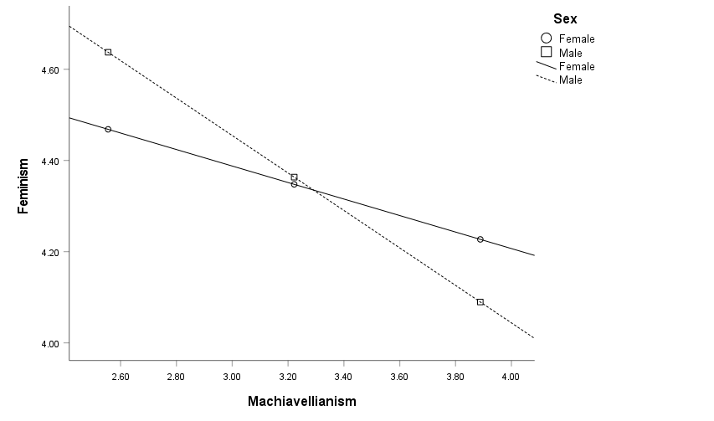
Figure 1. Interaction of sex and Machiavellianism on Feminism relationship.
Regarding narcissism, the model was significant (R² = 9%, F[3,339] = 10.71 p < .001). The interaction between sex and narcissism (b = -0.12, SE = .06, t = -2.01, p < .05, LLCI = -0.25; ULCI = -0.01) significantly predicted attitudes towards feminism (see Figure 2). Inclusion of the interaction predicted 1% additional variance (F[1,339] = 4.84 p < .05) with conditional effects of the focal predictor indicating larger effects for men (b = -0.32, SE = .06, t = -5.01, p < .001, LLCI = -0.45; ULCI = -0.19) compared to women (b = -0.12, SE = .06, t = -2.01, p < .05, LLCI = -0.25; ULCI = -0.01).
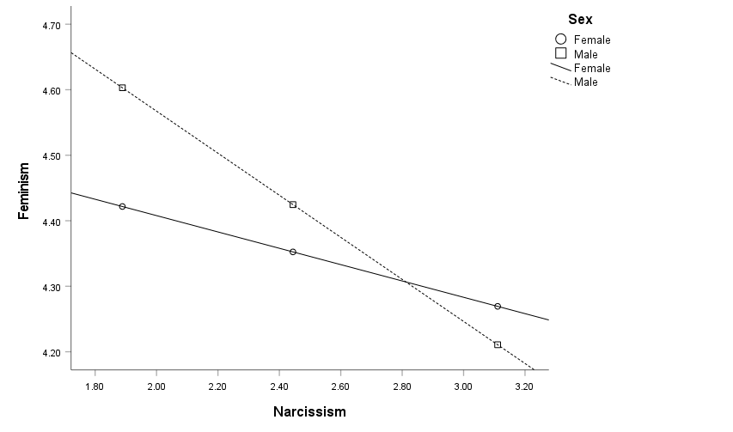
Figure 2. Interaction of sex and Narcissism on Feminism relationship.
Regarding psychopathy, the model was significant (R² = 14%, F[3,339] = 17.74 p < .001). The interaction between sex and psychopathy (b = -0.21, SE = .08, t = -2.62, p < .01, LLCI = -0.37; ULCI = -0.05) significantly predicted attitudes towards feminism (see Figure 3). Inclusion of the interaction predicted 3% additional variance (F[1,339] = 9.93 p < .01) with conditional effects of the focal predictor indicating larger effects for men (b = -0.59, SE = .09, t = -6.57, p < .001, LLCI = -0.76; ULCI = -0.41) compared to women (b = -0.20, SE = .08, t = -2.62, p < .01, LLCI = -0.37; ULCI = -0.05).
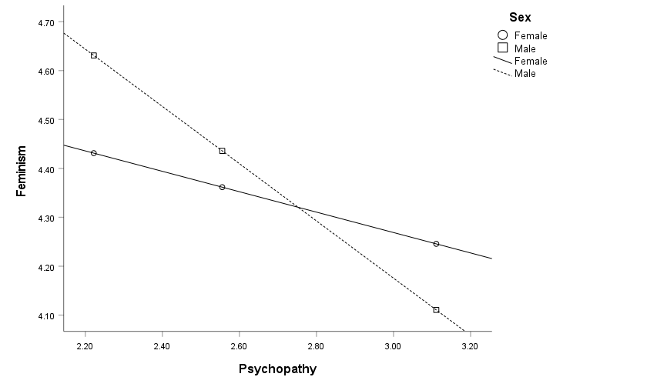
Figure 3. Interaction of sex and Psychopathy on Feminism relationship.
4. Discussion
Gender inequality and sexism are public issues and understanding the contributing factors is an essential task. In this study, we took an individual differences approach in understanding feminist attitudes versus more conservative attitudes. As predicted, all three Dark Triad traits were significantly negatively correlated with feminism, with all significantly contributing to predict feminism. In addition, and consistent with previous literature, Dark Triad scores were significantly higher for men. This suggests a degree of validity of the results, given this is a well-established finding (Gluck et al., 2020; Vaughan et al., 2019). The magnitude of effects was stronger for men in all cases, which is also consistent with previous research (Gluck et al.), albeit feminism scores did not differ between the sexes. This may be consistent with the concept of increasingly egalitarian attitudes in Western societies (Knight & Brinton, 2017). Though, to the extent that attitudes reflect behaviour, it is somewhat inconsistent with the view that sexism is common in the West.
The finding that Dark Triad scores negatively predicted feminist attitudes is consistent with previous literature showing a positive correlation between sexism and Dark Triad (Gluck et al., 2020). In terms of men, this is consistent with previous findings, thereby strengthening our understanding of the relationship. However, as noted, there is some complexity in the literature regarding gender roles and sexism in women who identify with more stereotypic masculine traits who show less sexism but those who identify more with masculine behaviours show more sexism (Lemaster et al., 2015).
Results suggest that women who score high on the Dark Triad may adopt more flexible life approaches (e.g., disclose higher or lower attitudes towards feminism depending on the situation; Jonason et al., 2009; Jonason et al., 2011; Jonason et al., 2013; Jonason & Davis, 2018). That is, they may be more stereotypically masculine and engage in more intrasexual competition (Lyons et al., 2019), and may be less feminine in some other aspects (Jonason & Davis). They do not typically hold feminist ideals because they favour their own self-interests over that of solidarity with other women. Also, Dark Triad women may identify less with masculine stereotypic traits (Lemaster at al., 2015) and use feminine roles for intrasexual competition. Future research could test this idea by examining the interplay between the Dark Triad, feminism, and intrasexual competition in men and women.
Research suggests that maintaining adaptable interpersonal attitudes allows easier exploitation of others (Koehn et al., 2019). Research also attests that high scores in the Dark Triad are related to behaviours that manifest in the exploitation of others (Koehn et al.). We believe this explanation is the most likely and a candidate for future work. That is, those high in the Dark Triad favour their own interests irrespective of their sex. This would support Gluck et al.’s (2020) argument that sexism underpins sex differences in the Dark Triad stemming from socially supported privilege surrounding men and masculinity.
4.1. Limitations and Future Directions
The present study has a few limitations. The findings support Gluck et al.’s (2020) argument that sexism underpins Dark Triad but, feminism scores did not differ between the sexes, whereas correlations between variables were significantly different for each sex. Future research should aim to investigate these relationships by measuring gender identity, gender roles, endorsement of sexist attitudes, and Dark Triad scores in men and women.
A second limitation is the use of self-report measures, which raises the possibility of socially desirable responding. This may be particularly the case of the FEM scale. With the increase of egalitarian attitudes in society (Knight & Brinton, 2017), those who do not hold such beliefs may be reluctant to admit to anti-feminist attitudes, particularly in a Higher Education setting, where there may be more homogeneity in attitudes. In addition, the FEM score contains some outdated conceptualisations, which may either fail to tap modern anti-feminist ideology or be more prone to socially desirable responding. Future research should therefore seek to find ways of investigating feminism that are less prone to socially desirable responding. Moreover, whilst previous research has supported the scales internal consistency and unidimensional structure (Smith et al., 1975), there is evidence that such scales are not appropriate for use with younger samples (Byrne et al., 2011). Given this, and recent research showing that misogynistic dialogue on social media (Blake et al., 2021) predict violence against women, future research should investigate predictors of behavioural outcomes directly (e.g., misogyny, sexual aggression, sexual objectification) in experimental designs.
Next, the Dark Triad as a concept has also been criticised (Glen & Sellborn, 2015). For example, with regards to the SD3, narcissism mostly reflects grandiosity and superiority rather than vulnerability – an important facet of the construct; Maples, Lamkin, & Miller, 2014). There is considerable overlap amongst the traits, however each predict diverse outcomes and are distinct constructs (Koehn et al., 2019). It is believed that the various scales do not sufficiently tap into female manifestations of the personality. This may explain why research consistently finds sex differences between men and women. To combat this, extensive work is needed to develop an empirical understanding of the traits and to find effective ways of measuring them. Finally, research has advanced dark personality theory to include additional traits such as sadism (i.e., Dark Tetrad; Book et al., 2016). Future research could replicate these findings with additional traits such as sadism.
4.2. Conclusions
The results were consistent with the hypotheses. All three aspects of the Dark Triad negatively predicted feminism and Dark Triad traits significantly differing between men and women. However, endorsement of feminist attitudes did not differ between men and women. This adds to previous research suggesting that Dark Triad are correlated with sexism but is the first known paper to directly investigate the relationship between Dark Triad traits and feminism. Given the negative consequences of sexism, and the impact this has on society, it is important to understand the factors that underpin such attitudes, so that steps can be taken to combat them.

References
Aosved, A. C., & Long, P. J. (2006). Co-occurrence of rape myth acceptance, sexism, racism, homophobia, ageism, classism, and religious intolerance. Sex Roles, 55(7-8), 481-492. https://doi.org/10.1007/s11199-006-9101-4
Becker, J. C., & Wagner, U. (2009). Doing gender differently—The interplay of strength of gender identification and content of gender identity in predicting women's endorsement of sexist beliefs. European Journal of Social Psychology, 39(4), 487-508. https://psycnet.apa.org/doi/10.1002/ejsp.551
Book, A., Visser, B. A., Blais, J., Hosker-Field, A., Methot-Jones, T., Gauthier, N. Y., Volk, A., Holden, R. R., & D'Agata, M. T. (2016). Unpacking more "evil": What is at the core of the dark tetrad?. Personality and Individual Differences, 90, 269-272. https://doi.org/10.1016/j.paid.2015.11.009
Buss, D. M., & Schmitt, D. P. (2011). Evolutionary psychology and feminism. Sex Roles, 64(9), 768-787. https://doi.org/10.1007/s11199-011-9987-3
Brandt, M. J. (2011). Sexism and gender inequality across 57 societies. Psychological Science, 22, 1413–1418. https://psycnet.apa.org/doi/10.1177/0956797611420445
Brewer, G., Lyons, M., Perry, A., & O’Brien, F. (2019). Dark Triad Traits and perceptions of sexual harassment. Journal of Interpersonal Violence, 36, 1-15. https://doi.org/10.1177%2F0886260519827666
Byrne, Z. S., Felker, S., Vacha-Haase, T., & Rickard, K. M. (2011). A comparison of responses on the Attitudes Toward Women Scale and Attitudes Toward Feminism Scale: Is there a difference between college-age and later-life adults with the original norms?. Measurement and Evaluation in Counseling and Development, 44(4), 248-264. https://doi.org/10.1177/0748175611418982
Campbell, A. (1999). Staying alive: Evolution, culture, and women's intrasexual aggression. Behavioral and brain sciences, 22(2), 203-214. doi: 10.1017/S0140525X99001818
Carter, G. L., Montanaro, Z., Linney, C., & Campbell, A. C. (2015). Women’s sexual competition and the Dark Triad. Personality and Individual Differences, 74, 275-279. doi: 10.1016/j.paid.2014.10.022
Davis, A. C. (2021). Resolving the tension between feminism and evolutionary psychology: An epistemological critique. Evolutionary Behavioral Sciences, 15(4), 368–388. https://doi.org/10.1037/ebs0000193
Decety, J., & Yoder, K. J. (2016). Empathy and motivation for justice: Cognitive empathy and concern, but not emotional empathy, predict sensitivity to injustice for others. Social Neuroscience, 11(1), 1-14. https://doi.org/10.1080/17470919.2015.1029593
Derks, B., Ellemers, N., van Laar, C., & de Groot, K. (2011). Do sexist organizational cultures create the Queen Bee? British Journal of Social Psychology, 50, 519-525. https://doi.org/10.1348/014466610X525280
Ellemers, N., & Barreto, M. (2009). Collective action in modern times: How modern expressions of prejudice prevent collective action. Journal of Social Issues, 65(4), 749-768. https://psycnet.apa.org/doi/10.1111/j.1540-4560.2009.01621.x
Faul, F., Erdfelder, E., Lang, A. G., & Buchner, A. (2007). G∗Power 3: A flexible statistical power analysis program for the social, behavioral, and biomedical sciences. Behavior Research Methods, 39, 175–191. https://doi.org/10.3758/BF03193146
Fassinger, R. E. (1994). Development and testing of the Attitudes Toward Feminism and the Women's Movement (FWM) Scale. Psychology of Women Quarterly, 18(3), 389-402. https://psycnet.apa.org/doi/10.1111/j.1471-6402.1994.tb00462.x
Glenn, A. L., & Sellbom, M. (2015). Theoretical and empirical concerns regarding the Dark Triad as a construct. Journal of Personality Disorders, 29(3), 360-377. doi: 10.1521/pedi_2014_28_162
Gluck, M., Heesacker, M., & Choi, H. D. (2020). How much of the Dark Triad is accounted for by sexism?. Personality and Individual Differences, 154, 109728. https://doi.org/10.1521/pedi_2014_28_162
Haywood, H., & Swank, E. (2008). Rape myths among Appalachian college students. Violence and Victims, 23(3), 373-389. doi:10.1891/0886-6708.23.3.373
Jonason, P. K., & Buss, D. M. (2012). Avoiding entangling commitments: Tactics for implementing a short-term mating strategy. Personality and Individual Differences, 52, 606-610. https://psycnet.apa.org/doi/10.1016/j.paid.2011.12.015
Jonason, P. K., & Davis, M. D. (2018). A gender role view of the Dark Triad traits. Personality and Individual Differences, 125, 102-105. https://psycnet.apa.org/doi/10.1016/j.paid.2018.01.004
Jonason, P. K., Girgis, M., & Milne-Home, J. (2017). The exploitive mating strategy of the
Dark Triad traits: Tests of rape-enabling attitudes. Archives of Sexual Behavior, 46(3),
697-706. https://doi.org/10.1007/s10508-017-0937-1
Jonason, N. P., Li, N. P., Webster, G. D., & Schmitt, D. P. (2009). The Dark Triad:
Facilitating a short-term mating strategy in men. European Journal of Personality, 23,
5-18. https://doi.org/10.1002%2Fper.698
Jonason, P. K., Lyons, M., Bethell, E. J., & Ross, R. (2013). Different routes to limited empathy in the sexes: Examining the links between the Dark Triad and empathy. Personality and Individual Differences, 54(5), 572-576. https://doi.org/10.1016/j.paid.2012.11.009
Jonason, P. K., Valentine, K. A., Li, N. P., & Harbeson, C. L. (2011). Mate selection and the Dark Triad: Facilitating a short-term mating strategy and creating a volatile environment. Personality and Individual Differences, 51, 759-763. https://doi.org/10.1016/j.paid.2011.06.025
Jones, D. N., & Paulhus, D. L. (2014). Introducing the short Dark Triad (SD3) a brief measure of dark personality traits. Assessment, 21(1), 28-41. doi: 10.1177/1073191113514105
Koehn, M. A., Jonason, P. K., & Davis, M. D. (2019). A person-centered view of prejudice: The Big Five, Dark Triad, and prejudice. Personality and Individual Differences, 139, 313–316. https://doi.org/10.1177%2F1073191113514105
Koehn, M. A., Okan, C., & Jonason, P. K. (2019). A primer on the Dark Triad traits. Australian Journal of Psychology, 71(1), 7–15. https://psycnet.apa.org/doi/10.1111/ajpy.12198
Knight, C. R., & Brinton, M. C. (2017). One egalitarianism or several? Two decades of
gender-role attitude change in Europe. American Journal of Sociology, 122(5), 1485-
1532. doi:10.1086/689814
Leaper, C., & Van, S. R. (2008). Masculinity ideology, covert sexism, and perceived gender
typicality in relation to young men's academic motivation and choices in
college. Psychology of Men & Masculinity, 9(3), 139-153. https://psycnet.apa.org/doi/10.1037/1524-9220.9.3.139
Lemaster, P., Strough, J., Stoiko, R., & DiDonato, L. (2015). To have and to do: Masculine
facets of gender predict men’s and women’s attitudes about gender equality among
college students. Psychology of Men & Masculinity, 16(2), 195-205. https://psycnet.apa.org/doi/10.1037/a0036429
Lyons, M., Gillies, N., & Brewer, G. (2019). Dark Triad traits, Facebook intensity, and intrasexual competition. Personality and Individual Differences, 141, 157-159. https://doi.org/10.1016/j.paid.2019.01.012
Maples, J. L., Lamkin, J., & Miller, J. D. (2014). A test of two brief measures of the dark triad: The dirty dozen and short dark triad. Psychological Assessment, 26(1), 326– 331. https://psycnet.apa.org/doi/10.1037/a0035084
Menie, M. A., Luoto, S., Peñaherrera-Aguirre, M., & Sarraf, M. A. (2021). Life history is a major source of adaptive individual and species differences: A critical commentary on Zietsch and Sidari (2020). Evolutionary Psychological Science, 7(3), 213-231. https://doi.org/10.1007/s40806-021-00280-2
Navas, M. P., Maneiro, L., Cutrín, O., Gómez-Fraguela, J. A., & Sobral, J. (2020). Associations between Dark Triad and ambivalent sexism: Sex differences among adolescents. International Journal of Environmental Research and Public Health, 17(21), 7754. https://doi.org/10.3390/ijerph17217754
Paulhus, D. L., & Williams, K. M. (2002). The dark triad of personality: Narcissism, Machiavellianism, and psychopathy. Journal of Research in Personality, 36(6), 556-563. https://doi.org/10.1016/S0092-6566(02)00505-6
Semenyna, S. W., & Honey, P. L. (2015). Dominance styles mediate sex differences in Dark Triad traits. Personality and Individual Differences, 83, 37-43. https://doi.org/10.1016/j.paid.2015.03.046
Smith, E. R., Ferree, M. M., & Miller, F. D. (1975). A short scale of attitudes toward feminism. Representative Research in Social Psychology, 6, 51-58.
Swami, V., & Voracek, M. (2013). Associations among men's sexist attitudes, objectification of women, and their own drive for muscularity. Psychology of Men & Masculinity, 14(2), 168-174. https://psycnet.apa.org/doi/10.1037/a0028437
Takamatsu, R., & Takai, J. (2019). With or without empathy: Primary psychopathy and difficulty in identifying feelings predict utilitarian judgment in sacrificial dilemmas. Ethics & Behavior, 29(1), 71-85. https://psycnet.apa.org/doi/10.1080/10508422.2017.1367684
Twenge, J. M. (1999). Mapping gender: The multifactorial approach and the organization of gender-related attributes. Psychology of Women Quarterly, 23(3), 485-502. https://psycnet.apa.org/doi/10.1111/j.1471-6402.1999.tb00377.x
Unger, R. K., & Crawford, M. E. (1992). Women and gender: A feminist psychology. Temple University Press.
Vaughan, R., Madigan, D. J., Carter, G. L., & Nicholls, A. R. (2019). The Dark Triad in male and female athletes and non-athletes: Group differences and psychometric properties of the Short Dark Triad (SD3). Psychology of Sport and Exercise, 43, 64-72. https://psycnet.apa.org/doi/10.1016/j.psychsport.2019.01.002
Wai, M., & Tiliopoulos, N. (2012). The affective and cognitive empathic nature of the Dark Triad of personality. Personality and Individual Differences, 52(7), 794-799. https://psycnet.apa.org/doi/10.1016/j.paid.2012.01.008
White, B. A. (2014). Who cares when nobody is watching? Psychopathic traits and empathy in prosocial behaviors. Personality and Individual Differences, 56, 116-121. https://doi.org/10.1016/j.paid.2013.08.033
Willis, M., Birthrong, A., King, J. S., Nelson-Gray, R. O., & Latzman, R. D. (2017). Are infidelity tolerance and rape myth acceptance related constructs? An association moderated by psychopathy and narcissism. Personality and Individual Differences, 117, 230-235. https://psycnet.apa.org/doi/10.1016/j.paid.2017.06.015
Zietsch, B. P., & Sidari, M. J. (2020). A critique of life history approaches to human trait covariation. Evolution and Human Behavior, 41(6), 527-535. https://doi.org/10.1016/j.evolhumbehav.2019.05.007

