Empirical article
Using a novel autoethnographically-informed research design to explore participants’ experiences of an educational arts programme at a UK university
Ruth Knight & Ruth Lambley

This article describes a novel autoethnographically-informed approach to exploring participants’ experiences of Converge (a UK university-based educational arts programme) as part of a wider research project focusing on mental health recovery. In addition to using traditional research methods, we developed an innovative and creative autoethnographically-informed approach. We trained 16 Converge students – who we named ‘Storytellers’ – to explore their experience of Converge using artistic approaches. Our Storytellers had frequent group sessions; one-to-one meetings with a research assistant; were offered the opportunity to be involved in the thematic analysis of their creations; and were involved in the dissemination of findings. Four major themes were constructed: the importance of community; recovery as a series of small steps; acceptance and belonging; and exchange of attitudes and values. Storytellers frequently reported profound lasting positive effects on their lives which they attributed to their participation, in particular the developing of friendships and feelings of accomplishment. The accessibility of research methods for participants may explain why our autoethnographically-informed design using a creative approach appears to be a particularly successful pathway for exploratory mental health research.
Key words: Coproduction, Autoethnography, Arts-based research methods, Mental health

Introduction
Using art as a research method
Art can be a uniquely powerful and insightful research method. According to Travers (2011), visual methods have been described as the “oldest new methods in qualitative research” (in Henwood et al., 2020, p.556). Similarly, Andriolo (2020) notes that the use of images, drawings, paintings, and photographs (among others) for understanding the mental world, or subjectivity, has a very long history, citing examples relating to psychoanalysis from the 1920s. As such Denzin (2004) explains how social scientists have long held that visual representations of society are both research methods and resources or topics which should be studied (in Gleeson, 2020). Henwood et al. (2020) continue, arguing for art’s uniqueness, claiming that recording and analysing what is seen and how it is viewed, alongside the diverse ways of telling, which is inspired by such viewings and sightings, gives unique access to diﬀerent types of information which is not available by other means. This enriches presentations of experience and enhances the understanding of studied life. Concurring with this, Reavey (2020) observed that images are a powerful form of communication, which form a vital part of our everyday worlds and lived experiences.
Further reasons to use art as a research method are expressed by Ward and Shortt (2020) who argue that arts-based methods including visual and performative approaches can be powerful, promoting individuals and communities to reflect and engage. They argue that using arts-based and visual research methods can bring about deeper, more emotional, more reflexive data compared to more traditional verbal-based qualitative research approaches. As such, Reavey explains that visual research in psychology highlights the spaces in which people experience themselves so that the different forms of self-hood reported (verbally) and shown (visually) can be contextualised (Reavey, 2020). These arguments all justify using art-based research methods in mental health research where a deeper exploration of people’s lived experiences is sought.
Gerber et al. (2012, as cited in Leavy, 2015), proposed four features that underly why arts-based research can be such a valuable methodology: First, that art can convey truth(s) or bring about awareness (both knowledge of the self and knowledge of others). Second, using art can be critical in achieving self/other knowledge. Third, art values preverbal ways of knowing. Fourth and finally, art evokes multiple ways of knowing such as sensory, kinaesthetic, and imaginary. Thus, according to Leavy (2015), through valuing diverse ways of perceiving, knowing, and making meaning, using arts-based research can contribute new, holistic and intimate perspectives to projects.
Reavey (2020) further develops this, arguing that allowing participants to engage in more creative ways with the research process is especially important for those who are traditionally silent or passive recipients of researchers’ activities, which would include those with mental health challenges. In addition, Ward and Shortt (2020) suggest that using art in research can address the power dynamics between researcher and participant which can act to hinder the traditional research process. Like Reavey, they suggest that arts-based approaches can be particularly useful when working with vulnerable and marginalised voices, communities, and other stakeholders. In addition, Boden-Stuart et al. (2021) used a visual methodology to explore family relationships in young adults with psychosis, arguing that this methodology facilitates the exploration of subtle, complex, ambivalent, and ambiguous aspects of experiences to be explored. These arguments all advocate for using art as a research method in activity which involves learning from people with lived experience of mental health challenges, particularly for social justice reasons. This is because, as Reavey (2020) noted, such populations have historically been passive participants who faced considerable power imbalances in traditional research settings.
Autoethnography
Kara (2015) interprets that ‘auto’ comes from the Greek word for ‘self’, ‘ethno’ from Greek for ‘folk’ or ‘people’, and ‘graphy’ from the Greek for ‘write’” (p.25). Thus, the most simplified definition of autoethnography is ‘the study of the self’ (Reed-Danahay, 1997, as cited in Hughes & Pennington, 2017). Hughes and Pennington explain that autoethnography is unique as a research perspective, as the researcher themselves is the subject of study, and that questioning and unveiling the self is at the heart of critical autobiographical work. As a consequence of the intimate nature of identity and contextualised experiences, autoethnography’s foregrounding of the author allows ‘intimate aspects’ of understandings and experiences which are often inaccessible to researchers to become part of the narrative (Hughes & Pennington, 2017). Thus, autoethnography is a research approach which seeks to describe and systematically analyse lived experience to understand cultural experiences (Ellis, Adams & Bochner, 2011). Poulos (2021) explains how autoethnography stuns/provokes the reader towards experiencing deeply felt emotion, silence, action, questioning, vibrant conversation and deep reflection. This leads readers to embrace life at its fullest, richest, most painful, and most ecstatic. According to Hughes and Pennington (2017), autoethnography as a methodology acts to explicate the role of the researcher in relation to research participants, making the researcher themselves a participant in the study.
Traditional autoethnography can take many months or even years to complete, and has typically been single-authored. However, autoethnographies by two (duoethnographies) or more authors have become more common: ‘community autoethnography’ (coined by Toyosaki et al., 2009, as cited in Ngunjiri et al., 2010). Ngunjiri et al. (2010) identify five benefits achieved from adopting a collaborative approach to autoethnography. First, the merging of the role of the researcher and participant allows exploration of researcher subjectivity via reflexive processes. This not only includes researchers, but also participant researchers. Second, the pooling of personal stories/autobiographical material acts to ensure all researchers are "on an even playing field” (p26). Third, they argue that collaboration leads to greater efficiency and enrichment in the research process. Fourth, they state that the process of engaging with each other’s stories allows collaborators to interrogate experiences both intimately and deeply. Fifth and finally, they argue that collaboration acts to promotes community building among research participants. It is therefore clear that autobiographical approaches can be a powerful way of learning deeply about someone’s lived experiences of the subject of interest, accessing profoundly intimate data which cannot be collected in any other way.
Models of recovery
Leamy et al. (2011) conducted a systematic review of personal recovery in mental health across 97 papers. They identified key characteristics of the recovery journey, including that recovery is an active, individual and unique process which can be a struggle, non-linear and gradual experience. They identified five processes associated with recovery with the acronym ‘CHIME’: ‘Connectedness’ (building relationships), ‘Hope’ and optimism about the future, ‘Identity’ (rebuilding identity/overcoming stigma), ‘Meaning’ in life and ‘Empowerment’ (personal responsibility and control over life). We will explore the many ways in which our findings indicate that Converge offers these opportunities for recovery.
The Converge project
Founded in 2008 and now operating at both York St John University, Northumbria University, and via post (‘Converge Connected’), Converge aims to open the universities and everything they can offer by providing free educational courses including visual art, theatre, music, creative writing and social sciences to local people who use, or have used, mental health services in York or Newcastle. With an emphasis on promoting social justice, Converge has three key elements:
- working with participants as students, which is why they are called ‘Converge students,’ not ‘patients’ or ‘service users’. Courses are wholly educational, not therapeutic in intent;
- to involve university students in both the delivery of courses and in supporting Converge students; and
- to work closely with both the University and the local mental health provider (currently Tees, Esk and Wear Valley NHS Foundation Trust) to offer a resource that facilitates social integration and recovery.
Established in 2017, the Converge Evaluation and Research Team (CERT) is a group of Converge students referred to as ‘CERT Researchers.’ CERT conducts evaluations of mental health projects and carries out academic research and is a formal university Research Group. For both social justice (such as empowerment, equality, and inclusivity) and methodological reasons (such as research validity and credibility), CERT adopts participatory and coproduced approaches to its work.
Funded by Research England and the Office for Students, the Converge Evaluation Project began in 2020 and intended to evaluate all aspects of the impact of Converge. The specific aims, objectives and research questions are detailed in box 1. The core project team included the project manager (senior research associate), two research assistants, and the CERT co-ordinator.
From the start, the Converge Evaluation Project aimed to be as coproduced as possible alongside Converge and university students, within the financial, practical, and organisational constraints such resources, time and concerns around the burden placed on participants. CERT’s participatory approach to research, alongside Converge’s artistic environment led the Converge Evaluation Project team and CERT to develop an innovative approach to part of its methodology. This was based on facilitating Converge students to become researchers of their own experiences. We termed these individuals Converge ‘Storytellers’ and they were essentially peer autoethnographers. Artworks created by Storytellers in this process were treated as autoethnographically-informed research data which could be analysed. In this paper we refer to participants as those who took part in the wider project, and Storytellers as those who specifically joined the Storytelling aspect of the project, which we will focus on in this paper. Peer researchers are defined as those who take part in co-produced research in the wider sector, not those linked to this project.
Box 1: Converge Evaluation Project’s (CEP) approach and methodology (taken from the CEP final report, 2022).

Key research aims:
- To build and showcase a strong, holistic evidence-base about Converge, specifically how it benefits and impacts on university students, people who use mental health services and the lead organisations running the programme (York St John University, the TEWV NHS Trust, and Northumbria University).
- To provide the universities and the NHS with evidence to help them scale up and spread the Converge approach and ethos into other projects and locations nationally and internationally.
- Provide the Office for Students and Research England with evidence of the distinctive way that knowledge exchange is being conducted and achieved through the reciprocally beneficial, co-created model that the universities and NHS use to implement a Converge programme.

Specific objectives:
- The use of a mixed methodology embracing a coproduction approach founded on participatory research, creative methods, and collaboration;
- Involvement in the design, delivery, and dissemination process from university students, Converge students, staff, and stakeholders; and
- The dissemination of learning from the evaluation to influence future NHS approaches and raise awareness in Higher Education and amongst community/third-sector organisations, including with international partners.

Specific research questions:
- What is the impact of university students and Converge students’ involvement in Converge (including skills and employability, educational and practice-based impacts, social cohesion, and wellbeing)?
- What is the impact of university students’ involvement in Converge (including skills and employability, educational and practice-based impacts, social cohesion, and wellbeing)?
- What is the impact of Converge on the practice, culture, processes, and common operating principles of the universities (including individual academics), mental health providers and other partners involved in its delivery?
- What wider insights does Converge demonstrate about knowledge exchange models and practice, the impact of these on accessibility and progression, and the role of education in community outreach, social integration, and social justice?
- What insights for participatory and creative research methodology do both Converge and this evaluation bring to light?

The Converge Evaluation Project: An autoethnographically-informed approach
With their history of mental health challenges, Converge students may be considered to be marginalised, vulnerable, silenced or in a less powerful position within a traditional research context, thus may benefit considerably from using an arts-based approach to research. As already discussed, Boden-Stuart et al. (2021) wrote that using visual methodologies can enable different aspects of participants’ experiences to be explored. Similarly, as Leavy (2015) wrote, through valuing different ways of perceiving, knowing, and making meaning, using arts-based research can contribute new holistic and intimate perspectives to projects. Furthermore, Ngunjiri et al. (2010) state that in autoethnography, the process of engaging with each other’s stories through community autoethnography allows collaborators to interrogate participant experiences both intimately and deeply about experiences which are often inaccessible to researchers. It is these features which resonated with Converge’s artistic inclinations and the nature of the data the project was seeking to collect, making arts-based research attractive as a major research method in the Converge Evaluation Project.
Thus, Converge’s artistic ethos and social justice values led CERT and the Converge Evaluation Project team to develop an innovative ‘autoethnographically-informed’ approach to its evaluation methodology based on art using both individual and ‘community autoethnography’ approaches. We chose to name our approach autoethnographically-informed as we have adapted traditional autoethnography methodologies to suit our project’s tight timeframe, limited budget, and further practicalities such as the potential burden of work placed on our Storytellers. Thus, we make no claim to have carried out autoethnography in a traditional sense.
The Converge ‘Storyteller’ project brought together a group of Converge student researchers who conducted an autoethnographically-informed artistic exploration of their own experiences of Converge and that of their peers (community). Below we outline the methods used to facilitate this exploration, and the themes that we collaboratively generated from the Storytellers’ work.

Methods
Participants
In total, 16 Storytellers took part in the project, but three left the research before the end (the wider Converge Evaluation Project had 174 participants in all.) Five Storytellers were current Converge students at York St John University and another five were current Converge students at Northumbria University. The group also included one past Converge student from Northumbria University and two past Converge students from York St John University. A range of ages was represented, and all Storytellers were over 18, with the oldest Storytellers being 67. All Storytellers were white, and a mixture of socioeconomic backgrounds were represented. Educational backgrounds varied, some participants had completed postgraduate degrees whilst others had finished secondary level education.
All current Converge students were sent information about the Converge Evaluation Project at the beginning of the data collection phase, and Storytelling was one of several options that they could choose to take part in (others included questionnaires and semi-structured interviews). If participants expressed an interest in being a Storyteller, they were sent a detailed information sheet and had an online video call from the research assistant about what to expect from their participation. Following this conversation, they were able to fill in an informed consent form. Recruitment and data collection took place during 2021, so much of the project was carried out online because of the Covid-19 pandemic restrictions.
Storytellers were offered payment at the host university’s research assistant grade for their research activity. However, only two Storytellers claimed payment - this was related to stress and anxiety around being paid for work for those receiving unemployment benefits. Storytellers who were not paid were offered a small voucher as a thank-you for taking part in the project (university finance capped the amount we could pay in vouchers so they received less than they would have been paid).
Procedure
Our Storytelling project involved two cohorts; the first in Spring 2021 and the second in Autumn 2021. Broadly, each group followed the same process. Following recruitment, the first session that our Storytellers took part in were training sessions provided by two CERT Researchers. Each group of Storytellers took part in one, two hour long online training session via Zoom. These provided a brief background to relevant qualitative research methods, specifically a simple introduction about what autoethnography is and how it might be used in creative ways. Training also included outlining and practicing various creative and reflective exercises, and using some time to go over the design of the project and what would happen each week. Training about the project itself was delivered by the research assistants and the research associate as part of these wider training sessions.
Following training sessions, our Storytellers were encouraged to attend fortnightly (for the first group) or weekly (for the second group) ‘coffee morning’ sessions, led by the research assistants. These events took place predominantly online via Zoom due to the pandemic; however, a few events took place on university campus. Each coffee morning was dedicated to a theme that was intended to help Storytellers reflect on their journey with Converge. These included beginnings; hopes, aspirations and expectations; creativity and wellbeing; knowledge exchange, community, and learning from each other; skills, knowledge and experience, and reflections. Storytellers were not required to follow these prompts, but many found it easier to have some guidance and structure around their work. Coffee mornings began with a short reflective exercise, and then moved on to a creative piece of work focusing on the week’s theme. Over the course of the coffee mornings, we all took part in writing poetry, making ‘zines’ (short personal magazines), creating abstract art, making ‘mind trees’ and drawing. Research assistants facilitating the coffee mornings also took part in the activities, which fostered a sense of collaboration and cooperation between us all. In total, each group of Storytellers took part in six coffee mornings. For the first group, these occurred every week over a period of six weeks. For the second, they happened every other week over a period of twelve weeks.
Storytellers each had a budget of up to £35 to spend on any art supplies that they needed for their autoethnographic work. They ordered what they needed through the project administrator, and these products were sent directly to their home. It was up to each individual Storyteller whether they spent their time working on one large project to sum up their reflections on their journey with Converge, or whether they worked on small projects around each theme.
Storytellers were given an opportunity to be involved in the analysis of their autoethnographic work. Given what we had learnt about the importance of providing a variety of options and ways to engage with the project, we offered Storytellers several ways to contribute to analysis: they could choose to engage in those which interested them. Storytellers could also take part in an interview about their work with one of the research assistants on the project either online or in person, with the option of a walking interview if that met their needs best. CERT researchers and participants were also given the opportunity to join a Collaborative Analysis Group, which met several times over the course of data analysis (participants were able to join as many sessions as they wanted to) which facilitated a process of ‘community autoethnography.’ Collaborative Analysis Group meetings brought together the core research team, CERT researchers, staff and participants who worked together to reflect on interview transcripts and Storyteller work. The meetings themselves were recorded and transcribed, although they were not used as data themselves. Instead, we aimed to explore the themes and experiences that were represented and used these reflections as part of our core data analysis. In total, there were seven collaborative analysis groups; attendees did not have to come along to every group; indeed, many chose to just participate in one or two.
Finally, Storytellers were invited to attend the conference that marked the end of the project. Many of our Storytellers attended (travel and expenses were paid for them), with some taking part in the final keynote panel of the day. One Storyteller who had contributed to the project read one of their own poems to mark the end of the event. We hoped to ensure that our Storytellers were able to take part in the project throughout its timeline and that they were celebrated as an integral part of the research team.
Data Analysis
The overall research design and individual research materials for the wider project were taken to a consultation group regularly throughout the planning process. This was to gather input on their suitability. During the latter half of the data collection period (January-December 2021), we also facilitated a Collaborative Analysis Group (see above.) This group proved extremely useful, providing additional perspectives on preliminary themes. Throughout the analysis and coding phase in spring 2022, we expanded the group, renaming it the ‘Discussion Group’ to make it more accessible and less intimidating. Each of these groups examined and discussed selected interview extracts at length at each meeting, with the Discussion Group also working on analysing the finalised Storyteller work in the spring term of 2022. In total, we held eleven group analysis sessions: seven Collaborative Analysis Group sessions in autumn 2021, and five sessions of the Discussion Group in spring 2022 concurrent with our data analysis phase. Alongside this group analysis work, during January-April 2022 all project data was uploaded to the data analysis software programme NVivo and then thematically coded – first by pre-set parent codes (Community, Organisational Practice, etc.), and then again by sub-codes which had been constructed inductively throughout the first stage of coding. Pre-set parent codes were based on previous literature around Converge, as well as discussions in Collaborative Analysis and Discussion Groups. This process was still deductive, with the parent codes being based on previous research findings and co-production. Due to the large volume of data and the relatively short time period allocated to analysis, we were not able to double code everything, but instead selected a representative sample across all strands to be coded a second time at both parent code and sub-code level. Seven peer researchers from Converge joined our team training on NVivo in January 2022, three of whom went on to support the double coding of the data (with payment offered for all time spent on the project, including training and ongoing guidance sessions). The fully coded data set was then analysed via Thematic Analysis (Braun & Clarke, 2006) by the core research team, with emerging findings regularly taken both to the Discussion Group outlined above and to the Project Design and Delivery Group. Storyteller artwork was included as data in the analysis process, alongside data from interviews and surveys, which were the other participation options available.

Results
Creative methods
Before exploring the themes constructed from the creative autoethnographically-informed work created by Storytellers as part of this project, we will briefly consider the kinds of work that they produced. We were particularly struck by the varied methods that our Storytellers chose. Many Storytellers used the visual arts, creating drawings or paintings. Others chose 3D sculptures, including models made of clay or card. Crafts were also used, with one Storyteller weaving a small rug representing the different threads of their time with Converge. Others chose to use creative writing as their medium, writing a small compendium of poems throughout the project. One Storyteller composed and recorded a piece of music to epitomise their experiences. This diversity in the methods used highlighted the importance of providing Storytellers with the practical and emotional support needed to choose their own ways of expressing themselves.
The Storytelling project highlighted themes around individual experiences of Converge, and also underlined more general themes about arts-based, coproduced mental health research. We will explore the many ways in which our findings indicate that Converge offers opportunities for recovery outlined in Leamy et al.’s (2011) CHIME framework of personal recovery in mental health.

Themes
The importance of community
Reflecting Leamy et al.’s (2011) framework which emphasised the importance of ‘connectedness’, ‘community’ was a key theme throughout the Storytelling work. All Storytellers were clear that the community they found throughout the programme was a key part of why it was helpful. Converge was described as ‘a family,’ providing vital relationships that had a positive effect on individual mental health and general wellbeing. For many of our Storytellers, isolation and loneliness were a big part of their lives, particularly throughout the pandemic. Storytellers were often struggling with anxiety connected with relationships and leaving the house, which had been compounded by lockdowns and lack of access to their usual support structures.
Storytelling training and coffee mornings were a first step towards engaging with others and beginning to form or re-form relationships. One Storyteller wrote a poem about the first Zoom meeting, highlighting the tapestry of faces that they were welcomed into and how we were all willing to be open and share with each other. Another Storyteller created a colourful woven mat (see Figure 1) to illustrate the way that all the threads of our lives and personalities were woven together throughout the Storytelling project. Storytellers especially valued the regular check-ins with research assistants, and the frequent ways in which we spent time together, whether that was online or in-person. The sense of community was the foundation upon which the other changes and themes were built. Storytellers were clear that strong feelings of community within the group allowed them to feel brave enough to try new creative methods, to share their feelings and experiences, and to ask for help or accept the offer of it when it was needed.

Figure 1: Photograph showing a woven piece of artwork made by a Storyteller to represent the different ways each individual’s threads were woven together through the project.

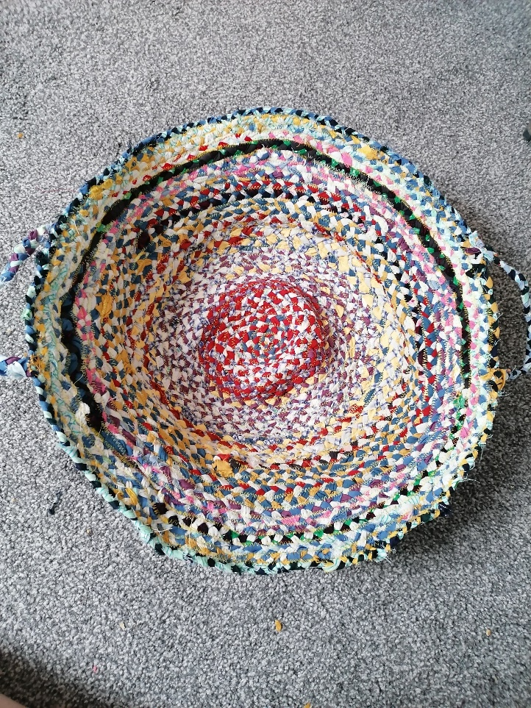

We argue that this reflects Leamy et al.’s (2011) process of finding ‘meaning in life’. In this way, Storytellers were able to use the foundation of finding community as a starting block. From this they could to try new experiences and take risks (for example, by trying new creative approaches or requesting support from the group). This gentle risk taking inevitably had mixed results; things did not always go well. Perhaps the final creative piece was not what was anticipated, as was the case for one Storyteller who experimented with modelling clay for the first time. However, the process of trying new things and experiencing both the positive and mixed outcomes allowed Storytellers to begin to experiment with looking for meaning in life. Leamy et al. (2011) indicate that this is an important part of the wider recovery journey, and can be instigated through connection with others. We suggest that this was the case in the Storytelling project.
Recovery as a series of small steps
The recovery experiences that many of our Storytellers shared presented recovery as being a series of small steps on a longer journey. This resonates with some of Leamy et al.’s (2011) characteristics of recovery – as a non-linear, gradual journey in stages/phases. For some, taking part in the Storytelling project was one step on this longer path. Storytellers highlighted the fact that they could look back to see where they were at the beginning of their experiences with Converge, and that this allowed them to see how far they had come. One Storyteller represented this in a sculpture (see Figure 2), which showed a small figure in a prison at the back of a path, which gradually became wider and more colourful. The path was made up of images of all the things that had helped this Storyteller n their recovery journey. This evocative tableau highlighted how each journey on the path had taken them further away from the imprisonment of their original experiences. These mirrored other themes raised in the traditional semi-structured interviews of the wider project (including Belonging, The Impact on Identity, Knowledge Exchange, and The Impact of Converge on Wellbeing).

Figure 2: Photo showing Storyteller sculpture representing the journey of recovery.
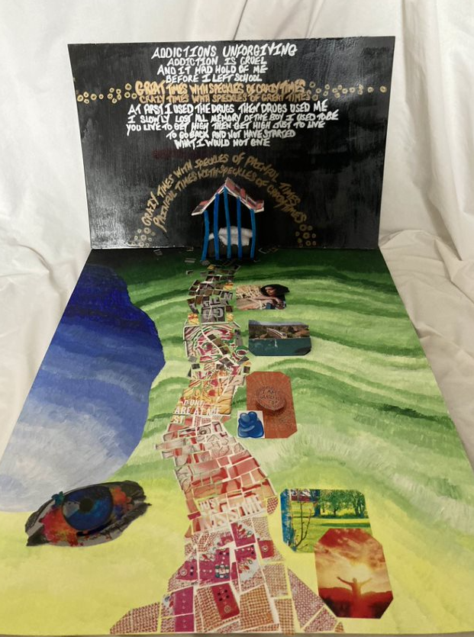

The effect of acceptance and belonging
Many of our Storytellers highlighted the effects of the acceptance and belonging they experienced at Converge. Leamy et al. (2011) identified that recovery is aided by a ‘supportive and healing environment’ and that ‘connectedness’ is a crucial recovery process. For many Storytellers, feeling accepted and part of a group was an unusual experience, given the stigma associated with poor mental health. In their autoethnographic work they represented the ways that they felt accepted by Converge from the very moment that they joined. Interestingly, this extended to their experiences of the Storytelling project itself. One Storyteller represented this acceptance and belonging through a series of watercolour paintings of faces organised as they would be in a Zoom room (see Figure 3). When explaining their work, they shared that this image represented to them how it is possible to feel truly seen by others, even online. Contrary to feeling adrift in a sea of faces, as the image may be interpreted, they reported feeling part of a wider group, by whom they were accepted as they were. Another Storyteller created a zine about a character who had superpowers granted to them by the acceptance and belonging they felt from their Converge colleagues. The Storyteller shared that they frequently struggled with self-doubt and imposter syndrome, which actively prevented them from taking part in things that were important to them. The acceptance that they experienced from Converge helped them begin to see themselves in a different light; they began to ask themselves whether they really could do these things, and whether their feelings of being an imposter were accurate. In this way, Converge served as a sandbox for them to practice in, lessons from which they could then take out into the wider world. The superhero character in their zine represented the self they felt they could be with the acceptance and belonging of the community.
These examples demonstrated ways in which these feelings and experiences directly influence how individuals feel about themselves and what they are capable of, reflecting Leamy et al.’s (2011) processes of ‘empowerment’, ‘hope and optimism about the future’ and ‘meaning in life’. As with many of the other themes, Storytellers shared how they experienced feelings through their autoethnographic work which were similar to other Storytellers as well as the core project team.
Feelings of acceptance and belonging seemed to be generated by shared experience, openness amongst staff and Storytellers, as well as a willingness to accept others at whatever point they were currently at. Coming into the project, all Storytellers were aware that they shared the experience of being or having been a Converge student; alongside this came acknowledgement of shared experiences of struggling with mental health. In interviews and as part of collaborative analysis groups, it was suggested that this common understanding of what it is like to live with poor mental health provided a solid foundation of acceptance of one another, related to a lack of judgement around how someone may be feeling or behaving. With this as the foundation, it became natural for Storytellers to share their experiences, not just of mental health, but also of Converge and other artistic endeavours. This had the cascading effect of generating further feelings of acceptance and belonging.
Figure 3: Watercolour by Storyteller to represent acceptance and belonging via Zoom.

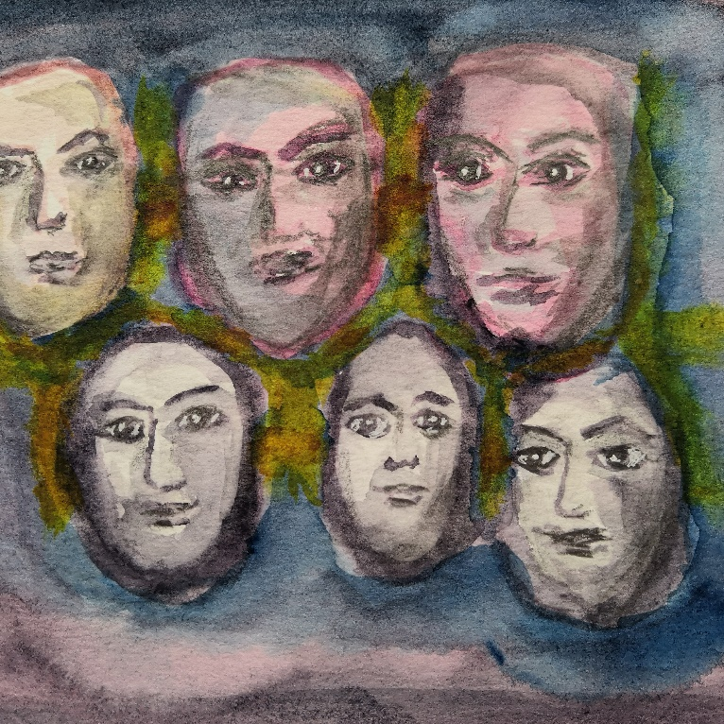

Exchange of attitudes and values
A key theme constructed by the Converge Evaluation Project was the importance of specific kinds of knowledge exchange. Our Storytellers reported that they learnt many new creative and technical skills through their time at Converge, which they found useful and interesting. This was not the form of knowledge exchange that was highlighted by Storytellers in the data, though. The kinds of knowledge exchange that our Storytellers valued most was related to an exchange of attitudes and values or life lessons. These related to the value of making mistakes; the importance of having belief in yourself; and the wisdom that comes from experience. Importantly, Converge students (both Storytellers and participants in the wider project) felt that they were able to share these values and attitudes with university students, just as they learned new skills and techniques from university students in their courses. This was a source of self-esteem for many of our Storytellers, who felt valued by university students for their capacity to share life lessons with each other. Storytellers represented this through poetry and songs, and also through the use of colour in clay sculptures that was intended to represent the diversity of experiences within Converge (see Figure 4). Again, these processes are reflected in Leamy et al.’s (2011) processes of ‘identity’, ‘meaning in life’ and ‘empowerment’.

Figure 4: Photo of sculpture made by Storyteller
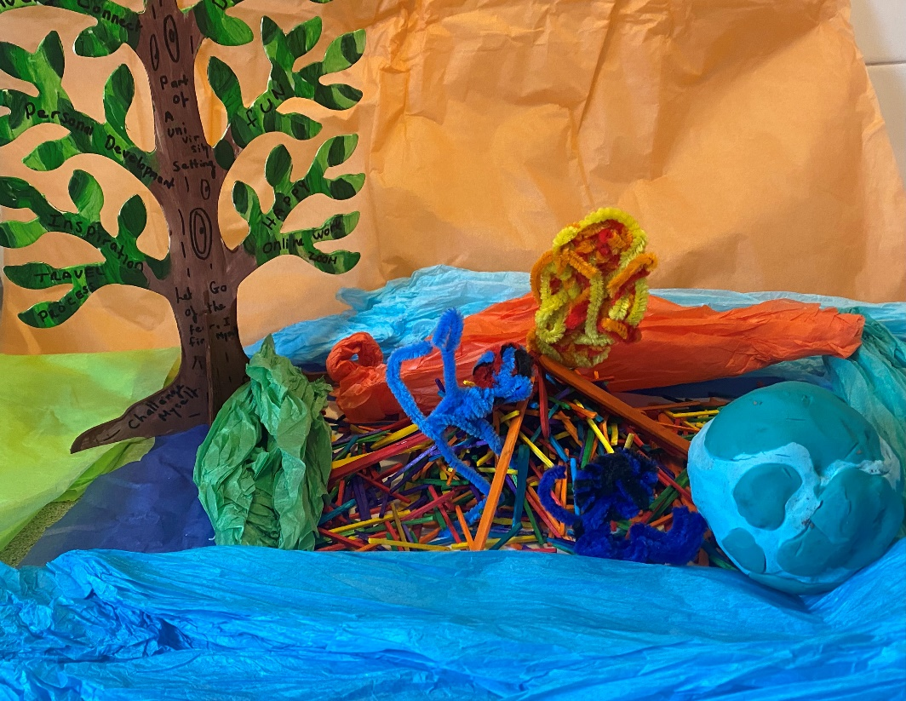

Outcomes for Storytellers
Being part of our Storytelling project had longer-term effects for many Storytellers. Some of these were positive and some more difficult; it seems important to highlight these as part of the results of the project. Coproduced autoethnographic research may be more likely to have lasting effects for peer researchers than traditional experiences of participating in research, given the more in-depth ways they may have been involved and deeper relationships that may be built. Many Storytellers reported that their wellbeing was positively affected by being part of the research. This may be linked to the themes above around community, self-esteem, and small recovery steps, again reflecting Leamy et al.’s (2011) characteristics of the recovery journey. Access to community and the chance to build lasting relationships was another long-term effect of being part of the project. Several Storytellers developed friendships through the project and started to build a support network that became very valuable for them. Some also took the first steps towards returning to education whilst part of the project; they attributed their ability to do this directly to being part of this research project. This was related to feeling a sense of accomplishment and a developing belief in their academic capabilities as a result of the research work they engaged in. Several Storytellers also felt that they were able to begin considering other avenues of paid work; some of these were related to research and co-production activities – evidence of Leamy et al.’s (2011) ‘hope and optimism about the future’.
It would be unbalanced, however, to suggest that every Storyteller’s experience on the project was solely positive. Several Storyteller left the project after struggling with their mental health. This was not necessarily related to the Storytelling activity; however, it is essential that researchers acknowledge fluctuations in Storytellers’ mental health and consider the possible role of the project in their difficulties. In all, three participants chose to end the Storytelling project early, however they all wished for their work so far to be included in analysis. When the Storytellers (two in the first group, one in the second) discussed wishing to leave, we offered multiple catch ups and relaxed chats to see if there was anything that could be done to provide more support. However, it also felt important to us as researchers to balance offering support with respect for each Storyteller’s autonomy and knowledge/expertise of what was best for them as individuals. All three Storytellers who left the project early were in touch with the researchers at the end of the overall project, after being invited to the final sharing event. Although they did not choose to attend, they all wanted to be sent copies of the final report, which they shared their thoughts on with the research assistant.
Given that we all worked together over several months, the end of the project raised the question of how to maintain or resolve the relationships that had been built over the course of the research. This points to wider issues concerning how we work relationally within our research framework: how do we handle these relationships at the end of the project? As researchers, we do not suggest we have found an answer to this conundrum. We tried to work in a person-centered way and indeed some Storytellers have remained in touch with some of the researchers over the subsequent months. Leamy et al. (2011) observe that the recovery journey can be ‘a struggle,’ a ‘non-linear’ and ‘gradual’ process.

Discussion
The Converge Storytelling project brought together a group of Converge students and researchers to reflect upon their experiences of being part of Converge using creative approaches. The themes constructed in this project highlight the importance of arts-based university-led education programmes for both university students and people who are currently experiencing, or in the past have experienced mental health challenges. There is a focus on the importance of community, of recovery being a series of small steps, the effect of acceptance and belonging, and the exchange of attitudes and values. There are many ways in which our findings indicate that Converge offers the opportunities for recovery identified by Leamy et al. (2011): connectedness, hope, identity, meaning in life and empowerment.
The first theme constructed from the data related to the importance of community – ‘connectedness’ in Leamy et al.’s (2011) framework. All storytellers made reference to the importance of being part of Converge, and how much they felt a part of the community we built together as Converge Storytellers. Research indicates that access to community is related to individual wellbeing, such that feeling part of a community leads to better overall wellbeing and mental health (Albanesi et al.,, 2007; Davidson & Cotter, 1991; Prezza & Costantini, 1998). This finding was borne out through the creative work of Storytellers and collaborative discussions together. Interestingly it was not just the wider Converge community that was cited, but also the smaller Storytelling community that we collaboratively created. A relational approach to community can help us understand this in more depth, partly by allowing us to consider the issues of power and inequality that existed within the group.
Whilst all Storytellers could claim payment for the hours they worked on the project, not all were able to because of fears around losing unemployment benefits, which created an inequality between the paid research assistants on the project, those who chose to be paid as Storytellers, and their colleagues/peers who were essentially giving their time for free. This meant that we, as research staff, needed to reflect on how we could attempt to equalise the power dynamics inherent to a research group like this one.
We were wary of putting across a message that there was one correct way of doing this kind of autoethnography-informed creative work, and so the research assistants participated in each activity as a group member and shared our own experiences of becoming part of Converge. This led to the building of strong relationships within the Storytelling group grounded in an acceptance and awareness of the differences between us, whilst attempting to be congruent members of the group. By seeing this process through a relational framework and moving away from the primacy of the individual, we can understand how we all contributed to the process of building community via the ways in which our relationships with each other shaped both us and the group we were part of (Atkinson et al., 2020).
Open acceptance of and discussion about our different experiences amongst all the researchers (staff and Storytellers) allowed us to build an open community that each member reported feeling part of. This mirrored the wider Converge community and the ways that access to that community improved mental health for individual participants. This also reflects Leamy et al.’s (2011) characteristic of recovery being aided by a ‘supportive and healing environment.’
Research indicates that having strong social relationships contributes to mental health and wellbeing (Umberson & Montez, 2010). The importance of community that was identified as a theme in the autoethnographic work of our Storytellers may be related to the building of friendships, both within the smaller group and within Converge more widely. Many Converge students experience social isolation as a result of their mental health challenges (and sometimes also physical disability). Research indicates that high quality relationships are especially important for the wellbeing of this population (Tough et al., 2017). The regular coffee mornings with scaffolded activities and discussion may have laid the foundation for these relationships to grow more easily, a process that is likely mirrored in Converge courses in which students are brought together around the course topic. These experiences highlight our interconnectedness and also help us understand how to care for others and ourselves, all of which are factors that contribute to friendship and sense of community (Cleary, Lees & Sayers, 2018).
Storytellers identified that part of their experience with Converge was the sense of belonging to and being accepted by Converge, and also the Storytellers group. Research indicates that isolation can exacerbate mental ill health (e.g., Wang et al., 2017; Rohde et al., 2016). Given that this project took place during the Covid-19 pandemic and accompanying lockdowns, with its widely acknowledged detrimental effect on mental health (e.g., Ganesan et al., 2021; Henssler et al., 2021), it is perhaps not surprising that these factors became so important. Converge courses and Storyteller meetings became a cornerstone of people’s lives during lockdowns and social distancing, and for many of the Storytellers who lived alone they were a key source of feelings of belonging to and being accepted by a community.
Themes of belonging and acceptance also related to the importance of participants being accepted for who and how they were in that moment. Converge courses do not require participants to meet any entry requirements or experience for enrolment, which facilitates a sense of belonging and inclusion for all. Storytellers shared that the research assistants playing an active role in coffee mornings contributed to the feelings of acceptance they experienced. As researchers, we can reflect on our own sense of belonging and being accepted by the Storytellers when we shared our own lived experiences around mental health. Traditionally, it is easy to hold ourselves apart from the research. However, in striving for coproduction and collaborative research in this project demanded that we did ourselves what we expected of the Storytellers we were working with. That often meant sharing our own stories and feelings, and accepting the sentiments that were conveyed in response. Suggesting that this sense of community only applied to the Storytellers themselves would be disingenuous; in reality, we as research staff felt this too.
One theme in these experiences related to recovery being a series of small steps, and not of one direct journey to being ‘recovered.’ This theme appears in Leamy et al.’s (2011) characteristics of the recovery journey – that it is an ‘active;’ ‘individual and unique;’ non-linear’ journey which is sometimes ‘a struggle.’ A definition of exactly what constitutes mental health recovery is not easy to find (Jacob et al., 2017) despite it being a concept that is commonly discussed by service providers and clinicians alike. For Storytellers, their recovery was a journey made up of small steps. Some of those steps may seem insignificant to others – things as simple as getting up and dressed to attend a Converge class. However, Storytellers believed each of these seemingly small actions contributed to an overall movement towards a way of life that was more connected, meaningful, and happier. It may be useful in future for researchers to consider how important small steps towards recovery are, and how we can help facilitate these. For Storytellers, the communities they were part of and the acceptance and belonging they felt from them provided the impetus and motivation to take small steps even when life was difficult. Here we can see how interlinked each of the themes in this project are. Mental health is complex with multiple interconnected facets, and it is not possible to extricate one of these themes to consider it in isolation.
The final theme identified from this data relates to findings from the wider project around the exchange of attitudes and values between the groups that make up Converge. Knowledge exchange refers to the exchange of information between different people, for example universities and local communities or across different healthcare service groups (Ward et al., 2012). There were, of course, instances of traditional knowledge exchange within the Storytelling group. Among these were the sharing of creative methods and the teaching of new skills such as zine-making, but this was not the kind of knowledge exchange identified in the autoethnographic work. The most important kind of exchange for Storytellers was an exchange of values and attitudes. This might have been in exchanging attitudes of acceptance and openness, or the ways in which Storytellers shared attitudes relating to the importance of mistakes with researchers. This kind of attitudinal knowledge exchange formed the foundation for the more traditional kinds of knowledge exchange that take part in Converge. It is clear that for our Storytellers, participating in Converge offers ‘connectedness’ between peers and with university students. Furthermore, ‘hope and optimism about the future’ and establishing a new, positive ‘identity’ are clearly evident in the Storyteller’s work. Related to this, gaining ‘meaning in life’ appears to be a common experience for Converge students, and the ‘empowerment’ that comes from these experiences are clear in the work of the Storytellers.
Certain methodological conclusions can be drawn from this project. One relates to the range of creative methods that Storytellers used to represent their experiences, from poetry to musical composition, to modelling and collage. Often mental health research focuses on traditional semi-structured interviews, which have great value in helping us to understand lived experiences of mental health. However, it is important to consider who we may be excluding from the data by offering such limited methods/opportunities for participation. By allowing Storytellers to choose their own medium of autoethnography, we tried to make the process more accessible to a group of people with a range of abilities, skills, and interests. The value of this seems obvious in the rich and varied responses, as well as the wider themes that have been constructed from those responses through our conversations with one another in the Storytelling group. We know that marginalised communities struggle with accessing healthcare, but it also seems they are less likely to take part in mental health research (Silberholz et al., 2017; Schueller et al., 2019). Some research indicates that accessing digital healthcare may be easier for these populations (Schueller et al., 2019) and it is important that as researchers we also reflect on what methods of participation might be most accessible for marginalised groups. By not doing this, we limit our understanding of the lived experience of mental health to a very specific kind of participant. Using creative methods and facilitating participants to craft their own responses may be one step in addressing this bias.
The accessibility of research methods for participants may explain why autoethnographically-informed designs, particularly using creative approaches, can be a particularly successful pathway for exploratory mental health research such as we have presented here. At the beginning of the project, many of the Storytellers struggled with not knowing what the ‘right’ answer was, or what we wanted their responses to be. The training led to a basic understanding of autoethnography and the importance of lived experience. This helped them to see the value in their own experiences and reflections and in considering the experiences of other Storytellers. This process was particularly empowering for some Storytellers. Creative autoethnographically-informed measures allow for the primacy of lived experience and this was something that Storytellers could relate to and understand.
The Storytelling group itself had a range of different outcomes, with some Storytellers moving into formal education or seeking out new working opportunities following the end of the project – reflecting Leamy et al.’s (2011) characteristics of recovery as an ‘active’ and ‘unique process’ and a ‘life-changing’ experience. Many of them made lasting friendships and are still in touch with some of the researchers now. Collaborative research such as this has the capacity to create positive change for the individuals involved, especially when researchers consider how to incorporate this into the programme. The senior research associate on this project prioritised experiences that would give Storytellers the opportunity to learn new skills and develop others, and for one Storyteller, this culminated in applying for and being offered a place on a university degree course. As researchers, we want to highlight the importance of considering the effect the research will have on participants such as Storytellers. This goes beyond simple ethical considerations around minimising harm and nudges us to an approach that considers how the research we do might have a tangibly beneficial effect on the participants themselves.
Not all Storytellers benefited from the project; several members of the group dropped out before the project ended. This did not appear to be a direct result of the project and seemed to be more related to general mental health fluctuations, something which should be anticipated when working within this population. Given that the project focused on experiences with Converge and thus were strongly related to mental health, it is possible that being part of the project was too intense or challenging for some Storytellers. It is important that we consider the risk of this and highlight it to Storytellers in order to ensure that their consent is fully informed and make it clear to them that they can withdraw if they need to without repercussions. Leamy et al. (2011) identify that recovery is a ‘non-linear’, ‘gradual’, ‘multidimensional’ and ‘trial and error process’ – as such, it should be expected that some Storytellers would drop out for a variety of reasons related or unrelated to the project.
This project focused on a small group of Storytellers and explicitly looked at their personal experiences with Converge. Hence there is a limit to how broadly generalizable the conclusions are. Furthermore, to be more fully coproduced, this article would have been written collaboratively with Storytellers, however, for a range of practical reasons related to time constraints and payment complications, no Storytellers chose to take part in writing. This means that any conclusions made in our project report and in this article are seen through the lens of the researcher authors as opposed to our Storytellers themselves.

Conclusions
The novel autoethnographically-informed research described here has produced evidence which resonates strongly with Leamy et al.’s (2011) CHIME recovery framework, both the recovery processes and the characteristics of the recovery journey they identified from their systematic review. It is clear that for our Storytellers, participating in Converge offers ‘connectedness’ between peers and with university students. Furthermore, ‘hope and optimism about the future’ and establishing a new, positive ‘identity’ are clearly evident in the Storyteller’s work. Related to this, gaining ‘meaning in life’ appears to be a common experience for Converge students, and the ‘empowerment’ that comes from these experiences are clear in the work of the Storytellers. This work highlights the importance of community, acceptance and belonging for mental health, and reflects that mental health recovery is a series of small steps on a longer journey. The significance of exchange of attitudes and values as a foundation for traditional knowledge exchange is also highlighted. We underline the importance of creating accessible mental health research participation methodologies when working with this population and suggest that our creative autoethnographically-informed approach might be an approach which is particularly well-suited to this activity.
We suggest that this novel autoethnographically-informed approach facilitating Storytellers to explore their own experiences of Converge, is a notably successful research design. Using art as both research method and data appears to have made our research project particularly accessible for the Storytellers, offering them a broad range of opportunities to express themselves and explore their experiences of Converge. Storytellers reported pride in their accomplishments and establishing friendships within their group. These findings resonate with Leamy et al.’s (2011) framework for personal recovery in mental health. We argue that our innovative autoethnographically-informed Storyteller design can be a very accessible and successful approach to exploratory mental health research.

Correspondence
Dr Ruth Knight
York St John University
r.knight1@yorksj.ac.uk
@RuthKnightPhD

Acknowledgements
The authors would like to thank Dr Harriet Barratt, Senior Research Associate who led the Converge Evaluation Project, for her consistent encouragement and mentorship. We also thank Prof Nick Rowe and Prof Matthew Reason for their considered and constructive feedback on initial drafts of this article, as well as their support.

References
Albanesi, C., Cicognani, E., & Zani, B. (2007). Sense of community, civic engagement and social well‐being in Italian adolescents. Journal of Community & Applied Social Psychology, 17(5), 387-406. https://doi.org/10.1002/casp.903
Andriolo, A. (2020). Image-based methodology in social psychology in Brazil: Perspectives and possibilities. In P. Reavey, (Ed.). A handbook of visual methods in psychology: Using and interpreting images in qualitative research (2nd edition) (pp. 502-535). Routledge https://doi.org/10.4324/9781351032063-3429
Atkinson, S., Bagnall, A. M., Corcoran, R., South, J., & Curtis, S. (2020). Being well together: Individual subjective and community wellbeing. Journal of Happiness Studies, 21(5), 1903-1921. https://doi.org/10.1007/s10902-019-00146-2
Barratt, H., et al. (2022). The Converge Evaluation Project 2020-22: Final report. Project Report. York St John University, York. https://www.yorksj.ac.uk/converge/evaluation-project/
Boden‐Stuart, Z. V., Larkin, M., & Harrop, C. (2021). Young adults’ dynamic relationships with their families in early psychosis: Identifying relational strengths and supporting relational agency. Psychology and Psychotherapy: Theory, Research and Practice, 94(3), 646-666. https://doi.org/10.1111/papt.12337
Braun, V., & Clarke, V. (2006). Using thematic analysis in psychology. Qualitative research in psychology, 3(2), 77-101.
Cleary, M., Lees, D., & Sayers, J. (2018). Friendship and mental health. Issues in Mental Health Nursing, 39(3), 279-281. https://doi.org/10.1080/01612840.2018.1431444
Davidson, W. B., & Cotter, P. R. (1991). The relationship between sense of community and subjective well‐being: A first look. Journal of Community Psychology, 19(3), 246-253. https://doi.org/10.1002/1520-6629(199107)19:3%3C246::AID-JCOP2290190308%3E3.0.CO;2-L
Ellis, C., Adams, T. E., & Bochner, A. P. (2011). Autoethnography: An overview. Historical Social Research / Historische Sozialforschung, 36(4-138), 273–290. http://www.jstor.org/stable/23032294
Ganesan, B., et al. (2021). Impact of coronavirus disease 2019 (COVID-19) outbreak quarantine, isolation, and lockdown policies on mental health and suicide. Frontiers in Psychiatry, 12, 565190. https://doi.org/10.3389/fpsyt.2021.565190
Gleeson, K. (2020). Polytextual thematic analysis for visual data. In P. Reavey (Ed.), A handbook of visual methods in psychology: Using and interpreting images in qualitative research (2nd edition) (pp. 536-554). Routledge. https://doi.org/10.4324/9781351032063-3631
Henssler, J., et al. (2021). Mental health effects of infection containment strategies: Quarantine and isolation—a systematic review and meta-analysis. European Archives of Psychiatry and Clinical Neuroscience, 271(2), 223-234. https://doi.org/10.1007/s00406-020-01196-x
Henwood, K., Shirani, F., & Finn, M. (2020). ‘So you think we’ve moved, changed, the representation got more what?’ Methodological and analytical reflections on visual (photo-elicitation) methods used in the men-as-fathers study. In P. Reavey (Ed.), A handbook of visual methods in psychology: Using and interpreting images in qualitative research (2nd edition) (pp. 555-571). Routledge. https://doi.org/10.4324/9781351032063-3732
Kara, H. (2015). Creative research methods in the social sciences: A practical guide. Bristol University Press.
Leamy, M., Bird, V., Boutillier, C., Williams, J., & Slade, M. (2011). Conceptual framework for personal recovery in mental health: Systematic review and narrative synthesis. The British Journal of Psychiatry, 199(6), 445-452. https://doi.org/10.1192/bjp.bp.110.083733
Leavy, P. (2015). Method meets art (3rd edition). Guildford Press.
Ngunjiri, F.W, Hernandez, K-A.C. & Chang, H. (2010). Living autoethnography: Connecting life and research. Journal of Research Practice, 6(1). Article E1.
Poulos, C. (2021). Essentials of autoethnography. American Psychological Association. https://psycnet.apa.org/doi/10.1037/0000222-000
Prezza, M., & Costantini, S. (1998). Sense of community and life satisfaction: Investigation in three different territorial contexts. Journal of Community & Applied Social Psychology, 8(3), 181-194. https://doi.org/10.1002/(SICI)1099-1298(199805/06)8:3%3C181::AID-CASP436%3E3.0.CO;2-4
Reavey, P. (2020). Introduction. In P. Reavey (Ed.), A handbook of visual methods in psychology: Using and interpreting images in qualitative research (2nd edition) (pp. 1-19). Routledge. https://doi.org/10.4324/9781351032063
Richardson, L. (2000). Evaluating ethnography. Qualitative Inquiry, 6(2), 253-255. http://dx.doi.org/10.1177/107780040000600207
Rohde, N., D’Ambrosio, C., Tang, K. K., & Rao, P. (2016). Estimating the mental health effects of social isolation. Applied Research in Quality of Life, 11, 853-869. https://doi.org/10.1007/s11482-015-9401-3
Schueller, S. M., Hunter, J. F., Figueroa, C., & Aguilera, A. (2019). Use of digital mental health for marginalized and underserved populations. Current Treatment Options in Psychiatry, 6, 243-255. https://doi.org/10.1007/s40501-019-00181-z
Silberholz, E. A., Brodie, N., Spector, N. D., & Pattishall, A. E. (2017). Disparities in access to care in marginalized populations. Current Opinion in Pediatrics, 29(6), 718-727. https://doi.org/10.1097/mop.0000000000000549
Tough, H., Siegrist, J., & Fekete, C. (2017). Social relationships, mental health and wellbeing in physical disability: A systematic review. BMC Public Health, 17(1), 1-18. https://doi.org/10.1186/s12889-017-4308-6
Umberson, D., & Karas, J.M. (2010). Social relationships and health: A flashpoint for health policy. Journal of Health and Social Behavior, 51(1_suppl), S54-S66. https://doi.org/10.1177/0022146510383501
Wang, J. et al. (2017). Social isolation in mental health: A conceptual and methodological review. Social Psychiatry and Psychiatric Epidemiology, 52, 1451-1461. https://doi.org/10.1007/s00127-017-1446-1
Ward, V., Smith, S., House, A., & Hamer, S. (2012). Exploring knowledge exchange: A useful framework for practice and policy. Social Science & Medicine, 74(3), 297-304. https://doi.org/10.1016/j.socscimed.2011.09.021
Ward, J. and Shortt, H. (2020). Using arts-based methods of research: A critical introduction to the development of arts-based research methods. In J. Ward & H. Shortt (Eds), Using arts-based research methods. Palgrave Studies in Business, Arts and Humanities. Palgrave Macmillan. http://dx.doi.org/10.1007/978-3-030-33069-9_1

