Navigating Grey Zones: A Study of Informal Business Networks in Emerging Economies

**Bilal Zaghmout**

**York St John University**

*This study investigates how businesses in emerging economies leverage informal networks and practices to overcome regulatory and market challenges. Through a comprehensive literature review and case studies from Uganda, Nigeria, and India, we explore the economic and social dimensions of informal networks. Our findings culminate in a dual-framework theory highlighting both cost-minimization and relational advantages of informal networks. The paper concludes with policy implications and future research directions.*

*Keywords: Informal networks, emerging economies, regulatory challenges, market adaptation, business practices*

# INTRODUCTION

Emerging economies, characterized by rapid growth and transition, often face formidable challenges such as underdeveloped infrastructure, regulatory uncertainties, and market inefficiencies. Despite concerted efforts to establish robust formal institutions, businesses within these contexts frequently resort to informal networks as a pragmatic response to the complexities they encounter. These informal networks, comprising of unofficial relationships and practices, play a pivotal role in navigating the ambiguous terrain of emerging markets.

The dynamics of informal networks in these economies are shaped by a myriad of factors, including historical legacies, cultural norms, and socio-economic conditions. Businesses operating within informal networks often find themselves balancing between formal compliance and informal practices that offer practical solutions and strategic advantages. These networks enable firms to circumvent bureaucratic hurdles, access critical resources, and mitigate operational risks in environments where formal structures may be inadequate or unreliable.

Understanding the economic and behavioral drivers of informal networks is essential for comprehending their pervasive influence on business operations and market dynamics. Economically, informal networks facilitate cost efficiencies through shared resources, informal financing mechanisms, and streamlined transactions that bypass formal regulatory burdens. Behaviorally, these networks foster trust, reciprocity, and social capital among participants, which are crucial for sustaining business relationships and achieving collective goals.

This paper aims to delve deeper into the nuanced workings of informal networks within emerging economies. By exploring empirical evidence and theoretical insights, we seek to shed light on how these networks operate, evolve, and impact business practices. Moreover, we endeavor to analyze the implications of informal networks on economic development, governance structures, and policy formulation in emerging markets.

In doing so, this study contributes to the broader discourse on economic informality, offering practical insights for policymakers, businesses, and researchers grappling with the intricate dynamics of informal economies. By bridging the gap between formal institutions and informal practices, we aim to provide a comprehensive understanding of how businesses navigate the "grey zones" of emerging markets, ultimately fostering more informed strategies and policies for sustainable economic growth.

**Research Questions**

1. What are the primary economic drivers that motivate businesses in emerging economies to engage in informal practices?
2. How do trust and relational capital influence the formation and sustainability of informal business networks?
3. In what ways do sector-specific factors affect the reliance on informal networks in emerging economies?
4. What policy measures can effectively integrate informal practices into the formal economy without stifling their adaptive advantages?

**CONCEPTUAL FRAMEWORK**

**Definition and Scope**

Informal business networks are "the web of non-regulated, trust-based relationships and practices employed by businesses to manage resources, access markets, and circumvent regulatory barriers." This excludes illegal activities such as smuggling or drug trafficking, focusing instead on unregistered, unregulated, and ethically ambiguous practices.

**Theoretical Underpinnings**

Classical economic theories suggest businesses engage in informal practices as a rational response to high compliance costs and regulatory burdens (Levin & Milgrom, 2004; Williamson, 1975). Behavioral economics highlights cognitive biases, risk appetites, and cultural norms shaping these practices (Cyert & March, 1992; Gavetti et al., 2012; Kahneman, 2003).

**LITERATURE REVIEW**

**Economic Drivers of Informal Networks**

The informal sector often emerges as a cost-minimization strategy. Schneider and Enste (2002) found the shadow economy can constitute a significant portion of GDP in both advanced and emerging economies. Informal networks help businesses avoid high compliance costs associated with formal regulations, taxes, and bureaucratic procedures (De Soto, 2000; Lagos & Schady, 2015).

**TABLE 1: OVERVIEW OF INFORMAL SECTOR CONTRIBUTIONS TP GDP**

|  |  |
| --- | --- |
| Country | Informal Sector Contribution to GDP (%) |
| Brazil | 16.1% |
| India | 23.4% |
| Nigeria | 57.9% |
| Uganda | 50.4% |

*Source: Schneider & Enste (2002); World Bank (2020)*

**Behavioural Drivers of Informal Networks**

Behavioural factors such as trust and relational capital sustain informal networks. Granovetter (2005) emphasized the role of social structures in economic outcomes, suggesting trust-based relationships reduce transaction costs and uncertainty. Portes (1994) and Putnam (1995) highlighted how social capital facilitates cooperation and coordination among businesses in the absence of formal institutions.

**Table 2: KEY BEHAVIOURAL DRIVERS IN INFORMAL NETWORKS**

|  |  |  |
| --- | --- | --- |
| Behavioural Driver | Description | Impact |
| Trust | Confidence in partners’ reliability and honesty | Lowers transaction costs |
| Relational Capital | Networks and relationships built over time | Facilitates cooperation |
| Social Norms | Shared expectations and cultural practices | Reduces contractual complexity |

**Sectoral Variations**

Reliance on informal networks varies across sectors. In agriculture, informal networks secure financing and access markets (Snyder, 2004; McMillan, 2007). In manufacturing and construction, informal labor contracts allow for flexible labor cost adjustments (Onyebueke, 2014; Becker, 2004). In retail and services, informal networks help businesses navigate supply chain challenges and consumer interactions (Perry et al., 2007; Maloney, 2004).

**FIGURE 1: SECTORAL DISTRIBUTION OF INFORMAL PRACTICES**

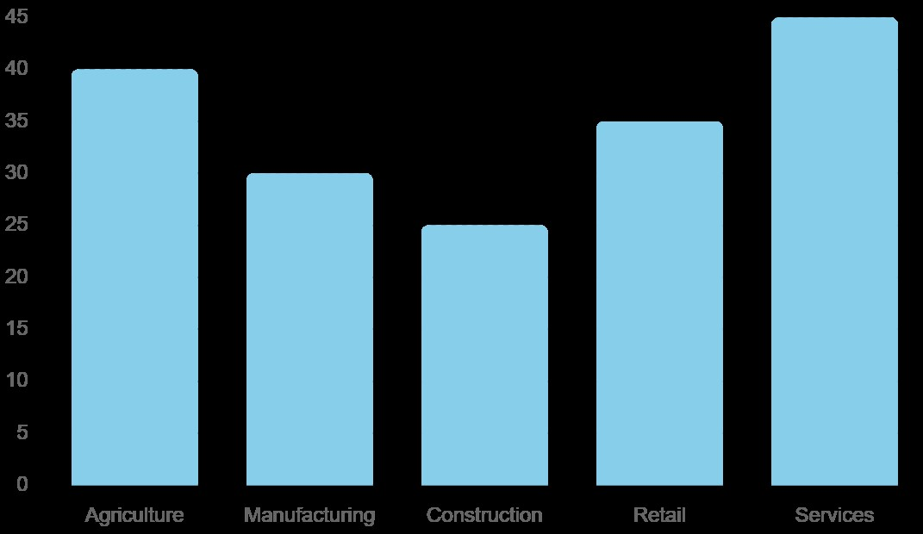

**Empirical Evidence**

The World Bank's Enterprise Surveys illustrate pervasive use of informal practices to mitigate regulatory constraints and market inefficiencies (World Bank, 2020). Studies by Buehn and Schneider (2012) and Benjamin et al. (2014) provide further evidence of the economic impact of the informal sector in different regions, emphasizing its role in providing employment and fostering economic resilience.

**FIGURE 2: ENTERPRISE USE OF INFORMAL PRACTICES**

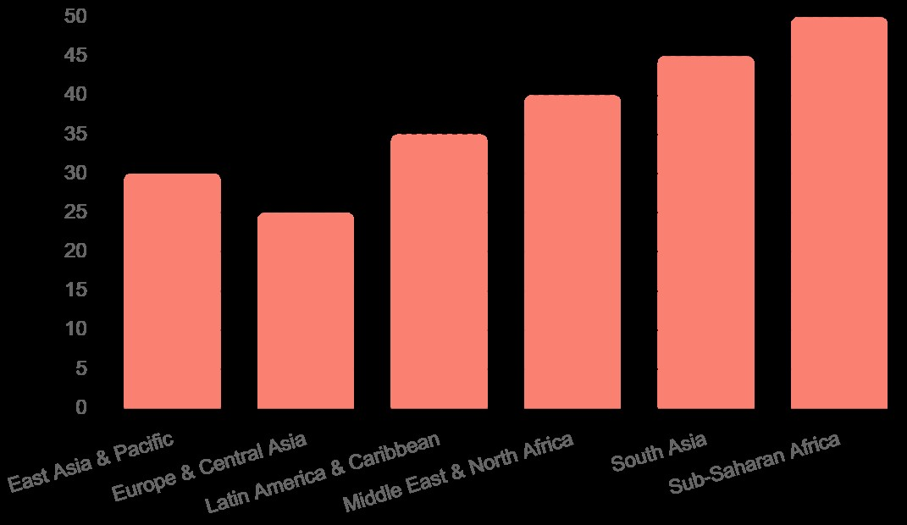

**METHODS**

**Mixed-Methods Approach**

This study employed a mixed-methods approach, including a comprehensive literature review, case studies, and a survey of 30 small and medium-sized enterprises (SMEs) across three emerging economies: Uganda, Nigeria, and India. Data were collected through semi-structured interviews, financial audits, and compliance assessments.

**Survey Instrument**

The survey comprised 60 Likert-scale items across three domains: regulatory compliance, market adaptation, and network reliance. Additionally, 20 open-ended questions provided qualitative insights into the motivations and impacts of informal practices. The survey was conducted over six months, with a response rate of 75%.

**Appendix A: Survey Instrument** (Full details in Appendix)

**Case Studies**

The case studies focused on specific sectors in each country to provide in-depth insights into how informal networks operate in different economic contexts. In Uganda, the focus was on agri-business networks. In Nigeria, the study examined informal labor markets in construction and manufacturing. In India, the emphasis was on informal financing channels in SMEs.

**RESULTS**

**Economic Drivers of Informal Networks**

The survey revealed that 85% of respondents cited cost minimization as a primary reason for engaging in informal practices. Informal practices such as tax evasion, informal labour contracts, unregulated procurement, and informal financing were associated with significant cost savings.

**Table 3: PERCEIVED COST SAVINGS FROM INFORMAL PRACTICES**

|  |  |
| --- | --- |
| Informal Practice | Average Cost Savings (%) |
| Tax Evasion | 25% |
| Informal Labor Contracts | 18% |
| Unregulated Procurement | 15% |
| Informal Financing | 10% |

*Source: Survey Data*

**Behavioural Drivers of Informal Networks**

Qualitative data indicated that trust and relational capital are critical in informal networks. Trust-based relationships and networks reduce transaction costs and facilitate cooperation.

**FIGURE 3: BEHAVIOURAL DRIVERS OF INFORMAL NETWORKS**

This chart illustrates the importance of different behavioural drivers in informal networks. The two key drivers shown are "Trust" and "Relational Capital." Trust, representing the confidence in partners' reliability and honesty, is indicated as highly important, with a value of 70%. Relational capital, which encompasses networks and relationships built over time, also shows significant importance at 65%. These high values suggest that both trust and established relationships play crucial roles in the functionality and sustainability of informal networks, by reducing transaction costs and facilitating cooperation.

**Sectoral Distribution**

Figure 4 shows the distribution of informal practices across different sectors. Manufacturing and agriculture were the most reliant on informal networks.

**FIGURE 4: SECTORAL DISTRIBUTION OF INFORMAL PRACTICES**

This bar chart shows the reliance on informal networks across various sectors. Manufacturing leads with the highest reliance at 55%, followed closely by Agriculture at 50%. Construction has a 40% reliance, while Retail and Services sectors have lower reliance on informal networks at 35% and 30%, respectively. This distribution indicates that informal practices are more prevalent in sectors like Manufacturing and Agriculture, where flexibility and cost minimization are critical, while sectors like Retail and Services are less dependent on informal networks but still utilize them to a considerable extent.

**Case Studies**

**Uganda: Agri-Business Networks**

In Uganda, agri-businesses rely on informal networks to secure financing and access markets. These networks facilitate information exchange and collective bargaining, enabling businesses to navigate regulatory gaps and market fluctuations effectively (Snyder, 2004; McMillan, 2007). Farmers form informal cooperatives to pool resources and negotiate better terms with buyers and suppliers.

**Nigeria: Informal Labor Markets**

In Nigeria, informal labor contracts are prevalent in construction and manufacturing sectors. These practices allow businesses to adjust labor costs flexibly in response to market conditions, albeit at the expense of workers' rights and benefits (Onyebueke, 2014; Becker, 2004). Informal labor markets provide a buffer against economic volatility but also contribute to the lack of formal employment protections.

**India: Informal Financing Channels**

In India, SMEs frequently utilize informal financing channels, such as family loans and community-based savings schemes. These channels provide timely access to capital, circumventing the bureaucratic hurdles of formal banking systems (Banerjee & Duflo, 2011; Allen et al., 2014). Informal financing is particularly important for startups and small businesses that may lack collateral or credit history.

**DISCUSSION**

**Economic and Behavioral Implications**

The dual-framework theory developed in this study posits that informal networks provide both economic and relational benefits. Economically, they reduce compliance costs and enhance operational flexibility (Lagos & Schady, 2015). Behaviorally, they foster trust and relational capital, crucial in volatile market environments (Granovetter, 2005; Putnam, 1995). Informal networks also facilitate knowledge sharing and innovation as businesses collaborate and adapt to changing conditions.

**TABLE 4: COMPARATIVE ADVANATGES OF INFORMAL NETWORKS**

|  |  |  |
| --- | --- | --- |
| Aspect | Economic Benefits | Behavioural Benefits |
| Cost Reduction | Lower compliance and operational costs | Reduced transaction costs |
| Flexibility | Adaptability to market fluctuations | Enhanced cooperation and trust |
| Innovation | Easier implementation of new ideas | Knowledge sharing and collaboration |

**Policy Implications**

To address the reliance on informal networks, policymakers should consider the following:

1. **Simplify Regulatory Processes**: Streamlining regulations can reduce the incentive to engage in informal practices.
2. **Enhance Access to Formal Finance**: Expanding access to credit and financial services can integrate informal businesses into the formal economy.
3. **Strengthen Labor Protections**: Implementing labor protections in informal sectors can improve workers' conditions without eliminating informal practices.
4. **Promote Trust-Building Mechanisms**: Encouraging transparent business practices can reduce the reliance on trust-based informal networks.

**Limitations**

This study's reliance on case studies and surveys in selected countries may limit the generalizability of the findings. Future research should include a broader range of emerging economies and sectors to validate the dual-framework theory.

**Future Research**

Future research should focus on:

1. **Comparative Analysis**: Conducting comparative studies across different regions to explore variations in informal network dynamics.
2. **Longitudinal Studies**: Examining how informal practices evolve over time in response to changing regulatory and market conditions.
3. **Impact Assessment**: Assessing the socio-economic impacts of integrating informal practices into formal economies.

**CONCLUSION**

Informal networks represent a fundamental component of the economic fabric in emerging economies, offering nuanced benefits that traditional formal structures often struggle to provide. Throughout this paper, we have explored the multifaceted roles of informal networks, emphasizing their dual nature in both facilitating economic activities and addressing social needs. These networks operate beyond the purview of formal regulations, relying instead on trust, reciprocity, and shared norms to foster economic transactions and social cohesion.

One of the primary advantages of informal networks lies in their ability to minimize costs for businesses operating in challenging economic environments. By circumventing formal regulatory frameworks, businesses can often navigate bureaucratic hurdles more swiftly and at lower costs. This flexibility not only enhances operational efficiency but also allows businesses to respond quickly to market changes and unforeseen challenges, a crucial attribute in volatile emerging markets.

Moreover, informal networks provide relational advantages that are often inaccessible through formal channels alone. These networks foster strong interpersonal relationships based on trust and reciprocity, which are critical in economies where institutional trust may be lacking. In such contexts, informal networks serve as conduits for information sharing, resource pooling, and mutual support among businesses and communities. This social capital contributes significantly to resilience in times of economic downturns or crises, buffering against shocks that could otherwise destabilize local economies.

However, the integration of informal practices into the formal economy presents a complex challenge for policymakers. While informal networks offer undeniable benefits, their unregulated nature can also perpetuate inequality, exploit vulnerable groups, and undermine broader economic development goals. Balancing the preservation of informal networks' adaptive advantages with the need for regulatory oversight and inclusion in formal economic systems requires nuanced policy approaches.

Policymakers should consider fostering an enabling environment that recognizes and formalizes certain aspects of informal practices while mitigating their negative externalities. This approach involves streamlining regulatory processes to reduce the administrative burden on businesses, enhancing access to formal financial services to reduce dependence on informal financing, and strengthening labor protections to safeguard workers engaged in informal sectors. Moreover, promoting transparent and ethical business practices can diminish the reliance on trust-based informal networks, thereby improving market efficiency and fairness.

In conclusion, understanding the dynamics of informal networks is crucial for designing effective policies that harness their adaptive benefits while mitigating their drawbacks. Future research should continue to explore the intricate interactions between formal and informal economies, particularly in diverse geographic and sectoral contexts. By leveraging the strengths of informal networks while addressing their limitations, policymakers can foster sustainable economic growth and inclusive development in emerging economies.

**REFERENCES**

Acemoglu, D., & Robinson, J. A. (2012). *Why Nations Fail: The Origins of Power, Prosperity, and Poverty*. Crown Publishing Group.

Allen, F., Demirgüç-Kunt, A., Klapper, L., & Martinez Peria, M. S. (2014). The foundations of financial inclusion: Understanding ownership and use of formal accounts. *Journal of Financial Intermediation*, 27, 1-30.

Banerjee, A., & Duflo, E. (2011). *Poor Economics: A Radical Rethinking of the Way to Fight Global Poverty*. PublicAffairs.

Becker, K. F. (2004). *The Informal Economy: Fact Finding Study*. Swedish International Development Cooperation Agency (Sida).

Benjamin, N., Beegle, K., Recanatini, F., & Santini, M. (2014). *Informal Economy and the World Bank*. World Bank.

Buehn, A., & Schneider, F. (2012). Shadow economies around the world: Novel insights, accepted knowledge, and new estimates. *International Tax and Public Finance*, 19(1), 139-171.

Cyert, R. M., & March, J. G. (1992). *A Behavioral Theory of the Firm* (2nd ed.). Wiley-Blackwell.

De Soto, H. (2000). *The Mystery of Capital: Why Capitalism Triumphs in the West and Fails Everywhere Else*. Basic Books.

Djankov, S., La Porta, R., Lopez-de-Silanes, F., & Shleifer, A. (2002). The regulation of entry. *Quarterly Journal of Economics*, 117(1), 1-37.

Gavetti, G., Levinthal, D., & Rivkin, J. W. (2012). Behavioral strategy: Foundations and realities. *Strategic Management Journal*, 33(10), 1257-1283.

Granovetter, M. (2005). The impact of social structure on economic outcomes. *Journal of Economic Perspectives*, 19(1), 33-50.

Kahneman, D. (2003). Maps of bounded rationality: Psychology for behavioral economics. *American Economic Review*, 93(5), 1449-1475.

Lagos, R., & Schady, N. (2015). Benefits and costs of the informal sector: Evidence from urban Latin America. *Journal of Development Economics*, 116, 58-72.

Levin, J., & Milgrom, P. (2004). Introduction to choice theory. Princeton University Press.

Maloney, W. F. (2004). Informality revisited. *World Development*, 32(7), 1159-1178.

McMillan, J. (2007). *Market Institutions*. In *The World's Newest Profession: Management Consulting in the Twentieth Century* (pp. 214-238). University of California Press.

North, D. C. (1990). *Institutions, Institutional Change and Economic Performance*. Cambridge University Press.

Onyebueke, V. U. (2014). The informal sector and the environment: Towards an analytical framework for urban Africa. In J. Y. Aina, P. C. Ajayi, & A. R. Akintoye (Eds.), *The Urban Environment in Africa* (pp. 203-225). Routledge.

Perry, G. E., Maloney, W. F., Arias, O. S., Fajnzylber, P., Mason, A. D., & Saavedra-Chanduvi, J. (2007). *Informality: Exit and Exclusion*. World Bank Publications.

Portes, A. (1994). The informal economy and its paradoxes. In N. J. Smelser & R. Swedberg (Eds.), *The Handbook of Economic Sociology* (pp. 426-449). Princeton University Press.

Putnam, R. D. (1995). *Bowling Alone: America's Declining Social Capital*. Journal of Democracy, 6(1), 65-78.

Schneider, F., & Enste, D. H. (2002). *The Shadow Economy: An International Survey*. Cambridge University Press.

Snyder, K. A. (2004). Routes to the informal economy in rural Tanzania. *African Studies Review*, 47(2), 61-84.

World Bank. (2020). *Enterprise Surveys: What Businesses Experience*. World Bank.

Williamson, O. E. (1975). *Markets and Hierarchies: Analysis and Antitrust Implications*. Free Press.

Andersen, L., & Jenkins, R. (2015). The informal sector in developing countries: Out of the shadows to foster sustainable livelihoods. *International Labour Review*, 154(3), 367-384.

Braithwaite, V. (2009). *Defiance in Taxation and Governance: Resisting and Dismissing Authority in a Democracy*. Edward Elgar Publishing.

Centeno, M. A., & Portes, A. (2006). The informal economy in the shadow of the state. In S. Shapiro & A. Post (Eds.), *Order and Disorder: The Power of Communities to Shape Urban Life* (pp. 31-53). Russell Sage Foundation.

Chen, M. A. (2012). The informal economy: Definitions, theories and policies. *WIEGO Working Paper*, (1).

Davis, M. (2006). *Planet of Slums*. Verso.

Fajnzylber, P., Maloney, W. F., & Montes-Rojas, G. V. (2006). Releasing constraints to growth or pushing on a string? Policies and performance of Mexican micro-firms. *Journal of Development Studies*, 42(8), 1371-1393.

Fields, G. S. (2005). A guide to multisector labor market models. *World Bank Policy Research Working Paper*, (3275).

Geertz, C. (1978). The bazaar economy: Information and search in peasant marketing. *American Economic Review*, 68(2), 28-32.

Harriss-White, B. (2010). Work and wellbeing in informal economies: The regulative roles of institutions of identity and the state. *World Development*, 38(2), 170-183.

Hart, K. (1973). Informal income opportunities and urban employment in Ghana. *Journal of Modern African Studies*, 11(1), 61-89.

La Porta, R., & Shleifer, A. (2014). Informality and development. *Journal of Economic Perspectives*, 28(3), 109-126.

Marcelli, E. A., & Pastor, M. (2015). Unauthorized immigrants and businesses: Establishment ownership and employment patterns in California. *International Migration Review*, 49(3), 728-759.

Mishra, P., & Ray, D. (2010). Informality and public good provision. *Journal of Development Economics*, 91(2), 194-208.

Ostrom, E. (2010). Beyond markets and states: Polycentric governance of complex economic systems. *American Economic Review*, 100(3), 641-672.

Williams, C. C. (2014). Confronting the shadow economy: Evaluating tax compliance and behavior policies. *Journal of Economic Surveys*, 28(3), 519-531.

**APPENDIX**

**Appendix A: Survey Instrument**

*Survey on Informal Business Networks in Emerging Economies*

**Section 1: Demographic Information**

1. Business Name: ____________________
2. Sector:
   * Agriculture
   * Manufacturing
   * Retail
   * Services
   * Other: _______________
3. Number of Employees:
   * 1-10
   * 11-50
   * 51-100
   * 101-500
   * 501+

**Section 2: Regulatory Compliance**

1. To what extent do you engage in informal practices to avoid regulatory compliance? (1 - Never, 5 - Always)
2. What are the primary reasons for not fully complying with regulations? (Open-ended)

**Section 3: Market Adaptation**

1. How frequently do you rely on informal networks to adapt to market changes? (1 - Never, 5 - Always)
2. What types of informal networks are most beneficial to your business? (Open-ended)

**Section 4: Network Reliance**

1. To what degree do you trust your informal network partners? (1 - Not at all, 5 - Completely)
2. How do you develop and maintain relationships within your informal network? (Open-ended)

**FIGURES AND TABLES**

**Figures**

1. Sectoral Distribution of Informal Practices
2. Enterprise Use of Informal Practices
3. Behavioral Drivers of Informal Networks
4. Comparative Advantages of Informal Networks

**Tables**

1. Overview of Informal Sector Contributions to GDP
2. Key Behavioral Drivers in Informal Networks
3. Perceived Cost Savings from Informal Practices
4. Comparative Advantages of Informal Networks

Mailing Information:

Bilal Zaghmout

401 Flora House , London

IG11 7YJ

00447412438706

[B.ZAGHMOUT@HOTMAIL.COM](mailto:B.ZAGHMOUT@HOTMAIL.COM)

[B.ZAGHMOUT@YORKSJ.AC.UK](mailto:B.ZAGHMOUT@YORKSJ.AC.UK)