‘Precarious Voices’: From Containment to Dissensus

Society of Women in Philosophy UK, Annual Conference 2016

Charlotte Haines Lyon

Doctoral Researcher: York St John University

This paper will explore how my research project which sought to extend parental voice in a primary school, through the implementation of Community Philosophy, might actually have further contained voices, especially precarious voices. I will explain how what might be seen as a problem has actually helped contribute to knowledge regarding the minutiae of parental voice within schools. Using the work of Wendy Brown, I will explore how voices can be contained by the need to be creditworthy. Finally, I draw upon the work of Luce Irigaray and Jacques Rancière to suggest how we might counter such containment and move towards a model of dissensus and thus begin to understand parental voice and engagement differently.
Carol Vincent developed three common positions for parents with regard to school: “consumers” who make wise choices to gain the best education for their children, “partners” who support the learning of the children and “citizens” who may be involved in governance issues of the school (Vincent, 2000: 1ff). However I would argue that all three of these positions contain or restrict voices of parents, especially angry voices, to some extent. My research set out to counter these prevailing narratives surrounding parents and education in England. At best, parents are placed as support acts to the school (Lumby, 2007; Vincent, 2000) and at worst blamed for the underachievement of their disadvantaged child (Milburn, 2014; Wilshaw, 2013).
I did not want to be seen as a rabble rouser when writing my participatory action research proposal and seeking access to ‘Greenleaf Primary School’. I placed much emphasis on “harmonious relations” between parents and schools. Community Philosophy (CP) draws upon ‘Philosophy for Children’ methodology, (SAPERE, 2015) encouraging: critical engagement with community issues, collectively building an argument in relation to these issues and exploring appropriate actions to take. The ethos of CP, it was hoped, would mitigate against the risk of individuals dominating the group with ‘pet peeves’.
The small group of participants, in fact, requested an end to the formality of CP sessions after three meetings. They felt that the formality and expectation to ‘do something’ put off people; despite this they maintained the focus on being problem solving. The focus of the meetings was parental engagement and closing the gap in achievement between the most disadvantaged children and their peers. The participants quickly identified Free School Meals as the proxy for disadvantage as problematic. One of the issues identified was that the precarity of employment, health and housing did not necessarily trigger Free School Meals, but may have an impact on families. There was also concern regarding the stereotyping of precarious families.

Containment of moaning, containment of rage?
Throughout the project there has been an emphasis by participants and the first headteacher of Greenleaf (a second took over in January), on preventing moaning and concern that the meetings would become ‘slagathons’.
In an interview the headteacher said,
“Well I think it’s really good to come at it from a different point of view and not be a kind of ‘come a long and moan about the school’. . . thinking about problems or issues and how we can solve them together has a lot more merit.” (HT interview June 2015)
During the second Community Philosophy meeting two participants said:
I think [the project’s] a sort of early warning system for [the school] as well and before it gets to a big problem it gives them some sensible people saying ‘actually have you thought about. . . ‘ (H July 2015)
It’s like mediating isn’t it? . . . We’ve got people we need to meet half way who go ‘ok I understand, can you think of a way to tackle it?’
(D July 2015)
The above quotations suggest a concern to keep anger and moaning at bay; instead focussing on a more consensual problem solving approach. Mary Beard criticises terms such as moaning, whinging, and whining as “they underpin an idiom that acts to remove the authority, the force, even the humour from what women have to say . . .effectively reposition[ing]women back into the domestic sphere.” (Beard, 2015: 814). Seen in this light, the emphasis within the project to avoid ‘moaning’ was a form of containment of anger and voice. Within the realm of parent-school relationships, which is very gendered (Reay, 1998), it is easy to silence women by condemning or excluding moaning, complaints or indeed anger.
Moreover, the above quotes all hint at some form of othering, by the headteacher and participants, of those who may have complaints. Throughout the analysis of my transcripts an ‘us and them’ narrative appeared: middle class or privileged parents versus disadvantaged parents, as well as parents versus school’. However, recently some of the participants read through our transcripts with me and concern was expressed for how teachers might also be stuck in the same ‘system’, as well as all parents finding it difficult to live up to the concept of the apparent perfect parent.

Creditworthiness and the neoliberal subject
Wendy Brown argues that within the neoliberal discourse everybody is fighting to be seen as creditworthy (Brown, 2015). I have applied this concept to my research in order to explore how voices, especially angry voices might be contained.
Parents are deemed to be creditworthy if they make the ‘right’ choices (for example the correct school and good employment (Gewirtz, 2001; Reay, 2008)). Such parents may criticise the school on occasion, as due to their generally good credit rating such criticism is seen an irregularity and may be forgiven as they are generally supportive. However they do risk being accused of being self-serving and over indulgent; Toby Young said that parents protesting against the new Year 2 SATs tests were “moronic, selfish middle-class warriors entrenching class divisions. . . it’s kids from disadvantaged backgrounds who are penalised by this therapeutic approach” (Young, 2016).
Those who are uncreditworthy, are less able to voice concerns, as it may reflect badly on them. Those in precarious employment may find their anger particularly contained; if they voice anger at an injustice, are they less likely to be given the next shift or employment contract? Often such families are described as vulnerable, which Kate Brown argues often links to notions of wrongdoing or undeserving and deserving poor (Brown, 2014). This can lead to self-policing of anger and voice, to avoid being seen as undeserving and one of ‘them’. It could be argued that within the school parental engagement context, some parents are seen as more deserving of voice, and recognition of their anger or complaints.
Those with fewer resources cannot take the ultimate exit action, when there is a problem with the school (Hirschman, 1970; Vincent, 2000; Wilson, 2008). Those who might be uncreditworthy must also be kept at arm’s length by the creditworthy, so as not to contaminate a good credit rating. Similarly, a school must be creditworthy, in order to maintain a good OFSTED rating. With regard to parents, this requires ensuring good results as well as managing parental anger in such a way that Parent View (the OFSTED website questionnaire to be filled in by parents) is positive.
Whilst on the surface it may seem that there are three distinct parties: ‘precarious’ or ‘uncreditworthy parents’, ‘privileged’ or ‘creditworthy parents’ and schools, I would argue that there is a myriad of different human beings, regularly contained by the need to be a supplicant neoliberal subject who must maintain or develop their creditworthiness at all times.
Hodge argues that traditionally, the subject is someone who is able to be objective and behave in a rational way, but that such concepts of objectivity and rationality are problematic (Hodge, 1988). Rationality and reason, are not benign, but can be used to keep those who want to talk about domestic problems such as parenting issues at bay. I am arguing that within the school setting, parents and schools are having to contend with being perfect neoliberal subjects whom make the correct economically beneficial choices.
As highlighted in the iceberg diagram, on first appearance there are three different groups angry voices contained in different ways, but actually there is a more complex picture beneath the surface within which voice and anger are contained.
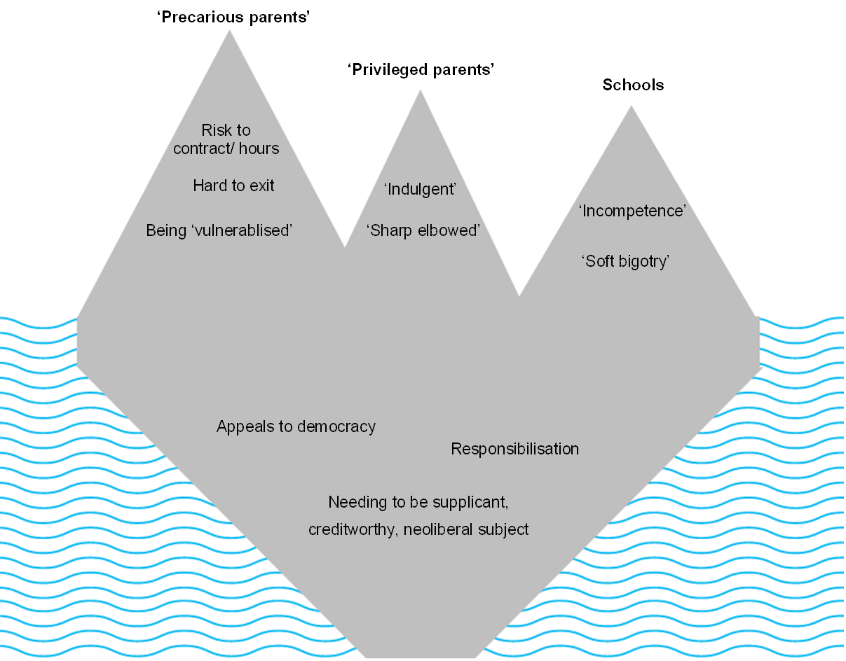
However it must be recognised that some people have more privilege than others. As Kelly Oliver explains, those who are oppressed do not receive forgiveness from the community for their transgressions as easily as those who are privileged members. This makes it far more difficult to speak out in anger, knowing that it is more dangerous to do so:
Those who benefit from dominant values are forgiven their individuality, their difference. But those excluded and disowned by dominant values are not forgiven; they are shamed, ridiculed, abjected, and abused for the difference. They are not allowed to become individuals who belong to the community. (Oliver, 2004: 92)

Dissenting subjects
Luce Irigaray argues that Western philosophy has developed a concept of a particular subject and that it has been built around the idea of a man (Irigaray, 1993; Irigaray, 1996; Irigaray, 1998; Irigaray and Pluháek, 2008). Whilst recognising (amongst other problems) the whiteness and heteronormativity of her arguments, she is helpful in problematizing concepts of a ‘perfect subject’ and difference between subjects. Furthermore considering the gendered nature of parental engagement and Mary Beard’s words, Irigaray highlights how we may be contained by false assumptions of what it means to be human.
Irigaray wrote that “A model of humanity is imposed that estranges man and woman from themselves. As such they do not fulfil themselves but conform to an idea of what it is to be human , of what the human being is” (Irigaray, 1996: 38). Rather than assuming that we must become a particular form of human being it is important to recognise the two subjects (male and female) and each one is only “one half of human kind”(Irigaray, 1996: 41). Without recognising the full identity and experience of each subject it is impossible to fully relate to each other, or be fully human.
For Irigaray, being fully human is a process of becoming, which occurs through relating to each other and learning from each other. There is a process of recognition but, because of our differences, we can never fully identify the other nor subordinate them. This allows for “a new ontology, a new ethics and a new politics in which the other is recognized as other and not as the same: greater, smaller, at best equal to me.” (Irigaray, 1998: 141). This process of becoming, whilst seemingly harmonious, requires us to break away from concepts of the perfect subject or human being. As Ziarek argues, this is a “double task of resistance and creation” (Ziarek 2001: 47). The resistance to the perfect subject is similar to Jacques Rancière’s concept of dissensus, in which the common sense is ruptured; in this particular case the sense of the creditworthy subject (Rancière, 2010).
Echoing Beard, Rancière argues that the simplest way to exclude people from the demos was to “assert that they belonged to the ‘domestic space’” rather than the acceptable public space in which only those with a public voice were allowed to govern (Rancière, 2010: 46). It is those who are excluded but take a stand and speak out against the ‘common sense’, who are taking political action. It is this speaking out that Rancière argues makes us human (Bingham et al, 2010).
Returning to the school situation, I am arguing that far from trying to maintain harmonious relationships in an effort to be creditworthy, it is necessary to be prepared for and indeed welcome dissensus. Formal overtures to seek voice may in turn become exclusionary or containing. However, it is as we seek to disrupt the concept of being the perfect parent or school that we can seek to become what it means to relate to each other within that community. Speaking out and people speaking out at us, may in fact be more beneficial in helping us become human and resisting the need to be creditworthy. Anger, frustration and upset, are not to be avoided but absolutely necessary.

References
Beard M. (2015) The Public Voice of Women. Women's History Review, 24 (5): 809-818.

Bingham CW, Biesta G and Rancière J. (2010) Jacques Rancière : Education, Truth, Emancipation. London, Continuum.

Brown K. (2014) Questioning the Vulnerability Zeitgeist: Care and Control Practices with ‘Vulnerable’ Young People. Social Policy & Society 13 (3): 371.

Brown W. (2015) Undoing the Demos: Neoliberalism's Stealth Revolution.New York,Zone.

Gewirtz S. (2001) Cloning the Blairs: New Labour's Programme for the Re-Socialization Of Working-Class Parents. Journal Of Education Policy 16 (4): 365-378.

Hirschman AO. (1970) Exit, Voice, and Loyalty: Responses to Decline in Firms, Organizations, and States. Cambridge, Massechussets, Harvard University Press.

Hodge J. (1988) Subject, Body and the Exclusions of Women from Philosophy. In: Griffiths M and Whitford M (eds) Feminist Perspectives in Philosophy. Basingstoke, Macmillan, 153-168.

Irigaray L. (1993) Je, Tu, Nous: Toward a Culture of Difference. New York, Routledge.

Irigaray L. (1996) I Love to You: Sketch for a Felicity Within History. New York, Routledge.

Irigaray L. (1998) Democracy between two. London, Athlone Press.

Irigaray L and Pluháek S. (2008) Conversations. London, Continuum.

Lumby J. (2007) Parent Voice: Knowledge, Values and Viewpoint. Improving Schools 10 (3): 220-232.

Milburn A. (2014) State of the Nation 2014. London, Social Mobility and Child Poverty Commission.

Oliver K. (2004) The Colonization of Psychic Space a Psychoanalytic Social Theory of Oppression. Minneapolis, University of Minnesota Press.

Rancière J. (2010) Dissensus: On Politics and Aesthetics.London, Continuum.

Reay D. (1998) Engendering Social Reproduction: Mothers in the Educational Marketplace. British Journal of Sociology of Education 19(2): 195-209.

Reay D. (2008) Tony Blair, the Promotion of the "Active" Educational Citizen, and Middle-Class Hegemony. Oxford Review of Education 34(6): 639-650.

SAPERE. (2015) Community Philosophy. Available at: http://www.sapere.org.uk/Default.aspx?tabid=102.

Vincent C. (2000) Including Parents? Education, Citizenship and Parental Agency.Buckingham, Open University Press.

Wilshaw M. (2013) Unseen Children - HMCI Speech. Available at: http://webarchive.nationalarchives.gov.uk/20131216154121/https://www.ofsted.gov.uk/resources/unseen-children-hmci-speech.

Wilson D. (2008) Exit, Voice and Quality in the English Education Sector: University of Bristol. Centre for Market and Public Organisation. Available at: http://www.bristol.ac.uk/media-library/sites/cmpo/migrated/documents/wp194.pdf
Young T. (2016) Status Anxiety: If the Sats-strike parents get their way only the poorer kids will suffer. Available at: http://www.spectator.co.uk/2016/05/if-the-sats-strike-parents-get-their-way-only-the-poorer-kids-will-suffer/.
Ziarek E. (2001) An Ethics of Dissensus; Postmodernity, Feminism, and the Politics of Radical Democracy. Standford, Standford University Press.

A pseudonym has been used.

