Using 3D modelling and game engine technologies for interactive exploration of cultural heritage: an evaluation of four game engines in relation to Roman archaeological heritage

Matthew Smithª
m.smith4@yorksj.ac.uk

Nigel Stephen Walford^{b} (corresponding author)
N.Walford@kingston.ac.uk

Carlos Jimenez-Bescos^{c}
Carlos.Jimenez-Bescos@nottingham.ac.uk

ª Geography Subject Area,
School of Humanities, Religion and Philosophy,
York St John University,
Lord Mayor’s Walk
York. YO31 7EX
United Kingdom

^{b} Department of Geography, Geology and the Environment,
Kingston University,
Penrhyn Road,
Kingston upon Thames. KT1 2EE
United Kingdom

^{c} Department of Architecture and Built Environment,
University of Nottingham,
University Park Campus,
Nottingham, NG7 2Rd
United Kingdom

Acknowledgements

The authors gratefully acknowledge the assistance received from Sussex Archaeological Society and in particular Dr Rob Symmons at the Fishbourne Palace Museum for their help with providing access to the site and its artefacts.

This work was supported by a doctoral research studentship from Kingston University, UK. The University had no involvement in the study design, collection, analysis and interpretation of data in writing the article and the decision to submit the article for publication.

Abstract

Developments in information technology have challenged the traditional model of museums, libraries and similar venues acting as relatively passive ‘learning spaces’ for the public to access ‘knowledge‘ as an exchange between tutor and learner, or in this context curator and visitor enabling them to offer more immersive and interactive modes of transfer. This article examines the development of a 3D model built from plans of a Roman edifice and its transfer into four game engines as vehicles for independent navigation around the ‘virtual building’. The game engines are evaluated in respect of their ability to enhance visitors’ experience by using an on-site facility when visiting a museum constructed over the physical remains. Cost and licensing override technical factors such as audio visual and functional fidelity or composability and installing the system on a PC is preferable to more specialist game control devices if a broad user base is targeted.

Key words: 3D modelling; serious gaming; virtual reality; Roman archaeology

Declarations of conflicts of interest: none.

1.0 Introduction

Publicly accessible experiential ‘learning spaces’, such as galleries, libraries and museums, are on a journey transitioning from experiences based on transferring “sets of knowledge ... between tutor and learner” to more immersive, interactive encounters. (De Freitas, 2009: 43). More recently Pescarin (2014: 131-132) argued that importance of museums now goes “much beyond the simple display of objects or artworks, their conservation and study”: they are “places of social aggregation and of informal learning” where can hear stories“. The growing popularity of such a transformative approach to ‘public learning’ is revealed by a competition run by the British Library in 2013 that invited game design students to convert maps into virtual worlds using CryENGINE (Click, 2013). Keeping abreast of such technological changes is regarded as important for sustaining the “cultural authority and position [of museums] in the 21st century” (Müller, 2002: 21). Variation in visitor number trends between museums may indicate the extent to which individual attractions have engaged with these evolving technologies. Visitor numbers at the Fishbourne Roman Palace Museum near Chichester West Sussex have fallen for over a decade (Symmons, 2013: pers comm.) and this paper explores the potential for enhancing the ‘visitor experience’ by developing a game engine enabled 3D model of the Palace as, according to the available archaeological evidence, it was in Roman times.

The remains of the Roman Palace were excavated in the 1960s adjacent to the contemporary village of Fishbourne some 3 km west of Chichester, West Sussex, England. They date from around the time of the Roman invasion and archaeologists have identified three phases of development: AD 43-75 a pre-palace period when military buildings and a granary were built; AD 75-100 palace construction and initial occupation; and AD 100-280(290) a period of renovation ultimately concluded by the palace’s destruction by fire (Cunliffe, 1977). The early buildings, referred to as the ‘proto-palace’, were incorporated into construction of the main Palace complex in AD 75, which occupies some 150 m² with formal and informal gardens surrounded by many rooms with painted walls, mosaics, marble inlays and friezes of moulded stucco and extensive bath suites the palace was clearly an impressive edifice (Cunliffe, 1971). He determined that various archaeological finds over many years originated from a single structure, which came to be known as Fishbourne Roman Palace. The site was acquired by the Sussex Archaeological Trust, which constructed buildings (opened to the public in 1968) to house, preserve and display the site and its finds. Further excavations throughout the 1980s, partly facilitated by realignment of the east-west A27 turn road around Chichester and Fishbourne revealed more about the Palace (Cunliffe, 1998) and the area’s occupation from the Mesolithic period (Manley and Rudkin, 2003).

The detailed documents arising from these archaeological investigations together with the visible physical remains themselves constituted a starting point for building a 3D model and visualisation of this important Roman building. In addition a physical model of the Palace had been created from these documents and, although it was not used explicitly as a basis for the digital model, the situation is not entirely dissimilar from that pertaining in the City of Prague where “the Langweil model ... [was] enclosed in a large glass case” from whence it was transformed into a virtual model (Rizvic, 2015: 2; see also Rizvic and Prazina, 2015) The aims of this article are to outline the building of the 3D model visualising Fishbourne Palace in virtual reality (VR) and its transfer to game engines and an evaluation of the suitability of four game engines according a specified set of criteria. The following section reviews literature related to visualisation, especially in the context of game engines technology, and to methods used by museums and similar public learning spaces for engaging with the public through virtual representations of archaeological heritage. The methods section examines building the 3D model of Fishbourne Roman Palace and transferring it into the game engines and the results section discusses the strengths and weaknesses of four game engines in respect of a standard set of assessment criteria. Finally, the lessons learnt from this case study are reviewed in the discussion and conclusion, which seeks to tease out the wider outcomes that may be applicable in other contexts.

2.0 Visualisation, Game Engines and Digital Cultural Heritage
2.1 Virtual environments and Game Engines
Why create a game engine enabled virtual environment? The term “serious gaming” (Stone, 2008) distinguishes between the use of game engines for non-recreational purposes, such as to enable interaction with virtual representations of heritage buildings or artefacts, and recreational applications, such as those attracting increasing numbers of participants and are now evolving into a spectator ‘sport’ (Cheung and Huang, 2011; Taylor et al. 2014; Hong and Magnusen, 2017). In a similar vein Natale and Piccininno (2018: 137) recently highlighted the ‘spectacularization’ of cultural heritage as a way of cities keeping abreast of tourists‘ expectations and increased familiarity with virtual worlds as well as a means of enhancing people’s understanding of the essence of cultural spaces as they were at the time of their construction (paraphrasing the words of Francesco Prosperetti, head of the Special Superintendency for Archaeology, Fine Arts and the Natural Landscape of Rome). Past research reveals a complex mix of conclusions in respect of the advantages and disadvantages of virtual environments in formal and informal learning situations, such as those presented in museums, art galleries and libraries. Connolly et al. (2012: 671), reviewing research on the topic, suggested that, although such games lead to improvements in “attentional and visual perceptual skills”, there is limited evidence that they lead to more effective learning, although these authors acknowledged the difficulties of classifying learning outcomes due to their diversity across the range of applications areas. One attempt to compare 2D visualisation (historical maps) with interactive displays that included a virtual tour of Nicosia, Cyprus (Michael et al., 2010: 257) concluded that the “interactive ICT exhibits have been rated higher than the traditional teaching methods (real map) and that most of the school children would want to do it again”, although it is worth noting that only one example of a traditional display is used, so the study is not exhaustive. Wrzesien and Raya (2010) reached a different conclusion when comparing the attainment of learning objectives by two groups of students one in a traditional context and the other in a virtual world. They found no statistically significant gain in learning effectiveness from either approach, although students recorded a higher level of engagement and greater willingness to participate. Roussou (2010) concluded that the combination of a virtual environment and interactivity had a higher level of learning effectiveness compared with those lacking this enhanced functionality. In contrast Pujol and Economou (2007: 92) argued that an interactive display “could not achieve an empathic engagement … because it lacked immersion and the presence of real human agents”, they also noted that their virtual world cannot work as a substitute for interaction with real world objects, an aspect which is essential to learn about the “practical/methodological aspects of sciences or life”. However, they noted that an important contribution of virtual realities in respect of heritage is the possibility of reconstructing and manipulating “elements or phenomena” which are no longer available, suggesting that such interactive exhibitions are at their best when supplementing traditional displays, and/or providing a service which cannot be achieved by static displays alone. Dalgarno and Lee (2010: 23) attempted to summarise “what authors are claiming/asserting and implying about 3D (Virtual Learning Environments), their characteristics and potential learning benefits” (see Figure 1) and thereby to define an outline for further research into their design and use.
Increasing amounts of time and resources have been devoted to the development of 3D games and virtual worlds with only limited systematic effort to discover how best to exploit the capabilities and features of such systems for improving attainment of learning outcomes (see for example, Jasink, Faralli and Kruklidis, 2017). Dalgarno and Lee (2010: 26) propose a research agenda prioritising the “testing of basic assumptions and linking characteristics to affordances” in order to specify guidelines on ‘best practice’ for the design and development of virtual environments. Zin and Yue (2009) also identified a lack of clarity over the use of games as a medium for conveying knowledge and attempted to rectify this omission by proposing a game design model incorporating educational objectives. Figure 2, adapted from Zin and Yue (2009) outlines an approach derived from this model that could be adopted with respect to designing a virtual learning environment for Fishbourne Roman Palace using game engine technologies.
2.2 Museums and digital culture
Museums serve the dual purpose of conserving and curating artefacts and other items of cultural heritage, and informing or educating society and the public at various levels ranging from academic research to casual interest. The success of museums in serving these twin aims is increasingly assessed, including by funding agencies, in respect of their continued engagement and ability to ‘reinvent’ themselves, especially with successive generations (Styliani, 2009). The ‘digital age’ has intersected this process potentially offering opportunities to enrich people’s experience of museums, including through use of virtual reality for visualisation of artefacts (Barsanti, et al., 2015; Guerra, Pinto and Beato, 2015; Kiourt, Koutsoudis and Pavlidis, 2017). In this context Witcomb (2007: 38) argued that multimedia museum installations “play a structural role in the production of a meaningful text [and] demand our interpretive reading of them just like the traditional object on display does”. Conversely Marty and Jones (2008) observed limited exploration of the role of museums within the ‘information society’ and attempted to address the issues arising when people, information and technology interact within the ‘museum context’. The underlying question in respect of incorporating virtual environments into museums is whether they “help [us] to question or modify people’s understanding of the cultural significance of heritage sites” (Champion and Dave, 2007: 334). Such environments should nurture a richer sense of place by including elements such as role play or interactivity in addition simply to moving around. Perhaps a useful starting point is to enable participants in the virtual environment to see as much as possible through the eyes of the original inhabitants or occupants and to “suggest ideas of thematically related events, evidence of social autonomy, notions of territorial possession and shelter, and focus points of artifactual possession” (Champion and Dave, 2007: 336). Role playing, possibly involving the following of a narrative or event is envisaged with respect to large scale outdoor heritage by Refsland et al. (2007), would potentially help to enhance the interactive experience turning the museum visitor or “knowledgeable tourist” into an “active agent” (Flynn, 2007: 363). Arguably this is a necessary prerequisite for counteracting disruption to the connection between monuments and artefacts as museums transition from physical to virtual heritage. The inclusion of constraints, affordances and challenges within a virtual reconstruction can assist in creating a relationship between the user and the environment, helping to foster a sense that this place is not only a virtual representation, but was/is a real place, or even a home.
Support for incorporating digital technology and virtual representation in museums is now well established, however there remains the question of justifying the incorporation of game engines in such systems. Hongyan et al. (2009) detailed an example of using the Torque game engine to enhance problem solving skills by allowing users to conduct experiments in a virtual environment. Importantly the engine allows attributes or parameters associated with the experiments to be altered. Another aspect of recreational gaming that can beneficially be transferred to serious gaming applications in museums is the ability to allow users to follow a story (Wyeld and Leavy, 2008) and to learn about cultural heritage (Mortara, et al., 2014; Pietroni, Forlani and Ruffia, 2015; Sylaiou, et al., 2015; Hammady, Ma and Temple, 2016; Liarokapis, et al., 2017). Müller (2002: 28) discussing digital representations of artworks on the Internet observed that these “only gain depth when they are presented as part of a larger story”. He also noted that digital reproductions are less expensive and quicker than transportation of the physical objects which incurs costs of shipping, conservation and insurance. Champion (2016: 67) has questioned whether the incorporation of gaming (i.e. a form of entertainment) “helps or constrains the primary purposes of virtual heritage projects” by ignoring or trivialising the significance of behaviours that might today raise ethical issues.
In the period since the Fishbourne Roman Palace 3D visualisation project started (2010), there has been a substantial quantity of research recreating digital representations of monuments and artefacts some of which have incorporated serious gaming component. One of the most notable, certainly form an multi-national, European perspective, is the Virtual Museum Transnational Network. It involved researchers from several countries and different types of archaeological and cultural heritage collaborating with the aim of providing “the heritage sector with the tools and support to develop Virtual Museums that are educational, enjoyable, long-lasting and easy to maintain” (V-must, 2011). Antonaci and Pagano (2015) maintained that such virtual museums have the potential to ‘revolutionise’ visitors’ preconceptions, especially those from younger generations, about the staid, unexciting and essentially ‘boring’ nature of traditional museums. Under the auspices of the V-must initiative Pietroni, Forlani and Rufia (2015) reported on an innovative approach to storytelling in virtual museums and Abate and Sturdy-Colls (2018) worked on the less savoury, but nonetheless culturally significant topic of the extermination and labour camps at Treblinka.
The main aim here is to assess a selection of game engines for use in 3D virtual environments of archaeological heritage, using the example of Fishbourne Roman Palace, with a view to establishing basic principles for wider application. However, a brief review of other virtual environments incorporating game engine technology is appropriate. Stone et al. (2009a) established the proof of concept that a 3D model with game engine enhancement could be created cheaply and effectively with freely available software in respect of a submarine training application (Subsafe). Two further examples placing particular emphasis on situational awareness are the Integrated Subsea Visualisation Concept and Helicopter Brownout (Stone, 2012) and the first example tangentially connected with virtual heritage is Virtual Scylla that focuses on the population of ‘sterile’ virtual reconstructions with artificial life (Stone et al., 2009b; Stone and Guest, 2012). The notion of using a game engine to ‘visit’ a virtual environment first appeared in an application concerning a disused pyrites mine (Soares et al., 2010). Two Swedish examples concern use of VR to represent alternative road design and invited professionals and members of the public to consider the implications of alternative road design in relation to cultural heritage (Heldal, 2007). Table 1, adapted from Heldal (2007) summarises the advantages and issues associated with VR applications of this type.
It is in the nature of museums concerned with archaeological and social heritage that they seek to ‘bring the past to life’ or ‘show things as they were’, since the physical structures, living personages and human intercourse of times past by definition no longer exist. Game engine enabled VR constitutes an unrivalled tool for this purpose, by enabling visitors to overcome the passage of time, sweeping aside the decay or even destruction of buildings and physical artefacts, and vocalising the voices of people long since consigned to their graves. Examples of game engine enabled VR systems concerning heritage go beyond the systems just considered to provide further insight into issues and possible solutions. Champion (2008) argued that one of the main questions concerns how the museum audience or visitor will interact with the virtual visualisation rather than simply be presented with it so that an opportunity to “experience and understand” the past can be achieved. Two notable examples attempting to achieve this are of an Egyptian Temple and Queenscliff Fort respectively using the Unreal Tournament and Crytek CryENGINE game engines (Champion 2008). These examples are relatively small scale in comparison with Fishbourne Roman Palace. A larger scale example of using game engines is the creation of an Egyptian model (Bawaya, 2010), who highlighted the absence of standards in respect of software for this type of endeavour. Accuracy of representation is a further significant issue, which Martini and Ono (2010) address when discussing the Citadel of Bam example. This offers some parallels with the present aim of recreating the Fishbourne Roman Palace in so far as the earthquake of 2003 destroyed the buildings, but differs to the extent that in the case of the Citadel of Bam there were images and drawings from before its destruction, which were not available for Fishbourne Roman Palace. At the time of creating the Fishbourne Palace model two further examples of 3D modelling of cultural heritage sites had been reported: the Famosa Fortress in Melaka, Malaysia produced using 3DS Max (Izani et al. 2010) and the Roman Villa of Casal de Freira, Portugal created using AutoDesk’s AutoCAD and a GIS for landscaping (Rua and Alvito, 2011). These have now been joined by other examples including castles in the Czech Republic (Tobiáš, Cajthaml, and Krejčí, 2018).
3.0 Methods
3.1 Issues for consideration

The main focus in this section is on the issues involved with creating the 3D model of Fishbourne Roman Palace and its transfer into a selection of game engines. The issues concerned the availability of source materials, choice of modelling software, selection of game engines, defining the process for comparing them and the hardware possibilities for a public-facing application. A number of drawings of the palace as a whole (including unknown or speculative areas), plans of individual wings or rooms and cross-sections depicting highlights have been made since the site was excavated in the 1960s (see Figure 3). Physical finds also informed other aspects of the model, such glass fragments indicating that windows may have had a blue tint. The industry standard software Autodesk Maya, which is widely used in the television, film and gaming industries, has two important facilities in relation to creating a 3D virtual model of Fishbourne Roman Palace: the ability to import images as reference sources when creating models of buildings and other structures and to export in many formats suitable for game engines. It is also capable of exporting high quality video and images. Game engines are easier to use than specialist software, which was important in a public-facing application, they are readily customisable for different purposes and capable of being used on a range of hardware. However, not all game engines are ‘equal’ and four were selected on the basis of popularity, availability, cost and previous use in similar cultural heritage modelling applications. CryENGINE, created by German game developer Crytek, has been used in popular commercial releases such as Crysis and MechWarrior Online. Torque 3D, developed by GarageGames, is an open source engine used in games such as Penny Arcade Adventures, Unity, by Unity Technologies is available in free and chargeable versions and has been used in games such as Gone Home, Kerbal Space Program and for the PlayMancer project (Conconi, et al., 2008). Finally, Unreal, developed by Epic Games, has been used in X-COM and Dishonored amongst many others.

Trenholme and Smith (2008) undertook a comparison of CryENGINE, id Tech 3 and 4, Jupiter EX, Source, and Unreal 2, but the relatively rapid evolution of game engines meant that by the time the Fishbourne model was developed several of these had been superseded. Petridis et al. (2010) and Petridis et al. (2012) also included qualitative factors in their comparison and a combination of these approaches was used here. Petridis et al. (2010) and Petridis et al. (2012) listed five distinct comparators (fidelity (audio visual and functional), composability, accessibility, networking and heterogeneity (interoperability)), which were adapted to take account of the specific needs and resources of the Fishbourne Museum. Rendering and animation were considered important elements of audio visual fidelity, but sound less so, so as to minimise distraction to other museum visitors. Functional fidelity in respect of accurate physics and artificial intelligence were also considered minimal, limited to environmental effects such as weather and fire. Composabilty in terms of the ability to accept models from other software and the presence of tools to create environments were more important. Accessibility was also relevant with issues of cost and licensing determined by the brief of creating a virtual environment within the public space of the museum. Taking into account the likely need for museum staff to maintain, update or troubleshoot the application, ease of learning how to use each game engine and provision of support were also relevant. The aim was to create a standalone facility, which implied that network capability was unimportant, although support for various platforms and hardware was relevant in relation to the host museum’s purchasing decisions. Taking all these issues into account, Table 2 summarises the comparators or criteria considered to be of equal importance in our assessment.

The fifth issue concerned reviewing the range of hardware possibilities and the options available at the time (2014) were mainly PC, Microsoft Xbox 360, the Nintendo Wii, and the Sony PlayStation 3. Despite the ubiquity of the PC as a hardware format, each remains a computer designed for general, non-specific use, whereas a console, such as the Xbox 360, is designed and mass produced for use with games. The implication is that if an application works on one Xbox 360 it will work on all and these are less expensive, whereas the same ease of use does not necessarily apply to all PCs, whose modular nature means there is an infinite number of hardware and software configurations. Mouse, keypad, gamepad and motion controllers were the main options available as user input devices to the Fishbourne model, which would simply need to allow looking around, walking in different directions and an interact button (relatively uncomplicated facilities compared with most games). These considerations suggested that either an arcade joystick or a tracker ball, which offer the user a limited number of actions to perform, were the most suitable options.
3.2 Implementation
Creation of the 3D game engine enabled virtual environment of Fishbourne Roman Palace had three main phases: deciding what could feasibly be represented; conversion of this information into usable digital models in Autodesk Maya; and transferring these models to the four game engines and creating the overall environment. It was decided to represent the Palace as it would have existed towards the end of the first century AD, when it was significantly larger and more extravagant than during either the first phase of its existence or its declining years. Despite a rich wealth of information sources being available some of the physical remains are incomplete or missing altogether leaving no indication of what had been present. Figure 4a illustrates this variability revealing that despite restoration some of the mosaics contain gaps. This difficulty can be addressed in a number of ways and the approach adopted here was either to use altered forms of known mosaics on the site or ‘borrow’ images of mosaics from other contemporary buildings, such as the nearby Bignor Roman Villa. However, this does raise questions about the veracity of the final model. Phase two involved importing Cunliffe’s (1971) floor plan into Autodesk Maya so that the model could be built from the known and hypothecated ‘footprint’ of the Palace, using elevation drawings to help with creating the third dimension. The completed digital model was then textured by creating appropriate materials with which to cover the internal and external surfaces by a process known as UV mapping, which correctly aligns a 2D texture with a 3D object. Again, one of Fishbourne’s mosaics illustrates the complexity of this process (see Figure 4 b to d). Gaps in the mosaic were filled by means of an image editor or by recreating the image using the original as a reference or template. The final image has three layers representing the basal cement or grout, the mosaic image itself and a mosaic tile pattern that acts as removable mask that enables the gaps in the mosaic image to be viewed. Different approaches were required to transfer of the model to each of the four game engines according to their individual characteristics. Details of the procedure for each game engine are not included, but are published elsewhere (Smith, 2015). Each game engine allows importation of genuine terrain height data, but the Palace is located on a relatively featureless plain and so this was not carried out and instead a new landscape was created in each engine. This contrasts with other applications in which high resolution remotely sensed data and geographical information systems have been used to create a “realistic image of historic buildings and monuments” (Gabellone, 2017: 64) where data from excavations are missing.
4.0 Results

It is important to be aware of differences in language and methods when comparing software, the same thing can be referred by different terms and produced by different methods. CryENGINE’s Deferred Lighting and Unreal’s Deferred Rendering illustrate both issues. This issue was accommodated by simplifying and combining various aspects of the comparators into one, DirectX, or more specifically Direct3D. DirectX is updated regularly and acts as an interface between the hardware and software and therefore the more versions of DirectX a game engine supports, the more compatible it will be with various hardware. Table 3 summarises the comparison of the four game engines in respect of audio visual fidelity, functional fidelity, composability and accessibility. Any such comparison is inevitably ‘frozen in time’ and subsequent changes to the game engines software may have addressed some of the issues identified. In respect of audio visual fidelity Unreal and CryENGINE are capable of more sophisticated rendering on account of their layered textures and more advanced special effects, but this increased functionality adds complexity in comparison with a simpler approach (e.g. Torque 3D). The lack of shadows in the free version of Unity is also an issue as this detracts from the realism that can be achieved. With regard to functional fidelity the Torque 3D engine lacked capability in some areas, but as these artificial intelligence techniques are less important in the Fishbourne reconstruction, this was considered to have relatively low impact.

The most important factor once the environment had been created in the four engines related to the ease with which they could accept the 3D model of Fishbourne Palace that had been created using industry standard formats native to Maya. Most problems occurred when attempting this transfer into CryENGINE and necessitated many hours of ‘troubleshooting’, and there was an issue relating to scaling with the Unreal engine. The two main factors with regard accessibility relate to learning how to use the software and the licensing and charges involved in respect of public-facing cultural heritage facility that applies a general admission charge. The learning curve is a qualitative measure combining several elements including time required, user-friendliness of interface and provision of help text that provides an indication of how difficult it was to learn to use the software. The difficulty of transferring the 3D model into CryENGINE accounted for its ‘steep’ score on this comparator. The expected charges and licensing arrangements that would be likely to apply for installing a game engine enabled facility in the museum were determined by contacting representatives of each game engine supplier. There was considerable difference between them from ‘hundreds of thousands of dollars US’ in the case of CryENGINE through one-off payments of $1500 and $99 respectively for Unity Pro and Unreal to ‘free of charge with no royalties and full access’ for Torque 3D. Variation in the cost of the different engines relates to factors such as the degree of support provided, the inclusion of ready-made assets and the age of the engine. Overall the Unreal engine appears to be the most cost effective, offering an inexpensive solution with high visual fidelity and user support. It is followed by Torque 3D with slightly decreased visual fidelity but is free of charge. Reduced fidelity in the free version of Unity can be overcome by opting for the chargeable Pro version. CryENGINE offers comparable audio visual and functional fidelity, but for considerably higher cost.

Consideration of the hardware on which the four game engines were capable of operating is shown in the upper part of Table 4. There is widespread compatibility apart from with respect to the Nintendo Wii, although as use of the engines on any of the proprietary hardware would introduce a licensing charge, installation on a PC is really the only viable option for public-facing organisations with limited resources. The modular nature of PCs (see above) means the main parameters to be considered are the CPU (Central Processing Unit), GPU (Graphics Processing Unit) and RAM (Random Access Memory). The lower part of Table 4 provides an overview of the system requirements in respect of these elements. The CryENGINE and Unreal game engines posed more expensive hardware specifications compared with Unity and Torque 3D, although opportunity for scalability (i.e. more or less complexity and graphical fidelity) mean there is a degree of flexibility in the hardware requirements. However, opting for a lower specification could inhibit further development of the game engine enabled model. On the basis of the assessments presented here the Unreal Development Kit (UDK) is the most appropriate in situations such as those presented by the Fishbourne Roman Palace Museum provided that relatively modest resources can be deployed, although if these are a limiting factor the Torque 3D engine would be a suitable alternative. A standard gamepad is the most suitable type of controller as it avoids unnecessary complexity and would be familiar to many of the intended users. A standard gamepad is also relatively robust and easy to replace in case of damage.

User experience of the visualisation was assessed in terms of the degree of sophistication and amount of interactivity enabled in the 3D representation of the Palace. User’s readiness to embrace new technologies is an important factor in their positive and negative response to the game-enabled model that allowed unfettered navigation and in the most realistic version included shadow effects (Smith, Walford and Jimenez-Bescos, 2018) Users interact with the implementation through a standard Microsoft Xbox 360 control pad, which enables them to navigate freely around the virtual environment of the Palace encountering internal features such as the mosaics and external water fountains and box hedge planting in the gardens. Figure 5 offers a series of screenshots to illustrate selected internal and external views of the visualisation as seen by users of the application.

5.0 Discussion and Conclusion

The twin aims of this article were to review the building of a game engine enabled 3D model of the Fishbourne Roman Palace in VR as it existed during the time of the Roman occupation and, using this as an example, assess the merits of a selection of game engines according to a specified set of criteria. Although each application is unique, the intention was to provide a critical assessment and template that could be applied in similar situations where the aim is to ‘open up’ cultural heritage to new and existing visitors in ways that capture their imagination and enhance their learning experience. One of the main conclusions from the present investigation, which accords with the findings from Petridis et al (2010), is that composability is the main limiting factor when assessing the technical capability of a game engine for accepting digital models. However, in practice the availability or scarcity of finance is an overriding factor in non-commercial applications such as outlined here. Some aspects of the assessment carried out, for example graphical fidelity and ease of use, are less easy to define and quantify than others. Any comparison between elements of information technology inevitably encounters the problem that it is in a permanent state of flux. Indeed, shortly after completion of the assessment presented here the free version of Unity 3D was upgraded with shadow effects included. The usefulness of the findings rests not so much in the specific recommendations in this instance as in establishing robust criteria for undertaking such an assessment of available options.

These findings suggest that the search for a comprehensive, all embracing method of comparison and assessment may be somewhat illusory and that a selection of approaches tailored to the individual situation is more appropriate. Nevertheless, similar projects concerned with archaeological heritage and a museum with visitor and conservation functions could use the approach adopted here as a useful starting point. The principal consideration in these circumstances is cost, the most quantifiable factor in an assessment, and this should form the starting point. The recommendation that the Unreal Development Kit (UDK) with a standard gamepad, closely followed by the free of charge Torque 3D engine, are well suited to applications where resources are limited. Creation of the 3D model itself using Maya or similar industry standard software is also likely to be beyond the scope of non-commercial organisations such as the Fishbourne Roman Palace Museum both for reasons of cost and availability of personnel with the necessary skill-set, freely available modelling software such as Blender or SketchUp could address the first of these issues. Ott and Freina (2015) note that the use of immersive VR for educational purposes could increase as lower cost options become available and the same could apply in public learning spaces, although the issue of licensing may apply if admission charges apply.

There are certainly ways in which the virtual Fishbourne Palace created here could be enhanced, for example by having people performing tasks and more objects in the digital environment. Another possible extension would be to allow areas and rooms in the Palace to dissolve from one time period to another thus enabling users to appreciate its rise and fall over some 240 years. Fernandez-Palacios, Morabito and Remondino (2017: 46) using the Unity game engine, one of those assessed in respect of the Fishbourne 3D model, overlapped actual and hypothetical 3D models of Bettini tomb “to create a temporal VR visualisation to compare different situations”. It would also be possible, following ideas suggested by Trapp et al. (2010) to allow users to strip away the reconstructed Palace leaving only the existing archaeology behind, the foundations and mosaics in Fishbourne’s case, which would help to communicate the relationship between the reconstruction and the physical foundations upon which it was built. Further options could situate the reconstructed Palace within fully modelled contemporary and historical environments since it was abandoned in AD280 (290). No matter how much complexity is built into such museum-based virtual environments they may not automatically enhance the visitor experience and could potentially have a negative effect on social interaction among visitors (Marty, 2008). Pujol and Economou (2009) highlighted this point stating that “in order to be suitable for learning, cultural heritage virtual worlds need to be complete and show not only a visually realistic reconstruction of architecture but a real interactive and meaningful reconstruction of the past, containing active human presence”. At one level this could be achieved in Fishbourne by including some form of puzzle in the interactivity to engage viewers and encourage them to contribute to the system. However, a more advanced approach with “virtual humans (VHs) showing appearance and behaviour very similar (hopefully identical) to that of the original inhabitant” (Machidon, Duguleana and Carrozzoni, 2018: 249) can create greater realism. Recent developments in augmented reality could also allow these virtual humans to take on facial and other features of the users and visitors themselves enabling them to populate the virtual environment. The equipment required for such augmented reality has become progressively less cumbersome to use (Nassar and Meowed, 2010; Barry et al., 2012). The transition to digital cultural heritage noted at the start is now an inescapable factor of museum management and it as well to recall Müller’s (2002: 295) comment that “digital expansion will largely influence whether museums can sustain their cultural authority and position in the 21st century” and any museum that does not follow suit may soon be considered history itself.

References

Abate, D. and Sturdy-Colls, 2018 A multi-level and multi-sensor documentation approach of the Treblinka extermination and labour camps. Journal of Cultural Heritage, 34: 129-135. Doi: https://doi.org/10.1016/j.culher.2018.04.012
Antonaci, A., and Pagano, A. 2015 Technology Enhanced Visit to Museums. A Case Study: “Keys to Rome”. In L. Gómez Chova, A. López Martínez, I. Candel Torres (Eds.), Proceeding of the 9th International Technology, Education and Development Conference (INTED), Madrid, Spain, 02-04 March 2015 (pp. 4563- 4570). Madrid: IATED Academy, IATED Digital Library.
Barry, A., Thomas, G., Debenham, P. and Trout, J., 2012 Augmented reality in a public space: the Natural History Museum, London. Computer, 45(7): 42-47. Doi: http://dx.doi.org/10.1109/MC.2012.106
Barsanti, S.G., Caruso, G., Micoli, L.L., Rodrigues, M.C. and Guidi, G. 2015 3D visualisation of cultural heritage artefacts with virtual reality devices. The International Archives of the photogrammetry, Remote Sensing and Spatial Information Sciences, Vol. XL-5/W7, 25th International CIPA Symposium, Taipei, Taiwan.
Bawaya, M., 2010 Virtual archaeologists recreate parts of ancient worlds. Science, 327: 140-141. Doi: http://dx.doi.org/10.1126/science.327.5962.140
Champion, E.M., 2016 Entertaining the similarities and distinctions between serious games and virtual heritage projects. Entertainment Computing, 14: 67-74. Doi: http://dx.doi.org/10.1016/j.entcom.2015.11.003.
Champion, E.M., 2008 Otherness of place: game-based interaction and learning in virtual heritage projects. International Journal of Heritage Studies, 14(3): 210-228. Doi: https://doi.org/10.1080/13527250801953686
Champion, E.M. and Dave, B., 2007 Dialing Up the Past. In: F. Cameron and S. Kenderline, eds. Theorizing Digital Cultural Heritage. Cambridge, Massachusetts: MIT Press, pp. 333-347.
Cheung, C and Huang, J. 2011 StarCraft from the stands: understanding the game spectator, Proceedings of the SIGCHI Conference on Human Factors in Computing Systems, pp. 763-777.
Click. 2013 [Film]: BBC Two, 11 November 2013, 10:30 hrs.
Conconi, A., Ganchev, T., Kocsis, O., Papadopoulos, G., Fernandez-Aranda, F. and Jimenez-Murcia, S. 2008 PlayMancer: a serious gaming 3D environment. Florence, IEEE Computer Society, pp. 111-117.
Connolly, T.M., Boyle, E.A., MacArthur, E., Hainey, T. and Boyle, J.M. 2012 A systematic literature review of empirical evidence on computer games and serious games. Computers and Education, 59: 661-686. Doi: https://doi.org/10.1016/j.compedu.2012.03.004
Cunliffe, B. 1971 Excavations at Fishbourne. Leeds: Society of Antiquaries of London.
Cunliffe, B. 1977 Fishbourne Roman Palace. The Sussex Archaeological Society.
Cunliffe, B. 1998 Fishbourne Roman Palace. Stroud: Tempus.
Dalgarno, B. and Lee, M.J.W., 2010 What are the learning affordances of 3-D virtual environments? British Journal of Educational Technology, 41(1): 10-32. Doi: https://doi.org/10.1111/j.1467-8535.2009.01038.x
de Freitas, S., Rebolledo-Mendez, G., Liarokapis, F., Magoulas, G. and Poulovassilis, A. 2009 Developing an evaluation methodology for immersive learning experiences in a virtual world. Coventry, VS-GAMES, pp. 43-50.
Fernández-Palacios, B.J., Morabito, D. and Remondino, F. 2017 Access to complex reality-based 3D models using virtual reality solutions. Journal of Cultural Heritage, 23: 40-48. Doi: http://dx.doi.org/10.1016/j.culher.2016.09.003
Flynn, B., 2007 The Morphology of Space in Virtual Heritage. In: F. Cameron and S. Kenderline, (eds.) Theorizing Digital Cultural Heritage. Cambridge, Massachusetts: MIT Press, pp. 349-368.
Gabellonea, F., Lanorteb, A., Masinic, N. and Lasaponaraba, R. 2017 From remote sensing to a serious game: Digital reconstruction of an abandoned medieval village in Southern Italy. Journal of Cultural Heritage, 23: 63-70. Doi: http://dx.doi.org/10.1016/j.culher.2016.01.012
Guerra, J.P., Pinto, M.M. and Beato, C. 2015 Virtual reality – shows a new vision for tourism and heritage. European Scientific Journal, March 2015 Special Edition: 49-54. Doi: http://dx.doi.org/10.19044/esj.2015.v11n9p%25p
Hammady R. and Ma M., Temple N. 2016 Augmented Reality and Gamification in Heritage Museums. In: Marsh T., Ma M., Oliveira M., Baalsrud Hauge J., Göbel S. (eds) Serious Games. JCSG 2016. Lecture Notes in Computer Science, vol 9894. Springer, Cham
Heldal, I., 2007 Supporting participation in planning new roads by using virtual reality systems. Virtual Reality, 11: 145-159. Doi: https://doi.org/10.1007/s10055-006-0061-3
Hong, S.I.L. and Magnusen, M. 2017 From virtual reality to reality: examining the relationship between sport video gaming and sport consumption behaviours. Journal of Physical Education and Sport Management, 8(4): 41-49. Doi: http://dx.doi.org/10.5897/JPESM2016.0272
Hongyan, D., Zheng, J., Jia, W. and Xingyan, T., 2009 A platform of physical experiment inquiring learning based on 3D game engine. International Conference on Computational Intelligence and Software Engineering, IEEE, pp. 1-4.
Izani M., Bridges A., Grant P., Razak A., Rafi A. 2010 3D Modelling of the A Famosa Fortress in Melaka, Malaysia. In: Ioannides M., Fellner D., Georgopoulos A., Hadjimitsis D.G. (eds) Digital Heritage. EuroMed 2010. Lecture Notes in Computer Science, 6436. Springer, Berlin, Heidelberg
Jasink, A. M., Faralli, C. and Kruklidis, P. 2017 MUSINT II: a complex project on a virtual and interactive museum involving institutions of Florence, Rome and Heraklion. Studies in Digital Heritage, 1(2): 282-297. Doi: http://dx.doi.org/10.14434/sdh.v1i2.23192
Kiourt, C., Koutsoudis, A. and Pavlidis, G. 2016 DynaMus: a fully dynamic 3D virtual museum framework. Journal of Cultural Heritage, 22: 984-991. Doi: http://dx.doi.org/10.1016/j.culher.2016.06.007
Liarokapis, F., Petridis, P., Andrews, A. and de Freitas, S. 2017 Multimodal serious games technologies for cultural heritage. In: M. Ioannides, M., Magnenat-Thamann, N. and Papagiannakis, G. (eds.) Mixed Reality and Gamification for Cultural Heritage, Springer International Publishing AG. Doi: http://dx.doi.org/10.1007/978-3-319-49607-8_15
Machidon, O.M., Duguleana, M. and Carrozzino, M. 2018 Virtual humans in cultural heritage ICT applications: a review. Journal of Cultural Heritage, 33: 249-260. Doi: https://doi.org/10.1016/j.culher.2018.01.007
Manley, J and Rudkin, D. 2005 A pre-A.D. 43 ditch at Fishbourne Roman Palace, Chichester. Britannia, 36: 55-99. Doi: https://doi.org/10.3815/000000005784016973
Marty, P.F., 2008. Interactive Technologies. In: P.F. Marty and K.B. Jones, (eds.) Museum Informatics: People, Information, and Technology in Museums. New York: Routledge, pp. 131-135.
Marty, P.F. and Jones, K.B. (eds.), 2008 Museum Informatics: People, Information and Technology in Museums. New York: Routledge.
Matini M.R., Ono K. 2010 Accuracy Verification of Manual 3D CG Reconstruction: Case Study of Destroyed Architectural Heritage, Bam Citadel. In: Ioannides M., Fellner D., Georgopoulos A., Hadjimitsis D.G. (eds) Digital Heritage. EuroMed 2010. Lecture Notes in Computer Science, 6436. Springer, Berlin, Heidelberg
Michael, D., Pelekanos, N., Chrysanthou, I., Zaharias, P., Hadjigavriel, L.L. and Chrysanthou, Y. 2010 Comparative Study of Interactive Systems in a Museum. Lemessos, Cyprus, EuroMed'10 Proceedings of the Third international conference on Digital Heritage, Springer-Verlag Berlin, Heidelberg, pp. 250-261.
Mortara, M., Catalno, C.E., Bellotti, F., Fiucci, G., Houry-Panchetti, M. and Petridis, P. 2014 Learning cultural heritage by serious games. Journal of Cultural Heritage, 15: 318-325. Doi: http://dx.doi.org/10.1016/j.culher.2013.04.004
Müller, K., 2002 Museums and virtuality. Curator the Museum Journal, 45(10): 21-33. Doi: https://doi.org/10.1111/j.2151-6952.2002.tb00047.x
Nassar, M. and Meawad, F. 2010 An Augmented Reality Exhibition Guide for the iPhone. Shah Alam, Malaysia, International Conference on User Science and Engineering (i-USEr) Institute of Electrical and Electronics Engineers,157-162. Doi: https://doi.org/10.1109/IUSER.2010.5716742
Natale, M.T. and Piccininno, M. 2018 Tourism and technological innovation: the spectacularization of cultural heritage in Rome and Cerveteri. Cultural Heritage: Real and Virtual, 7 (1/2): 134-145. https://journals.uic.edu/ojs/index.php/UC/article/view/9244/7449
Ott, M. and Freina, L. 2015 A literature review on immersive virtual reality in education: state of the art and perspectives. Conference Proceedings of eLearning and Software for Education, 1: 133-141.
Pescarin, S. 2014 Museum and virtual museums In Europe: reaching expectations. SCIRES- Science Research and Information Technology, 4(4): 131-140, Doi: http://dx.doi.org/10.2423/i22394303v4n4p131
Petridis, P., Dunwell, I., de Freitas, S. and Panzoli, D., 2010 An Engine Selection Methodology for High Fidelity Serious Games. Braga, Portugal, IEEE Computer Society, pp. 27-34.
Petridis P., Dunwell, I., Pennzoil, D., Arnab, S., Protopsaltis, A., Hendrix, M. and de Freitas, S. 2012 Game engines selection framework for high-fidelity serious applications. International Journal of Interactive Worlds. Doi: http://dx.doi.org/10.5171/2012.418638
Pietroni, E., Forlani, M., and Rufia, C. 2015 Livia’s villa reloaded: an example of re-use and update of a pre-existing virtual museum, following a novel approach to storytelling inside virtual reality environments. Digital Heritage. Granada: IEEE.
Pujol, L. and Economou, M., 2007 Exploring the suitability of virtual reality interactivity for exhibitions through an integrated evaluation: the case of the Ename Museum. Museology, 4: 81-97.
Pujol, L. and Economou, M., 2009 Worth a thousand words? The usefulness of immersive virtual reality for learning in cultural heritage settings. International Journal of Architectural Computing, 7(1): 157-176. Doi: https://doi.org/10.1260/147807709788549367
Refsland, S.T., Tuters, M. and Cooley, J., 2007 Geo-Storytelling: A Living Archive of Spatial Culture. In: F. Cameron and S. Kenderline, (eds.) Theorizing Digital Cultural Heritage. Cambridge, Massachusetts: MIT Press, pp. 409-416.
Rizvic, S., Pletinckx, D. and Okanovic, V. 2015 Enhancing museum exhibitions with interactive digital content: Sarajevo City model interactive. 25th International Conference on Information, Communication and Automotion Technologies (ICAT, 29-31 October, Sarajevo, Bosnia and Herzegovina. Doi: http://doi.org/10.1109/CAT.2015.7340510
Rizvic, S. and Prazina, I. 2015 Tasˇlihan virtual reconstruction: interactive digital story or a serious game. 7th International Conference on Games and Virtual Worlds for Serious Applications (VS-Games). Doi: http://doi.org/10.1109/VS-GAMES.2015.7295786
Roussou, M., 2010 Learning by Doing and Learning Through Play: An Exploration of Interactivity in Virtual Environments for Children. In: R. Parry, (ed.) Museums in a Digital Age. London; New York: Routledge, pp. 247-265.
Rua, H. and Alvito, P., 2011 Living the past: 3D models, virtual reality and game engines as tools for supporting archaeology and the reconstruction of cultural heritage - the case-study of the Roman villa of Casal de Freira. Journal of Archaeological Science, 30: 1-13. Doi: https://doi.org/10.1016/j.jas.2011.07.015
Smith, M. 2015 3D Interactive Technology and the Museum Visitor Experience. PhD Thesis, Kingston University.
Smith, M., Walford, N.S. and Jimenez_bescos, C. 2018 Assessing the user response to differences in functionality when visualizing 3D models of cultural heritage sites using the Technology Readiness Index. Digital Applications in Archaeology and Cultural Heritage, 10, e00076. Doi: https://doi.org/10.1016/j.daach.2018.e00076
Soares, L.P., Pires, F., Varela, R., Bastos, R., Carvalho, N., Gaspar, F. and Dias, M.S. 2010 Designing a highly immersive interactive environment: the virtual mine. Computer Graphics Forum, 29(6): 1756-1769. Doi: https://doi.org/10.1111/j.1467-8659.2010.01656.x
Stone, R.J., 2008 Human Factors Guidelines for Interactive 3D and Games-Based Training Systems Design. Available online at: https://www.birmingham.ac.uk/Documents/college-eps/eece/research/bob-stone/human-factors-guidelines.pdf [Accessed: 02 September 2018].
Stone, R.J., 2012 Human Factors Guidance for Designers of Interactive 3D and Games-Based Training Systems. Available online at: http://www.birmingham.ac.uk/Documents/college-eps/eece/research/bob-stone/human-factors-guidance.pdf [Accessed 02 September 2018].
Stone, R.J., Caird-Daley, A. and Bessell, K., 2009a SubSafe: a games based training system for submarine safety and spatial awareness (Part 1). Virtual Reality, 13: 3-12. Doi: https://doi.org/10.1007/s10055-008-0110-1
Stone, R.J., White, D., Guest, R. and Francis, B., 2009b The Virtual Scylla: an exploration of ‘‘serious games’’, artiﬁcial life and simulation complexity. Virtual Reality, 13: 13-25. Doi: https://doi.org/10.1007/s10055-008-0111-0
Stone, R.J. and Guest, R., 2012 Virtual Scylla: interactive 3D and artificial life for marine virtual heritage. Frankfurt, Römisch-Germanische Kommission/NAS Publications, pp. 485-492.
Styliani, S., Fotis, L., Kostas, K. and Petros, P. 2009 Virtual museums, a survey and some issues for consideration. Journal of Cultural Heritage, 10: 520-528. Doi: http://dx.doi.org/10.1016/j.culher.2009.03.003
Sylaiou, S., Mania, K., Liarokapis, F., White, M. Walczak, K., Wojciechowski, R, Wiza, W. and Patias, P. 2015 Evaluation of a cultural heritage augmented reality game. In: Arvanitis, A, Basbas, S., Lafazani, P. Papadopoulou, M., Paraschakis, I. and Rossikopoulos, D. (eds) Cartographies of Mind, Soul and Knowledge, Special issue for Professor Emeritus Myron Myridis School of Rural and Surveying Engineers, AUTH, pp. 154-174.
Taylor, N., Jenson, J., de Castell, S. and Dilouva, B., 2014 Public displays of play, Journal of Computer-Mediated Communication, 19(4): 763-779. Doi: https://doi.org/10.1111/jcc4.12054
Trapp M., Semmo, A., Pokorski, R., Hermann, C-D., Döllner, J., Eichhorn, M and Heinzelmann, M. 2010 Communication of Digital Cultural Heritage in Public Spaces by the Example of Roman Cologne. In: Ioannides M., Fellner D., Georgopoulos A., Hadjimitsis D.G. (eds) Digital Heritage. EuroMed 2010. Lecture Notes in Computer Science, vol 6436. Springer, Berlin, Heidelberg
Trenholme, D. and Smith, S. P., 2008 Computer game engines for developing first-person virtual environments. Virtual Reality, 12: 181-187. Doi: https://doi.org/10.1007/s10055-008-0092-z
Tobiáš, P., Cajthaml, J. and Krejčí, J. 2018 Rapid reconstruction of historical urban landscape: The surroundings of Czech chateaux and castles. Journal of Cultural Heritage, 30: 1-9. Doi: https://doi.org/10.1016/j.culher.2017.09.020
V-must. 2011 Virtual Museum Transnational Network. URL: http://v-must.net last accessed 16/07/2019.
Witcomb, A., 2007 The Materiality of Virtual Technologies: A New Approach to Thinking about the Impact of Multimedia in Museums. In: F. Cameron and S. Kenderline, (eds.) Theorizing Digital Cultural Heritage. Cambridge, Massachusetts: MIT Press, pp. 35-48.
Wrzesien, M. and Raya, M.A., 2010 Learning in serious virtual worlds: evaluation of learning effectiveness and appeal to students in the e-junior project. Computers and Education, 55(1): 178-187. Doi: https://doi.org/10.1016/j.compedu.2010.01.003
Wyeld, T.G. and Leavy, B., 2008 Reaching out to a younger generation using a 3D computer game for storytelling. Australian Aboriginal Studies, 2: 43-53. Available online at:<https://search.informit.com.au/documentSummary;dn=501220647868611;res=IELAPA> ISSN: 0729-4352. [accessed 22 October 2018].
Zin, N.A.M. and Yue, W.S., 2009 History educational games design. International Conference on Electrical Engineering and Informatics Conference, IEEE, pp. 269-275.

Identified problems | Examples | Affected groups | Examples of proposed solutions
Misinterpretation of representations in early phases of a project | Representations for items that can be changed later: the position of corridors, details on corridors, noise level, etc. | Public  Professionals | • Visualise dynamic variations  • Visualise possible intervals, minimum and maximum values for them  • Mark places where variations are possible  • Use photos from previous, already finished projects to illustrate variations (their occurrences and effects etc.)
Misinterpretation of representations due to varied knowledge background | The same abstraction can be understood differently. E.g. archaeologists need more details on and around historical items | Public  Professionals | • Integrate concrete photos or films for representations that can be misunderstood  • Better support for communication with different groups, e.g. make a list for eventual misinterpretations  • Implement information layers depending on the user’s background
Misinterpretation of representations due to communication difficulties | During communication the same abstraction can be used differently | Public  Professionals  Between different groups of professionals | • Define information layers for each group  • Visualise the interests of each group separately  • Visualise communication interest conflicts (between groups)  • Exemplify solutions for typical interest conflicts
Problems with access in general | Individuals from the public do not have information on or cannot access the VR models | Public | • Sending out more information, guidelines  • Better Internet support  • More accessible user kiosks, e.g. at the local supermarket
Usability difficulties observed with usage | The technology is not intuitive enough | Public  Professionals | • Proper information and technical help  • Using intuitive technologies  • Showing positive examples  • Combining the VR models with films, videos, or other communication media  •Stimulating use by allowing more interaction
Dealing with passive users | People do not care or think that VR technology is too complicated | Public  Professionals | • Simulate the effect in time (traffic, safety, statistical data on the effects of delays) of not developing a new or improved road—e.g. number of expected accidents per year and difficulty of rescue operations with the existing road  • Show positive examples on public participation

Table 1: Problems and solutions of using virtual reality systems (adapted from Heldal, 2007).
Audio visual Fidelity | Rendering | Texturing
 |  | Lighting
 |  | Shadows
 |  | Special Effects
 | Animation
 | Sound
Functional Fidelity | Scripting | Script
 |  | Object Model
 | Supported AI techniques | Collision Detection
 |  | Path Finding
 |  | Decision Making
 | Physics | Basic Physics
 |  | Rigid Body
 |  | Vehicle Dynamics
Composability | Import / Export content | CAD Platforms Supported
 |  | Import / Export Limitations
 |  | Content Availability
 | Developer toolkits | SDK/GDK
Accessibility | Learning Curve
 | Documentation and support | Documentation Quality
 |  | Technical Support
 |  | Community Support
 | Licensing
 | Cost

Table 2: Important comparators used for assessing game engines.

 |  | CryENGINE | Torque | Unity | Unreal
Audio visual Fidelity
Rendering | DirectX | 9, 10, 11 | 9 | 9, 11 | 9, 10, 11
 | Texturing | Layered | Simple | Simple | Layered
 | Shadows | Yes | Yes | Only in Unity Pro | Yes
Animation |  | Yes | Only through importing from animation software | Yes | Yes
Sound |  | 2D, 3D, streaming | 2D, 3D, streaming | 2D, 3D, streaming | 2D, 3D, streaming
Functional Fidelity
Scripting | Script | Yes | Yes | Yes | Yes
 | Object Model | No | No | No | No
Supported AI techniques | Collision Detection | Yes | Yes | Yes | Yes
 | Path Finding | Yes | No (Extra purchase) | Yes | Yes
 | Decision Making | Yes | No (Extra purchase) | Yes | Yes
Physics | Basic Physics | Yes | Yes | Yes | Yes
 | Rigid  Body | Yes | Yes | Yes | Yes
 | Vehicle Dynamics | Yes | No | Yes | Yes
Composability
Import/Export Content | CAD Platforms Supported | Can convert from 3DSMax, Maya, and XSI | Natively accepts COLLADA and DTS file formats | Natively accepts COLLADA, 3DS, FBX, OBJ, and DXF file formats  Can convert from 3DSMax, Maya, Blender, and others | Natively accepts FBX file format
 | Import/Export Limitations | Complex conversion/import process | Size limitation for DTS import, none for COLLADA | Size limit per object | None
 | Content Availability | Large | Medium | Medium | Large
Developer toolkits | SDK/GDK | Yes | Yes | Yes | Unreal Development Kit (UDK)
Accessibility
Learning Curve |  | Steep | Medium | Medium | Medium
Documentation and Support | Documentation | Documents and tutorials | Documents and tutorials | Documents, tutorials, and free training courses | Documents and tutorials
 | Technical  Support | Specialist support for serious games | Basic support via forums, "premium support" at extra cost | Basic support via e-mail, "premium support" at extra cost | Support via official forums
 | Community Support | Yes | Yes | Yes | Yes
Licensing |  | Specialist licensing for serious games | No restrictions | Basic and “Unity Pro” licenses available | Free and commercial use licence
Cost |  | Price on request (hundreds of thousands of dollars US) | Free | Free for premises with < $100,000 a year revenue or budget. $1,500 for Pro licence, plus additional costs for “add-ons” | UDK is free for non-commercial and educational use. Cost for commercial use available on request

Table 3 Comparison of the four game engines in respect of audio visual fidelity, functional fidelity, composability and accessibility.

 | CryENGINE | Torque 3D | Unity 3D | Unreal
 | Hardware
PC
Microsoft Xbox 360™
Nintendo Wii | - |  |  | -
Sony PlayStation® 3
 | Recommended Specifications
CPU | Intel Core 2 Duo 2GHz, AMD Athlon 64 X2 2GHz | 1.7 GHz Processor | Dependant on project complexity | 2.0 GHz multi-core processor
GPU | NVIDIA 8800GT 512MB RAM, ATI 3850HD 512MB RAM | NVIDIA 6800 or 7300, ATI Radeon X1300 | Any card made since 2004 | NVIDIA 8000 series
RAM | 4GB | 2GB | Dependant on project complexity | 8GB

Table 4 Assessment of the hardware compatibility and requirements of selected game engines.

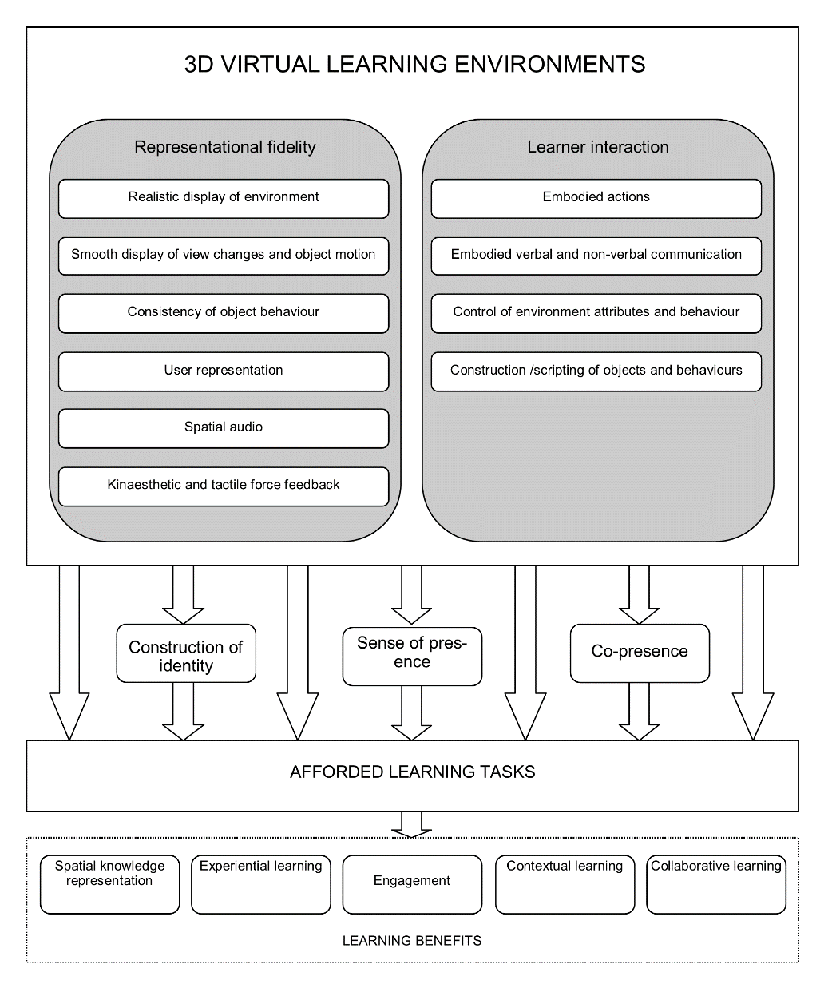M
Figure 1: Model of learning in 3D Virtual Learning Environments (adapted from Dalgarno and Lee, 2010).

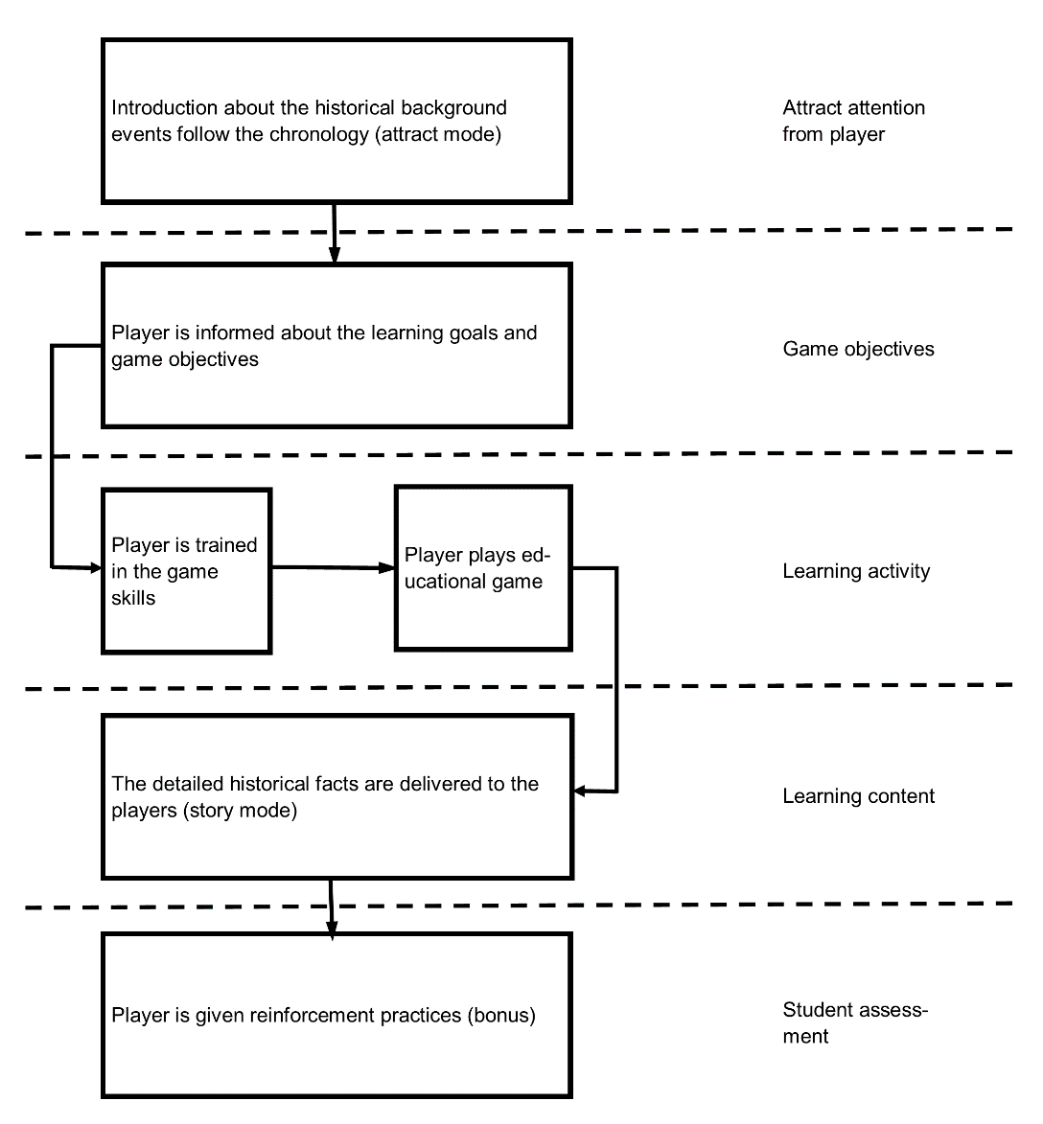
Figure 2: Embedding educational elements in game design process (adapted from Zin and Yue, 2009).

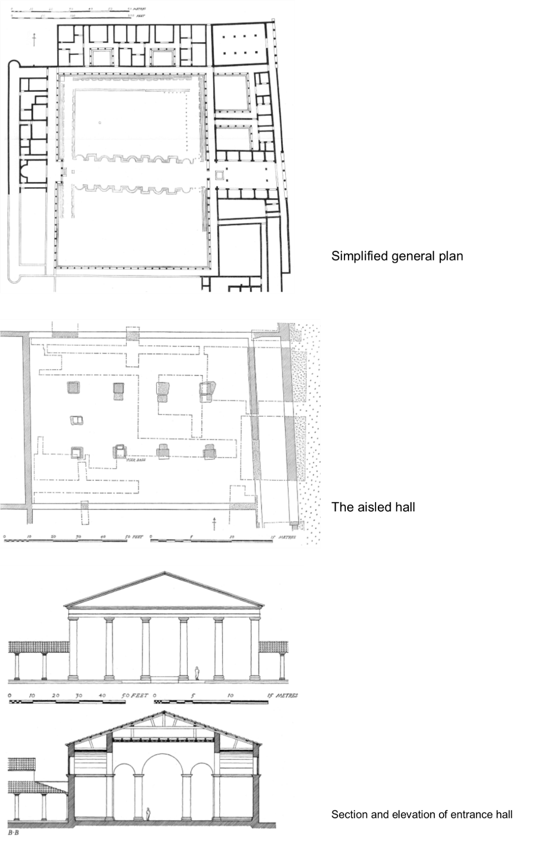
Figure 3: Examples of documentary plans and elevation drawings used as input to the Fishbourne model (adapted from Cunliffe, 1971).
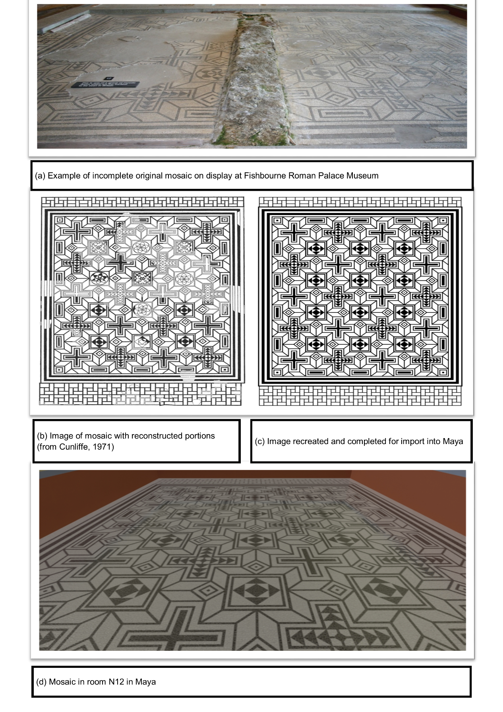
Figure 4: Stages in the creation of a mosaic texture from incomplete physical remains to digital texture (source authors unless otherwise stated).

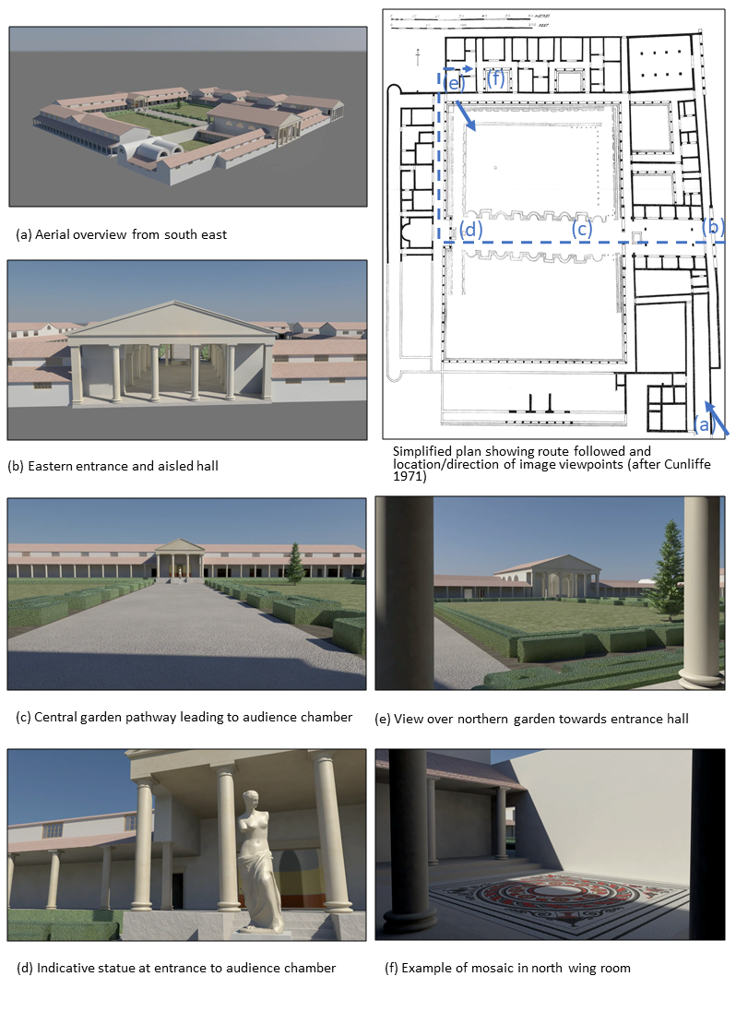Figure 5: Selection of internal and external screenshots of the Fishbourne Roman Palace game engine enabled 3D visualisation as seen by users (source authors).

