Main Manuscript for

The temporal dynamics of sitting behaviour at work

Pam ten Broeke^{a*}, Merlijn Olthofª, Debby G. J. Beckersª, Nicola D. Hopkins^{b}, Lee E. F. Graves^{b}, Sophie E. Carter^{b,c}, Madeleine Cochrane^{b,d}, David Gavin^{b}, Abigail S. Morris^{b,e}, Anna Lichtwarck-Aschoffª, Sabine A. E. Geurtsª, Dick H. J. Thijssen^{f,b}, Erik Bijleveldª
ªBehavioural Science Institute, Radboud University, 6525 HR Nijmegen, the Netherlands
^{b}Research Institute for Sport and Exercise Sciences, Liverpool John Moores University, Liverpool, L3 3AF, United Kingdom
^{c}School of Sport, York St John University, York, YO31 7EX, United Kingdom
^{d}Bristol Medical School, University of Bristol, Bristol, BS8 1QU, United Kingdom
^{e}Health Research Department, Lancaster University, Lancaster, LA1 4YW, United Kingdom
^{f}Department of Physiology, Radboud University Medical Center, 6525 GA Nijmegen, the Netherlands

* Corresponding author:
Pam ten Broeke, Behavioural Science Institute, Radboud University
Montessorilaan 3, Postbus 9104, 6500 HE Nijmegen, The Netherlands
Email: p.tenbroeke@psych.ru.nl, Tel.: +31 (0) 24 3615729

Classification
SOCIAL SCIENCES: Psychological and Cognitive Sciences

Abstract
Sitting for prolonged periods of time impairs people’s health. Prior research has mainly investigated sitting behaviour on an aggregate level, e.g., by analysing total sitting time per day. By contrast, taking a dynamic approach, here we conceptualise sitting behaviour as a continuous chain of sit-to-stand and stand-to-sit transitions. We use multilevel time-to-event analysis to analyse the timing of these transitions. We analyse ~30,000 objectively-measured posture transitions from 156 people during worktime. Results indicate that the temporal dynamics of sit-to-stand transitions differ from stand-to-sit transitions, that people are quicker to switch postures later on the workday, and quicker to stand up after having been more active in the recent hours. We found no evidence for associations with physical fitness. Altogether, these findings provide insights into the origins of people’s stand-up and sit-down decisions, show that sitting behaviour is fundamentally different from exercise behaviour, and provide pointers for the development of interventions.
Keywords (min 3; max 6)
Sedentary behaviour, Time-to-event analysis, Survival analysis, Fatigue, Occupational health

Significance Statement
Nowadays, most people spend large parts of their waking time sitting. Problematically, sitting for long, uninterrupted periods of time harms people’s health. To develop effective interventions, we need a solid understanding of the aetiology of unhealthy sitting patterns. We proposed a novel approach to studying sitting behaviour, which aims to unravel the temporal dynamics of sitting patterns. Our research yielded novel insights regarding why and when people sit (e.g., mental fatigue may play a key role), and regarding how to best study sitting behaviour (e.g., we need to distinguish sitting behaviour from exercise behaviour). These findings have implications for the design of effective interventions targeting sitting behaviour. Moving forward, the science of sitting may benefit from adopting a dynamic approach.

Main Text

Introduction

In modern society, most people spend large parts of their waking time sitting, especially when they are at work (1–4). Numerous studies have demonstrated that sitting for extended periods of time contributes to mental and physical health conditions, such as depression, stress, obesity, diabetes, cardiovascular diseases, cancer, and all-cause mortality (5–7). Problematically, the detrimental health consequences of sitting appear present even in those who otherwise meet recommended levels of daily physical activity (6). Therefore, to improve society’s health and well-being, it is vital to change people’s sitting behaviour.
So far, research into sitting behaviour has yielded crucial insights, such as that for working adults extensive sitting time mostly accumulates during worktime (8, 9), and that sitting directly influences metabolism, bone mineral content, and vascular health (10, 11). However, prior research on sitting behaviour has typically examined sitting on an aggregate level. That is, typically, summary characteristics of sitting behaviour (e.g., total sitting time, average duration of sitting episodes) are used as primary outcomes (12). This traditional approach conceptualises sitting behaviour as a static property of a person—or at best, as a static property of a person on a specific day. This approach parallels the mainstream approach that is used to study physical exercise, where volume of exercise is usually expressed and investigated as total hours or minutes per week. Yet, when used on sitting behaviour, such a static approach overlooks the fact that sitting is a highly dynamic phenomenon that is characterised by a continuous chain of transitions between sitting and standing. Here, we examine sitting behaviour on a more granular level: the level of individual sit-to-stand and stand-to-sit transitions.
Relative to the traditional approach, our dynamic approach has three main advantages. First, our approach provides a sensitive method to capture the variability that is characteristic of natural sitting behaviour. On an average day, people transition between sitting and standing between ~70 and ~140 times; also, people may stay in a single posture for time periods ranging from a few seconds to several hours (13). These substantial variations are presumably also present when people’s sitting behaviour is strongly constrained by the physical and social context, such as when people are paid to work behind a desk. That is, in such constrained contexts, people still make short but frequent posture switches, for example stretching the legs, visiting the bathroom, or grabbing coffee (14, 15). So, examining sitting behaviour on a person-level or day-level does not provide an ecologically valid representation of the time scale on which sitting behaviour occurs (see also 16). Recent studies support the potential importance of acknowledging dynamic variation in sitting. That is, the time people spend in prolonged, uninterrupted periods of sitting (>30 minutes), rather than total sitting time, may be the main cause of sitting-related health problems (17, 18). Our approach can be used to gain unique and detailed insight into the dynamic variations in sitting, and therefore into the specific unhealthy characteristics of sitting behaviour.
Second, our dynamic approach allows us to examine a range of candidate predictors to help explain sitting behaviour. Examining individual sit-to-stand and stand-to-sit transitions will yield more precise insights into people’s decision-making processes that drive their sit-to-stand and stand-to-sit transitions. Moreover, going beyond the traditional approach, a more granular investigation of sitting behaviour allows us to examine candidate predictors whose values vary throughout the day. In this research, we tested several candidate predictors: (a) We examined time of the day to examine natural circadian fluctuations in sit-to-stand and stand-to-sit transitions. Specifically, later during the workday people tend to experience higher levels of mental fatigue (19, 20); thus, examining time of the day may provide an insight into how mental fatigue affects sitting behaviour. (b) We examined people’s physical effort expenditure in recent hours, as recent effort is known to affect other health behaviours (21, 22). For example, after expending effort during the workday, people are less motivated to exercise in the evening (23). (c) We examined individual differences in physical fitness, as people who are less physically fit likely perceive higher energetic costs of standing up when sitting (24). By examining these candidate predictors, our dynamic approach opens the door to a more detailed understanding of the psychological processes that drive sitting behaviour (25).
Third, our dynamic approach provides a way of analysing data from modern wearable technology (in our case, the activPAL monitor). Such technology records all individual sit-to-stand and stand-to-sit transitions that people make, with measurement precision in seconds. We capitalise on the richness of such time-series data by modelling individual posture transitions. For this purpose, we use multilevel time-to-event analysis.
Time-to-event analysis, also known as survival analysis, is used to examine the timing of events—or, transitions from one state to another (26, 27). Originally developed to predict the timing of death (27), time-to-event analysis has subsequently been used in other fields of study, for instance, to predict the timing of relapse into substance abuse (28) or to predict the timing of emotion expression in children (26, 29). To the best of our knowledge, time-to-event analysis has not yet been used to examine determinants of health behaviour. In time-to-event analysis, researchers estimate the hazard of an event, which refers to the conditional (i.e., given that the event has not happened yet) probability that an event occurs per unit of time. As we examine events that can happen more than once within each individual (i.e., sit-to-stand and stand-to-sit transitions), we use a multilevel framework to model random variability in the timing of sit-to-stand and stand-to-sit transitions between individuals (i.e., events nested within individuals; 26, 29). Specifically, using multilevel time-to-event analysis, we were able to examine predictors of (a) the hazard of standing up when sitting, and (b) the hazard of sitting down when standing.
For working adults, overall unhealthy sitting behaviour is mostly accumulated during worktime (2). Thus, in this paper we limited our investigation to sitting behaviour during worktime. We analysed ~30,000 objectively measured posture transitions of 156 UK-based employees from various worksites, who performed mainly desk-based work. We used a split-samples cross-validation procedure (30, 31). Specifically, prior to looking at the data, we randomly split the data into two samples of equal size: A training sample (n = 79; 7,316 sit-to-stand and 7,263 stand-to-sit transitions) and a testing sample (n = 77; 7,216 sit-to-stand and 7,158 stand-to-sit transitions). We used the training sample for data exploration and fine-tuning of analyses and analytical decisions. After this, we preregistered our analysis plan for the testing sample to the Open Science Framework (URL to the preregistration). As the present study is, to our knowledge, the first study to use timing of sit-to-stand and stand-to-sit transitions as the primary outcome, and as we could reasonably expect associations with predictors in different directions, we anticipated a range of different study outcomes. Thus, rather than to specify one-sided hypotheses, we preregistered (a) our research questions, (b) a detailed analysis plan, and (c), for all plausible outcomes, what our interpretation would be. Unless otherwise specified, in this paper we report results from the preregistered analyses on the testing sample, along with the preregistered interpretation. We used this split-samples procedure because it diminishes the chance of reporting false positives through preregistration; at the same time, the training sample offered opportunity to explore the data, thus decreasing the probability of overlooking potentially relevant predictors (30, 31).

Results

Standing up versus sitting down
First, we estimated the baseline probability of standing up when sitting versus sitting down when standing, and whether these develop differently over time. To investigate whether sit-to-stand versus stand-to-sit transitions were qualitatively different, we tested whether the type of transition predicted the hazard of posture transition, and whether the hazard of standing up when sitting and the hazard of sitting down when standing developed differently over time.
Results are presented in Table 1. Figure 1 displays the baseline survival function (i.e., the proportion of events that has not happened yet as a function of time) of stand-to-sit transitions and sit-to-stand transitions separately. There was a significant effect of type of transition, which suggested that participants were 5.4 times more likely to sit down per minute of standing, than to stand up per minute of sitting. Median survival times indicated that 50% of the time participants sat down within 1.8 minutes of standing, and stood up within 5.6 minutes of sitting. In other words, people were quicker to select sitting over standing, i.e., they were quicker to choose the behavioural option that costs the least energy (32) and yields most comfort in the context of desk-based working (33). These low median survival times suggest that participants were often rather quick to switch back and forth between standing and sitting. On the other hand, Figure 1 suggests that, consistent with previous research (4), 15% of sitting episodes lasted longer than 30 minutes. In fact, in our sample, 88% of participants had ≥ 3 long episodes of uninterrupted sitting on at least one single workday. Thus, despite the relatively large amount of short sitting and standing episodes, unhealthy sitting behaviour at the workplace is abundantly present.
Going beyond previous work, the significant Transitions x Event time interaction suggests that sit-to-stand and stand-to-sit transitions have distinct associated probabilities and a different development over time. Specifically, the hazard of sitting down when standing was relatively high in the first minutes of standing, and decreased quickly over the time course of a standing episode. In other words, most of the time when people were active, they quickly sat down again. Conversely, the hazard of standing up when sitting was relatively low in the first minutes of sitting, and decreased gradually over the time course of a sitting episode (See also Figure S1). This means that once participants remained seated beyond the first minutes, they were likely to remain seated for a long, uninterrupted amount of time.
Time of the day
We examined time of the day as a predictor of the hazard of standing up when sitting and the hazard of sitting down when standing (Table 1). Figure 2 displays estimated survival functions for sit-to-stand and stand-to-sit transitions for a typical beginning (9 am) and end (5 pm) of a workday. With each hour increase in time of the day, participants were 4% more likely to stand up per minute of sitting, and 3% more likely to sit down per minute of standing. Estimated median survival times for 9 am indicated that 50% of the time participants stood up within 7.1 minutes of sitting and sat down within 2.0 minutes of standing. At 5 pm, estimated median survival times were 4.4 minutes and 1.6 minutes, respectively. This result suggests that later on the day, when fatigue had likely set in (19, 20), participants were quicker to switch back-and-forth between sitting and standing.
Activity in last 5 hours
We then examined recent activity, specifically activity in the last 5 hours, as a predictor of the hazard of standing up when sitting and the hazard of sitting down when standing (Table 1). We chose a 5-hour time window, based on previous studies on muscle fatigue that show that physical discomfort tends to set in within 2–5 hours of activity (34, 35). Figure 2 displays the estimated survival functions for 45 minutes (15%; ≈ -1 SD) versus 150 minutes (50%; ≈ +1 SD) of activity in the last 5 hours. With each additional minute that participants had been physically active in the last 5 hours, they were 0.17% more likely to stand up per minute of sitting, and 0.21% less likely to sit down per minute of standing. We estimated median survival times for low activity in the last 5 hours (i.e., 45 minutes of activity in the last 5 hours), and for high activity in the last 5 hours (i.e., 150 minutes of activity in the last 5 hours). Our estimates suggest that when participants had been relatively inactive in the last 5 hours, they stood up within 6.7 minutes of sitting 50% of the time. However, when participants had been relatively active, they stood up within 4.1 minutes of sitting 50% of the time. Also, when participants had been relatively inactive in the past 5 hours, they sat down within 1.5 minutes of standing 50% of the time. However, when participants had been relatively active, they sat down within 2.5 minutes of standing 50% of the time. So, after periods of more standing (i.e., being active, exerting more physical effort), people were more likely to stand, and less likely to sit.
Individual differences in physical fitness
Finally, we explored associations between individual differences related to physical fitness and the hazard of standing up when sitting and the hazard of sitting down when standing. We assumed that people who have higher Body Mass Index (BMI), are older, and/or are less active in their leisure time, are less physically fit. We conducted a-priori sensitivity analyses (Supplementary Text) to determine the magnitude of effects we could detect with a power of 1 – β = .80. Results indicated that we could detect medium to large effect sizes. However, based on exploratory analyses on the training sample, we expected only small effects, if any. Therefore, we decided to consider the analyses regarding individual differences exploratory, and to conduct these analyses on the full sample (training sample + testing sample), in order to provide the most precise effect size estimates that we can at this point, given the available data. There were some missing values on the predictor variables (See Methods).
Results (See Table 2) indicated that none of the indicators of physical fitness were related to the hazard of standing up or to the hazard of sitting down. These results suggests that the timing of standing up while sitting and sitting down while standing does not depend on one’s level of physical fitness. It is important to note, however, that these tests were exploratory and that statistical power for these tests was relatively low. Therefore, more research into the associations between physical fitness and sitting patterns is necessary before drawing firm conclusions.

Discussion

We investigated sitting behaviour as a continuous chain of sit-to-stand and stand-to-sit transitions, using multilevel time-to-event analysis. In line with previous findings, people in our study switched often and quickly between sitting and standing (within minutes; 13), but also engaged in a considerable amount of prolonged, unhealthy sitting episodes at work (4). Extending previous research, we showed that sit-to-stand and stand-to-sit transitions are different both in probability and timing. This underscores the relevance of zooming in on these individual transitions when investigating sitting behaviour. Adopting our dynamic approach, we found that people were quicker to switch postures later during the workday compared to earlier during the workday. Moreover, when people were more active (non-sitting) in the previous hours, they were quicker to stand up when sitting and slower to sit down when standing. Finally, whereas previous findings indicate that people who are older, have a higher BMI, or engage in less physical activity in their leisure time, generally sit more and longer (2, 36), we found no evidence that the timing of standing up and sitting down depends on individual differences in physical fitness.
Our findings yield several novel insights into the nature of sitting and standing behaviour during the workday. First, our findings suggest that sitting behaviour is critically different from other health behaviours. When people feel fatigued at the end of the day they are generally more prone to engage in unhealthy behaviours, such as unhealthy eating or skipping exercise sessions (21, 23, 37–39). By contrast, our findings regarding time of the day suggest that when people feel fatigued at the end of the day, they engage in healthier sitting patterns—characterised by quicker posture switching. Although this finding is somewhat counter-intuitive, it is in line with a recent account of fatigue, which suggests that fatigue functions as a signal to stop the current task and switch to another (22, 40). Specifically, our findings are consistent with the idea that later on the day, people feel more fatigued (and possibly more restless and less concentrated); as a result, they more quickly change posture while working (e.g., stand up while reading a document), more quickly switch to a different work task that involves a change in posture (e.g., decide to print some documents), and/or more quickly take a short break that involves a change in posture (e.g., walk to the coffee machine).
In a similar vein, our findings on activity in the last 5 hours also contradicted previous findings on other health behaviours. That is, previous research suggest that people are less motivated to engage in active behaviour after they have exerted effort (e.g., people are less motivated to go to the gym after an effortful workday; 21–23). In contrast, our findings show that people display fairly stable sitting and standing patterns over a timeframe of several hours. Thus, our findings imply that previous effort exertion does not necessarily diminish future effort exertion, at least not in the context of light physical activity (i.e., sitting versus standing and walking).
Thus, where prior research has aimed to understand sitting behaviour using the same psychological models that proved useful for other health behaviours, physical activity in particular (41), our findings suggest that sitting behaviour is not necessarily comparable to these other health behaviours. The fundamental differences in energy expenditure, frequency, duration, and deliberate processing between physical activity and sitting behaviour (42) may contribute to these observations. This emphasizes that, to target sitting behaviour, practitioners cannot simply follow intervention strategies that have proven to successfully boost physical activity and exercise—rather, they have to consider the potentially unique nature of sitting behaviour.
Second, our findings highlight that our dynamic approach to sitting behaviour, along with the use of multilevel time-to-event analysis, complements and goes beyond the traditional approach that is used to understand sitting behaviour. We demonstrated that a dynamic approach is useful when attempting to outline the psychology of sitting (25), i.e., when attempting to uncover the decision-making processes that drive sit-to-stand and stand-to-sit transitions. However, we anticipate that other research fields that take an interest in the antecedents of sitting (e.g., environmental psychology, industrial design, medicine, and epidemiology) can also benefit from analysing sitting patterns on the level of sit-to-stand and stand-to-sit transitions, making use of time-to-event analysis.
To date, numerous interventions to decrease sitting time have been designed and tested, such as height-adjustable desks (43), and online tailored advice on how to reduce and break up sitting (44). Although these interventions indeed reduce sitting time on the short-term, the benefits seem to wear off over a few months (45, 46). A plausible explanation for this decline is that, even though theory-based interventions are known to be more effective (47), the majority of existing interventions that aim to change sitting behaviour lack a theoretical basis (45). As our dynamic approach can be used to unravel the decisions that drive sitting behaviour, we expect that our approach will substantially contribute to the theoretical understanding of sitting behaviour—and, thus, help provide a solid basis for designing interventions. In particular, to effectively reduce the number of prolonged, uninterrupted periods of sitting, interventions should aim to accelerate people’s decisions to stand up when sitting. Besides gaining insights into potential intervention targets, exploring the temporal dynamics of sit-to-stand and stand-to-sit transitions also provides ideas on when interventions are most necessary. Our findings showed that later during the work day people naturally engage in healthier sitting patterns. This implies that interventions to change people’s sitting behaviour are most needed at the beginning of the workday.
With our dynamic approach, future research can isolate the determinants of sit-to-stand and stand-to-sit decisions—and, thus, help identify targets for interventions that may otherwise be overlooked. A limitation of the current study is that we did not directly assess psychological states, such as mental fatigue, with self-report measures. Thus, in our view, it would be worthwhile for future research to combine our dynamic approach with an experience sampling procedure. This combined design would allow researchers to study how the impact of psychological states, including fatigue, varies over the course of a day (e.g., using models that include time-varying predictors; 48, 49). Such research should aid the development of interventions that target specific decision-making processes at specific moments in time (e.g., just-in-time adaptive interventions; 50).
Our results suggest that unhealthy sitting behaviour is a general problem concerning many employees, not only less physically fit or older people. Conversely, we observed that people’s sitting patterns are most unhealthy at the beginning of a new workday, when employees plausibly still feel fresh and fit. Sitting thus seems to be a ubiquitous consequence of present-day work. Building on our findings, along with the accumulating evidence on the negative consequences of sitting, one could argue that unhealthy sitting patterns should be considered a serious occupational risk for developing disease (see also 51). Regulation of other known occupational risks, such as exposure to loud noises, exposure to chemicals, or working nightshifts, has long been a formal responsibility of employers (‘duty of care’; 52). This line of reasoning raises the question who should take responsibility for changing employees sitting behaviour, in order to protect and improve our workforce’s physical health and mental wellbeing. Ultimately, gaining insights into the mechanisms that predict sit-to-stand and stand-to-sit transitions during worktime will provide practical starting points for both employers and employees to adopt and apply interventions that will help employees engage in healthier sitting patterns during work.

Materials and Methods

We used existing data collected by the Research Institute of Sport and Exercise Sciences at Liverpool John Moores University, UK. The dataset included objectively measured, continuous activity data of 167 working adults from various worksites in the United Kingdom.
Participants and procedure.
The full sample (n = 167) was combined out of four different samples that were collected for different research projects. Data from sample A (n = 14) were collected from university desk workers (not academic staff or technicians), data from sample B (n = 70) were collected from call agents from two different contact centres, and data from sample C (n = 61) and sample D (n = 22) were collected from working adults without specific criteria for job role or sitting time. In each sample, the procedure for data collection was the same. All participants first provided demographics and other personal characteristics; anthropometric assessment was conducted by a trained researcher. Next, participants were instructed to continuously wear a thigh-mounted activPAL monitor (PAL Technologies, Glasgow, UK) for seven consecutive days. In addition, participants recorded the times they started and finished work each day in a log book. For all samples, study procedures were approved by the Liverpool John Moores University Ethics Committee. The samples did not significantly differ in the hazard of standing up when sitting (p = .991) and in the hazard of sitting down when standing (p = .999).
Data from participants for whom no worktime data were available were excluded, leaving n = 156 of the full sample, and n = 77 of the testing sample. Participants in the full sample had an average age of 33.92 (SD = 11.47), an BMI of 27.84 (SD = 6.84), and scored on average 3.52 (SD = 0.88; on a 5-point scale) on leisure time activity level. The sample included 95 females (61%; one participant had a missing value on gender). The number of workdays varied between one and seven, (M = 3.99, SD = 1.29). Per workday, participants on average sat for 5.31 hours (SD = 1.92) and were active for 2.18 hours (SD = 1.79).
Measures.
Sitting behaviour is defined as “any waking behaviour characterized by an energy expenditure ≤ 1.5 metabolic equivalents (METs), while in a sitting, reclining or lying posture” (9). In this study, we distinguished between sitting behaviour and activity, referring to all non-sitting behaviour. Sitting behaviour and activity were assessed using an activPAL monitor, a device that is worn on the thigh that directly assesses posture using triaxial accelerometry. ActivPAL monitors are known to have a good reliability and validity to measure sitting and activity behaviour (See 53 for more information on the activPAL monitor). Placement was standardised to the anterior midline of the upper right thigh, with monitors inserted into a flexible waterproof sleeve and attached using a hypoallergenic waterproof adhesive strip (3M Tegaderm). Time of the day, in hours since midnight (precision in seconds), was calculated from the time variable in the activPAL data. Activity in last 5 hours, in minutes (precision in seconds), was calculated as the sum of all active (non-sitting) time in the 5 hours prior to the previous stand-to-sit or sit-to-stand transition, per participant, per day. This variable was calculated before exclusion of non-work hours, such that we also took into account activity accumulated in the hours prior to starting the workday. BMI was calculated following an anthropometric assessment. Stature was measured to the nearest 0.1cm using a portable stadiometer and body mass to the nearest 0.1 kg using a calibrated mechanical flat scale. Body mass index was calculated as mass divided by stature (kg/m2). Data on BMI were available for 95 participants in the dataset (8222 sit-to-stand and 8172 stand-to-sit transitions). Age was assessed by self-report. Data on age were available for 150 participants in the dataset (14211 sit-to-stand and 14102 stand-to-sit transitions). Leisure time activity level was assessed by self-report on a scale from 1 (physically inactive) to 5 (physically active). Data on leisure time activity level were available for 58 participants in the dataset (6080 sit-to-stand and 6020 stand-to-sit transitions).
Data analysis.
Split-samples procedure. In this study we used a split-samples cross-validation procedure (30, 31). Prior to looking at the data, we randomly split the data into two equal samples: A training sample (n = 79) and a testing sample (n = 77). As the data were combined out of several projects, we stratified data-splitting on project. First, we used the training sample for data exploration and fine-tuning of analytical decisions. Then, we designed and preregistered a specific analysis plan for the testing sample. This preregistration (URL to the preregistration) described all research questions, preregistered interpretations of results, all data-processing steps (i.e., calculation of variables; data exclusion based on worktimes and non-wear), all analyses, and handling of assumptions, and convergence / singularity issues. Unless otherwise mentioned, the main text of this paper reports preregistered analyses on the testing sample.
Data on the between-subjects predictors BMI, age, and leisure time activity level were only available for part of the sample. We conducted a-priori sensitivity analyses (Supplementary Text) to determine the magnitude of the effects that we could detect with a power of .80. Results from this sensitivity analyses indicated that, given the sample sizes in our testing sample for BMI, age, and leisure time activity level, we could detect medium to large effects (Hazard Ratio [HR] ≈ 1.5 for positive associations; HR ≈ 0.7 for negative associations). However, based on our exploratory analyses on the training sample, we expected only small (or null) effects. Therefore, we decided to examine these predictors in an exploratory fashion, and to examine associations with these predictors on the full sample (training sample + testing sample), in order to provide the most precise effect size estimates, given the data that we have.
Exclusion of non-working hours. We excluded observations that fell outside of participants workings hours, using participants’ self-reported work start and end times. First, we narrowed the work time window by 15 minutes on both start and end times to correct for recall bias, settling into the building, and to make sure that commuting time was not included in the dataset (see also 53). Next, we excluded observations that fell outside of the narrowed work-time window. For observations crossing work start or end times, we only retained observations with at least 50% of the time inside the (narrowed) worktime window and excluded the rest (53; 75% of transitions in the training sample; 76% of transitions in the testing sample). After exclusion of non-worktimes, 7,316 sit-to-stand and 7,263 stand-to-sit transitions remained in the training sample, and 7,216 sit-to-stand and 7,158 stand-to-sit transitions remained in the testing sample.
Non-wear and extreme values. Sitting episodes with a duration longer than 8 hours were identified as non-wear (i.e., as a time period in which the participant did not wear the activPAL monitor; 53) and excluded from the analyses (one observation in the training sample; no observations in the testing sample). In addition, active episodes with a duration longer than 8 hours were identified as extreme values and excluded from the analyses (one observation in the training sample; no observations in the testing sample).
Data preparation for time-to-event analysis. ActivPAL data were downloaded from the monitors using activPAL software and saved in event-based summary files. Event-based data files contain one row for each episode of lying/sitting, standing, and for each step. Each row indicates the time the episode begins (start time) and an activity code (sitting/lying down; standing; or stepping). For the current research, standing and stepping were taken together as active. In order to prepare the data for time-to-event analysis, we computed an event (sit-to-stand vs. stand-to-sit) variable and an event time (in minutes; precision in seconds) variable (26, 29). The event time variable contained the timing of the event since the previous event had ended (i.e., since the person was at risk for the event to happen). To illustrate, for each sit-to-stand transition, the event time variable indicated how long people had been sitting; for each stand-to-sit transition, the event time variable indicated how long people had been standing.
Model fitting. All statistical analyses were performed in R version 3.6.1, using the survival package (55). For each research question, we fit a separate shared frailty Cox model (see Supplementary Text for model equations) on the event times for the transition of interest (posture transitions; sit-to-stand transition; or stand-to-sit transition), using the coxph function. We used the Cox approach because (a) it is a well-established approach for event data measured in continuous time (27), and (b) it provides robust estimates without requiring a-priori knowledge about the exact shape of the hazard function (26, 29). In each model, we included the predictor of interest (time of the day, activity in last 5 hours, age, BMI, or leisure time activity level). We also included a frailty term for participant, which is comparable to a random intercept in linear mixed-level models. The frailty term captures the random variability in baseline hazard between individuals. We used Efron’s method for handling ties (27). Where we conducted separate analyses for sit-to-stand transitions and stand-to-sit transitions, we split the data into two datasets: one including only event times for sit-to-stand transitions, and one including only event times for stand-to-sit transitions. For each model, we interpreted the statistical significance of the fixed effect. If this effect was statistically significant, we interpreted the hazard ratio (HR; antilog of the raw coefficient) of the predictor. Furthermore, to aid interpretation, we calculated median survival times, which is the event time at which 50% of the events have happened, based on model predictions for different values of the predictor. In addition, we examined estimated survival functions (i.e., proportion of events that has not happened yet as a function of time). In Figure 1 and Figure 2, we zoomed in on event times between 0 and 120 minutes to better visualise the differences in survival function for different levels of the predictor. As a result, in Figure 1, 0.29 % of the posture transitions were excluded; in Figure 2, 0.26 % of the sit-to-stand transitions and 0.32 % of the stand-to-sit transitions were excluded.
For each model, assumptions for multilevel time-to-event analysis were assessed following our preregistered analysis plan. Visual inspection of histograms indicated no concerns regarding the distribution of predictor variables. Examination of deviance residuals and score residuals (27) indicated no concerns regarding influential cases. For each model, the proportionality assumption was met, based on examination of Schoenfeld residuals (27).
Data availability. All data that we used for our analyses, and R code for data processing, analysis and visualization, are available in EASY at https://doi.org/10.17026/dans-zfe-gk3b.
.

References
1. J. A. Bennie, et al., The prevalence and correlates of sitting in European adults - a comparison of 32 Eurobarometer-participating countries. Int J Behav Nutr Phys Act 10, 107 (2013).
2. M. F. Leitzmann, C. Jochem, D. Schmid, Sedentary Behaviour Epidemiology (Springer International Publishing, 2018).
3. K. Milton, J. Gale, E. Stamatakis, A. Bauman, Trends in prolonged sitting time among European adults: 27 country analysis. Preventive Medicine 77, 11–16 (2015).
4. C. G. Ryan, P. M. Dall, M. H. Granat, P. M. Grant, Sitting patterns at work: objective measurement of adherence to current recommendations. Ergonomics 54, 531–538 (2011).
5. S. J. H. Biddle, et al., Too much sitting and all-cause mortality: is there a causal link? BMC Public Health 16, 635 (2016).
6. A. Biswas, et al., Sedentary time and its association with risk for disease incidence, mortality, and hospitalization in adults: a systematic review and meta-analysis. Ann. Intern. Med. 162, 123–132 (2015).
7. M. Kilpatrick, K. Sanderson, L. Blizzard, B. Teale, A. Venn, Cross-sectional associations between sitting at work and psychological distress: Reducing sitting time may benefit mental health. Ment. Health Phys. Act. 6, 103–109 (2013).
8. S. Kurita, et al., Patterns of objectively assessed sedentary time and physical activity among Japanese workers: a cross-sectional observational study. BMJ Open 9, e021690 (2019).
9. N. Owen, et al., Adults’ Sedentary Behavior: Determinants and Interventions. American Journal of Preventive Medicine 41, 189–196 (2011).
10. J. A. Levine, Sick of sitting. Diabetologia 58, 1751–1758 (2015).
11. S. Carter, Y. Hartman, S. Holder, D. H. Thijssen, N. D. Hopkins, Sedentary Behavior and Cardiovascular Disease Risk: Mediating Mechanisms. Exercise and Sport Sciences Reviews 45, 80 (2017).
12. S. T. Boerema, L. van Velsen, M. M. R. Vollenbroek, H. J. Hermens, Pattern measures of sedentary behaviour in adults: A literature review. Digit. Health 6, UNSP 2055207620905418 (2020).
13. R. W. Bohannon, Daily sit-to-stands performed by adults: a systematic review. J. Phys. Ther. Sci. 27, 939–942 (2015).
14. K. Mackenzie, E. Such, P. Norman, E. Goyder, Sitting less at work: a qualitative study of barriers and enablers in organisations of different size and sector. BMC Public Health 19, 884 (2019).
15. D. Löffler, et al., Office Ergonomics Driven by Contextual Design. Ergonomics in Design: The Quarterly of Human Factors Applications 23, 31–35 (2015).
16. J. P. Maher, D. E. Conroy, A dual-process model of older adults’ sedentary behavior. Health psychology : official journal of the Division of Health Psychology, American Psychological Association 35, 262–272 (2016).
17. G. N. Healy, et al., Breaks in sedentary time: beneficial associations with metabolic risk. Diabetes Care 31, 661–666 (2008).
18. T. Honda, et al., Sedentary bout durations and metabolic syndrome among working adults: a prospective cohort study. BMC Public Health 16, 888 (2016).
19. A. A. Borbély, A two process model of sleep regulation. Hum Neurobiol 1, 195–204 (1982).
20. R. Pietrowsky, O. Lahl, Diurnal variation of physical and mental fatigue. Sleep Biol. Rhythms 6, 228–233 (2008).
21. M. Inzlicht, B. Schmeichel J., K. Vohs, R. Baumeister, “Beyond limited resources: Self-control failure as the product of shifting priorities” in The Handbook of Self-Regulation, 3rd Ed., (Guilford Press, 2016).
22. R. Kurzban, A. Duckworth, J. W. Kable, J. Myers, An opportunity cost model of subjective effort and task performance. Behavioral and Brain Sciences 36, 661–679 (2013).
23. S. Sonnentag, S. Jelden, Job Stressors and the Pursuit of Sport Activities: A Day-Level Perspective. Journal of occupational health psychology 14, 165–81 (2009).
24. L. H. Epstein, J. A. Smith, L. S. Vara, J. S. Rodefer, Behavioral economic analysis of activity choice in obese children. Health Psychol 10, 311–316 (1991).
25. Stuart. J. H. Biddle, Fit or sit? Is there a psychology of sedentary behaviour? Sport & Exercise Psychology Review 7, 5–10 (2011).
26. J. Lougheed, L. Benson, P. M Cole, N. Ram, Multilevel Survival Analysis: Studying the Timing of Children’s Recurring Behaviors. Developmental Psychology (2018) https:/doi.org/10.1037/dev0000619.
27. J. D. Singer, J. B. Willet, Applied longitudinal data analysis (Oxford University Press, 2003).
28. D. Hasin, et al., Effects of major depression on remission and relapse of substance dependence. Arch. Gen. Psychiatry 59, 375–380 (2002).
29. M. Stoolmiller, J. Snyder, Modeling heterogeneity in social interaction processes using multilevel survival analysis. Psychol Methods 11, 164–177 (2006).
30. M. Fafchamps, J. Labonne, Using Split Samples to Improve Inference on Causal Effects. Political Analysis 25, 465–482 (2017).
31. B. A. Nosek, C. R. Ebersole, A. C. DeHaven, D. T. Mellor, The preregistration revolution. PNAS 115, 2600–2606 (2018).
32. G. K. Zipf, Human behavior and the principle of least effort (Addison-Wesley Press, 1949).
33. P. B. Júdice, M. T. Hamilton, L. B. Sardinha, T. W. Zderic, A. M. Silva, What is the metabolic and energy cost of sitting, standing and sit/stand transitions? Eur J Appl Physiol 116, 263–273 (2016).
34. M.-G. Garcia, T. Läubli, B. J. Martin, Long-Term Muscle Fatigue After Standing Work. Hum Factors 57, 1162–1173 (2015).
35. M.-G. Garcia, R. Wall, B. Steinhilber, T. Läubli, B. J. Martin, Long-Lasting Changes in Muscle Twitch Force During Simulated Work While Standing or Walking. Hum Factors 58, 1117–1127 (2016).
36. A. Loyen, H. P. van der Ploeg, A. Bauman, J. Brug, J. Lakerveld, European Sitting Championship: Prevalence and Correlates of Self-Reported Sitting Time in the 28 European Union Member States. PLoS ONE 11, e0149320 (2016).
37. W. A. Boland, P. M. Connell, B. Vallen, Time of day effects on the regulation of food consumption after activation of health goals. Appetite 70, 47–52 (2013).
38. D. M. Y. Brown, S. R. Bray, Effects of Mental Fatigue on Exercise Intentions and Behavior. Ann Behav Med 53, 405–414 (2019).
39. B. M. Millar, Clocking self-regulation: why time of day matters for health psychology. Health Psychology Review 11, 345–357 (2017).
40. R. Hockey, The psychology of fatigue (Cambridge University Press, 2013).
41. J. C. Spence, R. E. Rhodes, V. Carson, Challenging the Dual-Hinge Approach to Intervening on Sedentary Behavior. American Journal of Preventive Medicine 52, 403–406 (2017).
42. S. J. H. Biddle, N. Mutrie, T. Gorely, “Psychology of sitting. New kid on the block” in Psychology of Physical Activity. Determinants, Well-Being and Interventions, (Routledge, 2015).
43. L. Straker, R. A. Abbott, M. Heiden, S. E. Mathiassen, A. Toomingas, Sit-stand desks in call centres: associations of use and ergonomics awareness with sedentary behavior. Appl Ergon 44, 517–522 (2013).
44. K. De Cocker, I. De Bourdeaudhuij, G. Cardon, C. Vandelanotte, Theory-driven, web-based, computer-tailored advice to reduce and interrupt sitting at work: development, feasibility and acceptability testing among employees. BMC Public Health 15, 959 (2015).
45. A. K. Hutcheson, A. J. Piazza, A. P. Knowlden, Work Site-Based Environmental Interventions to Reduce Sedentary Behavior: A Systematic Review. Am J Health Promot 32, 32–47 (2018).
46. A. Stephenson, S. M. McDonough, M. H. Murphy, C. D. Nugent, J. L. Mair, Using computer, mobile and wearable technology enhanced interventions to reduce sedentary behaviour: a systematic review and meta-analysis. International Journal of Behavioral Nutrition and Physical Activity 14, 105 (2017).
47. N. Taylor, M. Conner, R. Lawton, The impact of theory on the effectiveness of worksite physical activity interventions: a meta-analysis and meta-regression. Health Psychology Review 6, 33–73 (2012).
48. J. P. Maher, G. F. Dunton, Within-day time-varying associations between motivation and movement-related behaviors in older adults. Psychology of Sport and Exercise 47, 101522 (2020).
49. M. P. Shiyko, S. T. Lanza, X. Tan, R. Li, S. Shiffman, Using the time-varying effect model (TVEM) to examine dynamic associations between negative affect and self confidence on smoking urges: differences between successful quitters and relapsers. Prev Sci 13, 288–299 (2012).
50. I. Nahum-Shani, et al., Just-in-Time Adaptive Interventions (JITAIs) in Mobile Health: Key Components and Design Principles for Ongoing Health Behavior Support. Ann Behav Med 52, 446–462 (2018).
51. D. Koh, Sedentary behaviour at work—an underappreciated occupational hazard? Occup Med (Lond) 68, 350–351 (2018).
52. Council of the European Union, On the introduction of measures to encourage improvements in the safety and health of workers at work (1989).
53. C. L. Edwardson, et al., Considerations when using the activPAL monitor in field-based research with adult populations. Journal of Sport and Health Science 6, 162–178 (2017).
54. A. Fisher, et al., Associations between the Objectively Measured Office Environment and Workplace Step Count and Sitting Time: Cross-Sectional Analyses from the Active Buildings Study. Int. J. Environ. Res. Public Health 15, 1135 (2018).
55. T. M. Therneau, “A package for survival analysis in S (Version 2.38)” (2015).

Figures.

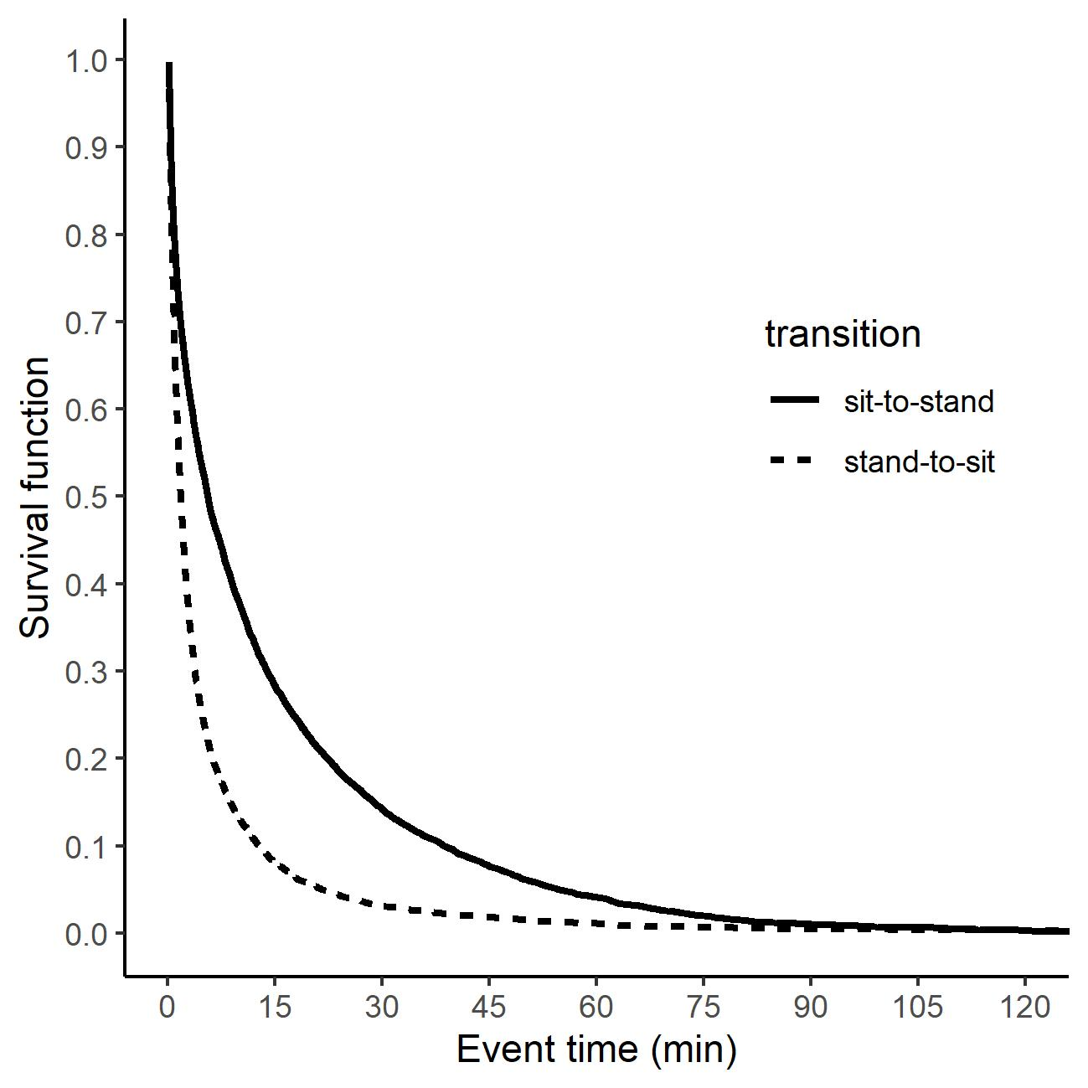
Figure 1. Baseline survival functions for the hazard of standing up when sitting and the hazard of sitting down when standing separately

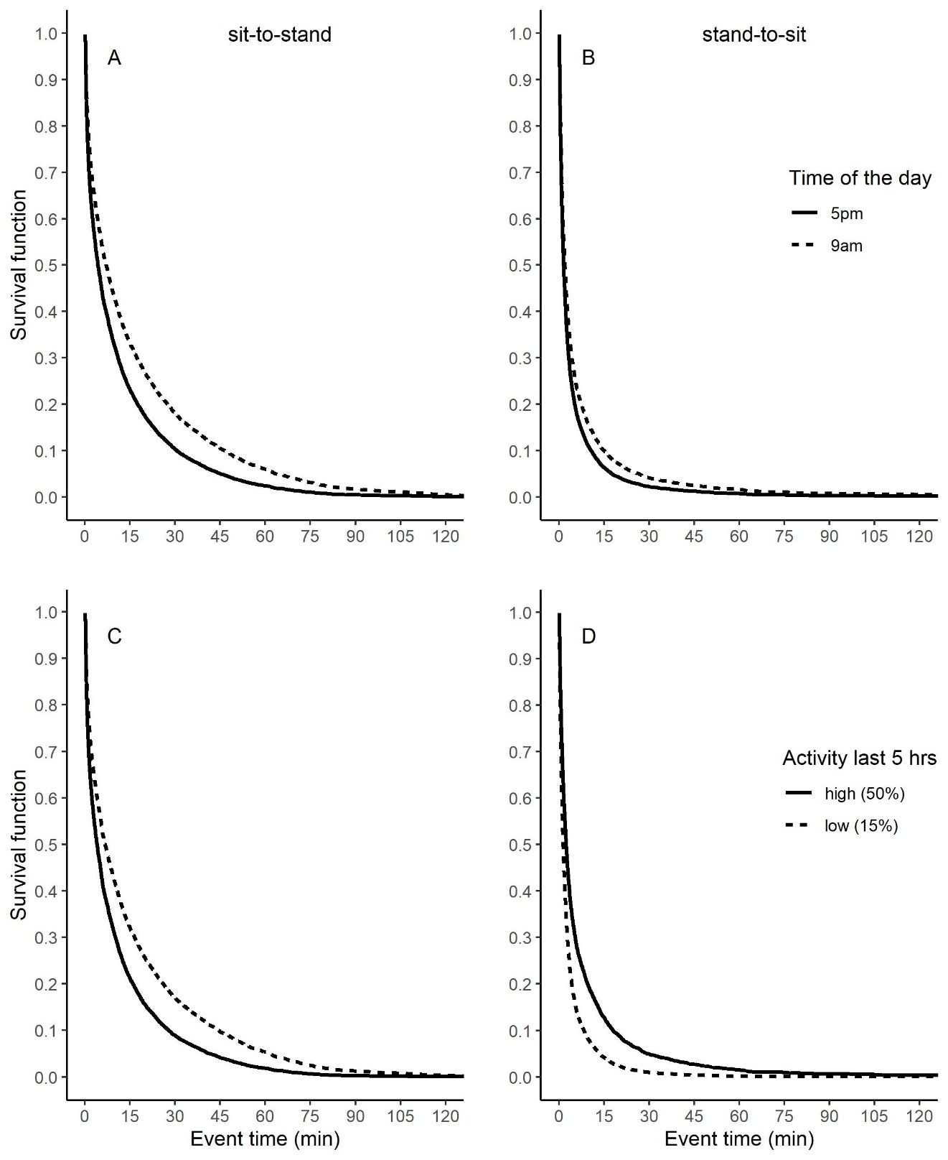
Figure 2. Estimated survival functions based on model predictions for indicative values of time of the day and activity in last 5 hours. Panels show (A) the estimated survival function for the hazard of standing up when sitting for 9am vs. 5pm time of the day, (B) the estimated survival function for the hazard of sitting down when standing for 9am vs. 5pm time of the day, (C) the estimated survival function for the hazard of standing up when sitting for high vs. low activity in the last 5 hours, and (D) the estimated survival function for the hazard of sitting down when standing for high vs. low activity in last 5 hours. The values for high (50%; 150 minutes) and low (15%; 45 minutes) activity in last 5 hours roughly correspond to -1 SD and + 1 SD of the mean.

Tables

Table 1. Results of the shared frailty Cox regression models for the baseline hazard of sit-to-stand and stand-to-sit transitions, and the predictors time of the day and activity in last 5 hours

Predictor | Estimate | df | SE | HR | 95% CI of HR
Model 1: Transition and Transition x Event time predicting the hazard of changing posture
Random effect θ | 0.194*** | 74.34
Transitionª | 1.69*** | 1 | 0.026 | 5.40 | [5.128, 5.685]
Transitionª x Event time | -0.094*** | 1 | 0.002 | 0.91 | [0.906, 0.914]
Model 2: Time of the day predicting the hazard of standing up when sitting
Random effect θ | 0.303*** | 73.74
Time of the day | 0.035*** | 1 | 0.005 | 1.036 | [1.026, 1.046]
Model 3: Time of the day predicting the hazard of sitting down when standing
Random effect θ | 0.514*** | 74.62
Time of the day | 0.033*** | 1 | 0.005 | 1.034 | [1.024, 1.044]
Model 4: Activity in last 5 hours predicting the hazard of standing up when sitting
Random effect θ | 0.153*** | 69.35
Activity in last 5 hours | 0.002*** | 1 | < 0.001 | 1.002 | [1.001, 1.002]
Model 5: Activity in last 5 hours predicting the hazard of sitting down when standing
Random effect θ | 0.228*** | 71.11
Activity in last 5 hours | -0.002*** | 1 | < 0.001 | 0.998 | [0.997, 0.999]
*** p < .001
Note. df = degrees of freedom, SE = Standard Error, HR = Hazard Ratio, CI = Confidence Interval, ª Transition was coded as 0 = sit-to-stand vs. 1 = stand-to-sit

Table 2. Results of the shared frailty Cox regression models for the predictors BMI, age, and leisure time activity level.

Predictor | Estimate | df | SE | HR | 95% CI of HR
Model 1: BMI predicting the hazard of standing up when sitting
Random effect θ | 0.455*** | 90.86
BMI | 0.070 | 1 | 0.072 | 1.073 | [0.932, 1.235]
Model 2: BMI predicting the hazard of sitting down when standing
Random effect θ | 0.477*** | 90.63
BMI | 0.038 | 1 | 0.102 | 1.039 | [0.850, 1.270]
Model 3: Age predicting the hazard of standing up when sitting
Random effect θ | 0.371*** | 144.20
Age | 0.014 | 1 | 0.060 | 1.014 | [0.901, 1.142]
Model 4: Age predicting the hazard of sitting down when standing
Random effect θ | 0.458*** | 144.70
Age | <.001 | 1 | 0.067 | 1.000 | [0.877, 1.141]
Model 5: Leisure time activity level predicting the hazard of standing up when sitting
Random effect θ | 0.181*** | 53.24
Leisure time activity level | -0.012 | 1 | 0.066 | 0.988 | [0.867, 1.125]
Model 6: Leisure time activity level predicting the hazard of sitting down when standing
Random effect θ | 0.381*** | 54.34
Leisure time activity level | -0.026 | 1 | 0.082 | 0.975 | [0.829, 1.146]
*** p < .001
Note. df = degrees of freedom, SE = Standard Error, HR = Hazard Ratio, CI = Confidence Interval

