Running head: Testing the factor structure of the FPTS

Testing the factor structure of the Francis Psychological Type Scales (FPTS): a replication among Church of England clergy and laity

Andrew Village
York St John University, York, UK

Author note
I would like to thank the editors of Church Times for running the survey, and Leslie Francis for helping with its organisation. Correspondence should be addressed to Andrew Village, Professor of Practical and Empirical Theology, York St John University, Lord Mayor’s Walk, York YO31 7EX, UK. E-mail: A.Village@yorksj.ac.uk

Abstract
The factor structure of the Francis Psychological Type Scales (FPTS) was examined using structural equation modelling and confirmatory factor analysis on samples of 1522 clergy and 2474 laity from the Church of England. The study built on an earlier analysis that had suggested a four-dimensional structure for the FTPS that corresponded to the four dimensions of the psychological type model. Results confirmed that most items loaded satisfactorily on their intended dimension (orientation, perceiving, judging, or attitude to the outer world). Using maximum likelihood estimation may have overestimated the fit of models compared with using weighed least squares estimation, which was better suited to the binary categorical variables used in the instrument. The analysis identified a few items that may have contributed to the reduced fit of the four-dimensional model.

Keywords: CFA; Francis Psychological Type Scales; psychological type; SEM

Introduction
The Francis Psychological Type Scales (FPTS) were created primarily in order to operationalize psychological type constructs in research (Francis, 2005). Since its release it has been widely used in questionnaire surveys, especially among religious groups (for examples see, Francis, Clymo, & Robbins, 2014; Francis, Craig, Horsfall, & Ross, 2005; Francis, Robbins, & Wulff, 2011; Francis & Village, 2017; Francis, Village, & Powell, 2019; Village, 2014, 2015). The instrument consists of 10 binary-choice items related to each of the four dimensions of the psychological type models proposed by Katharine Briggs and Isabel Myers (Myers, McCaulley, Quenk, & Hammer, 1998; Myers & Myers, 1980). The factor structure of the instrument has been tested among Anglican clergy in England and found to perform quite well (Francis, Laycock, & Brewster, 2017). This study repeats a Confirmatory Factor Analysis on a large sample of clergy and laity who completed the Church Times survey in 2013 (Village, 2018). It extends previous studies by using Structural Equation Modelling (SEM) to test the fit of orthogonal and non-orthogonal models, and to compare models the results of models that treat the observed variables as categorical with models that assume they are measured on a continuous scale.

The four dimensional psychological type model
The Myers-Briggs four-dimensional model is based on Carl Jung’s three-dimensional model of psychological types (Jung, 1923). Jung posited two core processes, by which people take in and evaluate information: termed perceiving and judging respectively. Jung suggested that in each of these processes there were two possible modes of functioning: sensing and intuition for the perceiving process and thinking and feeling for the judging process. The type model assumes that although all four of these functions are generally accessible, most people prefer one or the other in each process. Jung further suggested that the widely-recorded distinction between extraverts and introverts reflected basic preferences for where information is processed, externally or internally. It is the combination of preferences in these three dimensions that predicts the characteristics of various types of personality. The Myers-Briggs model added a further binary distinction related to ‘attitude to the outer world’. This posits that a preference for externally projecting either the preferred perceiving or the preferred judging function can further define particular types of personality. In theory, preferences in each dimension are independent, giving the possibility of 16 different types. In practice in a given population particular preferences may dominate so that the different factors corresponding to the four dimensions are not entirely orthogonal.
Operationalizing the four-factor model is based on using items that reflect the characteristic preferences in each of the four dimensions of the psychological type model. These have been discussed in detail elsewhere (Bayne, 1997; Goldsmith & Wharton, 1993; Myers et al., 1998; Myers & Myers, 1980) and need only be summarized here:
The two orientations are concerned with where individuals prefer to function psychologically. Extraverts (E) are orientated toward the outer world, and much of their psychological functioning is done by interaction with others, which they find stimulating and energizing. They are usually open, sociable people who enjoy having many friends. Introverts (I) are orientated toward their inner world, and much of their psychological functioning is done in periods of solitude, silence, and contemplation, which they find stimulating and energizing. They may prefer to have a small circle of intimate friends rather than many acquaintances.
The two perceiving functions are concerned with the way in which people gather and process information. Sensing types (S) prefer to process the realities of a situation as perceived by their senses, attending to specific details rather than the wider picture. Their interests lie mainly with practical issues and they are typically down to earth and matter of fact. Intuitive types (N), on the other hand, prefer to process the possibilities of a situation as perceived by their imaginations, attending to wider patterns and relationships rather than specific details. Their interests lie mainly with abstract theories and they are typically imaginative and innovative.
The two judging functions are concerned with the way in which people make decisions and judgments. Thinking types (T) prefer to process information objectively, attending to logic and principles rather than to relationships and personal values. They value integrity and justice, and they are typically truthful and fair, even at the expense of harmony. Feeling types (F) prefer to process information subjectively, attending to their personal values and relationships rather than abstract principles. They value compassion and mercy, and they are typically tactful and empathetic, even at the expense of fairness and consistency.
The two attitudes toward the outer world indicate which of the two preferred functions is engaged in dealings with the outer world, that is, the preferred perceiving function (sensing or intuition), or the preferred judging function (thinking or feeling). Judging types (J) actively judge external stimuli rather than passively perceive them, so they tend to order, rationalize, and structure their outer world. They enjoy routine and established patterns, preferring to reach goals by following schedules and using lists, timetables, or diaries. Perceiving types (P) passively perceive external stimuli rather than actively judge them, so they tend to avoid imposing order on the outer world. They enjoy a flexible, open-ended approach to life that values change and spontaneity, preferring to attend to the moment rather than plan too far into the future

Operationalizing the psychological type model
The four-dimensional model was first operationalized by the Myers-Briggs Type Indicator (MBTI®). It is designed to be used by trained practitioners in workshops where the model can be explained to participants. It has been widely used as a tool for helping individuals to increase their self-understanding, especially in organizational contexts. The limitations of the MBTI for measuring the type of participants in research surveys led others to develop type scales that could be more easily completed and scored. The Keirsey Temperament Sorter (KTS) is one such instrument (Keirsey, 1998; Keirsey & Bates, 1978) which has had some use as a research tool (Jones & Francis, 1999; Village & Francis, 2005; Ware, Knapp, & Schwarzin, 1989; Waskel & Coleman, 1991). The KTS is designed to be self-scored, and is not easily integrated into questionnaires. This led Francis to develop scales that could be freely used in research and which could be completed in a reasonable amount of time (Francis, 2005).
The FPTS offer ten binary choices in each dimension introduced with the following statements: “For each pair tick the ONE box next to the characteristic which is closer to the real you, even if you feel that both characteristics apply to you. Tick the characteristic that reflects the real you, even if other people see you differently”. The pairs for each dimension are shown in Table 1 (items from different dimensions are mixed together in questionnaires). For analysis, each item is coded to give a score of zero or one so that scores for preferences within each dimension are complementary and sum to ten.

Research questions
The main aim of this study was test the four-dimensional factor structure of the FTPS in a sample of clergy and lay people. A subsidiary question was whether scores between dimensions were correlated or independent (orthogonal) of one another.

Method
In 2013, a four-page questionnaire was published in two editions of the Church Times, one in July and one in October. The newspaper is published in hard copy and online, and the questionnaire appeared in both formats. The Church Times is the main newspaper of the Church of England, with a circulation of around 25,000. It is widely read by a cross section of the Church of England laity and clergy. Details of the survey and sample can be found elsewhere (Village, 2018).

Participants
The total response was 4,909, of which 54% completed the survey online and 46% completed the hardcopy version. This study is based on the results from 1522 clergy and 2474 lay people lay people who gave sufficiently complete answers to be used in this analysis. Of the clergy, 26 % were women and 74% men; 13% were under 50, 23% in their 50s, 30% in their 60s, and 35% in their 70s or older. Of the laity, 52 % were women and 48% men; 13% were under 50, 12% in their 50s, 28% in their 60s, and 47% in their 70s or older.

Instrument
Psychological type was assessed by the Francis Psychological Type Scales (FPTS: Francis, 2005). This is a 40-item instrument comprising four sets of ten forced-choice items related to each of the four components of psychological type: orientation (extraversion or introversion), perceiving process (sensing or intuition), judging process (thinking or feeling), and attitude toward the outer world (judging or perceiving). Scores on each scale were complementary, so the analysis used scores for only one item in each dimension to avoid unnecessary redundancy. Items scores for extraversion (E), sensing (S), thinking (T), and judging (J) were used as observed variables and score zero or one.

Analysis
A SEM was created using Mplus (Muthén & Muthén, 1998-2017) which specified four latent variables each related to ten observed variables in a typical CFA. Models were run separately for the clergy and laity. For each group analyses were run using maximum likelihood (ML) estimation (which assumes observed variables are measured on a continuous scale) and robust weighted least squares (WLSMV) estimation, which is the preferred method for binary categorical data (Beauducel & Herzberg, 2006; Rhemtulla, Brosseau-Liard, & Savalei, 2012). Models were repeated with some error terms within dimensions allowed to covary to improve fit as indicated by modification indices in the ML model. These models were then specified as orthogonal (no covariation between latent variables) and model fit compared with the standard model. Model fit was tested with Tucker-Lewis Index (TLI), the Comparative Fit Index (CFI) and the Root Mean Square Error of Approximation (RMSEA). Well-fitted models are generally thought to have TFI and CFI > .95 and RMSEA < .05 (Byrne, 2010). Model diagrams were produced with standardized factor loadings to help identify items that loaded poorly. Although these may be underestimated compared to those from WLSMV in a binary-categorical model (Beauducel & Herzberg, 2006) they are used here to indicate relative rather than absolute loadings.

Results
Clergy
The original ML model (no error covariance) was a poor fit according to the TLI and CFI, but close to a reasonable fit according to the RMSEA (Table 2a). Using the categorical model improved the TLI and CFI slightly, but the RMSEA suggested a poorer fit. The adjusted model with some error covariances (Figure 1) was a better fit, but the still not particularly well fitted, especially using the categorical estimation. The orthogonal model fitted less well, mainly because of correlations between sensing and judging and thinking and judging (Figure 1). Poor model fit may have been partly due to one or two items loading poorly, notably ‘keep the same’ for sensing and ‘justice’ and ‘truthful’ for thinking.

[Table 2 about here]

[Figure 1 about here]

Laity
The results for the sample of lay people were similar to those for clergy (Table 2b), with the best fitted model being the ML model with some error covariance, the categorical models fitting less well generally, and the orthogonal model being the worst fit, again because of correlations between sensing and judging and thinking and judging (Figure 2). Poor model fit may again have been partly due to one or two items loading poorly, in this case ‘speak before thinking’ in extraversion, ‘keep the same’ for sensing and ‘justice’ and ‘truthful’ for thinking.

[Figure 2 about here]

Despite the lack of fit for some models, most items in the FTPS loaded satisfactorily on the expected factor, with ML standardised coeffects of over .30 in all but four items, echoing the results found for a sample of 722 clergy in the Church of England (Francis et al., 2017).

Discussion
The results for both sub-samples in this study suggested that the expected four-factor structure was a reasonable approximation to the data. However, there remained some significant lack of fit, which could be reduced by allowing some error terms to covary for observed variables in the same dimensions of the model. Nonetheless, even after this judicious adjustment the model fit indices were not at levels generally recognised as implying a well-fitted model. The reason for this is not certain, and may require further exploratory analysis. There were a few items that loaded poorly on their expected factors, and in two cases these were also items that loaded poorly in a previous study (Francis et al., 2017). The two items were ‘Do you prefer to: Speak before thinking (E) or Think before speaking (I)’ from the Orientation dimension and ‘Do you prefer to: Keep things as they are (S) or Improve things (N)’ from Perceiving process. These may suffer from some social desirability bias among churchgoers, where listening to others first and improving things may be seen as virtues by most people. The low loadings for the two items in the Thinking scale (‘Justice’ and ‘Truthful’) were not apparent in the earlier study and may have some other cause specific to this sample.
The results suggest that using ML estimation (which assumes continuous rather than categorical data) on these sorts of binary items may overestimate model fit when SEM is used for factor analyses. The sample sizes here are large in relation to the number of parameters fitted, so small sample size may not be an issue. Future work could use exploratory factorial analysis with estimations suitable for dichotomous data which may help to identify poorly loaded or cross-loaded items in some scales. Evidence suggests that these may be few and that limited revision of some items in the FTPS may improve the instrument.

Table 1 Items in the Francis Psychological Type Scales
 | Extraversion (E) | Introversion (I)
Do you tend to be more… | Active | Reflective
Are you more… | Sociable | Private
Do you prefer… | Having many friends | A few deep friendships
Do you… | Like parties | Dislike Parties
Are you… | Energised by others | Drained by too many people
Are you… | Happier working in groups | Happier working alone
Do you tend to be more… | Socially involved | Socially detached
Are you more… | Talkative | Reserved
Are you mostly… | An extravert | An introvert
Do you… | Speak before thinking | Think before speaking
 | Sensing (S) | Intuition (N)
Do you tend to be more… | Interested in facts | Interested in theories
Are you more… | Practical | Inspirational
Do you prefer… | The concrete | The abstract
Do you… | Prefer to make | Prefer to design
Are you… | Conventional | Inventive
Do you tend to be more… | Concerned about details | Concerned for meaning
Are you more… | Sensible | Imaginative
Are you mostly focused on… | Present realities | Future possibilities
Do you prefer to… | Keep things as they are | Improve things
Are you… | Down to earth | Up in the air
 | Thinking (T) | Feeling (F)
Do you tend to be more concerned for… | Justice | Harmony
Are you more… | Analytic | Sympathetic
Do you prefer… | Thinking | Feeling
Do you tend to be… | Firm | Gentle
Are you… | Critical | Affirming
Do you tend to be more… | Logical | Humane
Are you more… | Truthful | Tactful
Are you mostly… | Sceptical | Trusting
Do you… | Seek for truth | Seek for peace
Are you… | Fair-minded | Warm-hearted
 | Judging (J) | Perceiving (P)
Do you tend to be more… | Happy with routine | Unhappy with routine
Are you more… | Structured | Open-ended
Do you prefer… | To act on decisions | To act on impulse
Do you… | Like to be in control | Like to be adaptable
Do you tend to be more… | Orderly | Easy going
Are you more… | Organised | Spontaneous
Are you mostly… | Punctual | Leisurely
Do you… | Like detailed planning | Dislike detailed planning
Are you… | Happier with certainty | Happier with uncertainty
Are you… | Systematic | Casual

Note. Items were presented as per Francis (2005) in the actual questionnaire . Items in the first column were used in the analyses, with 0 = not chosen and 1 = chosen.
Table 2 Model fit indices
(a) Clergy
N=1522 | Model |  |  | CMIN | df |  | CMIN/df |  | TLI |  | CFI |  | RMSEA | LO90 | HI90 | PCLOSE
 | Original | Normal |  | 3916.9 | 734 |  | 5.335 |  | .755 |  | .770 |  | .053 | .052 | .055 | .000
 |  | Categorical |  | 4675.9 | 734 |  | 6.370 |  | .817 |  | .805 |  | .059 | .058 | .061 | .000
 | Error covariance | Normal |  | 3424.0 | 730 |  | 4.690 |  | .792 |  | .805 |  | .049 | .048 | .051 | .771
 |  | Categorical |  | 4287.2 | 730 |  | 5.873 |  | .823 |  | .835 |  | .057 | .055 | .058 | .000
 | Orthogonal | Normal |  | 4035.4 | 736 |  | 5.483 |  | .747 |  | .761 |  | .054 | .053 | .056 | .000
 |  | Categorical |  | 6857.0 | 736 |  | 9.317 |  | .698 |  | .715 |  | .074 | .072 | .076 | .000
(b) Laity
N=2474 | Model |  |  | CMIN | df |  | CMIN/df |  | TLI |  | CFI |  | RMSEA | LO90 | HI90 | PCLOSE
 | Original | Normal |  | 5457.8 | 734 |  | 7.436 |  | .756 |  | .771 |  | .051 | .050 | .052 | .095
 |  | Categorical |  | 6649.7 | 734 |  | 9.060 |  | .803 |  | .814 |  | .057 | .056 | .058 | .000
 | Error covariance | Normal |  | 4778.4 | 725 |  | 6.591 |  | .788 |  | .803 |  | .048 | .046 | .049 | .999
 |  | Categorical |  | 6188.1 | 725 |  | 8.535 |  | .816 |  | .829 |  | .055 | .054 | .056 | .000
 | Orthogonal | Normal |  | 5577.6 | 731 |  | 7.630 |  | .749 |  | .765 |  | .052 | .051 | .053 | .011
 |  | Categorical |  | 9249.0 | 731 |  | 12.653 |  | .715 |  | .733 |  | .069 | .067 | .070 | .000

Figure 1 CFA for clergy sample.
Note: Standardised factor loadings using ML estimation
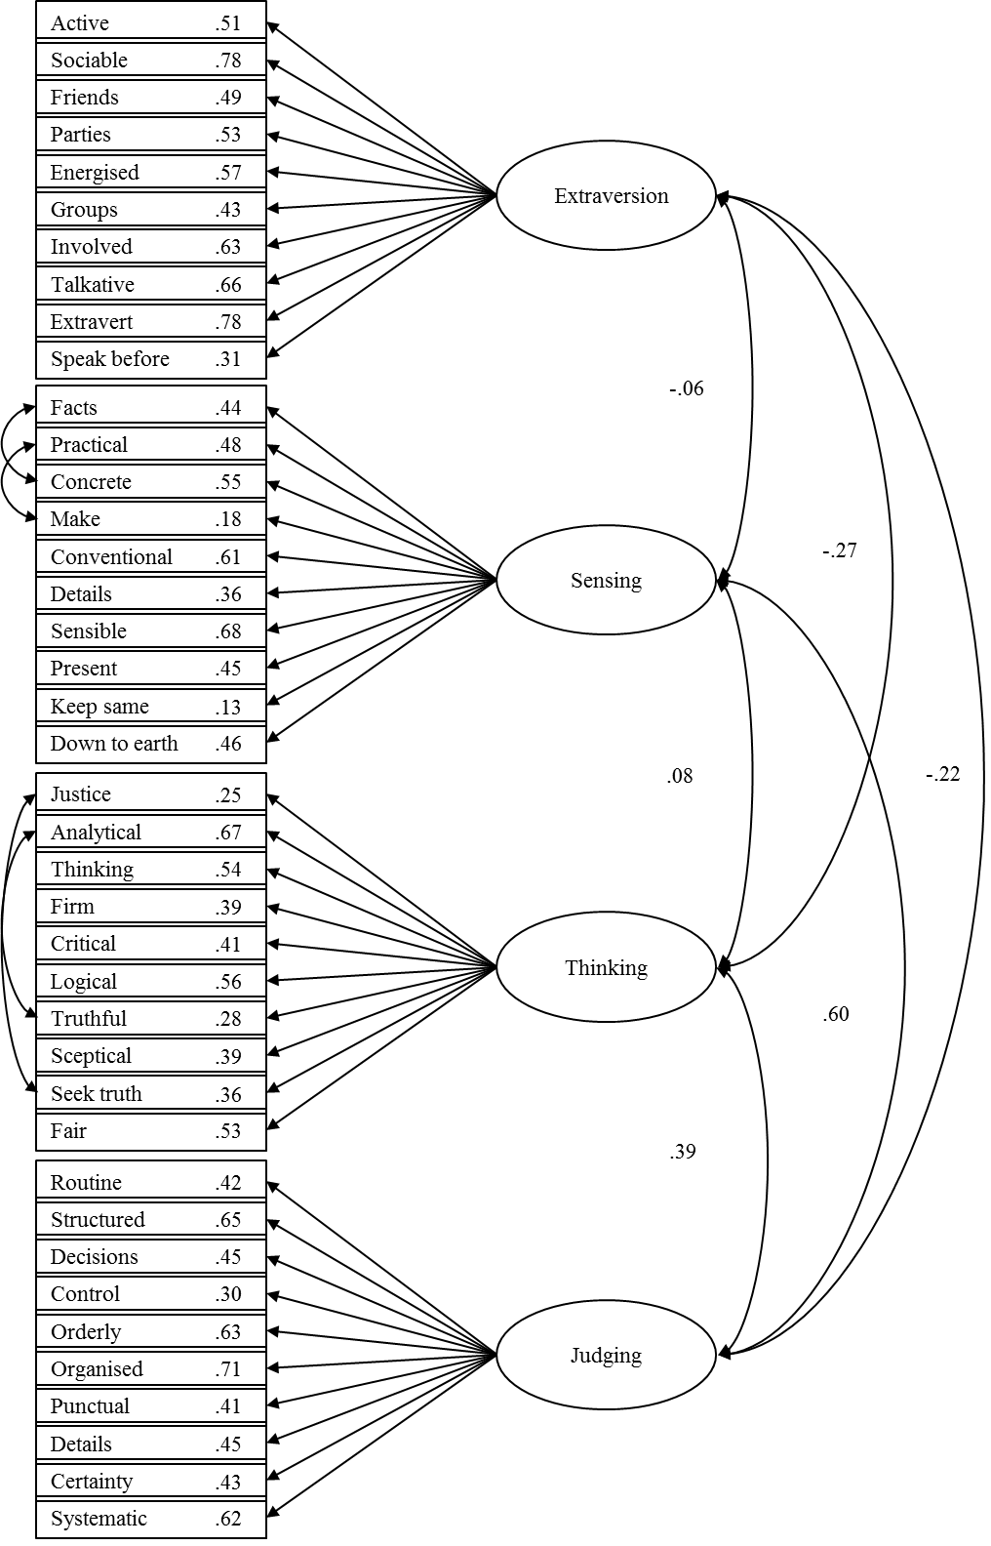
Figure 2 CFA for laity sample.
Note: Standardised factor loadings using ML estimation
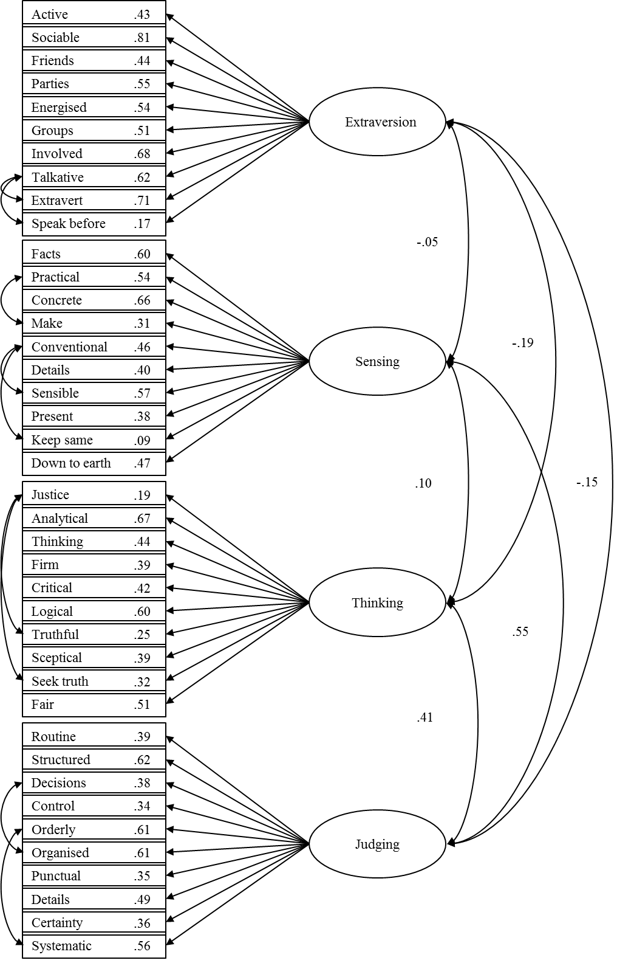
References

Bayne, R. (1997). The Myers-Briggs Type Indicator: A critical review and practical guide. Cheltenham: Stanley Thornes.
Beauducel, A., & Herzberg, P. Y. (2006). On the performance of maximum likelihood versus means and variance adjusted weighted least squares estimation in CFA. Structural Equation Modeling: A Multidisciplinary Journal, 13(2), 186-203. doi:10.1207/s15328007sem1302_2
Byrne, B. M. (2010). Structural equation modeling with AMOS: Basic concepts, applications, and programming (2nd ed.). New York, NY: Routledge.
Francis, L. J. (2005). Faith and psychology: Personality, religion and the individual. London: Darton, Longman & Todd.
Francis, L. J., Clymo, J., & Robbins, M. (2014). Fresh Expressions: Reaching those psychological types conventional forms of church find it hard to reach? Practical Theology, 7(4), 252-267. doi:10.1179/1756073X14Z.00000000045
Francis, L. J., Craig, C. L., Horsfall, T., & Ross, C. F. J. (2005). Psychological types of male and female Evangelical lay church leaders in England compared with United Kingdom population norms. Fieldwork in Religion, 1(1), 69-83. doi:10.1558/firn.v1i1.69
Francis, L. J., Laycock, P., & Brewster, C. (2017). Exploring the factor structure of the Francis Psychological Type Scales among a sample of Anglican clergy in England. Mental Health, Religion & Culture, 20(9), 930-941. doi:10.1080/13674676.2017.1375469
Francis, L. J., Robbins, M., & Wulff, K. (2011). Psychological type profile of clergywomen and clergymen serving in the Presbyterian Church (USA): Implications for strengths and weaknesses in ministry. Research in the Social Scientific Study of Religion, 22, 192-211. doi:10.1163/ej.9789004207271.i-360.38
Francis, L. J., & Village, A. (2017). Psychological type and reported religious experience: an empirical enquiry among Anglican clergy and laity. Mental Health, Religion & Culture, 20(4), 367-383. doi:10.1080/13674676.2017.1328404
Francis, L. J., Village, A., & Powell, R. (2019). Quest-religious orientation among church leaders in Australia: A function of psychological predisposition or openness to mystical experience? Psychology Of Religion And Spirituality, 11(2), 123-130. doi:10.1037/rel0000125
Goldsmith, M., & Wharton, M. (1993). Knowing me- knowing you. London: SPCK.
Jones, S. H., & Francis, L. J. (1999). Personality type and attitude toward Christianity among student churchgoers. Journal of Beliefs & Values, 20(1), 105-109.
Jung, C. G. (1923). Psychological types. London: Routledge.
Keirsey, D. (1998). Please understand me II: Temperament, character and intelligence. Del Mar, CA: Prometheus Nemesis.
Keirsey, D., & Bates, M. (1978). Please understand me (3rd ed.). Del Mar, CA: Prometheus Nemesis.
Muthén, L. K., & Muthén, B. O. (1998-2017). Mplus users guide. Eighth edition. Los Angeles, CA: Muthén & Muthén.
Myers, I. B., McCaulley, M. H., Quenk, N. L., & Hammer, A. L. (1998). MBTI manual: A guide to the development and use of the Myers-Briggs Type Indicator (3rd ed.). Palo Alto, CA: Consulting Psychologists Press.
Myers, I. B., & Myers, P. B. (1980). Gifts differing. Palo Alto, CA: Consulting Psychologists Press.
Rhemtulla, M., Brosseau-Liard, P. É., & Savalei, V. (2012). When can categorical variables be treated as continuous? A comparison of robust continuous and categorical SEM estimation methods under suboptimal conditions. Psychological Methods, 17(3), 354-373. doi:10.1037/a0029315
Village, A. (2014). The relationship of psychological type to interpretations of Genesis among churchgoers in England. Psychology Of Religion And Spirituality, 6(1), 72-82. doi:10.1037/a0035184
Village, A. (2015). Who goes there? Attendance at fresh expressions of church in relation to psychological type preferences among readers of the Church Times. Practical Theology, 8(2), 112-129. doi:10.1179/1756074815Y.0000000007
Village, A. (2018). The Church of England in the first decade of the 21st century: The Church Times Surveys. Cham, Switzerland: Palgrave Macmillan.
Village, A., & Francis, L. J. (2005). The relationship of psychological type preferences to biblical interpretation. Journal of Empirical Theology, 18(1), 74-89. doi:10.1163/1570925054048929
Ware, R., Knapp, C. R., & Schwarzin, H. (1989). Prayer form preferences of Keirsey temperaments and psychological types. Journal of Psychological Type, 17, 39-42.
Waskel, S. A., & Coleman, J. (1991). Correlations of the temperament types, intensity of crisis at midlife with scores on a death scale. Psychological Reports, 68, 1187-1190.

