SHE WALKED TO SCULPT, INTERLOPE, WRAP, LICK & SQUEEZE INTO SPACE

NATURAL

Descending a steep cliff, 400ft down  walking, feels like tumbling  haphazardly arriving at the bottom  on the rocky beach.  Hiding behind the military pillbox  standing out like a sore thumb  a ruin in the natural environment.  Taking off my clothes to change  silently staring at the sea, blue, brown, grey. Naked.  I don a green dress.  On go the boots.  This bay is swooping and takes in names such as  Ravenscar, Stoupe Beck, Boggle Hole and Robin Hood’s Bay  an area of significant displacement  due to rock-mass movement. | 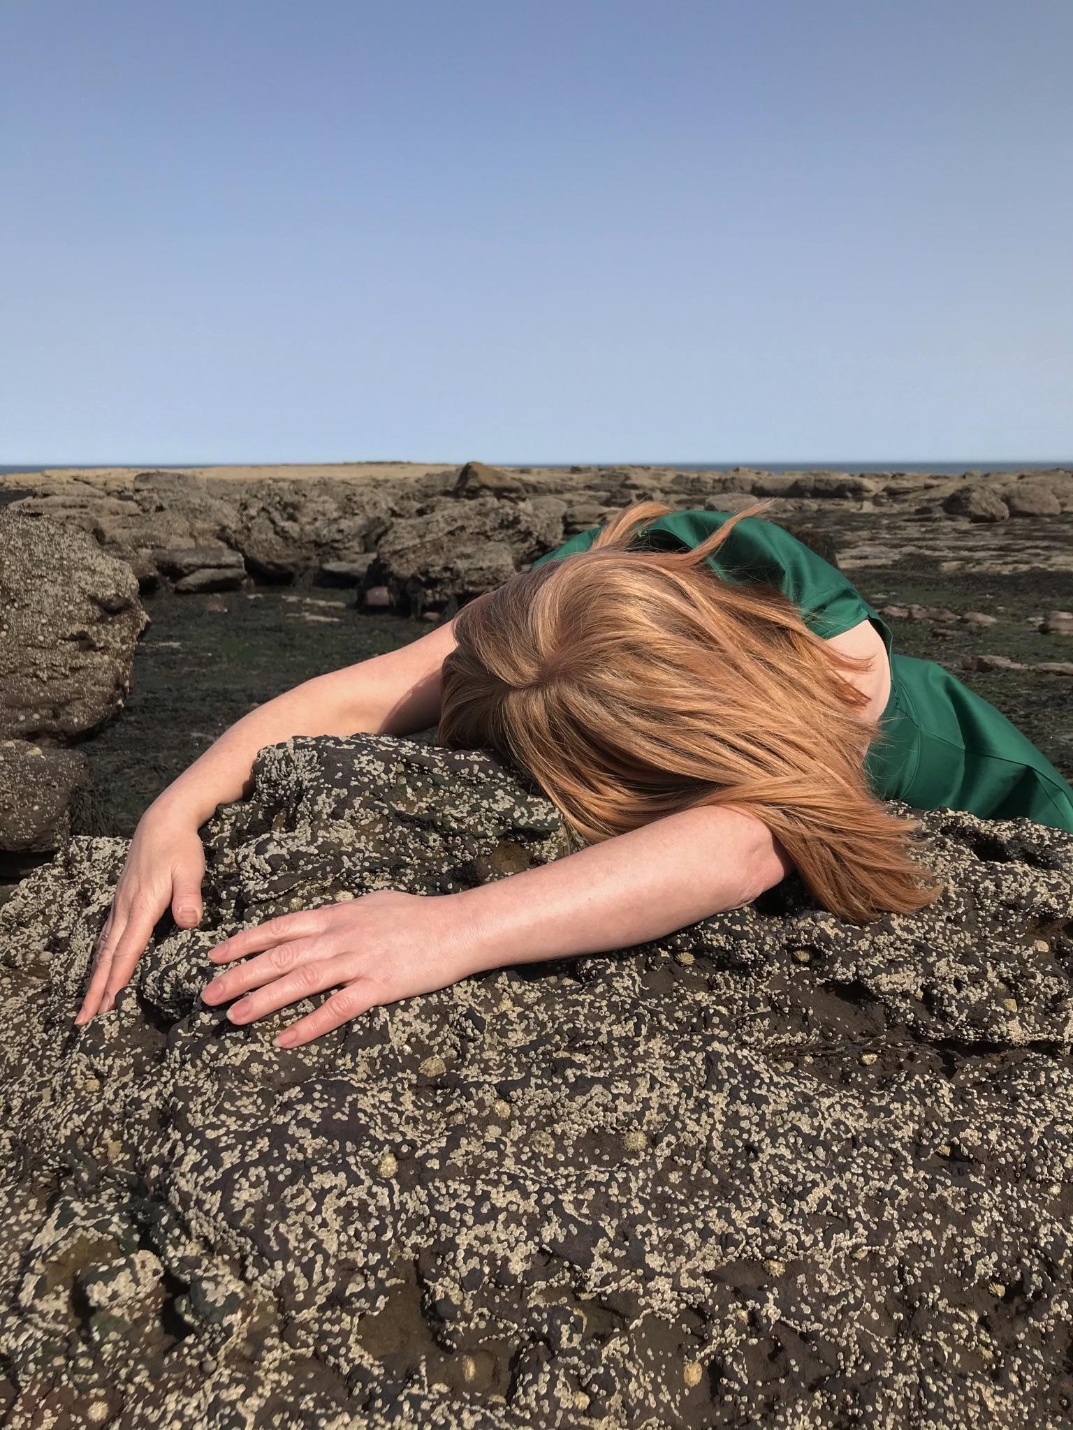

Memories of lone days hiking
and times well spent with my daughter, on 9-mile walks
steep access to the beach at Ravenscar.
Orweed found on very low tides
Mid shore Sea lettuce and Bladder Wrack.
Here’s a thing
Limpets are male for 2 years then change sex to female.
Return via the Cleveland Way.
The peak fault named Peak Steal is a marker of seismic forces
Evidencing different stratigraphy;
Lower Jurassic Sandstone juxtaposes the Middle Jurassic Dogger
And I return to walk here in the knowingness
that if I don’t catch the tide times correctly
I will be cut off
stranded
left to drown.
The elevation and gradient of these cliffs is threatening.
Serious is the history of coastal erosion
landslides are plentiful.
In 1780 the original road into the village was lost
200 properties gone due to cliff top recession.
Two little feet and hands scrambling would trigger big heap landslides.
If I stay here at the bottom, inevitable is my passing
would waves bring my body back to this shore?

I am a performer
walking to situate the self between landscape, sea and ground
I am the observer and the observed, the sentient shape shifter
a body gathering energy from geological wonder.
Others collect pebbles, Roger Caillois was known for his lot
I did too, as a child.
Now, rather than collect, I lay with them and hold my body close
mould into their shape and mimic their direction
understand their textures through intimate contact.
Performance actions interrupt the liminal experience of walking
the terrain trodden behind me and the path yet to come.
Let’s face it
walking is mostly recognised, within the solitary, male, romantic frame.
These performances that scatter across this bay, from rock to scaur
on sand, in pools, at the base of a cliff
claim a space that connects me and my finds to the universe
and the seismic forces that split visible time and space.

I made a little sign,
“Performance in Progress”
It rests above on the cliff where 22m of coastline has eroded
where active slope instability is due to climate change.
A series of actions are performed,
unannounced, engage in fleetingly.
Some actions embody a shape for up to one hour.
Others require my body to move with the tide.
Stay close and hang for the duration or
pass me by and remember a time of gatherings.
I am a rock distorting the notion of a romantic view
I am a sensual crust wrapped up with a rock
This experience is intensely personal.
These actions put the feminist in the landscape
making meaning for women walking.
People collect fossils to connect to a lost time.
My imagination works in situ with site, shaped by the temporal environment
that forever moves.
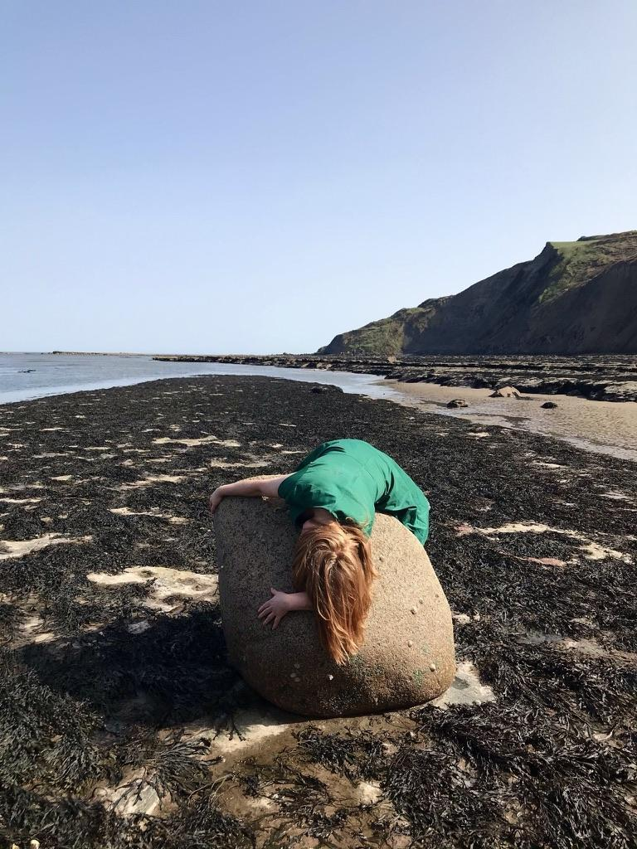 | Meditatively mimicking the rock formations,  I lay on top of a large boulder carried across and deposited here  in the last Ice Age  Rhomb Porphyry is from Norway.  Meanwhile dangerously falling rocks and mini landslides can be heard.  Cliff-top recession due to movement of the clay  cause short-lived one-off slips.  Scratch the surface of a woman’s fears  what is revealed is based upon experience.  Rocks, sedimentary shales, mudstones and sandstones  were deposited 200 million years ago.  Closing my eyes, I have to take a breath  this extraordinary passage of time, how do I comprehend it?  Visualising the universe  we are living on a spherical shape hurtling through space  whilst another spherical shape’s gravitational  pull controls the high and low tides.  I have an out-of-body experience.

Three spherical shapes form an alignment
the earth, moon and the sun of spring tide create a bulging sea.
A two weekly occurrence scattering pebbles, tossing up rocks, and eroding patterns.
I desire to stay in this position and wait
feeling the force of waves refracting, bending
taken in a drift, pulled along by the backwash
woven into the Irish Moss.
Remaining here, fossilised so that others may discover my impression.
70 million years ago
movements from the earth forced the up layers of rock
creating a raised dome shape.
Gradually, due to natural erosion the raised platform of exposed rock
reveals patterns of ridges shaped in semi circles
uncovers hidden dips and scaurs;
evident of the varied rates of erosion over long periods of time.
You can see the eroded dome shape when the tide is fully out.

I am a sea creature with 192 tentacles
Settling into the scaurs left behind by the natural erosion of daily,
yearly, millennial tides.
Squeezing into a scaur, moulding my body between the rock and the sea bed
I let the water wash over me.
Non-human, although in my apparent stillness
from the point of view of the rambler from the top of the 200ft cliffs, I am dead.
I recall the fetishization of dead women.
Tide moves me.
As a Beadlet anemone I imagine an orgasm.
As a school kid, I would regularly confuse the word organism for orgasm.
Wrapping my body around the hard nodules on the beach,  overate in shape and loaded with fossils.  My action prevents others from chiselling away keepsakes.  The 160-million-year-old ammonites rest here now, with me  hammer away at me first, if you must.  Wrapping my body tight around the imperfect surface  Channelling another time  listening to the rock, breasts press down into hard surface  arms drooped around, fingers gently hugging.  Did the tide wash and leave me here?  Am I dead? | 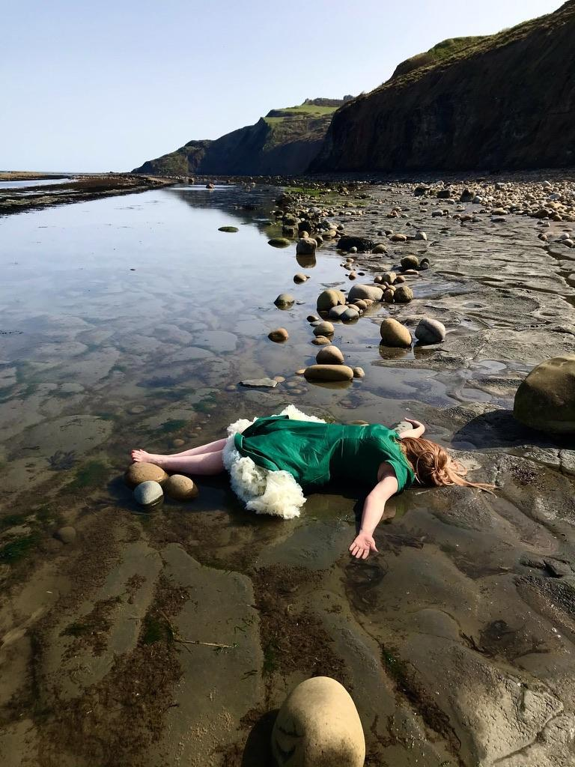

I am transmitting energy between my body and scaur,
my dress being the only thing that may come between us
until the tide returns.
I strip myself of all forms of existence, open and willing to encounter the conditions abstract to the onlooker.
The image may conjure meaning for women walking.
People take and decorate fossils for ornamental value.
My body with the environment is the artefact, ephemeral as the changed beach
after each high tide.

Fear is closely linked to desire
Desire is not an invitation for others to cause harm.
All pilgrimages start with an intention
a reason to leave on foot to some sacred space.
The word sacred is up for interpretation, I like this idea
but let us not overlook environmental catastrophe.
Addressing discomfort, I like to endure pain if it is my choice to experience it.
Tides move me.
Composing creative thoughts into performance
I find the lines and creases in the terrain.
Ammonites don’t think of themselves as magicians,
yet I sense their mystical presence in the world.
Fossils are dead organisms, preserved.
Erosion reveals the buried, the hidden, the other,
and the burning forests of a distant era,
Jurassic wood and fossilised charcoal.

I hear the sounds of an Oyster Catcher.
I come around to an unsightly view
a vessel on the horizon rammed high with shipping containers
reminding me I am all too human.
I imagine the photos of this performance being found
hundreds of years later at the bottom of a dusty old box at auction.
Someone will use my images to collage them into their art project
and blush in public at vernissage
when they slip up in their speech with the word organism.
I understand the fear of doing things alone
contradicted by the excitement of my wild self.
I feel the energy of natural erosion
juxtaposed with the effects of irreversible change.
Cliffs above me rapidly retreat,
falling, sliding due to climate change.
The tide will keep naturally eroding
transforming this landscape, reshaping me.

URBAN

So to begin with she felt like there was absolutely nothing to make a story from. How could she be in a story when nothing happened and there was nowhere to go?
Despite this lack she persisted with the possibility that imagining things that could happen might be enough.

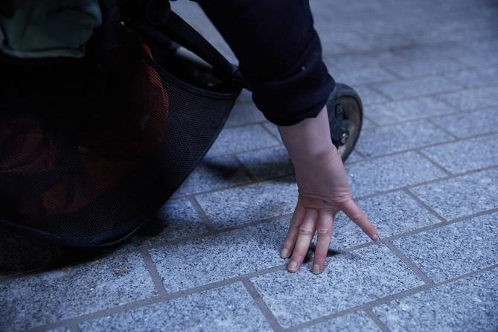 | Put a hand on the ground.  Press fingers against the sparkly oblong of expensive paving. It only really knows the touch of feet.

Just as she was overwhelmed by the nothingness so was the city.
Where before it had been flooded with people and things and action and lives,
now it was empty and alone. The occasional security guard walks around.
A cycle courier perhaps. But the crowds, the surges and the chatter are stuck at home
each in their own bedroom, home office, kitchen.

The steps and the planters, the walls and ledges have reverted back to their material, geological, geometric selves. Cubes and chunks and blocks of granite and sandstone and marble and serpentine abandoned by the lunchtime crowd and the evening drinkers and the going-for-a-smokers long for touch (perhaps?). Or maybe not, maybe they have already forgotten what it is like to be in contact with bodies and instead remember their before-lives long ago in the ground when touch was not a concern because instead of being a block or a slab or a chunk they were part of a greater mass, a mass without edges, no end or beginning; touched and untouched all at the same time.
Perhaps the city’s stones are lost in a dream of themselves way way before, when they were sea creatures and silt, crustaceans and salt water; liquid and alive.

Of course there is never nothing. And she knows that really. She is of course going to sleep and waking up and making breakfast for the children and ordering more dishwasher tablets and trying to get some work done. But what is the work now? When you can’t go where you need to go. When all you can do is sit at a computer and imagine the things that could happen.

So the woman and the city both imagined. In their imaginations was a longing and desire. Through the longing and within the imagining came plotting and planning. To plot has a different tone than to plan. The plot thickens.

She can imagine and desire and work through the longing by plotting.
Who knows if this will be the sort of plot that makes the doing easier, more immediate, instant? Or if it will be the sort of planning that results in disappointment, a mismatch between the imagination and the reality. She knows that feeling too well - the best laid plans and all that. The danger of imagining in too much detail and struggling to adapt when it just doesn’t go that way.

And there in the moment the cold is colder than it was in her imagination, and the sun brighter, and the small child more willful, and the city just as empty, and the material of the street and the buildings just as unyielding.

She can see the place she wants to go. It’s on the horizon. She’s close but not close enough. The cityscape here is quite abrupt. The fringe between the City of London and the East End is short and a bit ragged. In places the shiny metal and glass fan out further into the streets of lower rise more ordinary buildings. Spitalfields used to be East End, now its heart has been pierced and it leans more towards the city. She’s stuck on the wrong side of Brick Lane. Permitted exercise takes her close but not there. The kids are tired and cold and one of the bikes isn’t working properly. She’s tired and cold too. They can’t go further. She knows it’s the right call. But it’s frustrating to get so close and not achieve the destination. Acceptance. She wanted to get to the empty city. From a log in the park she looks across to the skyscrapers, so close.

When you finally get there you don’t see the height of the building, too close so you see the detail. You spend time in close contact and you get to know the surface, the texture, the patterns. That meander is carved in, with joints in the stone where the panels meet. Trace it with your finger, imitate it with your body – see if you can get it to make a straight line or a right angle.

Setting out with an intention, and then having to abandon it feels like a fact of parenting, and the pandemic. Sudden curtailment and cancellation. Change the plan, stop, go home, do nothing instead. Acceptance is hard. Harder when you have imagined in such sensory detail what you were going to do. But maybe it contributes to the sense of longing? Girds the intention for a future when the bike is not broken, it’s not quite so cold, everyone is not quite so tired?
She wants to curl her body into the fold of a building. To get closer, too close to it. She wants to lie down on the cold stone step and feel the chill of its weight. Part of the longing is the imagining of what it would feel like, what it would look like to enact these performances. Inserting a body into and onto the built structures. Blurring her boundaries with the materials of the street. | 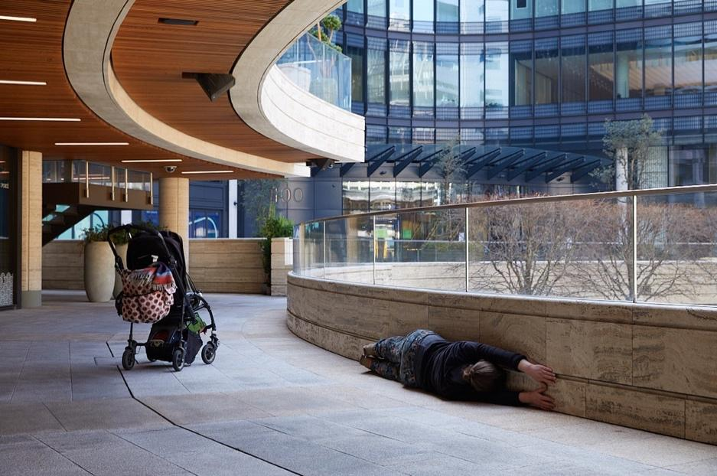

The imagining of the act is an articulation of desire. It’s fully sensory. She doesn't only imagine the feel of the cold smooth surfaces, she can taste them too. She conjures the textures of porphyry and limestone, the rough and the smooth. Conjuring might mean more than imagination? To conjure is magic. A feat of pulling ideas from the air, from the city, from the stuff around you. Placing yourself there.

Take this space as yours to play in, no one else is here, no one will stop you or even look askance.
Claim it.

Conjure an image that captures the scene, a cityscape with tall glass and concrete and stone buildings. Perhaps a square, maybe with benches or steps or other structures. In the space a lone figure, a woman with a pram. Actually, not a lone figure as there is a child. The child is in the pram or maybe not in the pram, maybe refusing to go in the pram. The bodies of the woman and the child are not behaving normally in the city scene. They are too close to a building, pressed up against it. Making physical contact with its structures, trying to penetrate it. Allowing its hard cold surfaces to penetrate them. Perhaps they are lying on the steps, draping their soft bodies over the shapes of the stone, trying to make themselves step-like. The pram is always there too, an incongruous awkward insertion. Maybe there are images where they are trying to get the pram up the stairs, pulling and lifting and twisting and struggling. Fighting the topography.

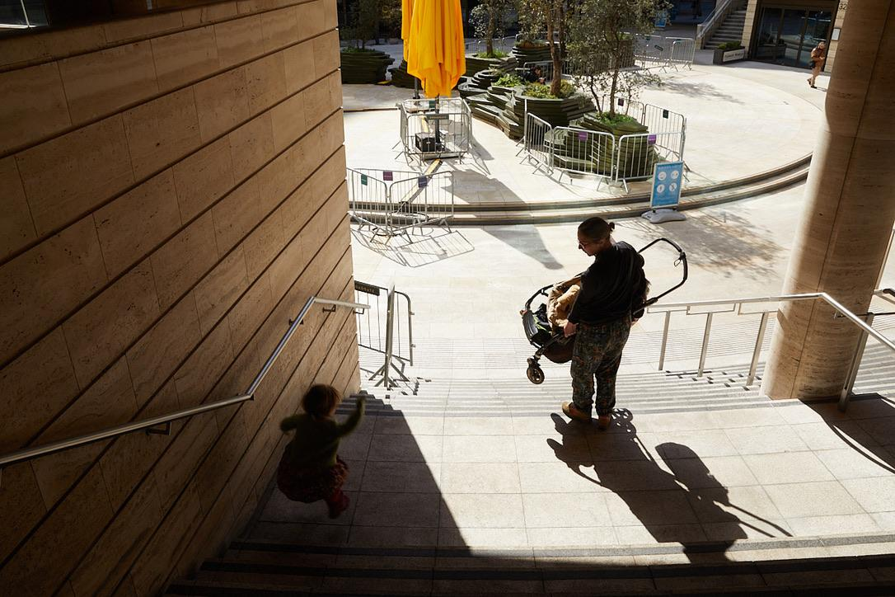

Although bodies seem soft and stones seem hard, they too are wearing away. We are eroding in different ways. She is soft but is a force of erosion. Feet worry away, combined with the repetition of the footfall of many others, dips in the steps. But only in the paths most trodden.
Let’s go right to the edges - the bit where no one would walk. Too close, closer. Inappropriate touch.

Postscript

Claire Hind and Clare Qualmann performed their actions inspired by the artist
VALIE EXPORT and her work Body Configurations (1972-82):

I inserted the female subject into the object of male power structures. This penetration into things, aggression, provocation, these are still important elements of dramatic art because they are challenges to dialogue and discussion. (EXPORT, 2018)

They sought to embody environments that connect to their own walking practices and claim a space for women in the walking landscape. EXPORT’s influence on these performances registers the effects of bodily presence in the built and natural environment during a period of restricted movement. Claire Hind performed on the North Yorkshire Coast in collaboration with her daughter Amalie who captured the images through photography. They took a 9-mile walk to look for sites of geological interest, paying attention to textures, patterns, shapes and lines, whilst reflecting upon the area’s coastal erosion and environmental change. Clare Qualmann performed in the finance-dominated topography of the city of London in collaboration with her child Astrid, and their pram, photographed by Katie Wilson. They enacted and re-enacted moments of parental performance in an attempt to capture photographically the conjunctions between bodies, mobility tools and the finance-dominated city.
Claire and Clare’s collaboration to conceive and plan these events began as an online exchange during the UK’s third lockdown period in early 2021, responding directly to The New Poetics of Space conference. At home they pondered on a heap of words that related to the places they intended to walk as soon as the stay-at-home restrictions lifted. The words: erosion, desire, planning, plotting, fear, cold, intention, discomfort, conjuring and sensation, were prompts to think creatively and imaginatively about the sites planned for performance, as a provocation on bodies, language and the place of women in the natural and urban environment.

Photo Credits:
N A T U R A L: Amalie Iona U R B A N: Katie Wilson

References:
EXPORT, VALIE (2018) Body Configurations [Video] Galerie Thaddaeus Ropac, online https://vimeo.com/515403291 (accessed 02/09/21)

(Mid Sweden University, December 2020) https://www.miun.se/online-conference

