Title: The Partly Present Mother

Abstract:
This essay makes critical reflections on a performance titled The Partly Present Mother, which traced acts of nurturing and loss at the Kosar Contemporary Gallery, Bristol, in 2019. The research reflects upon the silence of pregnancy without birth or ‘miscarriage’ as a Matrixial space, where the union of both m/other are in flux. This changeableness or uncertainty embedded within the maternal is critiqued by making parallels between the becomings of drawing and mothering by positioning them both as verbs or acts. Derrida’s Memoirs of the Blind (1993) and the Greek myth of Pliny’s shadow are used to consider loss as interwoven within drawing practice, where the corporeality of drawings practices wavers amid discovery and loss. The project takes these experiences of loss answering Hélène Cixous’ call to ‘write the body’ (1976), performing them through touch and repositioning textuality as live and physical. The parallels of becoming imbedded in the acts of drawing and mothering look to Elena Marchevska’s notional of the maternal as a verb (2019) and the process of becoming subjectivity as embedded within drawing (Bryson, 2003; Fisher, 1998; Naginski 2000; Sawdon and Marshall, 2012) to reclaim the flux of the maternal notwithstanding pregnancy without birth.

Introduction:

… to mother is a verb, an action, and thus separable from biology and even gender, an idea that runs counter to popular and patriarchal myths that motherhood is a destiny, a natural state from conception onwards, and that caring for one’s child is the biological epitome of female experience. Such discussions of good mothering are still frequently framed by prescriptions of consistent, unmediated and unbroken presence to the child, and, whatever the contributing personal factors may be, divergence from this classed and constructed norm can still send the mother further down the scale of social judgment. Elena Marchevska (2019: 121)

The theories and practices drawn upon in this research are used to question the stability of identity construction(s). For this enquiry, the Maternal is centred as a verb, or as a series of exchanges, (Elena Marchevska (2019), and answers Hélène Cixous’ call to ‘write the body’ (1976). To acknowledge the maternal as a verb dislocates it as a fixed construct, and so instead it can be addressed as lived experience. This research looks to the social/cultural implications of the maternal as an unfertile body. Writing the maternal body in these terms disputes its status as predictable, thereby bringing uncertainties to the fore. If we champion the pregnant subject using Bracha Ettinger’s reflections of a Matrixial space (1993) – a body in joint becomings – explorations can allow the identity constructions around both personhoods, that of the mother and other, the baby or foetus, in flux.

The Matrix is modelled upon certain dimensions of the prenatal state which are culturally foreclosed, occluded or repressed. It corresponds to a feminine dimension of the symbolic order dealing with asymmetrical, plural, and fragmented subjects, composed of the known as well as the not-rejected and not-assimilated unknown, and to unconscious processes of change and transgression in borderlines, limits, and thresholds of the “I” and the “non-I” emerging in co-existence. (1992: 176–77)

In this research, Ettinger’s proposition of the non-I is utilised in the context of pregnancy without birth. She describes this non-I as a partner in difference and by framing it within the Matrix to reflect ‘multiple and/or partial subjectivity whose elements recognize each other without knowing each other’. (1993:12) These frameworks create an opportunity to revisit binaries when considering the development of personhood as interrelated by specifically concentrating upon the maternal body when it becomes a place of ‘arrest’.

Pregnancy without birth or a ‘miscarriage’ is often concealed from public discussion as it sits uncomfortably within Western constructed norms, thus becoming an experience that is unnecessarily shameful for those who move through it. The objectification of ‘mother’ as a maternal figure shifts wildly from one ‘who makes everything all right, who nourishes, and who stands up against separation – a force that will not be cut off but will knock the wind out of the codes’ of patriarchal order’. (Cixous 1976: 882). My experiences sat outside of this gynocentric affirmation of women’s subjectivity; moreover, my womb performed like, as Bueno describes, a ‘place of death’; ‘I felt like a “human coffin”’ (Bueno 2019: 89). This research affirms the order of birth before death as interchangeable.

Current statics given by Tommy’s PregnancyHub (accessed 30/5/22) describe the definition of miscarriage as the loss of pregnancy within the first 23 weeks. One in five pregnancies end in miscarriage, one in a hundred women experience multiple miscarriage (3 or more in a row), and 123 million miscarriages occur every year worldwide. The research undertaken by The Partly Present Mother looks to the habitual internalisation of this loss and its subjective affects on identity construction. Within the timeframe when miscarriage occurs, pregnant people receive confirmation of the baby’s due date and, if requested, their gender. Expectant parents can view ultrasound scan images, with a commentary from the midwife or the person carrying out the scan that attaches a personality to the foetus. With comments such as ‘this is a shy baby it won’t turn around’ or ‘this is a excited baby it will not stop dancing around’. (Mitchell, L & Georges, E. 1998) All of these experiences construct the pregnancy as a baby and asserts the pregnant person as a mother. This research looks at how this geocentric affirmation of subjectivity is challenged when miscarriage takes place, and how these persons are cast outside of binary constructions. Perceptions of the self as maternal are broken and lead to guilt and shame. Loss is a significant interruption to synthesizing identity constructions: how can the maternal figure understand themselves within the culture of silence that excludes loss as a lived experience?

Drawing practice is a key mode of enquiry to this research. Its non-verbal nature empowers subjective becoming and can revisit knowledge structures as specifically bound to language and textuality. Drawing is peripatetic, and this research acknowledges it as time bound, moving through possibilities. (Bryson 2003; Fisher 1998; Naginski 2000; Sawdon and Marshall 2012) Loss is often overlooked within drawing practice yet, within this project, it is centred using Derrida’s Memoirs of the Blind (1993) and the Greek myth of Pliny’s shadow. It is also practiced as a means to verbalise maternal identities as fluid and subjective. This research looked to the performative nature of drawing as thi is a powerful mode to explore bodies – their acts, unions, and losses. It documents a performance titled The Partly Present Mother made in 2019 at Kosar Contemporary, Bristol. In this paper, the title The Partly Present Mother is used to describe both the work and myself. This practice-led research is set within the context of drawing to rethink its traces as appearing and disappearing, to acknowledge human presence despite the absence of a body and note it as impermanent. The performance worked with a collection of methods – touch, the grid, the photograph/photocopied image, and the human shadow – to explore the silence of miscarriage and notions of the maternal body as a fixed fertile construct.

Research Questions and Methodology

The project considers how to answer Cixous’ call to write the body within the context of performance drawing. By acknowledging drawing as an animated undertaking, the project centers drawing as performative and as remembering ontological precariousness through its live acts. Failure is recognized as being imbedded in the acts of drawing and mothering, which are tested by the project and its methods. Here, I interrogate the parallels of drawing and mothering as being fluid by working with methods and materials that echo or apply a flux.

This research has developed from previous drawn works on paper published in Sitting with Uncertainty IBSN 978-1-5272-4881-6 . This artist’s catalogue framed miscarriage using drawing as a method to ask how can drawing articulate the loss, uncertainty, and trauma of miscarriage, which has been hitherto excluded from culture’s representations of pregnancy? Only by addressing the silence that often surrounds pregnancy without birth can we rethink our understandings of it. In Western culture, grieving after pregnancy without birth or miscarriage is not accredited by rituals, and so often becomes a solitary process accompanied by shame and taboo. The maternal is deeply interconnected to a nurturing figure, and to share ambivalence to pregnancy loss, goes against the grain and is, at worst, vilified. There are minimal spaces for the maternal figure to voice loss or doubt. (Kilshaw, S. 2020) Sitting with Uncertainty brought together a collection of gridded drawings made in 2019 with reference to the ultrasound image undertaken at 12 weeks of pregnancy. There are 4 large gridded drawings in the publication, grouped in four sections, each comprising of 297 individual works measuring 105 x 74mm. These 4 gridded works made reference to the reoccurring miscarriages where the monochromatic drawings build and break forms, referencing the growth and arrested development of the m/other. These drawings are significant in articulating the actuality of pregnancy without birth, as they explicitly avoid images of ‘baby’ whilst using cues from ultrasound scans
(See figure1; one of the 4 gridded works made for the publication.)

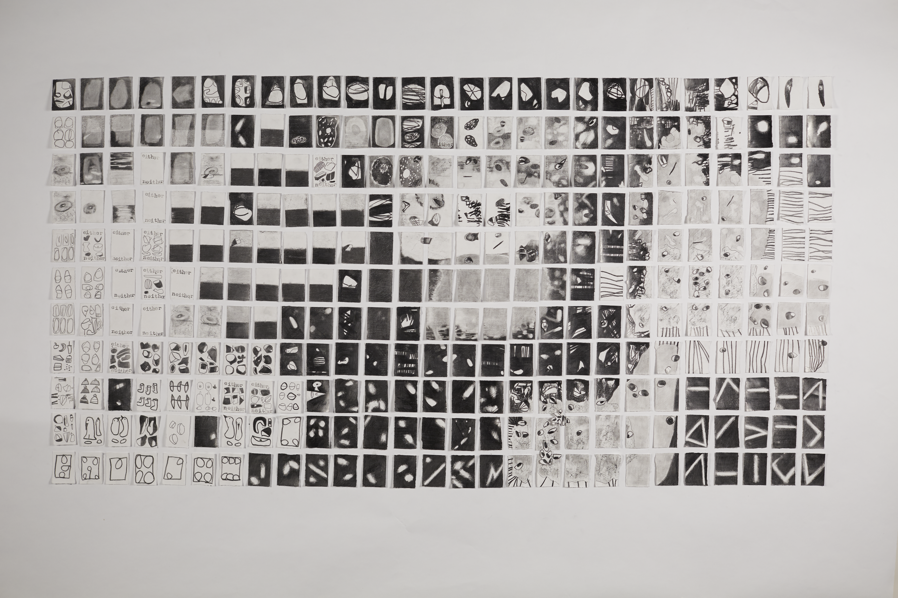
FIG 1

Accompanying these drawings within the catalogue publication are a collection of written texts from curators, researchers, therapists, academics, and artists that frame the work within contexts of loss and grief. This publication was subsequently endorsed by the British Infertility Counselling Association (BICA) as tool to support clinical practice in the NHS in the UK. In 2021, TRACEY Journal of Visualisation published All the Thoughts I Ever Had: Sitting with Uncertainty. More recently still Victoria Browne’s book, published by Bloomsbury, Pregnancy Without Birth: A Feminist Philosophy of Miscarriage, (2022) used the drawings Sitting With Uncertainty on the front cover, see figure 1.

The research positioned drawing as an important method that had the power to participate in the process of becoming subjectivity (Bryson 2003; Fisher 1998; Naginski 2000; Sawdon and Marshall 2012) However, by integrating its anti-thesis of ‘unbecoming’ as maternal loss and reproductive failure, a second question asks, how can the experience miscarriage, as an unravelling or unbecoming of self, nuance the emphasis on ‘becoming’ in the discourse on drawing?

The Partly Present Mother’s materials and methods are an accredited resource for the methodology in its interrogation of the research questions. The materials and methods are discussed throughout this paper; however, I will tentatively introduce them as touch, the grid, the photograph/photocopied image, and cast human shadows. Touch is significant as an action that confirms presence through bodily sensation. Touch is captured in the photocopied images used in the project and repeated in the gallery space where the interactions are performed. The philosophical and practical characteristics of touch place emphasis on drawing, centering it as tacit and generative. The performance saw touch as a significant tool to explore nurturing and loss by creating unions and breaking them. Touch is significant to the methodology when considering the coming together of bodies, that of mother and child, where questions of good mothering are framed by consistent, unmediated, and unbroken presence to the child. Any divergence from this constructed norm can assert negativity around the quality of maternal care, used in this circumstance to examine pregnancy without birth, or the union of bodies and their parting. The touch imbedded within drawing is tested, as a method of describing lived experience. Touch is positioned in this methodology as poignant to both exploring and confirming corporeal knowledge.
The grid is a long-standing method within my studio practice and, as observed in this research, it has been developed from the works on paper that make up Sitting with Uncertainty (2019). Working in multiples arranged within a gridded composition allows for the repetition of visual events, which functions as a mode that appears to give speed to visual occurrences through this repetition of motive. The grid is described by Rosalind Krauss as refusing the fixity of the viewer’s gaze and constructing an aesthetic encounter that is forever in motion (1986) and this is strategized in this project to restage touch as a process of connectivity and loss. The performance uses the grid to act out systematic encounters of touch as a union, which is adjacent to parting and its bereavement.

For The Partly Present Mother performance, the grid was constructed on the gallery walls and floors using photocopied images of touch undertaken by both my hands and my daughter’s. These images captured traces of contact, manifest as photocopies that spoke of an aesthetic of photography or the photographed ‘moment’. Susan Sontag’s photograph as a memento mori (1973) where captured images participate in another’s mortality, vulnerability, and mutability. The images for The Partly Present Mother are modes of connection that allow her to revisit touch; it is where bodies meet, and relationships are developed.
Cast shadows are used in this project to create impertinent traces of figures which move over the photocopied images in the gallery setting. The shadow is created by casting strong light sources in the gallery space and moving my body to cast silhouettes over images of hands coming together. A revision of loss reframed the drawings’ generative communicative powers, where the emphasis on becoming included loss. This replies to Jacques Derrida’s Memoirs of the Blind (1993). This text shifts drawing’s process from being reliant on sight to establishing connectivity to its subject; by excluding the presence of perception, drawing is endowed with blindness and memory. Here the process of looking emphasizes the gaps between observing and marking, thus reasserting recall and reproduction as significant to the process. The composition of this drawing, in part, corroborates the myth of the first drawing, which is known as Pliny’s shadow. This classical Greek myth describes how Boutades’ daughter is about to see her lover sail away. She feels that this will be the last time she sees him. As he sleeps, she takes a piece of coal from the fire and draws his profile from his shadow cast on the wall. This record of drawing is motivated by both love and loss. Using the drawn line to trace the profile of her lover, one plane is separated from another on the wall and frames drawing as a philosophical and practical method bound up in loss and presence. The impermanence of presence is highlighted by this myth, where sight and presence form the creation of this drawing. Derrida’s analysis repositions the inevitable recall of drawing as taking place between eye, hand, and support. This methodology looks to question the significance of marking in the production of drawing by refocusing upon actions and deliberates these as mutually corporeal in its ontological explorations. This paper narrates the performance of The Partly Present Mother – which is used as both a phrase to describe myself and also as the title of the work – to explore the maternal. It is pertinent to note that the words that appear as italics within the following text do so because they are terms I have heard others use in my experiences of multiple miscarriages.

The Partly Present Mother

The Partly Present Mother, without a child in tow, takes up the gallery space; I organized photocopied papers of hands by laying them over the floor and securing them to the walls. These were recoded a few weeks ago as I balanced a poorly child who was absent from school and admin at work. Here, we played with the photocopier by laying down our hands, reinventing different positions of contact with the machine and each other. The hands, now spreading through the Kosar gallery, hover in their flat pictorial space as various tonal grounds shield the participant’s bodies, which lay beyond the frame of the paper edges. The photocopies captured our images, confirming our interactions and reasserting our personhood by picking up on Susan Sontag’s (1973) recognition of photographs as memento mori, images that participate in another’s mortality, vulnerability, and mutability. The photograph or photocopy was a significant material for the project and The Partly Present Mother as a tool that could jointly reference presence and death. These images sprawled in the gallery, slowly being arranged into gridded compositions, held a precious memory of our every day actions and interactions, leading me to think of public and private moments, presence and absence. Whilst recalling these interactions with my child, now 6 years old, my mind wandered to the more recent experiences of looking at graphic images projected by an ultra sound scan onto a monitor during a 12-week pregnancy check. This process is used to confirm progress and, fundamentally, the existence or status of subject as baby. Having had multiple miscarriages since my child’s birth, I had previously looked at various ultrasound scan images on monitors, in muted light rooms, lying on my back waiting for some sort of confirmation.
However confirmation of death came from these photographic images. Whilst my first pregnancy and now child of 6 years, depicted live, animated results on the ultra sound scan confirming her life sanctioning existence and the status as baby. The subsequent following pregnancies at these events were in reverse – with descriptions of growth as arrested. Technology had used its lens to peer into my body observing beyond ordinary ranges looking to pronounce me as pregnant – fruitful – expectant or as a vessel of expiry. Back in the gallery, I looked at the photocopies that held images of my child’s hand positioned next to mine, yet both of us cut off from our bodies by the rectangle frame created by the screen. Here we played with a range of gestures that felt both tender and mischievous. The disembodied anonymous hand motions now on the gallery walls spoke of absent bodies. The paper grounds were various tonal grey grades that created a type of veil, hiding the bodies beyond the gestures. These images were laid out and organized in the gallery space as tools to rethink the moments of connectivity we had making them.

When laid, the rectangle paper copies became a grid – a compositional device that created a significant rhythm in the Sitting with Uncertainty collection of drawn works on paper. This device acknowledged Rosalind Krauss’ application of the grid as mobilizing the viewer’s gaze (1986). It had been utilized with these works on paper to reconsider how the aesthetic encounter, when set into motion, could be read. It was important to speak of the continuous nature of time, with life and death bound in its momentum, and the grid, with its repetitive rectangle units, helped to achieve this. I wanted to wander in amongst the gestures, using my shadow to integrate and play once more, see figure 2.

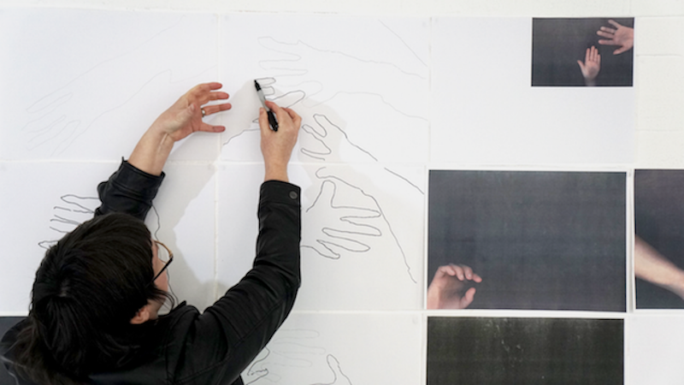
FIG 2

I began to mimic the acts back into and over the photocopied hands: finding places in which we hold hands, part company, and give reassurance. The significance of
Pliny’s shadow was purposeful here; known as the first drawing ever made, Pliny’s shadow was a meaningful to deal with loss and the fleeting nature of bodily unions within the context of a live drawing performance. As I move my body to create shadows cast onto and over the photocopied hands, I rejoin the images on the gallery wall; simultaneously grappling to record, study, and save these actions with drawn pencil lines (see figure 2).

The configurations of the hands reminded me of experiences of cradling a baby or supporting and managing an animated older child who’s acting upon their inquisitive desire to explore the world past your lap and assert their independence. They also resonated with the shapes and actions I’d seen in the gestures within sign language, and I wanted to act them out as types of instructions or scores. Reflecting the touches held within the images in the gallery, I began moving my body, arms, and hands to recreate them, see figure 3.

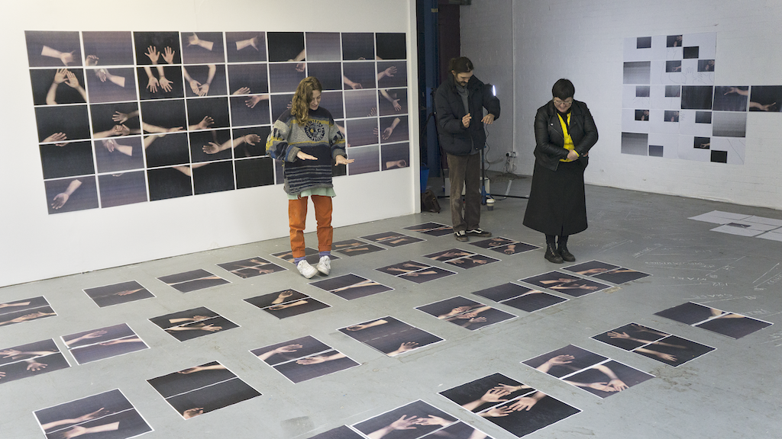
FIG 3

Held within these touches were traces of parting, absence, and loss, and a sense of reclaiming the status of mother through these connections, despite the absence of my child in the gallery. Here my body as performer felt reasserted and activated in the gallery space; the body’s politics, deportment, becomings, and viability were all at play by moving from the anonymous paper grounds of the photocopies back into sight, assuming her place at the gallery. Here as I performed the live acts of drawing visitors joined me interpreting the actions, see figure 4.

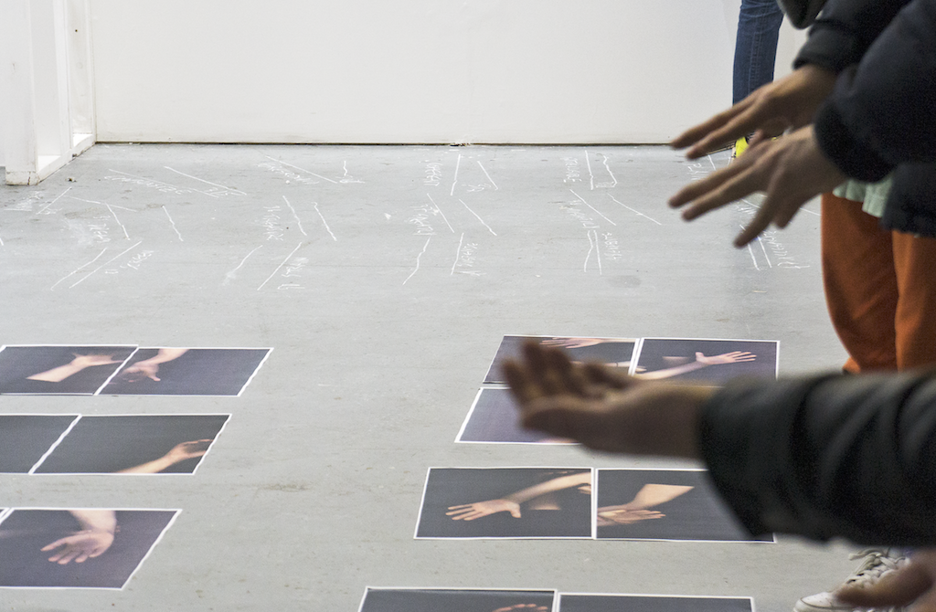
FIG 4

This performance created a place that Western society does not offer for pregnancy loss rituals. Pregnant bodies shift from being an expectant person to one managing the physical demands of losing bodily products rather than persons. The becoming and unbecoming of the maternal figure is inbound, lived through the body, but surely cannot be framed within binary structures, as this omits the pregnancy and dismisses the frameworks of identity construction imposed by language. The silence of miscarriage had been overwhelming loud for the partly present mother yet, in the gallery space, acting out parting and loss assured a coexistence of bodies. The word miscarriage is framed by language implying a mistake, or a clumsy act undertaken by a person who is ill-equipped. The language surrounding the pregnancy changes, and a shift from baby to material of conception and the status of m/other as capable, is all so quickly taken away. This alteration from someone to something swiftly removes maternal status, amplifying a denial of identity to both m/other. This is an occurrence bound in self-trust as Ann Cahill describes when ‘calling the foetus into ‘personhood’ is suddenly discontinued, what can result is ‘an emotional isolation that is itself confusing and damaging to self-trust and bodily integrity’ (2015). With discussions of good mothering still frequently framed by prescriptions of consistent, unmediated, and unbroken presence to the child, highlighted by Elena Marchevska as the only credible mode to parent, any divergence from this can ‘send the mother further down the scale of social judgment.’ (2019:121) With these conventions framing how we see ourselves, it is unsurprising when the ‘loss’ of a pregnancy seizes status of ‘mother’ and propels the silent club membership or, as Ceballo et al. describe, for those who occupy de-valued social positions ‘silence shields women’s sense of shame, difference, and personal failure from public view’. (2015: 508) Iris Marion Young asserts how the pregnant person has the ‘privileged relation of feeling with the fetus’ ([1984] 2005: 61); however, joint becomings are arrested when our status of mother and baby are withdrawn in a confirmation of failure. For my pregnancies without birth, I saw that ‘we’ were only partly present, established only once in our identities; constructed by a thin blue line of a pregnancy test, our becomings are written as unbecoming.

Meskimmon and Sawdon (2016) name a concept to articulate individuals as fluid, creative subjects – ‘allotropic figuration’. To acknowledge this term, Meskimmon and Sawdon proposal makes way for material changes in meaning and identity. This chemical and epigenetic undertaking utilizes lines and marks to express ‘an unfolding of matter and meaning through manifold, non-binary, non-hierarchical modes’ (Meskimmon and Sawdon 2016). To apply this understanding of a fluid figure to this research, The Partly Present Mother gives renaissance to writing the body in drawings terms, reflecting and recounting experiences of pregnancy without birth with assurance. The corporeality of drawings practices wavers amid discovery and loss. The loss of sight emphasized by Derrida shifts the once additive and informative nature of drawing to blindness. For The Partly Present Mother performance, the absence and presence of bodies was important as this is authentic to experiences of parenting. Equally, in experiences of miscarriage, the Matrixial space is forever broken and the status of both m/other ceases. The Partly Present Mother revisited the verb and noun of drawing, magnifying its live acts in the context of the maternal. The drawing took place in the gallery as it provided a site to share its live acts. This empowered permission to be unsure, venerable, at a loss, and to practice loss, to be blind, and reveal this blindness as inherent, actual, and, at best, penetrable.

References

Browne, V. (2018), ‘The politics of miscarriage’, Radical Philosophy, https://www.radicalphilosophy. com/article/the-politics-of-miscarriage. Accessed 1 May 2019.
Browne, V. (2022), Pregnancy without Birth: A Feminist Philosophy of Miscarriage, London: Bloomsbury.
Bryson, N. (2003), ‘A walk for a walk’s sake’, in A. Newman (ed.), The Stage of Drawing Gesture and Act, London and New York: The Drawing Center, pp. 149–58.
Bueno, J. (2019), The Brink of Being: Talking about Miscarriage, New York: Penguin Books.
Cahill, A. (2015), ‘Miscarriage and intercorporeality’, Journal of Social Philosophy,46, pp. 44–58.
Ceballo, R., Graham, E. and Hart, J. (2015), ‘Silent and infertile: An intersectional analysis of the experiences of socioeconomically diverse African American women with infertility’, The Psychology of Women Quarterly, 39, pp. 427–31.
Cixous, H. (1993), ‘Without end no state of drawingness no, rather: The executioner’s taking off’, New Literary History, 24:1, pp. 91–103.
Cixous, H., Cohen, K. and Cohen, P. (1976), ‘The laugh of the Medusa’, Signs, 1:4, summer, pp. 875–93.
Derrida, J. (1993), Memoirs of the Blind: The Self-portrait and Other Ruins, Chicago, IL: University of Chicago Press.
Dexter, E. (2005), Vitamin D: New Perspectives in Drawing, New York and London: Phaidon Press.
Ettinger, B. (1992), 1992), ‘Matrix and metamorphosis’, Differences: A Journal of Feminist Journal Studies, 4, pp. 176–208.
Ettinger, B. (1993), Matrix-Borderlines, Oxford: Museum of Modern Art.
Fisher, P. (1998), Wonder, the Rainbow, and the Aesthetics of Rare Experiences, Cambridge, MA and London: Harvard University Press.
Kilshaw, S. (2020a), Navigating Miscarriage: Social, Medical and Conceptual Perspectives, New York and Oxford: Berghahn Books.
Kilshaw, S. (2020b), Pregnancy and Miscarriage in Qatar: Women Reproduction and the State, London: Bloomsbury.
Krauss, R. (1986), The Originality of the Avante-Garde and Other Modernist Myths, Cambridge, MA, and London: MIT Press.
Marchevska, E. (2019), The Maternal in Creative Work Intergenerational Discussions on Motherhood and Art, London: Taylor and Francis, and Routledge.
Meskimmon, M. and Sawdon, P. (2016), Drawing Difference: Connections between Gender and Drawing, London: Bloomsbury Publishing.
Mitchell, L. and Georges, E. (1998), Baby’s First Picture: The Cyborg Fetus of Ultrasound Imaging, New York: Routledge

List of illustrations
Figure 1 ‘ Sitting with Uncertainty’
‘The Partly Present Mother’ 1
Figure 2 ‘The Partly Present Mother’ 2
Figure 3 ‘The Partly Present Mother’ 3

