Predictors of church growth in Southwark Diocese, 2000-2008

Andrew Village
York St John University, England, UK

Direct correspondence to:
Andrew Village
Theology and Religious Studies
York St John University
Lord Mayor’s Walk
York YO31 7EX
UK
Tel: +44 (0)1904 876723
E-mail: a.village@yorksj.ac.uk
Abstract
During the first decade of this century Southwark Diocese saw a slight increase in ‘usual Sunday attendance’, a key statistic used by the Church of England to monitor year-on-year changes. This slight increase was in contrast to declines in usual Sunday attendance for many other dioceses over the same period. This study examines the change in usual Sunday attendance of 332 churches that took part in the Signs of Growth study to see if the average change from one year to the next from 2000 to 2008 could be explained by the profile of congregations and/or the sort of neighbourhood in which they were located. Aggregated data from congregation surveys were used to measure the age and ethnic profile of congregations, and the extent to which they might be considered eclectic (that is, gathering worshippers from some distance rather than locally). National Census data for 2011 were used to compare congregation ethnic profiles with the profile of the electoral wards in which they were situated. Across the diocese, most congregations grew, though the rate was modest and amounted to less than 0.2 per cent per year on average. Ethnic profiles and diversity varied considerably between the inner city, near Southwark Cathedral, and the outlying rural areas, but there was no evidence that average growth was greater in some deaneries than others. Percentage grow was not associated with congregation size or with the extent of eclecticism; average growth was higher in congregations with a higher proportion of younger adults. Churches in areas with higher proportions of Black Caribbeans tended to have lower growth, and churches in areas with higher proportions of Black Africans had higher growth, but there was nothing to suggest that more ethnically diverse or more homogenous congregations were more or less likely to grow.
Keywords: Church Growth; Church of England; congregations; ethnicity; homophily.

Introduction
When the Diocese of Southwark wanted a name for the survey that is the subject of this collection of essays, they chose ‘Signs of Growth’. There was good reason to do so: in 2008 all the signs were that many churches in the diocese had been growing over the previous few years, making them unusual in the Church of England, where numbers were generally declining (Church of England, 2014a: figure 32). As the Church is increasingly looking for ways to reverse the national decline, gathering statistical information has become more important (Church of England, 2014b). The Signs of Growth project offers a unique opportunity to examine in detail some of the factors that might help us to understand why some churches grow and others do not. It is not possible with cross-sectional data such as these to tell the difference between something that is the cause of growth and something that is the consequence of growth, but identifying factors associated with growth might give clues as to what was going on. Was growth uniform across the diocese, or were there geographical ‘hot spots’? Did growing churches attract younger people? Was growth a matter of size, either because small churches have more potential for growth or because large churches are more attractive? In a diocese that includes some of the most ethnically diverse communities in the UK, is there any relationship between growth and the ethnic profile of congregations or their neighbourhoods? Churches might grow because they offer diverse communities an opportunity to come together and celebrate that diversity, or because they offer ethnic groups the chance to worship with others from a similar ethnic background. Is growth associated with diversity or selectivity?
This paper attempts to answer these sorts of questions by examining 332 churches in the diocese which took part in the survey and for which there was a measure of growth over the first decade of this century. Data relating to churches (rather than individual worshippers) was available partly from diocesan data (for example, records of usual Sunday attendance or numbers on the electoral role), partly from aggregating answers to congregational questionnaires (for example, the average age or ethnic profile of the congregation), and partly from geographical data related to the church location (for example, which deanery it belonged to or data from the National Census). Together, these data allow a number of ideas about what factors might promote church growth to be tested.
The Homogenous Unit Principle (HUP) and church growth
Donald McGavran developed his ideas about church growth partly as a result of working as a Christian missionary in Asia. In that context, conversion usually involved Hindus (or those of other non-Christian backgrounds) taking on a new faith that also involved considerable social dislocation. Converts were often rejected by their families or communities, and these social (rather than purely religious) obstacles were a key limit to the success of missionary endeavours. The obvious corollary was the idea that church-growth requires minimal social dislocation: ‘[People] like to become Christians without crossing racial, linguistic or class barriers’ (McGavran, 1970, p. 198). This idea was for a while adopted as a tenet of the Church Growth Movement associated with Fuller Seminary (Glasser, 1986), but the translation of the principle into North America was not without its problems. It was adopted as a ‘marketing strategy’ or temporary expedient that may have allowed churches to focus on attracting particular sorts of people who fitted a particular ethnic or social profile. As such, it raised serious questions about its appropriateness for faith-based organisations that perhaps should be in the business of breaking down racial and social barriers, rather than exploiting them (McClintock, 1988).
Despite the passing of HUP from church growth circles, the issue of the diversity of congregations remains an important topic of study for sociologists of religion, especially in terms of racial diversity (Emerson & Smith, 2000). The idea that people tend to associate with those who are like them, ‘homophily’, has long been recognised (Lazersfeld & Merton, 1954; McPherson, Smith-Lovin, & Cook, 2001), and this can create pressures on minority groups in congregations. Studies in the United States have shown racial minorities tend to exit congregations sooner than those in the majority group, especially if the majority is large compared with the minority (Scheitle & Dougherty, 2010). In a situation such as inner London, where there is considerable diversity in the population, ethnic groups might find it easier to join churches where they will not be in a small minority. This might mean newcomers joining a congregation that is homogeneous and like them, or one where no single group dominates and no one feels like they are in the minority group. If growth is about new people joining a church (as it has tended to be in Southwark), then growth might be associated with either the dominance of a particular ethnic group, or the lack of any such dominance.
Eclecticism and church growth
One of the factors related to the spectacular growth of some very large (‘mega’) churches, especially in the United States, has been their tendency to draw worshippers from a long distance away. People travel to be at a church, perhaps abandoning their local congregation in order to find one that is more suited to their tastes. Eclectic churches can sometimes be the fastest growing, but mainly through transfer growth rather than recruiting new worshippers. In these circumstances, size itself can be a cause for growth because people are attracted to places that attract other people, and in a large church people can attend ‘anonymously’ without attracting what might be unwanted attention. Anglicans in England tend to be parish-orientated rather than selecting particular congregations to join, though in cities such as London parish boundaries are opaque and not recognised by many people beyond diocesan administrators and local parish clergy. Some congregations might be eclectic, drawing on people who travel some distance to be there, whereas others gather worshippers from their surroundings. Where ethnic profiles vary between parishes, we might expect some churches to reflect the surrounding level of diversity and some to have different profiles because they selectively recruit, either from within or beyond the parish. Degree of eclecticism might be another factor that is related to church growth, and this might be indicated by how far people travel to worship.
Age profile and church growth
There is a widely held belief that the decline in church numbers nationally reflects the ageing profile of Church of England congregations: the pre- and post-war generations that grew up attending church regularly continue to do so until infirmity makes this less feasible, while more recent generations have never attended regularly and will not do so as they age. The result will be smaller, older congregations. Congregations that buck this trend are likely to have more young people because they are attracting people whose peers tend not to attend. The drive to attract young people with families is frequently seen as the ‘solution’ to declining numbers. The counter argument is that we live in a population where more and more people are single, and where there are increasing numbers of active elderly people, so growth could be possible by encouraging these people as well to attend. Do growing churches have a different age profile from others or from their neighbourhoods?
Method
The Southwark Diocese Signs of Growth project
The Signs of Growth project invited congregants present in church on particular Sundays from 2009 to 2012 to complete a questionnaire during worship services, and virtually all churches in the diocese took part. The questionnaire included items asking about age, ethnicity and time taken to travel to church, which were used to create congregational profiles for those churches with at least ten returns. The Diocese also provided information on churches that was not available from the questionnaire survey, such as the electoral roll numbers and usual Sunday attendance figures. In all, over 31,000 questionnaires were received (24,348 from adults aged 20 or over) and full data were available for 332 of the 348 parishes that participated in the survey.
Measuring church growth
Churches are required to provide annual returns of the number of worshippers to the diocese, which form part of the statistics of the Church of England (Church of England, 2018). A standard measure for many years has been usual Sunday attendance (uSa), which is the number of different people (adults and children) who attend all the services on a ‘typical’ Sunday when services are held. Southwark Diocese reported growth in total uSa during the first decade of the century, peaking in 2008 (Church of England, 2014a). There are several different ways of measuring the growth of individual churches from such data. One way might be to use the difference between the 2009 and 2000 figures, which would be simple to understand, but is vulnerable to the vagaries of annual fluctuations, which might give an inaccurate measure for individual parishes that happen to have unusual circumstances in either of those two years. A better way is to average the year on year changes over the period, so that years of rapid growth or decline are not allowed to influence unduly the measure if they were of short duration. The other issue is whether to use absolute changes in numbers, or to allow for the fact that such numbers can vary in importance depending on the size of a church. An average increase of five people a year would represent a substantial growth for a church of 20, but be trivial for a church of 2000. This analysis is trying to identify factors associated with the tendency to grow, whatever the size of a church, so using the average percentage change in numbers (i.e. the average of the year-to-year percentage change from 2000-2001 to 2008-2009) was a better figure to use because it put large and small congregations on a similar footing.
Congregation profiles
Questionnaire returns were used to create a profile of each congregation. Age was recorded by decade for adults (starting at ‘20-29’ = 5 and ending with ’80 or over’= 11) and the mean score was used as an indicator of the age profile of the adults present when questionnaires were distributed. Ethnicity was recorded using the same categories as the National Census, and from this it was possible to calculate (for adults over 19) the percentages of main groups: White British, Black Caribbean, Black African, Mixed race and others. The questionnaire also asked how long it took them to travel to church on that particular day, with responses ranging from ‘less than 10 minutes’ to ‘an hour or more’. A second question asked about the means of transport, with responses including among others ‘walking’, ‘bike’, ‘car’ and ‘tube’. From this it was possible to calculate the proportion of adults who had not walked within ten minutes to church, which was used as a rough index of congregational eclecticism. Although traveling to church in inner London may be very different from rural parts of the diocese, those who walked to church within ten minutes were likely to have lived in or near the parish, whereas those who took longer, or travel by car or public transport, might have been coming from outside the parish.
Location and neighbourhood profiles
Parishes in the Church of England are grouped into deaneries and deaneries are grouped into Archdeaneries. The geography of Southwark Diocese is unusual in that the Cathedral lies at the northern edge, on the south bank of the Thames at London Bridge, and the diocese radiates east, west, and south from there. The southern-most parts of the diocese are in rural areas of Surrey around Reigate and Godstone, which are more typical of rural or semi-rural dioceses in the Church of England than the radically multicultural areas closer to the cathedral. Distance from the cathedral was, to some extent, a marker of change from inner city areas, through suburbs to more rural areas. Data for the 2011 National Census were used to test whether growth of a church was related to the nature of the population in the surrounding neighbourhood. Census Key Statistics are aggregated by electoral wards (Office for National Statistics, 2018) and churches were assigned to their nearest ward using postcode data. Ward statistics may not have entirely reflected the area from which congregations were drawn, because churches are sometimes on the edge of their ward. However, this measurement error was small compared to the considerable variations in ward statistics between churches across the diocese.
Ethnic diversity
Ethnic diversity was measured with a variant of the entropy index (Dougherty, 2003), which uses the proportionate frequency of different groups to assess the diversity of a population (in this case either congregations, based on questionnaire returns, or electoral wards, based on Census data). In each case ethnicity was ordered into one of five categories (as used for congregation profiles), so that it was possible to tell if congregations were more or less diverse than their neighbourhoods. This standardised statistic can, in theory, range from 0 (= perfectly homogenous, with only one group present) to 1 (= all five groups equally represented).
Analyses
Although parishes were grouped geographically into deaneries, the variation in growth between parishes within the same deanery was as great as the variation between deaneries, so there was no need to used mixed model analyses to allow for geographic grouping (Bickel, 2007). Instead each parish was treated as an independent statistical unit. Growth was first examined to test for differences between deaneries to see if there was any geographical clustering of growth. Hierarchical linear regression was then used to test the effects of predictor variables, starting with congregational profiles and then adding neighbourhood statistics.
Results
Overall level of growth
Of 332 churches in the sample, 28 had an average decline in uSa from 2000 to 2008, 15 showed no average change, and the remainder showed some level of growth. Growth was modest, with 265 churches growing at less than 0.2 percent per year on average. In 2001 the total uSa for all churches was 78,792; in 2008 it was 82,066, an increase of around 4 per cent. Over the same period the population of the diocese grew from 2.39 million to 2.53 million, an increase of around 6 per cent. Southwark Diocese has been unusual compared with the most of the Church of England, not because it grew markedly, but because the number of worshippers was maintained, or slightly increased, rather than declined. Growing churches were evenly distributed across the diocese, and there was no significant difference between the 26 deaneries (F(1,25) = 1.50, p = .06). The pattern of growth between churches was similar across the diocese, with just a few churches in each archdeanery growing at more than 0.2 percent per year (Figure 1).
- insert figures 1, 2, 3, and 4 about here -
Ethnic diversity
The ethnic diversity of the 332 electoral wards in which churches were situated was lower, on average, among those wards that were most distant from Southwark cathedral (figure 2). This represents the fact that it is the inner city wards that have the most racially mixed populations, and where immigrants have tended to settle. The ethnic diversity of the church congregations followed a similar trend, but there was more variation in inner city churches, which were sometimes much less ethnically diverse than the surrounding neighbourhood (figure 3). The diversity index does not indicate which group dominates when diversity is low, but in nearly all cases it was, as might be expected, White British (figure 4). The churches in Lewisham and Greenwich, Southwark, and Lambeth archdeaneries that had low diversity and few White British were almost all ones with a high percentage of Black Africans.
Congregational profiles
- insert table 1 about here -
The various measures of congregation profile were correlated with one another (table 1). In general, larger congregations tended to more eclectic, older, White British, and less ethnically diverse. Black Caribbean and Black African churches tended to be smaller, to draw on nearby populations, and to have younger worshippers.
Predictors of growth
- insert table 2 about here -
The percentage of White British in congregations and wards was closely inversely correlated with the corresponding percentage of Black Caribbeans or Black Africans, so only the latter two variables were included in the regression models in table 2. Model 1 showed that, with the effects of age allowed for, neither congregation size nor degree of eclecticism added more predictive information about the average annual percentage growth rate. Larger churches may have had a higher absolute growth rate, but not in terms of percentage growth. Adding ethnic profile suggested that congregations with a higher proportion of Black Caribbeans had significantly lower growth. Those with a higher percentage of Black Africans had larger growth, but this effect was not quite statistically significant (p = .06). Adding the ethnic profile of the ward (Model 3) suggested that growth was better predicted by this than congregation profiles. Churches in wards with a high proportion of Black Caribbeans tended to grow less, and those with a high proportion of Black Africans grew more, on average. Ethnic diversity of congregation or ward per se did not add any predictive information over and above the proportion of the two ethnic groups (Models 4 & 5). Adding ward diversity index removed the effect of ward percentage Black Caribbeans, probably because this ethnic group was most prevalent in the most diverse parts of the diocese.
Overall, the two factors most closely associated with growth in the Southwark diocese were the age profile of the congregation and the ethnic profile of the neighbourhood. Growing congregations tended to have younger adults and to be in areas with a high proportion of Black Africans.
Conclusion
Southwark is a large diocese that geographically radiates out from central London south of the Thames. As such it includes a wide range of neighbourhoods, from highly multiracial boroughs near Southwark cathedral to the predominately White British communities in rural areas south of the M25 motorway. The analysis presented here shows how extensive congregational studies, such as Signs of Growth, can allow both congregational and neighbourhood statistics to indicate the distribution patterns of growth and ethnic diversity across large areas. The data partly show what was already known, such as the changing ethnic diversity across the diocese, but also indicate the nature of the growth in attendance that was observed in the first decade of this century. Several key points emerged from the analysis:
First, the growth in uSa from 2000 to 2008 was modest, but consistent across the deaneries in the diocese. There were a few churches that showed marked growth, but the vast majority showed modest growth. Few showed an average year-on-year decline in numbers, and this contrasts with the picture for the Church of England nationally. The evidence is that since 2008 there has been little change in numbers, though the diocese has continued to maintain numbers in the face of continuing declines in most dioceses (Church of England, 2017). The growth was not quite as fast as the growth in the population of the diocese, so it should not be assumed that churches grew solely by recruitment of the existing population. It may be that population growth was largely due to immigration, and immigrant Anglicans sought out Anglican churches. This was the pattern in the 1950s, when Afro-Caribbeans arrives into areas such as Brixton, where they did not always receive a warm welcome (Kalilombe, 1997; Patterson, 1963).
Second, most congregations were less ethnically diverse than their neighbourhoods. This is not surprising because multi-ethnic communities will include people of many faiths and none, and churches are very likely to attract mainly people who originate in countries where Christianity is a key religion. Communities in London include many people from countries in the Middle East, North Africa, or Asia where non-Christian religions predominate. In these circumstances it was perhaps surprising that any churches had a more diverse congregation than their neighbourhoods. The most diverse congregations had around 30 per cent White British in the survey responses, and were found in all archdeaneries except Reigate, where no congregation had less than 80 per cent White British. There were a few congregations that had low diversity because they were dominated by another ethnic group, usually Black Africans. Diversity in congregation or neighbourhood was not associated with growth: the trend if anything was for less growth among churches in more diverse wards, but this was not statistically significant, so there is no evidence that growth in Southwark was influenced by London’s unusual multi-culturalism.
Third, the age profile of congregations was the best predictor of growth, with growing churches having more young adults, on average, than those that were not growing. This might seem to be inevitable, but that may be because so much attention is given to ‘children and young families’ by those who want to halt the decline in numbers and secure a long-term future for the church. While it must be true that the church will eventually disappear unless it recruits from emerging generations, it should also be possible to grow churches in the short to medium term by encouraging more participation by those who are sixty or older. It may be difficult to arrange church life to suit all generations, especially in a single Sunday worship service, and it has been recognised for some time that the uSa measure might not pick up growth that results in different forms of participation. Since the Signs of Growth study, the Church of England has begun to place more emphasis on recording those who may attend mid-week services only, or who might be considered part of the ‘worshipping community’, even if they rarely attend Sunday worship (Church of England, 2017). Such indices may be useful if Sunday worship is becoming a less significant expression of belonging to the Church of England, but there are concerns over the feasibility of creating a measure that is comparable between parishes or over time.
Fourth, there was some relationship between the prevalence of some ethnic groups and church growth. Results are not easy to interpret, not least because the National Census ethnic categories may not always capture the complexity of ethnicity (Brown & Langer, 2010), especially in the ‘Black African’ category (Aspinall, 2011). The census uses ‘Black Caribbean’ to identify people originally referred to as ‘West Indians’ and more recently as ‘Afro-Caribbeans’, who were a significant immigrant group into parts of the Southwark diocese from the late 1940s to the early 1960s (Patterson, 1963). Some of these migrants had Anglican backgrounds and gravitated to the Church of England when they arrived. Over fifty years on, their grandchildren and great grandchildren may have weaker ties to church, and there was some evidence (albeit a rather weak statistical trend) that congregations with a high proportion of Black Caribbeans showed lower than average growth. This group seemed to worship within their neighbourhood, and it was the proportion in the neighbourhood that was more closely related to growth rate than that in congregations. Allowing for ethnic diversity of the neighbourhood removed this effect, suggesting that Black Caribbeans tended to live in more ethnically diverse areas and that the churches in these areas were the least likely to growth. The situation with Black Africans was different because churches with a high proportion of this group had higher average growth, though this trend was not quite statistically significant. However neighbourhood proportion of Black Africans did positively predict growth, suggesting that this group also tended to worship locally, and that churches where they comprised a significant part of the population were more likely to grow. The origins and social status of this group are likely to be very diverse (Kalilombe, 1997), and more detailed work is needed to understand this phenomenon. It may reflect immigration that peaked slightly later than that of Black Caribbeans, and where there are more first or second generation Black Africans from former British colonies who see the Church of England as their ‘mother church’.
Fifth, the study has not produced evidence to support the ‘Homogenous Unit Principle’ of church growth. The most homogenous congregations were the White British congregations in the more southerly parts of the diocese which were larger, older and more eclectic. They were, if anything, less likely to grow than those from the smaller, inner city congregations in areas that were more racially mixed. Although the results for congregations with high proportions of Black Africans might suggest they tended selectively to associate with one another, it was unusual for this group to comprise more than half a congregation (only 16 of 332 congregations), so most non-White worshippers in this study were in a minority group in their church. The HUP might apply to non-White congregations in other denominations that have grown rapidly in South London, such as African Pentecostal churches (Hunt & Lightly, 2001), but the Church of England congregations in the inner city parishes of Southwark diocese seemed to be diverse congregations that maintained or grew their numbers in the period leading up to this study.

References
Aspinall, P. J. (2011). Who is ‘Black African’ in Britain? Challenges to official categorisation of the sub-Saharan African origin population. African Identities, 9, 33-48.
Bickel, R. (2007). Multilevel analysis for applied research: Itʼs just regression! New York: Guildford Press.
Brown, G. K., & Langer, A. (2010). Conceptualizing and measuring ethnicity. Oxford Development Studies, 38, 411-436.
Church of England (2014a). Statistics for mission 2012. London: Archbishopsʼ Council, Research and Statistics.
Church of England (2014b). From anecdote to evidence. London: Church Commissioners for England.
Church of England (2017). Statistics for mission 2016. London: Archbishopsʼ Council, Research and Statistics.
Church of England (2018). Research and statistics. London: Archbishopsʼ Council, Research and Statistics.
Dougherty, K. D. (2003). How monochromatic is church membership? Racial-ethnic diversity in religious community. Sociology of Religion, 64, 65-85.
Emerson, M. O., & Smith, C. (2000). Divided by faith: Evangelical religion and the problem of race in America. New York: Oxford University Press.
Glasser, A. F. (1986). Church growth at Fuller. Missiology, 14, 401-420.
Hunt, S., & Lightly, N. (2001). The British black Pentecostal ʻrevivalʼ: Identity and belief in the ʻnewʼ Nigerian churches. Ethnic and Racial Studies, 24, 104-124.
Kalilombe, P. (1997). Black Christianity in Britain. Ethnic and Racial Studies, 20, 306-324.
Lazersfeld, P. F., & Merton, R. K. (1954). Friendship as social process: A substantive and methodological analysis. In M. Berger (Ed.), Freedom and control in modern society (pp. 18-66). New York: Van Nostrand.
McClintock, W. (1988). Sociological critique of the homogeneous unit principle. International Review of Mission, 77, 107-116.
McGavran, D. A. (1970). Understanding church growth. Grand Rapids, MI: Eerdmans.
McPherson, M., Smith-Lovin, L., & Cook, J. M. (2001). Birds of a feather: Homophily in social networks. Annual Review of Sociology, 27, 415-444.
Office for National Statistics (2018). 2011 Census: Key statistics and quick statistics for wards and output areas in England and Wales. London: ONS.
Patterson, S. (1963). Dark strangers: A sociological study of the absorption of a recent West Indian migrant group in Brixton, south London. London: Tavistock Publications.
Scheitle, C. P., & Dougherty, K. D. (2010). Race, diversity, and membership duration in religious congregations. Sociological Inquiry, 80, 405-423.
Table 1
Correlation matrix for congregation profile variables
 | Diversity |  | % Black African |  | % Black Caribbean |  | % White British |  | Age |  | Eclecticism
Size | -.36*** |  | -.32*** |  | -.26*** |  | .37*** |  | .23*** |  | .33***
Eclecticism | -.29*** |  | -.28*** |  | -.17** |  | .30*** |  | .32***
Age | -.54*** |  | -.51*** |  | -.30*** |  | .56***
% White British | -.86*** |  | -.86*** |  | -.75***
% Black Caribbean | .75*** |  | .40***
% Black African | .60***

Note. ** p < .01; *** p < .001.

Table 2
Hierarchical multiple regression of church growth
 | Model 1 |  | Model 2 |  | Model 3 |  | Model 4 |  | Model 5
Size | -.03 |  | -.03 |  | -.03 |  | -.04 |  | -.06
Eclecticism | .06 |  | .07 |  | .08 |  | .07 |  | .06
Age | -.28*** |  | -.26*** |  | -.27*** |  | -.30*** |  | -.30***
% Black Caribbean (congregation) |  |  | -.15** |  | -.06 |  | .00 |  | -.03
% Black African (congregation) |  |  | .12 |  | .04 |  | .06 |  | .05
% Black Caribbean (ward) |  |  |  |  | -.21* |  | -.18* |  | -.11
% Black African (ward) |  |  |  |  | .20* |  | .19* |  | .26*
Diversity of congregation |  |  |  |  |  |  | -.13 |  | -.05
Diversity of ward |  |  |  |  |  |  |  |  | -.19

Note. Standardised regression weights. * p < .05; ** p < .01; *** p < .001.

Figure 1
Average growth of 332 churches by deanery

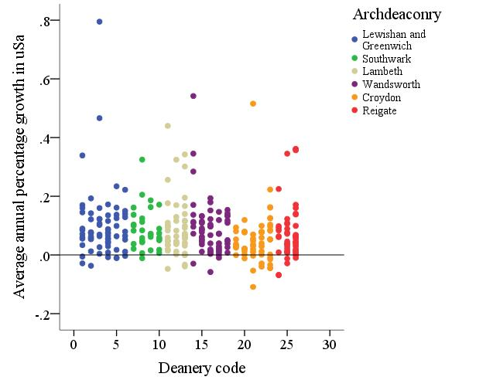

Figure 2
Ethnic diversity index for electoral wards by distance from Southwark Cathedral

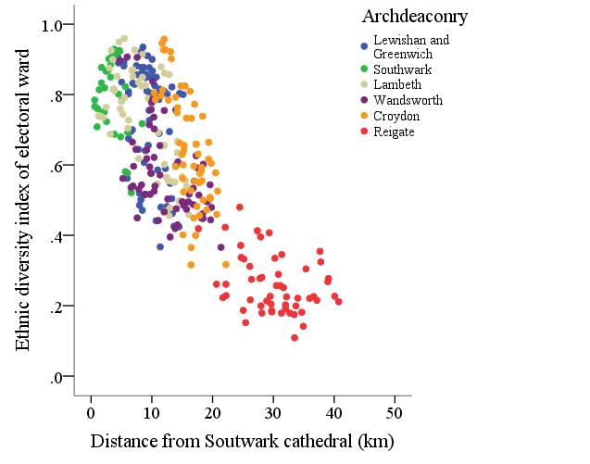

Figure 3
Ethnic diversity index of congregations compared with their matched electoral ward. Congregations above the line were more diverse than their neighbourhoods

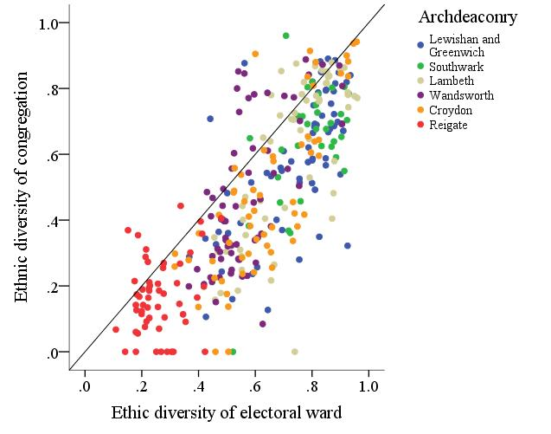

Figure 4
Ethnic diversity of congregations in relation to the percentage of White British

