On the Border Between Performance, Science and the Digital
a) A conversation with CREW
This interview was conducted by Eirini Nedelkopoulou and comprises of a section of a longer discussion on CREW’s contextual and collaborative approach to a forthcoming project that concerns the Digital Re-enactment of Planetarium Performances. Eric Joris, CREW’s artistic director together with his colleagues Philippe Bekaert (senior researcher, EDM, Expertise Centre for Digital Media, Hasselt University) and Kurt Vanhoutte (senior researcher, Theatre, Film and Literature studies, Antwerp University) reflect on the company’s practice and processes, which operate on the border between performance art, science and digital technologies.

CREW is a Belgian-based company renowned for its pioneering and creative use of immersive technologies. Eric Joris works with a collective of artists and scientists, and together they develop hybrid performances and installations in which they seek to push and expand the limits of performance art. CREW establishes a unique interaction with their participants, who are immersed into a world where the real and the virtual can no longer be distinguished.
Eirini Nedelkopoulou (EN): In CREW’s work scientific reflection plays a constitutive role in your creative process. Could you say more about the connection between performance, technology and scientific experimentation in your projects?
Eric Joris (EJ): CREW is interested in new possibilities of technologies; together with scientists, we start experimenting and ‘playing’ with technologies. People have suggested that this is a case of ‘toys for boys’ and it may be true in some respects, but this way of working is not necessarily gender or even technology specific, instead experimentation is driven simply by human curiosity. For instance, why and how can we see from somebody else’s perspective and how can we appropriate other bodies, which are not part of our own physicality? How can we experience bodies which are not ours? How does one’s past and present affect the relationship to one’s body? Asking and testing these questions in collaboration with scientists offers an intriguing common workspace.
Philippe Bekaert (PB): I work on applied science, engineering, blue-sky research and programming. The core of our undertaking is that we are all interested in technology. In CREW we share the same interest in technology and we have complementary backgrounds. My role is to develop the technology and think about how, in the long term, technology can make a difference. People working in industry need to think in the short term, to work on projects that run over a short time period and lead to quick financial returns so that they can pay their employees and make a profit as a company. The exciting part of this collaboration is that I don’t expect a short return for my contribution and experimentation with technology. Maybe our way of working is something that in 10-20 years time will highlight different elements of how we experience media. We want to stretch the boundaries of the use of technology, not by creating faster systems and problem solving devices, but by asking what we can do with this technology to enhance human perception and experience. I see what I do more as making something that mediates and facilitates the interaction between the conversant and the actor. One unique characteristic of the performance work of CREW is that the technology does what a stage does within a theatre; it facilitates the exchange and communication between the performer and the spectator.
EN: Eric, could you talk about the technical and dramaturgical context of your immersive practice?
EJ: We develop immersive technologies, that means we put the participant inside an image, at the inside of another reality, at the heart of an experience. We do this by using HMD’s (Head Mounted Displays) or video goggles that we combine with omnidirectional video. During the performance we induce physical and tactile manipulation upon the ‘immersant’ to heighten their experience. We are interested in a technology that can be performative; performative in a sense that it allows us to think and dream of technology as part of ourselves and vice versa. This idea doesn’t celebrate something new. Greek and Celtic myths are full of stories of hybrids, gods and demi-gods tried to take possession of human bodies and of other gods. It was the Gods’ and Demi-Gods’ favourite game. I can see a parallel here between these myths and our drive towards a technology that allows us to challenge our own and each other’s perspective (and often corporeality). Our inspiration from myths, allegories, old tragedies is helpful because by nature they reflect upon the status of that very human; they redefine man all over again.
Our actual immersive practice grew out of our 2002 performance Philoctetes which relied upon this idea of the colonisation of the body by viruses and by technology. Philoctetes was a staged performance: the audience was sat in a tower conceived as an anatomical theatre, they looked at the performer below them. The performer was a paraplegic patient, he lay on his back and he was wired to small devices (like a small laser at his head, contacts attached to his mouth, sensors, a navigation ball near to his chin) and a computer. We had mounted a big robotic arm on his torso, he looked like a scorpion. The robotic arm was used to grab and manipulate objects. The performer, Paul Antipoff had sensors and electronic devices attached to his forehead, his tongue and chin. The tiny movements he could make were captured by these devices and translated by a computer into the robot's movements.
But as he lay on his back he could not see the floor and the objects around him, we needed to offer him an overview from above so that he would know where to steer to. Therefore a camera was attached to the ceiling, and the camera's view, the view from above was shown on two videoscreens near to his head. He could then see himself on the video screen performing tasks upon himself, so to speak. As the image had a highly immersive quality this became confusing to the performer and the camera perspective made the performer dizzy; he got simulator sickness. So we decided to fix the video camera on the claw (hand) of the robotic arm. From there on our performer was immediately able to steer perfectly well and make full use of the robotic arm. His was enabled to perceive a tool as an extension of the body and had immediately integrated it into the performer's body schema. And this is a bit of a paradox since of course this bodily configuration does not correspond to a natural condition: we do NOT have eyes on our hands. The robotic arm became extension of his body and the medium as a prosthesis turned into reality.

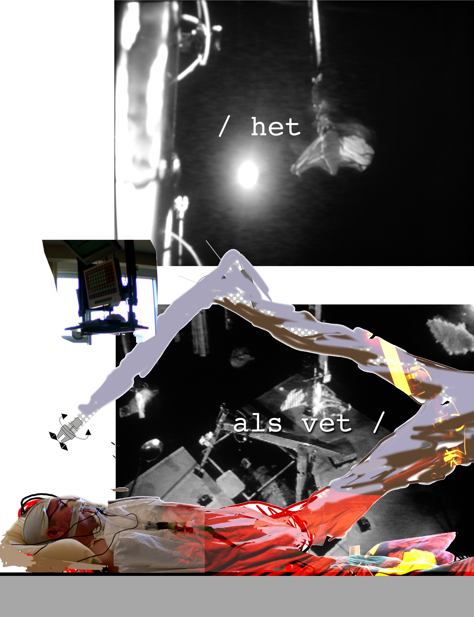Figure 1. Philoctetes / Man-of- War with Paul Antipoff, Bruges, European Capital of Culture 2002 ©eric joris
After this performance our next step was clear; we should allow the audience to experience these different perspectives themselves, they had to be in the machine. A year later I met Philippe and that is when we started developing a completely new way to involve our spectators, building a complete immersive configuration, with video goggles, omnidirectional video and sensors. CREW’s use of this technology had a fundamental impact on our dramaturgical context. We became interested in sensorial deprivation, illness, deficiency, failure and these dramaturgical key components, coincided with out-of-body effects frequently produced by our technology.
Kurt Vanhoutte (KV): CREW brings together a very conceptual and material idea about technology. Technology seems to have a conceptual/symbolic layer, while at the same time it can be used as a very instrumental, pragmatic, material thing to obtain a certain goal. In the work of CREW these two dimensions come together in a dialogue, yet they also stay separated. You have the plot or story, or dramaturgical concept that is often linked to the postmodern condition etc., and then the practical level, working with the team writing algorithms, in a work that only Philippe Bekaert can perform. This dialogic relationship remains visible in the projects, even on stage. Of course, this discernible relationship between the conceptual, the practical and the technical has brought criticism that the work is not consistent, not coherent and that the narrative is missing. But we think that is an honest way to show the hybrid qualities of CREW’s work where the performative and scientific components come together and then depart again. We are not interested in the merging of these two cultures of performance and science. We are not interested in hiding their differences. We are not interested in a seamless state where performance meets science. We want to show that the poetics of technology emerges from the performance and science dialogue.
EJ: As for the performances, we aren’t keen to replicate the Wagnerian ideal of total absorption. In immersive terms we would speak of a 100% feeling of presence, of total belief, elegantly phrased: ‘the illusion of non-mediation’. Strangely this was not so difficult to achieve, but it wasn’t our artistic goal. In 2004 with Crash, and 2005 with U_Raging Standstill, we regularly had people who totally believed what they experienced during a 50 minute immersive walk. Continuous and total absorption/presence was possible, and that was very interesting at the beginning. We called this ‘radical confluence’, but soon we found that the doubt of being in the middle of these two realities is far more fascinating. We decided to follow a slightly different artistic path. We’d rather have our playing field in the middle of two realities, one leg in the virtual, one leg in the real and the capacity of the mind of the immersant to balance and shift in between these two realities; what we identify as “the transitional zone”.
E.N: There seems to be a balance between human agency and the agency introduced by the technology. For instance in C.a.p.e. Brussels (2010) the participants have a specific task to fulfill. They have the choice to decide on where to go and look, but still their choices are informed and driven by the task to wander around following different characters. What is real or fictional is not of much importance.
- 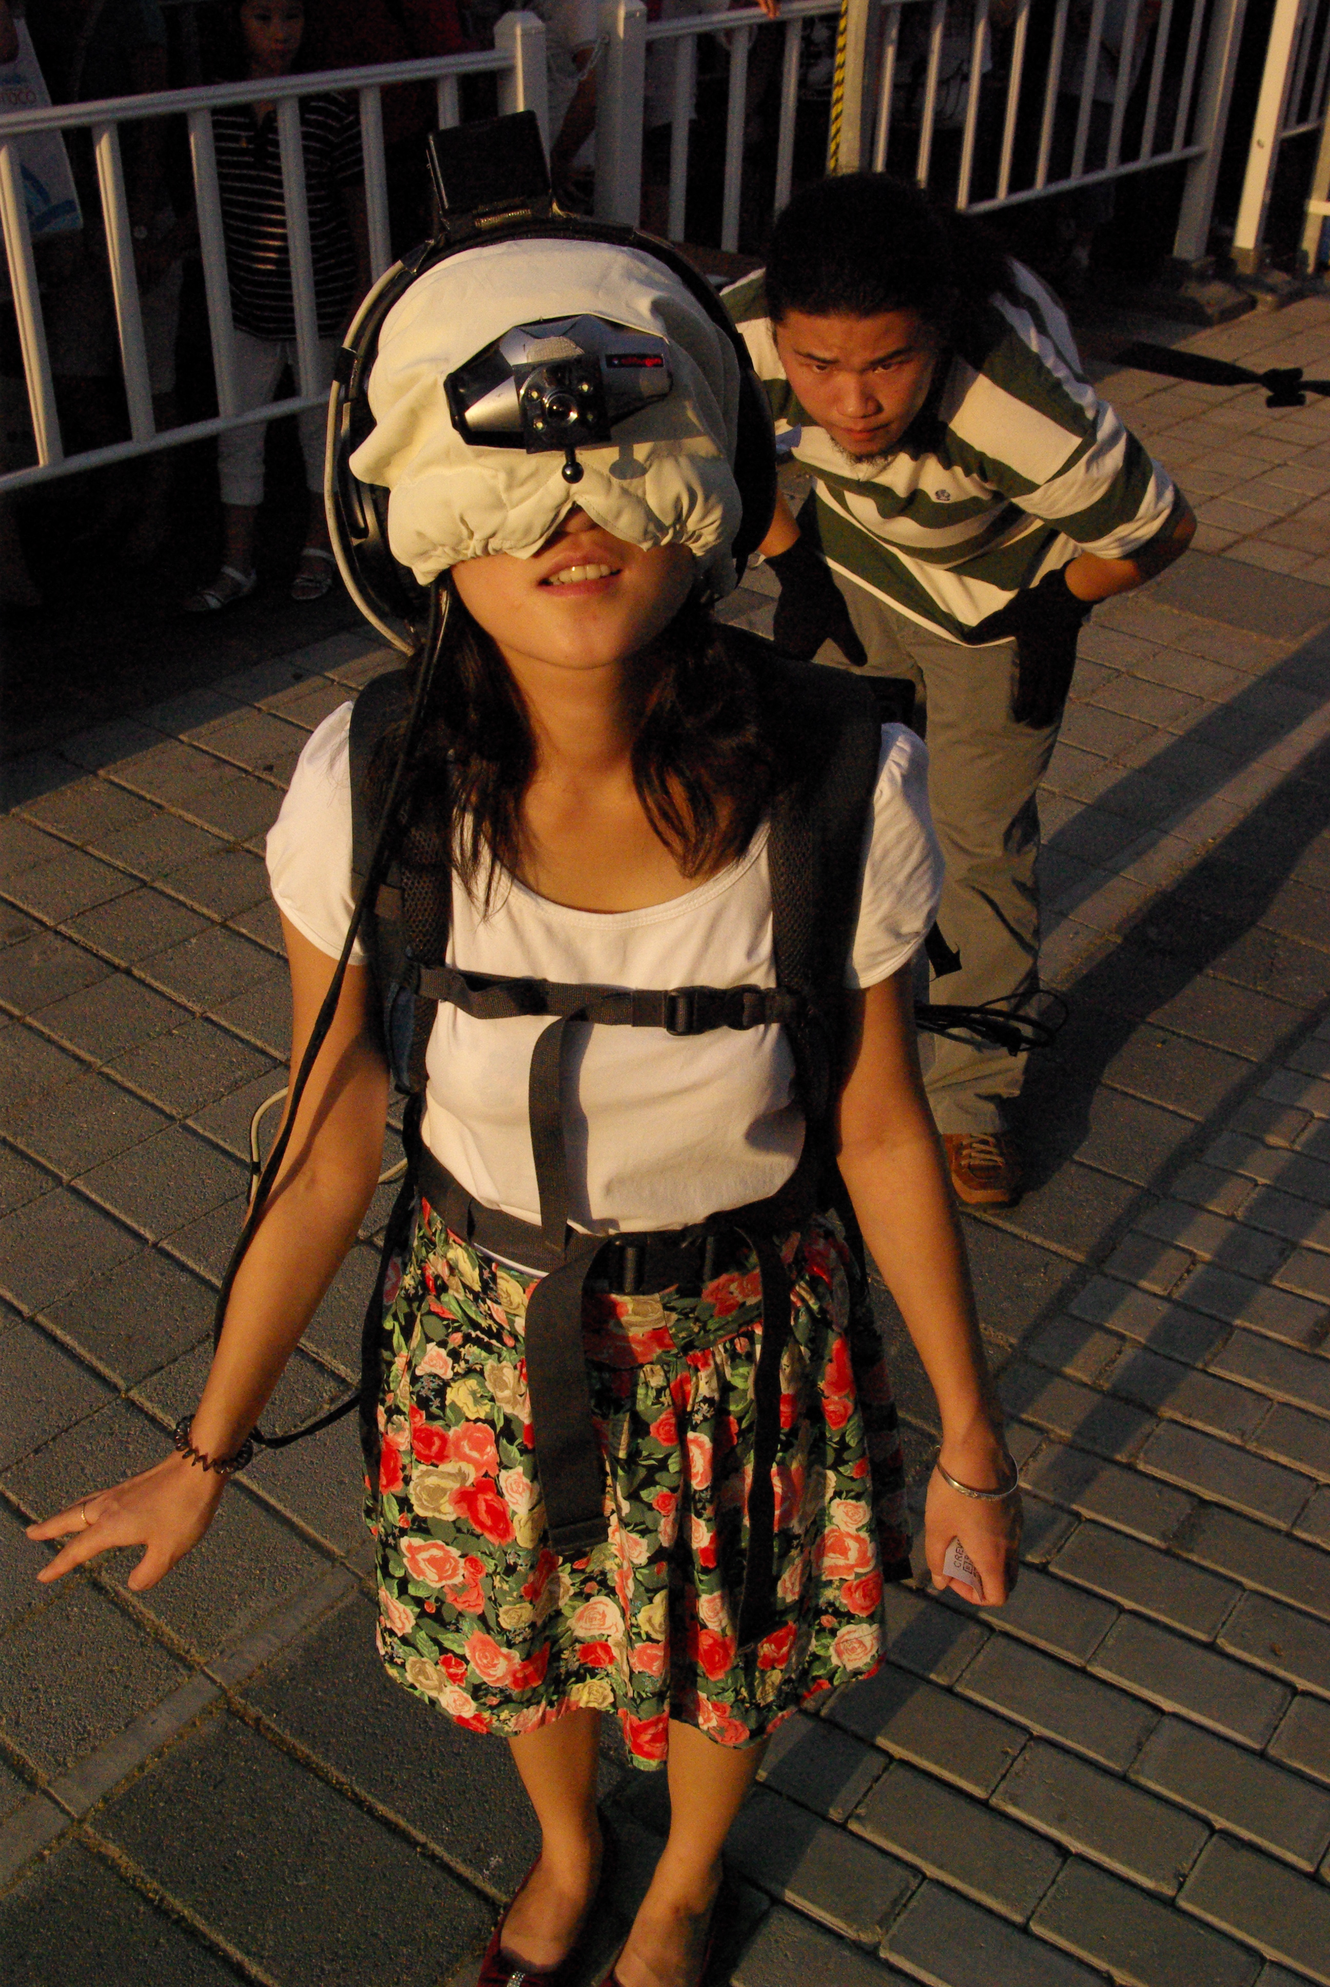
- Figure 2. C.a.p.e._Tohoku at Shangai World Expo 2010 © eric joris
E.J.: That’s right. When people are immersed in filmed worlds using HMD’s and walk around, they do not behave like cinemagoers. They automatically reach out their hand when a fictional character greets them, or they might answer the questions of the character, or look to their left and right before crossing a filmed street. This seems to come naturally. Another type of performance is Double U (2008) where we applied the ‘headswap’ configuration which was 100% live for two immersants. On top of our usual configuration with HMD the participants also have omnidirectional camera’s placed upon their body which connect to the HMD’s, and they have a live audio-connection with each other with their microphones. We position them in a different part of a building, and then we switch their video-streams, so that they perceive and see out from each other’s body. Then they have to move through the building, steering and guiding each other, which is quite unsettling. Although there is agency, a freedom to go any direction, both will have tendency to restrict that, they really try to control each other’s viewpoint by limiting it.

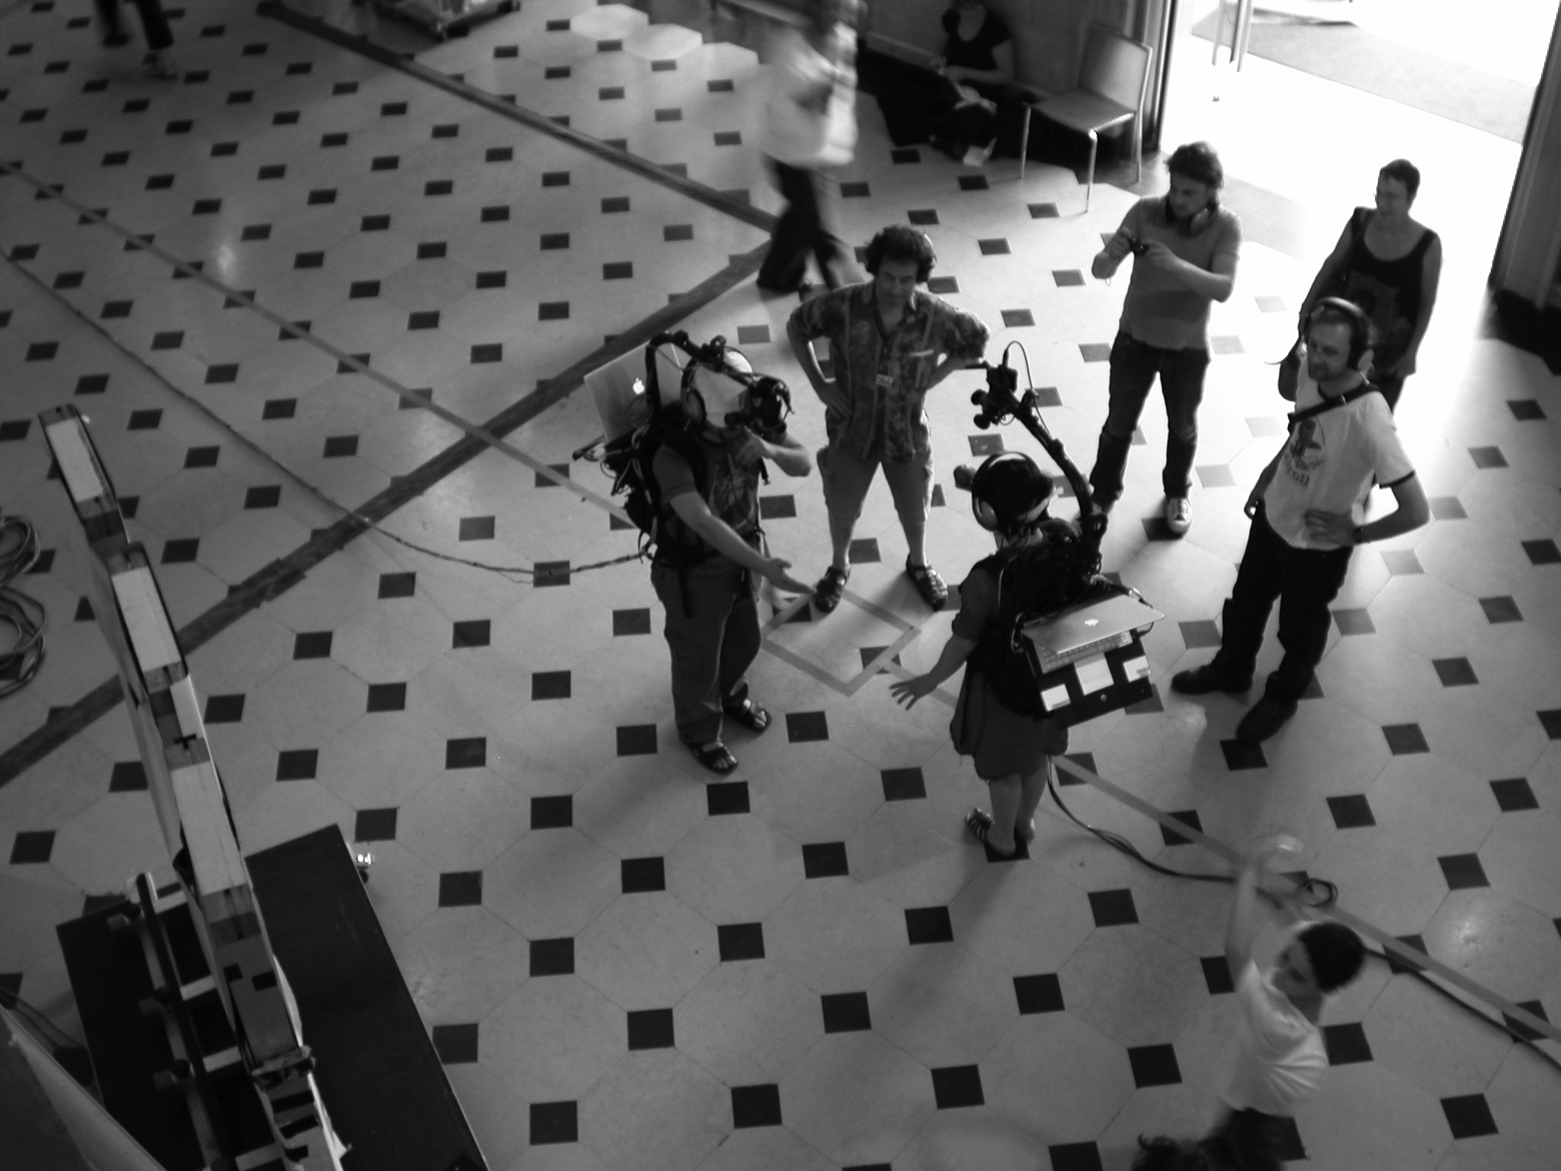
Figure 3. Double U -‘headswap’ at TCI, Paris 2009© eric joris

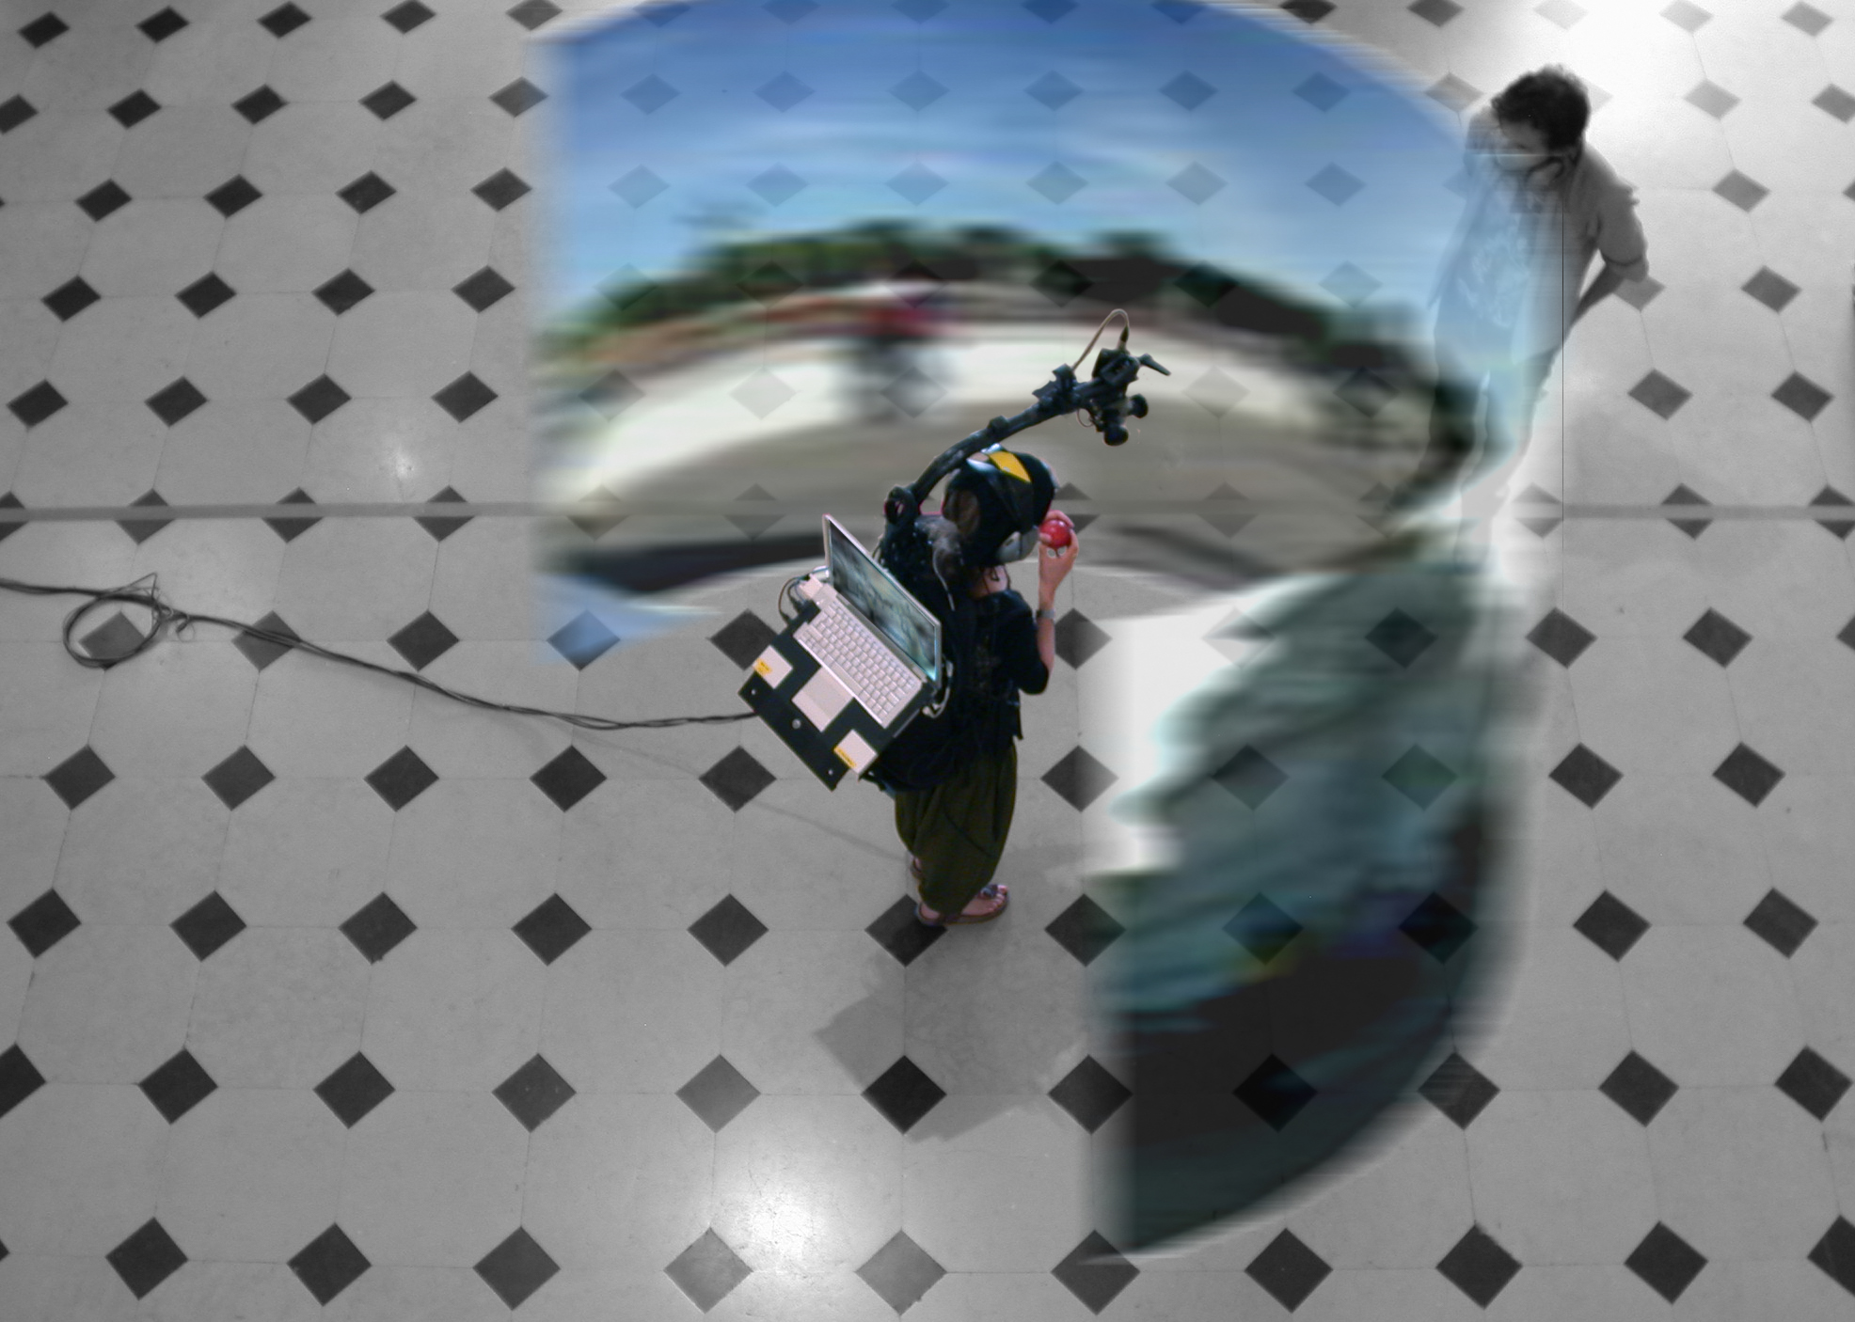Figure 4. Double U: The view of the immersant in at TCI, Paris 2009© eric joris

EN: What are the challenges you come across when you work with people from very different disciplines?
PB: I regularly work with people from the arts and social sciences. The first challenge is communication, finding a common language, and this is something that needs to build up over time. There is often a lot of misunderstanding or lack of understanding of what you can do. What you mean? Why are you there? A common language is very difficult to find. But I would also say that the level of difficulty in communication is often a personal thing rather than subject field based.
I was recently involved in a four year project, the 2020 3D Media Spatial Sound and Vision, which was a large scale European research project that intended to stimulate industry and to create, in some way, new opportunities for content production and exploitation. The partners coming from the industry had certain questions that needed to have resolved. On the contrary, me as a researcher, I don’t have the immediate need for a return, so we are in a position where we can think about the future and act in a more explorative way and let ourselves be driven by curiosity. What happens if we do that? Does it work as we expect or what new experiences will come out? The reason we worked together in a project like 2020 3D Media was because each of us as partners had an agenda and each agenda was open ended. In the case of businesses, it is more restricted, with a fixed agenda and a clearly defined goal.
EN: Philippe, earlier on you mentioned that in your collaboration with CREW you are offered the opportunity to test new grounds. So I guess CREW offered you a space for experimentation. How has this performance space/context accommodated your work?
PB: This performance space has been extremely valuable to me as I strongly believe that technological development makes no sense on its own. Again, I am more of an applied scientist. My colleagues from informatics would say that I just program things without finding new insights. However, I think that at the very least, the work we do with CREW facilitates and gains fundamental insights into how media can work in relation to the participants’ experiences. Computing research departments and companies may say that what we do is totally blue-sky research that has no immediate effect on the market and production. In a way it is nonsense to them, so why is it valuable to me? I strongly believe that technological developments should go hand in hand with creative production and what we want to produce are ‘immersive experience environments’. The main questions are: what are different media languages, how do we use them and what is the added value? I know these questions are already one hundred and fifty years old but the difference is that now technology is getting more affordable and accessible. So while CREW tries to engage with the above questions, I tackle them practically through my developments.
EN: In a similar question, but slightly altered, Eric – How do you actually think about science in your work? As a praxis? A tool? A methodology?
EJ: Perhaps, I can answer with what we labeled before as the ‘transitional zone’ in the immersive work of art. I would compare our working process to that of working within in a lab: with one foot in the scientific world, the other foot in the poetic /artistic world, and continuously shifting and balancing in between these two. Being together inside a lab and trying to fix things, try things and experience things –is the main driving force.
EN: Does CREW then offer a type of laboratory for testing bleeding edge technologies? Do you try to legitimise and define the artistic and performance component of your projects and interdisciplinary collaborations?
KV: It’s a training ground really. It’s not just a laboratory in the sense that you are devising new revolutionary technologies and ways to use them, it is fundamentally ambiguous. The process teaches us how to adapt to the new technologies, because of course we want things to work, but at the same time the performance practice of CREW makes both our audiences and us very sensitive and critical to what these technologies are doing to us. Then again, you have this idea of being inside and, at the same time, being outside and I think you can trace this dialectic between inside and outside on all the levels of production, conception and mediality.
EJ: Pragmatically, of course, as a performance company who works with different scientific disciplines, we do need to legitimate what we do, so we find ways to do this. Perhaps that’s not a thing we should talk about publicly, but as the political and economical conditions change, we are constantly asked to prove whether we are useful.
KV: I recognise similar pressures that challenge arts and humanities within an academic context. I suppose that these new emerging trends in research, like digital humanities that are invested in the intersection between computing and art and humanities, express part of this anxiety to legitimise specific subjects over others.

EN: Finishing our discussion I would like to ask about CREW’s relevance to astronomy and also to try and demystify a concept that Eric often uses to describe his practice, that is,“the viewpoint from nowhere”.
EJ: Human beings have the unique ability to view the world in a detached way. We can think about the world in terms that transcend our own experience or interest, and consider the world from a vantage point that is, in Thomas Nagel's words, "nowhere in particular" (1986). It has to do with truth, objectivity, and subjectivity. I have also encountered the term in the very different context of astronomy, about the history of “aperspectivical objectivity”(Daston 1992). Man’s own ‘default’ perspective system led him to understand the earth as being flat. By studying what he saw and using instruments he was able to understand the Earth as a planet, at the centre of a dynamic solar sytem that is geocentric. With better calculations, better instruments this understanding changed into a heliocentric perspective. It also generated the study of ‘seeing’ and Johannes Kepler’s findings in the field of optics. No doubt the perspective of a heliocentric solar system at that time was counter-intuitive. To imagine the solar system, scientists literally had to take their viewpoint outside. The result of this representation were the 18th and 19th century ‘orreries’.
But to return to your question: I like to understand the ‘view from nowhere’ as the confusion and capacity we experience while moving into a society which factually produces a ‘view from everywhere’ at any moment in time. Through machines and individuals, society continuously captures, monitors, films in every corner of the world, through handheld devices. We could suggest then that there is no central perspective and our everyday experience is no longer informed by a central perspective. This brings us to the role of art and performance. Just like some ingenious maps are able to make complex things intuitively understandable, art offers insight through its particular sense.
In CREW we talk about this view from no where/everywhere/anytime and we challenge ourselves to perform such a complex perception. We aim to do that through the making of a hybrid space that appears when the artistic viewpoint comes into dialogue with the scientific and vice versa.
KV: In the nineteenth century, the mother of sciences was astronomy. It was the first science to use technology to establish very precise measurements of what our place in the universe was, but we also see that during this same time period theatre was also being used for such purposes. New scientific findings were being popularised through theatre. Very early, even in the eighteenth century, theatres including the Royal Opera House put on performances about astronomy using the instruments of astronomy and showing the results of the information they had gathered. These performances were led by both artists and scientists. Was this art or was this science? The question was relevant to the discussion in a completely different manner than today. At that time, science was also supposed to be entertaining and the entertainment, when it came to putting science on display, had to have a didactic dimension. Both were closely connected. Only later was the divide between art and science was installed institutionally. Now the two strains are coming together again. You can see this in the ‘Embodied Orrery’ project in which CREW is participating. It’s a collaboration between artists, performance scholars, historians of science and astronomy and planetarium experts. In a way the mixture of their input and insights gives rise to imaginative potential. Each in their own way uses astronomy and the planetarium as a space to think about questions that are relevant for their field of research; questions about embodiment, criticism, subjective and objective points of view, perspective and visual perception.
References
Daston, Lorraine.1992. “Objectivity and the Escape from Perspective.” Social studies of Science (22): pp. 597-618.
Nagel, Thomas. 1986. The View From Nowhere. New York; Oxford: Oxford University Press.
Vanhoutte, K. and N.Wynants. 2011. “Performing phenomenology: negotiating presence in intermedial theatre.” Foundations of Science 16.2: pp. 275-284.

Notes on the contributors
Eric Joris studied filmmaking, visual arts, and economics. Started making strips (bandes dessinées) i.e. Chelsy (1990,’91) and Les Cuisiniers Dangereux (1996). With the arrival of the digital drawing tablet, internet and computer games Joris moved into working with new media within the theatre context (Kammerspiel, Kaufhaus Inferno 1996-‘98). He founded CREW in 1992. From 2000 onwards he focused on developing theatrical environments, using multimedia ‘as a prosthesis’ (Icarus, Philoctetes). Immersion is a recurrent element of CREW's creations since 2003 (Crash 2004, Eux 2008, Terra Nova 2012). Internationally recognised as pioneers in immersive media, Eric Joris and his team also participate in European and international academic and technological research programmes (i.e. 2020_3D Media, IBBT/Explorative TV, Dreamspace).
Vandernootstraat 23,
bus 8,1 080 Brussels
contact@crewonline.org

Philippe Bekaert is professor of visual computing at the Expertise Center for Digital Media (EDM) of Hasselt University (Belgium), and research leader in iMinds. He co-leads a group of 15 researchers in the area of omnidirectional and panoramic video, free viewpoint video, immersive environments, high performance computer graphics and general purpose GPU computing. He is leading several large scale R&D projects on the intersection of arts, cinema, TV broadcasting and visual computing, and strongly advocates joint creative and technological research. He is the author of the software technology used by the performance company CREW.

Philippe Bekaert
Expertisecentrum voor Digitale Media - Universiteit Hasselt
Wetenschapspark 2 - 3590 Diepenbeek - Belgie
Tel: +32 11 268411
www.edm.uhasselt.be

philippe.bekaert@uhasselt.be

Eric Joris referes to the kinaesthetic awareness of the body to itself, robotic and digital tools and its environment.
Vanhoutte, K. and N.Wynants. 2011. “Performing phenomenology: negotiating presence in intermedial theatre.” Foundations of Science 16.2: pp. 275-284.
C.a.p.e.(Computer Assisted Personal Environment) ‘An artistic concept and technical tour de force that transfers experience and illusion into the body itself. C.a.p.e puts you at the inside of the filmed image. With the help of video-glasses, trackers and a headset it is possible to explore a new reality, another space and time. With multiple C.a.p.e creations CREW is developing a performance format that puts the visitor at the centre of the experience’ http://www.crewonline.org/art/projects (last accessed 1/7/2014).
http://www.20203dmedia.eu (last accessed 1/7/2014)
Nagel, Thomas. 1986. The View From Nowhere. New York; Oxford: Oxford University Press.
Daston, Lorraine.1992. “Objectivity and the Escape from Perspective.” Social studies of Science (22): pp. 597-618.

